I2C

20140501
2015 12/16

Reference:
UM10204.pdf
i2c_utility_0.4.1.f

i2c-communication
i2c-communication need pull-up-resistors on scl/sda-lines.
Resistor-value is depended on total capasitance of i2c-devices on sda/scl-lines.
Normally, 10k-ohm is no problem.
For example,QuickStartboard and Demoboard,etc.

When there are many i2c-devices, total capacitance become bigger.
When capacitance on scl and sda-lines is too big, timing for i2c-signal become poor.
And propller can't load code inside eeprom even if executing 'reboot'.
So, Propeler reply nothing.

Prevending this phenominon, pull-up-resistor on scl and sda-lines should be small.
We need to add resistor on scl/sda-lines.
For example, combined resistance is 5k-ohm when adding 10k-ohm

Setting sda(scl) to Hi; Set bit of sda(scl) to input
Setting sda(scl) to Lo; Set bit of sda(scl) to output [bit of outa for sda(scl) is '0']

Slave-address
Slave-address is 7bit.
(10bit-addres cannot use on i2c_utility_0.4.1.f)
When this address is sent to device, it is placed to [bit7-bit1].
In case of h20, it is b01000000(write:h40) at writing and it is b01000001(read:h41) at reading.
Please refer UM10204.pdf in case of 10bit-address.

About clock-stretch
i2c_utility_0.4.1.f don't treat clock-stretch.
Because I don't have i2c-device generate clock-stretch.
If I get i2c-device generate clock-stretch, then I re-write i2c-words.
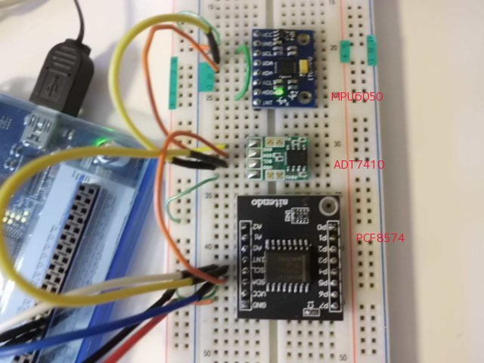
Prop0 Cog6 ok
i2c_detect
0 1 2 3 4 5 6 7 8 9 A B C D E F
00: 00 -- -- -- -- -- -- -- -- -- -- -- -- -- -- -- <-- ADT7410 reply to general-call--address
10: -- -- -- -- -- -- -- -- -- -- -- -- -- -- -- --
20: 20 -- -- -- -- -- -- -- -- -- -- -- -- -- -- -- <-- PCF8574
30: -- -- -- -- -- -- -- -- -- -- -- -- -- -- -- --
40: -- -- -- -- -- -- -- -- 48 -- -- -- -- -- -- -- <-- ADT7410
50: 50 -- -- -- -- -- -- -- -- -- -- -- -- -- -- -- <-- eeprom on QuickStartboard
60: -- -- -- -- -- -- -- -- 68 -- -- -- -- -- -- -- <-- MPU6050
70: -- -- -- -- -- -- -- -- -- -- -- -- -- -- -- --
i2c_device:4
[0 – 7] and [h78 – h7F] are reserve-address for 12c

Prop0 Cog6 ok

Bus clear
i2c-communication always is started by master.
But scl-line stuck Low in the unlikely event.
If i2c-device has HW reset input, reset by using it.
If nothing, do cycle power to device.

If sda-line stuck Low in the unlikely event,;
1 Sending nine clock pulse to device (word'bus_clr' inside i2c_utility_0.4.1.f)
2 Using HW reset input od device
3 Doing cycle power to device

About i2c_utility_0.4.1.f

_eestart
Firstly outa for sda is lo, and set output
Secondary outa for scl is lo, and set output
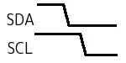
Sr
Repeated Start when using read-procedure
Set sda/scl to input (both line are Hi)
outa for sda is lo, and set output
outa for scl is lo, and set output
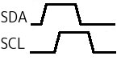
Sr is same as _eestart.
Device(MLX90614ESF-BAA) for SMBus caused Time-out error.
SMBus is almost same as I2C. But there is Time-out on SMBus.
Error occur because Sr is Forth-word.
_eestart(Sr) is re-defined as assembler-word.

_eestop
Stop i2c-commnication
Set scl to input
Set sda to input
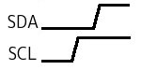

i2c_wr
Writing 1byte to device's register
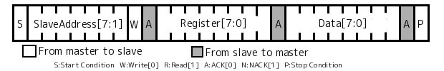
i2c_wr_multi
Writing multi-bytes to device's register
When this word is used, i2c_device need to have auto-increment for register.
Bytes is from 1 to n.
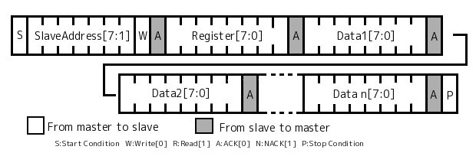
i2c_rd
Reading 1byte from device's register
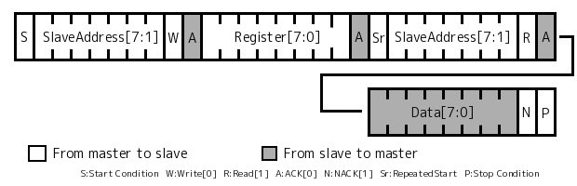

i2c_rd_multi
Reading multi-bytes to device's register
Bytes is from 1 to n.
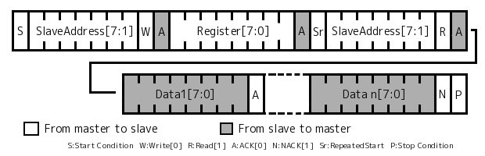
When this word is used, i2c_device need to have auto-increment for register.

Some i2c-devices don't have such a read/write-procedure.
So, some devices cannot use i2c_wr/i2c_wr_multi/i2c_rd/i2c_rd_multi.
And then, it can make procedure by using _eestart Sr _eestop _eewrite _eeread.

Clock for _eewrite is about 400kHz.
Number is ticks.
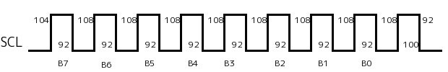
build_BootOpt :rasm
mov $C_treg1 , # h8 4ticks scl=Lo
\ --- Start tranmit 8bits
__1
\ Set data-bit to sda
test $C_stTOS , # h80 wz 4ticks scl=Lo
muxz dira , __sda 4ticks scl=Lo
\ Wait 88ticks
jmpret __delayret , # __delay 4ticks+84ticks scl=Lo

\ Set scl to input(Hi)
andn dira , __scl 4ticks scl=Lo
\ Wait 88ticks
jmpret __delayret , # __delay 4ticks+84ticks scl=Hi

\ Set scl to output(lo)
or dira , __scl 4ticks scl=Hi

\ Shift data-bit
shl $C_stTOS , # 1 4ticks scl=Lo
\ Finish 8bit?
djnz $C_treg1 , # __1 4ticks when jump scl=Lo 8ticks when no-jump
\ --- Finish transmit 8bits

\ Set sda to input(floating)
andn dira , __sda 4ticks scl=Lo
\ Wait 88ticks
jmpret __delayret , # __delay 4ticks+84ticks scl=Lo

\ Set scl to input(Hi)
andn dira , __scl 4ticks scl=Lo
\ Wait 88ticks
jmpret __delayret , # __delay 4ticks+84ticks scl=Hi
\ Input sda from slave, Read ACK
test __sda , ina wz 4ticks scl=Hi
muxnz $C_stTOS , $C_fLongMask 4ticks scl=Hi

\ Set scl to lo
or dira , __scl 4ticks scl=Hi

\ Wait 88ticks
jmpret __delayret , # __delay 4ticks+84ticks scl=Lo

\ Set sda to lo and output
or dira , __sda 4ticks scl=Lo

jexit

\ this delay makes for a 84ticks on an 80 Mhz prop [Xtal:5MHz]
__delay
mov $C_treg2 , # d71 5+(84-18)=71
add $C_treg2 , cnt
waitcnt $C_treg2 , # 0
__delayret
ret

__sda
h20000000
__scl
h10000000

;asm _eewrite

Clock for _eeread is about 400kHz.
Number is ticks.
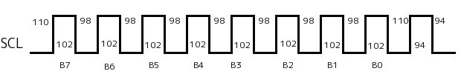
build_BootOpt :rasm
mov $C_treg1 , $C_stTOS 4ticks scl=Lo
mov $C_stTOS , # 0 4ticks scl=Lo
\ Set sda to input(floating)
andn dira , __sda 4ticks scl=Lo
mov $C_treg3 , # h8 4ticks scl=Lo
\ --- Start tranmit 8bits
__1
\ Wait 90ticks
jmpret __delayret , # __delay 4ticks+86ticks scl=Lo
\ Set scl to input(Hi)
andn dira , __scl 4ticks scl=Lo
\ Wait 90ticks
jmpret __delayret , # __delay 4ticks+86ticks scl=Hi

test __sda , ina wc 4ticks scl=Hi
rcl $C_stTOS , # 1 4ticks scl=Hi

\ Set scl to output(lo)
or dira , __scl 4ticks scl=Hi

djnz $C_treg3 , # __1 4ticks when jump scl=Lo 8ticks when no jump scl=Lo
\ --- Finish transmit 8bits

cmp $C_treg1 , # 0 wz 4ticks scl=Lo

\ Set sda to hi if $C_treg is not 0
muxz dira , __sda 4ticks scl=Lo
\ Wait 90ticks
jmpret __delayret , # __delay 4ticks+86ticks scl=Lo

\ Set scl to input(Hi)
andn dira , __scl 4ticks scl=Lo
\ Wait 90ticks
jmpret __delayret , # __delay 4ticks+86ticks scl=Hi

\ Set scl to output(lo)
or dira , __scl 4ticks scl=Hi

\ Set sda to output(lo)
or dira , __sda 4ticks scl=Lo
\ Wait 90ticks
jmpret __delayret , # __delay 4ticks+86ticks scl=Lo

jexit

\ this delay makes for a 86ticks on an 80 Mhz prop [Xtal:5MHz]
__delay
mov $C_treg2 , # d73 5+(86-18)
add $C_treg2 , cnt
waitcnt $C_treg2 , # 0
__delayret
ret

__sda
h20000000
__scl
h10000000

;asm _eeread

