USB Current Monitor

20131223

Reference;
USB_Current_Monitor_0.3.2.f

USB Current Monitor display USB-decvices-current(mA) and total-current(Ahour).
Displayment is 1second by 1second.
USB-decvices-current(mA): 0mA – 999mA [– – –]at more than 999mA
USB-total-current(Ahour): 0.00Ahour – 999Ahour [– – –]at more than 999Ahour
Current is an approximate value.

I/F Curcuit
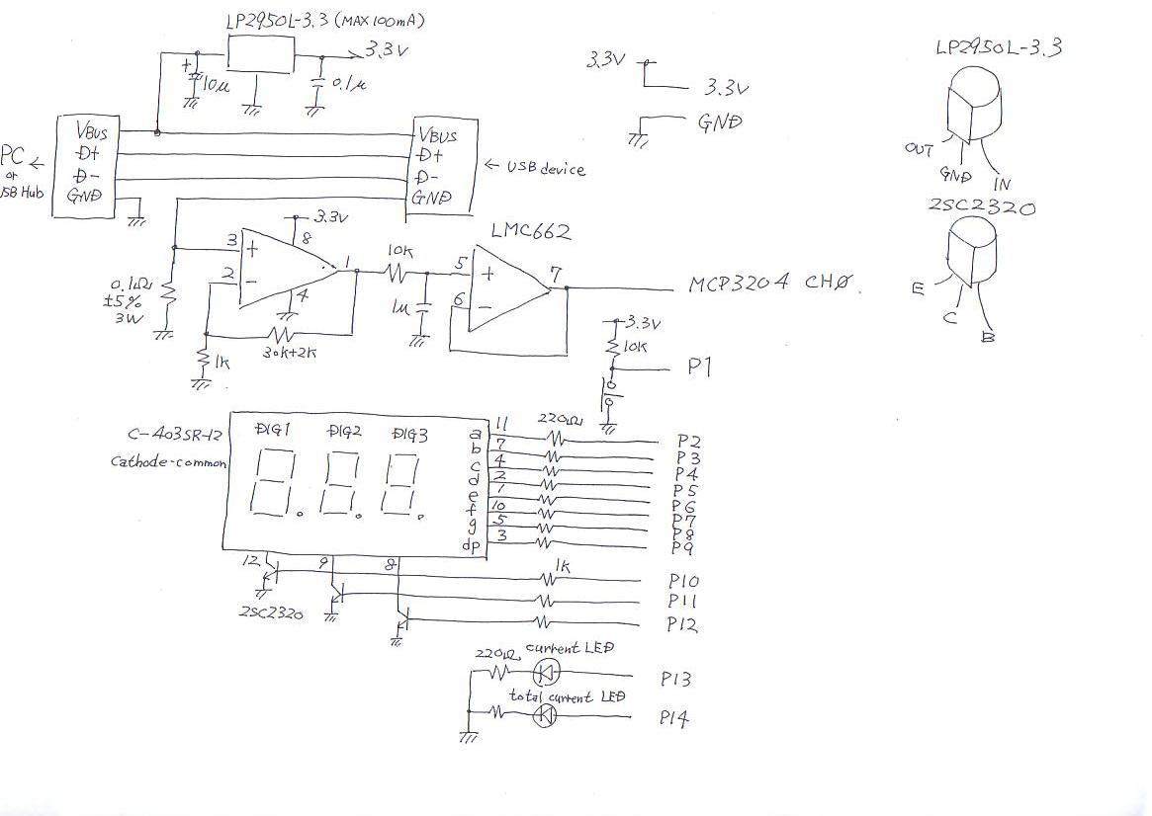
Power(3.3V) is generated by USB-Vbus.
3-digit-7SEG-LED display by Dynamic-drive(400Hz).
USB-device's current is sensed by resistor(0.1ohm).
This resistor has error (max+-5%). Resistor for op-amp is +-5%.
Current-sense-error is max+-5.25%.
CPU Curcuit
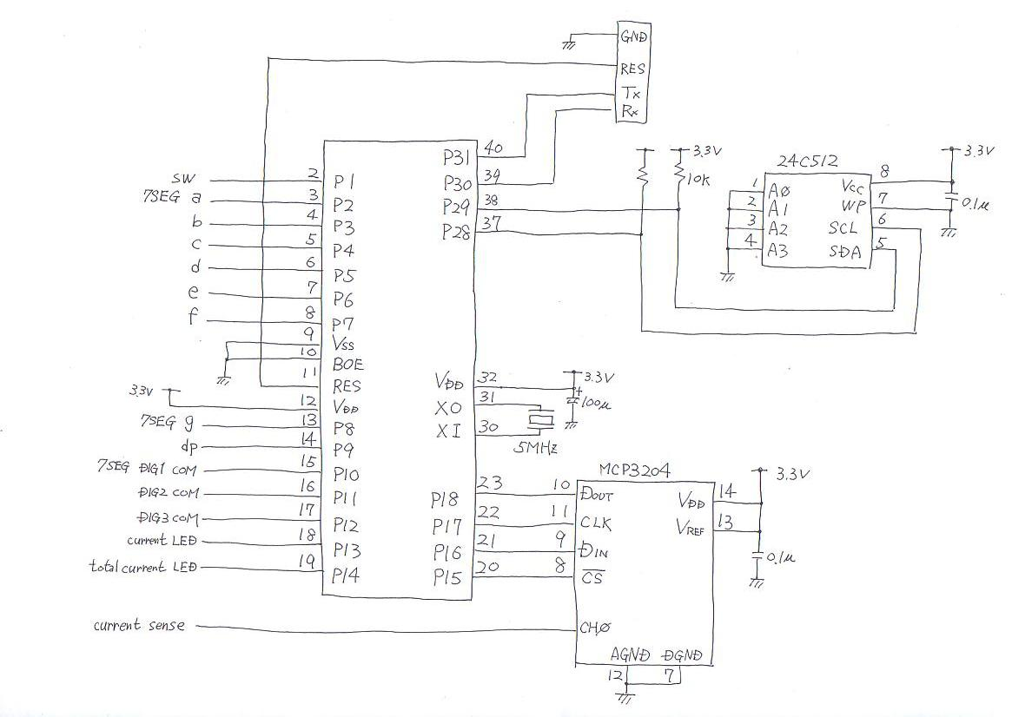

Thereis mistake about selection for Ope-Amp.
Power for LMC664 is min5V.
Correct Ope-Amp character is “Rail to Rail “ and “Single Power 3.3V”.
I replaced to NJM2732.

Although using 24C512 as eeprom, using 24C256 is ok.
I use Push-Switch for NormalClose-type.
So if using it for NormalOpen-type, modify word'read_sw'.
ADC(MCP3204) is using because converting current-sense-voltage.
Vref for MCP3204 use 3.3V(generated by LP2950L-3.3).
LP2950L-3.3 has error(max+-2%).
So, degital-value has max+-2%.

Error for current-sense-resistor and digital-value is +-5.355%.
USB-current's error is max+-5.355%.
But actually display-value is almost correct.

USB-current Volt for 0.1ohm Op-Amp Output ADC-value
1mA 0.1mV 3.3mV 4
10mA 1mV 33mV 40
100mA 10mV 330mV 409
1000mA 100mV 3.3V 4096

Using
- Inserting USB Current Monitor to USB-port for PC or USB-Hub.
- After “---” on 7SEG-LED, “0” is displayed on it. (zero-adjustment for op-amp)
- Inserting USB-device to USB Current Monitor
- When pushig switch, 7SEG-LED display total-current(Ahour).

Install
After built-up curcuit, insert USB Current monitor to USB-port.
Load DevKernel.spin connecting prop-plug to 4-pin-port.
Connect to TeraTerm.
Loading USB_Current_Monitor_0.3.2.f.

Prop0 Cog6 ok
saveforth
.......................................................................................................................................................................................................................................................................
Prop0 Cog6 ok
reboot

CON:Prop0 Cog0 RESET - last status: 0 ok

CON:Prop0 Cog1 RESET - last status: 0 ok

CON:Prop0 Cog2 RESET - last status: 0 ok

CON:Prop0 Cog3 RESET - last status: 0 ok

CON:Prop0 Cog4 RESET - last status: 0 ok

CON:Prop0 Cog5 RESET - last status: 0 ok

CON:Prop0 Cog6 RESET - last status: 0 ok

Prop0 Cog6 RESET - last status: 0 ok
Prop0 Cog6 ok

-- USB_Current_Monitor should operate ----

cog?
Cog:0 #io chan:1 RUNNING 7SEG_drive
Cog:1 #io chan:1 RUNNING read_sw
Cog:2 #io chan:1 RUNNING USB-current
Cog:3 #io chan:1 PropForth v5.5 2013Feb20 11:30 3
Cog:4 #io chan:1 PropForth v5.5 2013Feb20 11:30 3
Cog:5 #io chan:1 PropForth v5.5 2013Feb20 11:30 3
Cog:6 #io chan:1 PropForth v5.5 2013Feb20 11:30 3 6(0)->7(0)
Cog:7 #io chan:1 SERIAL 7(0)->6(0)
Prop0 Cog6 ok

-- Connected MP3-player ---
monitor
monitor
A/D Current[mA] Total Current[mAsec] Total Current[d100 X Ahour]
0 0 0 0
0 0 0 0
0 0 0 0
0 0 0 0
0 0 0 0
10 2 2 0
29 7 9 0
81 19 28 0
68 16 44 0
67 16 60 0
95 23 83 0
99 24 107 0
100 24 131 0
94 22 153 0
93 22 175 0
98 23 198 0
98 23 221 0
98 23 244 0
98 23 267 0
93 22 289 0

A/D Current[mA] Total Current[mA*sec]
93 22 311 0
114 27 338 0
99 24 362 0
99 24 386 0
99 24 410 0
99 24 434 0
99 24 458 0
99 24 482 0
99 24 506 0
99 24 530 0
99 24 554 0
99 24 578 0
99 24 602 0
99 24 626 0
99 24 650 0
99 24 674 0
94 22 696 0
93 22 718 0
99 24 742 0
99 24 766 0

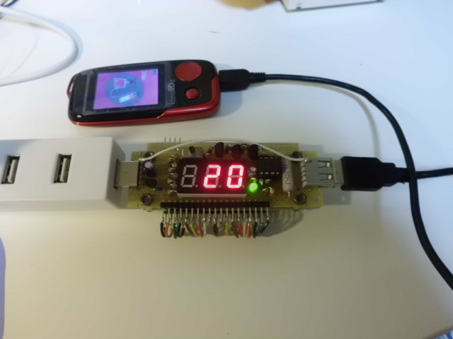
Current-measure mode

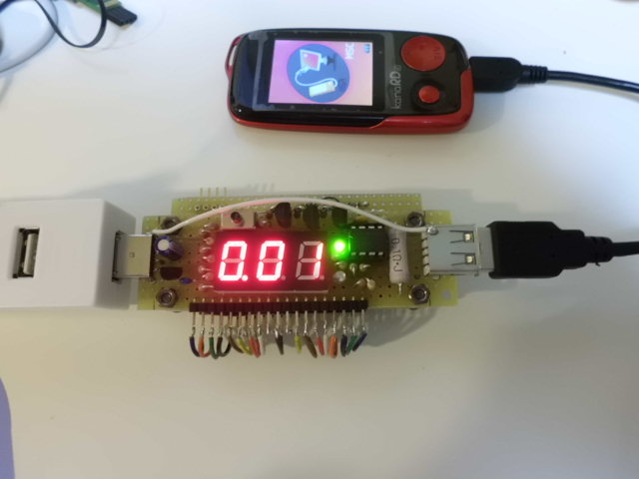
Total-Current-measure mode

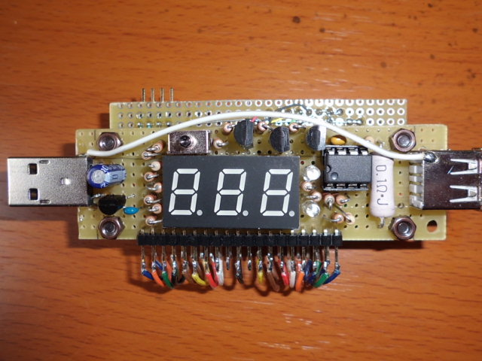
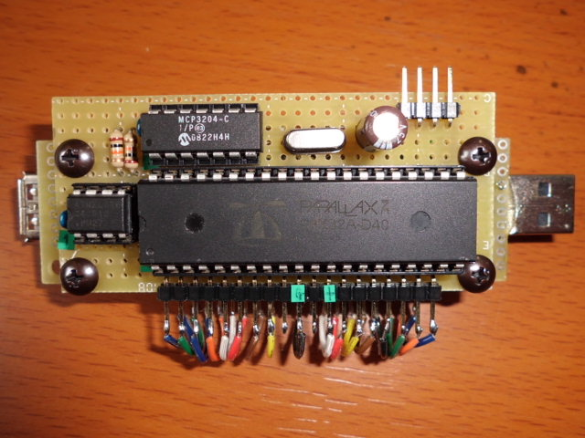

USB Current Monitor II
20140304

Modified USB_Current_Monitor.
Used OLED-LCD and SMD parts.

Reference;
USB_Current_Monitor_II_0.2_1.f
USB_Current_Monitor_II_0.2_2.f
Amp_offset_0.1.f

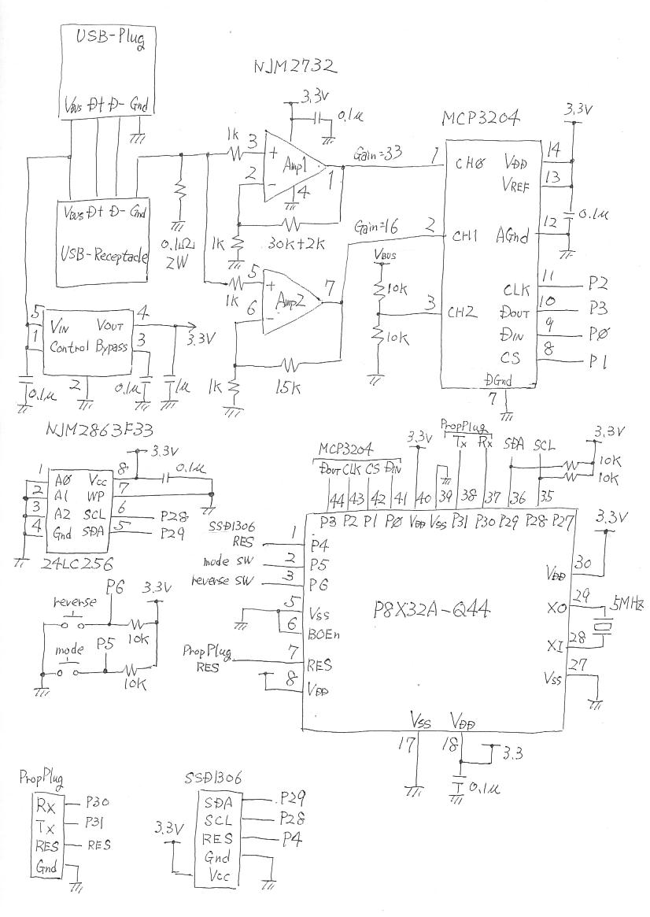
Curcuit:

Parts:

Install for Forth code
- Loading Dev-kernel to eeprom
- Loading Amp_offset_0.1.f
- Add 10mV to input for Amp1 and Amp2

Prop0 Cog6 ok
get_offset
ch0_offset:59
ch1_offset:67
Prop0 Cog6 ok
- Cop each value of ch0_offset and ch1_offset to USB_Current_Monitor_II_0.1_1.f
\ ch*_offset is plus when amp-offset is negative
Line No.355 d59 constant ch0_offset
Line No.356 d67 constant ch1_offset
- Execute “reboot”
- Loading USB_Current_Monitor_II_0.2_1.f and USB_Current_Monitor_II_0.2_2.f
- Execute “saveforth”
- Execute “reboot”

Resister for current use 0.1ohm 2W.
Really, 1W resister is ok in case of max current 2A.
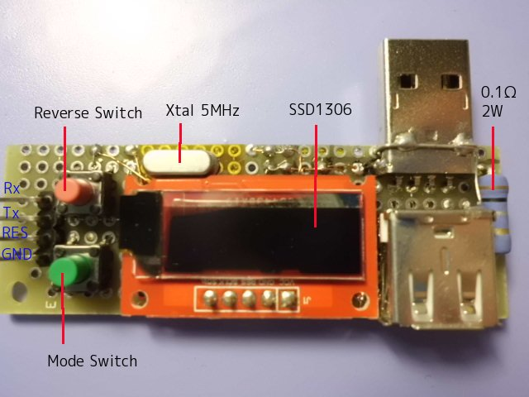

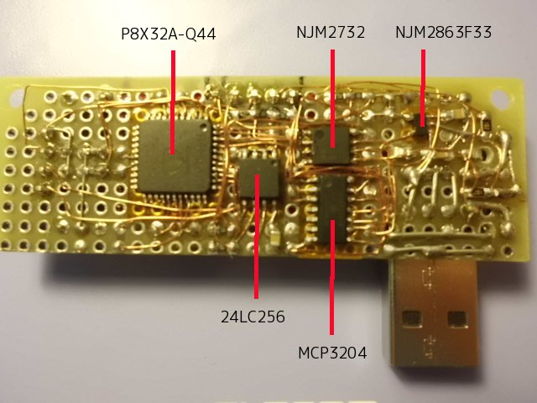
LCD for USBCurrent Monitor II use 32x16_font and 8x8_font.
32x16_font use vertical mode for SSD1306.
8x8_font use horizontal mode for SSD1306.
At less than 1A, ADC(MCP3204) select Amp1(Gain=33).
At more than 1A, ADC(MCP3204) select Amp2(Gain=16).

NJM2732 on USBCurrent Monitor has positive offset.
But NJM2732 on USBCurrent Monitor II has negative offset.
So, codes for USBCurrent Monitor can't use on USBCurrent Monitor II.

RC-curcuit need at output of Op-amp on USB Current Monitor.
Instead of RC-curcuit, USBCurrent Monitor II has ring-buffer for ADC-values.
ADC get ADC-value 50msec by 50msec.
And average value is got from 40 data inside ring-buffer 50msec by 50msec.

Delete USB Current Monitor II
- forget USB_Current_Monitor
- saveforth

Function:

When connected USB_Current_Monitor_II, it display [0mA] after [------mA].
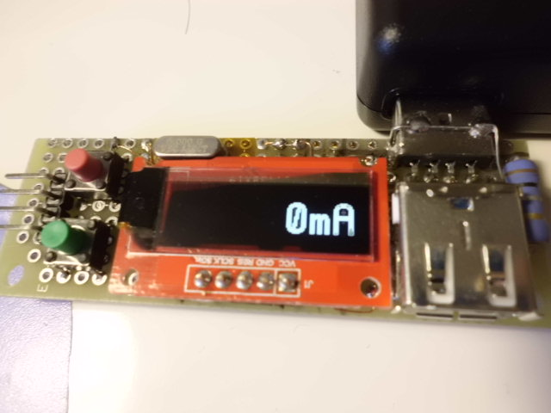
USB-decvices-current(mA) : 0mA – 2000mA
(This is added 200mV to op-amp-input for display-test.)
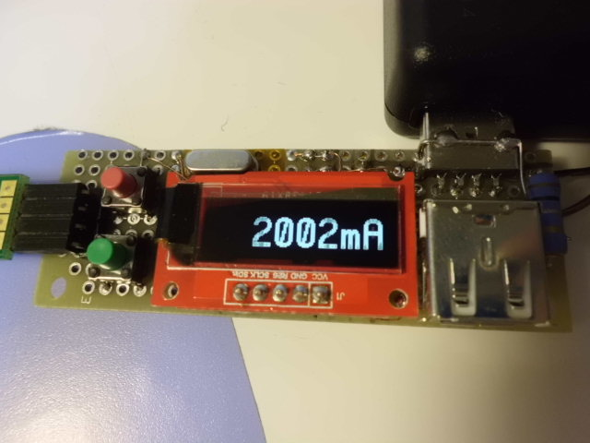

USB-voltage
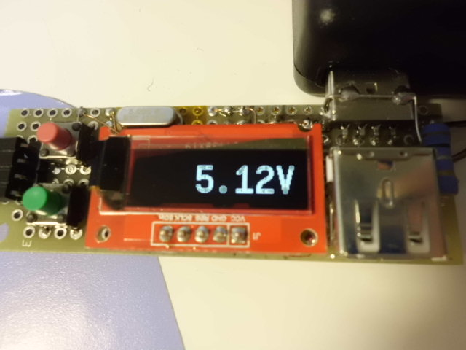
Total-current and Time after USB-device connected
Time 00:00:00 – 99:59:59
0mAs – 3600mAs
0mAh - 1000mAh
0Ah – 99999Ah

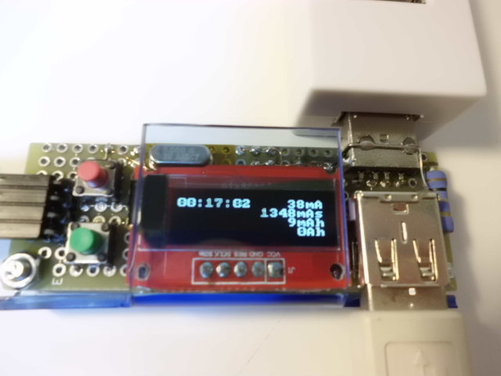
Top line Time and current
2nd Line Total-current[mAs]
3rd Line Total-current[mAh]
4th Line Total-current[Ah]

When reverse-sw is pushed, display' direction is chengeed.
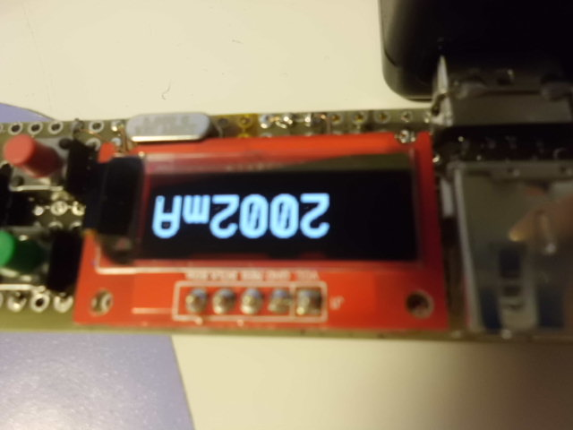
When input for Amp1/Amp2 is 0mv(removed USB-device), LCD is off.
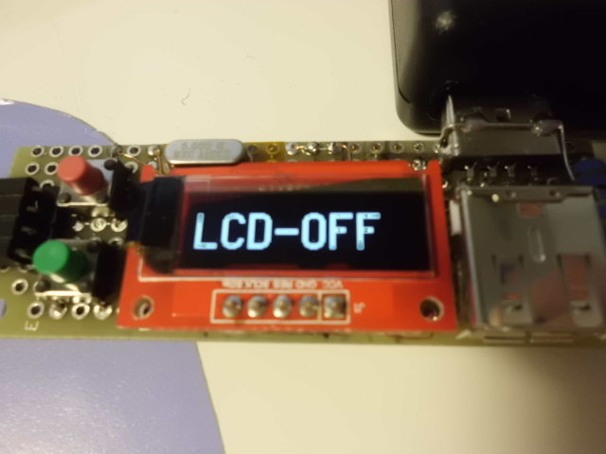
After this, LCD screen is off.
Removal for USB_Current_Monitor_II is ready.
If mode-sw is pushed for a while, back to initial status.(display 0mV)

Connecting to TeraTerm, below;
Prop0 Cog6 ok
cog?
Cog:0 #io chan:1 RUNNING ADC
Cog:1 #io chan:1 RUNNING total-current
Cog:2 #io chan:1 RUNNING Time
Cog:3 #io chan:1 RUNNING USB_Current_Monitor_II
Cog:4 #io chan:1 PropForth v5.5 2013Feb20 11:30 3
Cog:5 #io chan:1 PropForth v5.5 2013Feb20 11:30 3
Cog:6 #io chan:1 PropForth v5.5 2013Feb20 11:30 3 6(0)->7(0)
Cog:7 #io chan:1 SERIAL 7(0)->6(0)
Prop0 Cog6 ok
Cog0 convert data from MCP3204 to current and voltage.
Cog1 calculate total-current(mAs,mAH,Ah)
Cog2 measure elapsed time.
Cog3 is main of USB_Current_Monitor_II.

Detecting i2c-devices
Prop0 Cog6 ok

CON:Prop0 Cog3 RESET - last status: 0 ok
i2c_search
0 1 2 3 4 5 6 7 8 9 A B C D E F
00: -- -- -- -- -- -- -- -- -- -- -- -- -- -- -- --
10: -- -- -- -- -- -- -- -- -- -- -- -- -- -- -- --
20: -- -- -- -- -- -- -- -- -- -- -- -- -- -- -- --
30: -- -- -- -- -- -- -- -- -- -- -- -- 3C -- -- -- h3C is SSD1306
40: -- -- -- -- -- -- -- -- -- -- -- -- -- -- -- --
50: 50 -- -- -- -- -- -- -- -- -- -- -- -- -- -- -- h50 is eeprom
60: -- -- -- -- -- -- -- -- -- -- -- -- -- -- -- --
70: -- -- -- -- -- -- -- -- -- -- -- -- -- -- -- --
i2c_device:2

Prop0 Cog6 ok

Displayment for data
Prop0 Cog6 ok
monitor
Current[mA] Total Current[mAs] Total Current[mAh] Total Current[Ah]
2001 1424 327 0
2002 3426 327 0
2002 1828 328 0
2002 230 329 0
2002 2232 329 0
2002 634 330 0
2002 2636 330 0
2002 1038 331 0
2002 3040 331 0
2002 1442 332 0
2002 3444 332 0
2002 1846 333 0
2002 248 334 0
2002 2250 334 0
2002 652 335 0
2002 2654 335 0
2002 1056 336 0
2001 3057 336 0
2002 1459 337 0
2003 3462 337 0

Current[mA] Total Current[mAs] Total Current[mAh] Total Current[Ah]
2002 1864 338 0
2002 266 339 0
2002 2268 339 0
2002 670 340 0
2002 2672 340 0
2002 1074 341 0
2002 3076 341 0
2002 1478 342 0
2002 3480 342 0
2001 1881 343 0

Data inside ring-buffer when mouse is connected.
Prop0 Cog6 ok
disp_ADC_buf
101 102 97 99 98 97 98 195 97 244 99 98 98 98 106 98 256 97 101 101 101 101 102 103 101 99 101 99 98 98 98 97 236 98 253 98 99 98 98 99
101 102 97 99 98 97 98 195 97 244 99 98 98 98 106 98 256 97 101 101 101 101 102 103 101 99 101 99 98 98 98 97 236 98 253 98 99 98 98 99
96 102 97 99 98 97 98 195 97 244 99 98 98 98 106 98 256 97 101 101 101 101 102 103 101 99 101 99 98 98 98 97 236 98 253 98 99 98 98 99
96 254 97 99 98 97 98 195 97 244 99 98 98 98 106 98 256 97 101 101 101 101 102 103 101 99 101 99 98 98 98 97 236 98 253 98 99 98 98 99
96 254 96 99 98 97 98 195 97 244 99 98 98 98 106 98 256 97 101 101 101 101 102 103 101 99 101 99 98 98 98 97 236 98 253 98 99 98 98 99
96 254 96 96 98 97 98 195 97 244 99 98 98 98 106 98 256 97 101 101 101 101 102 103 101 99 101 99 98 98 98 97 236 98 253 98 99 98 98 99
96 254 96 96 96 97 98 195 97 244 99 98 98 98 106 98 256 97 101 101 101 101 102 103 101 99 101 99 98 98 98 97 236 98 253 98 99 98 98 99
96 254 96 96 96 102 98 195 97 244 99 98 98 98 106 98 256 97 101 101 101 101 102 103 101 99 101 99 98 98 98 97 236 98 253 98 99 98 98 99
96 254 96 96 96 102 102 195 97 244 99 98 98 98 106 98 256 97 101 101 101 101 102 103 101 99 101 99 98 98 98 97 236 98 253 98 99 98 98 99
96 254 96 96 96 102 102 102 97 244 99 98 98 98 106 98 256 97 101 101 101 101 102 103 101 99 101 99 98 98 98 97 236 98 253 98 99 98 98 99
96 254 96 96 96 102 102 102 104 244 99 98 98 98 106 98 256 97 101 101 101 101 102 103 101 99 101 99 98 98 98 97 236 98 253 98 99 98 98 99
96 254 96 96 96 102 102 102 104 103 99 98 98 98 106 98 256 97 101 101 101 101 102 103 101 99 101 99 98 98 98 97 236 98 253 98 99 98 98 99
96 254 96 96 96 102 102 102 104 103 103 98 98 98 106 98 256 97 101 101 101 101 102 103 101 99 101 99 98 98 98 97 236 98 253 98 99 98 98 99
96 254 96 96 96 102 102 102 104 103 103 103 98 98 106 98 256 97 101 101 101 101 102 103 101 99 101 99 98 98 98 97 236 98 253 98 99 98 98 99
96 254 96 96 96 102 102 102 104 103 103 103 105 98 106 98 256 97 101 101 101 101 102 103 101 99 101 99 98 98 98 97 236 98 253 98 99 98 98 99
96 254 96 96 96 102 102 102 104 103 103 103 105 99 106 98 256 97 101 101 101 101 102 103 101 99 101 99 98 98 98 97 236 98 253 98 99 98 98 99
96 254 96 96 96 102 102 102 104 103 103 103 105 99 98 98 256 97 101 101 101 101 102 103 101 99 101 99 98 98 98 97 236 98 253 98 99 98 98 99
96 254 96 96 96 102 102 102 104 103 103 103 105 99 98 99 256 97 101 101 101 101 102 103 101 99 101 99 98 98 98 97 236 98 253 98 99 98 98 99
96 254 96 96 96 102 102 102 104 103 103 103 105 99 98 99 97 97 101 101 101 101 102 103 101 99 101 99 98 98 98 97 236 98 253 98 99 98 98 99
96 254 96 96 96 102 102 102 104 103 103 103 105 99 98 99 97 216 97 101 101 101 102 103 101 99 101 99 98 98 98 97 236 98 253 98 99 98 98 99
96 254 96 96 96 102 102 102 104 103 103 103 105 99 98 99 97 216 97 251 101 101 102 103 101 99 101 99 98 98 98 97 236 98 253 98 99 98 98 99
96 254 96 96 96 102 102 102 104 103 103 103 105 99 98 99 97 216 97 251 95 101 102 103 101 99 101 99 98 98 98 97 236 98 253 98 99 98 98 99
96 254 96 96 96 102 102 102 104 103 103 103 105 99 98 99 97 216 97 251 95 99 102 103 101 99 101 99 98 98 98 97 236 98 253 98 99 98 98 99
96 254 96 96 96 102 102 102 104 103 103 103 105 99 98 99 97 216 97 251 95 99 97 103 101 99 101 99 98 98 98 97 236 98 253 98 99 98 98 99
96 254 96 96 96 102 102 102 104 103 103 103 105 99 98 99 97 216 97 251 95 99 97 97 101 99 101 99 98 98 98 97 236 98 253 98 99 98 98 99
96 254 96 96 96 102 102 102 104 103 103 103 105 99 98 99 97 216 97 251 95 99 97 97 99 99 101 99 98 98 98 97 236 98 253 98 99 98 98 99
Prop0 Cog6 ok
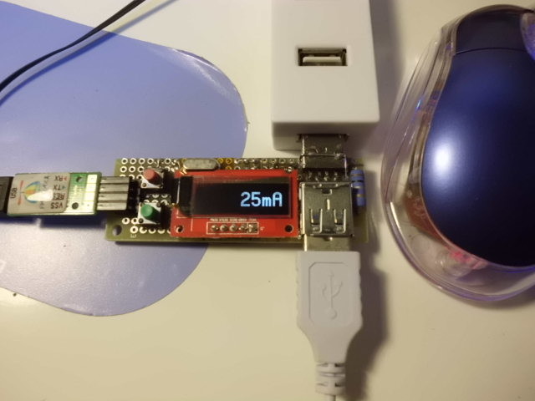
MP3 Player
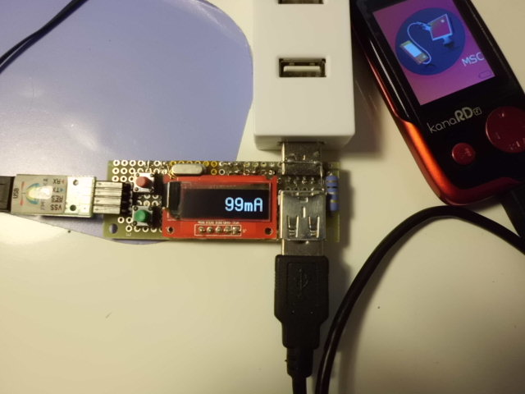
Wireless Router
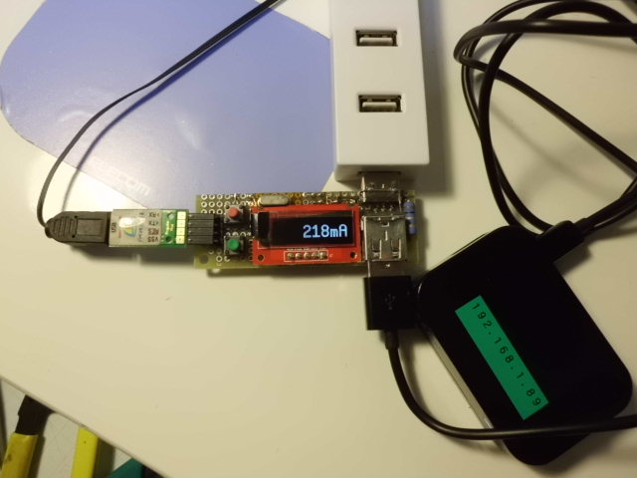

Generally, LCD value is a littel bigger.

TroubleShoot
When connecting to USB-Hub, display is [0mA].
But when connecting PropPlug,, display is [16mV].
GND of PropPlug-connecter connected to Amp1's 1k-ohm(GND-side).
I used wire(UEW polyuretan 0.2mm).
I think maybe GND-line was poor.
So, directly connected PropPlug's GND to USB-plug's GND by black wire(AWG32).

When connecting to PC's USB-port, USB_Current_monitor repeat reboot.
I added capacitor(1uF) to prop-chip's power(pin40 and pin 39).
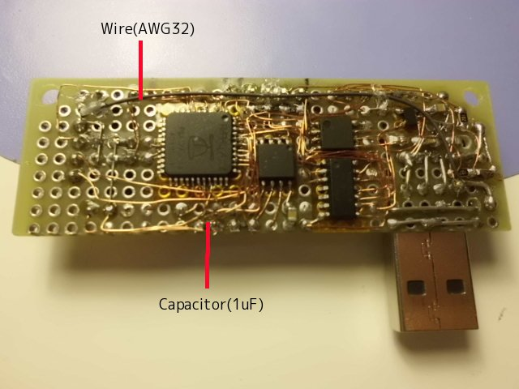
Each USB voltage is different

Camera's USB power supply
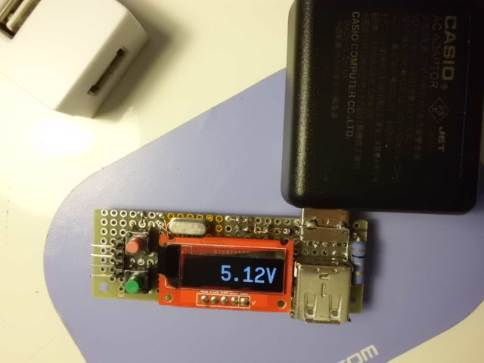
USB-Hub
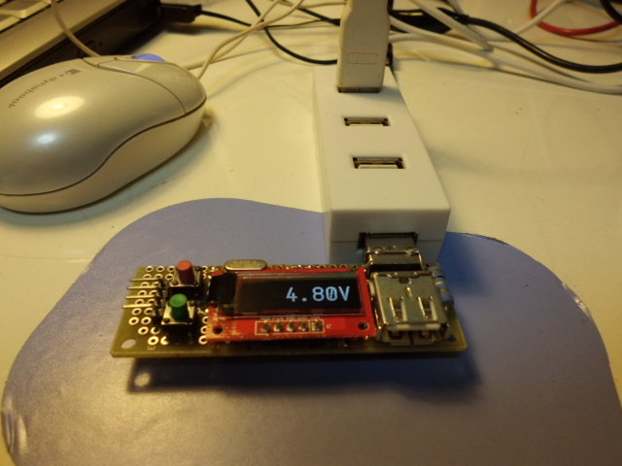
PC's USB port
