Single Step Motor

2016/9/25

Clock use SingleStepMotor.
I thought to drive clock by propeller.
You need to modify inside clock movement.
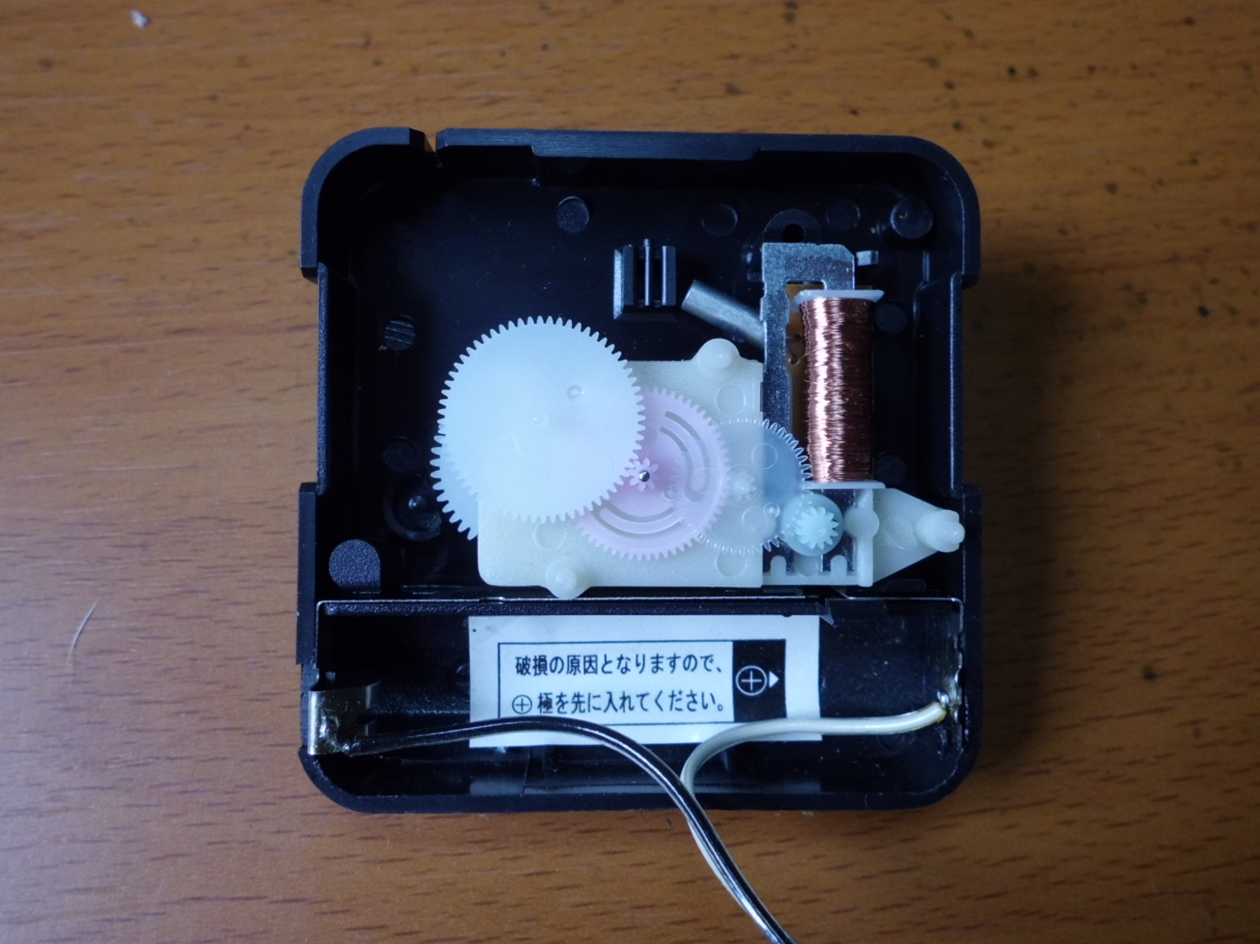

You find cogs and SingleStepMotor(solenoid and magnet).
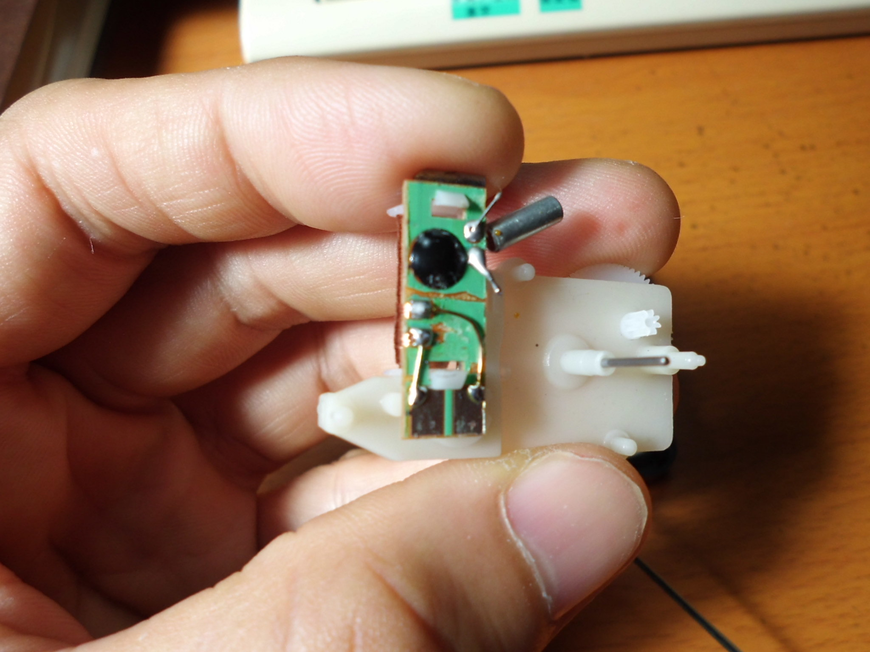

Black module is driver to output pulse in solenoid(1Hz).

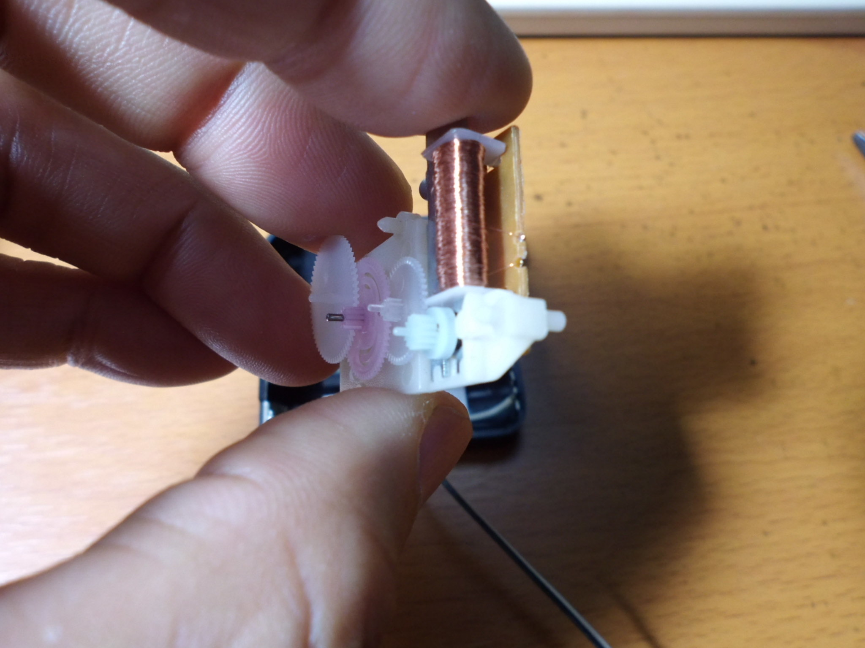

Driving solenoid cause rotating small cog.
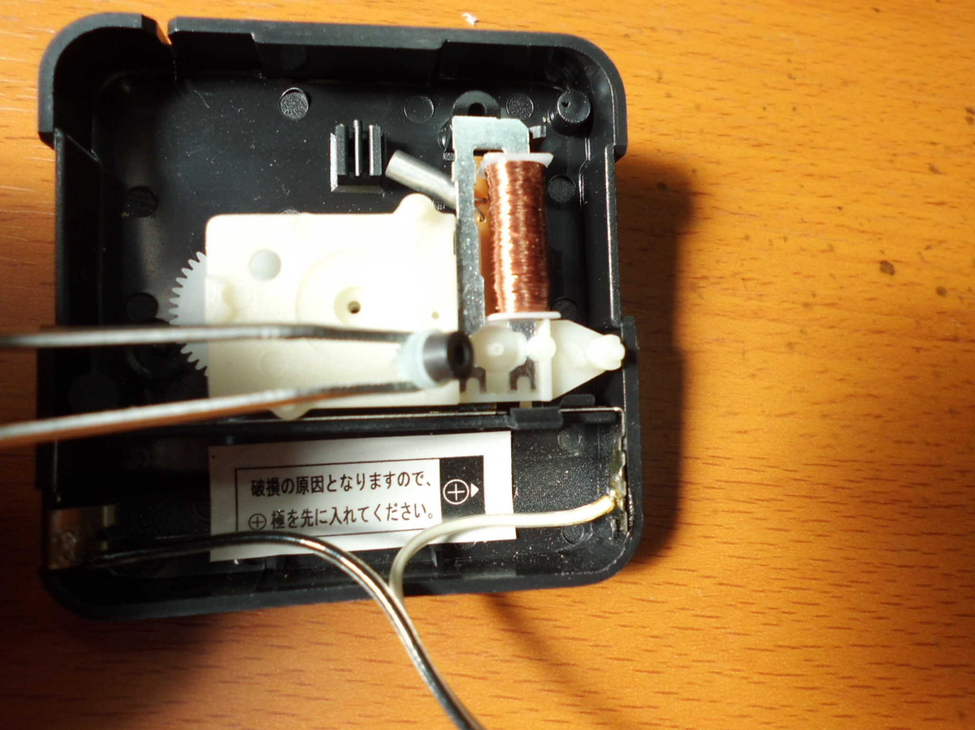

This cog had magnet.
To drive clock, you need cutting module IC's lines and pulling lines from solenoid.
( I re-use battery terminal.)
Some clock structure might be different, but base principle is same.
Tis solenoid' resistor is 130Ω. So current is 11.5mA(1.5V/130Ω).
Series resistor is 150Ω(3.3V/280Ω=11.8mA), because propeller output is 3.3V.

Clock_0.1.f control clock(SingleStepMotor) speed by rotary encorder.
CW direction
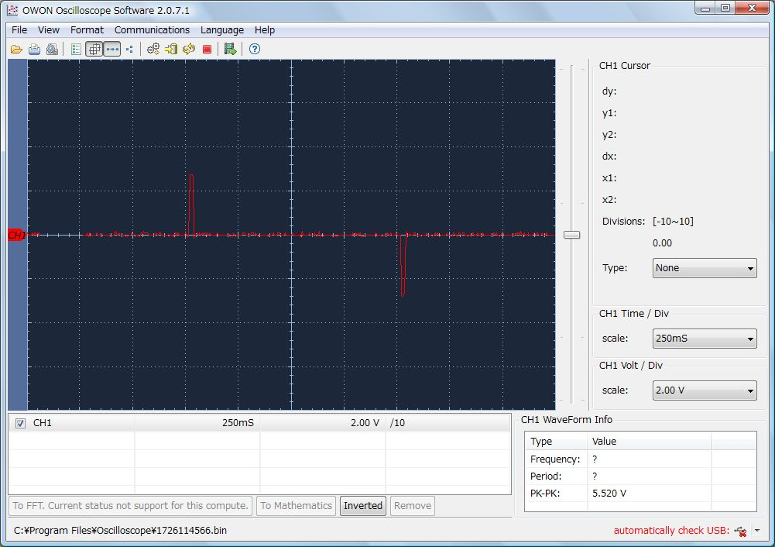
T(Cycle time) is 1second and pulse is alternative.
Clock moved when pulse width is within 10msec to 35msec.
I decided this pulse on 22msec.
Some clock might be different time.
Clock stopped when T(cycle time) shorted to 35msec.
Some clock might be different time.
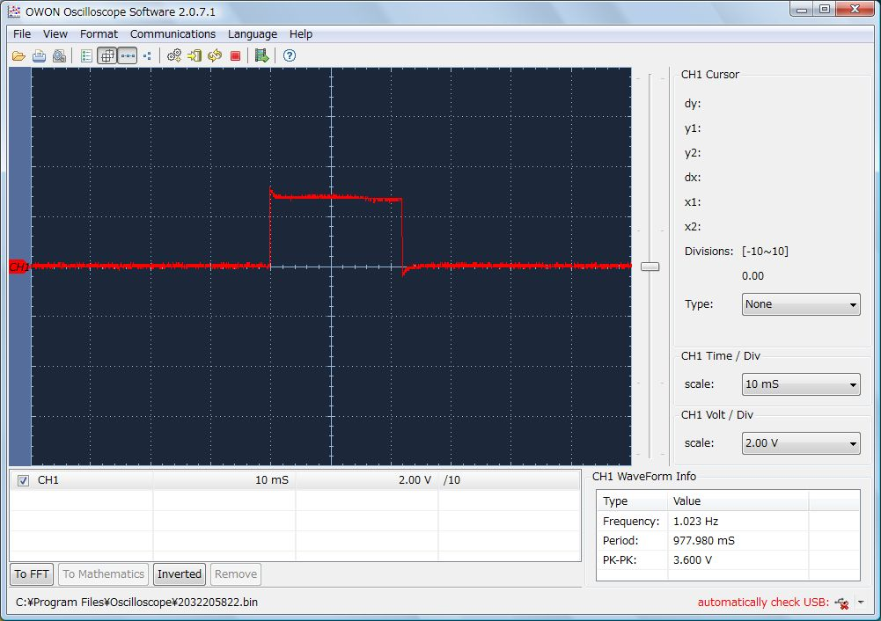
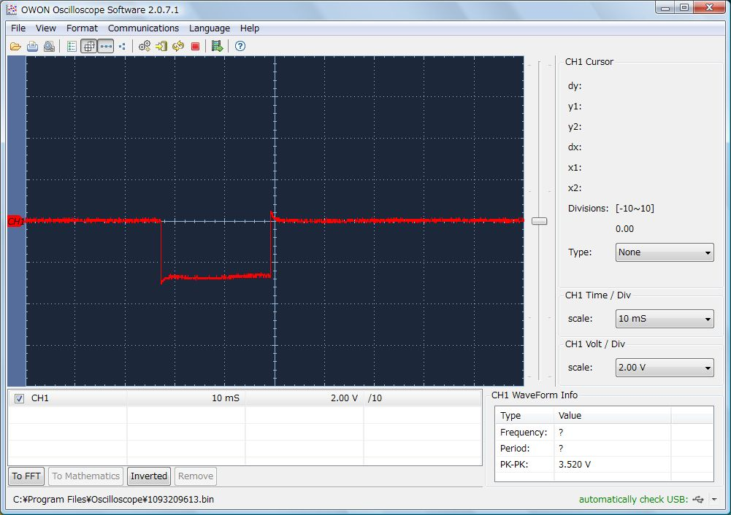

CCW direction
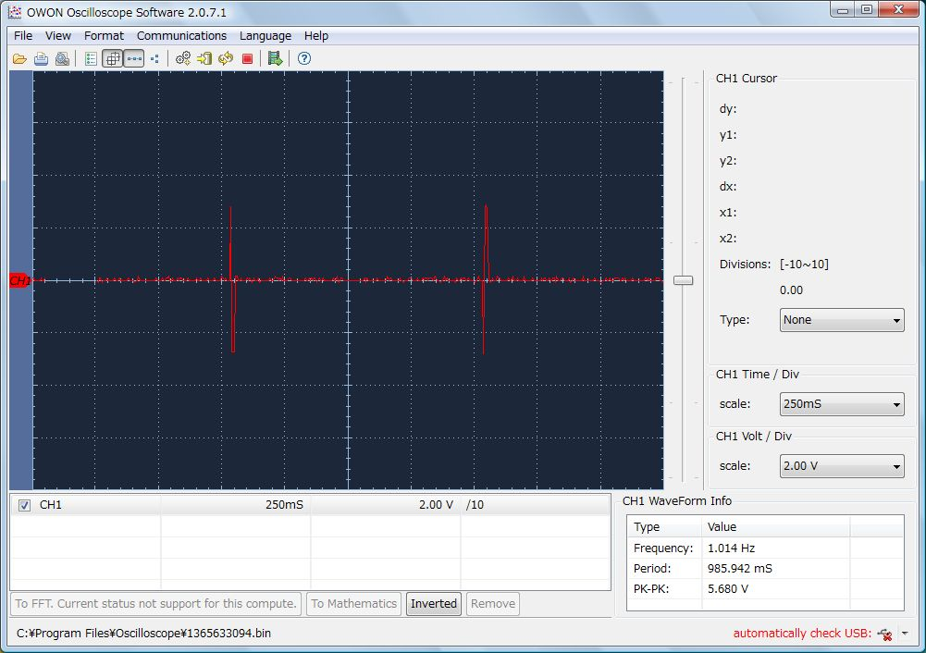
Cycle time is 1second and pulse is alternative same as CW direction.
Clock's SingleStepMotor is designed to rotate to CW direction.
So, rotating to CCW is a little tricky.
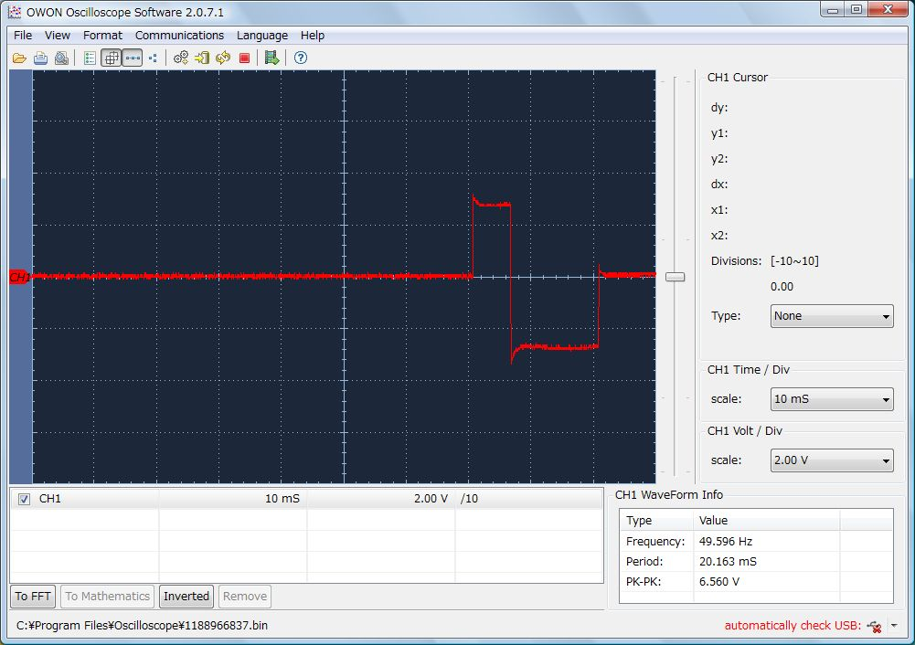
Firstly, short pulseT1( not rotating CW) supply.
Nextly, reverse pulseT2 supply.
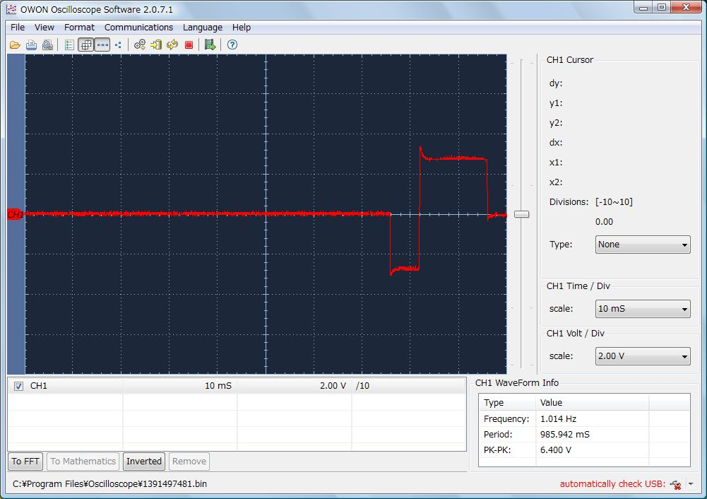
After cycle time, reverse pulses supply.

T1 is 6.5msec. T2 is 14msec.
Best pulse width might need to try many times.

CCW stopped when T(cycle time) shorted to 130msec.
Some clock might be different time.

