PID Exercise

20160204

2_wire_charLCD_0.1.f
PID_Exercize_-0.1.f
PID1 folder include Processing files.

I wrote PID-code to refer site below;
http://brettbeauregard.com/blog/2011/04/improving-the-beginners-pid-introduction/

I think Forth-code is easy. (Not using assembler word)
Important thing is only PID-code.

Procedure

1 Loading 2_wire_charLCD_0.1.f and PID_Exercize_-0.1.f.
Start PID1.pde inside PID1 folder.

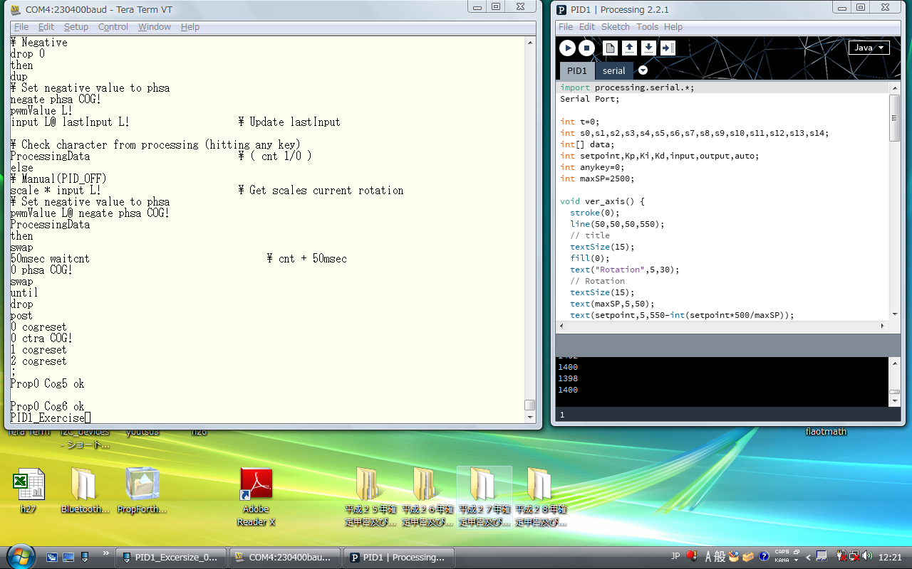
2 Execute PID1_Exercize
Start PID1.pde → Opened Processing-window

3 Click left-button inside Processing-window.

DC-Fan start to rotate.
Rotation-speed drawed inside Processing wibndow.
Default PID-parameters are setpoint:1400,Kp=300,Ki=50,Kd=10.
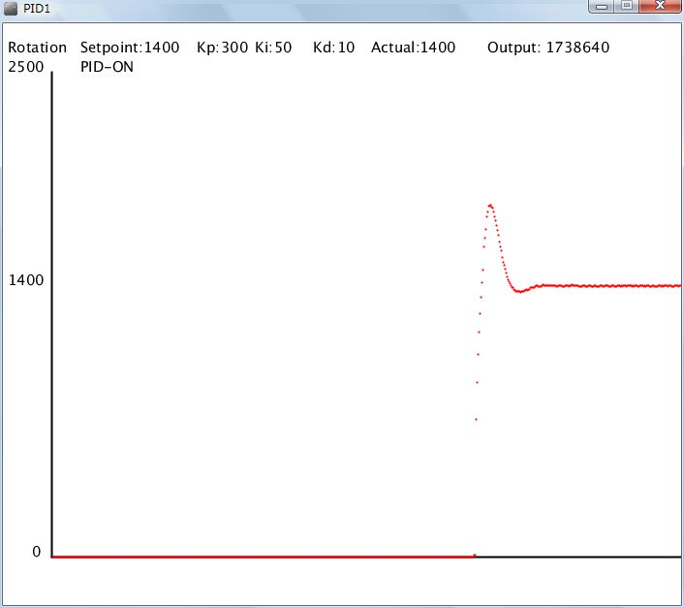
PID-parameters can be chenged by using 12-KeyPad.

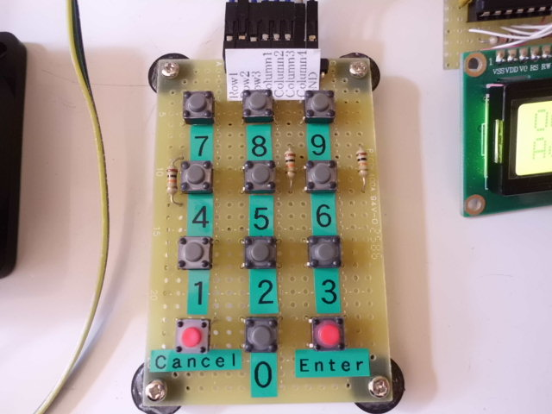
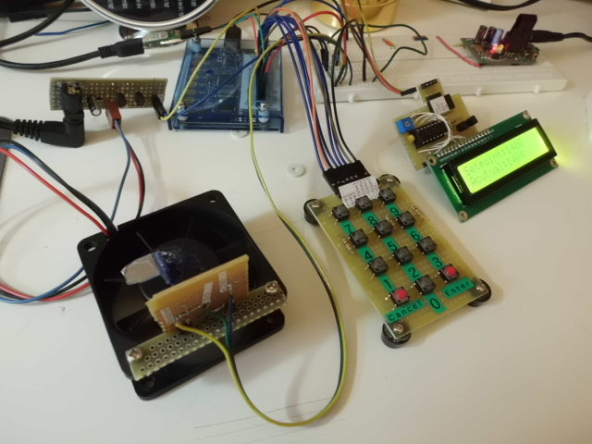

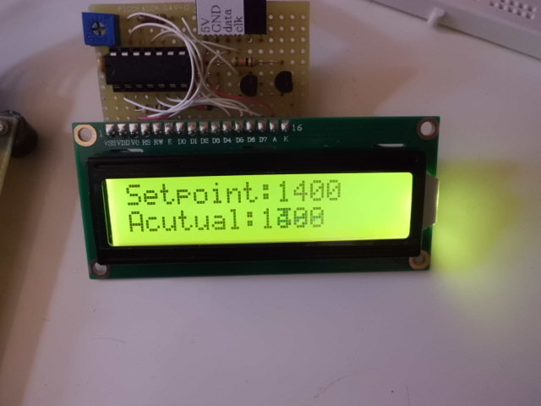
Setpoint is from 0 to 2500
By pushing Enter-key, value is entered

By pushing Cancel-key, next item is displayed.

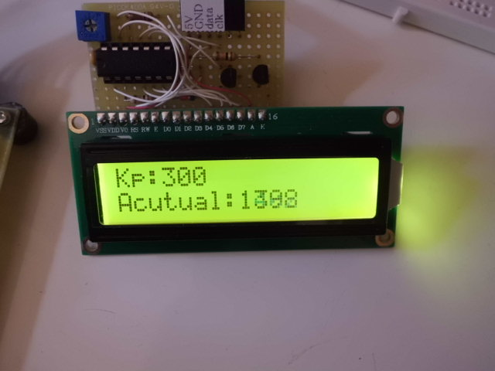

Kp is from 0 to 4095
By pushing Enter-key, value is entered

By pushing Cancel-key, next item is displayed.

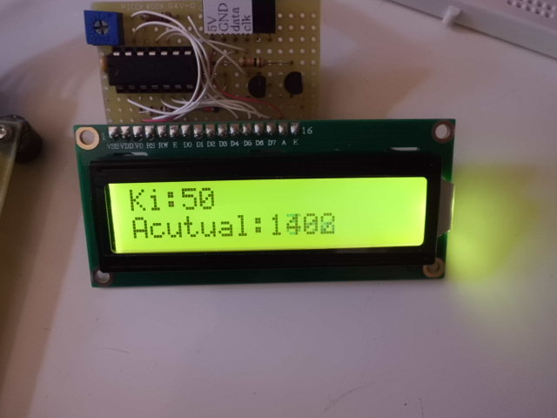

Ki is from 0 to 4095
By pushing Enter-key, value is entered

By pushing Cancel-key, next item is displayed.

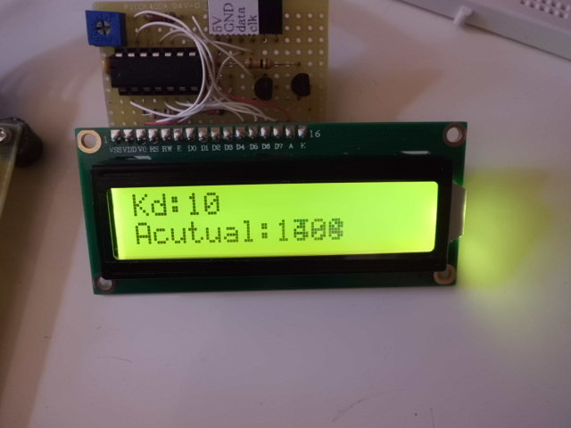
Kd is from 0 to 4095
By pushing Enter-key, value is entered

By pushing Cancel-key, next item is displayed.

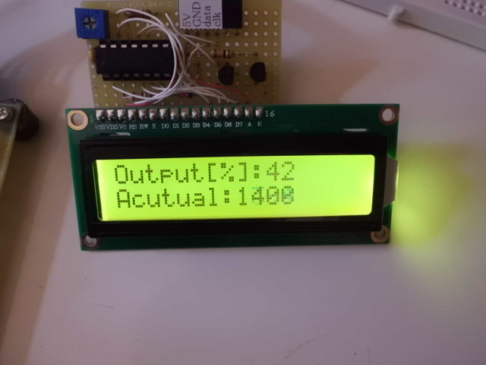
In case of Auto(PID-ON), Output(PWM signal) merely
display.
Output(PWM signal) can be changed under Manual
(PID-OFF).
Value is from 0 to 100.

By pushing Enter-key, value is entered

By pushing Cancel-key, next item is displayed.

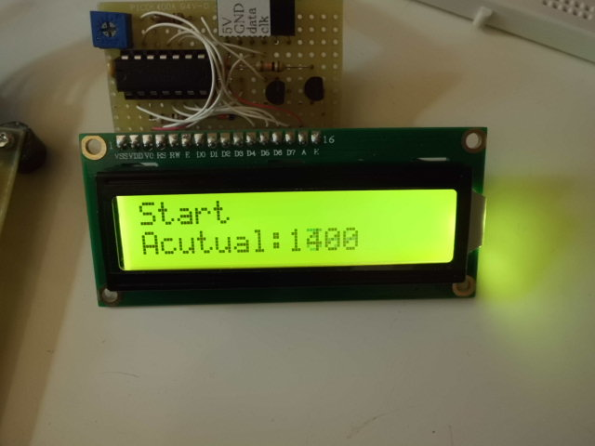
By pushing Enter-key, PID-parameters are adopted.

By pushing Enter-key, value is entered

By pushing Cancel-key, next item is displayed.

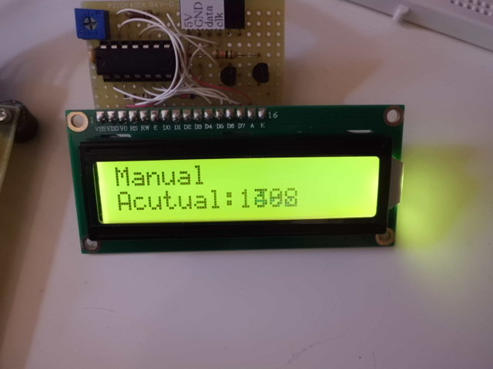

By pushing Enter-key, mode change to “Manual
(PID-OFF)”.
Displaying “AUTO(PID-ON)”.
Alterneting “Manual(PID-OFF)” and “AUTO(PID-ON”)

By pushing Cancel-key, back to “Setpoint”

Changed setpoint to 1000
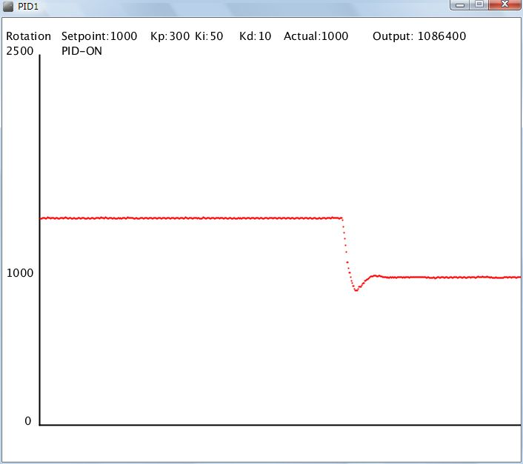

Changed setpoint to 2000
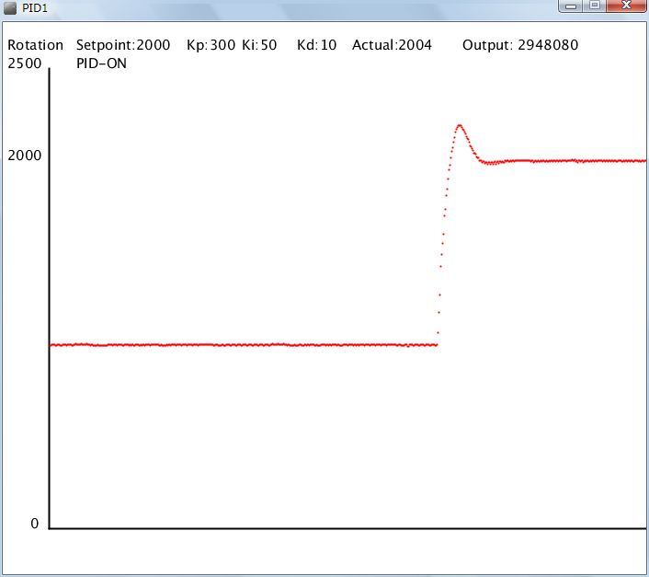

Changed to Manual(PID-OFF)
