Serial Communication

2017 Jan 8

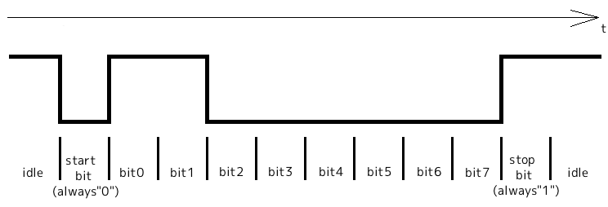
HalfDuplex Serial Communication
[ Startbit:1bit NoParity Stopbit:1bit]

When HalfDuplex-serialcommunication is used on PropForth, it make structure below;
{
half duplex serial structure
00 - 03 -- bitticks
04 - 07 -- rx pin mask
08 - 0B -- tx pin mask
}
\ hdserialStruct X ( baud rxpin txpin -- ) X is structure's name
: hdserialStruct
lockdict variable 8 allot lastnfa nfa>pfa 2+ alignl freedict
tuck swap >m swap 8 + L!
tuck swap >m swap 4 + L!
swap clkfreq swap u/ swap L!
;

0 wconstant Rx
1 wconstant Tx
d19200 constant baud

baud Rx Tx hdserialStruct hd_serial

Defined as {Rx is P0,Tx is P1 and baudrate is 19200bit/sec} by
{baud Rx Tx hdserialStruct serial}.
Name'hd_serial' indicate top address of halfduplex serial structure.

Transmit assembler code
( n1 n2 -- )
entry n1:sending data n2:hdserialStruct's name

Using register inside
$C_treg2:loop counter
$C_treg3:ticks(1bit)

exit none

fl
build_BootOpt :rasm
rdlong __bitticks , $C_stTOS
add $C_stTOS , # 8
rdlong __txmask , $C_stTOS
spop

or $C_stTOS , __stopbit
shl $C_stTOS , # 1

mov $C_treg2 , # d11
mov $C_treg3 , __bitticks
add $C_treg3 , cnt

__txloop
test $C_stTOS , # 1 wz
muxz dira , __txmask
waitcnt $C_treg3 , __bitticks
shr $C_stTOS , # 1
djnz $C_treg2 , # __txloop
spop

andn dira , __txmask
jexit

__bitticks
0
__txmask
0
__stopbit
h300

;asm a_hdserialTx

Receive assembler code
( n1 -- n2 )
entry n1:hdserialStruct's name

Using register inside
$C_treg1:loop counter
$C_treg2:next bit count(1st:1.25bit, 2nd-8th:1bit)

exit n2:receive data

fl
build_BootOpt :rasm
rdlong __bitticks , $C_stTOS
add $C_stTOS , # 4
rdlong __rxmask , $C_stTOS

mov $C_treg1 , # 8
mov $C_stTOS , # 0
mov $C_treg2 , __bitticks
shr $C_treg2 , # 2
add $C_treg2 , __bitticks

\ Wait from hi to lo transition
waitpeq __rxmask , __rxmask
waitpne __rxmask , __rxmask

\ first loop tick count (1.25bit+cnt)
add $C_treg2 , cnt
__rxloop
\ 1bit+cnt
waitcnt $C_treg2 , __bitticks
test __rxmask , ina wz
shr $C_stTOS , # 1
muxnz $C_stTOS , # h80
djnz $C_treg1 , # __rxloop

jexit

__bitticks
0
__rxmask
0

;asm a_hdserialRx

How to use;
Transmit; data hd_serial a_hdserialTx
Data on stack is transmitted to TX-pin.
Receive; hd_serial a_hdserialRx
Receiving data is on stack.

Sample;
ThermalPrinter_0.4.f

Above code use 2pin for Tx and Rx.
Tried to communicate by using only 1pin.
I refered below;
http://nerdralph.blogspot.ca/2014/01/avr-half-duplex-software-uart.html

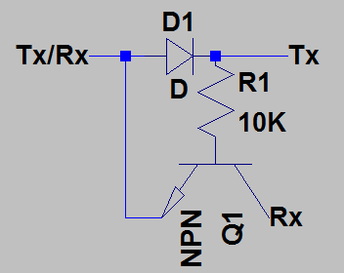

Connected P1 to Tx/Rx.
Conected Tx to printer Tx and Rx to printer Rx

Sample;
ThermalPrinter_0.5.f

Fullduplex Communication between PropForth and Processing

Requrired material;
Processing2.2.1
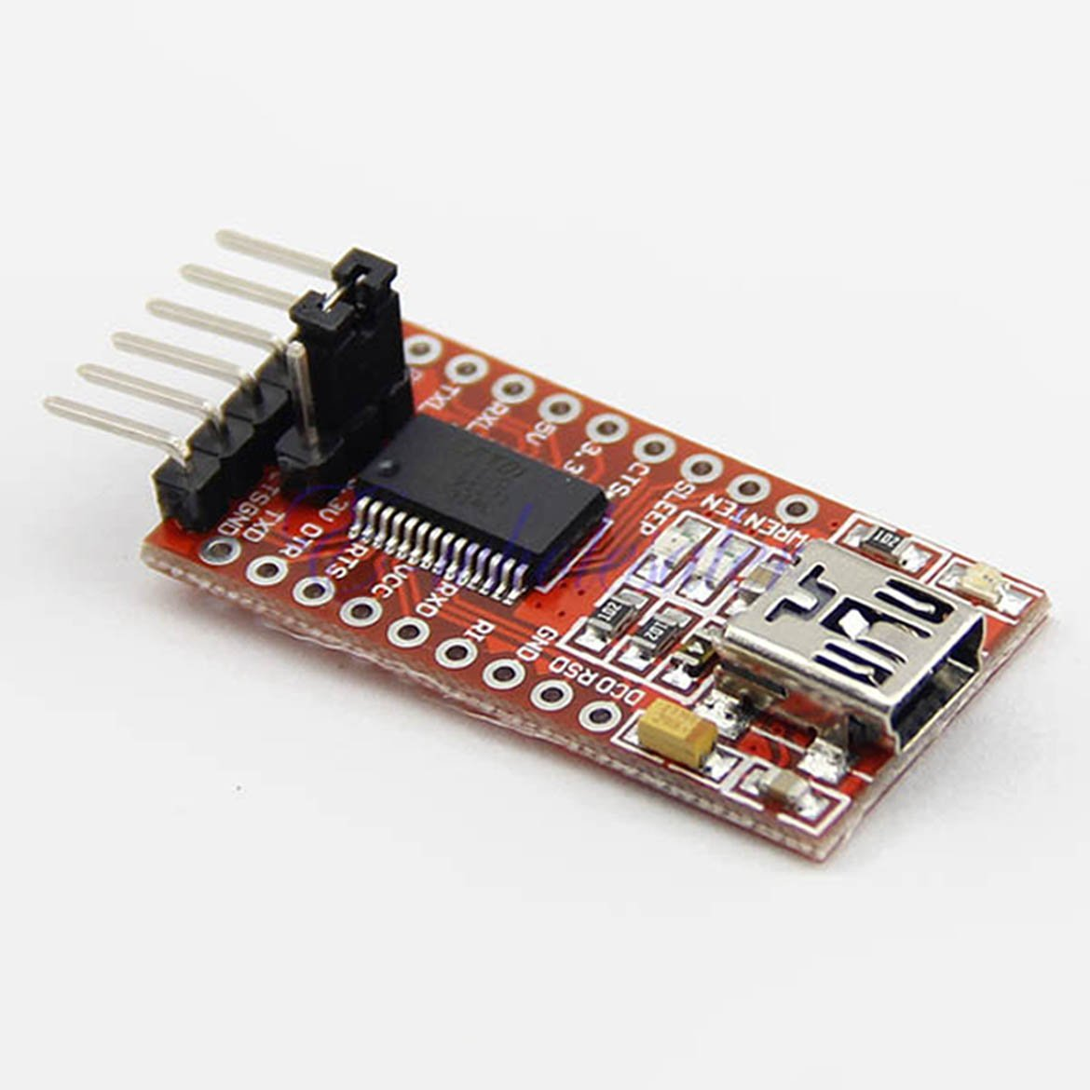
USB-Serial convert tool
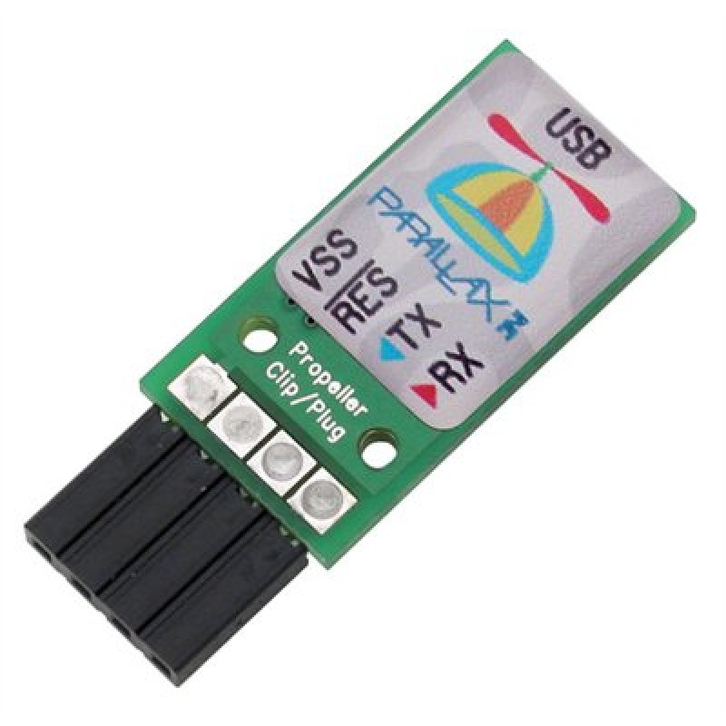

or

Fullduplex communication use word”serial”.
But this must re-define because this has bug.
: serial
4*
clkfreq swap u/ dup 2/ 2/
\
\ serial structure
\
\
\ init 1st 4 members to hFF
\
hFF h1C2
2dup COG!
1+ 2dup COG!
1+ 2dup COG!
1+ tuck COG!
\
\ next 2 members to h100
\
1+ h100 swap 2dup COG!
1+ tuck COG!
\
\ bittick/4, bitticks
\
1+ tuck COG!
1+ tuck COG!
\
\ rxmask txmask
\
1+ swap >m over COG!
1+ swap >m over COG!
\ rest of structure to 0
1+ h1F0 swap
do
0 i COG!
loop
\
c" SERIAL" numpad ccopy numpad cds W!
4 state andnC!
\ 0 io hC4 + L! <-- always “0 cogn sersetbreak” (driver don't transmit a breaklength
minimumlength is 16 cycle, at 80MHz this is 200 nanoseconds
\ 0 io hC8 + L! <-- always “0 cogn sersetflag” (CR[d13] is transmitted as CR [d13]LF [d10])
_serial
;
Only 2 lines need to comment or delete.

2016.8.21
I found mistakes in above.
Word”serial” set “0 cogn sersetbreak”and “0 cogn sersetflag” as default setting.
If you want to set different, you should set “1 cogn sersetbreak” or “1 cogn sersetflag”.

To connect to Processing, Cog5 start up “serial”.
This manipulate input pointer and output-pointer to connect Cog6 to Cog5.
Please read section6.2 in PropForth.html about these pointer.

IO for propforth is done via an io channel. An io channel is a long which is treated
as 2 words. The io channel which connects to the interpreter is at the beginning
of the cog data area. It is defined as io. Any cogs io is defined as n cogio.

The structure of the long is 2 words as follows:
io (word) - this is the input, if the h0100 bit is set, it means the interpreter is ready
to accept input. To send a byte to the input write h00cc,
where cc is the byte value. This word is used by key? and key
io + 2 (word) - this is a pointer to the where the output of the channel goes
This word is used by emit? and emit.
If this word is 0, the ouput destination is not valid and emit will simply
"throw away the output. If it is not zero, it is assumed to be a pointer to
an io channel. Thus the output of an io channel always points to the
input of another io channel.

Sample code:Forth_Processing_0.1.f
Word”pre” must be executed before connecting cog6 to cog5.
Output of cog5 is changed to inchar.
Output of cog6 is changed to input of cog5

Word”prost” must be back output and input for cog6 and cog5.
Output of cog5 is back to original.
Output of cog6 is back to input of cog7.

Before word”pre”;
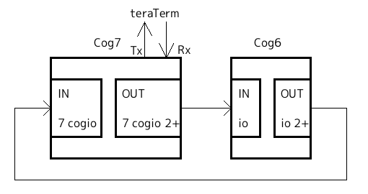
After word”pre”;
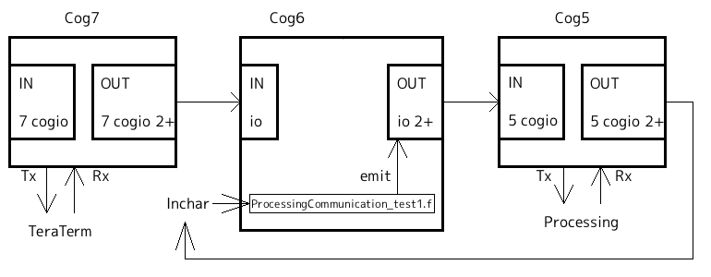
Cog7(serial)'s output still connect to Cog6's input.
If you type any key from TeraTerm, there are in cog6's input buffer.
After executing word”post”, there are something in stack of cog6.

I don't think this is big problem.
But if you dislike this, please modify these code(“pre” and “post”).

Sample code:ProcessingCommunication_test1.f

word”test1”;
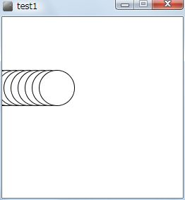
1. Firstly start "test1" on Processing
2. Start “test1”on PropForth
3. Circle moving from left to right

PropForth'test1” merely send data.
Processing”test1” merely receive data.

This check communication from PropForth to Processing.

word”test2”;

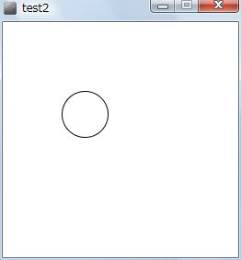
1. Start "test2" on Processing
2. Start “test2”on PropForth
3. Clicking mouse on Processing”test2”window
4. Circle moving from left to right

This check communication between PropForth and Processing .

When clicking mouse on Processing”test2”window, Processing send d65 to PropForth.
When PropForth receiving d65, it send data.

word”test3”;

1. Start "test3" on Processing
2. Start “test3”on PropForth
3. Clicking mouse on Processing”test3”window
4. Circle moving from left to right
5. Hitting any key on Processing”test3”window, PropForth”test3” stop

When clicking mouse on Processing”test2”window, Processing send d65 to PropForth.
When PropForth”test3” receiving d65, it send data.
When hitting any key on Processing”test3”, it send d66 to PropForth and PropForth”test3” stop.

word”test4”;
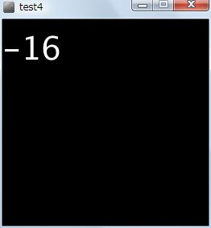
1. Start "test4" on Processing
2. Start “test4”on PropForth
3. Clicking mouse on Processing”test4”window
4. Repeat counting n Processing”test4”window
5. Hitting any key on Processing”test4”window, it stop.
6. After a while, PropForth”test4” also stop.

When clicking mouse on Processing”test4”window, Processing send d65 to PropForth.
When PropForth”test4” receiving d65, it send data.
When hitting any key on Processing”test4”, it send d66 to PropForth.
Processing”test4 stop.
PropForth”test4” also stop after a while.

Another solution

There is how to use directly io-ports because the above(pre and post) is Troublesome.

: initSerial
c” Tx Rx baud serial” 5 cogx \ Start serial on cog5
d100 delms
inchar 5 cogio 2+ W! \ Set output of cog5 to inchar
h100 inchar W! \ Clear inchar
1 4 sersetflags
;

: stopSerial 0 5 cogio 2+ W! 5 cogreset ;

\ ( n1 – n2 ) n1:repeat number n2:last addres+1 of free area
: receive
here W@
0 do
begin inchar W@ h100 and 0= until \ Wait until output for serial-cog is under ready-state
inchara W@ over C! \ Save output-data of cog5 to free area
h100 inchar W! \ Clear inchar
1+ \ Increment free space address
loop
;

\ ( n1 -- ) n1:trasmitting byte
: transmit
begin 5 cogio W@ h100 and until \ Wait until input for serial-cog is under ready-state
5 cogio W! \ Write data to cog5's input
;
There are data in free area[here W@] on receivement.
Data cannot receive when baud-rate is too fast.

Prop0 Cog6 ok
cog?
Cog:0 #io chan:1 PropForth v5.5 2013Feb20 11:30 0
Cog:1 #io chan:1 PropForth v5.5 2013Feb20 11:30 0
Cog:2 #io chan:1 PropForth v5.5 2013Feb20 11:30 0
Cog:3 #io chan:1 PropForth v5.5 2013Feb20 11:30 0
Cog:4 #io chan:1 PropForth v5.5 2013Feb20 11:30 0
Cog:5 #io chan:1 SERIAL 5(0)->X(X)
Cog:6 #io chan:1 PropForth v5.5 2013Feb20 11:30 0 6(0)->7(0)
Cog:7 #io chan:1 SERIAL 7(0)->6(0)
Prop0 Cog6 ok
Sample is ThermalPrinter_0.6.f.

