CharacterLCD

20160130

CharacterLCD generally use HD44780 compatible products.
This use 6 wires[RS,E,DB4-DB7] for signals on 4bit mode.
Adding power line, needing wires are 8!!.
I have used breadboard at test.
I often have been wrong connections.
So, I wanted to reduce connected wires.
I wanted to make reduced wire characterLCD by using normal characterLCD.

2_wire_LCD
Reference: 2_wire_chaLCD_0.1.f
This convert data from serial to parallel by using shift-regisre(74HC164).

Operation:
Firstly it make 7bit data by forth word.
bit6:Enable bit5:LED-(always'0') bit4:RS bit3:DB7 bit2:DB6 bit1:DB5 bit0:DB4

Secondly 8bit data is sent to shift-register by assemler-word'a_shift_data'.
bit7:Enable bit6:LED- bit5:RS bit4:DB7 bit3:DB6 bit2:DB5 bit1:DB4 bit0:'0'
This use 4bit control mode.

Signal diagram is below;
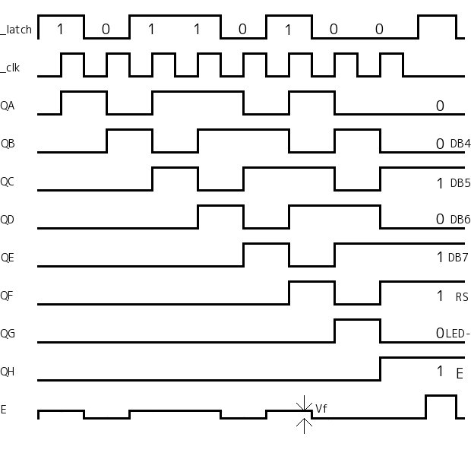
_data

Enable signal on characterLCD is cripped by diode while QH for shift-register is low.
After QH for shift-register reach to hi, data is written to characterLCD by Hi-pulse on _data.
Hi-pulse is entered to E on characterLCD because diode is off.

And then signal on shift-register are shifted out by assembler-word'a_clk_out'.

'demo1' display characters[h20 – h7F].
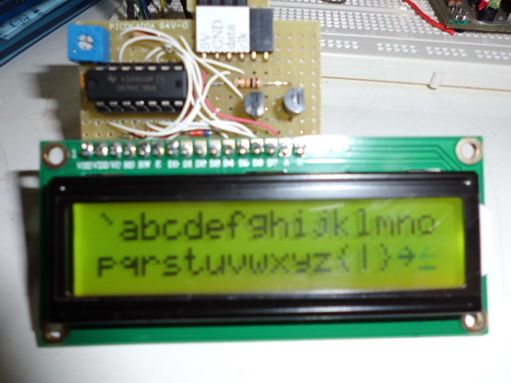
'demo2' look like moving wave.
It takes 1783msec.
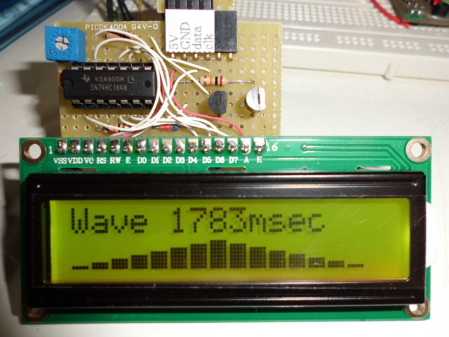

Caution;
From 74HC164 datasheet, VIH is min3.49V at Vcc=5V(min3.15V at Vcc=4.5V).
It doesn't satisfy VIH for 74HC164 because Propeller's VOH is min2.85V(actualy 3.3V).
There is no problem although direct conncting between Propeller's output and 74HC164.
But level-shift might be needed on safety operation.

Port curcuit diagram of HD44780 is below;
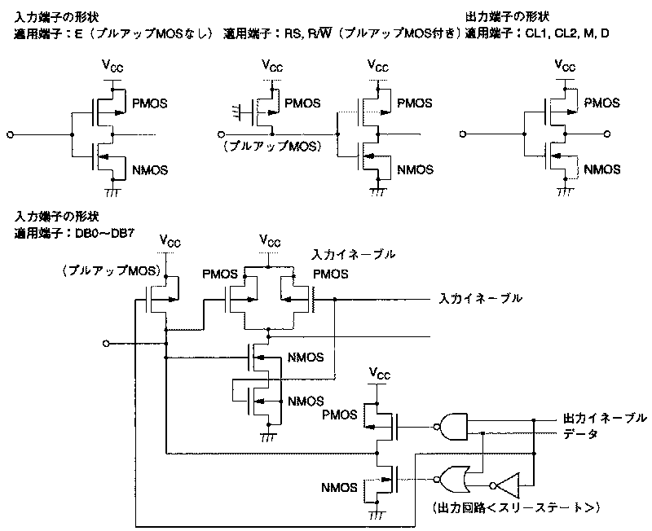
Reference:Page54 in HD44780.pdf

Ports for E,RS and DB0-DB7 are pulled up by FET(pull-up resister).
Sending data to characterLCD need small time.
CharacterLCD merely display much time.
If ports to E,RS and DB0-DB7 is low, current continue to flow.
So after sending data to characterLCD, ports are set to Hi.
It's h1F. [Bit4:RS bit3:DB7 bit2:DB6 bit1:DB5 bit0:DB4]

2_wire_charLCD_0.1.f
: lcd_com
reset_sr
dup h100 and if RS else 0 then \ RS bit
swap 2dup \ ( 10/0 n 10/0 n )
\ upper 4bit
4 rshift hF and or E or \ Add RS-bit and Enable-bit
shift_out
lcd_enable
reset_sr

\ lower 4bit \ ( 10/0 n )
hF and or E or \ Add RS-bit and Enable-bit
shift_out
lcd_enable
reset_sr

\ Set RS and DB4-DB7 to Hi, and Set LED- to hi if sleep is on
h1F
sleep_on W@
if LED- or then
shift_out
;

2_wire_charLCD is fast to display.
But it is meaningless although characterLCD don't need to change rapidly.
2_wire_charLCD curcuit is also simple.

