Exercise 1: Audience

This example looks at how writing is tailored to different audiences, using the recent discovery of gravity waves as an example. This was reported in all levels of media, and below are five examples of how one element of the experiment, the interferometer, was described for different audiences.

Read the examples, and associate the example with the right reference and audience. Think about what signifies a text is written for a particular audience. Don’t Google!

The references are:

1) Specialist physics audience (Abbott et al., Phys. Rev. D 95, 062003 (2017))

2) Semi-specialist physics audience (from the paper, Abbott et al, PRL 116, 061102 (2016)))

3) General physics audience (Physics Today 69, 4, 14 (2016))

4) General science audience (from [Science](http://www.sciencemag.org/news/2016/02/gravitational-waves-einstein-s-ripples-spacetime-spotted-first-time))

5) general public (from [The New York Times](https://www.nytimes.com/2016/02/12/science/ligo-gravitational-waves-black-holes-einstein.html))

**Example A**

“LIGO watches for a minuscule stretching of space with what amounts to ultraprecise rulers: two L-shaped contraptions called interferometers with arms 4 kilometers long. Mirrors at the ends of each arm form a long “resonant cavity,” in which laser light of a precise wavelength bounces back and forth, resonating just as sound of a specific pitch rings in an organ pipe. Where the arms meet, the two beams can overlap. If they have traveled different distances along the arms, their waves will wind up out of step and interfere with each other. That will cause some of the light to warble out through an exit called a dark port in synchrony with undulations of the wave.” 4)

**Example B**

These detectors, H1 located on the Hanford Reservation in Richland, Washington, and L1 located in Livingston Parish, Louisiana, are laser interferometers [2] that use four mirrors (referred to as test masses) suspended from multi-stage pendulums to form two perpendicular optical cavities (arms) in a modified Michelson configuration, as shown in Fig. 1. GW strain causes apparent differential variations of the arm lengths which generate power fluctuations in the interferometer’s GW readout port. These power fluctuations, measured by photodiodes, serve as both the GW readout signal and an error signal for controlling the differential arm length [3]. Feedback control of the differential arm length degree of freedom (along with the interferometer’s other length and angular degrees of freedom) is required for stable operation of the instrument. This control is achieved by taking a digitized version of the GW readout signal derr(f), applying a set of digital filters to produce a control signal dctrl(f), then sending the control signal to the test mass actuator systems which displace the mirrors. 2) – actually is 1)

**Example C**

“LIGO’s antennas are L-shaped, with perpendicular arms 2.5 miles long. Inside each arm, cocooned in layers of steel and concrete, runs the world’s largest bottle of nothing, a vacuum chamber a couple of feet wide containing 2.5 million gallons of empty space. At the end of each arm are mirrors hanging by glass threads, isolated from the bumps and shrieks of the environment better than any Rolls-Royce ever conceived. Thus coddled, the lasers in the present incarnation, known as Advanced LIGO, can detect changes in the length of one of those arms as small as one ten-thousandth the diameter of a proton — a subatomic particle too small to be seen by even the most powerful microscopes — as a gravitational wave sweeps through.” 5)

**Example D**

“To achieve sufficient sensitivity to measure gravitational waves, the detectors include several enhancements to the basic Michelson interferometer. First, each arm contains a resonant optical cavity, formed by its two test mass mirrors, that multiplies the effect of a gravitational wave on the light phase by a factor of 300 [48]. Second, a partially transmissive power-recycling mirror at the input provides additional resonant buildup of the laser light in the interferometer as a whole [49,50]: 20 W of laser input is increased to 700 W incident on the beam splitter, which is further increased to 100 kW circulating in each arm cavity. Third, a partially transmissive signal-recycling mirror at the output optimizes the gravitational-wave signal extraction by broadening the bandwidth of the arm cavities [51,52]. The interferometer is illuminated with a 1064-nm wavelength Nd:YAG laser, stabilized in amplitude, frequency, and beam geometry [53,54]. The gravitational-wave signal is extracted at the output port using a homodyne readout [55].” 1) – actually is 2)

**Example E**

“The observed strain, a mere 10−21, implies that the length changes in LIGO’s arms were 1/1000 the radius of an atomic nucleus. At face value, that’s an impossibly small value to measure. LIGO’s solution is to turn each arm into a resonant optical cavity (see figure [2](http://physicstoday.scitation.org/doi/10.1063/PT.3.3123?journalCode=pto&showFTTab=true&containerItemId=content%2Faip%2Fmagazine%2Fphysicstoday%2Fissues" \o "Open Figure Viewer)). Light injected into the cavities bounces back and forth hundreds of times before recombining. In effect, the cavity increases the light’s path length from 4 km to more than 1000 km. The attometer-size length change in the arms thus becomes a more manageable, although still impressive, femtometer-size difference in the light’s path length.” 3)

Exercise 2: Story

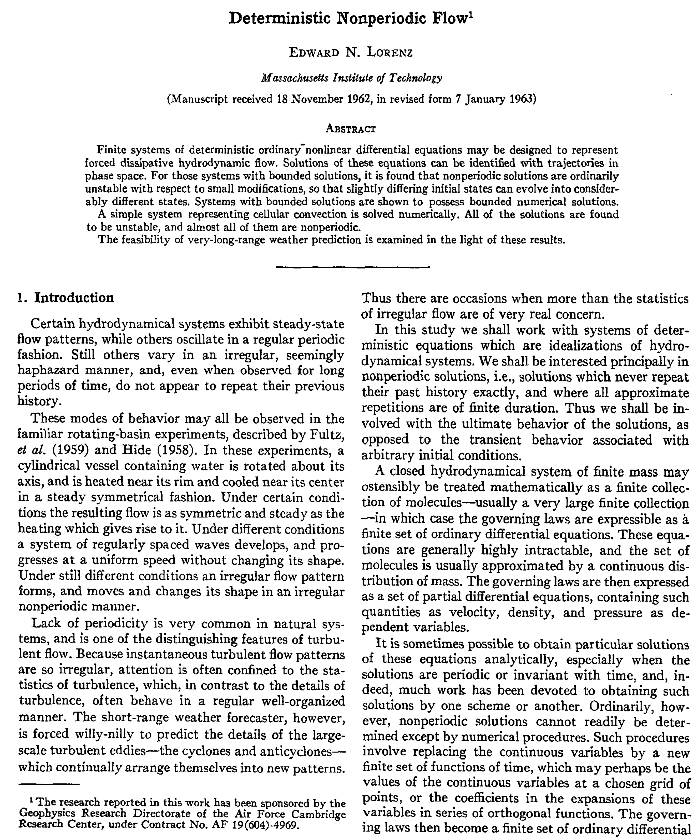

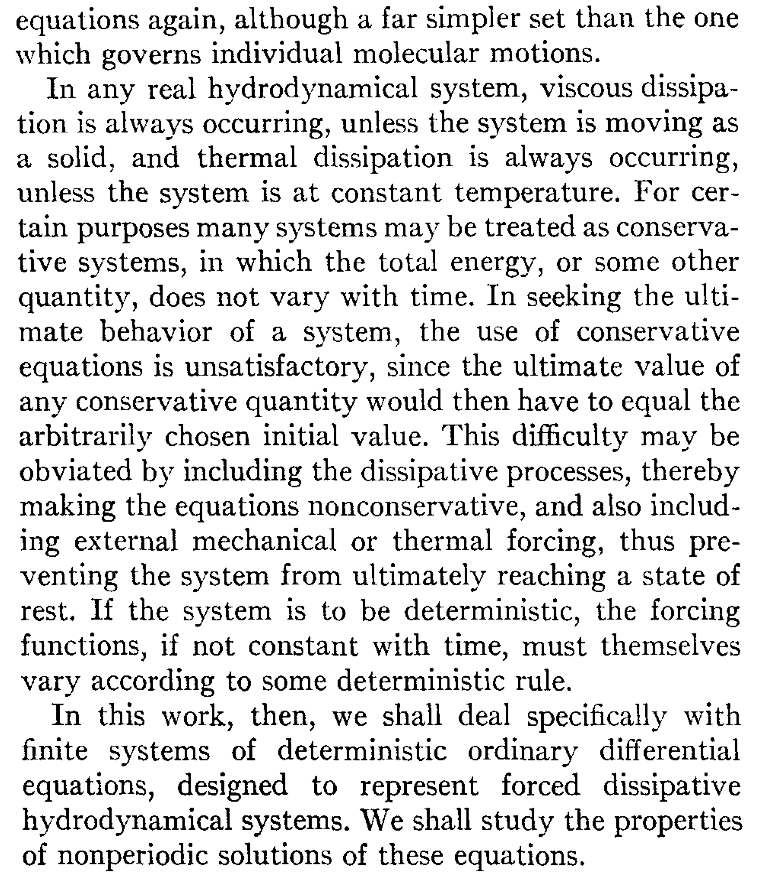

Exercise 4: Paragraph structure

The paragraph below is an example of how *not* to structure your writing. It is the first paragraph of the introduction to a paper, and describes the reason for the experiment done. Try to identify the main idea of the paragraph, and think about why the paragraph is hard to read. Then, read the rewritten version.

**Original text (230 words)**

Calcium fluoride is a cubic material. Rare-earth ions were known to occupy different sites due to charge compensation. Hamers *et al.*1 identified five different sites in CaF2 :Eu3+ 0.1% whose 7F0→5D0 absorption wavelengths fall at 579 0.6 nm. High-resolution spectral studies were also performed on these materials by the hole-burning technique. Hole-burning studies of the tetragonal site2 and oxygen-compensated trigonal site were performed in the past.3 – 5 Hole burning was also pursued in several other europium-doped crystals and glasses.6 – 10 The 5D0 and 7F0 states of Eu3+ are singlets in the crystal field. A transition between these two states is expected to reveal a single peak either in absorption or emission, in defect free perfect crystals. A recent investigation11 on the 7F0→5D0 transition of Eu3+ doped Y2SiO5 revealed more than 40 different satellite lines for the dopant though the prior studies revealed only two sites.12 Similar observations were made in EuVO413 and YAlO3:Eu3 14 also. The satellite lines were ascribed to ions that were on the sites differently perturbed, by defects or clustering of Eu3+ ions. It is not clear yet whether this multisite behavior is universal or dependent on the host material. So, we reinvestigated the high-resolution spectroscopy and hole-burning phenomena in CaF2 :Eu3 . Our studies revealed more than 40 different sites for the Eu3+ ion whose transition wavelengths (7F0→5D0) fall within 1 nm centered around 579.5 nm.

**Edited text (167 words)**

Rare earth dopant ions normally exist in crystals as substitutional defects. The number of substitutional sites the dopant occupies in the crystal can be determined from the number of lines in the optical spectrum of the dopant ion. For this purpose, the 7F0-5D0 transition of Eu3+ is particularly useful, since both levels are singlets and so each site gives rise to only a single peak in the emission or absorption spectrum.

Recent measurements in Eu:Y2SiO5[1], EuVO4 [2], and Eu:YAlO3[3], found many more sites than previously seen. In Eu:Y2SiO5, for example, two sites were expected but over forty sites were observed. The extra lines were ascribed to ions in either perturbed sites, or in Eu3+ clusters.

In this study, we revisit Eu3+ :CaF2, in which five sites have previously been seen [4], to determine whether the same perturbed and cluster sites are present. Using high resolution and holeburning spectroscopy, we find over forty different Eu sites with wavelengths for the 7F0-5D0 transition within 1 nm of 579.5 nm.