BRNO UNIVERSITY OF TECHNOLOGY
VYSOKÉ UČENÍ TECHNICKÉ V BRNĚ

FACULTY OF INFORMATION TECHNOLOGY
FAKULTA INFORMAČNÍCH TECHNOLOGIÍ

Advanced Database Systems (PDBe)

PROJET TITLE

GeoBook – A Location-Based Book Insight Application.

AUTHOR Samantha Suraweera

AUTOR PRÁCE Showkat Ali

SUPERVISOR RNDr. Marek Rychlý, Ph.D.
VEDOUCÍ PRÁCE

BRNO 2025

ABSTRACT
This project presents GeoBook, a location-based book insight application designed to enhance the reading experience by connecting narrative elements to real-world geographical locations. The system integrates a spatially-enabled Oracle database, a RESTful backend, and an interactive web-based frontend. GeoBook allows users to search for books, explore chapters, and view corresponding real-world locations on an interactive map, and access multimedia linked to those locations. The project demonstrates the use of advanced database concepts including spatial data modeling, spatial indexing, and geospatial queries through Oracle’s SDO_GEOMETRY type.
The system fulfills all functional and non-functional requirements defined in the proposal and represents a complete end-to-end application combining modern software engineering practices with advanced database capabilities.

1. INTRODUCTION
Books frequently reference real-world locations to build rich narrative worlds. However, traditional reading methods do not provide direct links between textual descriptions and the actual geographical places mentioned. This creates an opportunity to enhance the reading experience by visually connecting story locations to a map-based representation.
The GeoBook application addresses this by enabling readers to:
- browse books and chapters,
- explore real-world locations mentioned within the text,
- view multimedia content associated with these locations,
- understand the geographical context of the story,
- And interact with the data through a modern web interface.
This project was developed as part of the Advanced Database Systems (PDBe) course at the Faculty of Information Technology, Brno University of Technology. The primary aim was to design and implement an application that uses advanced database features—especially spatial data—while following software engineering best practices.
The resulting system integrates:
- A spatial Oracle database
- Spring Boot backend
- Web-based frontend with map functionality
- Multimedia storage
- Search and filtering capabilities
The integration of these components results in a complete system demonstrating both theoretical and practical aspects of advanced database design and application development.

2. PROBLEM STATEMENT
Readers lack a convenient way to visualize and interact with real-world locations mentioned in books. Searching for these locations manually is time-consuming and breaks the reading flow. Furthermore, existing book applications rarely offer enhanced contextual features, such as multimedia or geographical visualizations, related to story locations.
The problem addressed in this project is:
How to create a system that stores, manages, and visually presents spatial and multimedia data related to book content?
Key challenges:
- Storing spatial data in a structured and efficient way
- Representing point-based locations on an interactive map
- Allowing users to search for books and locations
- Associating multimedia content with spatial points
- Building an accessible and intuitive interface
GeoBook provides a solution by combining a spatial database with a user-friendly mapping interface.

3. OBJECTIVES
The main objectives of the project are:

Functional Objectives
- Store book metadata, chapters, locations, and multimedia.
- Represent real-world locations using geospatial coordinates.
- Enable users to view and explore these locations on an interactive map.
- Provide a search function for books and locations.
- Display multimedia associated with specific locations.

Technical Objectives
- Use Oracle Database with spatial extensions.
- Implement geospatial queries with SDO_GEOMETRY.
- Create a REST API backend using Spring Boot.
- Develop a web-based frontend using HTML, CSS, JavaScript, and Leaflet.
- Ensure proper data modeling and schema design.

4. SOFTWARE REQUIREMENTS SPECIFICATION

4.1 Functional Requirements

FR1 – Book Management
The system must store book details such as title, author, and ISBN.

FR2 – Chapter Management
Chapters must include chapter number, title, and related locations.

FR3 – Location Visualization
Real-world locations must be stored with GPS coordinates and displayed as pins on a map.

FR4 – Multimedia Integration
Each location may include optional multimedia (images, descriptions).

FR5 – Search
Users must be able to search for:
- Books
- Chapters
- Locations

FR6 – Web Interface
Application must run in a browser and allow interactive browsing.

4.2 Non-Functional Requirements

NFR1 – Usability
Interface must be intuitive and easy to navigate.

NFR2 – Performance
Spatial queries should retrieve data efficiently.

NFR3 – Scalability
Database should support multiple books, chapters, and many locations.

NFR4 – Maintainability
Project should follow clean architecture and good coding practices.

NFR5 – Reliability
Application should function consistently without failure.

5. DATABASE SPECIFICATION

5.1 Database Overview
The database consists of four main entities:
- Books
- Chapters
- Locations (spatial)
- Multimedia
These entities form a hierarchy:
Book → Chapters → Locations → Multimedia

5.2 Logical Model (ERD)

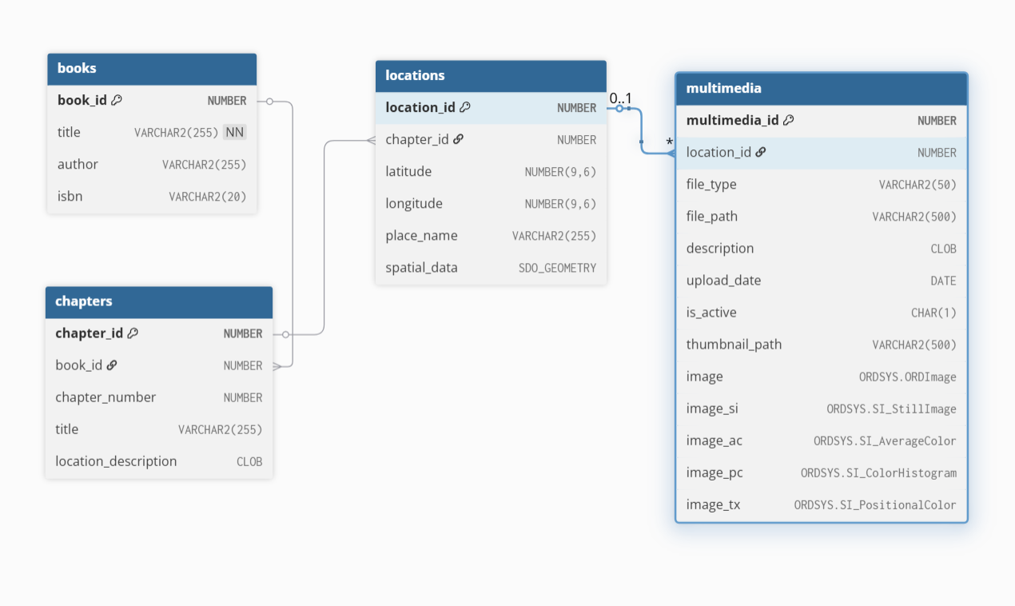

5.3 Spatial Data Representation
Locations use Oracle's SDO_GEOMETRY structure:
SDO_GEOMETRY(
2001, -- 2D point
8307, -- WGS84 coordinate system
SDO_POINT_TYPE(longitude, latitude, NULL),
NULL,
NULL
)
Spatial queries such as SDO_WITHIN_DISTANCE are used to find nearby locations.

6. SYSTEM ARCHITECTURE

6.1 Architecture Layers

1. Client (Frontend)
- HTML, CSS, JavaScript
- Leaflet.js for map rendering
- AJAX calls to backend

2. Application Layer (Backend)
- Spring Boot
- REST controllers
- Service layer for business logic

3. Database Layer
- Oracle 19c+
- Tables with spatial and multimedia data
- Spatial indexing

6.2 REST API Structure
Endpoint | Description
GET /api/books | List all books
GET /api/books?q= | Search books
GET /api/books/{id}/locations | Get locations for a book
GET /api/locations/search?q= | Search locations

7. IMPLEMENTATION

7.1 Backend Implementation
The backend was implemented using:
- Spring Boot
- Controllers
- Repositories (JPA)
- Entities for each table
It handles:
- Data validation
- Querying the Oracle database
- Serving JSON responses

7.2 Frontend Implementation
The frontend includes:
- Map interface (Leaflet.js)
- Search bar
- Dynamic pin placement
- Popup multimedia viewer

7.3 Database Implementation
Oracle database includes:
- Schema creation
- Sample demonstration data
- Spatial columns
- Indexing

8. TESTING & EVALUATION

8.1 Testing Methods
- UI testing for interaction and rendering
- Database testing for spatial accuracy
- Functional testing of search and multimedia features

8.2 Results
All core functions work as expected:
- Books load correctly
- Locations display on the map
- Popups show multimedia
- Spatial queries work accurately

9. LIMITATIONS
- No automatic book text extraction (location data is manual)
- Multimedia uploads are limited to images
- Only point geometry is supported (no polygons or regions)

10. FUTURE WORK
Improvement opportunities:
- Automated NLP-based location extraction from text
- User accounts and personalization
- Support for 3D visualization
- Full mobile application
- Heatmaps and advanced GIS visualizations

11. CONCLUSION
The GeoBook project successfully implements a complete spatial application integrating database, backend, and frontend layers. It demonstrates the use of Oracle spatial technologies, multimedia management, and modern web interfaces. The final system fulfills all objectives defined in the proposal and represents a strong demonstration of applied advanced database concepts.

