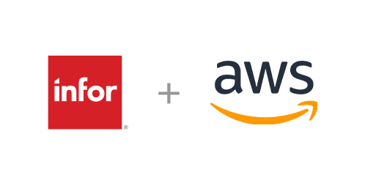
Fig. 1: Infor + AWS Collaboration Logo
https://www.infor.com/news/infor-aws-manufacturing-industrial-competency

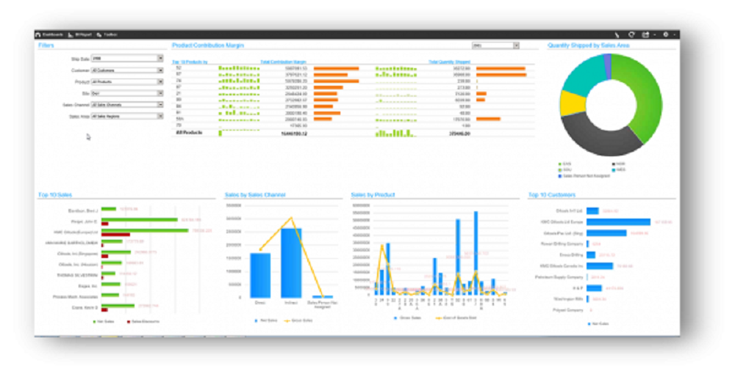
Fig. 2: Infor ERP Dashboard
https://comparecamp.com/infor-syteline-erp-review-pricing-pros-cons-features/infor-syteline-erp-dashboard/

What is Infor:
Infor is a multinational software company focusing on ERP (Enterprise Resource Planning) & EAP (Enterprise Application Platform) solutions. Infor was founded in 2002 and the first cloud ERP vendor in the market.
Notable Transformations & Acquisitions:
At the onset, Infor was under the name Agilisys. In 2004 Infor Business Solutions was acquired and the company was renamed to Infor Global Solutions. Later acquisitions include SSA Global in 2006, Lawson Software in 2011, and Birst in 2017. Always Infor has been privately held, today by Koch Equity Development LLC.
Infor Portfolio:
The core of Infor’s EAP is based upon their early ION (Intelligent Open Network) development. Initially offered as a hosted solution either on premise at Infor, or otherwise the customer, in 2014 the EAP was offered as a PaaS (Platform as a Service) through AWS (Amazon Web Services). Paired was the release of ION API Gateway, providing query functionality to the platform. Recent developments include digital assistants, document management, and process intelligence. Their products include various integrations with third-part applications through their Data Extract (ETL).

Cloud ERP Adoption Factors
Benefits and challenges of Infor will be accessed based upon their use cases and capabilities. Industry wide, these factors provide a ground for comparison across vendors.
Use Cases: ERP for Midsize Enterprises, ERP for Large and Global Enterprises, Discrete Manufacturing, Project/Asset-Intensive Manufacturing, Process Manufacturing, & Distribution of Goods
Capabilities: Single-Vendor ERP Suite Solution, Complex Corporate Requirements, Geographic Coverage, Discrete Manufacturing, Complex Manufacturing, Process Manufacturing, Distribution, Warehouse, Logistics, Support/SI/Methodology, Advanced Technology, Composable Platform, & Financial Management.
Infor is one of the most well-rounded ERP providers in terms of both use cases & capabilities. Top use cases fall under ERP for midsize enterprises, discrete manufacturing, and process manufacturing. Seen as most capable of providing a single-vendor ERP suite solution and process manufacturing, driving their preferred use cases.
Distribution, warehouse, logistics are capabilities values across all use cases in which Infor excels at, ranked second in the marketplace per Gartner research. Their platform also beats baselines in providing advanced technology and a composable platform.
Infor’s challenges stem less so from their technical capabilities, but rather customer relations. On this note Infor is one of the worst vendors for support/SI/methodology, posing a clear risk to use cases for large & global enterprises. For project/asset-intensive manufacturing risks are realized with respect to their only baseline competency in financial management & handling of complex manufacturing & corporate requirements.
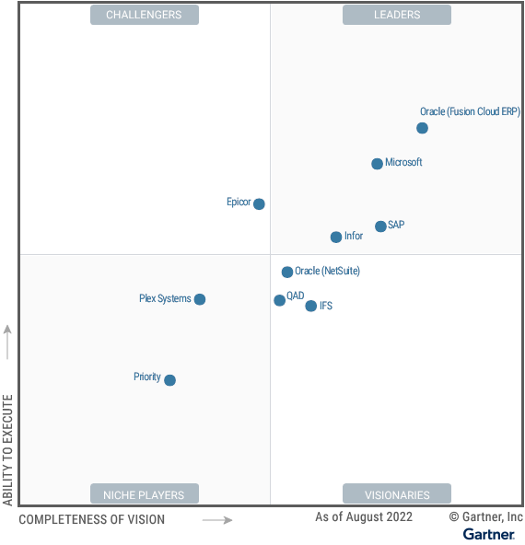
Fig. 3: Infor’s Positioning in the Cloud EAP Marketplace
https://www.infor.com/resources/gartner-names-cloudsuite-solutions-as-leader

