**Group 1 Phase 6**

|  |  |  |  |  |
| --- | --- | --- | --- | --- |
| **CSC 310 Human Computer Interaction**  **Heuristic Evaluation Individual Report**  **Dated**  **11/27/2020**   |  | | --- | | **Prepared By:**  **GROUP NAME:** Group 1  **CONTRIBUTOR(S):** Cole Dutil |  |  | | --- | | **Evaluation Of:**  **Name of system being evaluated:** CODE :: BLOCKS  **Group that created the system being evaluated:** Group 5 | | | |
| Feedback & Critical Incidence | << Record your observations in the table on the following page, based on your observations and notes taken during the evaluation.  Description of columns in the table are as follows:  *Prototype Screen/Page:*  Which screen of the user interface was being tested at the point of feedback/critical incidence/problem.  *Name of Heuristic:*  Which of the 9 heuristics is being referenced. Enter the full name of the heuristic. Refer to the heuristic evaluation lecture slides for the 9 design principles.  *Reason for negative feedback / breakdown:*  Explain the reasons why the interface violates this heuristic. Be sure to be clear about *where* in the screen you are referencing.  *Scope:*  Describe the scope of the feedback or the problem; include whether the scope of the issue is throughout the product or within a specific screen or screens. If the problems are specific to a page, include the appropriate page numbers.  *Severity (H/M/L) :*  Your assessment as to whether the implication of the feedback is *low*, *medium*, or *high* severity, and a justification for why you are giving it that rating.    *Way(s) to rectify and Tradeoffs (i.e., why the fix might not work):*  Suggestion for the modifications that might be made to the user interface to address the issue or issues in this row. You MUST include trade-offs to be credible. If you can’t think of some bad trade-off, say so.  *Action taken and Justification:*  DO NOT FILL IN THIS COLUMN. This will be filled in by the person who created the system being evaluated, to say what he did with respect to the recommendations you make. |

| **#** | **Prototype Screen** | **Name of Heuristic** | **Reason for negative feedback / breakdown** | **Scope** | **Severity**  (High/ Medium/ Low) and **Justification** for giving it that rating | **Way(s) to rectify and any Tradeoffs** (i.e., why the fix might not work) | **Action taken and Justification (*to by filled in later by the person who created the system being evaluated*)** |
| --- | --- | --- | --- | --- | --- | --- | --- |
| 1 | See Picture 1 | **Simple/Natural Dialog** | **Project type selection is cluttered.** The project type selection window lays out options in a tight grid. | Only the project selection screen. | **Low**  This effects only one screen and is not a major flaw. It took me a little longer than I feel it should have to find the correct option. | This would probably be better displayed as a list, be given a search interface to look for something specific, and/or use icons to make different options stand out.  Tradeoff: Increased development time and increased asset generation. |  |
| 2 | See Picture 2 | **Consistency** | **Main toolbar options spawn additional toolbars when clicked.** When an option from the main toolbar (i.e. file, edit, view) is selected an entire new toolbar is created beneath it. See picture for an example with three toolbars on screen at once. | All screens of the main window. | **High**  This impacts the main toolbar of the main window of the application. | The main toolbar would likely be better if it served drop down lists instead of stacking toolbars beneath each other. This would reduce the amount of screen real estate that is obscured.  Tradeoff: I cannot think of a significant reason not to do this. |  |
| 3 | See Picture 3 | **Provide Feedback** | **New project wizard does not show a confirmation summary.** When creating a new project, the wizard prompts the user to finish without confirming their selections. A summary would increase user confidence that they made correct selections without needing to backtrack. | All wizards | **Medium**  This applies to only one wizard, but it is an important portion of the application and could result in serious user error. | Present the user with a summary of their choices at the end of this and any wizards in the application.  Tradeoff: Increased development time, wizards show the user an additional screen and thus take longer to complete. |  |
| 4 | See Picture 4 | **Consistency** | **New file wizard presents the C/C++ header file option twice.** | Only one screen of the new file wizard. | **Low**  I clicked the inactive copy of the option first. It looks bad and can be confusing but does not seriously impact functionality and only impacts one screen of one wizard. | Remove/replace the duplicate option.  Tradeoff: I cannot think of a significant reason not to do this. |  |
| 5 | See Picture 5 | **Minimize user’s memory load** | **The ribbon profile editor presents a lot of information to the user at once.** | The ribbon profile editor only. | **Medium**  The textual explanation of how this feature works is small and difficult to read. It is even more difficult to refer back to specific parts of the instructions. | Break up the instructions so that less information is on screen at once and that relevant information is on screen when needed. Perhaps tooltips could pup up when the user mouses over certain options.  Tradeoff: Increased development time. Probably more difficult to implement. |  |
| 6 | See Picture 6 | **Consistency** | **NEW option in toolbar menu is the only option presented in all-caps.** | Sub menu for file option of main toolbar. | **Low**  This is visually inconsistent but does not cause any usability issues. | Make the text of this option consistent with the rest of the options.  Tradeoff: I cannot think of a significant reason not to do this. |  |

Picture 1:

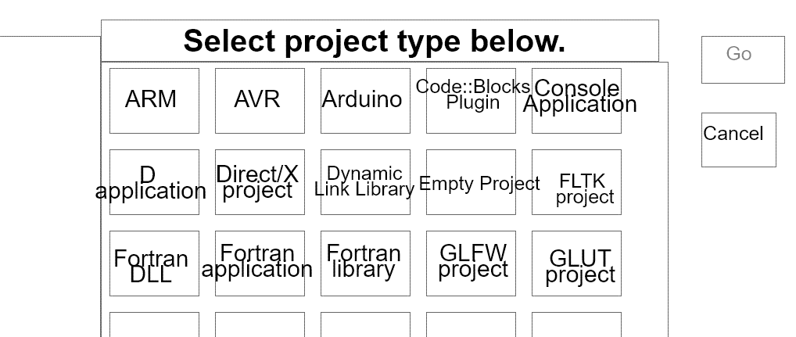

Picture 2:

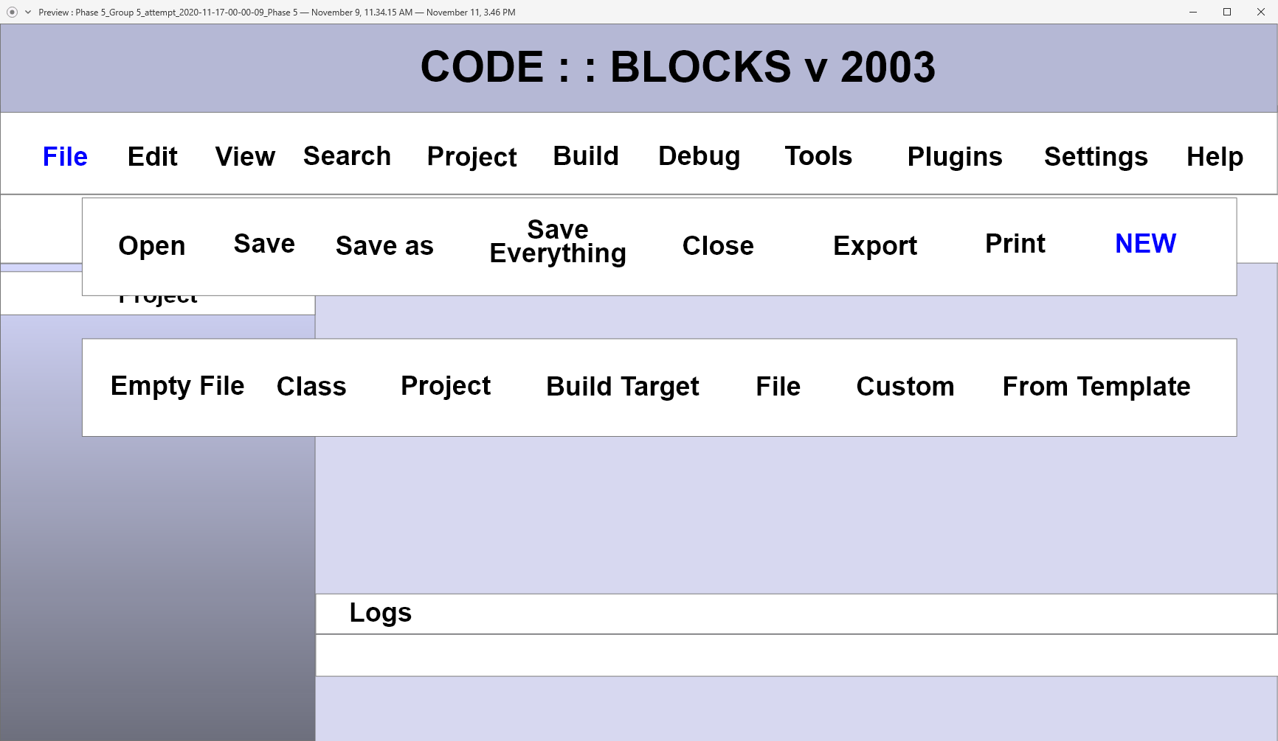

Picture 3:

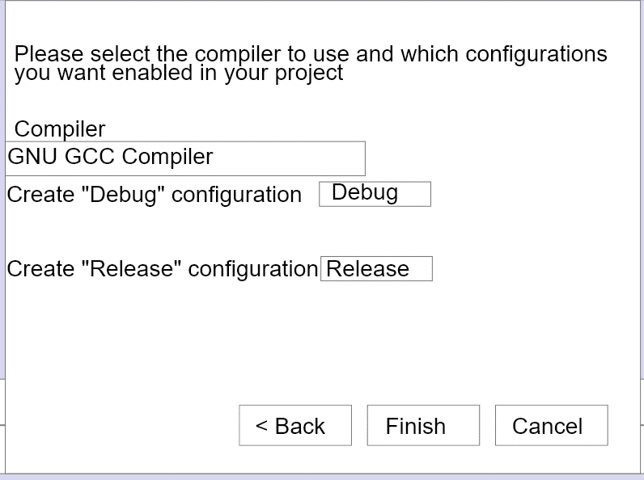

Picture 4:

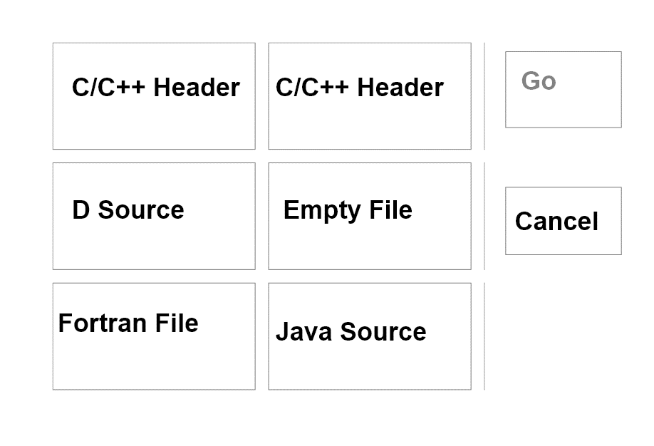

Picture 5:

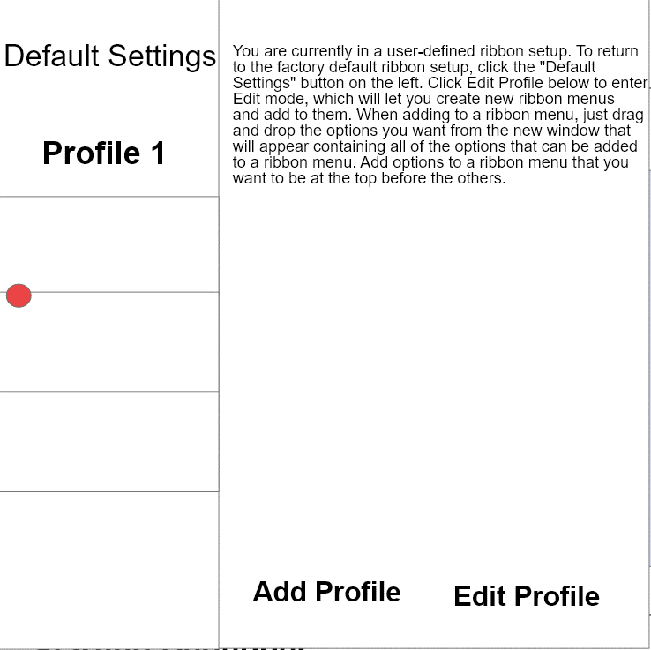

Picture 6:

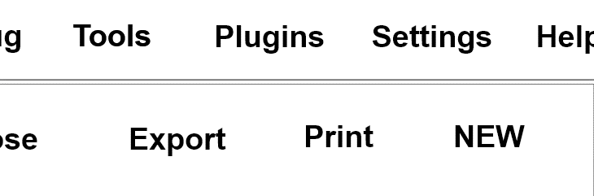

|  |  |  |
| --- | --- | --- |
| **CSC 310 Human Computer Interaction**  **Heuristic Evaluation Report Individual**  **Dated**  **11/22/2020**   |  | | --- | | **Prepared By:**  **GROUP NAME: Group 1**  **CONTRIBUTOR: Cason Konzer** |  |  | | --- | | **Evaluation Of:**  **Name of system being evaluated: CODE : : BLOCKS v 2003**  **Group that created the system being evaluated: Group 5** | |

|  |  |
| --- | --- |
| Feedback & Critical Incidence | << Record your observations in the table on the following page, based on your observations and notes taken during the evaluation.  Description of columns in the table are as follows:  *Prototype Screen/Page:*  Which screen of the user interface was being tested at the point of feedback/critical incidence/problem.  *Name of Heuristic:*  Which of the 9 heuristics is being referenced. Enter the full name of the heuristic. Refer to the heuristic evaluation lecture slides for the 9 design principles.  *Reason for negative feedback / breakdown:*  Explain the reasons why the interface violates this heuristic. Be sure to be clear about *where* in the screen you are referencing.  *Scope:*  Describe the scope of the feedback or the problem; include whether the scope of the issue is throughout the product or within a specific screen or screens. If the problems are specific to a page, include the appropriate page numbers.  *Severity (H/M/L) :*  Your assessment as to whether the implication of the feedback is *low*, *medium*, or *high* severity, and a justification for why you are giving it that rating.    *Way(s) to rectify and Tradeoffs (i.e., why the fix might not work):*  Suggestion for the modifications that might be made to the user interface to address the issue or issues in this row. You MUST include trade-offs to be credible. If you can’t think of some bad trade-off, say so.  *Action taken and Justification:*  DO NOT FILL IN THIS COLUMN. This will be filled in by the person who created the system being evaluated, to say what he did with respect to the recommendations you make. |

| **#** | **Prototype Screen** | **Name of Heuristic** | **Reason for negative feedback / breakdown** | **Scope** | **Severity**  (High/ Medium/ Low) and **Justification** for giving it that rating | **Way(s) to rectify and any Tradeoffs** (i.e., why the fix might not work) | **Action taken and Justification (*to by filled in later by the person who created the system being evaluated*)** |
| --- | --- | --- | --- | --- | --- | --- | --- |
| 1 | See Picture 1 | Be Consistent,  Provide clearly marked exits | This is a “dead” screen. The Read Me provides instructions that are not consistent with the model. There is no way for the user to leave this screen while they are directed here by the instructions. | Error occurs in this screen as well as some others | High. At this point the user has made 3 total clicks and is stuck on a screen. The cancel button does not function nor does any button on the screen. | Implement the cancel button to return to home screen. Implement the Console Application button so the user can complete the given directions. |  |
| 2 | See Picture 2 | Be Consistent,  Provide clearly marked exits | Read me directs user to press an edit mode button that is not available. Prototype has an edit profile button that does not work. Exit button is very hard to see. | Various screens do not have clearly marked exits, whole project is quite inconsistent with project directions and read me. | High. User has no way of advancing through the given script at this point. | Implement the edit button, either change the read me or project, mode/profile, so they are consistent. Make the exit button more pronounced. |  |
| 3 | See Picture 3 | Simple and Natural Dialog,  Speak the User’s Language, Be Consistent | Am unsure what the given script actually is, read me assume user has a background with technical language, wordage does not logically flow with the English language. (Do not think people would talk like this). | Project Wide. The read me is crucial for providing instructions for completion of tasks. | High. Read me is not consistent with the prototype. Read me is hard to follow. Some wordage is not in layman terms and users may get stuck. | Match the read me with the project so that they are consistent. Provide clear script labeling. Speak in layman terms so the prototype can be tested with new users. |  |
| 4 | See Picture 4 | Provide clearly marked exits | No exit available | Present within multiple project screens | Low. User can continue to navigate without the exit but this is a necessary feature. | Add in an exit |  |
| 5 | See Picture 5 | Be Consistent,  Provide clearly marked exits | This suffers similar errors as the only functioning click through is clicking Main.cpp which simply returns the user to the previous screen. The Read Me says to click Toggle Breakpoint, which is not consistent with what the prototype offers. | Inconsistency and lack of implementation is project wide. | High. Again, at this point the user cannot complete directions as the read me indicates. Additionally, there is no clear exit and the user will easily be stuck here. | Implementation of the toggle breakpoint button as the read me states. Provide an exit button. |  |
| 6 | See Picture 6 | Provide Help | While the help button opens up various help options there is no help provided | Project wide | Low. Help can be found in the read me. | Implement help dialog. |  |
| 7 | Project Wide | Provide Feedback, Be Consistent | No feedback to the users for any unimplemented buttons, buttons are only available on certain screens | Project Wide | Medium. Unimplemented buttons do not provide any feedback for the user and while buttons are available on one screen they may not be on the next. | Provide popups/ screens with a message of the “coming soon…” type. Be consistent and implement buttons on all screens. |  |

Picture 1:

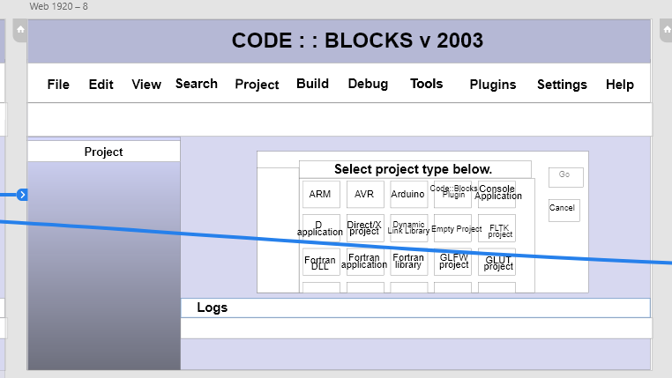

Picture 2:

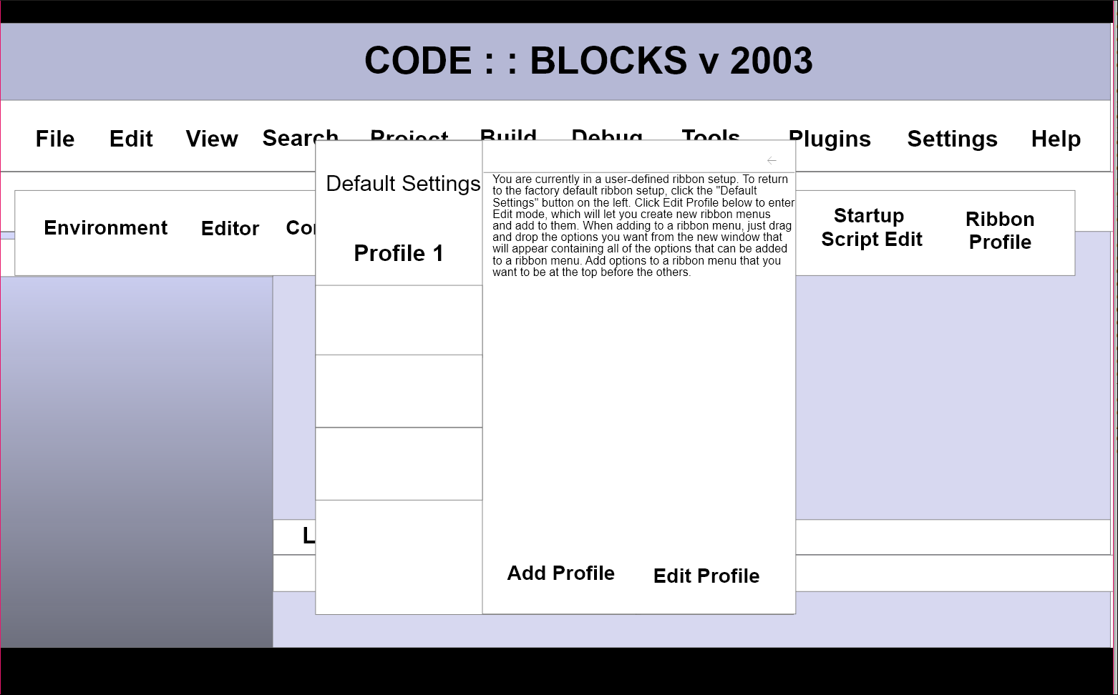

Picture 3:

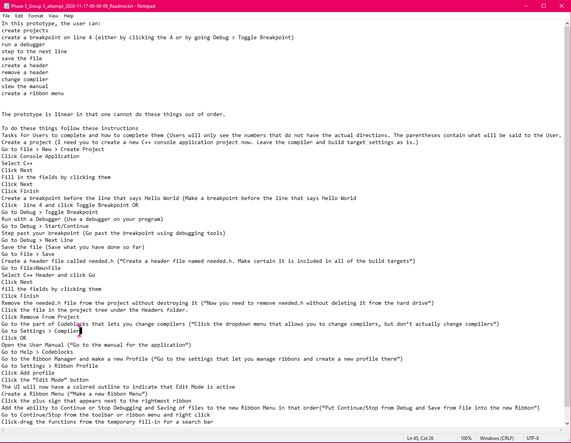

Picture 4:

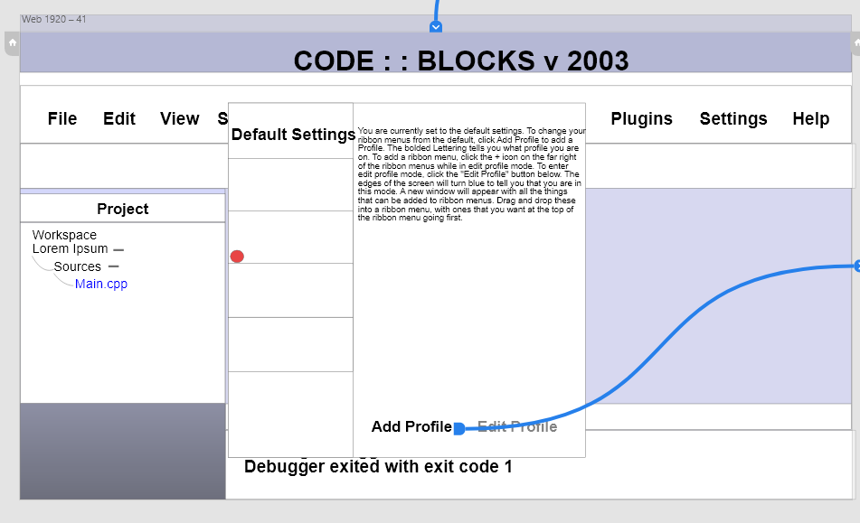

Picture 5:

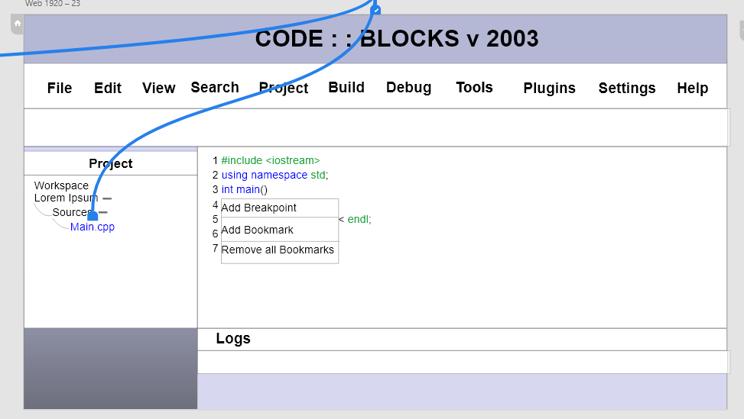

Picture 6:

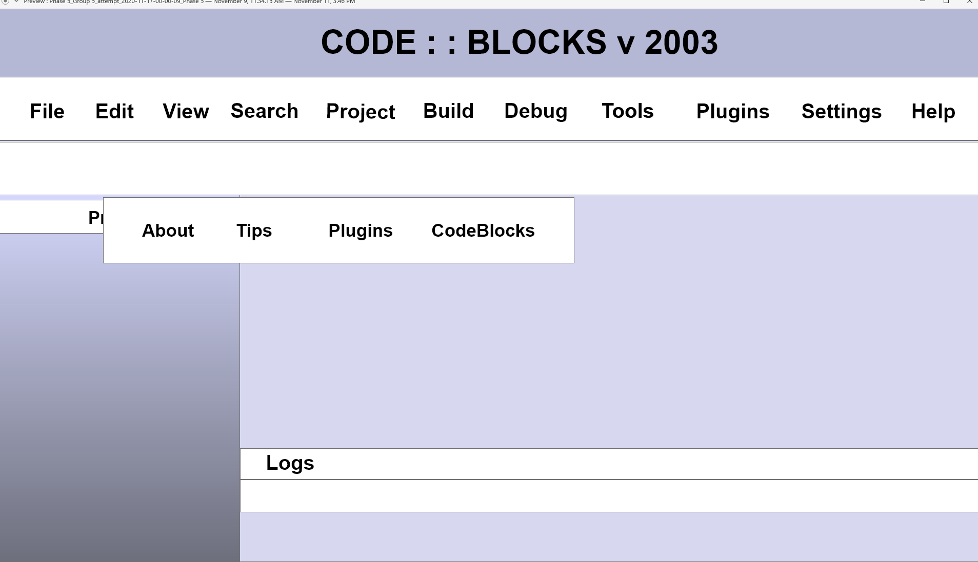

|  |  |  |
| --- | --- | --- |
| **CSC 310 Human Computer Interaction**  **Heuristic Evaluation Report Final**  **Dated**  **11/26/2020**   |  | | --- | | **Prepared By:**  **GROUP NAME: Group 1**  **CONTRIBUTOR: Cason Konzer, Cole Dutil** |  |  | | --- | | **Evaluation Of:**  **Name of system being evaluated: CODE : : BLOCKS v 2003**  **Group that created the system being evaluated: Group 5** | |

|  |  |
| --- | --- |
| Feedback & Critical Incidence | << Record your observations in the table on the following page, based on your observations and notes taken during the evaluation.  Description of columns in the table are as follows:  *Prototype Screen/Page:*  Which screen of the user interface was being tested at the point of feedback/critical incidence/problem.  *Name of Heuristic:*  Which of the 9 heuristics is being referenced. Enter the full name of the heuristic. Refer to the heuristic evaluation lecture slides for the 9 design principles.  *Reason for negative feedback / breakdown:*  Explain the reasons why the interface violates this heuristic. Be sure to be clear about *where* in the screen you are referencing.  *Scope:*  Describe the scope of the feedback or the problem; include whether the scope of the issue is throughout the product or within a specific screen or screens. If the problems are specific to a page, include the appropriate page numbers.  *Severity (H/M/L) :*  Your assessment as to whether the implication of the feedback is *low*, *medium*, or *high* severity, and a justification for why you are giving it that rating.    *Way(s) to rectify and Tradeoffs (i.e., why the fix might not work):*  Suggestion for the modifications that might be made to the user interface to address the issue or issues in this row. You MUST include trade-offs to be credible. If you can’t think of some bad trade-off, say so.  *Action taken and Justification:*  DO NOT FILL IN THIS COLUMN. This will be filled in by the person who created the system being evaluated, to say what he did with respect to the recommendations you make. |

| **#** | **Prototype Screen** | **Name of Heuristic** | **Reason for negative feedback / breakdown** | **Scope** | **Severity**  (High/ Medium/ Low) and **Justification** for giving it that rating | **Way(s) to rectify and any Tradeoffs** (i.e., why the fix might not work) | **Action taken and Justification (*to by filled in later by the person who created the system being evaluated*)** |
| --- | --- | --- | --- | --- | --- | --- | --- |
| 1 | See Picture 1 | **Be Consistent,**  **Provide clearly marked exits** | This is a **“dead” screen**. The Read Me provides **instructions that are not consistent with the model.** There is no way for the user to leave this screen while they are directed here by the instructions. | Error occurs in this screen as well as some others | **High**  At this point the user has made 3 total clicks and is stuck on a screen. The cancel button does not function nor does any button on the screen. | Implement the cancel button to return to home screen. Implement the Console Application button so the user can complete the given directions.  Tradeoffs: none |  |
| 2 | See Picture 2 | **Be Consistent,**  **Provide clearly marked exits** | **Read me directs user to press an edit mode button that is not available. Prototype has an edit profile button that does not work. Exit button is very hard to see.** | Various screens do not have clearly marked exits, whole project is quite inconsistent with project directions and read me. | **High**  User has no way of advancing through the given script at this point. | Implement the edit button, either change the read me or project, mode/profile, so they are consistent. Make the exit button more pronounced.  Tradeoffs: exit button takes more space, project would be less confusing. |  |
| 3 | See Picture 3 | **Simple and Natural Dialog,**  **Speak the User’s Language, Be Consistent** | Am unsure what the given script actually is, **read me assumes user has a background with technical language, wordage does not logically flow with the English language.** (Do not think people would talk like this). | Project Wide. The read me is crucial for providing instructions for completion of tasks. | **High**  Read me is not consistent with the prototype. Read me is hard to follow. Some wordage is not in layman terms and users may get stuck. | Match the read me with the project so that they are consistent. Provide clear script labeling. Speak in layman terms so the prototype can be tested with new users.  Tradeoffs: more wordage required |  |
| 4 | See Picture 4 | **Provide clearly marked exits** | **No exit available** | Present within multiple project screens | **Low**  User can continue to navigate without the exit but this is a necessary feature. | Add in an exit  Tradeoff: user can now leave the screen. Maybe this is designed to force user to stay there? |  |
| 5 | See Picture 5 | **Be Consistent,**  **Provide clearly marked exits** | This suffers similar errors as the only functioning click through is clicking Main.cpp which simply returns the user to the previous screen. **The Read Me says to click Toggle Breakpoint, which is not consistent with what the prototype offers.** | Inconsistency and lack of implementation is project wide. | **High**  Again, at this point the user cannot complete directions as the read me indicates. Additionally, there is no clear exit and the user will easily be stuck here. | Implementation of the toggle breakpoint button as the read me states. Provide an exit button.  Tradeoffs: none |  |
| 6 | See Picture 6 | **Provide Help** | While the help button opens up various help options **there is no help provided** | Project wide | **Low**  Help can be found in the read me. | Implement help dialog.  Tradeoffs: would take up more screen room. Possibly have help direct user to readme. |  |
| 7 | See Picture 7 | **Simple/Natural Dialog** | **Project type selection is cluttered.** The project type selection window lays out options in a tight grid. | Only the project selection screen. | **Low**  This effects only one screen and is not a major flaw. It took me a little longer than I feel it should have to find the correct option. | This would probably be better displayed as a list, be given a search interface to look for something specific, and/or use icons to make different options stand out.  Tradeoff: Increased development time and increased asset generation. |  |
| 8 | See Picture 8: | **Consistency** | **Main toolbar options spawn additional toolbars when clicked.** When an option from the main toolbar (i.e. file, edit, view) is selected an entire new toolbar is created beneath it. See picture for an example with three toolbars on screen at once. | All screens of the main window. | **High**  This impacts the main toolbar of the main window of the application. | The main toolbar would likely be better if it served drop down lists instead of stacking toolbars beneath each other. This would reduce the amount of screen real estate that is obscured.  Tradeoff: I cannot think of a significant reason not to do this. |  |
| 9 | See Picture 9: | **Provide Feedback** | **New project wizard does not show a confirmation summary.** When creating a new project, the wizard prompts the user to finish without confirming their selections. A summary would increase user confidence that they made correct selections without needing to backtrack. | All wizards | **Medium**  This applies to only one wizard, but it is an important portion of the application and could result in serious user error. | Present the user with a summary of their choices at the end of this and any wizards in the application.  Tradeoff: Increased development time, wizards show the user an additional screen and thus take longer to complete. |  |
| 10 | See Picture 10: | **Consistency** | **New file wizard presents the C/C++ header file option twice.** | Only one screen of the new file wizard. | **Low**  I clicked the inactive copy of the option first. It looks bad and can be confusing but does not seriously impact functionality and only impacts one screen of one wizard. | Remove/replace the duplicate option.  Tradeoff: I cannot think of a significant reason not to do this. |  |
| 11 | See Picture 11: | **Minimize user’s memory load** | **The ribbon profile editor presents a lot of information to the user at once.** | The ribbon profile editor only. | **Medium**  The textual explanation of how this feature works is small and difficult to read. It is even more difficult to refer back to specific parts of the instructions. | Break up the instructions so that less information is on screen at once and that relevant information is on screen when needed. Perhaps tooltips could pup up when the user mouses over certain options.  Tradeoff: Increased development time. Probably more difficult to implement. |  |
| 12 | See Picture 12: | **Consistency** | **NEW option in toolbar menu is the only option presented in all-caps.** | Sub menu for file option of main toolbar. | **Low**  This is visually inconsistent but does not cause any usability issues. | Make the text of this option consistent with the rest of the options.  Tradeoff: I cannot think of a significant reason not to do this. |  |
| 13 | Project Wide | **Provide Feedback, Be Consistent** | **No feedback to the users for any unimplemented buttons, buttons are only available on certain screens** | Project Wide | **Medium**.  Unimplemented buttons do not provide any feedback for the user and while buttons are available on one screen they may not be on the next. | Provide popups/ screens with a message of the “coming soon…” type. Be consistent and implement buttons on all screens.  Tradeoffs: none. |  |

Picture 1:



Picture 2:



Picture 3:



Picture 4:



Picture 5:



Picture 6:



Picture 7:



Picture 8: 

Picture 9: 

Picture 10: 

Picture 11:



Picture 12:

