Assignment #4

Cason Konzer 8/1/21

_Flint Campus_

[CSC-382]: Software Engineering



Contents

1. **Turn CRC Cards Into Class Diagram Format**: Pg. [2]
2. **Develop 2 of Each Diagram**: Pgs. [4-7]
   1. ***Inheritance* [4]**
   2. ***Aggregation* [5]**
   3. ***Association* [6]**
   4. ***Dependency*** [7]

* **Works Cited**: Pg. [8]

Class Diagrams

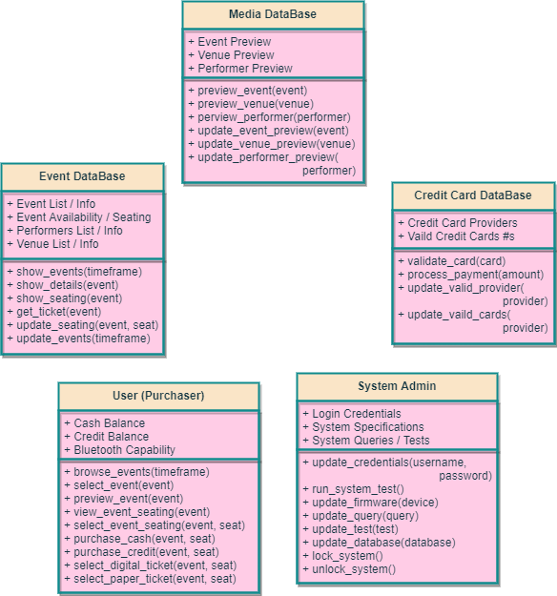

This page is intentionally left Blank.

Develop 2 of Each Diagram

*Inheritance (2)*

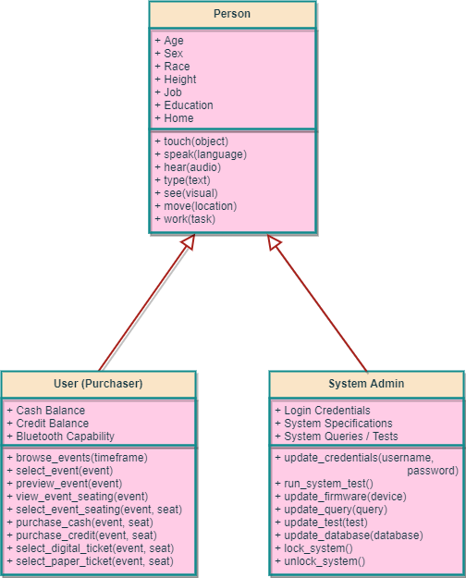

*Aggregation (2)*

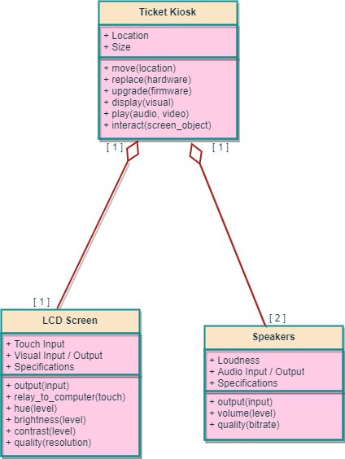

*Association (2)*

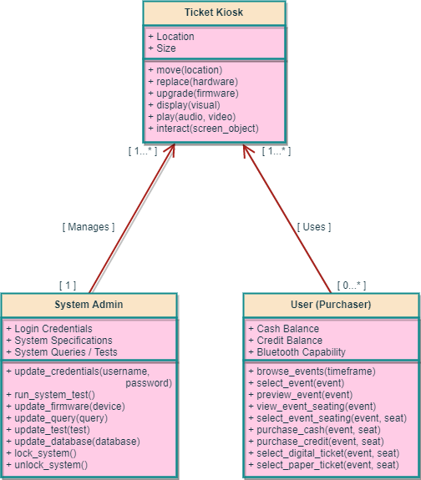

*Dependency (2)*

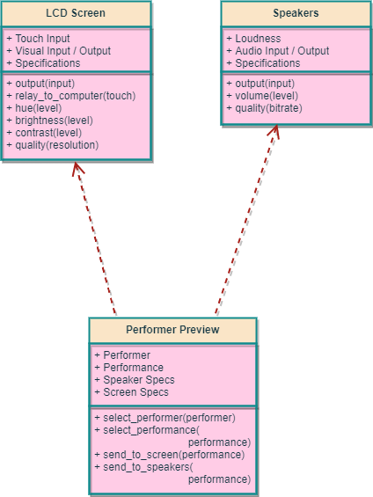

Works Cited

Pressman, R., and B. Maxim, *Software Engineering: A Practitioner’s*

*Approach, Eighth Edition*, McGraw-Hill, 2015.