**CSC384**

HomeWork 1: Due Feb 03 11:59 pm (via bb)

CASON KONZER

Remember: you will be graded for your sincere effort, and not for correctness.

1. Write SQL DDL (Data Definition Language) statements to create a table called studentInfo with attributes studentNum of type integer, and marks of type integer. [2]

Now import the data given into your table.

The solution that you turn in **MUST** include the SQL statement to create the studentInfo table.

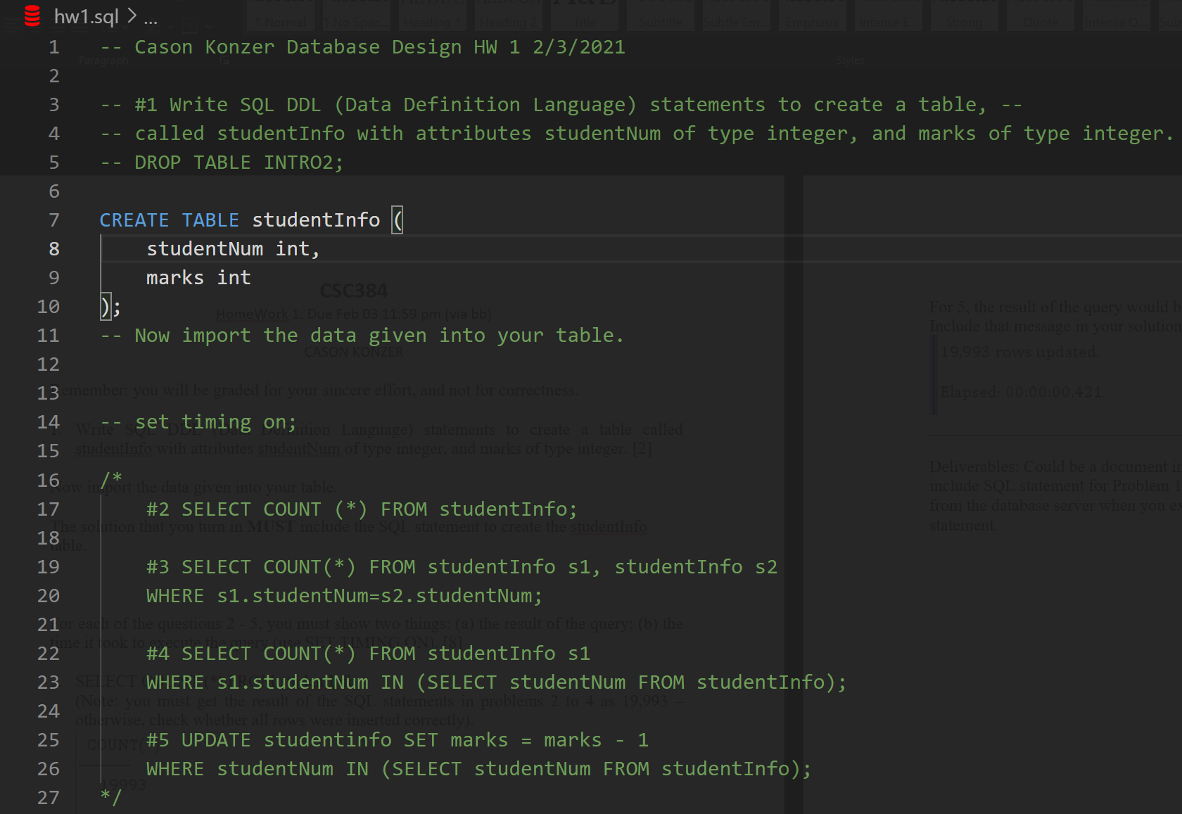

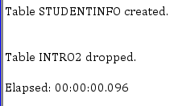

For each of the questions 2 - 5, you must show two things: (a) the result of the query; (b) the time it took to execute the query (use SET TIMING ON). [8]

1. SELECT COUNT (*) FROM studentInfo;

(Note: you must get the result of the SQL statements in problems 2 to 4 as 19,993 – otherwise, check whether all rows were inserted correctly).

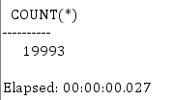

1. SELECT COUNT(*) FROM studentInfo s1, studentInfo s2

WHERE s1.studentNum=s2.studentNum;

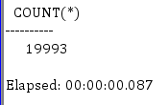

1. SELECT COUNT(*) FROM studentInfo s1

WHERE s1.studentNum IN (SELECT studentNum FROM studentInfo);

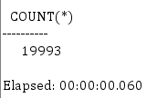

1. UPDATE studentinfo SET marks = marks - 1

WHERE studentNum IN (SELECT studentNum FROM studentInfo);

For 5, the result of the query would be a message saying how many rows were updated. Include that message in your solution that you turn in.

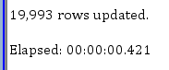

Deliverables: Could be a document in any format (.txt, .doc, …). The document should include SQL statement for Problem 1. For problems 2 – 5, there should be the result/message from the database server when you execute the statement and the time taken to execute the statement.