**CIS/CSC384**

HomeWork 2: Due Feb 17 11:59 pm (via bb)

For each question, note down your confidence level between 0 – 10, with 0 indicating the lowest level of confidence and 10 indicating the highest level of confidence. Remember that you will be graded for your sincere effort (in other words, you will not be graded on correctness). Feedback will be given.

1. Design a database for FreeChecking Bank, including information about customers and their accounts. Information about a customer includes name, address, phone, and social security number. For each account, we know the account number, type (e.g., savings, checking) and balance. Also the information about which customer owns which account is stored. [3 pts]

Answer the following questions?

1. What is a key for customer?
   1. Social Security Number
   2. 10
2. What is a key for account?
   1. Account Number
   2. 10
3. Can a customer own multiple accounts?
   1. Yes
   2. 10
4. Can an account have multiple owners?
   1. Yes
   2. 10
5. Using your answers above draw an E/R schema for your bank database.
   1. 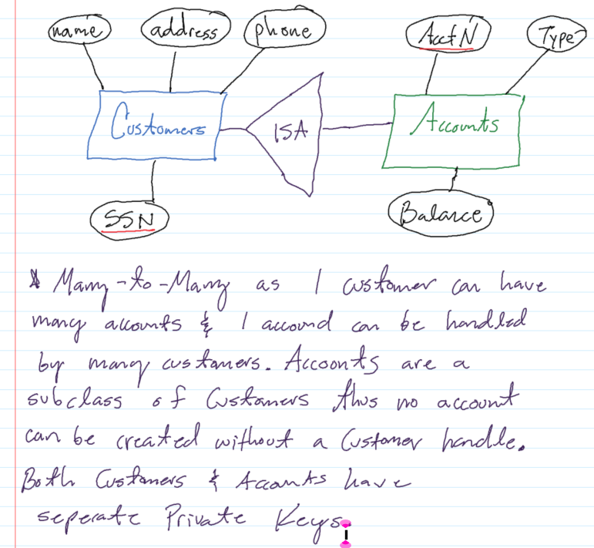
   2. 8

Note: Your solution must include your answers to parts (a) – (d). Different students can have different answers. Based on these answers, you should draw your ER schema in part (e).

1. Think of a real-life application where you need weak entity sets (come up with a different application than what is described in the course slides). **Describe your application requirements**, and **come up with the ER schema** for this application. [2 pts]
   1. Consider 3 entity sets: Person, Family and Origin. Person consist of 4 attributes: Name, Social Security Number, Birth Date and Birth Location. Family consists of 3 attributes: Maiden Name, Home Address and Size. Origin consists of 3 attributes: Continent, Nation and State. 2 Week entity sets are present here: Inheritance and History. The Inheritance relation uses Social Security Number as the key form Person for Family. The History relation uses Maiden Name as the key from Family for Origin. This is many-to-one in both instances as many Persons Social Security Number Inherit one Family and many Family maiden names are historic to one location. The Origin entity set uses State as a Public Key.
   2. 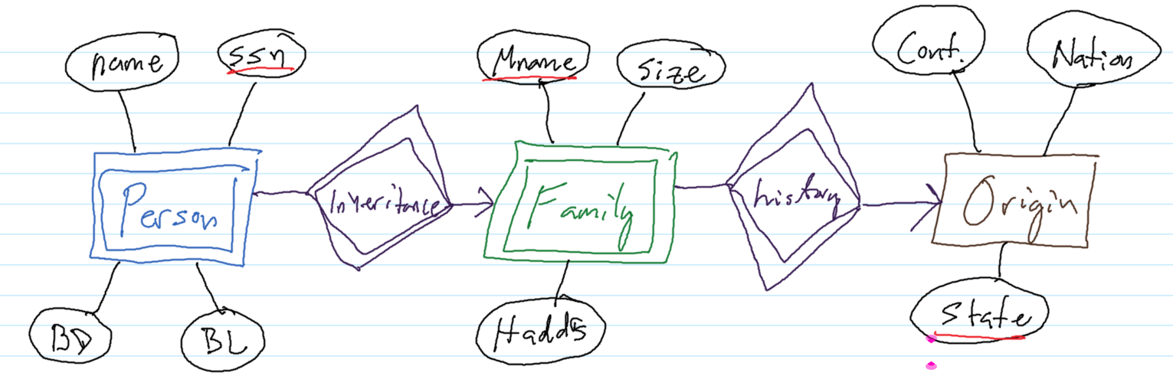
   3. 9
2. MoneyMaking supermarket chain wants to build a central database for keeping track of its branches, its employees, its inventory, as well as its sales. Design an ER schema for this supermarket chain, given the following requirements. Make any additional assumptions, as you find reasonable. [5 pts]
   1. 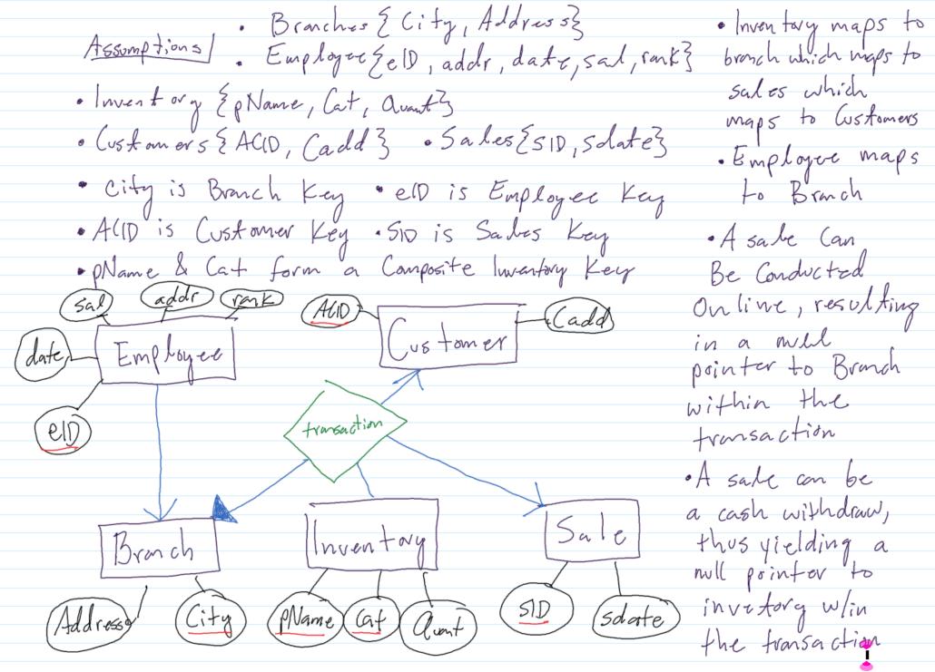
   2. 8

* There are several stores that belong to the chain. For each store, we know the city where the store is located, and the address of the store. There is only one store in any city.
* There are several employees who work at the supermarket chain. For each employee, we have a unique employeeID. We also know the employee’s address, year of joining, salary and rank (manager, sales assistant I etc). Any employee works at exactly one store.
* There are several products that the supermarket does business in. Each product has a unique name, also each product has a category (such as produce, canned item etc). Example of products include milk, eggs etc.
* Any store has several products, also for each product, we know the quantity available at the store.
* We also have a list of customers; every customer has “Advantage Card”. For each customer, we know his/her unique advantage card number, and address.
* We also record sales at every store. Each sale has a saleID (which is unique), and the date of the sale. Each sale happened at a particular store, and involved a particular customer. Each sale also involves one or more products, and the quantity that was bought as part of this sale

Example Instance to help in the design of the ER schema.

1. There are two stores belonging to the chain, one in Flint, and one in Detroit.
2. There are a total of 100 employees working at the chain, whose employeeIDs are 1..100. Of these, employees 1..40 work at the Flint store, and employees 41..100 work at the Detroit store.
3. The Flint store currently has 100 gallons of milk and 50 boxes of eggs. The Detroit store currently has 250 gallons of milk and 250 boxes of eggs. Detroit store also has 100 quantities of Nestle purified water (which is not carried by the Flint store).
4. We have 10 customers with AdvantageCard. Their AdvantageCard numbers are 101..110
5. Some of the sales recorded are:
   1. Sale 1001 involved customer with advantageCard number 101 and happened at the Flint store. The items purchased in this sale include 1 gallon of milk and 1 box of egg.
   2. Sale 1002 involved customer with advantageCard number 102 and happened at the Flint store. The items purchased in this sale include 2 boxes of eggs.
   3. Sale 1003 involved customer with advantageCard number 101 and happened at the Flint store. The items purchased in this sale include 2 gallons of milk.

.