CSC 565 – Computer System Architecture

**Deliverable 2**

*Cason Konzer*

* Block diagram with input output pins

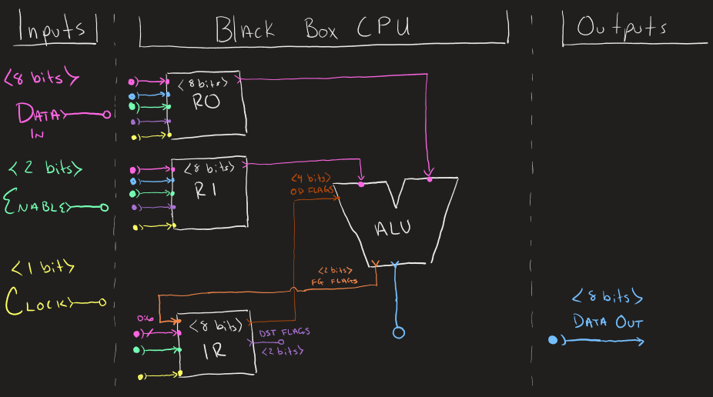

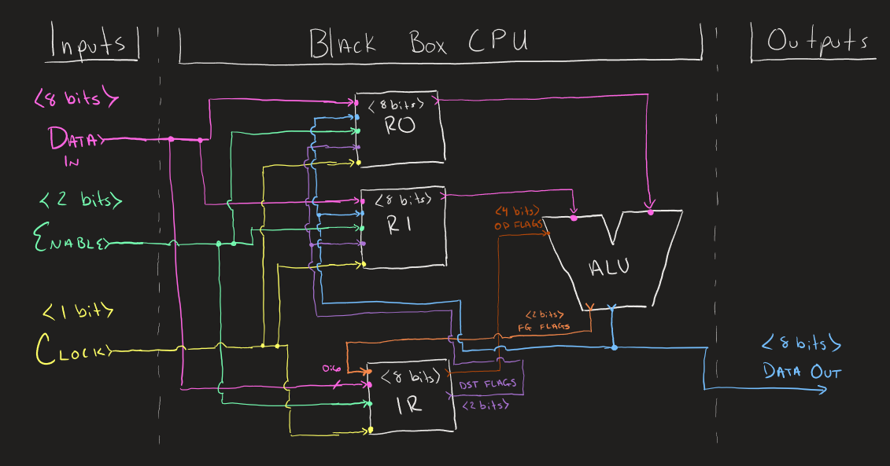

* Clock Signal

External Clock used for flexibility, and so the programmer knows when to read values on the output bus. (Realistic implementation supports both internal and external clock).

* Number of registers

|  |  |
| --- | --- |
| **Register** | **Description** |
| IR | Instruction Register (Also Holds Flags) |
| R0 | Register 0 |
| R1 | Register 1 |

3 Registers (Data Out is coded as a register)

* Flags

Supporting Signed and Overflow, Overflow only relevant for SUB instructions, Signed supported for both SUB and OR

* Other control registers that will be needed to perform operations

Use extra bits in IR to hold flags from ALU output, as well as pass ‘instruction’ flags specifying operands, operation, and output destinations.

* A draft of the instruction set

**Instruction/Flag Bit Encoding**

|  |  |  |  |  |  |  |  |
| --- | --- | --- | --- | --- | --- | --- | --- |
| **OVF** | **SGN** | **OR** | **SUB** | **OPO 1** | **OPO 0** | **DST 1** | **DST 0** |
| Overflown Output | Signed Output | ALU flag to use OR | ALU flag to use SUB | Operand 1 | Operand 0 | Destination 1 | Destination 0 |
| *BIT 7* | *BIT 6* | *BIT 5* | *BIT 4* | *BIT 3* | *BIT 2* | *BIT 1* | *BIT 0* |

**Destination Encoding**

|  |  |  |
| --- | --- | --- |
| **DST 1** | **DST 0** | **ALU Write Back Register(s)** |
| 0 | 0 | No Write Back (only bus) |
| 0 | 1 | Write Back to R0 |
| 1 | 0 | Write Back to R1 |
| 1 | 1 | Write Back to R0 & R1 |

**ALU Encoding**

|  |  |  |
| --- | --- | --- |
| **OR** | **SUB** | **ALU Operation** |
| 0 | 0 | unused |
| 0 | 1 | Integer Subtraction |
| 1 | 0 | Logical Or |
| 1 | 1 | unused |

**Operation Encoding**

|  |  |  |
| --- | --- | --- |
| **OPO 1** | **OPO 0** | **Output (* is the operation)** |
| 0 | 0 | R0 * R0 |
| 0 | 1 | R1 * R0 |
| 1 | 0 | R0 * R1 |
| 1 | 1 | R1 * R1 |

**Output Flag Encoding**

|  |  |  |
| --- | --- | --- |
| **OVF** | **SGN** | **Characteristics** |
| 0 | 0 | Operation has not overflow and output has positive sign |
| 0 | 1 | Operation has not overflow and output has negative sign |
| 1 | 0 | Operation has overflow and output has positive sign |
| 1 | 1 | Operation has overflow and output has negative sign |

**Enable Encoding**

|  |  |  |
| --- | --- | --- |
| **ENA 1** *(BIT 1)* | **ENA 0** *(BIT 0)* | **Enabled Registers** |
| 0 | 0 | None (required for ALU output loads) |
| 0 | 1 | R0 |
| 1 | 0 | R1 |
| 1 | 1 | IR |

* Timing Diagram For The Following Instructions

// Reset All Registers

// Load FF InTo R0

// Load 00 InTo R1

// Data_Out, R0, R1 = R0 | R1 = FF

// No Op

// Data_Out, R0, R1 = R0 - R1 = 00

// No Op

// No Op

