CSC 310 Human Computer Interaction

Heuristic Evaluation Individual Report

Dated
11/27/2020

Prepared By:

GROUP NAME: Group 1

CONTRIBUTOR(S): Cole Dutil

Evaluation Of:

Name of system being evaluated: CODE :: BLOCKS

Group that created the system being evaluated: Group 5

Feedback & Critical Incidence | << Record your observations in the table on the following page, based on your observations and notes taken during the evaluation.  Description of columns in the table are as follows:  Prototype Screen/Page:  Which screen of the user interface was being tested at the point of feedback/critical incidence/problem.  Name of Heuristic:  Which of the 9 heuristics is being referenced. Enter the full name of the heuristic. Refer to the heuristic evaluation lecture slides for the 9 design principles.  Reason for negative feedback / breakdown:  Explain the reasons why the interface violates this heuristic. Be sure to be clear about where in the screen you are referencing.  Scope:  Describe the scope of the feedback or the problem; include whether the scope of the issue is throughout the product or within a specific screen or screens. If the problems are specific to a page, include the appropriate page numbers.  Severity (H/M/L) :  Your assessment as to whether the implication of the feedback is low, medium, or high severity, and a justification for why you are giving it that rating.  Way(s) to rectify and Tradeoffs (i.e., why the fix might not work):  Suggestion for the modifications that might be made to the user interface to address the issue or issues in this row. You MUST include trade-offs to be credible. If you can’t think of some bad trade-off, say so.  Action taken and Justification:  DO NOT FILL IN THIS COLUMN. This will be filled in by the person who created the system being evaluated, to say what he did with respect to the recommendations you make.

# | Prototype  Screen | Name of Heuristic | Reason for negative feedback / breakdown | Scope | Severity  (High/ Medium/ Low) and Justification for giving it that rating | Way(s) to rectify and any Tradeoffs (i.e., why the fix might not work) | Action taken and Justification  (to by filled in later by the person who created the system being evaluated)
1 | See Picture 1 | Simple/Natural Dialog | Project type selection is cluttered. The project type selection window lays out options in a tight grid. | Only the project selection screen. | Low  This effects only one screen and is not a major flaw. It took me a little longer than I feel it should have to find the correct option. | This would probably be better displayed as a list, be given a search interface to look for something specific, and/or use icons to make different options stand out.  Tradeoff: Increased development time and increased asset generation.
2 | See Picture 2 | Consistency | Main toolbar options spawn additional toolbars when clicked. When an option from the main toolbar (i.e. file, edit, view) is selected an entire new toolbar is created beneath it. See picture for an example with three toolbars on screen at once. | All screens of the main window. | High  This impacts the main toolbar of the main window of the application. | The main toolbar would likely be better if it served drop down lists instead of stacking toolbars beneath each other. This would reduce the amount of screen real estate that is obscured.  Tradeoff: I cannot think of a significant reason not to do this.
3 | See Picture 3 | Provide Feedback | New project wizard does not show a confirmation summary. When creating a new project, the wizard prompts the user to finish without confirming their selections. A summary would increase user confidence that they made correct selections without needing to backtrack. | All wizards | Medium  This applies to only one wizard, but it is an important portion of the application and could result in serious user error. | Present the user with a summary of their choices at the end of this and any wizards in the application.  Tradeoff: Increased development time, wizards show the user an additional screen and thus take longer to complete.
4 | See Picture 4 | Consistency | New file wizard presents the C/C++ header file option twice. | Only one screen of the new file wizard. | Low  I clicked the inactive copy of the option first. It looks bad and can be confusing but does not seriously impact functionality and only impacts one screen of one wizard. | Remove/replace the duplicate option.  Tradeoff: I cannot think of a significant reason not to do this.
5 | See Picture 5 | Minimize user’s memory load | The ribbon profile editor presents a lot of information to the user at once. | The ribbon profile editor only. | Medium  The textual explanation of how this feature works is small and difficult to read. It is even more difficult to refer back to specific parts of the instructions. | Break up the instructions so that less information is on screen at once and that relevant information is on screen when needed. Perhaps tooltips could pup up when the user mouses over certain options.  Tradeoff: Increased development time. Probably more difficult to implement.
6 | See Picture 6 | Consistency | NEW option in toolbar menu is the only option presented in all-caps. | Sub menu for file option of main toolbar. | Low  This is visually inconsistent but does not cause any usability issues. | Make the text of this option consistent with the rest of the options.  Tradeoff: I cannot think of a significant reason not to do this.
7 | See Picture 7
8 | See Picture 8

Picture 1:
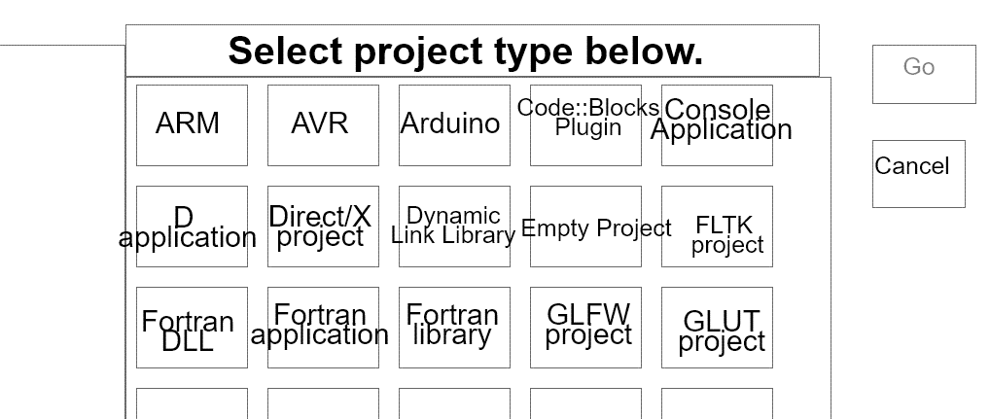

Picture 2:

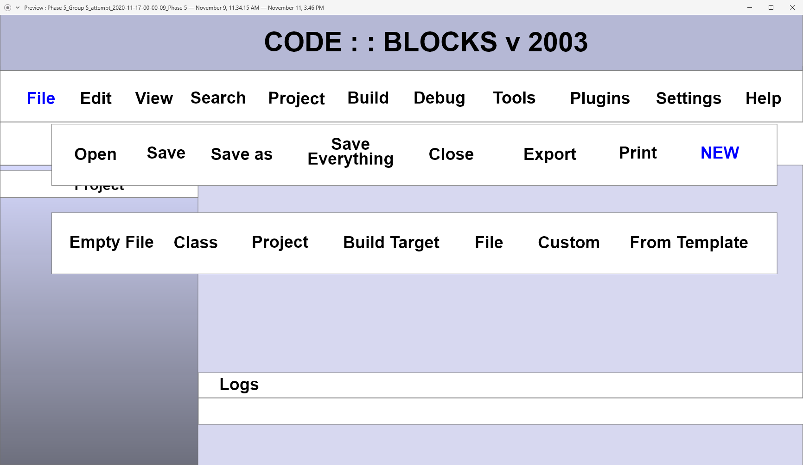

Picture 3:

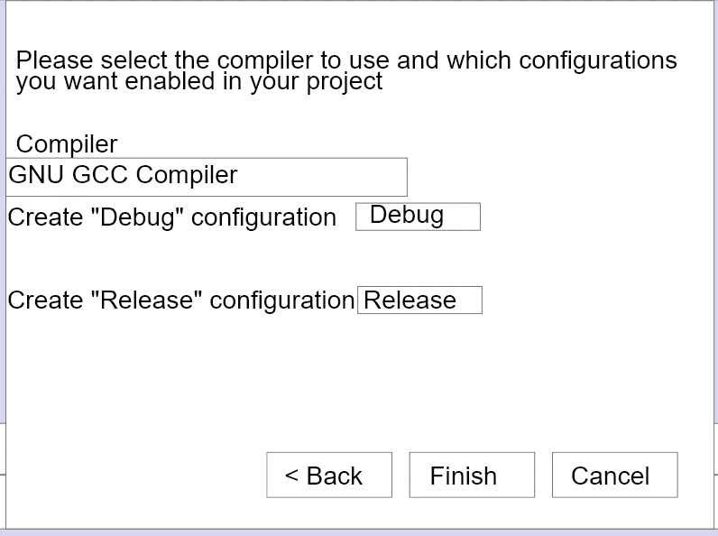
Picture 4:

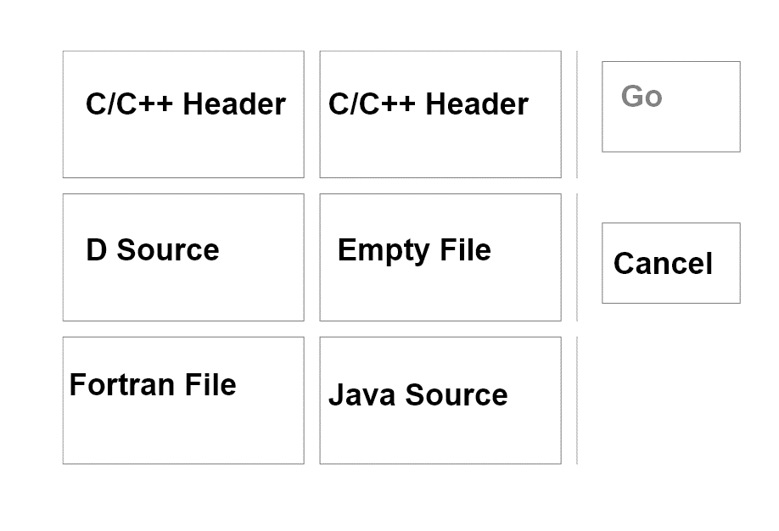

Picture 5:

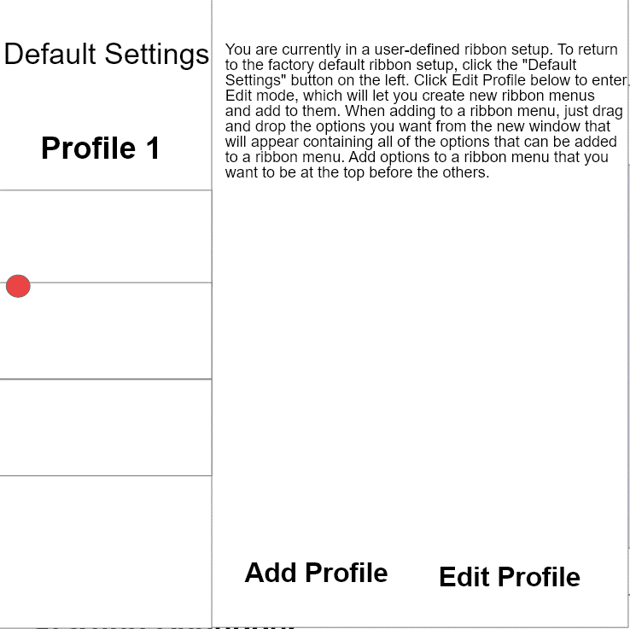

Picture 6:

