CIS/CSC384

HomeWork 4: Due Mar 24, 11:59 pm (via bb)

For each question, note down your confidence level between 0 – 10, with 0 indicating the lowest level of confidence and 10 indicating the highest level of confidence.

Consider the following three tables: PC, Laptop and Product, and the data as given.

model | speed | ram | hd | price
1001 | 2.66 | 1024 | 250 | 2114
1002 | 2.10 | 512 | 250 | 995
1003 | 1.42 | 512 | 80 | 478
1004 | 2.80 | 1024 | 250 | 649
1005 | 3.20 | 512 | 250 | 630
1006 | 3.20 | 1024 | 320 | 1049
1007 | 2.20 | 1024 | 200 | 510
1008 | 2.20 | 2048 | 250 | 770
1009 | 2.00 | 1024 | 250 | 650
1010 | 2.80 | 2048 | 300 | 770
1011 | 1.86 | 2048 | 160 | 959
1012 | 2.80 | 1024 | 160 | 649
1013 | 3.06 | 512 | 80 | 529

Sample Data for PC

model | speed | ram | hd | screen | price
2001 | 2.00 | 2048 | 240 | 20.1 | 3673
2002 | 1.73 | 1024 | 80 | 17.0 | 949
2003 | 1.80 | 512 | 60 | 15.4 | 549
2004 | 2.00 | 512 | 60 | 13.3 | 1150
2005 | 2.16 | 1024 | 120 | 17.0 | 2500
2006 | 2.00 | 2048 | 80 | 15.4 | 1700
2007 | 1.83 | 1024 | 120 | 13.3 | 1429
2008 | 1.60 | 1024 | 100 | 15.4 | 900
2009 | 1.60 | 512 | 80 | 14.1 | 680
2010 | 2.00 | 2048 | 160 | 15.4 | 2300

Sample Data for Laptop

maker | model | type
A | 1001 | PC
A | 1002 | PC
A | 1003 | PC
A | 2004 | Laptop
A | 2005 | Laptop
A | 2006 | Laptop
B | 1004 | PC
B | 1005 | PC
B | 1006 | PC
B | 2007 | Laptop
C | 1007 | PC
D | 1008 | PC
D | 1009 | PC
D | 1010 | PC
D | 3004 | Printer
D | 3005 | Printer
E | 1011 | PC
E | 1012 | PC
E | 1013 | PC
E | 2001 | Laptop
E | 2002 | Laptop
E | 2003 | Laptop
E | 3001 | Printer
E | 3002 | Printer
E | 3003 | Printer
F | 2008 | Laptop
F | 2009 | Laptop
G | 2010 | Laptop
H | 3006 | Printer
H | 3007 | Printer

Sample Data for Product

Compute the results for the plans below, for each of the steps labeled with a number. When reporting the result, you must include the names of the columns of each result table, along with the data.
Note: You can report your confidence level for each of the steps for each question (or) you can report one confidence level for all the steps for a question.

Plan 1: Compute the results for steps labeled (1) ... (7) [5 pts]

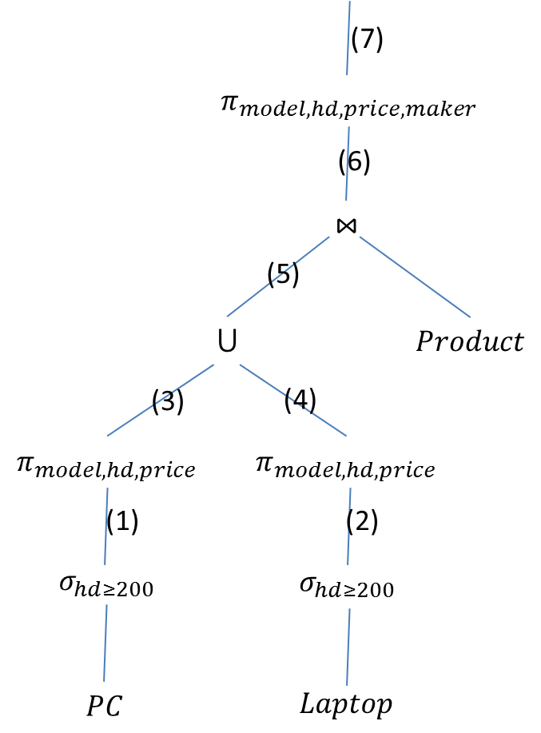
TOTAL CONFIDENCE (9/10)

- SELECT * FROM PC WHERE hd >= 200;
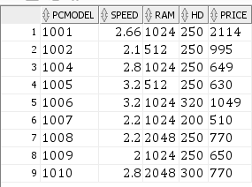
- SELECT * FROM Laptop WHERE hd >= 200;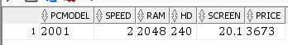
- SELECT pcmodel, hd, price FROM (SELECT * FROM PC WHERE hd >= 200); 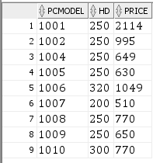
- SELECT pcmodel, hd, price FROM (SELECT * FROM Laptop WHERE hd >= 200); 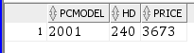
- (SELECT pcmodel, hd, price FROM (SELECT * FROM PC WHERE hd >= 200))UNION(SELECT pcmodel, hd, price FROM (SELECT * FROM Laptop WHERE hd >= 200)); 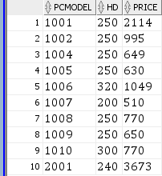
- SELECT * FROM ((SELECT pcmodel, hd, price FROM (SELECT * FROM PC WHERE hd >= 200)) UNION (SELECT pcmodel, hd, price FROM (SELECT * FROM Laptop WHERE hd >= 200))) NATURAL JOIN PRODUCT;
- SELECT pcmodel, hd, price, maker FROM (SELECT * FROM((SELECT pcmodel, hd, price FROM (SELECT * FROM PC WHERE hd >= 200)) UNION (SELECT pcmodel, hd, price FROM (SELECT * FROM Laptop WHERE hd >= 200))) NATURAL JOIN PRODUCT);
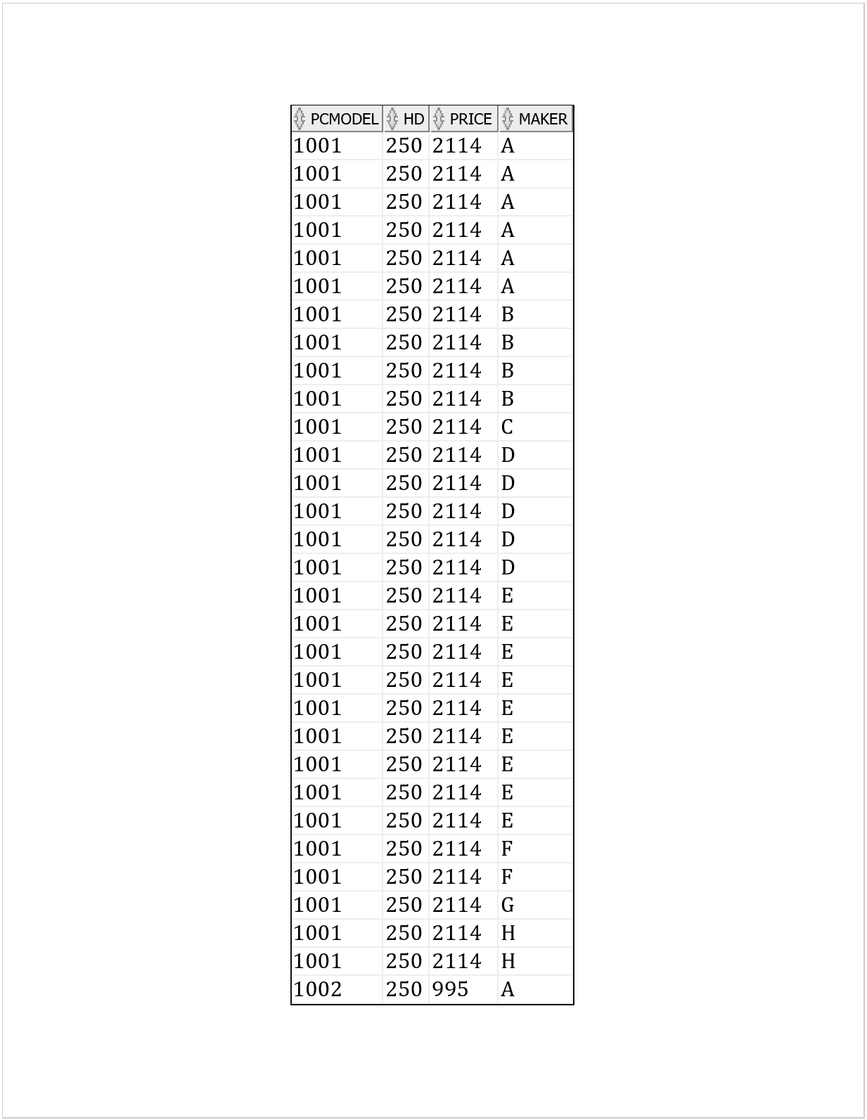
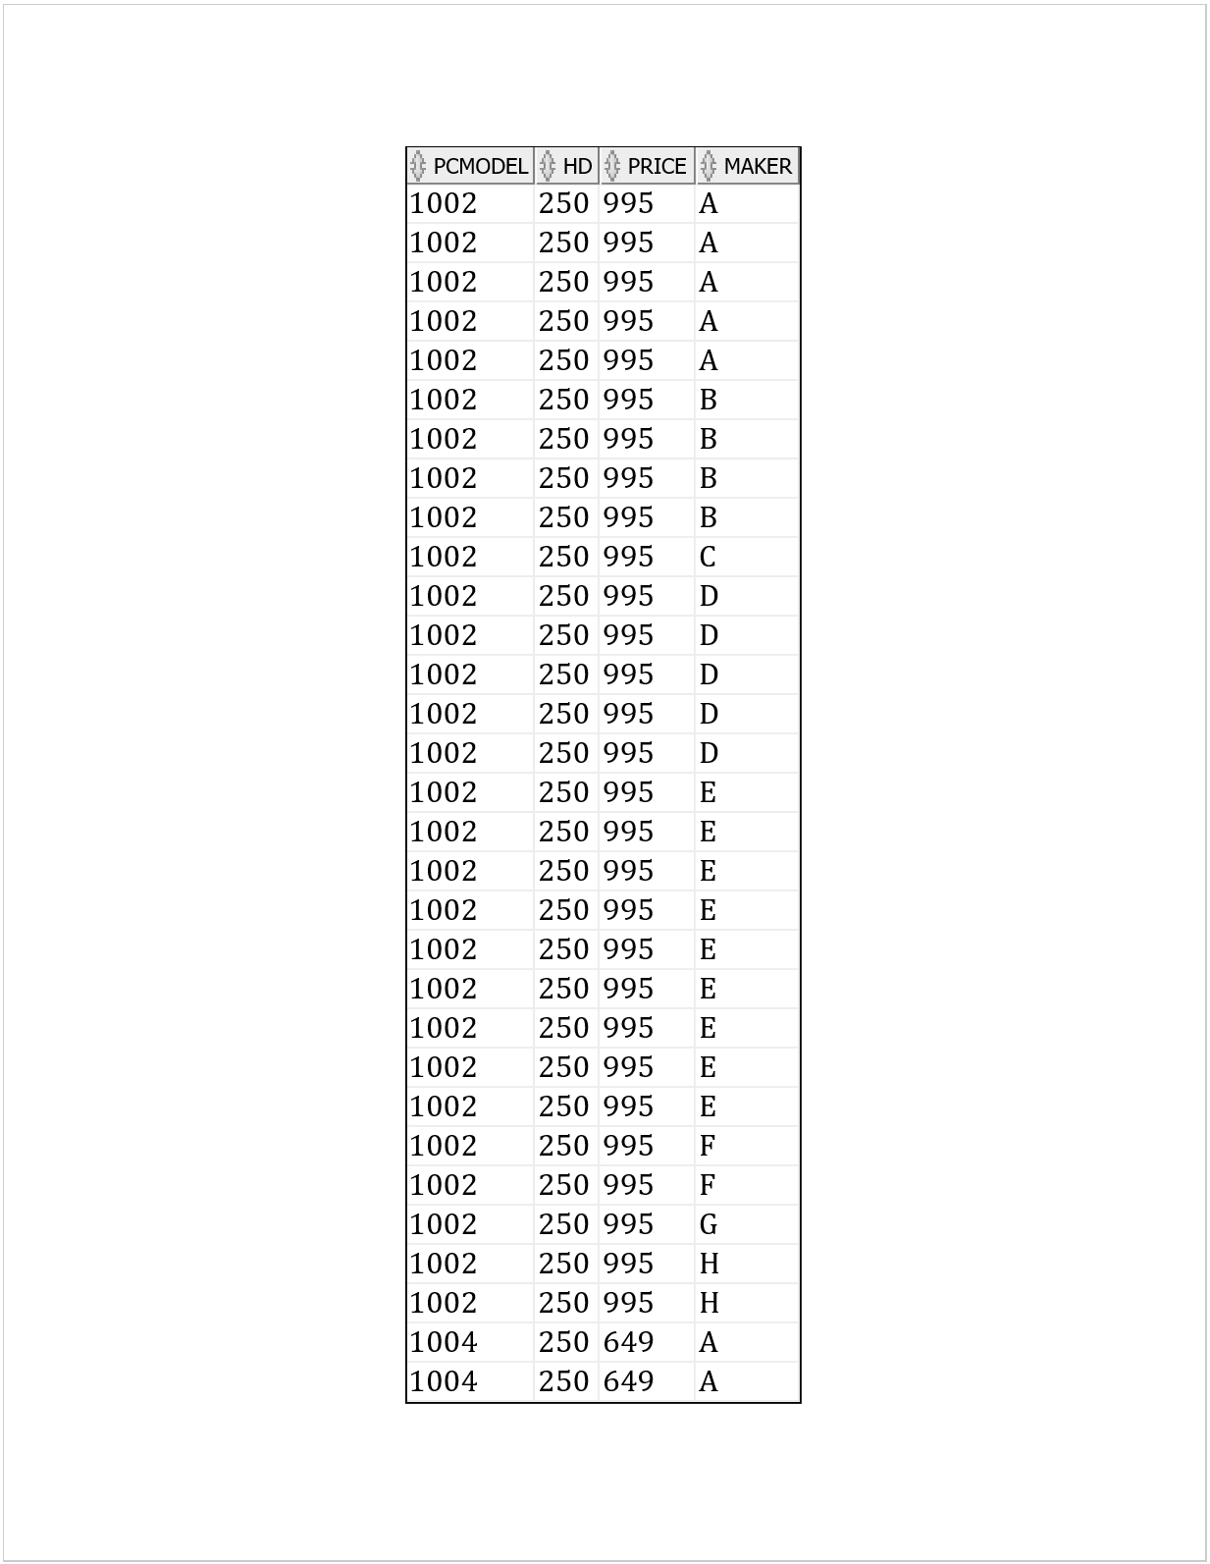
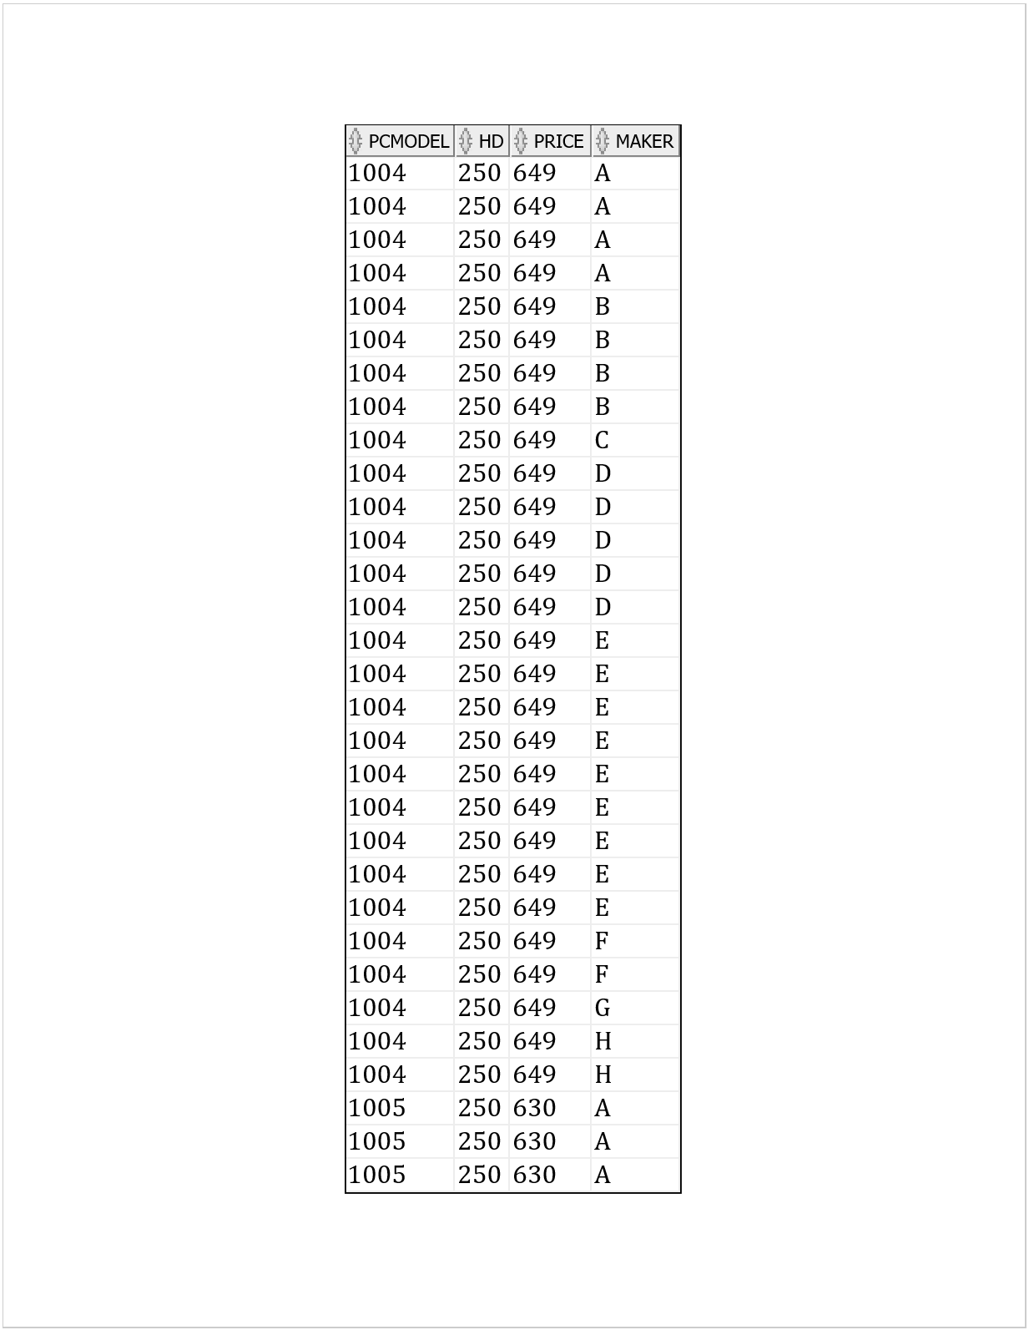
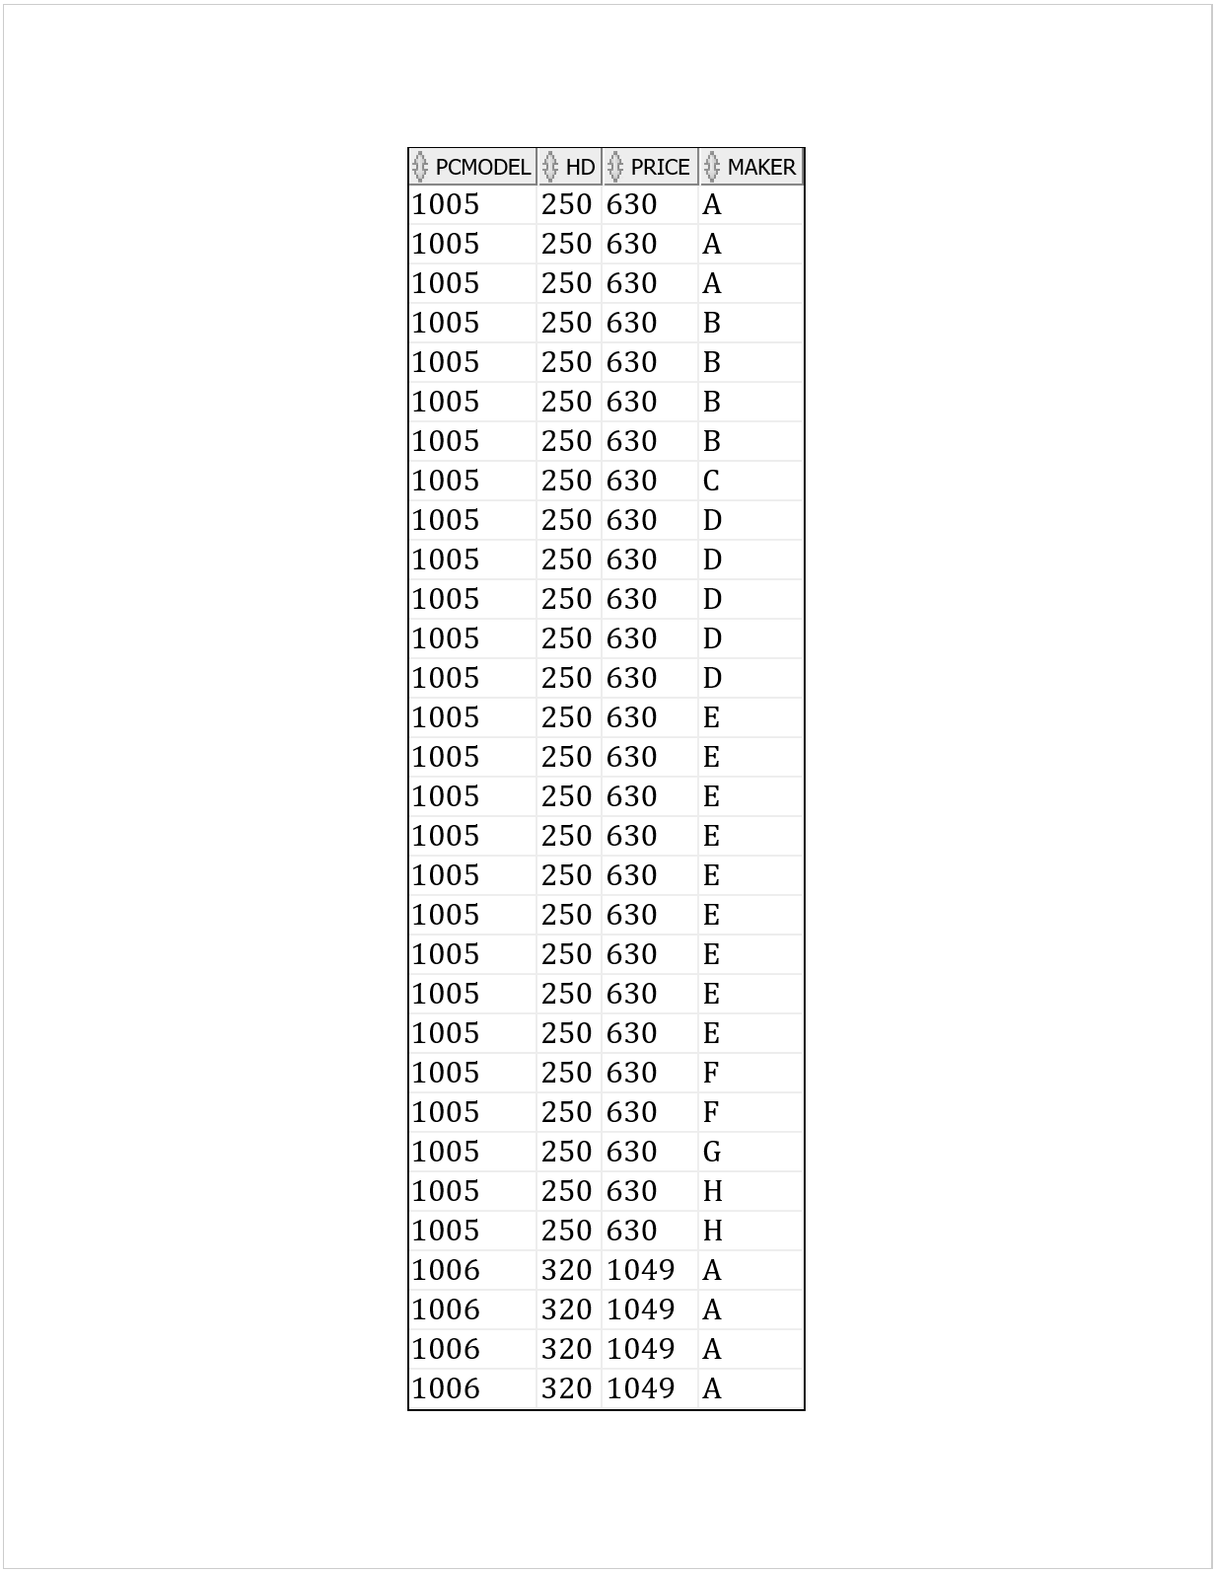
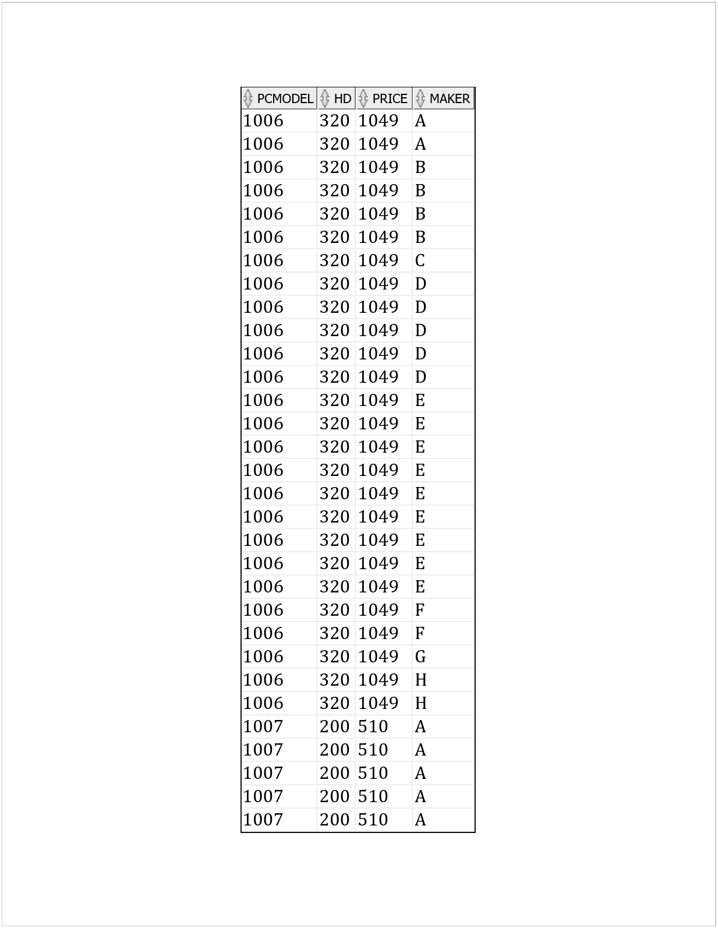
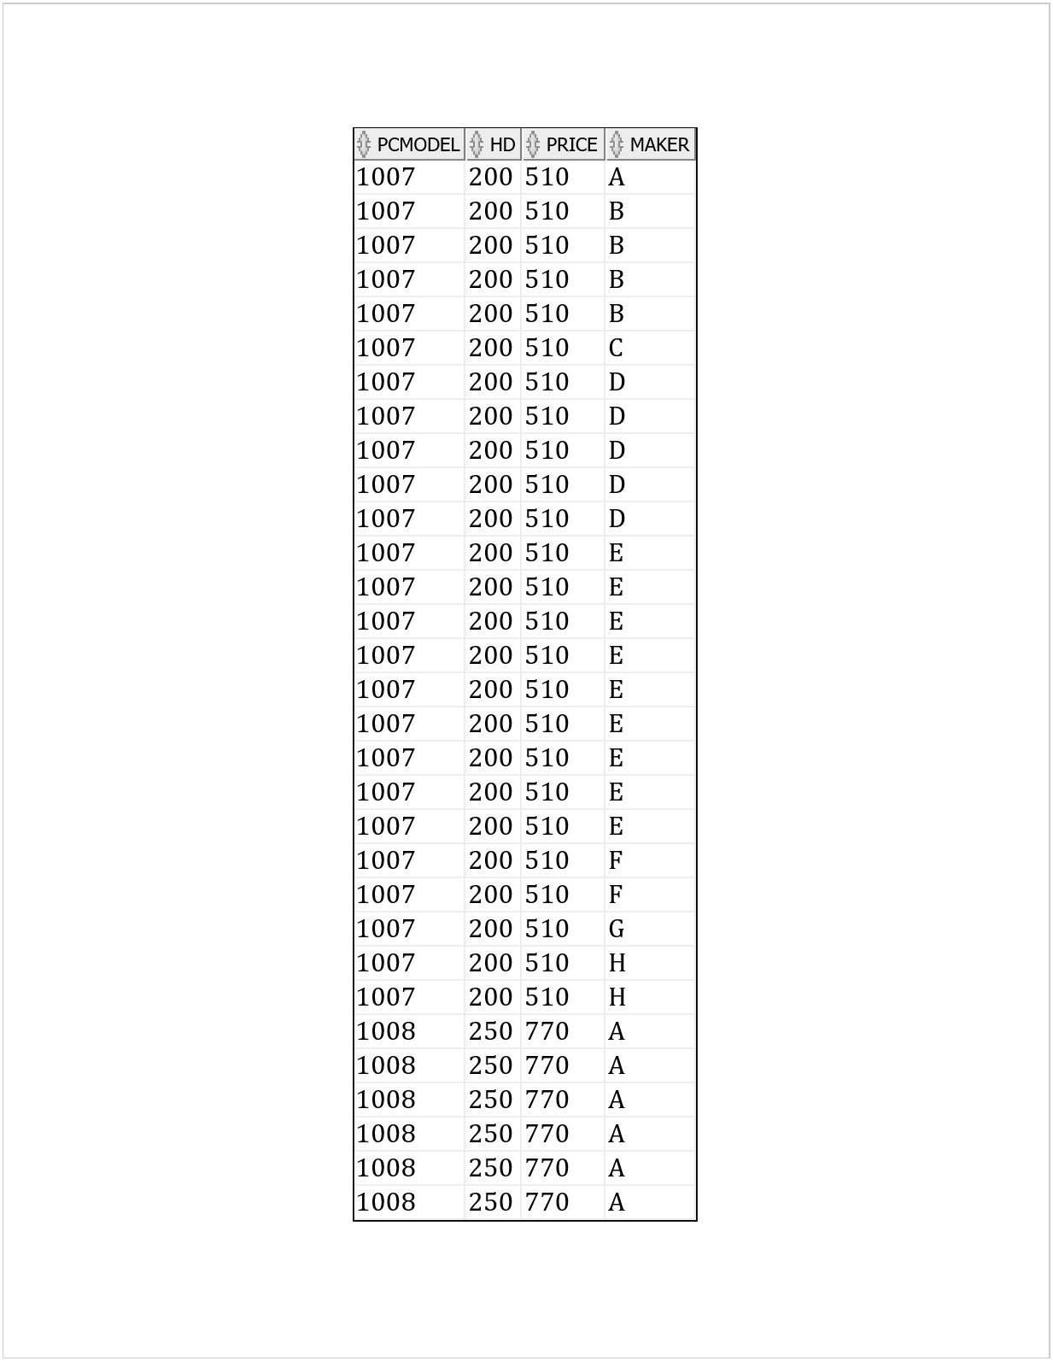
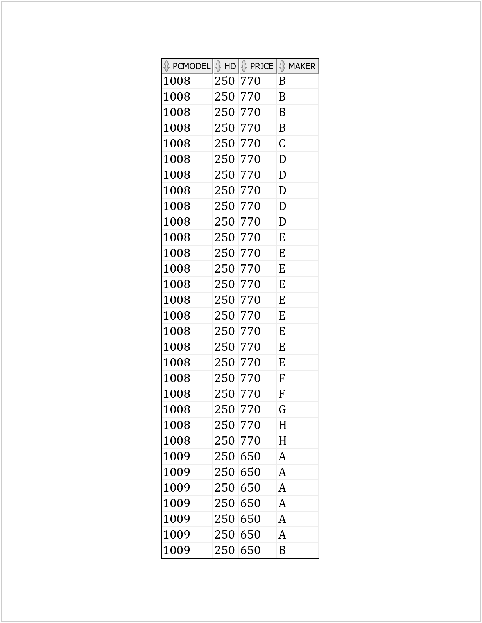
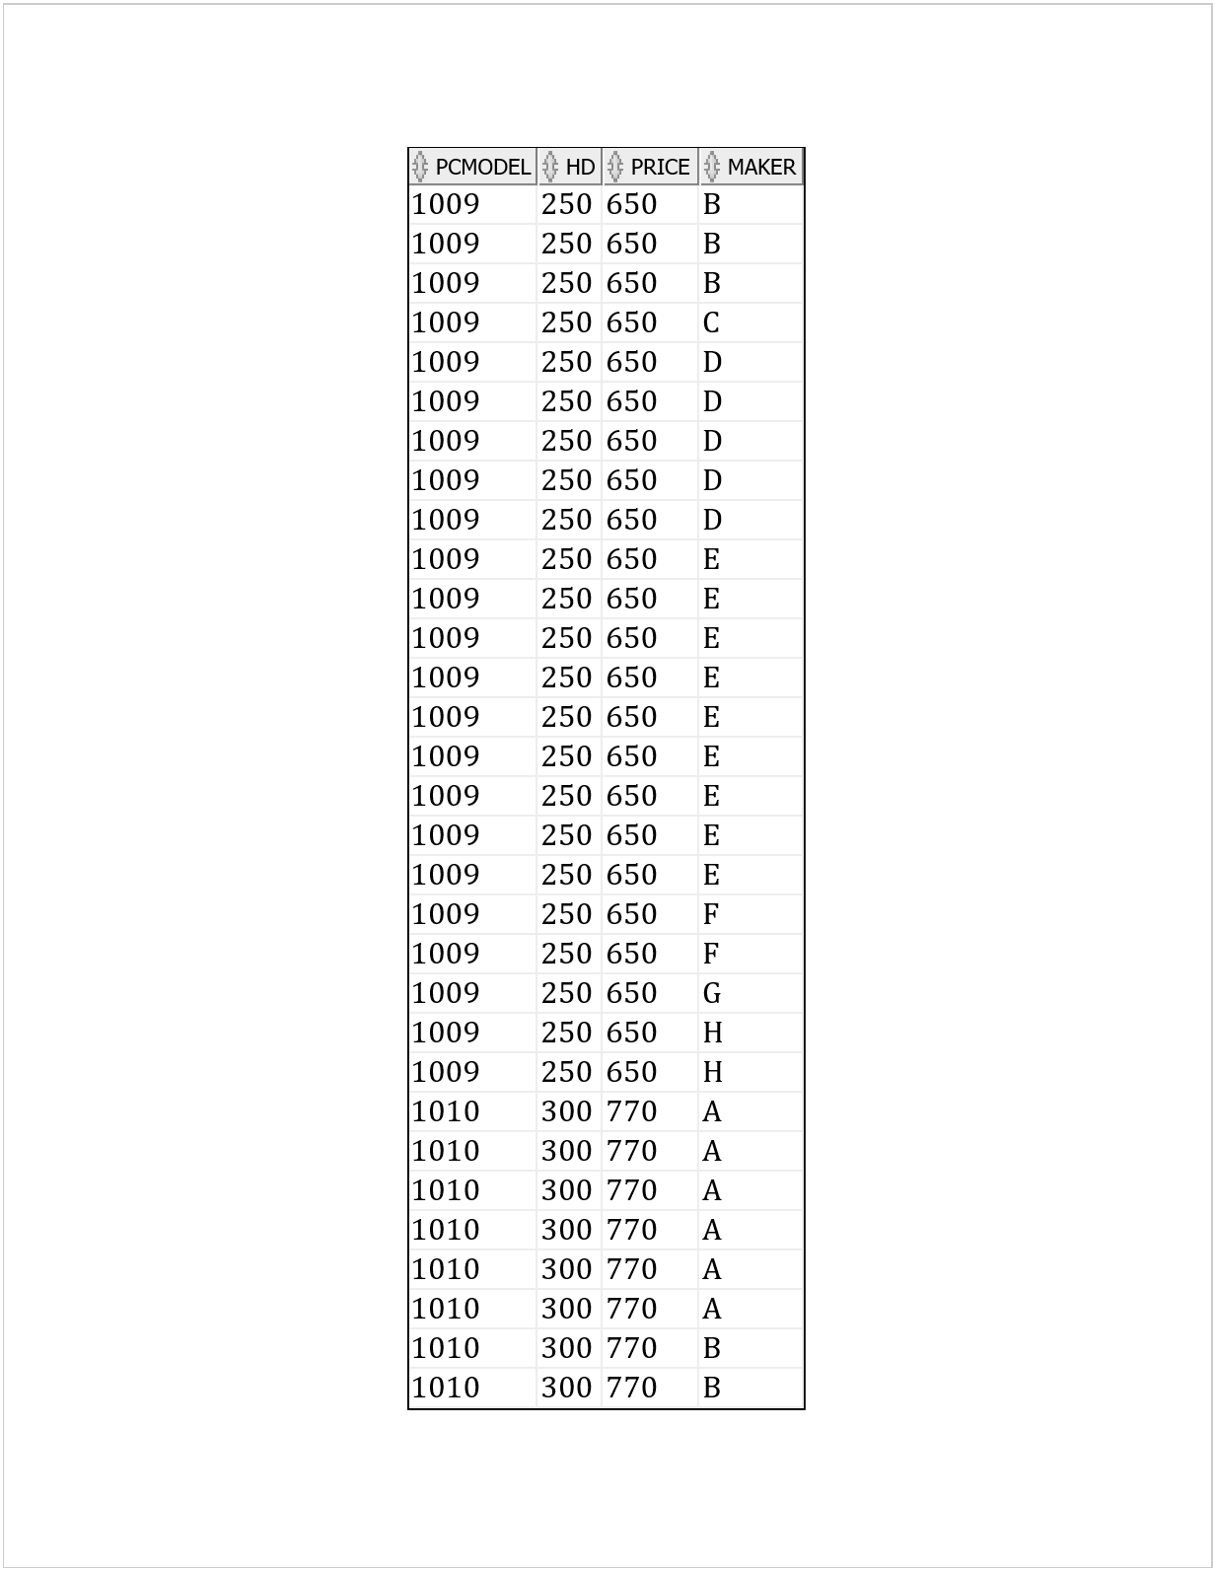
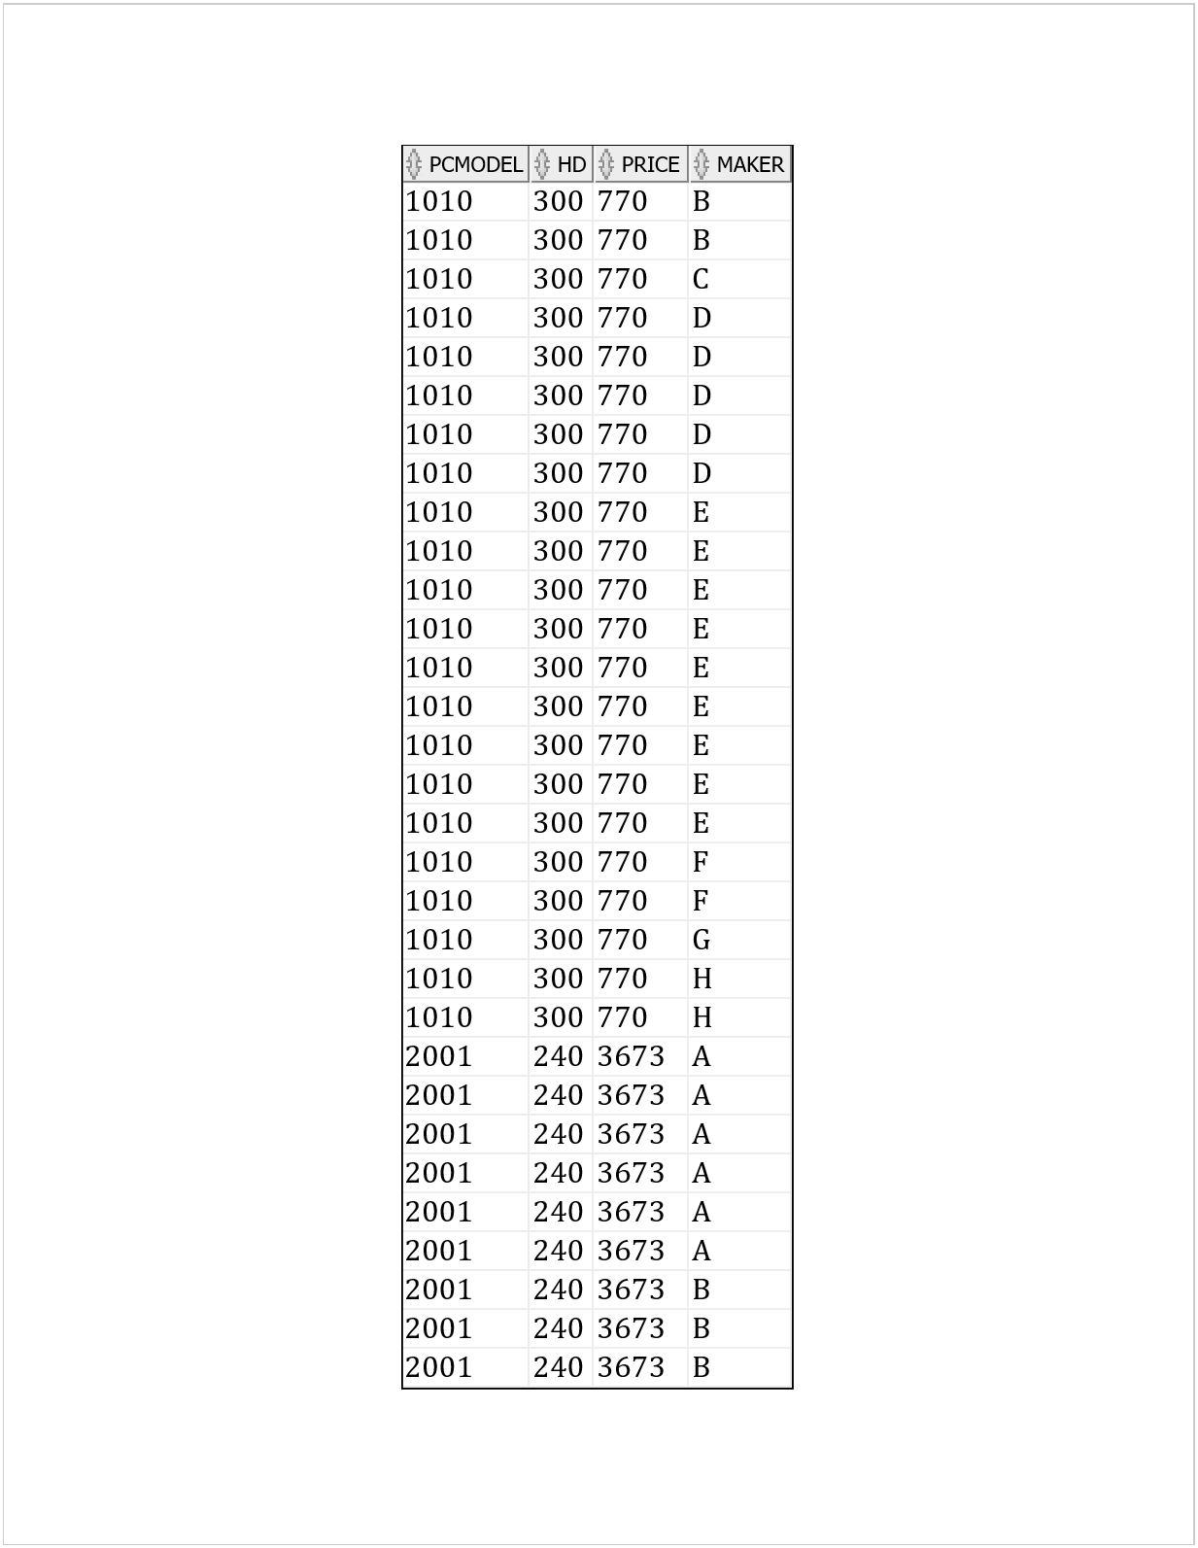
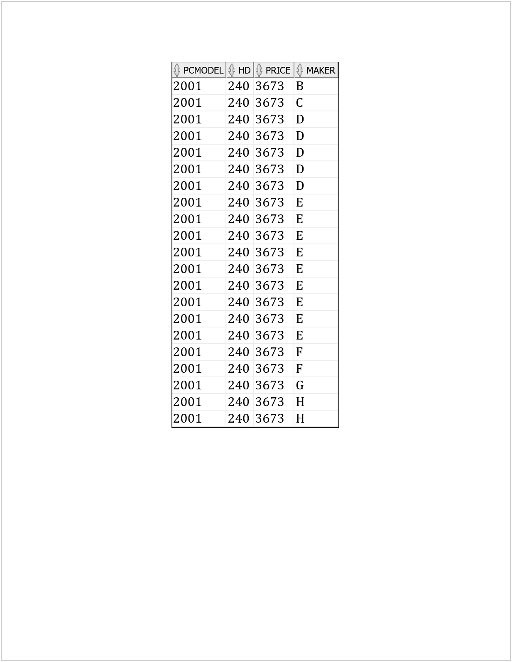

UNIQUE SOLUTIONS ---------
SELECT DISTINCT pcmodel, hd, price, maker FROM
(SELECT * FROM
((SELECT pcmodel, hd, price FROM (
SELECT * FROM PC WHERE hd >= 200))
UNION
(SELECT pcmodel, hd, price FROM (
SELECT * FROM Laptop WHERE hd >= 200)))
NATURAL JOIN
PRODUCT);

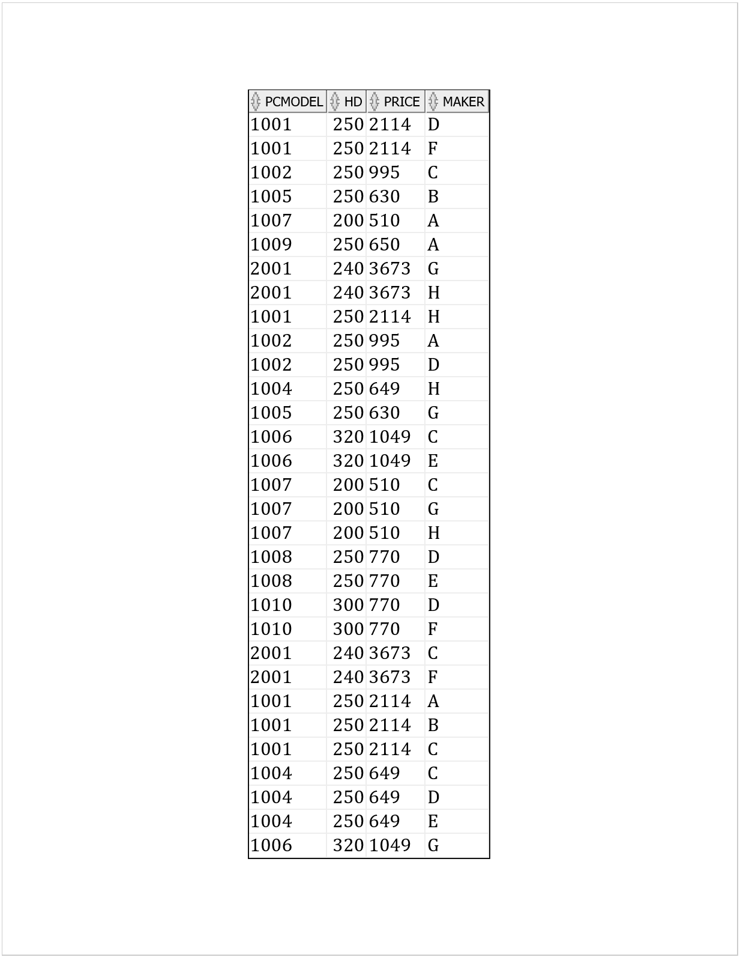
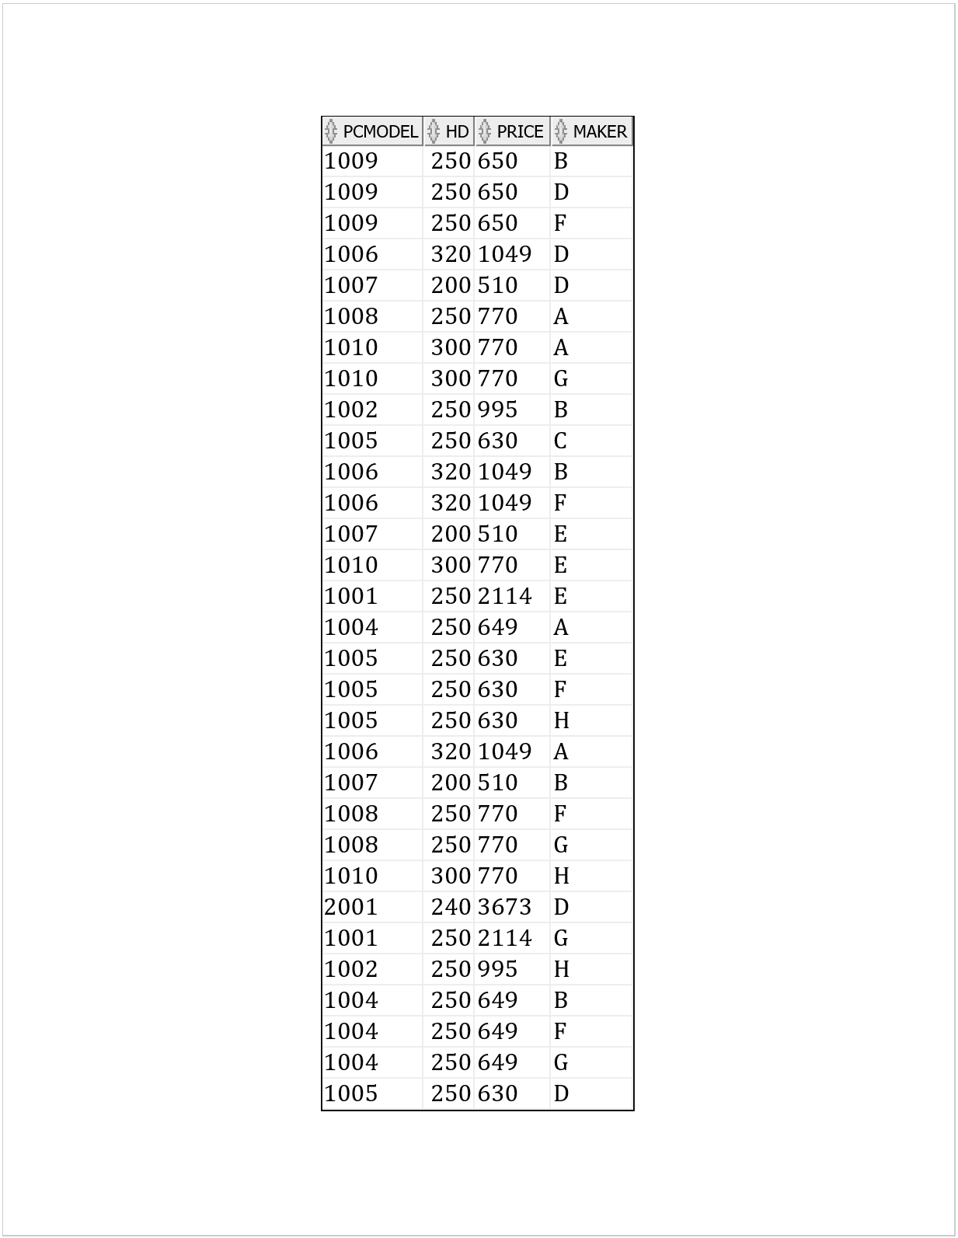
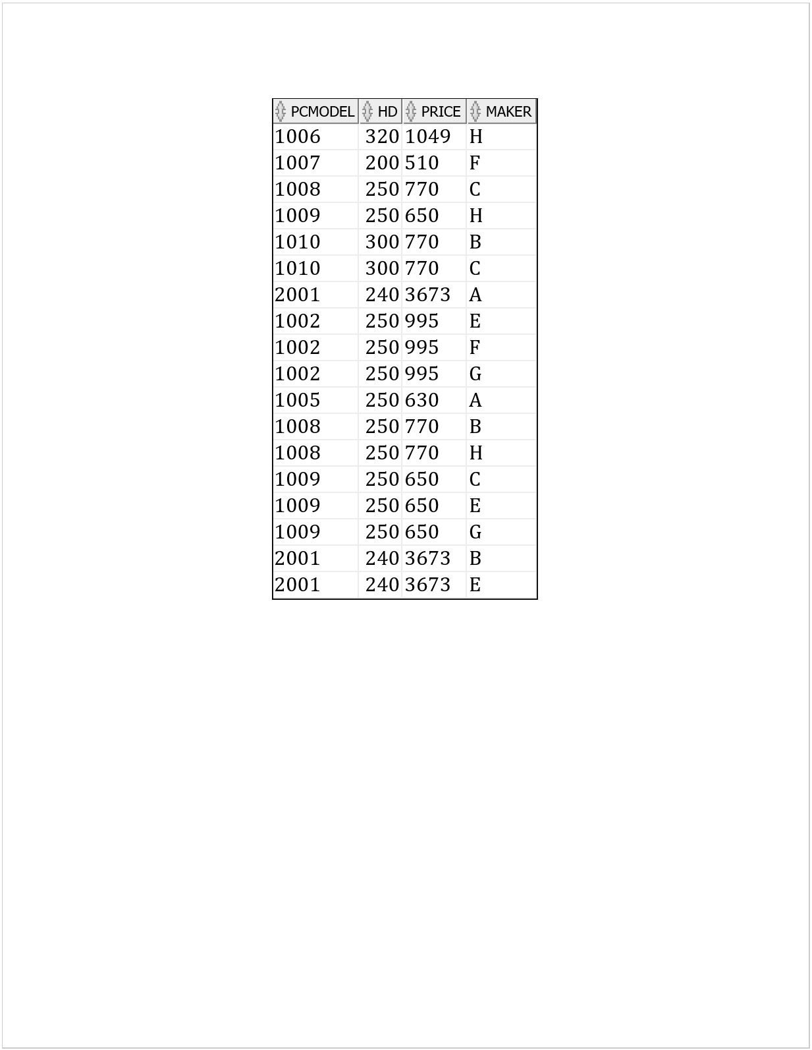

Plan 2: Compute the results for steps labeled (1) … (7) [5 pts]

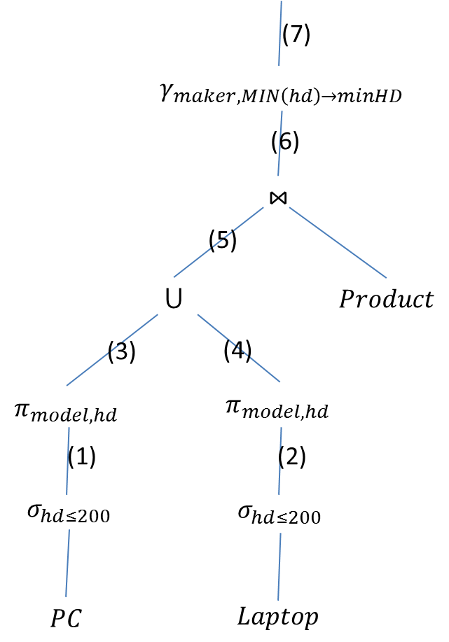
OVERALL CONFIDENCE (9/10)

- SELECT * FROM PC WHERE hd <= 200; 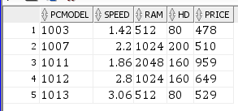
- SELECT * FROM Laptop WHERE hd <= 200; 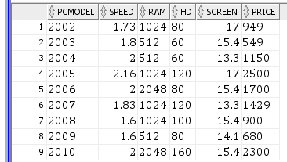
- SELECT pcmodel, hd FROM (SELECT * FROM PC WHERE hd <= 200); 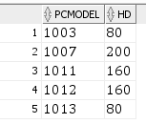
- SELECT pcmodel, hd FROM (SELECT * FROM Laptop WHERE hd <= 200); 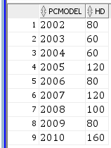
- (SELECT pcmodel, hd FROM (SELECT * FROM PC WHERE hd <= 200)) UNION (SELECT pcmodel, hd FROM (SELECT * FROM Laptop WHERE hd <= 200)); 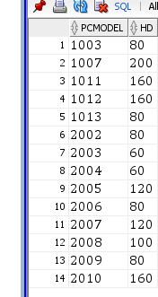
- SELECT * FROM ((SELECT pcmodel, hd FROM (SELECT * FROM PC WHERE hd <= 200)) UNION (SELECT pcmodel, hd FROM (SELECT * FROM Laptop WHERE hd <= 200))) NATURAL JOIN PRODUCT; 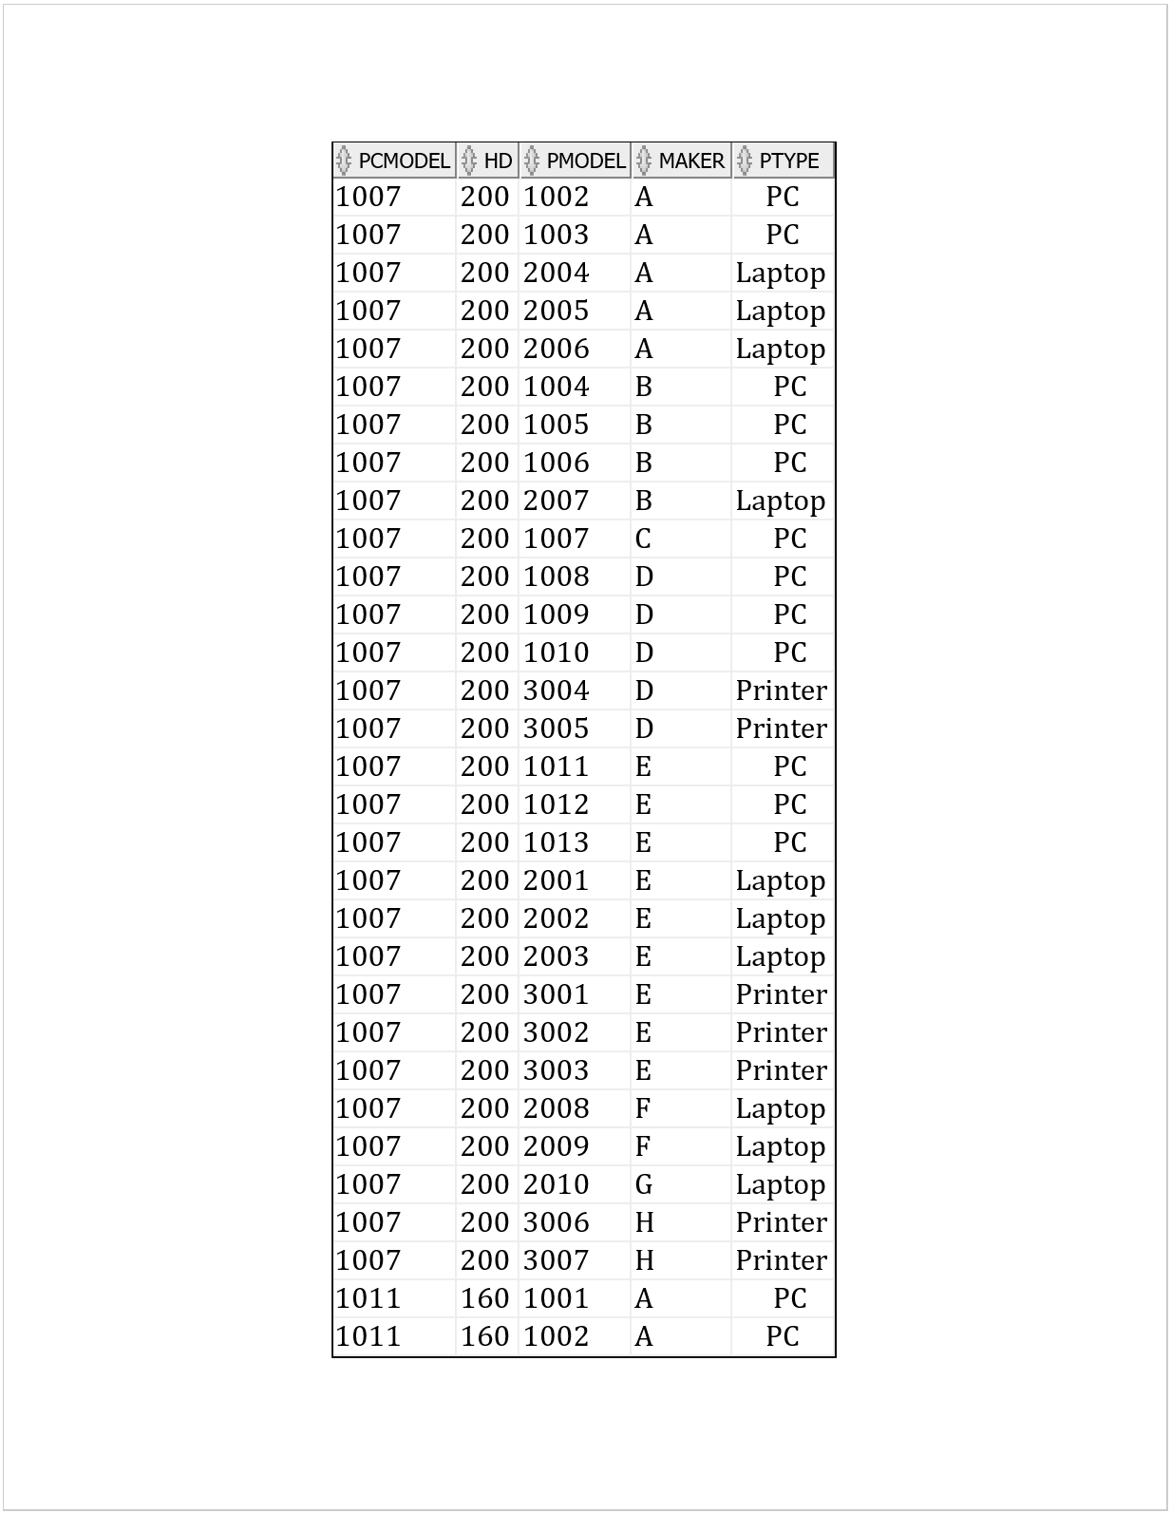
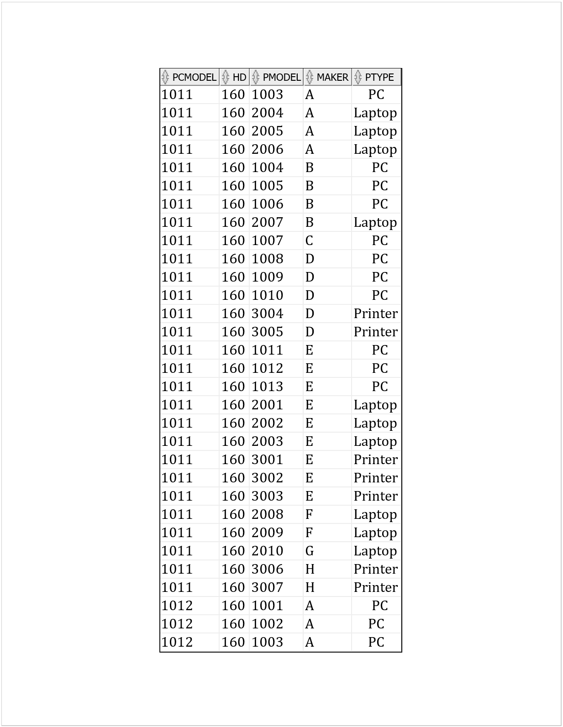
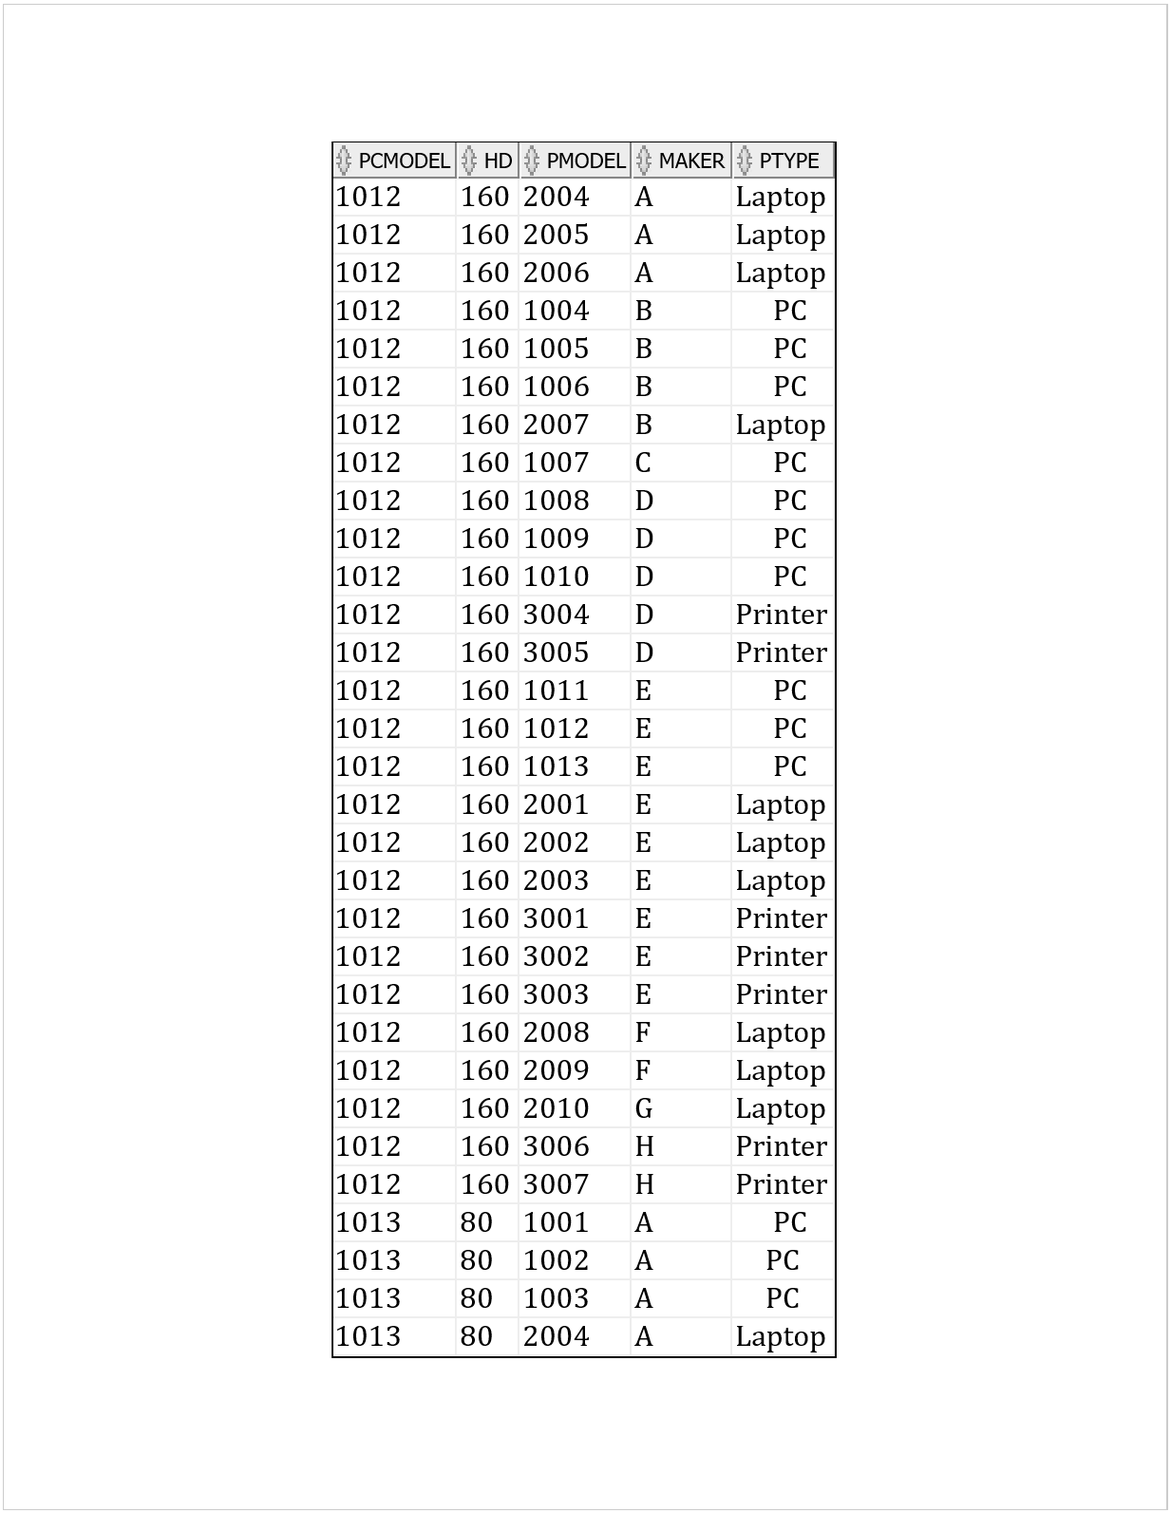
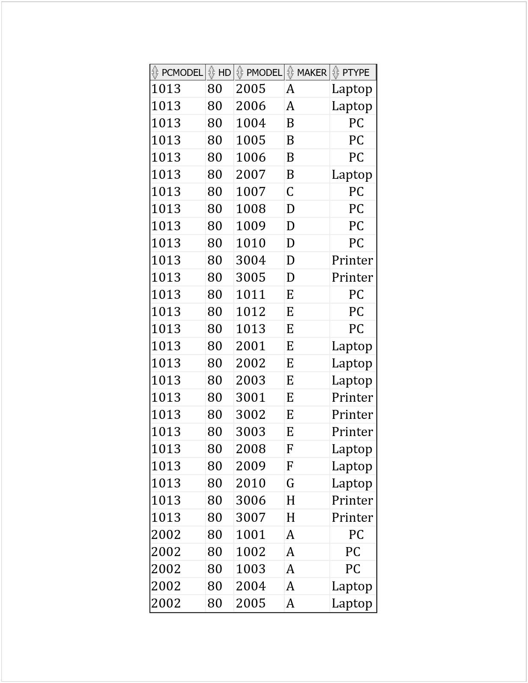
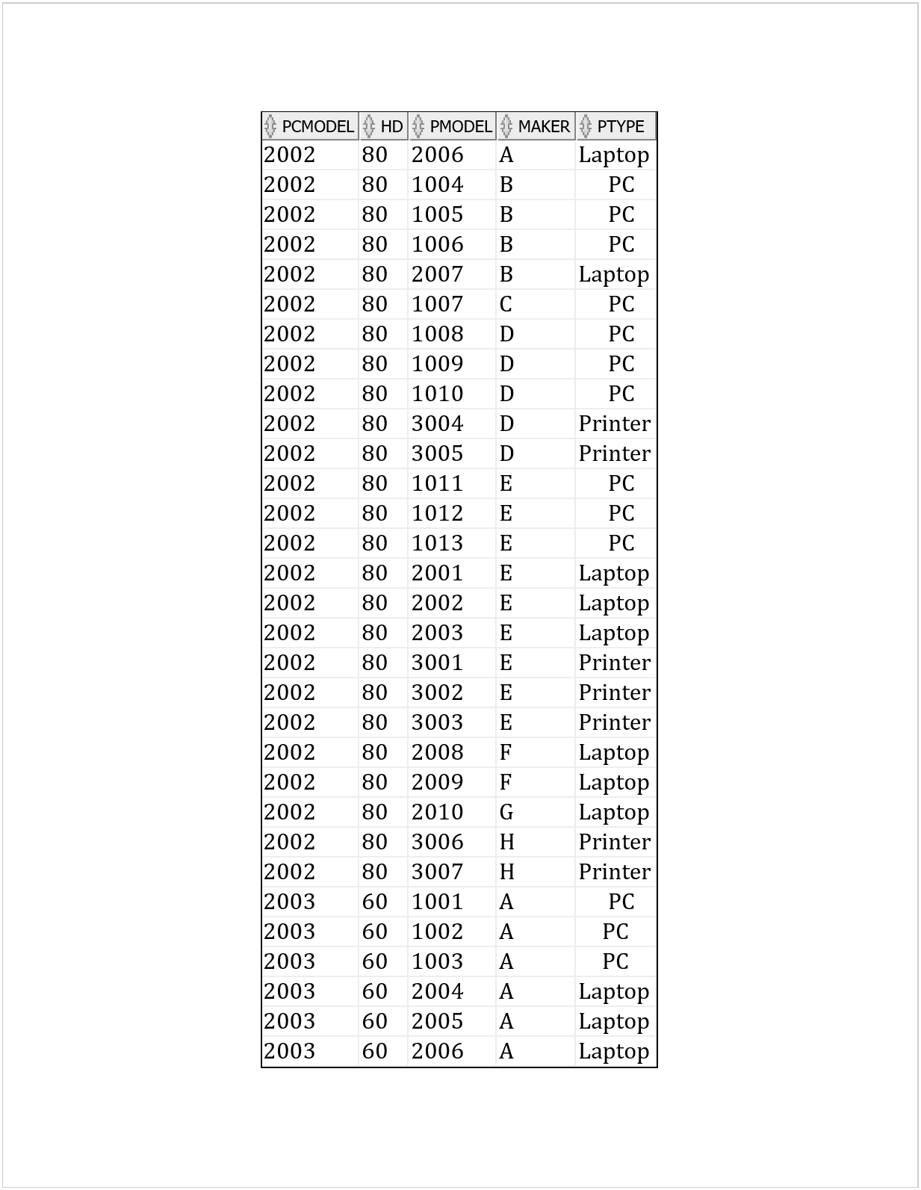
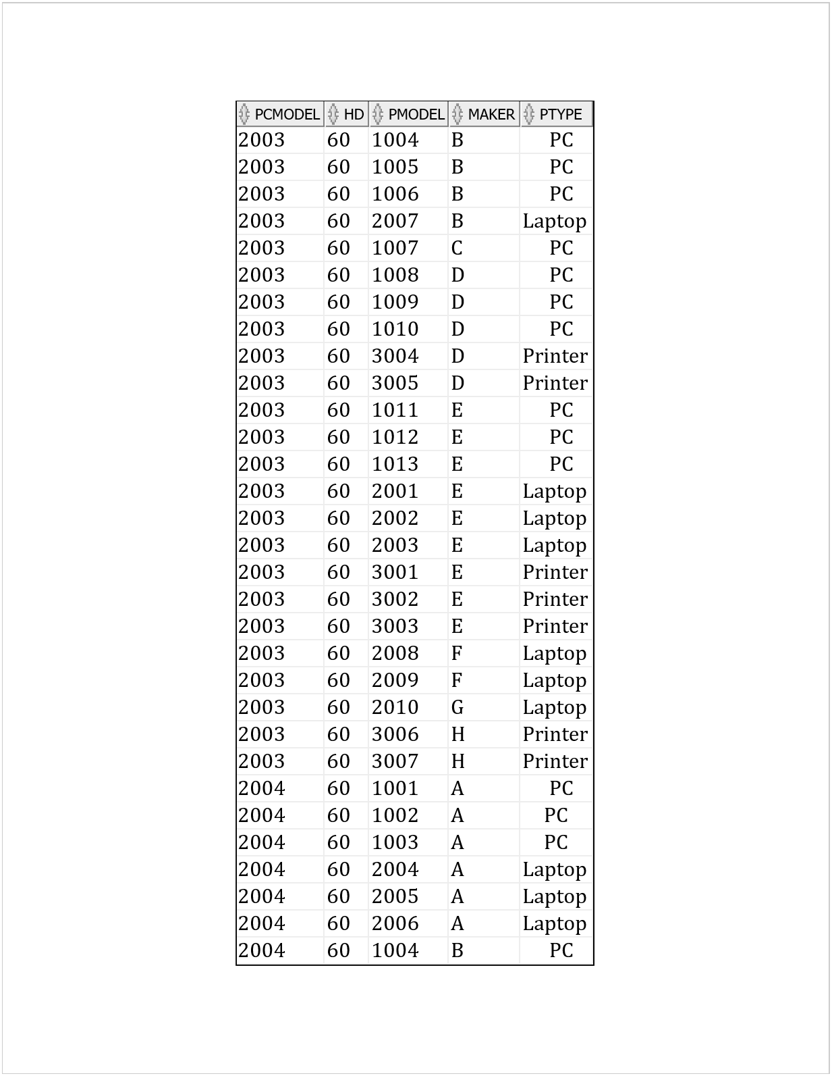
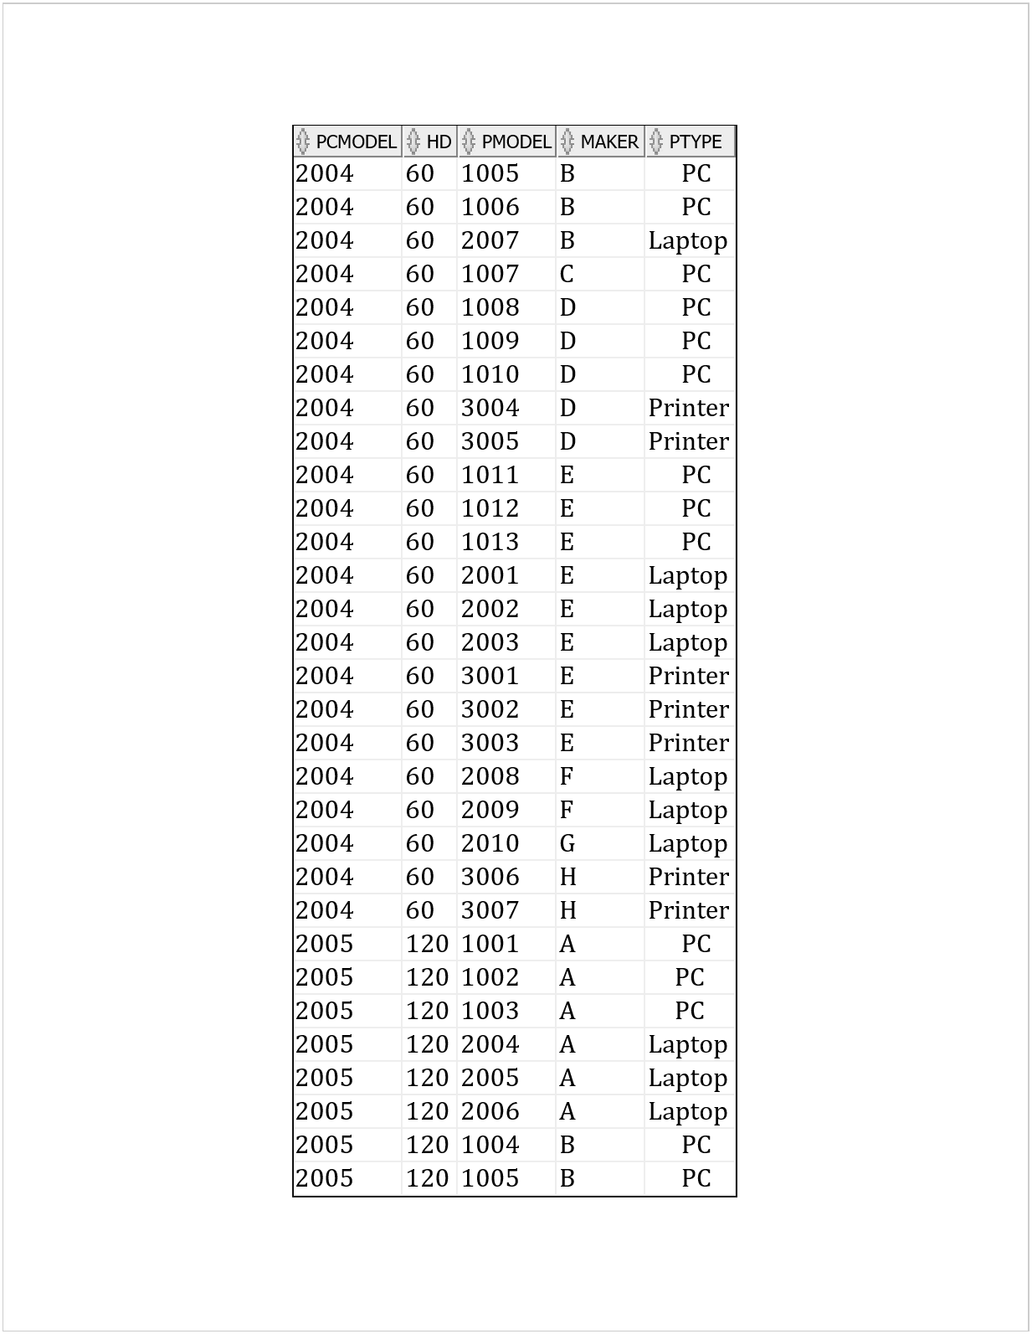
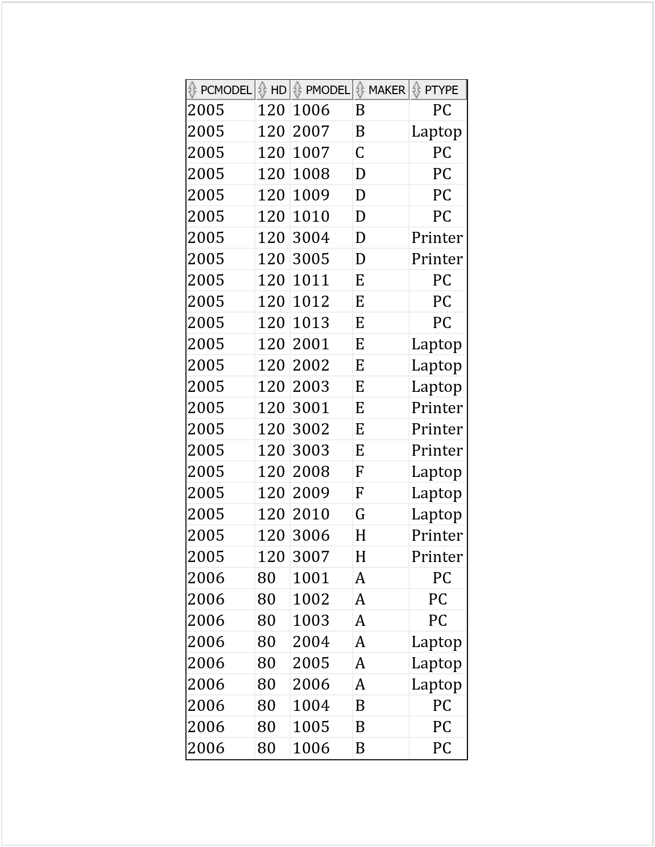
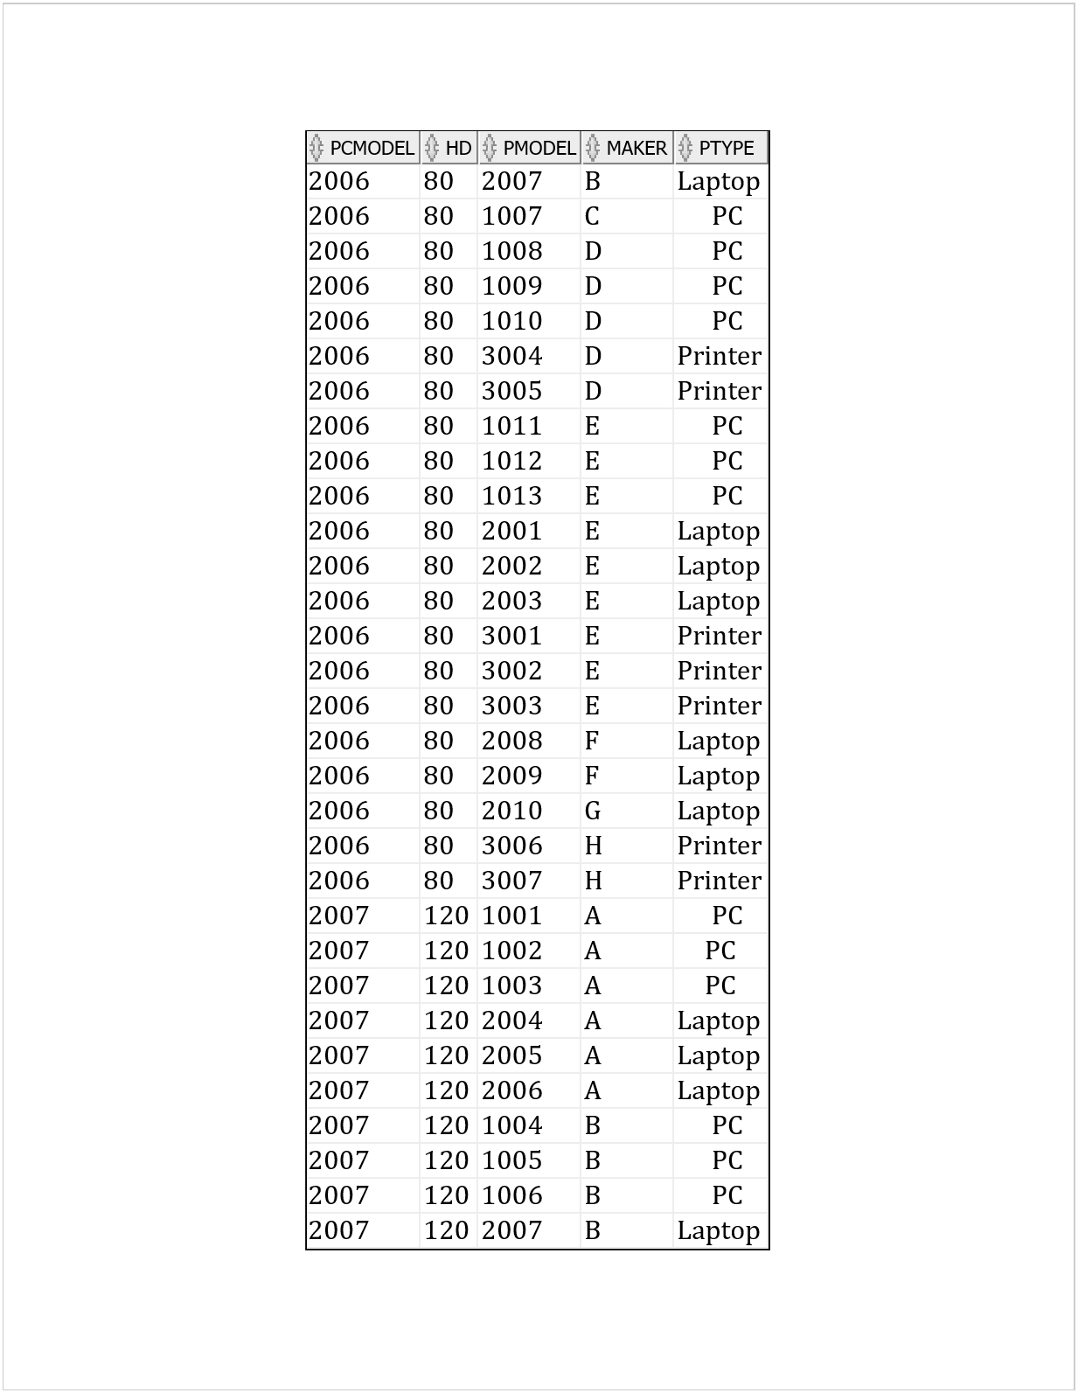
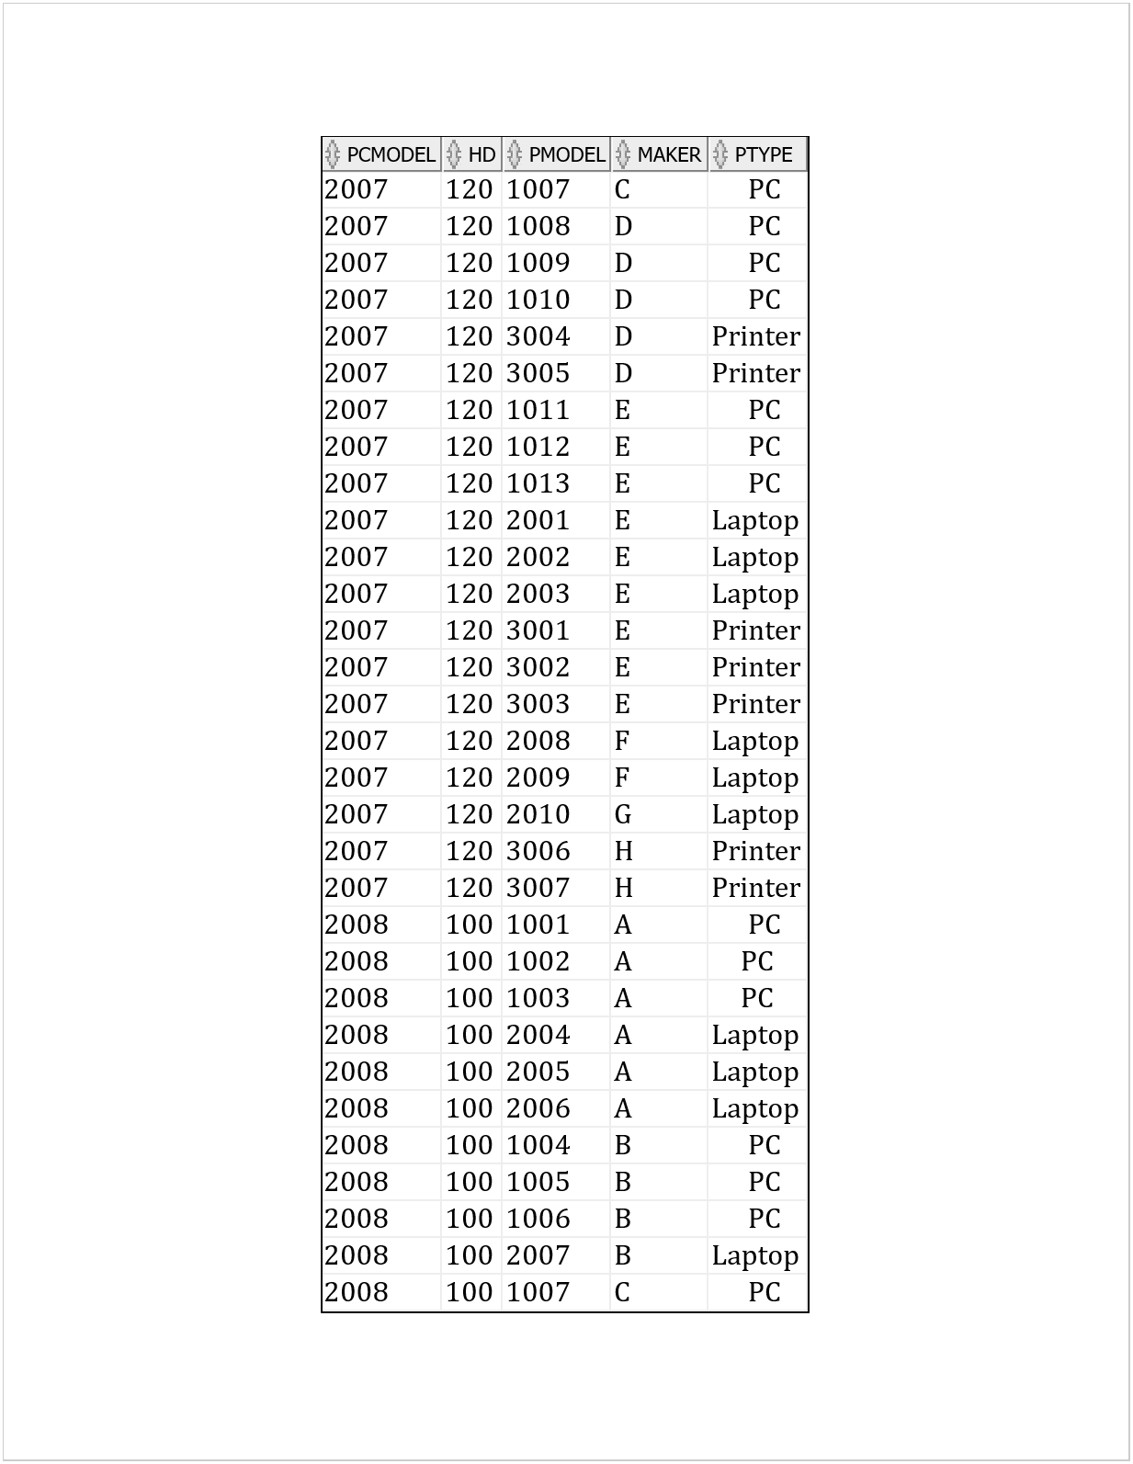
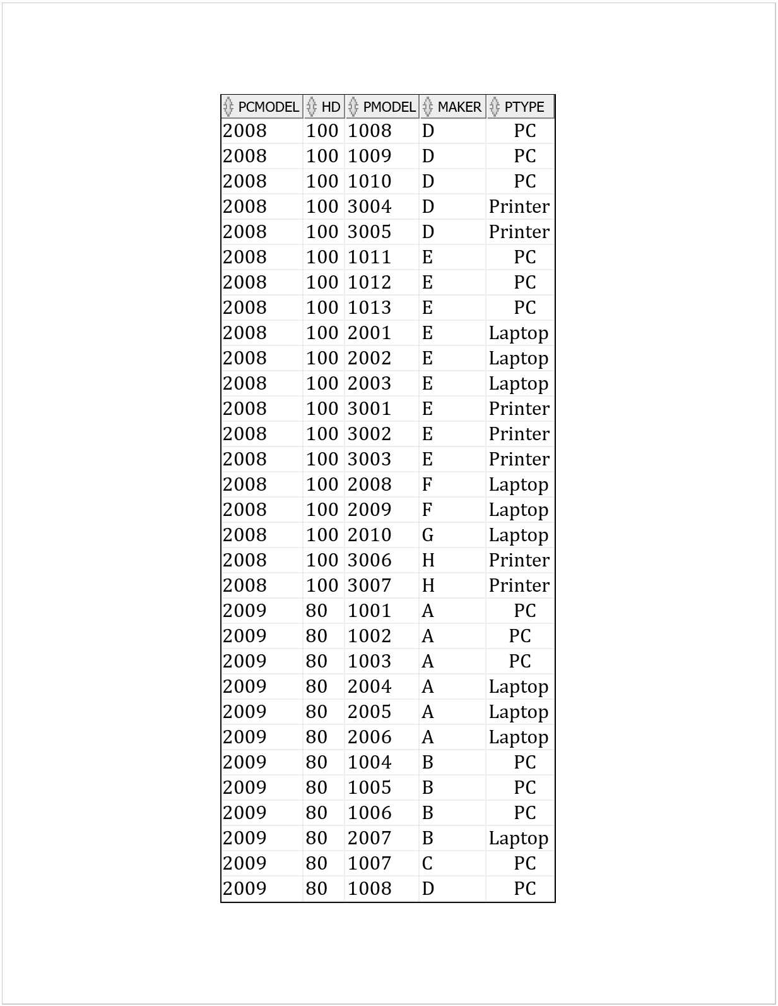
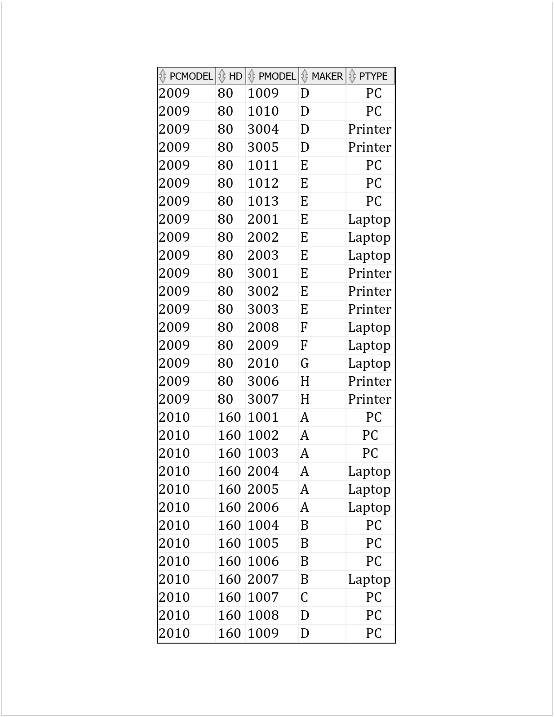
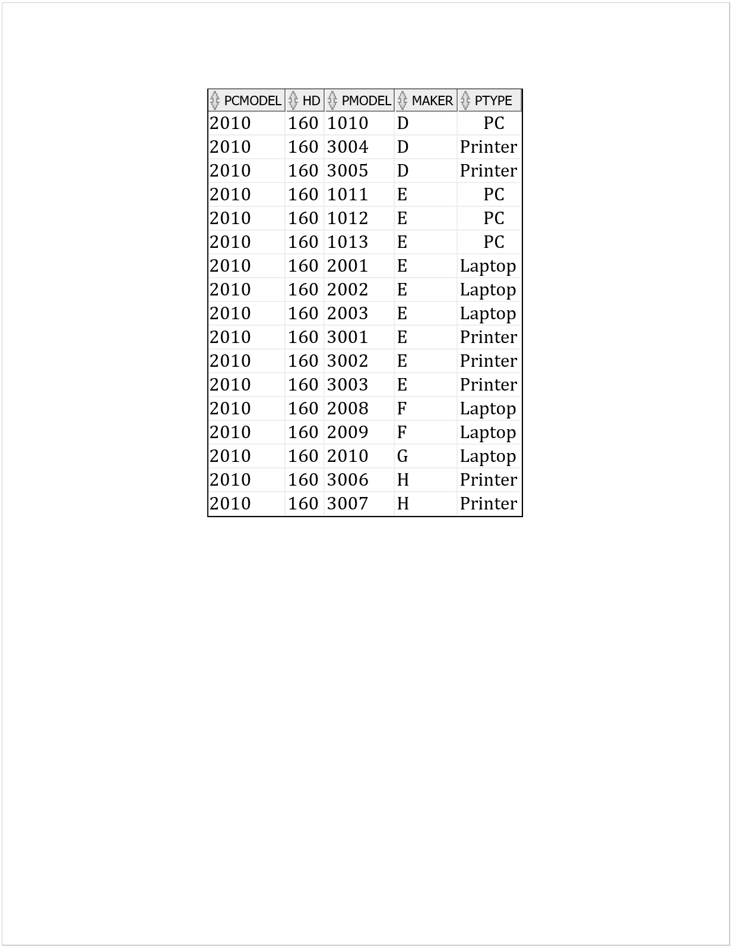
- SELECT maker, hd AS minhd FROM (SELECT * FROM ((SELECT pcmodel, hd FROM (SELECT * FROM PC WHERE hd <= 200)) UNION (SELECT pcmodel, hd FROM (SELECT * FROM Laptop WHERE hd <= 200))) NATURAL JOIN PRODUCT) WHERE hd <= ALL (SELECT hd FROM ((SELECT pcmodel, hd FROM (SELECT * FROM PC WHERE hd <= 200)) UNION (SELECT pcmodel, hd FROM (SELECT * FROM Laptop WHERE hd <= 200))) NATURAL JOIN PRODUCT);
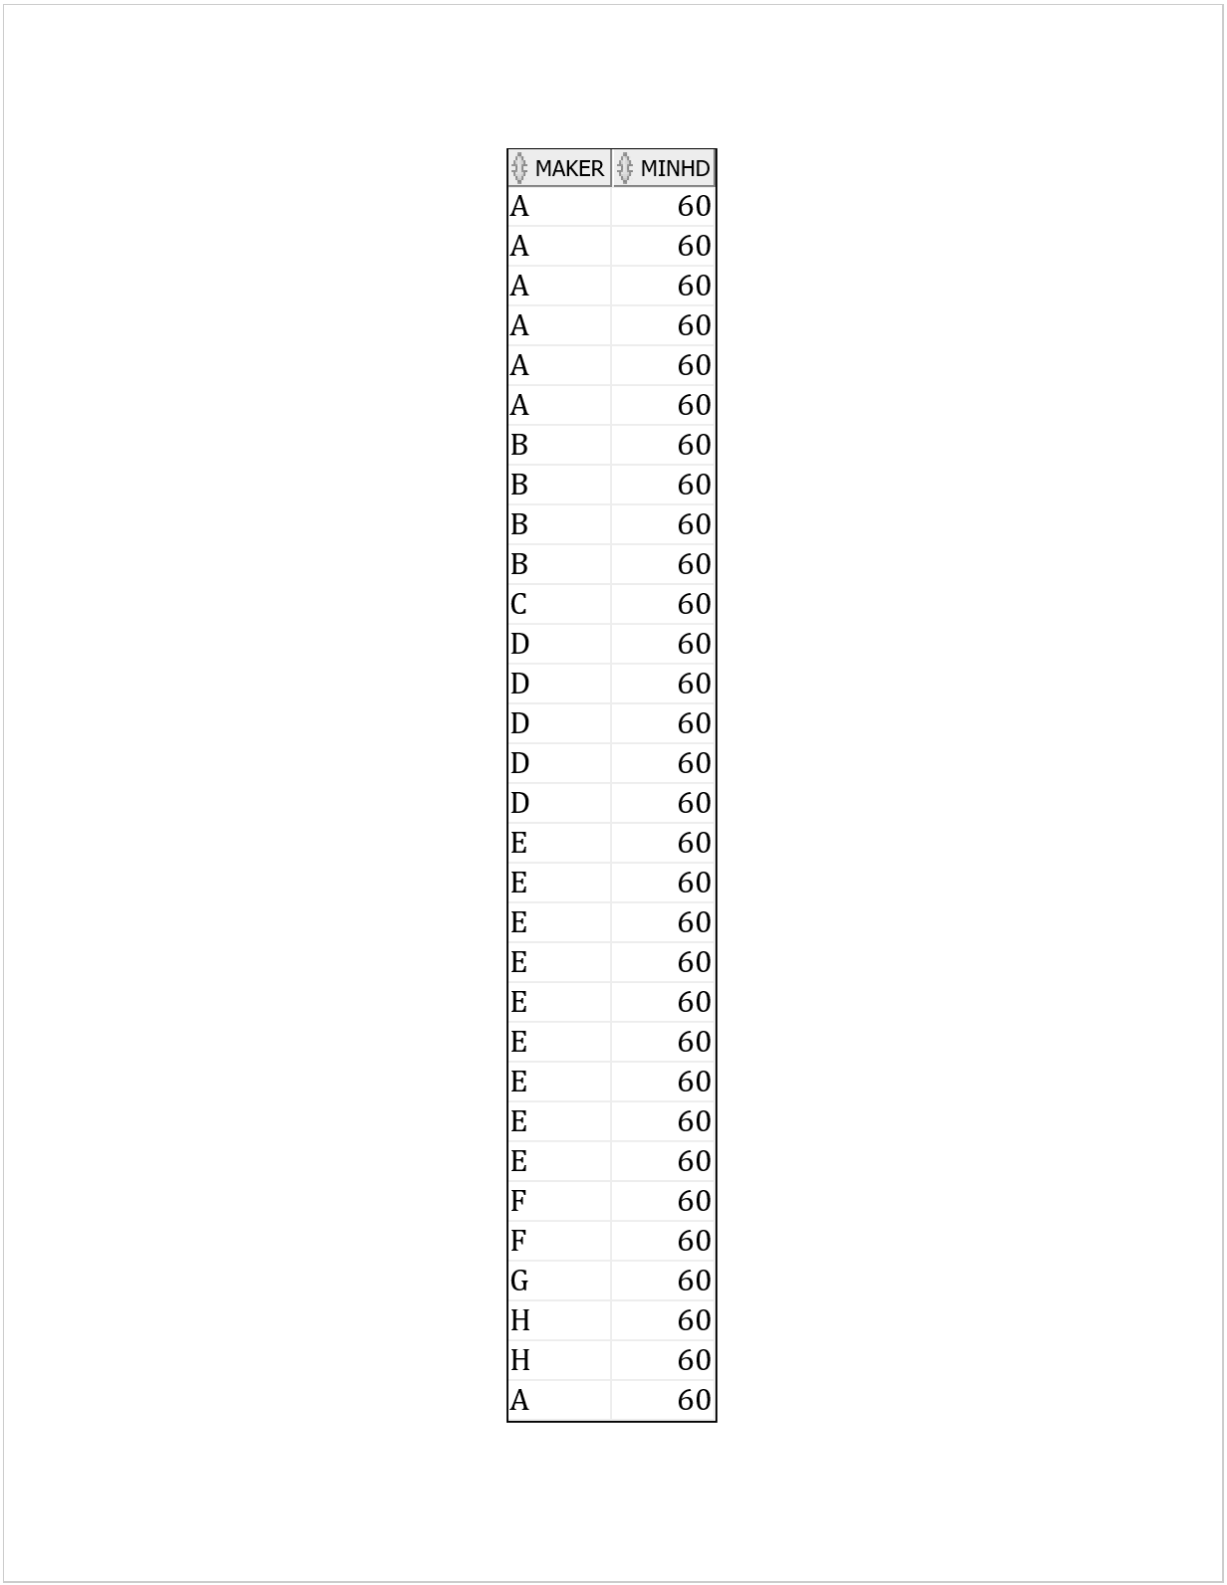
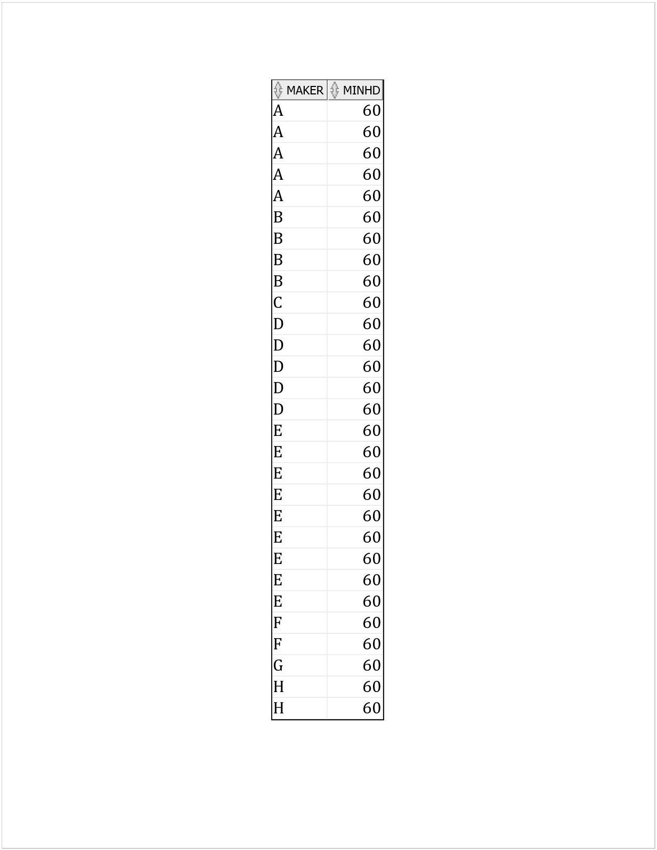

UNIQUE SOLUTIONS -------------

SELECT DISTINCT maker, hd AS minhd FROM
(SELECT * FROM
((SELECT pcmodel, hd FROM (
SELECT * FROM PC WHERE hd <= 200))
UNION
(SELECT pcmodel, hd FROM (
SELECT * FROM Laptop WHERE hd <= 200)))
NATURAL JOIN
PRODUCT)
WHERE hd <= ALL
(SELECT hd FROM
((SELECT pcmodel, hd FROM (
SELECT * FROM PC WHERE hd <= 200))
UNION
(SELECT pcmodel, hd FROM (
SELECT * FROM Laptop WHERE hd <= 200)))
NATURAL JOIN
PRODUCT);

