Assignment #3
Cason Konzer 7/25/21

_Flint Campus_
[CSC-382]: Software Engineering

Contents

- Complete 2 Activity Diagrams: Pgs. [2-3]
At least 4 diamonds (decisions and merges).

- Develop 2 Swim Lane Diagrams: Pgs. [5-6]
Use diagrams from part 1.

- Develop 5 CRC Cards: Pgs. [8-12]
Use Use-Case Narratives from HW 2.

- Works Cited: Pg. [13]

Complete 2 Activity Diagrams

Diagram 1 {Reddit Information Retrieval}

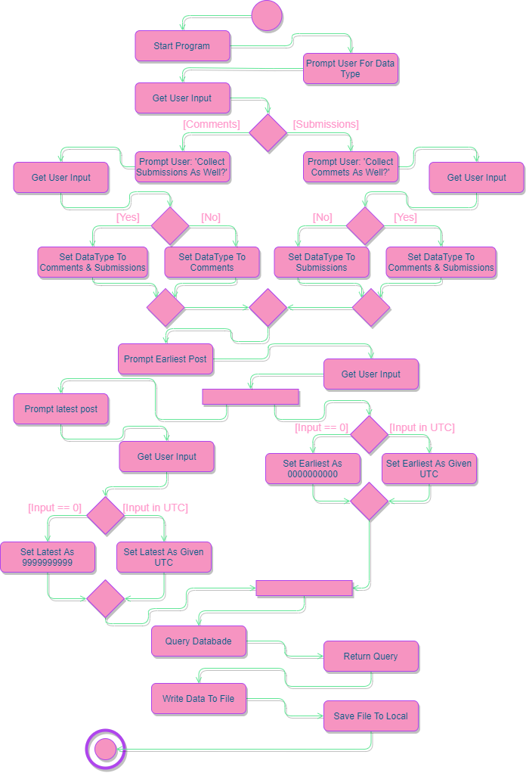

Diagram 2 {Diesel Engine Ignition}

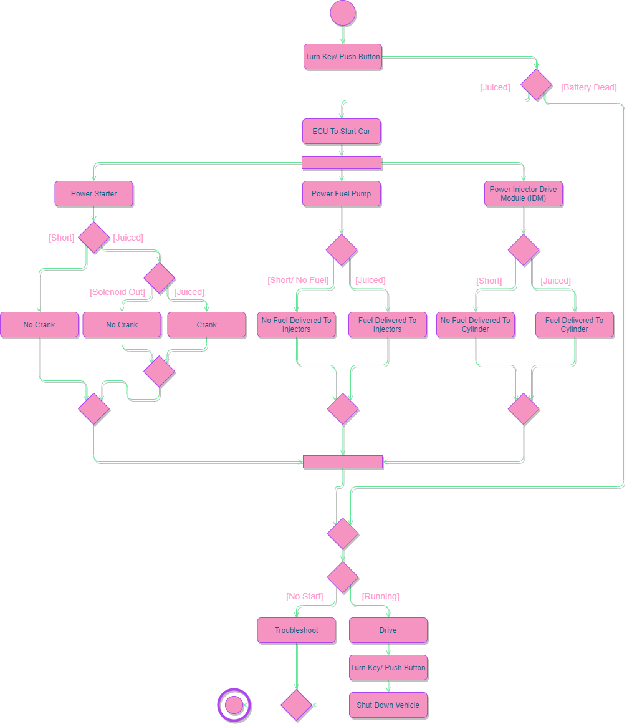

This page is intentionally left Blank.

Develop 2 Swim Lane Diagrams

Diagram 1 {Reddit Information Retrieval}

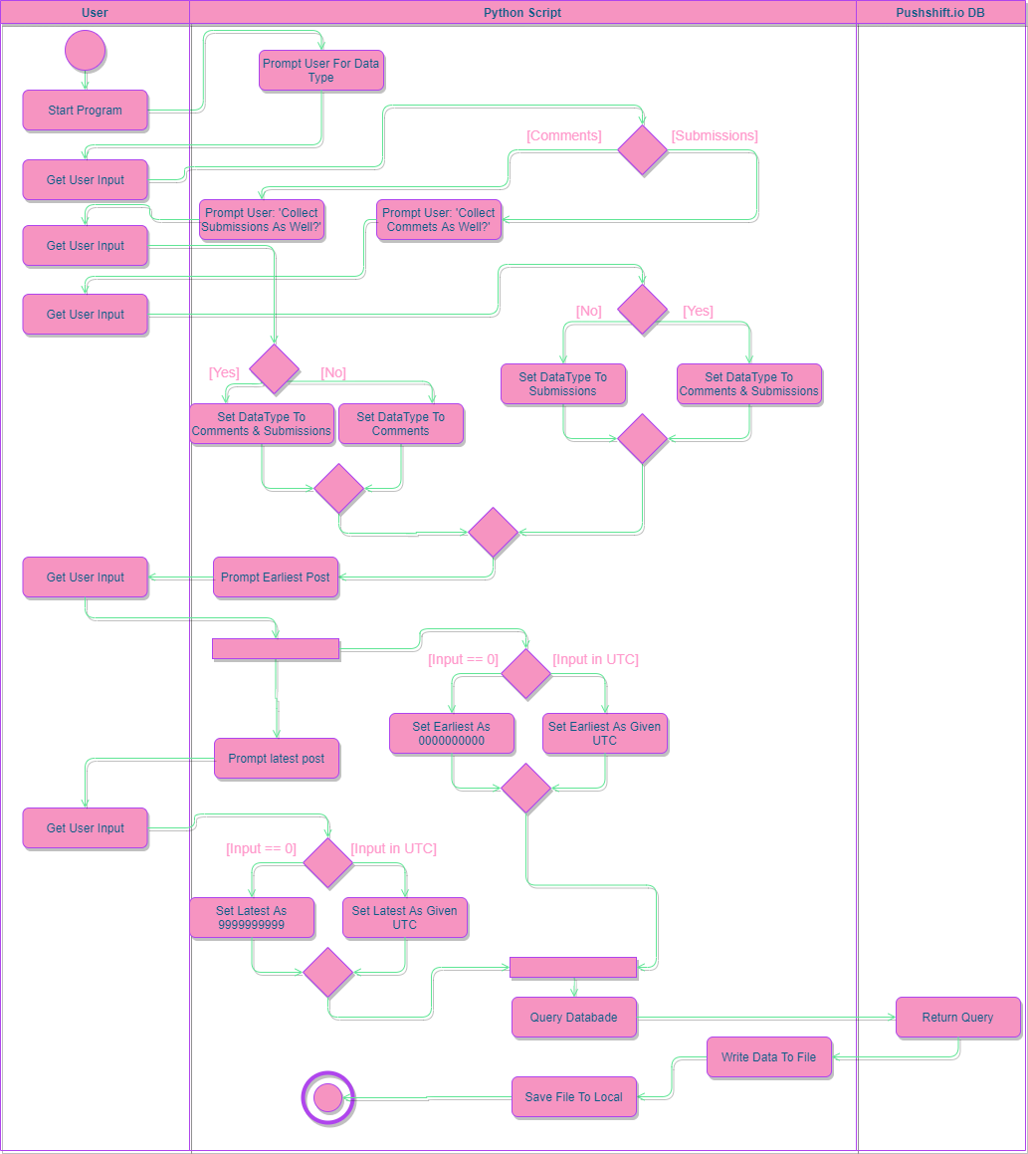

Diagram 2 {Diesel Engine Ignition}

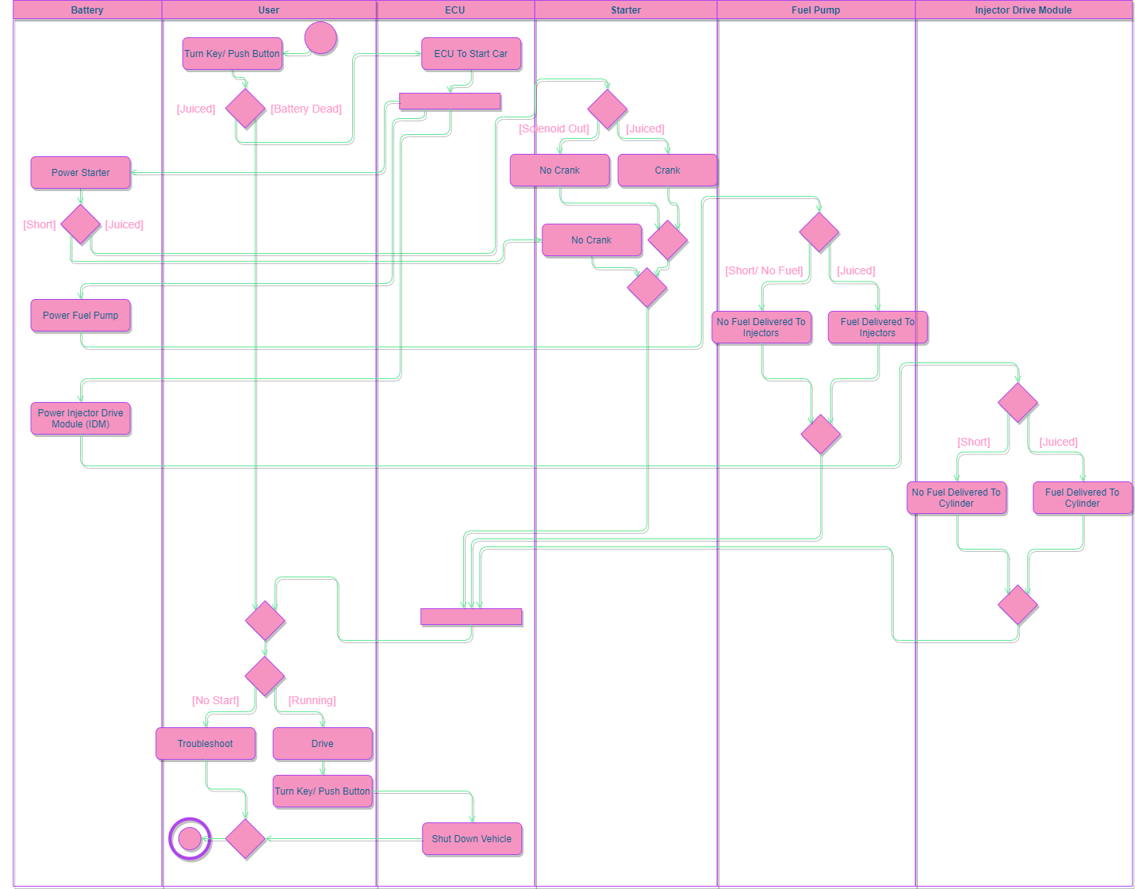

This page is intentionally left Blank.

Develop 5 CRC Cards

Card 1 {User}

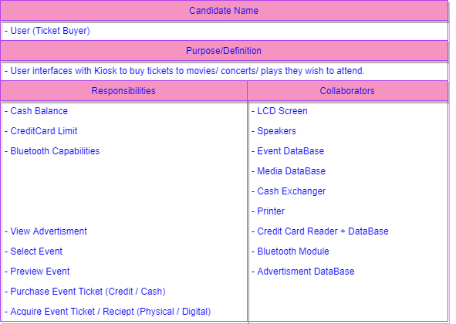

Card 2 {Admin}

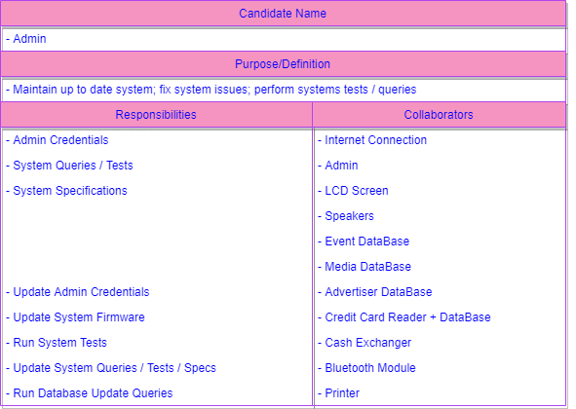

Card 3 {Credit Card DB}

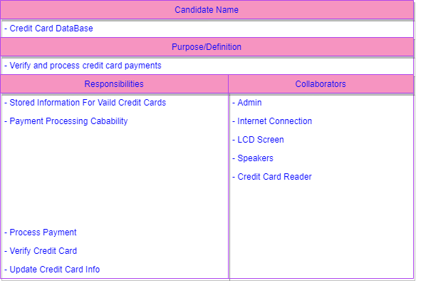

Card 4 {Media DB}

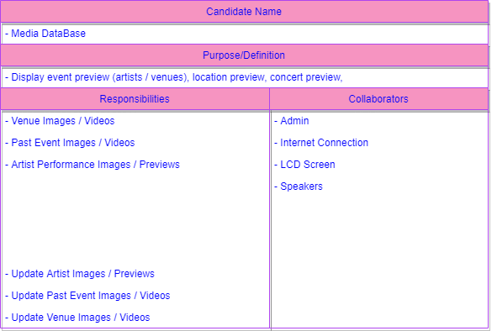

Card 5 {Event DB}

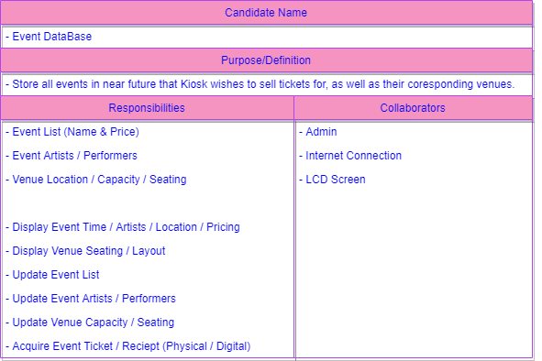

Works Cited

Pressman, R., and B. Maxim, Software Engineering: A Practitioner’s
Approach, Eighth Edition, McGraw-Hill, 2015.

