Assignment #4
Cason Konzer 8/1/21

_Flint Campus_
[CSC-382]: Software Engineering

Contents

- Turn CRC Cards Into Class Diagram Format: Pg. [2]

- Develop 2 of Each Diagram: Pgs. [4-7]

  - Inheritance [4]

  - Aggregation [5]

  - Association [6]

  - Dependency [7]

- Works Cited: Pg. [8]

Class Diagrams

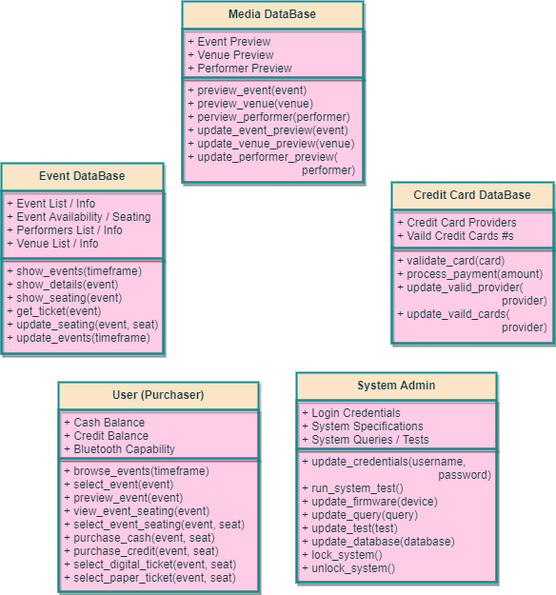

This page is intentionally left Blank.

Develop 2 of Each Diagram

Inheritance (2)
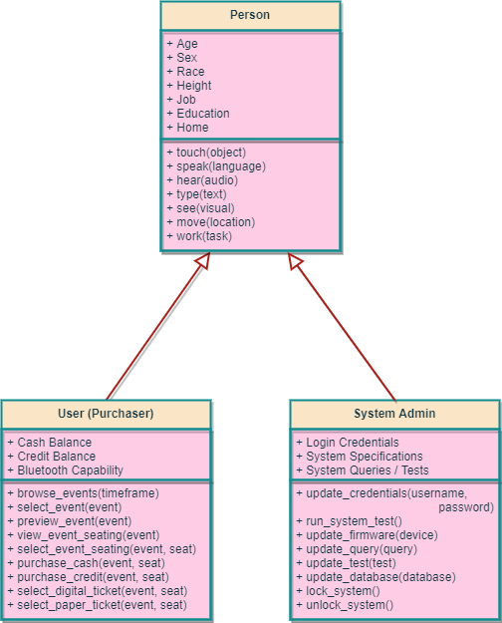

Aggregation (2)

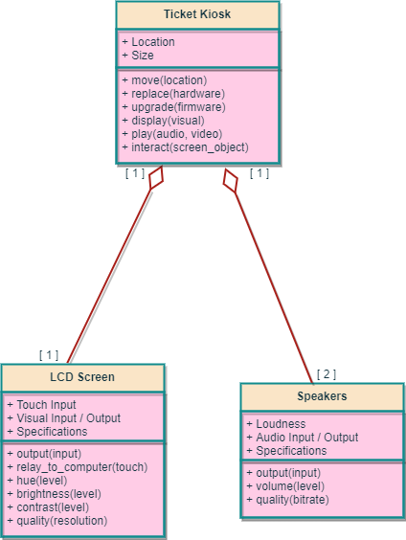

Association (2)

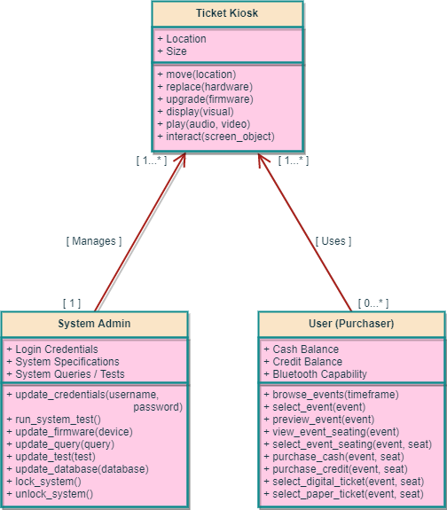

Dependency (2)

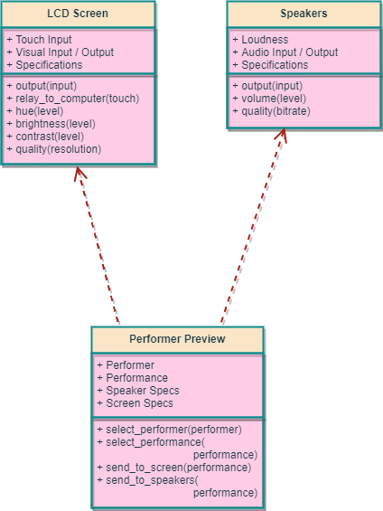

Works Cited

Pressman, R., and B. Maxim, Software Engineering: A Practitioner’s
Approach, Eighth Edition, McGraw-Hill, 2015.

