CSC 310 Human Computer Interaction

Final Heuristic Evaluation Report w/ Revisions

Dated
11/25/20; Revisions on 11/28/20

Prepared By: Austin Taylor, Ashley McIntosh, and Tony Ellis

GROUP NAME: Group 4

CONTRIBUTOR(S): Austin Taylor, Ashley McIntosh, and Toney Ellis

REVISIONS BY: Cason Konzer, Cole Dutil

Evaluation Of:

Name of system being evaluated: Steam website :
https://xd.adobe.com/view/872d6951-f95d-4aba-a098-e3b4719b18ad-d27e/

Group that created the system being evaluated: Group 1

Feedback & Critical Incidence |  | << Record your observations in the table on the following page, based on your observations and notes taken during the evaluation.  Description of columns in the table are as follows:  Prototype Screen/Page:  Which screen of the user interface was being tested at the point of feedback/critical incidence/problem.  Name of Heuristic:  Which of the 9 heuristics is being referenced. Enter the full name of the heuristic. Refer to the heuristic evaluation lecture slides for the 9 design principles.  Reason for negative feedback / breakdown:  Explain the reasons why the interface violates this heuristic. Be sure to be clear about where in the screen you are referencing.  Scope:  Describe the scope of the feedback or the problem; include whether the scope of the issue is throughout the product or within a specific screen or screens. If the problems are specific to a page, include the appropriate page numbers.  Severity (H/M/L) :  Your assessment as to whether the implication of the feedback is low, medium, or high severity, and a justification for why you are giving it that rating.  Way(s) to rectify and Tradeoffs (i.e., why the fix might not work):  Suggestion for the modifications that might be made to the user interface to address the issue or issues in this row. You MUST include trade-offs to be credible. If you can’t think of some bad trade-off, say so.  Action taken and Justification:  DO NOT FILL IN THIS COLUMN. This will be filled in by the person who created the system being evaluated, to say what he did with respect to the recommendations you make.

# | Prototype  Screen | Name of Heuristic | Reason for negative feedback / breakdown | Scope | Severity  (High/ Medium/ Low) and Justification for giving it that rating | Way(s) to rectify and any Tradeoffs (i.e., why the fix might not work) | Action taken and Justification  (to by filled in later by the person who created the system being evaluated)
1 | See Picture 1 | Speak the user’s language and Positive feedback | The reason this violates these heuristic principles is because the terms that are displayed to the user are system oriented terms and a user might get nervous about what the system is doing when they see terms such as ~$ echo prompt. Also because this is a text based screen they might not see that the program is installing. They might not know what the ####---- means. | The scope of the issue is only present on this screen | Medium, user can get confused by the terms on the screen and can get confused on whether the program is installing or not. | Group 1 could fix these issues by using simpler terms such as Destiny 2 installing please wait and have a progress bar at the bottom to indicate how much of the program has been installed. I couldn’t think of any tradeoffs for why this fix might not work. | Suggestion was followed and the text based terminal screen was replaced with a GUI progress bar and game box art graphic. See reference F for the redesigned install screen.
2 | See Picture 2 | Provide Shortcuts and Simple and Natural Dialog | The reason this violates the heuristic principle is because there are shortcuts that lead to different areas of the prototype when it should not. Group 1 had set up their prototype so that when the user clicked the screen all of the clickable parts of the screen are highlighted, and it revealed these accidental shortcuts | The scope of the issue is only present on this screen | Medium, user might click the screen to see what is clickable and see the three boxes on the left with no text and click those to see what they do, which distracts the user from completing their task. | Group 1 could fix this issue by removing the shortcuts that lead to the different areas of the screen. I couldn’t think of any tradeoffs for why this fix might not work. | These invisible buttons were removed as they were left implemented in the background by mistake. See picture 2, all circled highlights no longer pop up upon clicks.
3 | See Picture 3 | Be consistent Simple & Natural | On the home page I notice a store option and I also notice a price option on the games in the new releases. As a user I would kind of feel overwhelmed looking at of game options & how to navigate through the system | Just on the Home page scope | Medium to keep the page in simple order. It has feature programs and new releases on the side | I would suggest to possibly combine “featured programs and new releases”  So, it would look overwhelming for the user | We think that there is value to having a list of both featured and strictly new games. The featured section can show games that are on sale or that are relevant to the user, while the new games can highlight recent releases. We did make cycling through the featured games more obvious that it is a different list. See references G and H for examples of new cycling.
4 | See Picture 4 | Provide Feedback /Positive response | As user I was confused on the confirmation and installing game mode. This issue popped purchasing the game as well. | Just on the screen | Medium  It was important to change the user and speak the language of the user to verify the game is installed | Group 1 can fix this issue by creating a different format possibly adding a loading successfully page to the confirmation installing or “loading please wait prompt”  Add a confirmation purchase | This was fixed in majority following critique 1. The installation screen has been changed to speak the user’s language allowing for better interpretation of feedback. As the game is a free purchase, we feel the prompt change on the screen is adequate feedback. This prompt change has been made more relevant. See reference A, B & F
5 | See Picture 5 | Be Consistent | When Click on the Friends and Inbox tabs New messages pop up twice. recent messages and history are very confusing. This is overwhelming for the user because it too many of the same option | Just on screen | Low- I understand how to operate the page still but it seems annoying have a same task | I'm not sure for fixable changes. Added a flow model to realize the starting point and re-word task. Reorder the content on page Remove “new message from friends or inbox” and also recent messages can possibly be the same as history. | We think that a link to draft a new message is useful to have on both the friends and inbox pages so we won’t remove them. Changed “recent” header to instead read as “Recent Messages” and changed history to read All Messages to make them more distinct. See reference I for changes.
6 | See Picture 6 | Provide Feedback | After doing the friend search and putting in “Bob” , there isn’t a clear way to submit or select it. (1)I clicked the search bar with the name and(2) the name itself several times with no result. (3)The only way I got out was the “X” button, but that feels more like cancelling the search. was not found. | This happens throughout the group project | Medium, this just makes following the task a little confusing. The instructions don’t follow the order and then it’s not clear if the task is completed, so the testing is in question. | Re-word the task description to follow the steps in a more precise way. When you add Bob, it should also confirm the add and take you out of the screen so you can confirm that you tested the taks correctly. The X button needs a confirmation for cancel/back, and maybe add a homepage button. The friend list looks like regular gray text and should maybe reflect more as clickable or interactable links. This could be boxes around them, or something that sticks out so you can | New flow added that allows user to select bob as a friend which then takes you to bob’s profile page with a prompt saying new friend added! User is assumed to hit enter to search hence no search button after message is typed. New return to inbox button added. Friends list now boxed in with a higher contrast blue text and underlines. Extra step added in message flow to ensure user does not feel they are provided adequate feedback.  See Reference C,D,E & J
7 | See Picture 7 | Provide Feedback | After selecting Bob to send a message to, There wasn’t a clear way to simulate a message entered or that the message was sent. The only interaction on the screen is to exit, which feels like I’m trying to cancel my action. There is no text reponse to explain either way. | This happens throughout the group project | Medium, Confirmation is important to know if the test is done right. If nothing happens when you perform a test, then it’s almost as if it doesn’t work or has failed. | Add more confirmations and message screens. | Added a new screen with a simulated message being sent from the user to their friend, BOB. This new screen is accessed by clicking the send button and contains a message successful confirmation message. See reference J for new screen.

Picture 1:

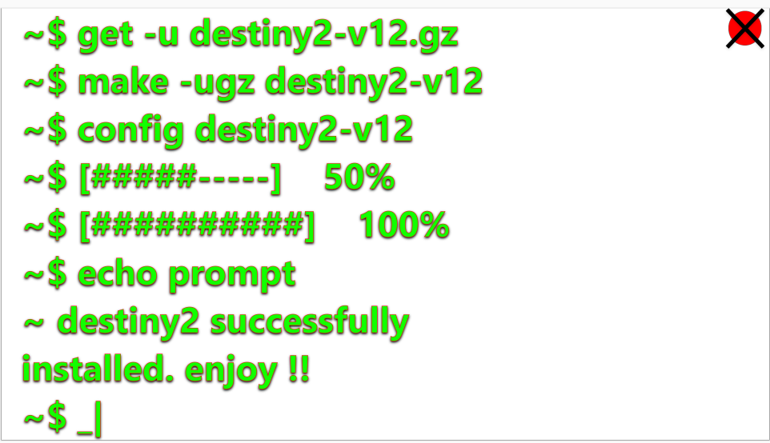

Picture 2:

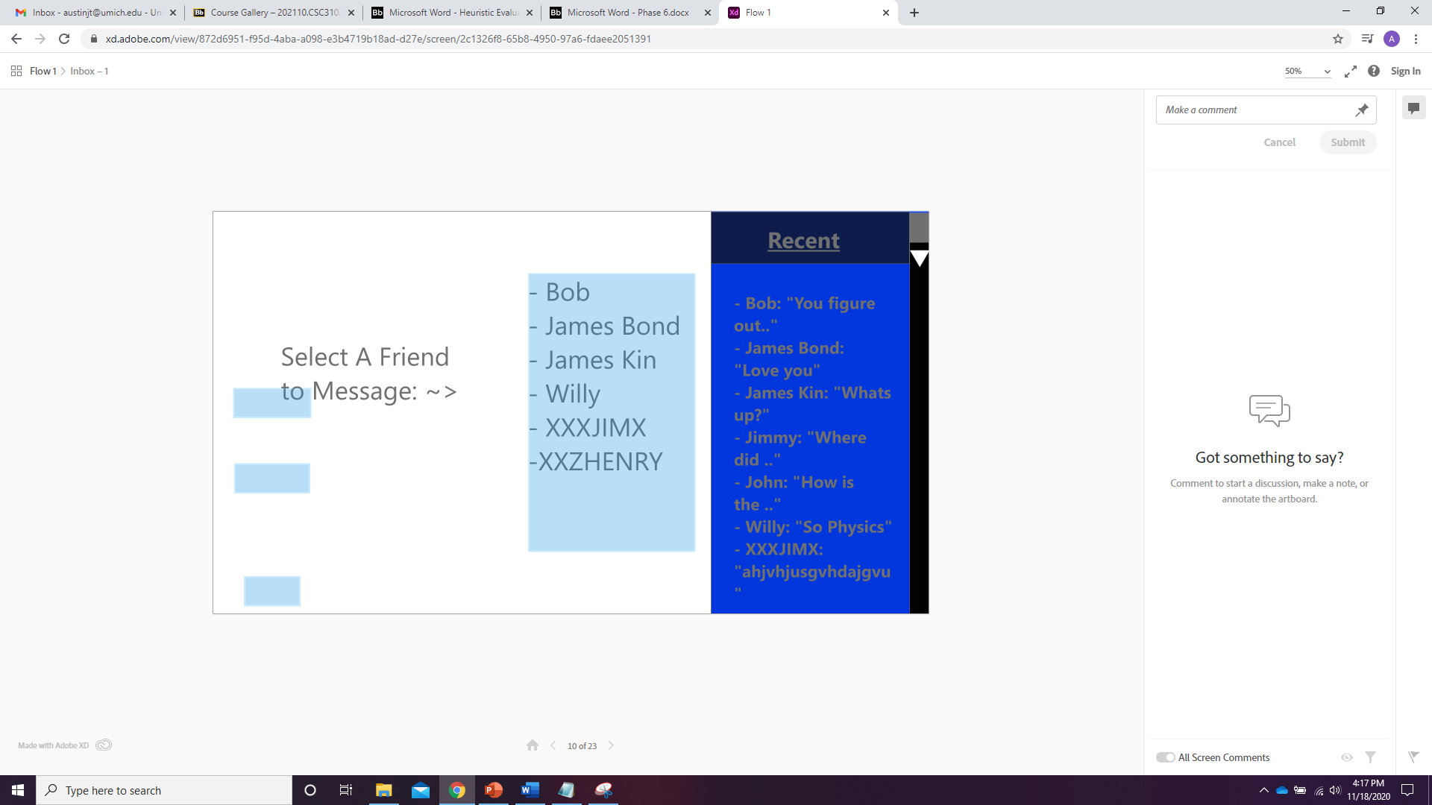

Picture 3:

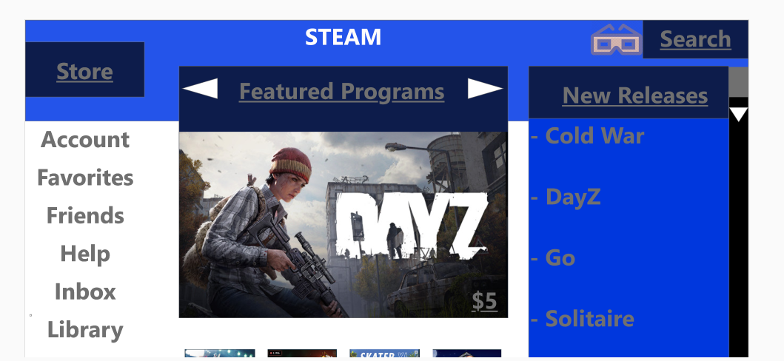

Picture 4:

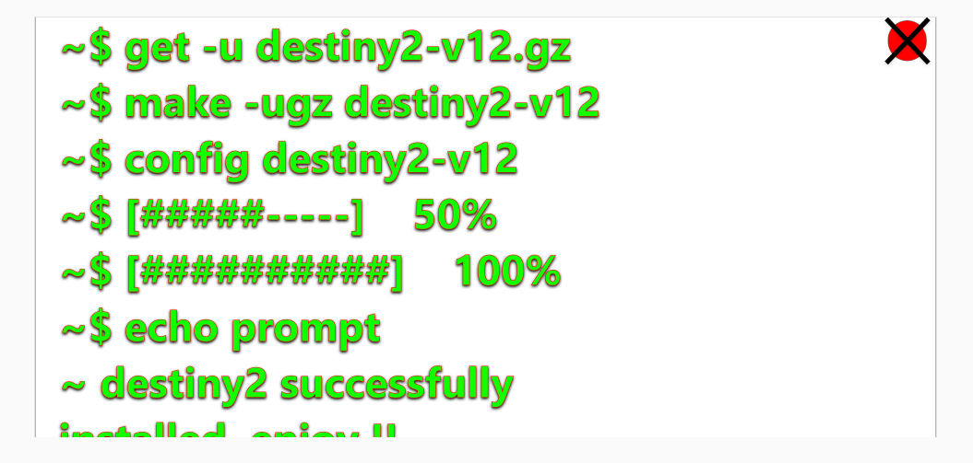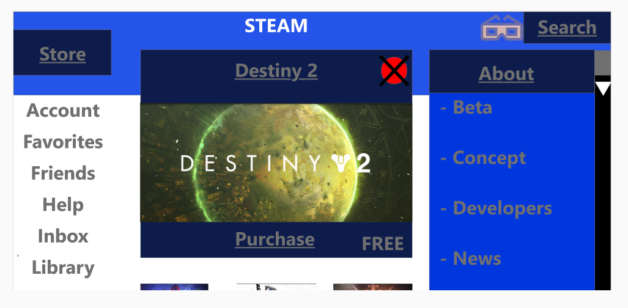

Picture 5:

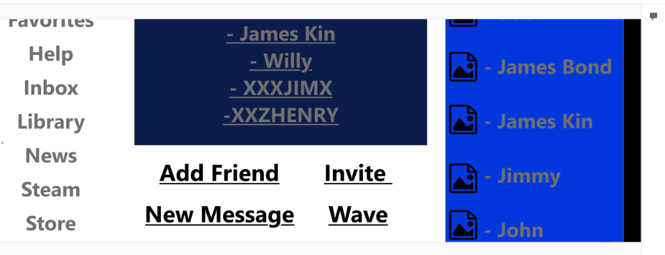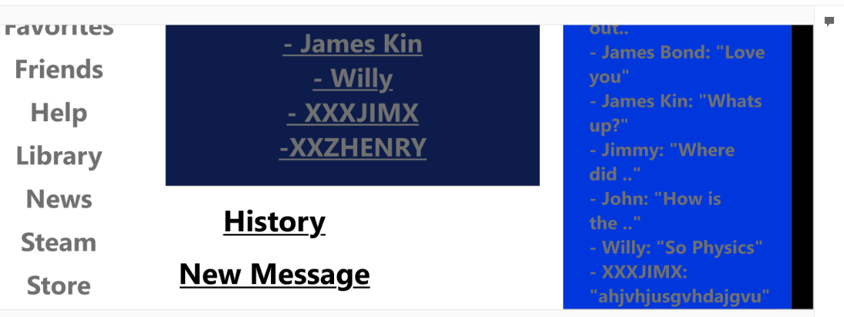

Picture 6:

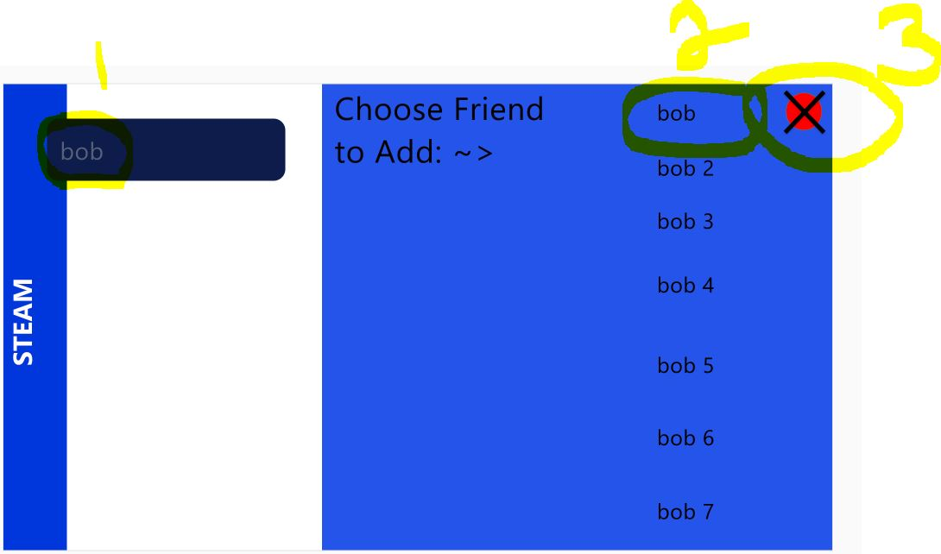

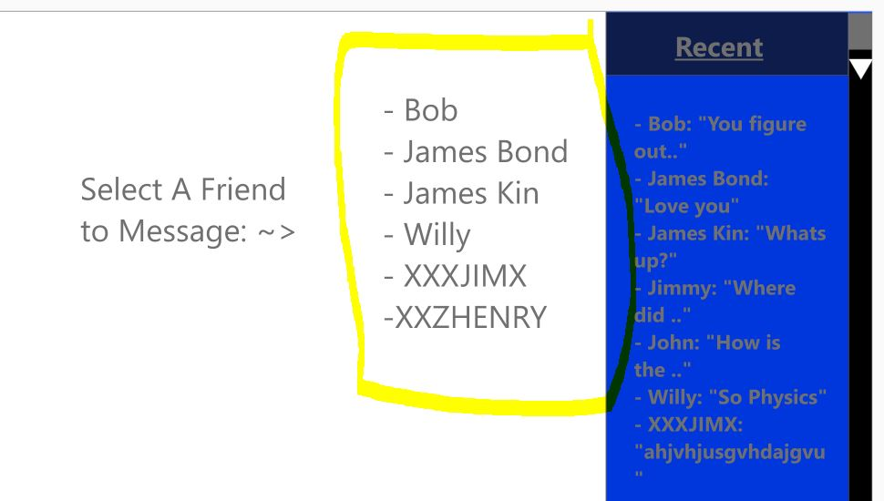

Picture 7:

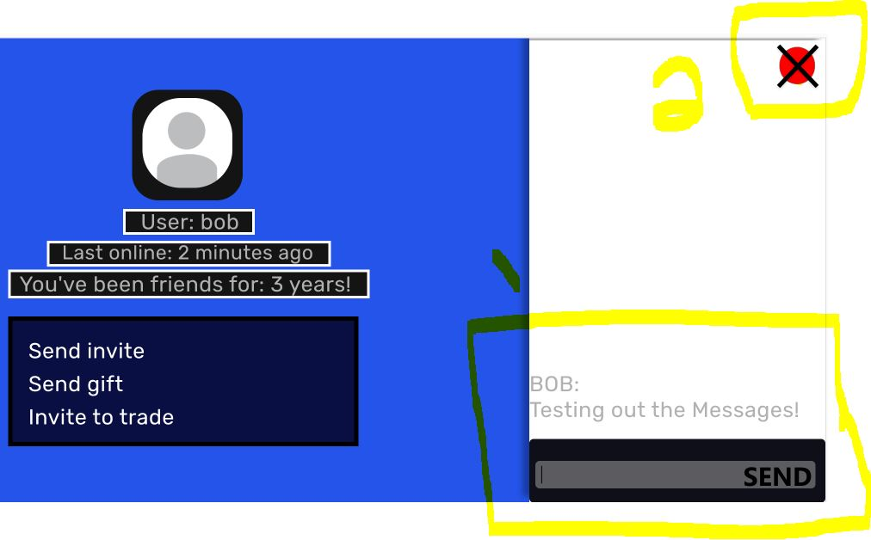

Reference A:
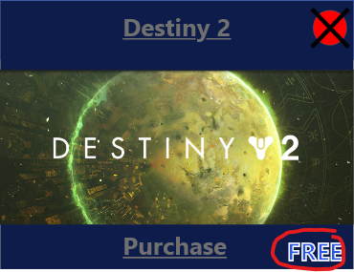

Reference B:
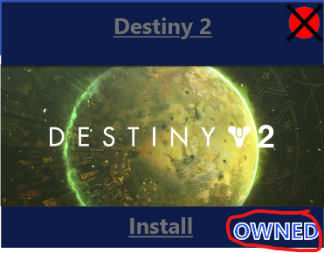
Reference C:
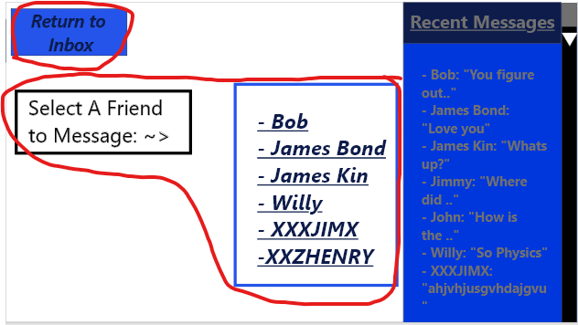

Reference D:
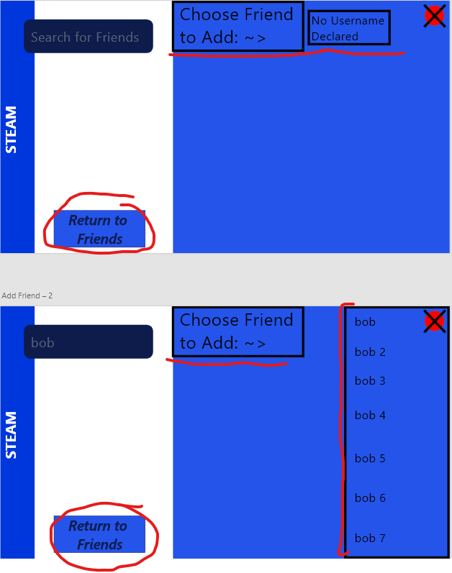

Reference E:
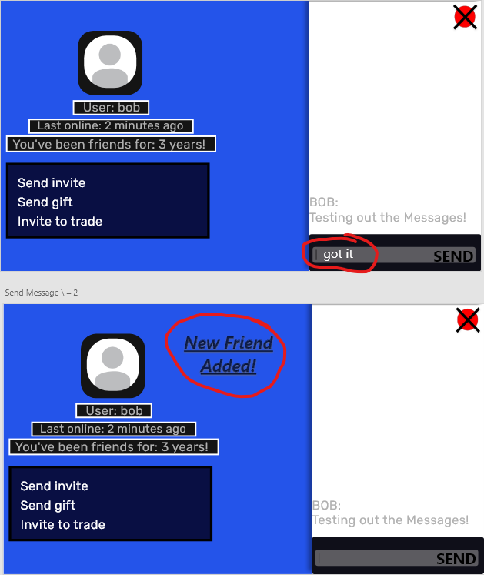

Reference F:
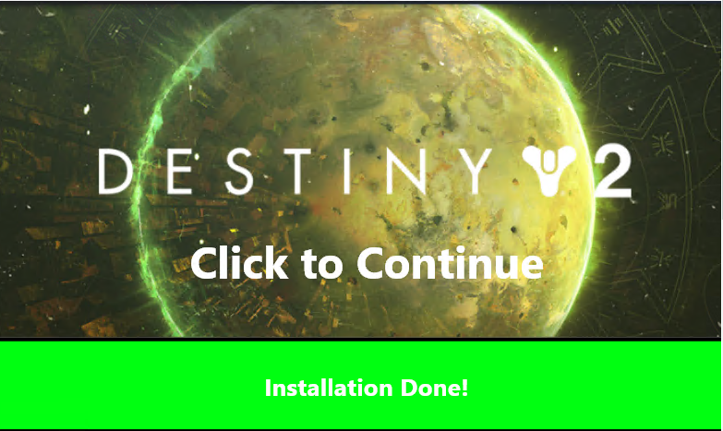

Reference G:
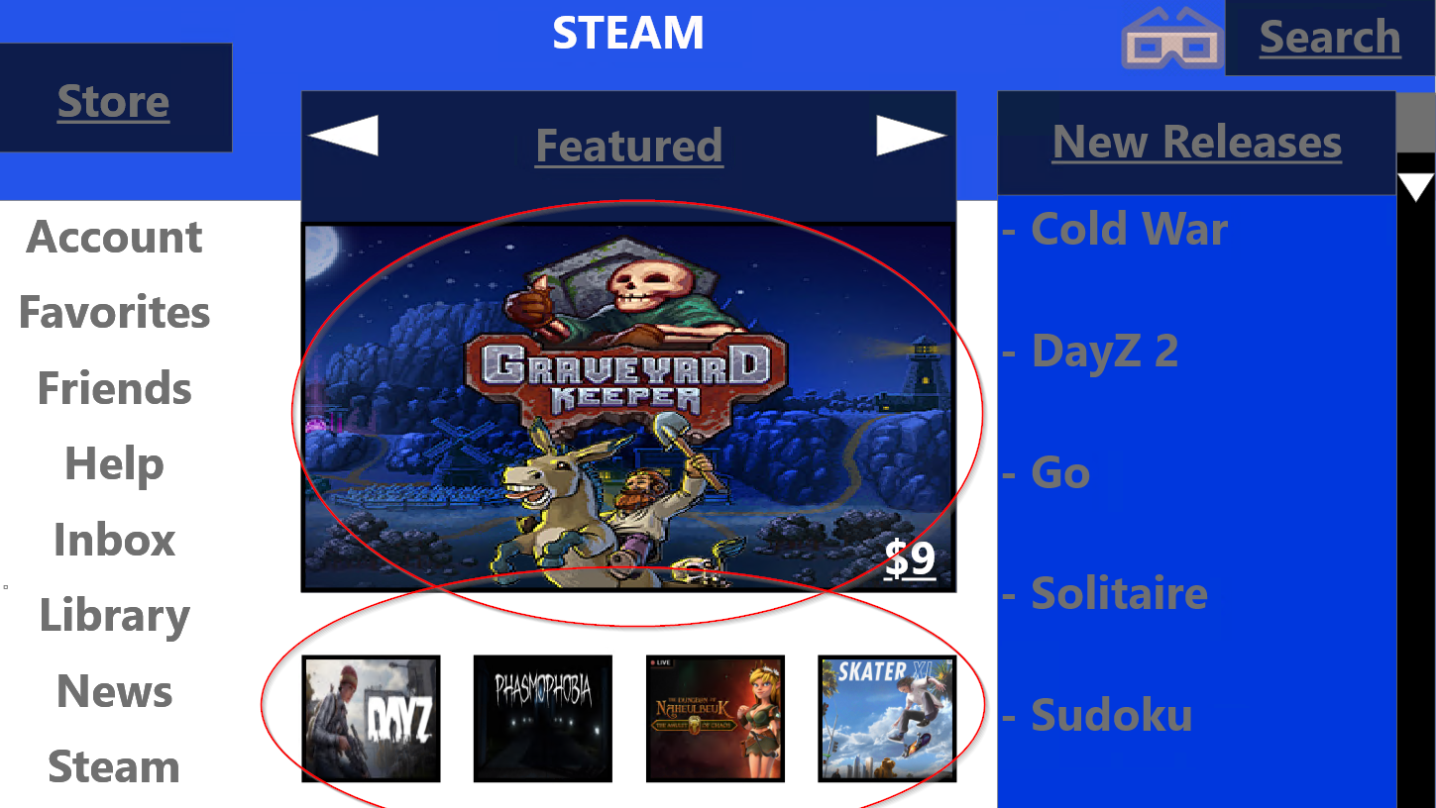

Reference H:
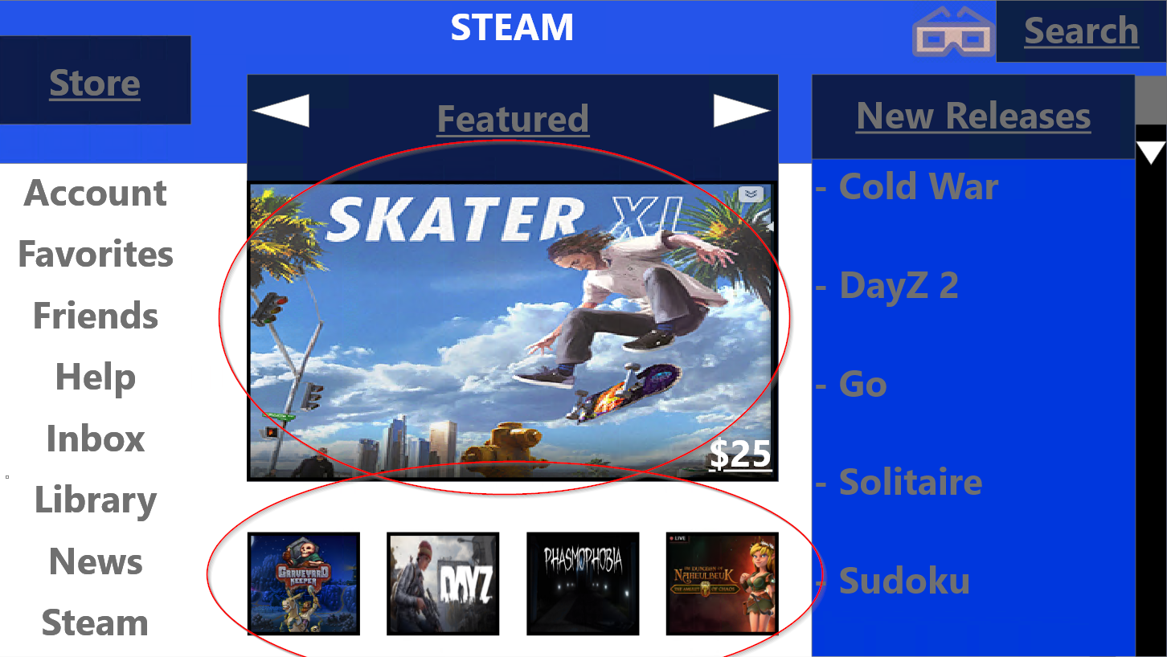
Reference I:
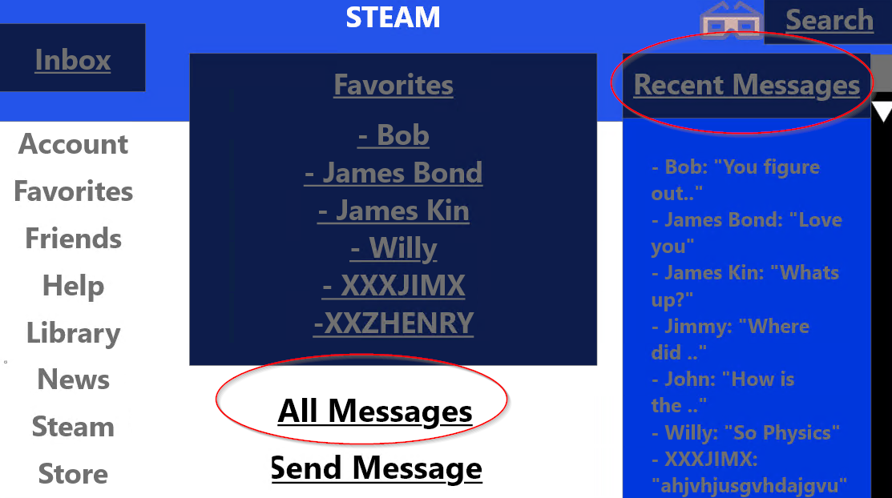

Reference J:
