

Altova Global Test Plan for Charts

May 31, 2010
Version 1.0

Document Revision History

Initial version | Baa | 1.0 | 2010-05-31
Update part XMLSpy | baa | 1.0 | 2010-06-14
Revision
Revision

TABLE OF CONTENTS

1 Introduction 4
2 Test plan components 4
2.1 Motivation for feature 4
2.2 Description 4
2.3 Areas to be tested 5
2.4 Areas not to be tested 7
2.5 Testing Environments 7
2.6 Test Strategy 7
2.7 Detailed description 8
XMLSpy 8
AltovaXML 23
DBQuery window 23
Mapforce 23
Stylevision 23
DatabaseSpy 23
Authentic 24
2.8 Risks & Dependencies 24
2.9 Automation Issues 24
3 Test Setup 24
4 Test Coverage Matrix (TCM) 26
5 References 26
6 Figure list 26

- Introduction

The Product Feature Test Plan is a high-level document that details the strategy QA will follow in testing the new feature of creating charts within several Altova products. This test plan provides an overview of the feature. The specifics of this feature in each product will be described in distinct product specific test plans as part of this document or linked to the external document.
This test plan is a living document which means that it might be modified due to changes in specification or done during development.

- Test plan components

  - Motivation for feature

Charts provide a graphical overview of data. In some cases for example for generating reports it is important to present data stored as xml or in databases in a graphical way. For that reason Altova products will provide this feature.

TTP 34179 - support for generating charts with the xslt engine
TTP 34193 - Chart support in XMLSpy
TTP 34304 - Charts
  - Description

Charts will be available in the following Altova products – and here only in Enterprise Editions. For products like DatabaseSpy and AltovaXML which are not providing an Enterprise edition, these will be introduced with the release of 2011.
- XMLSpy
- Mapforce
- Stylevision
- Authentic
- AltovaXML
- DatabaseSpy and probably
- Diffdog (Charts in Diffdog is cancelled at the moment)

Charts will be provided in a docking control bar and will feature multiple tabs for reloading, saving the chart and adapting the Chart’s layout.
The advantage of the docking control bar is that it can be undocked and so e.g. moved to another window and resized.

Over the buttons in the Charts window it is possible to
- change the charts type:
  - Pie
  - Category
  - Value
  - Gauge
- to change the appearance of the Chart
- to change the data used drawing the chart
- to save the picture
- to reload the chart manually so that changes are considered if data is from document and only as long the document is open
- to change to “Auto” mode that changes of the selected data are considered automatically

Over the tabs on the left side of the chart it is possible to create charts for different documents.

Charts data will be controlled by XPath statements in case of the data source is a document. This can be translated to a XSL generating the same chart with this input document.
If the data comes from document the user has the possibility to change the XPath statement and so to change the data source used for the chart individually. The XSL/Query profiler in XMLSpy for example does not support this feature.
  - Areas to be tested

As mentioned before the feature will be available in the Enterprise Edition of
- XMLSpy
- Stylevision
- Mapforce
- Authentic
- DatabaseSpy and
- AltovaXML
- Integration packages .Net and Eclipse

In the mentioned products the feature will be provided in different way and so the test areas also vary.
- XMLSpy
  - Charts will be available for data presented in
    - Text view
    - Grid view
    - XLS/XQ profiling window
    - Authentic view
      - Here it will use the stylevision integration for embedding charts? [must be cleared]
  - Generating XSL out of XPath statement used for creating the chart
  - Testing the functionality and usability of the charts docking control bar
  - Switching between views, changing data and checking the chart
  - The DBQuery dialog will provide the possibility creating charts from database record data. For that the DBQuery window will get an own tab “Charts” (like “Messages” and “Errors”)
- Stylevision
  - In Stylevision charts will be implemented as integration
the formatting of a chart is specified and Xpath statements are used to define the charts source values within an XML instance file.
  - The DBQuery dialog will provide the possibility creating charts from database record data. For that the DBQuery window will get an own tab “Charts” (like “Messages” and “Errors”)
- Mapforce:
  - Mapforce uses the Stylevision integration
  - Maybe there will also be the possibility to create an XSL file which generates the chart according to the input XML? [should be cleared]
  - The DBQuery dialog will provide the possibility creating charts from database record data. For that the DBQuery window will get an own tab “Charts” (like “Messages” and “Errors”)
- Authentic:
  - The usage of charts will be similar to the usage in Stylevision Authentic view
- DatabaseSpy:
  - At the moment it is planned to integrate charts like in XMLSpy using the docking control bar
  - In DatabaseSpy record data will be used for generating charts.
  - There will be a new edition. Starting with version 2011 there will be an Enterprise edition supporting charts and a Professional edition (no charts)
  - DBQuery window
- AltovaXML
  - New functions will be available for creating charts using the commandline providing a new extension function library
  - For introducing charts in AltovaXML a new edition will be generated. Charts will only be available in Enterprise edition.
- General
  - File handling
  - Reload
  - Undo / redo
  - Xpath statements
  - Auto update
  - Printing
  - Copy to clipboard
  - Create XSL stylesheet (if available)

  - Areas not to be tested

As all products use the same library (ICChartUI) and interface (ICChartDataProvider) it might not be necessary to do the GUI tests of the charts and their dialogs detailed in all products.

The functionality, correctness of drawn data and file handling must be tested in all products carefully.

  - Testing Environments

Charts should be tested on several operating systems. Our operating systems mainly used are:
Windows 7
Vista 32/64
XP 32/64
Windows 2008
Windows 2003 server
  - Test Strategy

The types of testing include:
GUI
Representation of charts,
different chart types
dialogs
changing coloring and chart appearance and type
german builds:
- dialogs,
- message boxes,
- docking control bar
Functional
Auto – update, reloading
Changing charts appearance
Changing charts data
Changing charts type
Checking charts after reload of file, undo/redo
Error handling:
File handling – saving charts
Creating charts using invalid data e.g. not suitable data types
Performance
Using big files and auto-loading of data
Usability
Dialogs
Creating charts
  - Detailed description

The description of handling and GUI in XMLSpy can also be used for all other products. The main and important differences to be tested carefully are the different sources the data comes from (XML document, Database records, Profiler, XSLT, etc). Creating charts differs depending on the type of data source.

The GUI will not differ as in all products the same interface is used.

XMLSpy

In XMLSpy charts are available
- In Text view
- In Grid view
- Using data out of XSL/XQ profiling window
- Embedded in Authentic view?
- DBQuery window – uses internal Chart tab and will be discussed separate from XMLSpy

Under the menu “XML” the function “Create Chart” is available.
To create charts the data must be selected and then the data source is available in the docking control bar.
Not the whole area has to be selected. It is sufficient to select e.g. the first item and the XPath is created. In text view it is sufficient to put the cursor in an element. In the example below that would be <data>, there is no need to make any selection.

In grid view a line based selection in a table should be possible. So only the selected lines will be pat of the initial XPath statement.

A dialog pops up directly after calling the function “Create Chart”. In this dialog the data source can be specified and by pressing OK this XPath statement is overtaken as chart data. This can be modified any time if needed in the Chart Data dialog of the docking control bar.
For example:
<?xml version="1.0" encoding="UTF-8"?>
<!--Sample XML file generated by XMLSpy v2011 (x64) (http://www.altova.com)-->
<root xsi:noNamespaceSchemaLocation="simpleTestdata.xsd" xmlns:xsi="http://www.w3.org/2001/XMLSchema-instance">
<data>
<x>62</x>
<y>28</y>
</data>
<data>
<x>61</x>
<y>31</y>
</data>
<data>
<x>67</x>
<y>29</y>
</data>
….
Selecting the first <data> tag in XML above creates the XPath statement /root/data which is then available in the Chart data dialog and can easily be modified there to further restrict the range of data if wanted.
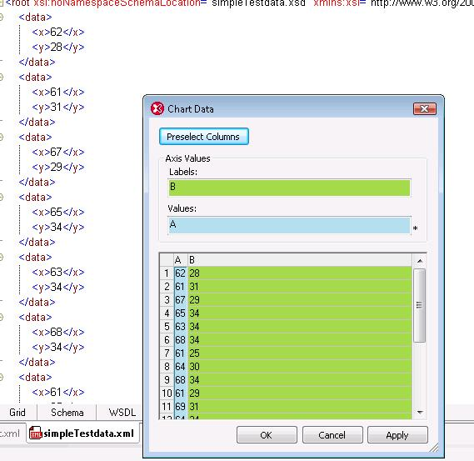
Figure 1: XMLSpy - Textview and Chart data window
Charts are provided in a docking control window in which several possibilities will be available for the user to create charts.

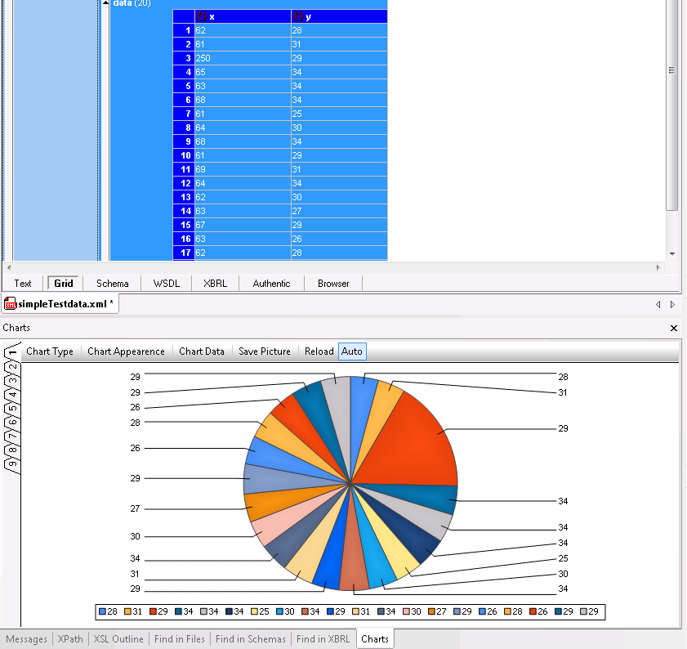
Figure 2: XMLSpy - grid view and Pie chart in docking control window
The docking control bar
The docking control bar in detail:

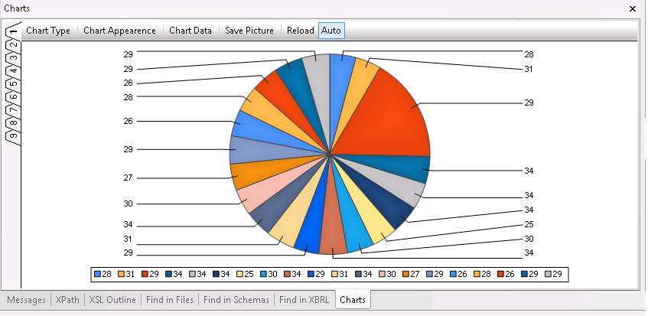
Figure 3: XMLSpy - docking control bar
The tabs:
- Chart Type
  - Here the user is able to change the chart type to one of the provided ones:
    - Pie
A pie chart (or circle graph) is a circular chart divided into sectors, illustrating proportion. It will be provided in 2D and 3D,
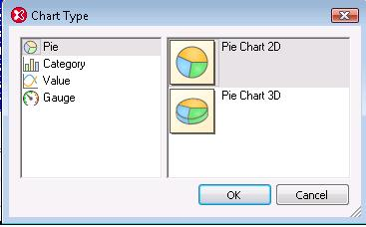
Figure 4: Chart Type window - Pie
      - Pie Chart 2D
      - Pie Chart 3D
Figure 5: Chart Type – Pie Chart 2D
    - Category
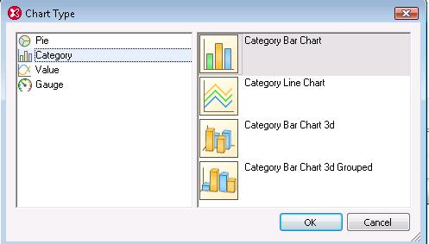
Figure 6_ Chart Type window - Category
      - Category Bar Chart
      - Category Line Chart
      - Category Bar Chart 3D
      - Category Bar Chart 3D Grouped
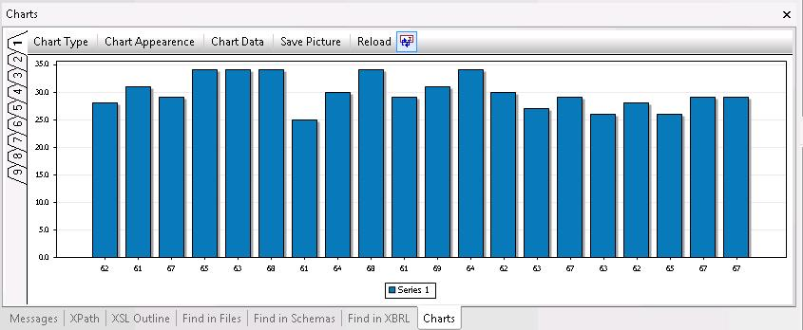
Figure 7: Chart Type – Category Bar Chart
    - Value
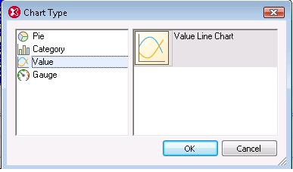
Figure 8: Chart Type window - Value
      - Value Line Chart
A line chart is a type of graph, which displays information as a series of data points connected by straight line segments.
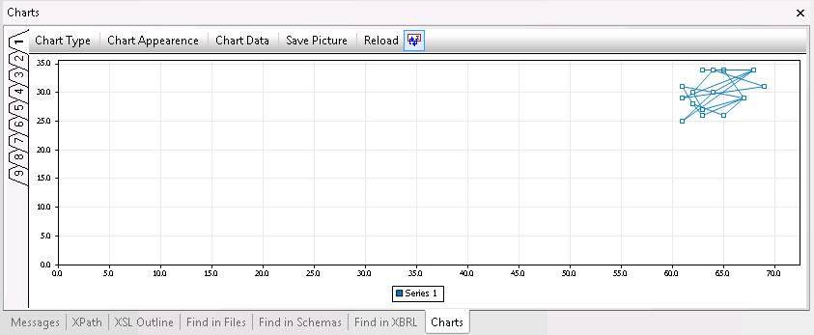
Figure 9: Chart Type – Value Line Chart
    - Gauge
A Gauge chart (dial chart) represents one or more values as needles on a circular or semicircular surface.
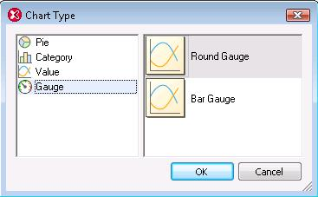
Figure 10: Chart Type - Gauge Chart
      - Round Gauge
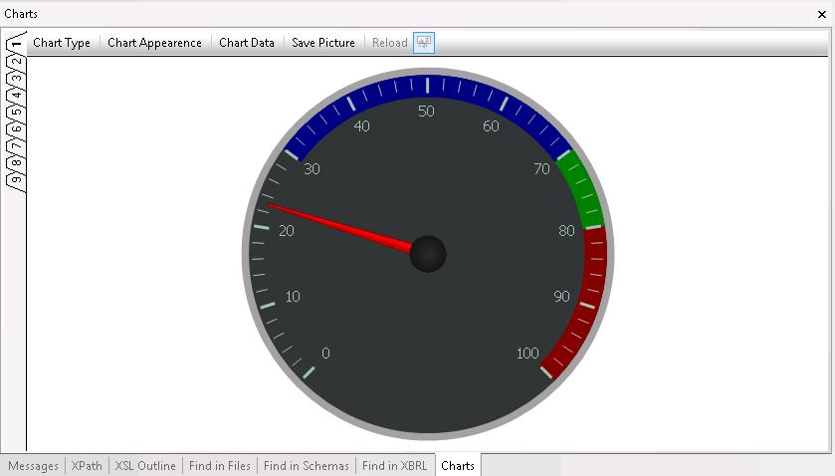
      - Bar Gauge

- Chart Appearance
The Charts appearance possibilities shown to the user depend on the current chart selected. Some are the same independent of the selected chart type.

  - General
Charts: all
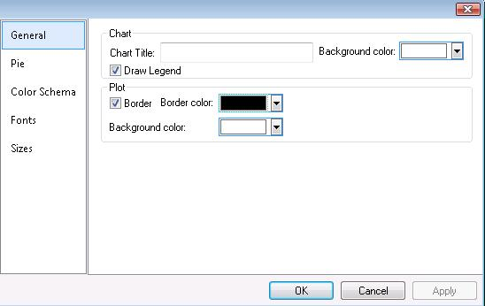
Figure 11: Chart Appearance window - General
Here the Chart’s title and background color can be defined, also whether the legend should be drawn, the plot should be bordered and which color and the plot’s background color.
  - Color Schema
Charts: all
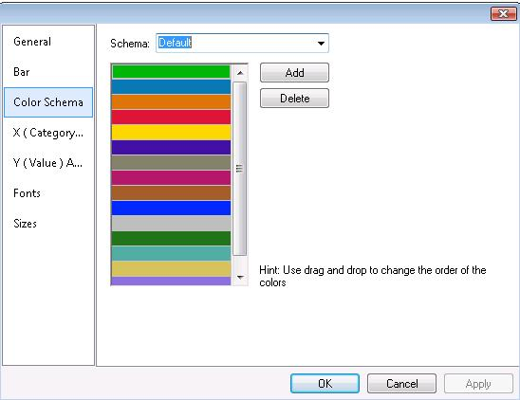
Figure 12: Chart Appearance window - Color Schema
The Color Schemas provided are:
    - Default
    - Grayscale
    - Colorful
    - Pastel
    - User defined
The order of the colors can easily be changed by drag&drop within the list.
  - Fonts
Charts: all
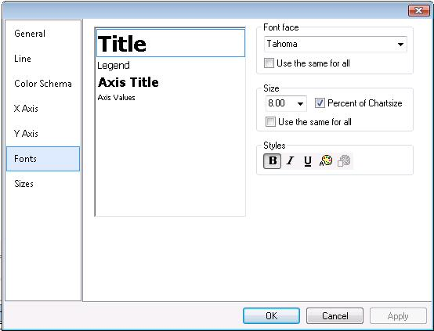
Figure 13: Chart Appearance window - Fonts
The fonts can be modified here dependent on elements available in the single charts type. Additional to other Font dialogs in our products, here a checkbox is available to set the font size in “percent of chartsize” so that it fits to any chart size. If the according checkbox is not set to true, the font size will be absolute and not adapted when the chart size is changed.
  - Sizes:
Charts: all
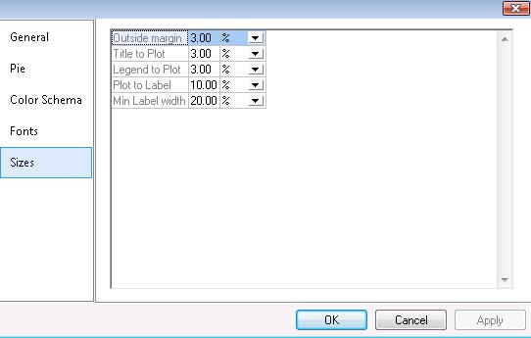
Figure 14: Charts Appearance window - Sizes
It is possible to set the size to percent (%) or pixel (px), in first case the values should be resized and in second the values should be absolute!
The Sizes categories depend on the current Chart type.
  - Pie:
Charts: Pie
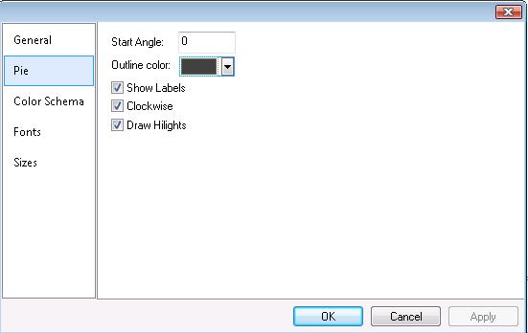
Figure 15: Charts Appearance window - Pie

  - Line
Charts: Value
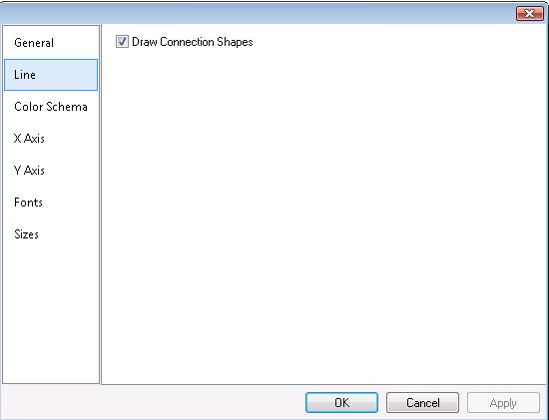
Figure 16: Charts Appearance window - Line

  - Bar
Charts: Category
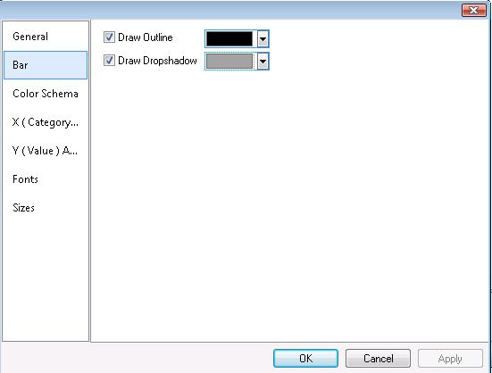
Figure 17: Charts Appearance window – Bar
  - X Axis
Charts: Category, Value
for Category chars the X Axis is named “X (Category) Axis”
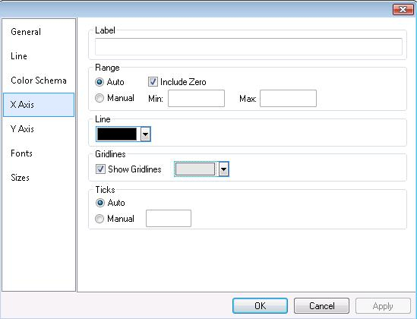
Figure 18: Charts Appearance window - X / Y / Z Axis
Change design of X Axis
Give it a label, define the line color define the gridlines, define ticks and range
  - Y Axis
Charts: Category, Value
for Category chars the Y Axis is named “X (Value) Axis”
Give it a label, Define a range, define Line color, define gridlines, define ticks
  - Z (Series) Axis
Charts: Category (3D only)
Give it a label, and define Line color
  - 3d
Charts: Category (3D only)
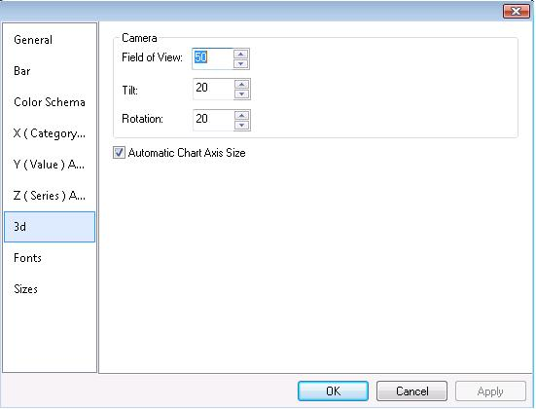
Figure 19: Chart Appearance - 3d
Change the layout of the 3D chart: Field of view, Rotation, and tilt, checkbox “Automated Chart Axis Size”
- Chart Data
How to define the chart data depends on the current chart type. All have in common that chart source data is controlled by XPath statements for document sources.
But how the source data can be selected varies between the charts. This means for each chart type this has to be tested separately.
A tooltip on the column headers will show the name of the element / attribute selected in the document.
Tests must include
  - valid Xpath statements
  - Invalid XPath statements
  - Any other invalid, useless values
- Save Picture
This menu will provide the following possibilities: Save picture, create XSL stylesheet, copy to clipboard and Print.
The charts can be saved in the formats:
PNG, BMP, GIF and JPG
Before the ‘Save As’ dialog is opened, the user has the possibility to define the size of the image.
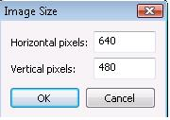
Figure 20: Image Size window

The default values are:
Horizontal pixels: 640
Vertical pixels: 480
- Reload
Reloads the chart considering changes made to the data in document and affecting the selected data source.
- Auto
When this button is enabled, the chart should be updated automatically as soon as the data selected in “Chart data” changes.
Preselect columns
This dialog shows up as soon as the source document supports it for example with an XML document open in grid or text view and selecting the menu item “Create chart”.

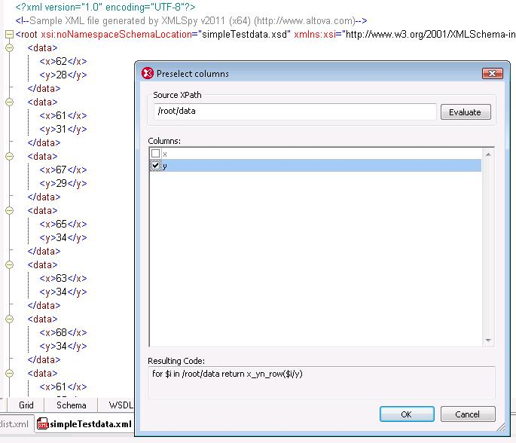
Figure 21: Preselect columns dialog

As in text and grid view the source document generates the source table from an XPath statement, this dialogs shows up.

All available columns are listed in the dialog and via checkboxes the wanted columns can be selected.

A sorting of the columns can be done using drag and drop. After pressing OK, only the checked columns will appear in the “Chart data” dialog.

Charts from text view

In text view it is sufficient to set the focus in a tag of an XML document and then this item is taken to create the XPath statement.

Selections can be made
- Selecting a tag (e.g. <data>)
the XPath statement is created for all <data> elements
- Selecting a single line
the XPath statement is created for all elements of the element selected in line
- Selecting multiple lines
the XPath statement is created for only these elements. The selection cannot be interrupted which means it is not possible to select data[0], data[1] and data[4]. In this case the XPath statement takes data[0] to data[4].

Charts from grid view

In grid view selections can be made
- Selecting single rows
the XPath statement is created for the elements selected only. The advantage of grid view is that the series can be interrupted. For example the first, second and fourth element can be selected and only these are taken as data source to create the chart.

Charts from the XSL/XQuery profiler window:
The XSL/XQ profiler is a tool that is used to analyze the execution time of XSLT (1.0 and 2.0) stylesheets and XQuery documents from within XMLSpy. It tells the user how much an instruction in the XSLT stylesheet or XQuery document takes to execute.

There are 2 different types of profiling - Hitcount and callgraph.

Within the window can be displayed in “Tree”view or “List”view which is important for testing charts and selecting the data for the data source.
In both views multiple selection is allowed.
When selecting a node in text view the values of the direct children are used as source data.
If not row selection is done all data is used.

A new button is available in the profiling window to create a chart using the selected data as data source.
A kind of “smart” pre-selection of columns and switch to a matching, useful chart type suiting to this selection will be offered. As pre-selected columns “name” and “ms” (milliseconds) are suggested as well as in XSL and XQuery profiling window. If the user switches to “%” instead of “ms” then there should be the Pie chart used automatically instead of the Bar chart.

A new transformation means that the column selection remains, but the rows selection will be reset within same transformation (XSL or XQuery). Changing from XSL to XQuery or vice versa will reset the rows as well as the columns selections.

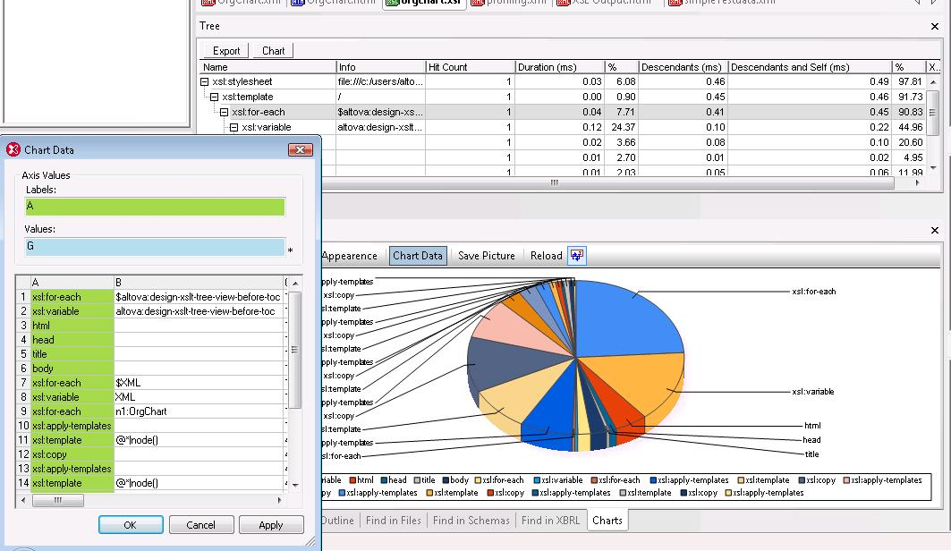
Figure 22: XMLSpy - XSLT / XQuery profiling and Charts

Planned tests in XMLSpy
- Test creating charts
  - From text view
    - Valid XML
    - Invalid XML – for example using data of various data types
    - Select whole document
    - Select nothing
      - Cursor at end / beginning of document
      - Cursor in tag
    - Select single row
    - Select multiple rows
    - Pre-select columns and cross check with “Chart data” dialog
  - From grid view
    - Select single row
    - Select single value
    - Select whole document
    - Select more than 1 row
    - Select rows with various datatypes
    - No selection
    - Pre-select columns and cross check with “Chart data” dialog
  - From XSLT and XQuery profiler window:
    - Select data from List and Tree tab
    - Check pre-selection and correct default chart type according to selection
    - Add columns to pre-selection
    - In both views select
  - Switch between views and reload after having made changes to the data in new view
  - Change document
    - undo / redo with Auto On
    - reload document
    - save document
    - “save as” the document under different name and place
  - Auto On with big files
  - Save picture
    - Read-only files, overwiting
    - Check if correct format
    - File handling
  - XSL stylesheet generation
    - Compare chart and data used with chart in docking control bar
  - Printing
    - Correct product logo and version
    - Correct date and username
    - Scale on print
  - Change chart types and reload
  - Change chart type with Auto On and modify data in file
  - Change chart appearance
  - docking control bar
    - change size of the dialogbar when docking control bar docked
    - change size of the dialog bar when docking control bar is undocked
    - dock anywhere else
    - close and re-open
    - DBQuery window
  - Authentic View

AltovaXML
Intention: Create an extension function library to support configuring / generating / saving chart images in when transforming the xslt.

AltovaXML will provide new functions to create charts. Running the transformation in commandline will create the chart as defined within the stylesheet.

“Copy to clipboard” out of the Charts dialog will also create a xslt stylesheet using these extensions.

The extensions can be used in XSLT 2.0 stylesheets and probably also in XQuery files.

[Details will follow as soon as they are available]

DBQuery window
The DBQuery window will get an own “Charts” tab like the “Messages” tab.

[detailed description missing]

Mapforce
[detailed description missing]

Stylevision
[detailed description missing]

DatabaseSpy
[detailed description missing]

Authentic
[detailed description missing]

  - Risks & Dependencies

The new docking control will be implemented in the ICChartUI library and will be reused by XMLSpy, DatabaseSpy, Mapforce etc.. The chart control bar can be used by all possible data source – XML document, database query window, XSL/XQ profiling.
As all products have access and use the same library there is a dependency. Problems occurring there will affect all products.
Also the ‘ICChartDataProvider’ interface can be re-used. It can easily be reused by other applications. Also here the products depend on the functionality.
  - Automation Issues

- An idea of automating could be automating using bitmaps to compare.
- Automating test cases using AltovaXML

- Test Setup

Developers / Dev Groups and products / parts of products:

Product | Dev / Dev Group
XMLSpy | Piotr Galler
ICChartUI library, ICChart library | Michi Pallinger
GUI docking control bar | Michi Pallinger
AltovaXML | Botond Biro
Stylevision | Botond Biro
DatabaseSpy | Christian Heinisch
DBQuery window | Christian Heinisch
Mapforce | Thomas Hattinger
Authentic | Botond Biro

Product | Tester
XMLSpy | baa
ICChartUI library, ICChart library | All - depending on product
GUI docking control bar | All - depending on product
AltovaXML | baa
Stylevision integration | rip (Stylevision, Authentic?), baa (XMLSpy), mas (MF)
DatabaseSpy | dab, flc?
Mapforce | mas

- Test Coverage Matrix (TCM)

- References

TTP 34193 - Chart support in XMLSpy
TTP 34179 - support for generating charts with the xslt engine
TTP 34304 - Charts

- Figure list

Figure 1: XMLSpy - Textview and Chart data window 9
Figure 2: XMLSpy - grid view and Pie chart in docking control window 10
Figure 3: XMLSpy - docking control bar 10
Figure 4: Chart Type window - Pie 11
Figure 5: Chart Type – Pie Chart 2D 11
Figure 6_ Chart Type window - Category 11
Figure 7: Chart Type – Category Bar Chart 12
Figure 8: Chart Type window - Value 12
Figure 9: Chart Type – Value Line Chart 12
Figure 10: Chart Appearance window - General 13
Figure 11: Chart Appearance window - Color Schema 13
Figure 12: Chart Appearance window - Fonts 14
Figure 13: Charts Appearance window - Sizes 14
Figure 14: Charts Appearance window - Pie 15
Figure 15: Charts Appearance window - Line 15
Figure 16: Charts Appearance window – Bar 16
Figure 17: Charts Appearance window - X / Y / Z Axis 16
Figure 18: Chart Appearance - 3d 17
Figure 19: Image Size window 18
Figure 20: Preselect columns dialog 19
Figure 21: XMLSpy - XSLT / XQuery profiling and Charts 21

