WSDL TimeService.wsdl

WSDL location: | C:\Work\gui-automation\data\spy\examples\TimeService.wsdl
targetnamespace: | http://www.Nanonull.com/TimeService/

services | bindings | porttypes | messages | types
TimeService | TimeServiceHttpGet | TimeServiceHttpGet | getCityTimeHttpGetIn | getCityTime
 | TimeServiceHttpPost | TimeServiceHttpPost | getCityTimeHttpGetOut | getCityTimeResponse
 | TimeServiceSoap | TimeServiceSoap | getCityTimeHttpPostIn | getOffesetUTCTime
 |  |  | getCityTimeHttpPostOut | getOffesetUTCTimeResponse
 |  |  | getCityTimeSoapIn | getServerCity
 |  |  | getCityTimeSoapOut | getServerCityResponse
 |  |  | getOffesetUTCTimeHttpGetIn | getServerTime
 |  |  | getOffesetUTCTimeHttpGetOut | getServerTimeResponse
 |  |  | getOffesetUTCTimeHttpPostIn | getServerTimeZone
 |  |  | getOffesetUTCTimeHttpPostOut | getServerTimeZoneResponse
 |  |  | getOffesetUTCTimeSoapIn | getTimeZoneTime
 |  |  | getOffesetUTCTimeSoapOut | getTimeZoneTimeResponse
 |  |  | getServerCityHttpGetIn | getUTCTime
 |  |  | getServerCityHttpGetOut | getUTCTimeResponse
 |  |  | getServerCityHttpPostIn | string
 |  |  | getServerCityHttpPostOut
 |  |  | getServerCitySoapIn
 |  |  | getServerCitySoapOut
 |  |  | getServerTimeHttpGetIn
 |  |  | getServerTimeHttpGetOut
 |  |  | getServerTimeHttpPostIn
 |  |  | getServerTimeHttpPostOut
 |  |  | getServerTimeSoapIn
 |  |  | getServerTimeSoapOut
 |  |  | getServerTimeZoneHttpGetIn
 |  |  | getServerTimeZoneHttpGetOut
 |  |  | getServerTimeZoneHttpPostIn
 |  |  | getServerTimeZoneHttpPostOut
 |  |  | getServerTimeZoneSoapIn
 |  |  | getServerTimeZoneSoapOut
 |  |  | getTimeZoneTimeHttpGetIn
 |  |  | getTimeZoneTimeHttpGetOut
 |  |  | getTimeZoneTimeHttpPostIn
 |  |  | getTimeZoneTimeHttpPostOut
 |  |  | getTimeZoneTimeSoapIn
 |  |  | getTimeZoneTimeSoapOut
 |  |  | getUTCTimeHttpGetIn
 |  |  | getUTCTimeHttpGetOut
 |  |  | getUTCTimeHttpPostIn
 |  |  | getUTCTimeHttpPostOut
 |  |  | getUTCTimeSoapIn
 |  |  | getUTCTimeSoapOut

schema location: | C:\Work\gui-automation\data\spy\examples\TimeService.wsdl
attributeFormDefault:
elementFormDefault: | qualified
targetNamespace: | http://www.Nanonull.com/TimeService/

Elements
getCityTime
getCityTimeResponse
getOffesetUTCTime
getOffesetUTCTimeResponse
getServerCity
getServerCityResponse
getServerTime
getServerTimeResponse
getServerTimeZone
getServerTimeZoneResponse
getTimeZoneTime
getTimeZoneTimeResponse
getUTCTime
getUTCTimeResponse
string

service TimeService

A sample Time service
diagram | 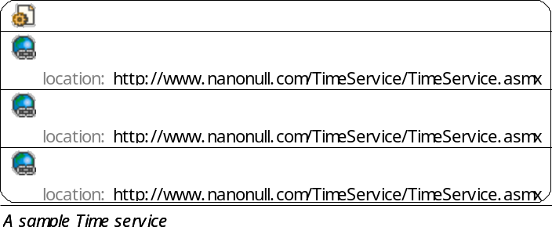
ports
  TimeServiceSoap
  binding | s0:TimeServiceSoap
  extensibility | <soap:address location="http://www.nanonull.com/TimeService/TimeService.asmx"/>
  TimeServiceHttpGet
  binding | s0:TimeServiceHttpGet
  extensibility | <http:address location="http://www.nanonull.com/TimeService/TimeService.asmx"/>
  TimeServiceHttpPost
  binding | s0:TimeServiceHttpPost
  extensibility | <http:address location="http://www.nanonull.com/TimeService/TimeService.asmx"/>
source | <service name="TimeService">  <documentation>A sample Time service</documentation>  <port name="TimeServiceSoap" binding="s0:TimeServiceSoap">  <soap:address location="http://www.nanonull.com/TimeService/TimeService.asmx"/>  </port>  <port name="TimeServiceHttpGet" binding="s0:TimeServiceHttpGet">  <http:address location="http://www.nanonull.com/TimeService/TimeService.asmx"/>  </port>  <port name="TimeServiceHttpPost" binding="s0:TimeServiceHttpPost">  <http:address location="http://www.nanonull.com/TimeService/TimeService.asmx"/>  </port>  </service>

binding TimeServiceHttpGet
diagram | 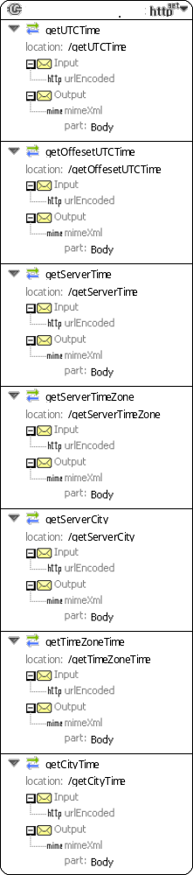
type | s0:TimeServiceHttpGet
extensibility | <http:binding verb="GET"/>
operations
  getUTCTime
  extensibility | <http:operation location="/getUTCTime"/>
  input | <http:urlEncoded/>
  output | <mime:mimeXml part="Body"/>
  getOffesetUTCTime
  extensibility | <http:operation location="/getOffesetUTCTime"/>
  input | <http:urlEncoded/>
  output | <mime:mimeXml part="Body"/>
  getServerTime
  extensibility | <http:operation location="/getServerTime"/>
  input | <http:urlEncoded/>
  output | <mime:mimeXml part="Body"/>
  getServerTimeZone
  extensibility | <http:operation location="/getServerTimeZone"/>
  input | <http:urlEncoded/>
  output | <mime:mimeXml part="Body"/>
  getServerCity
  extensibility | <http:operation location="/getServerCity"/>
  input | <http:urlEncoded/>
  output | <mime:mimeXml part="Body"/>
  getTimeZoneTime
  extensibility | <http:operation location="/getTimeZoneTime"/>
  input | <http:urlEncoded/>
  output | <mime:mimeXml part="Body"/>
  getCityTime
  extensibility | <http:operation location="/getCityTime"/>
  input | <http:urlEncoded/>
  output | <mime:mimeXml part="Body"/>
used by
  Port TimeServiceHttpGet in Service TimeService
source | <binding name="TimeServiceHttpGet" type="s0:TimeServiceHttpGet">  <http:binding verb="GET"/>  <operation name="getUTCTime">  <http:operation location="/getUTCTime"/>  <input>  <http:urlEncoded/>  </input>  <output>  <mime:mimeXml part="Body"/>  </output>  </operation>  <operation name="getOffesetUTCTime">  <http:operation location="/getOffesetUTCTime"/>  <input>  <http:urlEncoded/>  </input>  <output>  <mime:mimeXml part="Body"/>  </output>  </operation>  <operation name="getServerTime">  <http:operation location="/getServerTime"/>  <input>  <http:urlEncoded/>  </input>  <output>  <mime:mimeXml part="Body"/>  </output>  </operation>  <operation name="getServerTimeZone">  <http:operation location="/getServerTimeZone"/>  <input>  <http:urlEncoded/>  </input>  <output>  <mime:mimeXml part="Body"/>  </output>  </operation>  <operation name="getServerCity">  <http:operation location="/getServerCity"/>  <input>  <http:urlEncoded/>  </input>  <output>  <mime:mimeXml part="Body"/>  </output>  </operation>  <operation name="getTimeZoneTime">  <http:operation location="/getTimeZoneTime"/>  <input>  <http:urlEncoded/>  </input>  <output>  <mime:mimeXml part="Body"/>  </output>  </operation>  <operation name="getCityTime">  <http:operation location="/getCityTime"/>  <input>  <http:urlEncoded/>  </input>  <output>  <mime:mimeXml part="Body"/>  </output>  </operation>  </binding>

binding TimeServiceHttpPost
diagram | 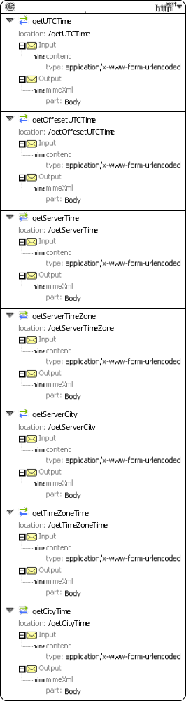
type | s0:TimeServiceHttpPost
extensibility | <http:binding verb="POST"/>
operations
  getUTCTime
  extensibility | <http:operation location="/getUTCTime"/>
  input | <mime:content type="application/x-www-form-urlencoded"/>
  output | <mime:mimeXml part="Body"/>
  getOffesetUTCTime
  extensibility | <http:operation location="/getOffesetUTCTime"/>
  input | <mime:content type="application/x-www-form-urlencoded"/>
  output | <mime:mimeXml part="Body"/>
  getServerTime
  extensibility | <http:operation location="/getServerTime"/>
  input | <mime:content type="application/x-www-form-urlencoded"/>
  output | <mime:mimeXml part="Body"/>
  getServerTimeZone
  extensibility | <http:operation location="/getServerTimeZone"/>
  input | <mime:content type="application/x-www-form-urlencoded"/>
  output | <mime:mimeXml part="Body"/>
  getServerCity
  extensibility | <http:operation location="/getServerCity"/>
  input | <mime:content type="application/x-www-form-urlencoded"/>
  output | <mime:mimeXml part="Body"/>
  getTimeZoneTime
  extensibility | <http:operation location="/getTimeZoneTime"/>
  input | <mime:content type="application/x-www-form-urlencoded"/>
  output | <mime:mimeXml part="Body"/>
  getCityTime
  extensibility | <http:operation location="/getCityTime"/>
  input | <mime:content type="application/x-www-form-urlencoded"/>
  output | <mime:mimeXml part="Body"/>
used by
  Port TimeServiceHttpPost in Service TimeService
source | <binding name="TimeServiceHttpPost" type="s0:TimeServiceHttpPost">  <http:binding verb="POST"/>  <operation name="getUTCTime">  <http:operation location="/getUTCTime"/>  <input>  <mime:content type="application/x-www-form-urlencoded"/>  </input>  <output>  <mime:mimeXml part="Body"/>  </output>  </operation>  <operation name="getOffesetUTCTime">  <http:operation location="/getOffesetUTCTime"/>  <input>  <mime:content type="application/x-www-form-urlencoded"/>  </input>  <output>  <mime:mimeXml part="Body"/>  </output>  </operation>  <operation name="getServerTime">  <http:operation location="/getServerTime"/>  <input>  <mime:content type="application/x-www-form-urlencoded"/>  </input>  <output>  <mime:mimeXml part="Body"/>  </output>  </operation>  <operation name="getServerTimeZone">  <http:operation location="/getServerTimeZone"/>  <input>  <mime:content type="application/x-www-form-urlencoded"/>  </input>  <output>  <mime:mimeXml part="Body"/>  </output>  </operation>  <operation name="getServerCity">  <http:operation location="/getServerCity"/>  <input>  <mime:content type="application/x-www-form-urlencoded"/>  </input>  <output>  <mime:mimeXml part="Body"/>  </output>  </operation>  <operation name="getTimeZoneTime">  <http:operation location="/getTimeZoneTime"/>  <input>  <mime:content type="application/x-www-form-urlencoded"/>  </input>  <output>  <mime:mimeXml part="Body"/>  </output>  </operation>  <operation name="getCityTime">  <http:operation location="/getCityTime"/>  <input>  <mime:content type="application/x-www-form-urlencoded"/>  </input>  <output>  <mime:mimeXml part="Body"/>  </output>  </operation>  </binding>

binding TimeServiceSoap
diagram | 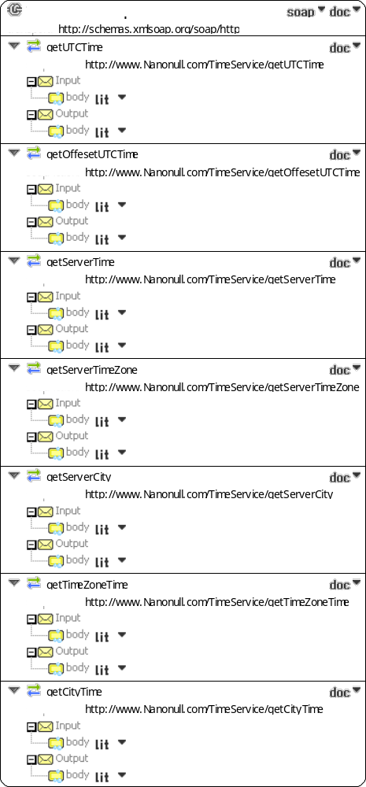
type | s0:TimeServiceSoap
extensibility | <soap:binding style="document" transport="http://schemas.xmlsoap.org/soap/http"/>
operations
  getUTCTime
  extensibility | <soap:operation soapAction="http://www.Nanonull.com/TimeService/getUTCTime" style="document"/>
  input | <soap:body use="literal"/>
  output | <soap:body use="literal"/>
  getOffesetUTCTime
  extensibility | <soap:operation soapAction="http://www.Nanonull.com/TimeService/getOffesetUTCTime" style="document"/>
  input | <soap:body use="literal"/>
  output | <soap:body use="literal"/>
  getServerTime
  extensibility | <soap:operation soapAction="http://www.Nanonull.com/TimeService/getServerTime" style="document"/>
  input | <soap:body use="literal"/>
  output | <soap:body use="literal"/>
  getServerTimeZone
  extensibility | <soap:operation soapAction="http://www.Nanonull.com/TimeService/getServerTimeZone" style="document"/>
  input | <soap:body use="literal"/>
  output | <soap:body use="literal"/>
  getServerCity
  extensibility | <soap:operation soapAction="http://www.Nanonull.com/TimeService/getServerCity" style="document"/>
  input | <soap:body use="literal"/>
  output | <soap:body use="literal"/>
  getTimeZoneTime
  extensibility | <soap:operation soapAction="http://www.Nanonull.com/TimeService/getTimeZoneTime" style="document"/>
  input | <soap:body use="literal"/>
  output | <soap:body use="literal"/>
  getCityTime
  extensibility | <soap:operation soapAction="http://www.Nanonull.com/TimeService/getCityTime" style="document"/>
  input | <soap:body use="literal"/>
  output | <soap:body use="literal"/>
used by
  Port TimeServiceSoap in Service TimeService
source | <binding name="TimeServiceSoap" type="s0:TimeServiceSoap">  <soap:binding style="document" transport="http://schemas.xmlsoap.org/soap/http"/>  <operation name="getUTCTime">  <soap:operation soapAction="http://www.Nanonull.com/TimeService/getUTCTime" style="document"/>  <input>  <soap:body use="literal"/>  </input>  <output>  <soap:body use="literal"/>  </output>  </operation>  <operation name="getOffesetUTCTime">  <soap:operation soapAction="http://www.Nanonull.com/TimeService/getOffesetUTCTime" style="document"/>  <input>  <soap:body use="literal"/>  </input>  <output>  <soap:body use="literal"/>  </output>  </operation>  <operation name="getServerTime">  <soap:operation soapAction="http://www.Nanonull.com/TimeService/getServerTime" style="document"/>  <input>  <soap:body use="literal"/>  </input>  <output>  <soap:body use="literal"/>  </output>  </operation>  <operation name="getServerTimeZone">  <soap:operation soapAction="http://www.Nanonull.com/TimeService/getServerTimeZone" style="document"/>  <input>  <soap:body use="literal"/>  </input>  <output>  <soap:body use="literal"/>  </output>  </operation>  <operation name="getServerCity">  <soap:operation soapAction="http://www.Nanonull.com/TimeService/getServerCity" style="document"/>  <input>  <soap:body use="literal"/>  </input>  <output>  <soap:body use="literal"/>  </output>  </operation>  <operation name="getTimeZoneTime">  <soap:operation soapAction="http://www.Nanonull.com/TimeService/getTimeZoneTime" style="document"/>  <input>  <soap:body use="literal"/>  </input>  <output>  <soap:body use="literal"/>  </output>  </operation>  <operation name="getCityTime">  <soap:operation soapAction="http://www.Nanonull.com/TimeService/getCityTime" style="document"/>  <input>  <soap:body use="literal"/>  </input>  <output>  <soap:body use="literal"/>  </output>  </operation>  </binding>

porttype TimeServiceHttpGet
diagram | 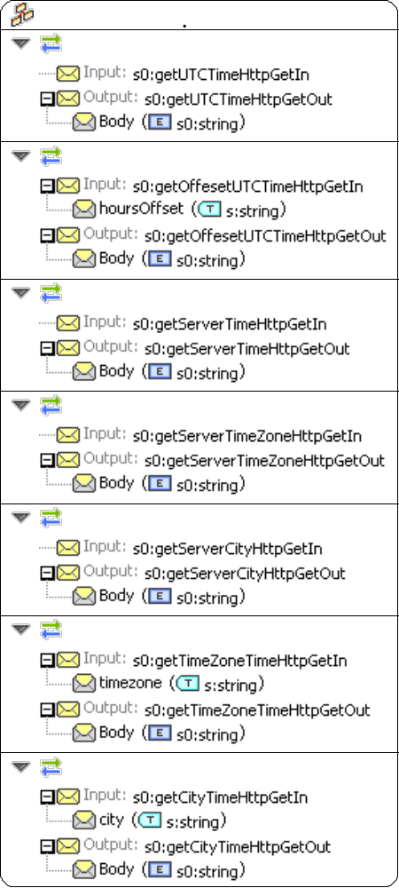
operations
  getUTCTime
  input | s0:getUTCTimeHttpGetIn
  output | s0:getUTCTimeHttpGetOut
  getOffesetUTCTime
  input | s0:getOffesetUTCTimeHttpGetIn
  output | s0:getOffesetUTCTimeHttpGetOut
  getServerTime
  input | s0:getServerTimeHttpGetIn
  output | s0:getServerTimeHttpGetOut
  getServerTimeZone
  input | s0:getServerTimeZoneHttpGetIn
  output | s0:getServerTimeZoneHttpGetOut
  getServerCity
  input | s0:getServerCityHttpGetIn
  output | s0:getServerCityHttpGetOut
  getTimeZoneTime
  input | s0:getTimeZoneTimeHttpGetIn
  output | s0:getTimeZoneTimeHttpGetOut
  getCityTime
  input | s0:getCityTimeHttpGetIn
  output | s0:getCityTimeHttpGetOut
used by
  binding TimeServiceHttpGet
source | <portType name="TimeServiceHttpGet">  <operation name="getUTCTime">  <input message="s0:getUTCTimeHttpGetIn"/>  <output message="s0:getUTCTimeHttpGetOut"/>  </operation>  <operation name="getOffesetUTCTime">  <input message="s0:getOffesetUTCTimeHttpGetIn"/>  <output message="s0:getOffesetUTCTimeHttpGetOut"/>  </operation>  <operation name="getServerTime">  <input message="s0:getServerTimeHttpGetIn"/>  <output message="s0:getServerTimeHttpGetOut"/>  </operation>  <operation name="getServerTimeZone">  <input message="s0:getServerTimeZoneHttpGetIn"/>  <output message="s0:getServerTimeZoneHttpGetOut"/>  </operation>  <operation name="getServerCity">  <input message="s0:getServerCityHttpGetIn"/>  <output message="s0:getServerCityHttpGetOut"/>  </operation>  <operation name="getTimeZoneTime">  <input message="s0:getTimeZoneTimeHttpGetIn"/>  <output message="s0:getTimeZoneTimeHttpGetOut"/>  </operation>  <operation name="getCityTime">  <input message="s0:getCityTimeHttpGetIn"/>  <output message="s0:getCityTimeHttpGetOut"/>  </operation>  </portType>

porttype TimeServiceHttpPost
diagram | 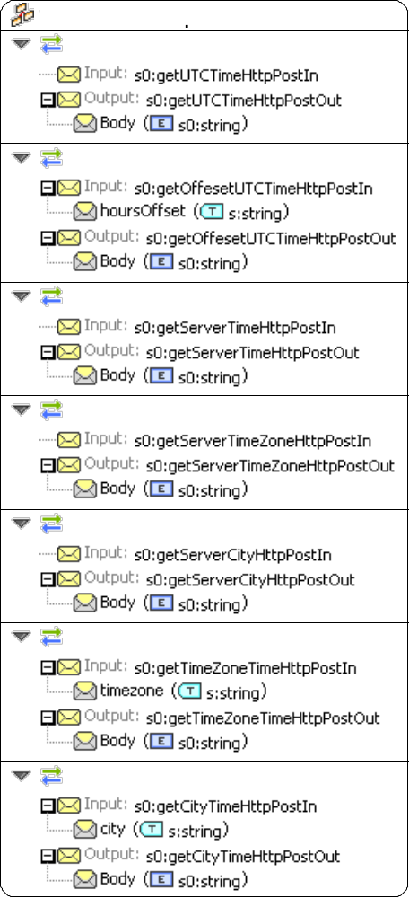
operations
  getUTCTime
  input | s0:getUTCTimeHttpPostIn
  output | s0:getUTCTimeHttpPostOut
  getOffesetUTCTime
  input | s0:getOffesetUTCTimeHttpPostIn
  output | s0:getOffesetUTCTimeHttpPostOut
  getServerTime
  input | s0:getServerTimeHttpPostIn
  output | s0:getServerTimeHttpPostOut
  getServerTimeZone
  input | s0:getServerTimeZoneHttpPostIn
  output | s0:getServerTimeZoneHttpPostOut
  getServerCity
  input | s0:getServerCityHttpPostIn
  output | s0:getServerCityHttpPostOut
  getTimeZoneTime
  input | s0:getTimeZoneTimeHttpPostIn
  output | s0:getTimeZoneTimeHttpPostOut
  getCityTime
  input | s0:getCityTimeHttpPostIn
  output | s0:getCityTimeHttpPostOut
used by
  binding TimeServiceHttpPost
source | <portType name="TimeServiceHttpPost">  <operation name="getUTCTime">  <input message="s0:getUTCTimeHttpPostIn"/>  <output message="s0:getUTCTimeHttpPostOut"/>  </operation>  <operation name="getOffesetUTCTime">  <input message="s0:getOffesetUTCTimeHttpPostIn"/>  <output message="s0:getOffesetUTCTimeHttpPostOut"/>  </operation>  <operation name="getServerTime">  <input message="s0:getServerTimeHttpPostIn"/>  <output message="s0:getServerTimeHttpPostOut"/>  </operation>  <operation name="getServerTimeZone">  <input message="s0:getServerTimeZoneHttpPostIn"/>  <output message="s0:getServerTimeZoneHttpPostOut"/>  </operation>  <operation name="getServerCity">  <input message="s0:getServerCityHttpPostIn"/>  <output message="s0:getServerCityHttpPostOut"/>  </operation>  <operation name="getTimeZoneTime">  <input message="s0:getTimeZoneTimeHttpPostIn"/>  <output message="s0:getTimeZoneTimeHttpPostOut"/>  </operation>  <operation name="getCityTime">  <input message="s0:getCityTimeHttpPostIn"/>  <output message="s0:getCityTimeHttpPostOut"/>  </operation>  </portType>

porttype TimeServiceSoap
diagram | 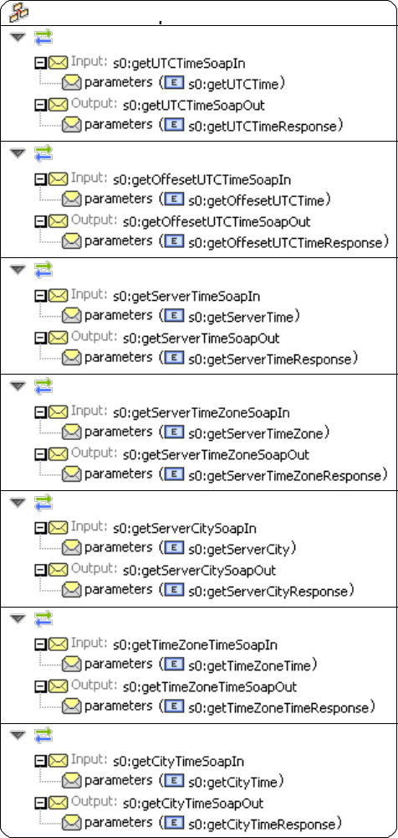
operations
  getUTCTime
  input | s0:getUTCTimeSoapIn
  output | s0:getUTCTimeSoapOut
  getOffesetUTCTime
  input | s0:getOffesetUTCTimeSoapIn
  output | s0:getOffesetUTCTimeSoapOut
  getServerTime
  input | s0:getServerTimeSoapIn
  output | s0:getServerTimeSoapOut
  getServerTimeZone
  input | s0:getServerTimeZoneSoapIn
  output | s0:getServerTimeZoneSoapOut
  getServerCity
  input | s0:getServerCitySoapIn
  output | s0:getServerCitySoapOut
  getTimeZoneTime
  input | s0:getTimeZoneTimeSoapIn
  output | s0:getTimeZoneTimeSoapOut
  getCityTime
  input | s0:getCityTimeSoapIn
  output | s0:getCityTimeSoapOut
used by
  binding TimeServiceSoap
source | <portType name="TimeServiceSoap">  <operation name="getUTCTime">  <input message="s0:getUTCTimeSoapIn"/>  <output message="s0:getUTCTimeSoapOut"/>  </operation>  <operation name="getOffesetUTCTime">  <input message="s0:getOffesetUTCTimeSoapIn"/>  <output message="s0:getOffesetUTCTimeSoapOut"/>  </operation>  <operation name="getServerTime">  <input message="s0:getServerTimeSoapIn"/>  <output message="s0:getServerTimeSoapOut"/>  </operation>  <operation name="getServerTimeZone">  <input message="s0:getServerTimeZoneSoapIn"/>  <output message="s0:getServerTimeZoneSoapOut"/>  </operation>  <operation name="getServerCity">  <input message="s0:getServerCitySoapIn"/>  <output message="s0:getServerCitySoapOut"/>  </operation>  <operation name="getTimeZoneTime">  <input message="s0:getTimeZoneTimeSoapIn"/>  <output message="s0:getTimeZoneTimeSoapOut"/>  </operation>  <operation name="getCityTime">  <input message="s0:getCityTimeSoapIn"/>  <output message="s0:getCityTimeSoapOut"/>  </operation>  </portType>

message getCityTimeHttpGetIn
parts
  city
  type | s:string
used by
  Operation getCityTime in PortType TimeServiceHttpGet
source | <message name="getCityTimeHttpGetIn">  <part name="city" type="s:string"/>  </message>

message getCityTimeHttpGetOut
parts
  Body
  element | s0:string
used by
  Operation getCityTime in PortType TimeServiceHttpGet
source | <message name="getCityTimeHttpGetOut">  <part name="Body" element="s0:string"/>  </message>

message getCityTimeHttpPostIn
parts
  city
  type | s:string
used by
  Operation getCityTime in PortType TimeServiceHttpPost
source | <message name="getCityTimeHttpPostIn">  <part name="city" type="s:string"/>  </message>

message getCityTimeHttpPostOut
parts
  Body
  element | s0:string
used by
  Operation getCityTime in PortType TimeServiceHttpPost
source | <message name="getCityTimeHttpPostOut">  <part name="Body" element="s0:string"/>  </message>

message getCityTimeSoapIn
parts
  parameters
  element | s0:getCityTime
used by
  Operation getCityTime in PortType TimeServiceSoap
source | <message name="getCityTimeSoapIn">  <part name="parameters" element="s0:getCityTime"/>  </message>

message getCityTimeSoapOut
parts
  parameters
  element | s0:getCityTimeResponse
used by
  Operation getCityTime in PortType TimeServiceSoap
source | <message name="getCityTimeSoapOut">  <part name="parameters" element="s0:getCityTimeResponse"/>  </message>

message getOffesetUTCTimeHttpGetIn
parts
  hoursOffset
  type | s:string
used by
  Operation getOffesetUTCTime in PortType TimeServiceHttpGet
source | <message name="getOffesetUTCTimeHttpGetIn">  <part name="hoursOffset" type="s:string"/>  </message>

message getOffesetUTCTimeHttpGetOut
parts
  Body
  element | s0:string
used by
  Operation getOffesetUTCTime in PortType TimeServiceHttpGet
source | <message name="getOffesetUTCTimeHttpGetOut">  <part name="Body" element="s0:string"/>  </message>

message getOffesetUTCTimeHttpPostIn
parts
  hoursOffset
  type | s:string
used by
  Operation getOffesetUTCTime in PortType TimeServiceHttpPost
source | <message name="getOffesetUTCTimeHttpPostIn">  <part name="hoursOffset" type="s:string"/>  </message>

message getOffesetUTCTimeHttpPostOut
parts
  Body
  element | s0:string
used by
  Operation getOffesetUTCTime in PortType TimeServiceHttpPost
source | <message name="getOffesetUTCTimeHttpPostOut">  <part name="Body" element="s0:string"/>  </message>

message getOffesetUTCTimeSoapIn
parts
  parameters
  element | s0:getOffesetUTCTime
used by
  Operation getOffesetUTCTime in PortType TimeServiceSoap
source | <message name="getOffesetUTCTimeSoapIn">  <part name="parameters" element="s0:getOffesetUTCTime"/>  </message>

message getOffesetUTCTimeSoapOut
parts
  parameters
  element | s0:getOffesetUTCTimeResponse
used by
  Operation getOffesetUTCTime in PortType TimeServiceSoap
source | <message name="getOffesetUTCTimeSoapOut">  <part name="parameters" element="s0:getOffesetUTCTimeResponse"/>  </message>

message getServerCityHttpGetIn
parts
used by
  Operation getServerCity in PortType TimeServiceHttpGet
source | <message name="getServerCityHttpGetIn"/>

message getServerCityHttpGetOut
parts
  Body
  element | s0:string
used by
  Operation getServerCity in PortType TimeServiceHttpGet
source | <message name="getServerCityHttpGetOut">  <part name="Body" element="s0:string"/>  </message>

message getServerCityHttpPostIn
parts
used by
  Operation getServerCity in PortType TimeServiceHttpPost
source | <message name="getServerCityHttpPostIn"/>

message getServerCityHttpPostOut
parts
  Body
  element | s0:string
used by
  Operation getServerCity in PortType TimeServiceHttpPost
source | <message name="getServerCityHttpPostOut">  <part name="Body" element="s0:string"/>  </message>

message getServerCitySoapIn
parts
  parameters
  element | s0:getServerCity
used by
  Operation getServerCity in PortType TimeServiceSoap
source | <message name="getServerCitySoapIn">  <part name="parameters" element="s0:getServerCity"/>  </message>

message getServerCitySoapOut
parts
  parameters
  element | s0:getServerCityResponse
used by
  Operation getServerCity in PortType TimeServiceSoap
source | <message name="getServerCitySoapOut">  <part name="parameters" element="s0:getServerCityResponse"/>  </message>

message getServerTimeHttpGetIn
parts
used by
  Operation getServerTime in PortType TimeServiceHttpGet
source | <message name="getServerTimeHttpGetIn"/>

message getServerTimeHttpGetOut
parts
  Body
  element | s0:string
used by
  Operation getServerTime in PortType TimeServiceHttpGet
source | <message name="getServerTimeHttpGetOut">  <part name="Body" element="s0:string"/>  </message>

message getServerTimeHttpPostIn
parts
used by
  Operation getServerTime in PortType TimeServiceHttpPost
source | <message name="getServerTimeHttpPostIn"/>

message getServerTimeHttpPostOut
parts
  Body
  element | s0:string
used by
  Operation getServerTime in PortType TimeServiceHttpPost
source | <message name="getServerTimeHttpPostOut">  <part name="Body" element="s0:string"/>  </message>

message getServerTimeSoapIn
parts
  parameters
  element | s0:getServerTime
used by
  Operation getServerTime in PortType TimeServiceSoap
source | <message name="getServerTimeSoapIn">  <part name="parameters" element="s0:getServerTime"/>  </message>

message getServerTimeSoapOut
parts
  parameters
  element | s0:getServerTimeResponse
used by
  Operation getServerTime in PortType TimeServiceSoap
source | <message name="getServerTimeSoapOut">  <part name="parameters" element="s0:getServerTimeResponse"/>  </message>

message getServerTimeZoneHttpGetIn
parts
used by
  Operation getServerTimeZone in PortType TimeServiceHttpGet
source | <message name="getServerTimeZoneHttpGetIn"/>

message getServerTimeZoneHttpGetOut
parts
  Body
  element | s0:string
used by
  Operation getServerTimeZone in PortType TimeServiceHttpGet
source | <message name="getServerTimeZoneHttpGetOut">  <part name="Body" element="s0:string"/>  </message>

message getServerTimeZoneHttpPostIn
parts
used by
  Operation getServerTimeZone in PortType TimeServiceHttpPost
source | <message name="getServerTimeZoneHttpPostIn"/>

message getServerTimeZoneHttpPostOut
parts
  Body
  element | s0:string
used by
  Operation getServerTimeZone in PortType TimeServiceHttpPost
source | <message name="getServerTimeZoneHttpPostOut">  <part name="Body" element="s0:string"/>  </message>

message getServerTimeZoneSoapIn
parts
  parameters
  element | s0:getServerTimeZone
used by
  Operation getServerTimeZone in PortType TimeServiceSoap
source | <message name="getServerTimeZoneSoapIn">  <part name="parameters" element="s0:getServerTimeZone"/>  </message>

message getServerTimeZoneSoapOut
parts
  parameters
  element | s0:getServerTimeZoneResponse
used by
  Operation getServerTimeZone in PortType TimeServiceSoap
source | <message name="getServerTimeZoneSoapOut">  <part name="parameters" element="s0:getServerTimeZoneResponse"/>  </message>

message getTimeZoneTimeHttpGetIn
parts
  timezone
  type | s:string
used by
  Operation getTimeZoneTime in PortType TimeServiceHttpGet
source | <message name="getTimeZoneTimeHttpGetIn">  <part name="timezone" type="s:string"/>  </message>

message getTimeZoneTimeHttpGetOut
parts
  Body
  element | s0:string
used by
  Operation getTimeZoneTime in PortType TimeServiceHttpGet
source | <message name="getTimeZoneTimeHttpGetOut">  <part name="Body" element="s0:string"/>  </message>

message getTimeZoneTimeHttpPostIn
parts
  timezone
  type | s:string
used by
  Operation getTimeZoneTime in PortType TimeServiceHttpPost
source | <message name="getTimeZoneTimeHttpPostIn">  <part name="timezone" type="s:string"/>  </message>

message getTimeZoneTimeHttpPostOut
parts
  Body
  element | s0:string
used by
  Operation getTimeZoneTime in PortType TimeServiceHttpPost
source | <message name="getTimeZoneTimeHttpPostOut">  <part name="Body" element="s0:string"/>  </message>

message getTimeZoneTimeSoapIn
parts
  parameters
  element | s0:getTimeZoneTime
used by
  Operation getTimeZoneTime in PortType TimeServiceSoap
source | <message name="getTimeZoneTimeSoapIn">  <part name="parameters" element="s0:getTimeZoneTime"/>  </message>

message getTimeZoneTimeSoapOut
parts
  parameters
  element | s0:getTimeZoneTimeResponse
used by
  Operation getTimeZoneTime in PortType TimeServiceSoap
source | <message name="getTimeZoneTimeSoapOut">  <part name="parameters" element="s0:getTimeZoneTimeResponse"/>  </message>

message getUTCTimeHttpGetIn
parts
used by
  Operation getUTCTime in PortType TimeServiceHttpGet
source | <message name="getUTCTimeHttpGetIn"/>

message getUTCTimeHttpGetOut
parts
  Body
  element | s0:string
used by
  Operation getUTCTime in PortType TimeServiceHttpGet
source | <message name="getUTCTimeHttpGetOut">  <part name="Body" element="s0:string"/>  </message>

message getUTCTimeHttpPostIn
parts
used by
  Operation getUTCTime in PortType TimeServiceHttpPost
source | <message name="getUTCTimeHttpPostIn"/>

message getUTCTimeHttpPostOut
parts
  Body
  element | s0:string
used by
  Operation getUTCTime in PortType TimeServiceHttpPost
source | <message name="getUTCTimeHttpPostOut">  <part name="Body" element="s0:string"/>  </message>

message getUTCTimeSoapIn
parts
  parameters
  element | s0:getUTCTime
used by
  Operation getUTCTime in PortType TimeServiceSoap
source | <message name="getUTCTimeSoapIn">  <part name="parameters" element="s0:getUTCTime"/>  </message>

message getUTCTimeSoapOut
parts
  parameters
  element | s0:getUTCTimeResponse
used by
  Operation getUTCTime in PortType TimeServiceSoap
source | <message name="getUTCTimeSoapOut">  <part name="parameters" element="s0:getUTCTimeResponse"/>  </message>

element getCityTime
diagram | 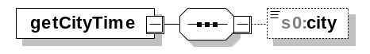
namespace | http://www.Nanonull.com/TimeService/
properties
  content | complex
children | s0:city
source | <s:element name="getCityTime">  <s:complexType>  <s:sequence>  <s:element name="city" type="s:string" minOccurs="0" maxOccurs="1"/>  </s:sequence>  </s:complexType>  </s:element>

element getCityTime/city
diagram | 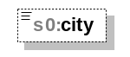
namespace | http://www.Nanonull.com/TimeService/
type | s:string
properties
  minOcc | 0
  maxOcc | 1
  content | simple
source | <s:element name="city" type="s:string" minOccurs="0" maxOccurs="1"/>

element getCityTimeResponse
diagram
namespace | http://www.Nanonull.com/TimeService/
properties
  content | complex
children | s0:getCityTimeResult
source | <s:element name="getCityTimeResponse">  <s:complexType>  <s:sequence>  <s:element name="getCityTimeResult" type="s:string" minOccurs="0" maxOccurs="1"/>  </s:sequence>  </s:complexType>  </s:element>

element getCityTimeResponse/getCityTimeResult
diagram | 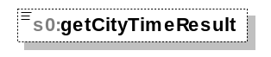
namespace | http://www.Nanonull.com/TimeService/
type | s:string
properties
  minOcc | 0
  maxOcc | 1
  content | simple
source | <s:element name="getCityTimeResult" type="s:string" minOccurs="0" maxOccurs="1"/>

element getOffesetUTCTime
diagram | 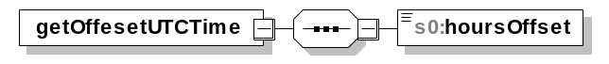
namespace | http://www.Nanonull.com/TimeService/
properties
  content | complex
children | s0:hoursOffset
source | <s:element name="getOffesetUTCTime">  <s:complexType>  <s:sequence>  <s:element name="hoursOffset" type="s:double" minOccurs="1" maxOccurs="1"/>  </s:sequence>  </s:complexType>  </s:element>

element getOffesetUTCTime/hoursOffset
diagram | 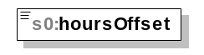
namespace | http://www.Nanonull.com/TimeService/
type | s:double
properties
  content | simple
source | <s:element name="hoursOffset" type="s:double" minOccurs="1" maxOccurs="1"/>

element getOffesetUTCTimeResponse
diagram
namespace | http://www.Nanonull.com/TimeService/
properties
  content | complex
children | s0:getOffesetUTCTimeResult
source | <s:element name="getOffesetUTCTimeResponse">  <s:complexType>  <s:sequence>  <s:element name="getOffesetUTCTimeResult" type="s:string" minOccurs="0" maxOccurs="1"/>  </s:sequence>  </s:complexType>  </s:element>

element getOffesetUTCTimeResponse/getOffesetUTCTimeResult
diagram | 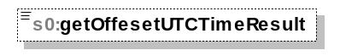
namespace | http://www.Nanonull.com/TimeService/
type | s:string
properties
  minOcc | 0
  maxOcc | 1
  content | simple
source | <s:element name="getOffesetUTCTimeResult" type="s:string" minOccurs="0" maxOccurs="1"/>

element getServerCity
diagram | 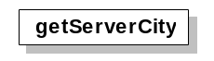
namespace | http://www.Nanonull.com/TimeService/
properties
  content | complex
source | <s:element name="getServerCity">  <s:complexType/>  </s:element>

element getServerCityResponse
diagram
namespace | http://www.Nanonull.com/TimeService/
properties
  content | complex
children | s0:getServerCityResult
source | <s:element name="getServerCityResponse">  <s:complexType>  <s:sequence>  <s:element name="getServerCityResult" type="s:string" minOccurs="0" maxOccurs="1"/>  </s:sequence>  </s:complexType>  </s:element>

element getServerCityResponse/getServerCityResult
diagram | 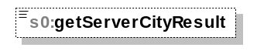
namespace | http://www.Nanonull.com/TimeService/
type | s:string
properties
  minOcc | 0
  maxOcc | 1
  content | simple
source | <s:element name="getServerCityResult" type="s:string" minOccurs="0" maxOccurs="1"/>

element getServerTime
diagram | 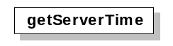
namespace | http://www.Nanonull.com/TimeService/
properties
  content | complex
source | <s:element name="getServerTime">  <s:complexType/>  </s:element>

element getServerTimeResponse
diagram
namespace | http://www.Nanonull.com/TimeService/
properties
  content | complex
children | s0:getServerTimeResult
source | <s:element name="getServerTimeResponse">  <s:complexType>  <s:sequence>  <s:element name="getServerTimeResult" type="s:string" minOccurs="0" maxOccurs="1"/>  </s:sequence>  </s:complexType>  </s:element>

element getServerTimeResponse/getServerTimeResult
diagram | 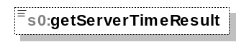
namespace | http://www.Nanonull.com/TimeService/
type | s:string
properties
  minOcc | 0
  maxOcc | 1
  content | simple
source | <s:element name="getServerTimeResult" type="s:string" minOccurs="0" maxOccurs="1"/>

element getServerTimeZone
diagram | 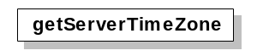
namespace | http://www.Nanonull.com/TimeService/
properties
  content | complex
source | <s:element name="getServerTimeZone">  <s:complexType/>  </s:element>

element getServerTimeZoneResponse
diagram
namespace | http://www.Nanonull.com/TimeService/
properties
  content | complex
children | s0:getServerTimeZoneResult
source | <s:element name="getServerTimeZoneResponse">  <s:complexType>  <s:sequence>  <s:element name="getServerTimeZoneResult" type="s:string" minOccurs="0" maxOccurs="1"/>  </s:sequence>  </s:complexType>  </s:element>

element getServerTimeZoneResponse/getServerTimeZoneResult
diagram | 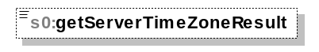
namespace | http://www.Nanonull.com/TimeService/
type | s:string
properties
  minOcc | 0
  maxOcc | 1
  content | simple
source | <s:element name="getServerTimeZoneResult" type="s:string" minOccurs="0" maxOccurs="1"/>

element getTimeZoneTime
diagram | 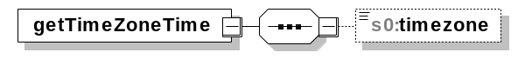
namespace | http://www.Nanonull.com/TimeService/
properties
  content | complex
children | s0:timezone
source | <s:element name="getTimeZoneTime">  <s:complexType>  <s:sequence>  <s:element name="timezone" type="s:string" minOccurs="0" maxOccurs="1"/>  </s:sequence>  </s:complexType>  </s:element>

element getTimeZoneTime/timezone
diagram | 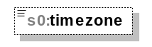
namespace | http://www.Nanonull.com/TimeService/
type | s:string
properties
  minOcc | 0
  maxOcc | 1
  content | simple
source | <s:element name="timezone" type="s:string" minOccurs="0" maxOccurs="1"/>

element getTimeZoneTimeResponse
diagram
namespace | http://www.Nanonull.com/TimeService/
properties
  content | complex
children | s0:getTimeZoneTimeResult
source | <s:element name="getTimeZoneTimeResponse">  <s:complexType>  <s:sequence>  <s:element name="getTimeZoneTimeResult" type="s:string" minOccurs="0" maxOccurs="1"/>  </s:sequence>  </s:complexType>  </s:element>

element getTimeZoneTimeResponse/getTimeZoneTimeResult
diagram | 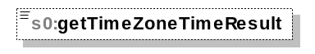
namespace | http://www.Nanonull.com/TimeService/
type | s:string
properties
  minOcc | 0
  maxOcc | 1
  content | simple
source | <s:element name="getTimeZoneTimeResult" type="s:string" minOccurs="0" maxOccurs="1"/>

element getUTCTime
diagram | 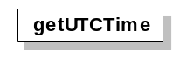
namespace | http://www.Nanonull.com/TimeService/
properties
  content | complex
source | <s:element name="getUTCTime">  <s:complexType/>  </s:element>

element getUTCTimeResponse
diagram
namespace | http://www.Nanonull.com/TimeService/
properties
  content | complex
children | s0:getUTCTimeResult
source | <s:element name="getUTCTimeResponse">  <s:complexType>  <s:sequence>  <s:element name="getUTCTimeResult" type="s:string" minOccurs="0" maxOccurs="1"/>  </s:sequence>  </s:complexType>  </s:element>

element getUTCTimeResponse/getUTCTimeResult
diagram | 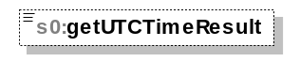
namespace | http://www.Nanonull.com/TimeService/
type | s:string
properties
  minOcc | 0
  maxOcc | 1
  content | simple
source | <s:element name="getUTCTimeResult" type="s:string" minOccurs="0" maxOccurs="1"/>

element string
diagram | 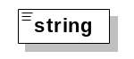
namespace | http://www.Nanonull.com/TimeService/
type | s:string
properties
  content | simple
  nillable | true
source | <s:element name="string" type="s:string" nillable="true"/>

WSDL documentation generated by XMLSpy WSDL Editor http://www.altova.com/xmlspy

