service TimeService

A sample Time service
diagram | 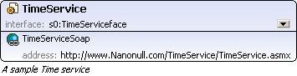
endpoints
  TimeServiceSoap
  binding | s0:TimeServiceSoap
  address | http://www.Nanonull.com/TimeService/TimeService.asmx
source | <service name="TimeService" interface="s0:TimeServiceface">  <documentation>A sample Time service</documentation>  <endpoint name="TimeServiceSoap" binding="s0:TimeServiceSoap" address="http://www.Nanonull.com/TimeService/TimeService.asmx"/>  </service>

WSDL documentation generated by XMLSpy WSDL Editor http://www.altova.com/xmlspy

