binding TimeServiceSoap
diagram | 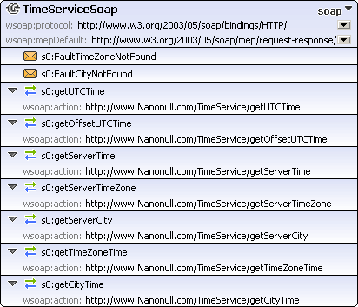
type | http://www.w3.org/ns/wsdl/soap
interface | s0:TimeServiceface
extensibility
  wsoap:protocol | http://www.w3.org/2003/05/soap/bindings/HTTP/
  wsoap:mepDefault | http://www.w3.org/2003/05/soap/mep/request-response/
operations
  s0:getUTCTime
  wsoap:action | http://www.Nanonull.com/TimeService/getUTCTime
  s0:getOffsetUTCTime
  wsoap:action | http://www.Nanonull.com/TimeService/getOffsetUTCTime
  s0:getServerTime
  wsoap:action | http://www.Nanonull.com/TimeService/getServerTime
  s0:getServerTimeZone
  wsoap:action | http://www.Nanonull.com/TimeService/getServerTimeZone
  s0:getServerCity
  wsoap:action | http://www.Nanonull.com/TimeService/getServerCity
  s0:getTimeZoneTime
  wsoap:action | http://www.Nanonull.com/TimeService/getTimeZoneTime
  s0:getCityTime
  wsoap:action | http://www.Nanonull.com/TimeService/getCityTime
faults
  s0:FaultTimeZoneNotFound
  s0:FaultCityNotFound
used by
  endpoint TimeServiceSoap in service TimeService
source | <binding name="TimeServiceSoap" interface="s0:TimeServiceface" type="http://www.w3.org/ns/wsdl/soap" wsoap:protocol="http://www.w3.org/2003/05/soap/bindings/HTTP/" wsoap:mepDefault="http://www.w3.org/2003/05/soap/mep/request-response/">  <operation ref="s0:getUTCTime" wsoap:action="http://www.Nanonull.com/TimeService/getUTCTime"/>  <operation ref="s0:getOffsetUTCTime" wsoap:action="http://www.Nanonull.com/TimeService/getOffsetUTCTime"/>  <operation ref="s0:getServerTime" wsoap:action="http://www.Nanonull.com/TimeService/getServerTime"/>  <operation ref="s0:getServerTimeZone" wsoap:action="http://www.Nanonull.com/TimeService/getServerTimeZone"/>  <operation ref="s0:getServerCity" wsoap:action="http://www.Nanonull.com/TimeService/getServerCity"/>  <operation ref="s0:getTimeZoneTime" wsoap:action="http://www.Nanonull.com/TimeService/getTimeZoneTime"/>  <operation ref="s0:getCityTime" wsoap:action="http://www.Nanonull.com/TimeService/getCityTime"/>  <fault ref="s0:FaultTimeZoneNotFound"/>  <fault ref="s0:FaultCityNotFound"/>  </binding>

WSDL documentation generated by XMLSpy WSDL Editor http://www.altova.com/xmlspy

