WSDL DocumGenExample.wsdl

WSDL location: | C:\work\gui-automation\data\spy\examples\DocumGenExample.wsdl
targetnamespace: | http:schemas.agilent.com/GC7890/

services | bindings | porttypes | messages | types
GC7890 | cmd | cmd | EchoRequest | BeginRunFault
 |  |  | EchoResponse | BeginRunRequest
 |  |  | GetConfigurationRequest | BeginRunResponse
 |  |  | GetConfigurationResponse | ControlRequestHeader
 |  |  | GetMethodRequest | EchoRequest
 |  |  | GetMethodResponse | EchoResponse
 |  |  | SetConfigurationRequest | FlowStatus
 |  |  | SetConfigurationResponse | GetConfigurationFault
 |  |  | SetMethodRequest | GetConfigurationRequest
 |  |  | SetMethodResponse | GetConfigurationResponse
 |  |  |  | GetMethodFault
 |  |  |  | GetMethodRequest
 |  |  |  | GetMethodResponse
 |  |  |  | GetServiceStateFault
 |  |  |  | GetServiceStateRequest
 |  |  |  | GetServiceStateResponse
 |  |  |  | InstrumentConfiguration
 |  |  |  | InstrumentMethod
 |  |  |  | InstrumentStatus
 |  |  |  | PressureStatus
 |  |  |  | ReadRequestHeader
 |  |  |  | SetConfigurationFault
 |  |  |  | SetConfigurationRequest
 |  |  |  | SetConfigurationResponse
 |  |  |  | SetMethodRequest
 |  |  |  | SetMethodResponse
 |  |  |  | StopRunFault
 |  |  |  | StopRunRequest
 |  |  |  | StopRunResponse
 |  |  |  | SubscribeToDataFault
 |  |  |  | SubscribeToDataRequest
 |  |  |  | SubscribeToDataResponse
 |  |  |  | SubscribeToEventsFault
 |  |  |  | SubscribeToEventsRequest
 |  |  |  | SubscribeToEventsResponse
 |  |  |  | SubscribeToStatusFault
 |  |  |  | SubscribeToStatusRequest
 |  |  |  | SubscribeToStatusResponse
 |  |  |  | TemperatureMethod
 |  |  |  | TemperatureStatus

service GC7890
diagram | 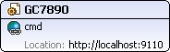
ports
source | <service name="GC7890">  <xs:annotation>  <xs:documentation>The entire collection of valid setpoints</xs:documentation>  </xs:annotation>  <port name="cmd" binding="y:cmd">  <soap:address location="http://localhost:9110"/>  </port>  <!--  <port name="data" binding="y:data">  <soap:address location="No Target Adress"/>  </port>  -->  </service>

binding cmd
diagram
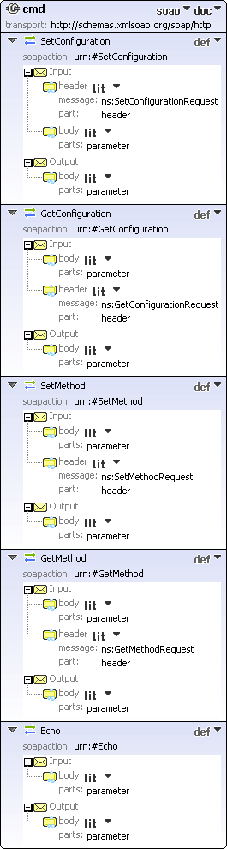
type
y:cmd
extensibility
<soap:binding style="document" transport="http://schemas.xmlsoap.org/soap/http"/>
operations
used by
Port cmd in Service GC7890
source
<binding name="cmd" type="y:cmd">
<soap:binding style="document" transport="http://schemas.xmlsoap.org/soap/http"/>
<operation name="SetConfiguration">
<soap:operation soapAction="urn:#SetConfiguration"/>
<input>
<soap:header message="ns:SetConfigurationRequest" part="header" use="literal"/>
<soap:body parts="parameter" use="literal"/>
</input>
<output>
<soap:body parts="parameter" use="literal"/>
</output>
</operation>
<operation name="GetConfiguration">
<soap:operation soapAction="urn:#GetConfiguration"/>
<input>
<soap:body parts="parameter" use="literal"/>
<soap:header message="ns:GetConfigurationRequest" part="header" use="literal"/>
</input>
<output>
<soap:body parts="parameter" use="literal"/>
</output>
</operation>
<operation name="SetMethod">
<soap:operation soapAction="urn:#SetMethod"/>
<input>
<soap:body parts="parameter" use="literal"/>
<soap:header message="ns:SetMethodRequest" part="header" use="literal"/>
</input>
<output>
<soap:body parts="parameter" use="literal"/>
</output>
</operation>
<operation name="GetMethod">
<soap:operation soapAction="urn:#GetMethod"/>
<input>
<soap:body parts="parameter" use="literal"/>
<soap:header message="ns:GetMethodRequest" part="header" use="literal"/>
</input>
<output>
<soap:body parts="parameter" use="literal"/>
</output>
</operation>
<!--
<operation name="SubscribeToStatus">
<soap:operation soapAction="urn:#SubscribeToStatus"/>
<input>
<soap:body parts="parameter" use="literal"/>
<soap:header message="ns:SubscribeToStatusRequest" part="header" use="literal"/>
</input>
<output>
<soap:body parts="parameter" use="literal"/>
</output>
<fault name="FaultName"/>
</operation>
<operation name="SubscribeToEvents">
<soap:operation soapAction="urn:#SubscribeToEvents"/>
<input>
<soap:body parts="parameter" use="literal"/>
<soap:header message="ns:SubscribeToEventsRequest" part="header" use="literal"/>
</input>
<output>
<soap:body parts="parameter" use="literal"/>
</output>
<fault name="FaultName"/>
</operation>
<operation name="StopRun">
<soap:operation soapAction="urn:#StopRun"/>
<input>
<soap:body parts="parameter" use="literal"/>
<soap:header message="ns:StopRunRequest" part="header" use="literal"/>
</input>
<output>
<soap:body parts="parameter" use="literal"/>
</output>
<fault name="FaultName"/>
</operation>
<operation name="BeginRun">
<soap:operation soapAction="urn:#BeginRun"/>
<input>
<soap:body parts="parameter" use="literal"/>
<soap:header message="ns:BeginRunRequest" part="header" use="literal"/>
</input>
<output>
<soap:body parts="parameter" use="literal"/>
</output>
<fault name="FaultName"/>
</operation>
<operation name="GetServiceState">
<soap:operation soapAction="urn:#GetServiceState"/>
<input>
<soap:body parts="parameter" use="literal"/>
<soap:header message="ns:GetServiceStateRequest" part="header" use="literal"/>
</input>
<output>
<soap:body parts="parameter" use="literal"/>
</output>
<fault name="FaultName"/>
</operation>
-->
<operation name="Echo">
<soap:operation soapAction="urn:#Echo"/>
<input>
<soap:body parts="parameter" use="literal"/>
</input>
<output>
<soap:body parts="parameter" use="literal"/>
</output>
</operation>
</binding>

porttype cmd
diagram
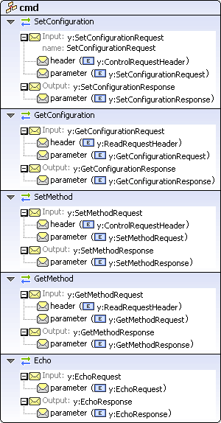
operations
used by
binding cmd
source
<portType name="cmd">
<operation name="SetConfiguration">
<input name="SetConfigurationRequest" message="y:SetConfigurationRequest"/>
<output message="y:SetConfigurationResponse"/>
</operation>
<operation name="GetConfiguration">
<input message="y:GetConfigurationRequest"/>
<output message="y:GetConfigurationResponse"/>
</operation>
<operation name="SetMethod">
<input message="y:SetMethodRequest"/>
<output message="y:SetMethodResponse"/>
</operation>
<operation name="GetMethod">
<input message="y:GetMethodRequest"/>
<output message="y:GetMethodResponse"/>
</operation>
<!--
<operation name="SubscribeToStatus">
<input message="y:SubscribeToStatusRequest"/>
<output message="y:SubscribeToStatusResponse"/>
<fault name="FaultName" message="y:SubscribeToStatusFault"/>
</operation>
<operation name="SubscribeToEvents">
<input message="y:SubscribeToEventsRequest"/>
<output message="y:SubscribeToEventsResponse"/>
<fault name="FaultName" message="y:SubscribeToEventsFault"/>
</operation>
<operation name="StopRun">
<input message="y:StopRunRequest"/>
<output message="y:StopRunResponse"/>
<fault name="FaultName" message="y:StopRunFault"/>
</operation>
<operation name="BeginRun">
<input message="y:BeginRunRequest"/>
<output message="y:BeginRunResponse"/>
<fault name="FaultName" message="y:BeginRunFault"/>
</operation>
<operation name="GetServiceState">
<input message="y:GetServiceStateRequest"/>
<output message="y:GetServiceStateResponse"/>
<fault name="FaultName" message="y:GetServiceStateFault"/>
</operation>
-->
<operation name="Echo">
<input message="y:EchoRequest"/>
<output message="y:EchoResponse"/>
</operation>
</portType>

message EchoRequest
parts
parameter
used by
Operation Echo in PortType cmd
source
<message name="EchoRequest">
<part name="parameter" element="y:EchoRequest"/>
</message>

message EchoResponse
parts
parameter
used by
Operation Echo in PortType cmd
source
<message name="EchoResponse">
<part name="parameter" element="y:EchoResponse"/>
</message>

message GetConfigurationRequest
parts
header
element | y:ReadRequestHeader

parameter
used by
Operation GetConfiguration in PortType cmd
source
<message name="GetConfigurationRequest">
<part name="header" element="y:ReadRequestHeader"/>
<part name="parameter" element="y:GetConfigurationRequest"/>
</message>

message GetConfigurationResponse
parts
parameter
used by
Operation GetConfiguration in PortType cmd
source
<message name="GetConfigurationResponse">
<part name="parameter" element="y:GetConfigurationResponse"/>
</message>

message GetMethodRequest
parts
header
element | y:ReadRequestHeader

parameter
used by
Operation GetMethod in PortType cmd
source
<message name="GetMethodRequest">
<part name="header" element="y:ReadRequestHeader"/>
<part name="parameter" element="y:GetMethodRequest"/>
</message>

message GetMethodResponse
parts
parameter
used by
Operation GetMethod in PortType cmd
source
<message name="GetMethodResponse">
<part name="parameter" element="y:GetMethodResponse"/>
</message>

message SetConfigurationRequest
parts
header
element | y:ControlRequestHeader

parameter
used by
Operation SetConfiguration in PortType cmd
source
<message name="SetConfigurationRequest">
<part name="header" element="y:ControlRequestHeader"/>
<part name="parameter" element="y:SetConfigurationRequest"/>
</message>

message SetConfigurationResponse
parts
parameter
used by
Operation SetConfiguration in PortType cmd
source
<message name="SetConfigurationResponse">
<part name="parameter" element="y:SetConfigurationResponse"/>
</message>

message SetMethodRequest
parts
header
element | y:ControlRequestHeader

parameter
used by
Operation SetMethod in PortType cmd
source
<message name="SetMethodRequest">
<part name="header" element="y:ControlRequestHeader"/>
<part name="parameter" element="y:SetMethodRequest"/>
</message>

message SetMethodResponse
parts
parameter
used by
Operation SetMethod in PortType cmd
source
<message name="SetMethodResponse">
<part name="parameter" element="y:SetMethodResponse"/>
</message>

complexType InstrumentConfiguration
diagram
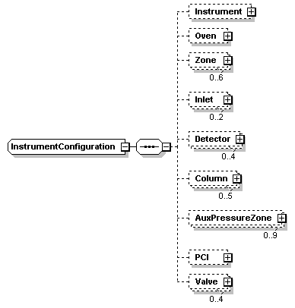
namespace
http:schemas.agilent.com/GC7890/
children
Instrument Oven Zone Inlet Detector Column AuxPressureZone PCI Valve
used by
elements | GetConfigurationResponse SetConfigurationRequest
source
<xs:complexType name="InstrumentConfiguration">
<xs:sequence>
<xs:element name="Instrument" minOccurs="0">
<xs:complexType>
<xs:attribute name="SN" use="optional">
<xs:simpleType>
<xs:restriction base="xs:string"/>
</xs:simpleType>
</xs:attribute>
<xs:attribute name="Version" use="optional">
<xs:simpleType>
<xs:restriction base="xs:string"/>
</xs:simpleType>
</xs:attribute>
</xs:complexType>
</xs:element>
<xs:element name="Oven" minOccurs="0">
<xs:complexType>
<xs:attribute name="Type" use="optional">
<xs:simpleType>
<xs:restriction base="xs:string">
<xs:enumeration value="Fast"/>
<xs:enumeration value="Regular"/>
</xs:restriction>
</xs:simpleType>
</xs:attribute>
<xs:attribute name="Power" use="optional">
<xs:annotation>
<xs:documentation>Oven power, in Watts</xs:documentation>
</xs:annotation>
<xs:simpleType>
<xs:restriction base="xs:double">
<xs:minInclusive value="0"/>
</xs:restriction>
</xs:simpleType>
</xs:attribute>
<xs:attribute name="Voltage" use="optional">
<xs:annotation>
<xs:documentation>Oven votrages, in Volts</xs:documentation>
</xs:annotation>
<xs:simpleType>
<xs:restriction base="xs:double">
<xs:minInclusive value="0"/>
</xs:restriction>
</xs:simpleType>
</xs:attribute>
<xs:attribute name="CryoType" use="optional">
<xs:simpleType>
<xs:restriction base="xs:string">
<xs:enumeration value="None"/>
<xs:enumeration value="CO2"/>
<xs:enumeration value="N2"/>
</xs:restriction>
</xs:simpleType>
</xs:attribute>
</xs:complexType>
</xs:element>
<xs:element name="Zone" minOccurs="0" maxOccurs="6">
<xs:complexType>
<xs:attribute name="ID" use="optional">
<xs:simpleType>
<xs:restriction base="xs:string">
<xs:enumeration value="1"/>
<xs:enumeration value="2"/>
<xs:enumeration value="3"/>
<xs:enumeration value="4"/>
<xs:enumeration value="5"/>
<xs:enumeration value="6"/>
</xs:restriction>
</xs:simpleType>
</xs:attribute>
<xs:attribute name="Type" use="optional">
<xs:simpleType>
<xs:restriction base="xs:string">
<xs:enumeration value="None"/>
<xs:enumeration value="FrontInlet"/>
<xs:enumeration value="BackInlet"/>
<xs:enumeration value="FrontDet"/>
<xs:enumeration value="BackDet"/>
<xs:enumeration value="ThirdDet"/>
<xs:enumeration value="Valve"/>
<xs:enumeration value="FrontSecondary"/>
<xs:enumeration value="BackSecondary"/>
<xs:enumeration value="Aux1"/>
<xs:enumeration value="Aux2"/>
</xs:restriction>
</xs:simpleType>
</xs:attribute>
<xs:attribute name="Power" use="optional">
<xs:annotation>
<xs:documentation>Heated zone power, in Watts</xs:documentation>
</xs:annotation>
<xs:simpleType>
<xs:restriction base="xs:double"/>
</xs:simpleType>
</xs:attribute>
<xs:attribute name="Cryo" use="optional">
<xs:simpleType>
<xs:restriction base="xs:string">
<xs:enumeration value="None"/>
<xs:enumeration value="CO2"/>
<xs:enumeration value="N2"/>
</xs:restriction>
</xs:simpleType>
</xs:attribute>
</xs:complexType>
</xs:element>
<xs:element name="Inlet" minOccurs="0" maxOccurs="2">
<xs:complexType>
<xs:attribute name="ID" use="optional">
<xs:simpleType>
<xs:restriction base="xs:string">
<xs:enumeration value="Front"/>
<xs:enumeration value="Back"/>
</xs:restriction>
</xs:simpleType>
</xs:attribute>
<xs:attribute name="Type" use="optional">
<xs:simpleType>
<xs:restriction base="xs:string">
<xs:enumeration value="None"/>
<xs:enumeration value="SS"/>
<xs:enumeration value="PP"/>
<xs:enumeration value="PTV"/>
<xs:enumeration value="VI"/>
<xs:enumeration value="COC"/>
</xs:restriction>
</xs:simpleType>
</xs:attribute>
<xs:attribute name="EPC" use="optional">
<xs:simpleType>
<xs:restriction base="xs:string">
<xs:enumeration value=""/>
</xs:restriction>
</xs:simpleType>
</xs:attribute>
<xs:attribute name="MaxPressure" use="optional">
<xs:annotation>
<xs:documentation>MAximum gas pressure (dyn/cm2 ?)</xs:documentation>
</xs:annotation>
<xs:simpleType>
<xs:restriction base="xs:nonNegativeInteger"/>
</xs:simpleType>
</xs:attribute>
<xs:attribute name="GasType" use="optional">
<xs:simpleType>
<xs:restriction base="xs:string">
<xs:enumeration value="He"/>
<xs:enumeration value="H2"/>
<xs:enumeration value="N2"/>
<xs:enumeration value="Ar"/>
<xs:enumeration value="ArMe"/>
</xs:restriction>
</xs:simpleType>
</xs:attribute>
<xs:attribute name="MaxFlow" use="optional">
<xs:simpleType>
<xs:restriction base="xs:decimal">
<xs:minInclusive value="0"/>
</xs:restriction>
</xs:simpleType>
</xs:attribute>
<xs:attribute name="MaxSprFlow" use="optional">
<xs:simpleType>
<xs:restriction base="xs:double"/>
</xs:simpleType>
</xs:attribute>
</xs:complexType>
</xs:element>
<xs:element name="Detector" minOccurs="0" maxOccurs="4">
<xs:complexType>
<xs:attribute name="Type" use="optional">
<xs:simpleType>
<xs:restriction base="xs:string">
<xs:enumeration value="None"/>
<xs:enumeration value="FID"/>
<xs:enumeration value="NPD"/>
<xs:enumeration value="FPD"/>
<xs:enumeration value="TCD"/>
<xs:enumeration value="ECD"/>
<xs:enumeration value="AIB"/>
</xs:restriction>
</xs:simpleType>
</xs:attribute>
<xs:attribute name="ID" use="optional">
<xs:simpleType>
<xs:restriction base="xs:string">
<xs:enumeration value="Front"/>
<xs:enumeration value="Back"/>
<xs:enumeration value="Third"/>
<xs:enumeration value="Fourth"/>
</xs:restriction>
</xs:simpleType>
</xs:attribute>
<xs:attribute name="EPC" type="xs:string" use="optional"/>
<xs:attribute name="DET" use="optional">
<xs:simpleType>
<xs:restriction base="xs:string"/>
</xs:simpleType>
</xs:attribute>
<xs:attribute name="_2ND" use="optional">
<xs:simpleType>
<xs:restriction base="xs:string">
<xs:enumeration value=""/>
</xs:restriction>
</xs:simpleType>
</xs:attribute>
<xs:attribute name="MakeupFlow" use="optional">
<xs:simpleType>
<xs:restriction base="xs:double"/>
</xs:simpleType>
</xs:attribute>
<xs:attribute name="FuelFlow" use="optional">
<xs:simpleType>
<xs:restriction base="xs:double"/>
</xs:simpleType>
</xs:attribute>
<xs:attribute name="AirFlow" use="optional">
<xs:simpleType>
<xs:restriction base="xs:double"/>
</xs:simpleType>
</xs:attribute>
</xs:complexType>
</xs:element>
<xs:element name="Column" minOccurs="0" maxOccurs="5">
<xs:complexType>
<xs:attribute name="ID" use="optional">
<xs:simpleType>
<xs:restriction base="xs:string">
<xs:enumeration value="1"/>
<xs:enumeration value="2"/>
<xs:enumeration value="3"/>
<xs:enumeration value="4"/>
<xs:enumeration value="5"/>
</xs:restriction>
</xs:simpleType>
</xs:attribute>
<xs:attribute name="Length" use="optional">
<xs:annotation>
<xs:documentation>Column length, in meters</xs:documentation>
</xs:annotation>
<xs:simpleType>
<xs:restriction base="xs:double">
<xs:minInclusive value="0"/>
</xs:restriction>
</xs:simpleType>
</xs:attribute>
<xs:attribute name="Diameter" use="optional">
<xs:simpleType>
<xs:restriction base="xs:double"/>
</xs:simpleType>
</xs:attribute>
<xs:attribute name="Film" use="optional">
<xs:simpleType>
<xs:restriction base="xs:double"/>
</xs:simpleType>
</xs:attribute>
<xs:attribute name="InletConnection" use="optional">
<xs:simpleType>
<xs:restriction base="xs:string">
<xs:enumeration value="Unknown"/>
<xs:enumeration value="FrontInlet"/>
<xs:enumeration value="BackInlet"/>
<xs:enumeration value="PCI"/>
<xs:enumeration value="APC1"/>
<xs:enumeration value="APC2"/>
<xs:enumeration value="APC3"/>
<xs:enumeration value="APC4"/>
<xs:enumeration value="APC5"/>
<xs:enumeration value="APC6"/>
<xs:enumeration value="APC7"/>
<xs:enumeration value="APC8"/>
<xs:enumeration value="APC9"/>
</xs:restriction>
</xs:simpleType>
</xs:attribute>
<xs:attribute name="OutletConnection" use="optional">
<xs:simpleType>
<xs:restriction base="xs:string">
<xs:enumeration value="Unknown"/>
<xs:enumeration value="FrontDet"/>
<xs:enumeration value="BackDet"/>
<xs:enumeration value="PCI"/>
<xs:enumeration value="APC1"/>
<xs:enumeration value="APC2"/>
<xs:enumeration value="APC3"/>
<xs:enumeration value="APC4"/>
<xs:enumeration value="APC5"/>
<xs:enumeration value="APC6"/>
<xs:enumeration value="APC7"/>
<xs:enumeration value="APC8"/>
<xs:enumeration value="APC9"/>
<xs:enumeration value="Vacuum"/>
</xs:restriction>
</xs:simpleType>
</xs:attribute>
</xs:complexType>
</xs:element>
<xs:element name="AuxPressureZone" minOccurs="0" maxOccurs="9">
<xs:complexType>
<xs:attribute name="ID" use="optional">
<xs:simpleType>
<xs:restriction base="xs:string">
<xs:enumeration value="1"/>
<xs:enumeration value="2"/>
<xs:enumeration value="3"/>
<xs:enumeration value="4"/>
<xs:enumeration value="5"/>
<xs:enumeration value="6"/>
<xs:enumeration value="7"/>
<xs:enumeration value="8"/>
<xs:enumeration value="9"/>
</xs:restriction>
</xs:simpleType>
</xs:attribute>
<xs:attribute name="Present" use="optional">
<xs:simpleType>
<xs:restriction base="xs:boolean"/>
</xs:simpleType>
</xs:attribute>
<xs:attribute name="GasType" use="optional">
<xs:simpleType>
<xs:restriction base="xs:string">
<xs:enumeration value="He"/>
<xs:enumeration value="H2"/>
<xs:enumeration value="N2"/>
<xs:enumeration value="Ar"/>
<xs:enumeration value="ArMe"/>
</xs:restriction>
</xs:simpleType>
</xs:attribute>
<xs:attribute name="MaxPressure" use="optional">
<xs:simpleType>
<xs:restriction base="xs:nonNegativeInteger"/>
</xs:simpleType>
</xs:attribute>
<xs:attribute name="Control" use="optional">
<xs:simpleType>
<xs:restriction base="xs:string">
<xs:enumeration value="FowardPressure"/>
<xs:enumeration value="BackPressure"/>
</xs:restriction>
</xs:simpleType>
</xs:attribute>
</xs:complexType>
</xs:element>
<xs:element name="PCI" minOccurs="0">
<xs:complexType>
<xs:attribute name="Present" use="optional">
<xs:simpleType>
<xs:restriction base="xs:boolean"/>
</xs:simpleType>
</xs:attribute>
<xs:attribute name="GasType" use="optional">
<xs:simpleType>
<xs:restriction base="xs:string">
<xs:enumeration value="He"/>
<xs:enumeration value="H2"/>
<xs:enumeration value="N2"/>
<xs:enumeration value="Ar"/>
<xs:enumeration value="ArMe"/>
</xs:restriction>
</xs:simpleType>
</xs:attribute>
<xs:attribute name="AuxPressureControl" use="optional">
<xs:simpleType>
<xs:restriction base="xs:boolean"/>
</xs:simpleType>
</xs:attribute>
</xs:complexType>
</xs:element>
<xs:element name="Valve" minOccurs="0" maxOccurs="4">
<xs:complexType>
<xs:attribute name="ID" use="optional">
<xs:simpleType>
<xs:restriction base="xs:string">
<xs:enumeration value="1"/>
<xs:enumeration value="2"/>
<xs:enumeration value="3"/>
<xs:enumeration value="4"/>
</xs:restriction>
</xs:simpleType>
</xs:attribute>
</xs:complexType>
</xs:element>
</xs:sequence>
</xs:complexType>

complexType InstrumentMethod
diagram
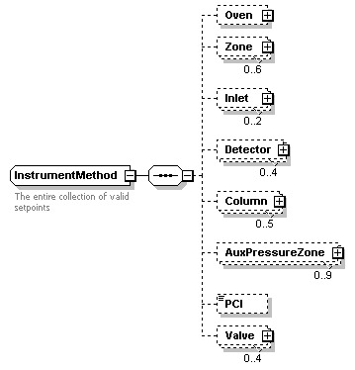
namespace
http:schemas.agilent.com/GC7890/
children
Oven Zone Inlet Detector Column AuxPressureZone PCI Valve
used by
elements | GetMethodResponse SetMethodRequest
annotation
documentation
The entire collection of valid setpoints
source
<xs:complexType name="InstrumentMethod">
<xs:annotation>
<xs:documentation>The entire collection of valid setpoints</xs:documentation>
</xs:annotation>
<xs:sequence>
<xs:element name="Oven" minOccurs="0">
<xs:complexType>
<xs:sequence>
<xs:element ref="y:TemperatureMethod" minOccurs="0"/>
</xs:sequence>
</xs:complexType>
</xs:element>
<xs:element name="Zone" minOccurs="0" maxOccurs="6">
<xs:complexType>
<xs:sequence minOccurs="0">
<xs:element ref="y:TemperatureMethod" minOccurs="0"/>
</xs:sequence>
<xs:attribute name="ID" use="optional">
<xs:simpleType>
<xs:restriction base="xs:string">
<xs:enumeration value="1"/>
<xs:enumeration value="2"/>
<xs:enumeration value="3"/>
<xs:enumeration value="4"/>
<xs:enumeration value="5"/>
<xs:enumeration value="6"/>
</xs:restriction>
</xs:simpleType>
</xs:attribute>
</xs:complexType>
</xs:element>
<xs:element name="Inlet" minOccurs="0" maxOccurs="2">
<xs:complexType>
<xs:sequence minOccurs="0">
<xs:element name="Pressure" minOccurs="0">
<xs:complexType>
<xs:sequence>
<xs:element name="PressureProgram" minOccurs="0">
<xs:complexType>
<xs:sequence minOccurs="0">
<xs:element name="PressureProgramStage" minOccurs="0" maxOccurs="unbounded">
<xs:complexType>
<xs:attribute name="Duration" type="xs:double" use="optional"/>
<xs:attribute name="ToTemp" type="xs:double" use="optional"/>
</xs:complexType>
</xs:element>
</xs:sequence>
</xs:complexType>
</xs:element>
</xs:sequence>
<xs:attribute name="Setpoint" use="optional">
<xs:simpleType>
<xs:restriction base="xs:string">
<xs:enumeration value="sss"/>
</xs:restriction>
</xs:simpleType>
</xs:attribute>
<xs:attribute name="ON" use="optional">
<xs:simpleType>
<xs:restriction base="xs:string">
<xs:enumeration value="Yes | No"/>
</xs:restriction>
</xs:simpleType>
</xs:attribute>
</xs:complexType>
</xs:element>
</xs:sequence>
<xs:attribute name="ID" use="optional">
<xs:simpleType>
<xs:restriction base="xs:string">
<xs:enumeration value="Front"/>
<xs:enumeration value="Back"/>
</xs:restriction>
</xs:simpleType>
</xs:attribute>
<xs:attribute name="Mode" use="optional">
<xs:simpleType>
<xs:restriction base="xs:string">
<xs:enumeration value="Split"/>
<xs:enumeration value="Splitless"/>
<xs:enumeration value="PulsedSplit"/>
<xs:enumeration value="PulsedSplitless"/>
</xs:restriction>
</xs:simpleType>
</xs:attribute>
<xs:attribute name="ControlMode" use="optional">
<xs:simpleType>
<xs:restriction base="xs:string">
<xs:enumeration value="Pressure"/>
<xs:enumeration value="Column"/>
</xs:restriction>
</xs:simpleType>
</xs:attribute>
<xs:attribute name="SplitRatio" type="xs:double" use="optional"/>
<xs:attribute name="Flow" type="xs:double" use="optional"/>
</xs:complexType>
</xs:element>
<xs:element name="Detector" minOccurs="0" maxOccurs="4">
<xs:complexType>
<xs:attribute name="ID" use="optional">
<xs:simpleType>
<xs:restriction base="xs:string">
<xs:enumeration value="Front"/>
<xs:enumeration value="Back"/>
<xs:enumeration value="Third"/>
<xs:enumeration value="Fourth"/>
</xs:restriction>
</xs:simpleType>
</xs:attribute>
<xs:attribute name="Polarity" use="optional">
<xs:simpleType>
<xs:restriction base="xs:string">
<xs:enumeration value="Positive"/>
<xs:enumeration value="Negative"/>
</xs:restriction>
</xs:simpleType>
</xs:attribute>
</xs:complexType>
</xs:element>
<xs:element name="Column" minOccurs="0" maxOccurs="5">
<xs:complexType>
<xs:attribute name="ID" use="optional">
<xs:simpleType>
<xs:restriction base="xs:string">
<xs:enumeration value="1"/>
<xs:enumeration value="2"/>
<xs:enumeration value="3"/>
<xs:enumeration value="4"/>
<xs:enumeration value="5"/>
</xs:restriction>
</xs:simpleType>
</xs:attribute>
</xs:complexType>
</xs:element>
<xs:element name="AuxPressureZone" minOccurs="0" maxOccurs="9">
<xs:complexType>
<xs:attribute name="ID" use="optional">
<xs:simpleType>
<xs:restriction base="xs:string">
<xs:enumeration value="1"/>
<xs:enumeration value="2"/>
<xs:enumeration value="3"/>
<xs:enumeration value="4"/>
<xs:enumeration value="5"/>
<xs:enumeration value="6"/>
<xs:enumeration value="7"/>
<xs:enumeration value="8"/>
<xs:enumeration value="9"/>
</xs:restriction>
</xs:simpleType>
</xs:attribute>
</xs:complexType>
</xs:element>
<xs:element name="PCI" type="xs:string" minOccurs="0"/>
<xs:element name="Valve" minOccurs="0" maxOccurs="4">
<xs:complexType>
<xs:attribute name="ID" use="optional">
<xs:simpleType>
<xs:restriction base="xs:string">
<xs:enumeration value="1"/>
<xs:enumeration value="2"/>
<xs:enumeration value="3"/>
<xs:enumeration value="4"/>
</xs:restriction>
</xs:simpleType>
</xs:attribute>
</xs:complexType>
</xs:element>
</xs:sequence>
</xs:complexType>

complexType InstrumentStatus
diagram | 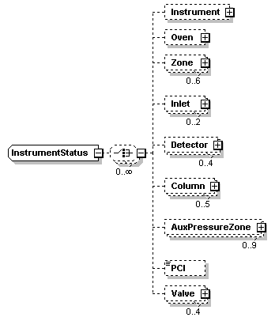
namespace | http:schemas.agilent.com/GC7890/
children | Instrument Oven Zone Inlet Detector Column AuxPressureZone PCI Valve
source | <xs:complexType name="InstrumentStatus">  <xs:choice minOccurs="0" maxOccurs="unbounded">  <xs:element name="Instrument" minOccurs="0">  <xs:complexType>  <xs:attribute name="Status" use="optional">  <xs:simpleType>  <xs:restriction base="xs:string"/>  </xs:simpleType>  </xs:attribute>  </xs:complexType>  </xs:element>  <xs:element name="Oven" minOccurs="0">  <xs:complexType>  <xs:sequence minOccurs="0">  <xs:element ref="y:TemperatureStatus" minOccurs="0"/>  </xs:sequence>  <xs:attribute name="Status" use="optional">  <xs:simpleType>  <xs:restriction base="xs:string"/>  </xs:simpleType>  </xs:attribute>  </xs:complexType>  </xs:element>  <xs:element name="Zone" minOccurs="0" maxOccurs="6">  <xs:complexType>  <xs:sequence minOccurs="0">  <xs:element ref="y:TemperatureStatus" minOccurs="0"/>  </xs:sequence>  <xs:attribute name="ID" use="optional">  <xs:simpleType>  <xs:restriction base="xs:string">  <xs:enumeration value="1"/>  <xs:enumeration value="2"/>  <xs:enumeration value="3"/>  <xs:enumeration value="4"/>  <xs:enumeration value="5"/>  <xs:enumeration value="6"/>  </xs:restriction>  </xs:simpleType>  </xs:attribute>  <xs:attribute name="Status" use="optional">  <xs:simpleType>  <xs:restriction base="xs:string"/>  </xs:simpleType>  </xs:attribute>  </xs:complexType>  </xs:element>  <xs:element name="Inlet" minOccurs="0" maxOccurs="2">  <xs:complexType>  <xs:sequence minOccurs="0">  <xs:element ref="y:PressureStatus" minOccurs="0"/>  <xs:element ref="y:FlowStatus" minOccurs="0"/>  <xs:element name="SeptumPurgeStatus" minOccurs="0">  <xs:complexType>  <xs:attribute name="Setpoint" type="xs:double" use="optional"/>  <xs:attribute name="Actual" type="xs:double" use="optional"/>  <xs:attribute name="On" type="xs:boolean" use="optional"/>  </xs:complexType>  </xs:element>  </xs:sequence>  <xs:attribute name="ID" use="optional">  <xs:simpleType>  <xs:restriction base="xs:string">  <xs:enumeration value="Front"/>  <xs:enumeration value="Back"/>  </xs:restriction>  </xs:simpleType>  </xs:attribute>  <xs:attribute name="Status" use="optional">  <xs:simpleType>  <xs:restriction base="xs:string"/>  </xs:simpleType>  </xs:attribute>  </xs:complexType>  </xs:element>  <xs:element name="Detector" minOccurs="0" maxOccurs="4">  <xs:complexType>  <xs:sequence minOccurs="0">  <xs:element name="MakeUp" minOccurs="0">  <xs:complexType>  <xs:attribute name="Setpoint" type="xs:double" use="optional"/>  <xs:attribute name="Actual" type="xs:double" use="optional"/>  <xs:attribute name="On" type="xs:boolean" use="optional"/>  </xs:complexType>  </xs:element>  <xs:element name="FuelStatus" minOccurs="0">  <xs:complexType>  <xs:attribute name="Setpoint" type="xs:double" use="optional"/>  <xs:attribute name="Actual" type="xs:double" use="optional"/>  <xs:attribute name="On" type="xs:boolean" use="optional"/>  </xs:complexType>  </xs:element>  <xs:element name="OxidizerStatus" minOccurs="0">  <xs:complexType>  <xs:attribute name="Setpoint" type="xs:double" use="optional"/>  <xs:attribute name="Actual" type="xs:double" use="optional"/>  <xs:attribute name="On" type="xs:boolean" use="optional"/>  </xs:complexType>  </xs:element>  </xs:sequence>  <xs:attribute name="ID" use="optional">  <xs:simpleType>  <xs:restriction base="xs:string">  <xs:enumeration value="Front"/>  <xs:enumeration value="Back"/>  <xs:enumeration value="Third"/>  <xs:enumeration value="Fourth"/>  </xs:restriction>  </xs:simpleType>  </xs:attribute>  <xs:attribute name="Status" use="optional">  <xs:simpleType>  <xs:restriction base="xs:string">  <xs:enumeration value="[Status]"/>  </xs:restriction>  </xs:simpleType>  </xs:attribute>  </xs:complexType>  </xs:element>  <xs:element name="Column" minOccurs="0" maxOccurs="5">  <xs:complexType>  <xs:sequence minOccurs="0">  <xs:element ref="y:FlowStatus" minOccurs="0"/>  </xs:sequence>  <xs:attribute name="ID" use="optional">  <xs:simpleType>  <xs:restriction base="xs:string">  <xs:enumeration value="1"/>  <xs:enumeration value="2"/>  <xs:enumeration value="3"/>  <xs:enumeration value="4"/>  <xs:enumeration value="5"/>  </xs:restriction>  </xs:simpleType>  </xs:attribute>  <xs:attribute name="Status" use="optional">  <xs:simpleType>  <xs:restriction base="xs:string"/>  </xs:simpleType>  </xs:attribute>  </xs:complexType>  </xs:element>  <xs:element name="AuxPressureZone" minOccurs="0" maxOccurs="9">  <xs:complexType>  <xs:sequence minOccurs="0">  <xs:element ref="y:PressureStatus" minOccurs="0"/>  </xs:sequence>  <xs:attribute name="ID" use="optional">  <xs:simpleType>  <xs:restriction base="xs:string">  <xs:enumeration value="1"/>  <xs:enumeration value="2"/>  <xs:enumeration value="3"/>  <xs:enumeration value="4"/>  <xs:enumeration value="5"/>  <xs:enumeration value="6"/>  <xs:enumeration value="7"/>  <xs:enumeration value="8"/>  <xs:enumeration value="9"/>  </xs:restriction>  </xs:simpleType>  </xs:attribute>  <xs:attribute name="Status" use="optional">  <xs:simpleType>  <xs:restriction base="xs:string"/>  </xs:simpleType>  </xs:attribute>  </xs:complexType>  </xs:element>  <xs:element name="PCI" type="xs:string" minOccurs="0"/>  <xs:element name="Valve" minOccurs="0" maxOccurs="4">  <xs:complexType>  <xs:attribute name="ID" use="optional">  <xs:simpleType>  <xs:restriction base="xs:string">  <xs:enumeration value="1"/>  <xs:enumeration value="2"/>  <xs:enumeration value="3"/>  <xs:enumeration value="4"/>  </xs:restriction>  </xs:simpleType>  </xs:attribute>  </xs:complexType>  </xs:element>  </xs:choice>  </xs:complexType>

element BeginRunFault
diagram
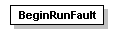
namespace
http:schemas.agilent.com/GC7890/
properties
content | complex
source
<xs:element name="BeginRunFault">
<xs:complexType/>
</xs:element>

element BeginRunRequest
diagram
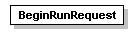
namespace
http:schemas.agilent.com/GC7890/
properties
content | complex
source
<xs:element name="BeginRunRequest">
<xs:complexType/>
</xs:element>

element BeginRunResponse
diagram
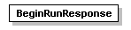
namespace
http:schemas.agilent.com/GC7890/
properties
content | complex
source
<xs:element name="BeginRunResponse">
<xs:complexType/>
</xs:element>

element ControlRequestHeader
diagram
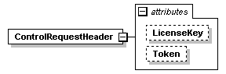
namespace
http:schemas.agilent.com/GC7890/
properties
content | complex
attributes
Name | Type | Use | Default | Fixed | annotation
LicenseKey | xs:string
Token | xs:long
source
<xs:element name="ControlRequestHeader">
<xs:complexType>
<xs:attribute name="LicenseKey" type="xs:string"/>
<xs:attribute name="Token" type="xs:long"/>
</xs:complexType>
</xs:element>

element EchoRequest
diagram
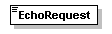
namespace
http:schemas.agilent.com/GC7890/
type
xs:string
properties
content | simple
source
<xs:element name="EchoRequest" type="xs:string"/>

element EchoResponse
diagram
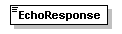
namespace
http:schemas.agilent.com/GC7890/
type
xs:string
properties
content | simple
source
<xs:element name="EchoResponse" type="xs:string"/>

element FlowStatus
diagram
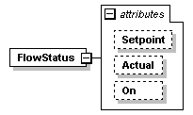
namespace
http:schemas.agilent.com/GC7890/
properties
content | complex
used by
elements | InstrumentStatus/Column InstrumentStatus/Inlet
attributes
Name | Type | Use | Default | Fixed | annotation
Setpoint | xs:double | optional
Actual | xs:double | optional
On | xs:boolean | optional
source
<xs:element name="FlowStatus">
<xs:complexType>
<xs:attribute name="Setpoint" type="xs:double" use="optional"/>
<xs:attribute name="Actual" type="xs:double" use="optional"/>
<xs:attribute name="On" type="xs:boolean" use="optional"/>
</xs:complexType>
</xs:element>

element GetConfigurationFault
diagram
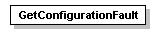
namespace
http:schemas.agilent.com/GC7890/
properties
content | complex
source
<xs:element name="GetConfigurationFault">
<xs:complexType/>
</xs:element>

element GetConfigurationRequest
diagram
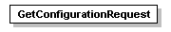
namespace
http:schemas.agilent.com/GC7890/
properties
content | complex
source
<xs:element name="GetConfigurationRequest">
<xs:complexType/>
</xs:element>

element GetConfigurationResponse
diagram
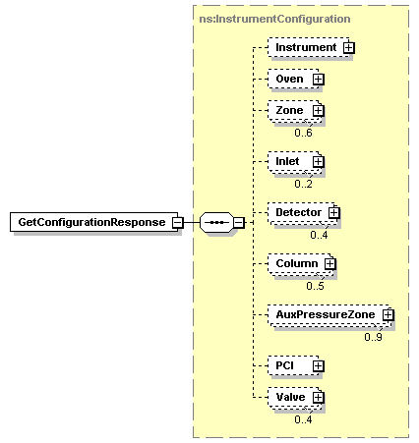
namespace
http:schemas.agilent.com/GC7890/
type
ns:InstrumentConfiguration
properties
content | complex
children
Instrument Oven Zone Inlet Detector Column AuxPressureZone PCI Valve
source
<xs:element name="GetConfigurationResponse" type="ns:InstrumentConfiguration"/>

element GetMethodFault
diagram
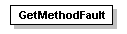
namespace
http:schemas.agilent.com/GC7890/
properties
content | complex
source
<xs:element name="GetMethodFault">
<xs:complexType/>
</xs:element>

element GetMethodRequest
diagram
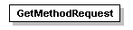
namespace
http:schemas.agilent.com/GC7890/
properties
content | complex
source
<xs:element name="GetMethodRequest">
<xs:complexType/>
</xs:element>

element GetMethodResponse
diagram
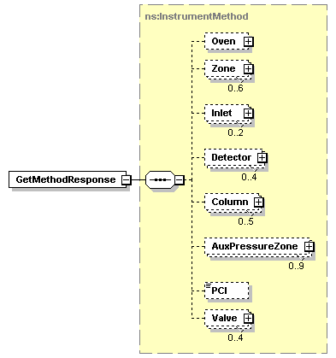
namespace
http:schemas.agilent.com/GC7890/
type
ns:InstrumentMethod
properties
content | complex
children
Oven Zone Inlet Detector Column AuxPressureZone PCI Valve
source
<xs:element name="GetMethodResponse" type="ns:InstrumentMethod"/>

element GetServiceStateFault
diagram
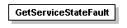
namespace
http:schemas.agilent.com/GC7890/
properties
content | complex
source
<xs:element name="GetServiceStateFault">
<xs:complexType/>
</xs:element>

element GetServiceStateRequest
diagram
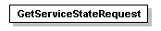
namespace
http:schemas.agilent.com/GC7890/
properties
content | complex
source
<xs:element name="GetServiceStateRequest">
<xs:complexType/>
</xs:element>

element GetServiceStateResponse
diagram
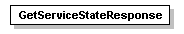
namespace
http:schemas.agilent.com/GC7890/
properties
content | complex
source
<xs:element name="GetServiceStateResponse">
<xs:complexType/>
</xs:element>

element PressureStatus
diagram
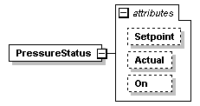
namespace
http:schemas.agilent.com/GC7890/
properties
content | complex
used by
elements | InstrumentStatus/AuxPressureZone InstrumentStatus/Inlet
attributes
Name | Type | Use | Default | Fixed | annotation
Setpoint | xs:double | optional
Actual | xs:double | optional
On | xs:boolean | optional
source
<xs:element name="PressureStatus">
<xs:complexType>
<xs:attribute name="Setpoint" type="xs:double" use="optional"/>
<xs:attribute name="Actual" type="xs:double" use="optional"/>
<xs:attribute name="On" type="xs:boolean" use="optional"/>
</xs:complexType>
</xs:element>

element ReadRequestHeader
diagram
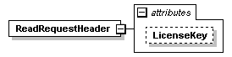
namespace
http:schemas.agilent.com/GC7890/
properties
content | complex
attributes
Name | Type | Use | Default | Fixed | annotation
LicenseKey | xs:string
source
<xs:element name="ReadRequestHeader">
<xs:complexType>
<xs:attribute name="LicenseKey" type="xs:string"/>
</xs:complexType>
</xs:element>

element SetConfigurationFault
diagram
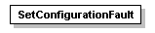
namespace
http:schemas.agilent.com/GC7890/
properties
content | complex
source
<xs:element name="SetConfigurationFault">
<xs:complexType/>
</xs:element>

element SetConfigurationRequest
diagram
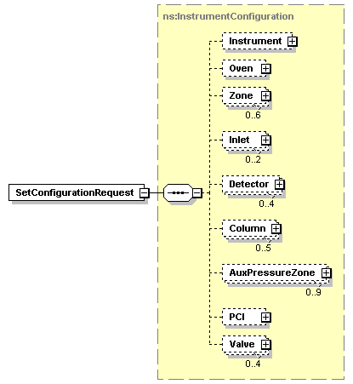
namespace
http:schemas.agilent.com/GC7890/
type
ns:InstrumentConfiguration
properties
content | complex
children
Instrument Oven Zone Inlet Detector Column AuxPressureZone PCI Valve
source
<xs:element name="SetConfigurationRequest" type="ns:InstrumentConfiguration"/>

element SetConfigurationResponse
diagram
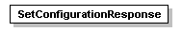
namespace
http:schemas.agilent.com/GC7890/
properties
content | complex
source
<xs:element name="SetConfigurationResponse">
<xs:complexType/>
</xs:element>

element SetMethodRequest
diagram
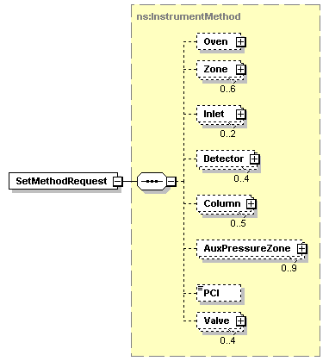
namespace
http:schemas.agilent.com/GC7890/
type
ns:InstrumentMethod
properties
content | complex
children
Oven Zone Inlet Detector Column AuxPressureZone PCI Valve
source
<xs:element name="SetMethodRequest" type="ns:InstrumentMethod"/>

element SetMethodResponse
diagram
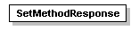
namespace
http:schemas.agilent.com/GC7890/
properties
content | complex
source
<xs:element name="SetMethodResponse">
<xs:complexType/>
</xs:element>

element StopRunFault
diagram
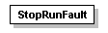
namespace
http:schemas.agilent.com/GC7890/
properties
content | complex
source
<xs:element name="StopRunFault">
<xs:complexType/>
</xs:element>

element StopRunRequest
diagram
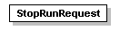
namespace
http:schemas.agilent.com/GC7890/
properties
content | complex
source
<xs:element name="StopRunRequest">
<xs:complexType/>
</xs:element>

element StopRunResponse
diagram
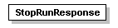
namespace
http:schemas.agilent.com/GC7890/
properties
content | complex
source
<xs:element name="StopRunResponse">
<xs:complexType/>
</xs:element>

element SubscribeToDataFault
diagram
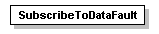
namespace
http:schemas.agilent.com/GC7890/
properties
content | complex
source
<xs:element name="SubscribeToDataFault">
<xs:complexType/>
</xs:element>

element SubscribeToDataRequest
diagram
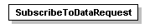
namespace
http:schemas.agilent.com/GC7890/
properties
content | complex
source
<xs:element name="SubscribeToDataRequest">
<xs:complexType/>
</xs:element>

element SubscribeToDataResponse
diagram
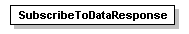
namespace
http:schemas.agilent.com/GC7890/
properties
content | complex
source
<xs:element name="SubscribeToDataResponse">
<xs:complexType/>
</xs:element>

element SubscribeToEventsFault
diagram
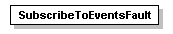
namespace
http:schemas.agilent.com/GC7890/
properties
content | complex
source
<xs:element name="SubscribeToEventsFault">
<xs:complexType/>
</xs:element>

element SubscribeToEventsRequest
diagram
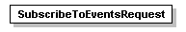
namespace
http:schemas.agilent.com/GC7890/
properties
content | complex
source
<xs:element name="SubscribeToEventsRequest">
<xs:complexType/>
</xs:element>

element SubscribeToEventsResponse
diagram
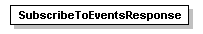
namespace
http:schemas.agilent.com/GC7890/
properties
content | complex
source
<xs:element name="SubscribeToEventsResponse">
<xs:complexType/>
</xs:element>

element SubscribeToStatusFault
diagram
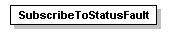
namespace
http:schemas.agilent.com/GC7890/
properties
content | complex
source
<xs:element name="SubscribeToStatusFault">
<xs:complexType/>
</xs:element>

element SubscribeToStatusRequest
diagram
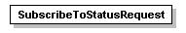
namespace
http:schemas.agilent.com/GC7890/
properties
content | complex
source
<xs:element name="SubscribeToStatusRequest">
<xs:complexType/>
</xs:element>

element SubscribeToStatusResponse
diagram
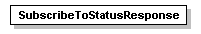
namespace
http:schemas.agilent.com/GC7890/
properties
content | complex
source
<xs:element name="SubscribeToStatusResponse">
<xs:complexType/>
</xs:element>

element TemperatureMethod
diagram
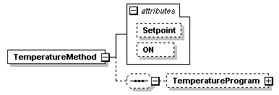
namespace
http:schemas.agilent.com/GC7890/
properties
content | complex
children
TemperatureProgram
used by
elements | InstrumentMethod/Oven InstrumentMethod/Zone
attributes
Name | Type | Use | Default | Fixed | annotation
Setpoint | xs:double | optional
ON | xs:boolean | optional
source
<xs:element name="TemperatureMethod">
<xs:complexType>
<xs:sequence minOccurs="0">
<xs:element name="TemperatureProgram" minOccurs="0">
<xs:complexType>
<xs:sequence minOccurs="0">
<xs:element name="TemperatureProgramStage" minOccurs="0" maxOccurs="unbounded">
<xs:complexType>
<xs:attribute name="Duration" type="xs:double" use="optional"/>
<xs:attribute name="ToTemp" type="xs:double" use="optional"/>
</xs:complexType>
</xs:element>
</xs:sequence>
</xs:complexType>
</xs:element>
</xs:sequence>
<xs:attribute name="Setpoint" type="xs:double" use="optional"/>
<xs:attribute name="ON" type="xs:boolean" use="optional"/>
</xs:complexType>
</xs:element>

element TemperatureStatus
diagram
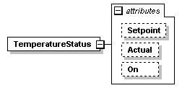
namespace
http:schemas.agilent.com/GC7890/
properties
content | complex
used by
elements | InstrumentStatus/Oven InstrumentStatus/Zone
attributes
Name | Type | Use | Default | Fixed | annotation
Setpoint | xs:double | optional
Actual | xs:double | optional
On | xs:boolean | optional
source
<xs:element name="TemperatureStatus">
<xs:complexType>
<xs:attribute name="Setpoint" type="xs:double" use="optional"/>
<xs:attribute name="Actual" type="xs:double" use="optional"/>
<xs:attribute name="On" type="xs:boolean" use="optional"/>
</xs:complexType>
</xs:element>

WSDL documentation generated by XMLSpy WSDL Editor http://www.altova.com/xmlspy

