interface TimeServiceface
diagram | 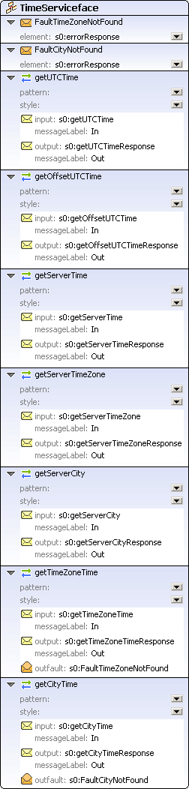
operations
  getUTCTime
  pattern
  input | In  s0:getUTCTime
  output | Out  s0:getUTCTimeResponse
  getOffsetUTCTime
  pattern
  input | In  s0:getOffsetUTCTime
  output | Out  s0:getOffsetUTCTimeResponse
  getServerTime
  pattern
  input | In  s0:getServerTime
  output | Out  s0:getServerTimeResponse
  getServerTimeZone
  pattern
  input | In  s0:getServerTimeZone
  output | Out  s0:getServerTimeZoneResponse
  getServerCity
  pattern
  input | In  s0:getServerCity
  output | Out  s0:getServerCityResponse
  getTimeZoneTime
  pattern
  input | In  s0:getTimeZoneTime
  output | Out  s0:getTimeZoneTimeResponse
  outfault | Out  s0:FaultTimeZoneNotFound
  getCityTime
  pattern
  input | In  s0:getCityTime
  output | Out  s0:getCityTimeResponse
  outfault | Out  s0:FaultCityNotFound
faults
  FaultTimeZoneNotFound
  element | s0:errorResponse
  FaultCityNotFound
  element | s0:errorResponse
used by
  binding TimeServiceSoap
  service TimeService
source | <interface name="TimeServiceface">  <operation name="getUTCTime">  <input messageLabel="In" element="s0:getUTCTime"/>  <output messageLabel="Out" element="s0:getUTCTimeResponse"/>  </operation>  <operation name="getOffsetUTCTime">  <input messageLabel="In" element="s0:getOffsetUTCTime"/>  <output messageLabel="Out" element="s0:getOffsetUTCTimeResponse"/>  </operation>  <operation name="getServerTime">  <input messageLabel="In" element="s0:getServerTime"/>  <output messageLabel="Out" element="s0:getServerTimeResponse"/>  </operation>  <operation name="getServerTimeZone">  <input messageLabel="In" element="s0:getServerTimeZone"/>  <output messageLabel="Out" element="s0:getServerTimeZoneResponse"/>  </operation>  <operation name="getServerCity">  <input messageLabel="In" element="s0:getServerCity"/>  <output messageLabel="Out" element="s0:getServerCityResponse"/>  </operation>  <operation name="getTimeZoneTime">  <input messageLabel="In" element="s0:getTimeZoneTime"/>  <output messageLabel="Out" element="s0:getTimeZoneTimeResponse"/>  <outfault ref="s0:FaultTimeZoneNotFound" message="FaultTimeZoneNotFound"/>  </operation>  <operation name="getCityTime">  <input messageLabel="In" element="s0:getCityTime"/>  <output messageLabel="Out" element="s0:getCityTimeResponse"/>  <outfault ref="s0:FaultCityNotFound" message="FaultCityNotFound"/>  </operation>  <fault name="FaultTimeZoneNotFound" element="s0:errorResponse"/>  <fault name="FaultCityNotFound" element="s0:errorResponse"/>  </interface>

WSDL documentation generated by XMLSpy WSDL Editor http://www.altova.com/xmlspy

