Open test.xml and the insert the entity „aleph“ at the highlighted part of the document.

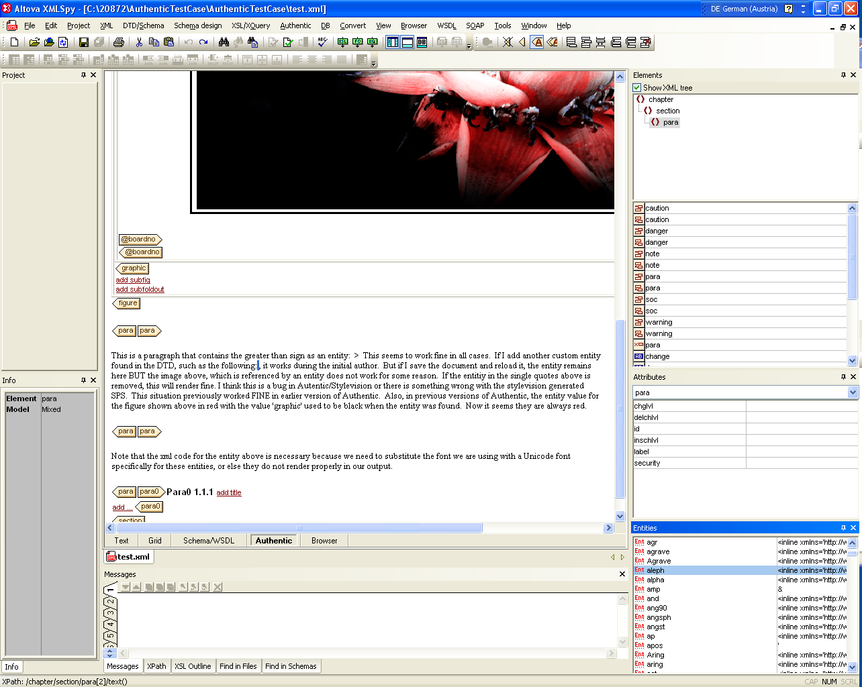

2) the entity has been inserted as one can see.

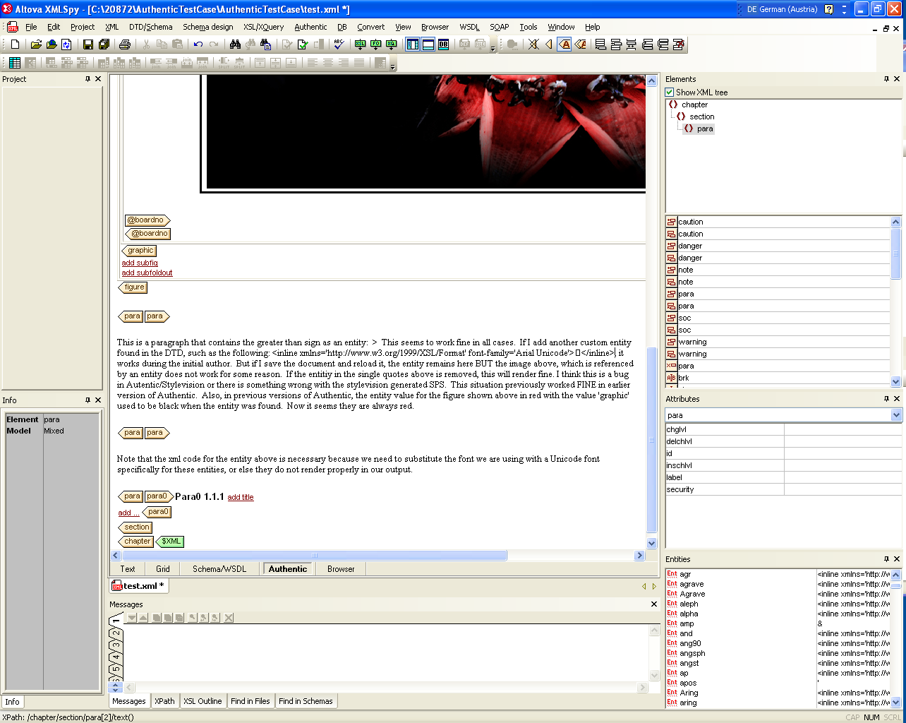

3) Now switch to the text view and back to the Authentic view or save the xml file and then reopen in the Authentic view. The image is gone (note the image is also referenced by an entity.

