Architecture 0
The object can live 2002 time steps without any motion or consumption. Given no brain and allowed to wander about the world eating everything with which it comes into contact

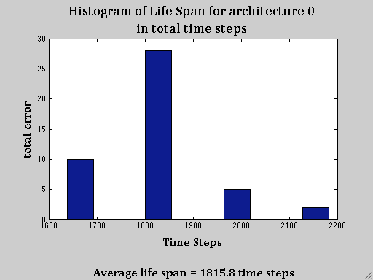Figure 1: Histogram of Life Span for Architecture 0 in total time steps

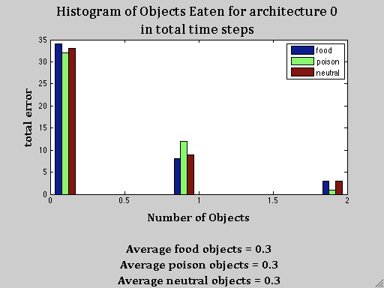Figure 2: Number of food, poison and neutral objects eaten at each occurrence.

Architecture 2

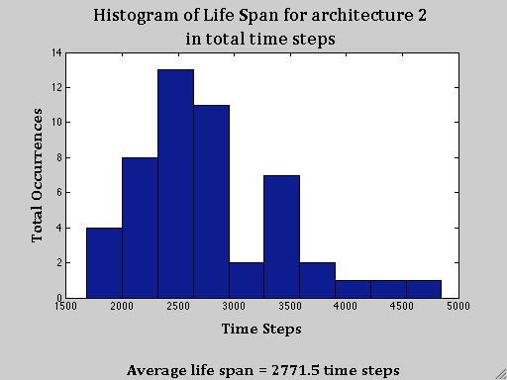Figure 3: Histogram of life span for architecture 2.
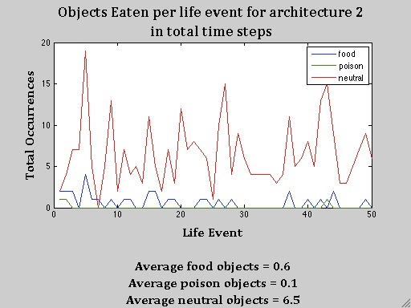Figure 4: Trend of type of objects eaten per life event

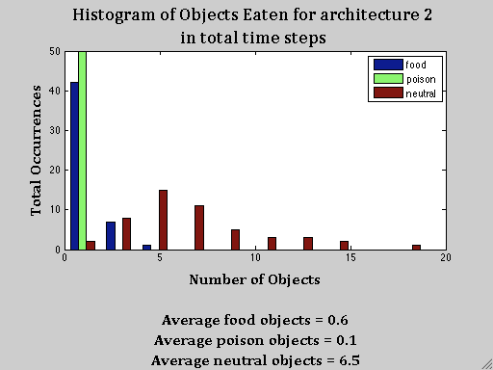Figure 5: Histogram of type of eat events occurring.

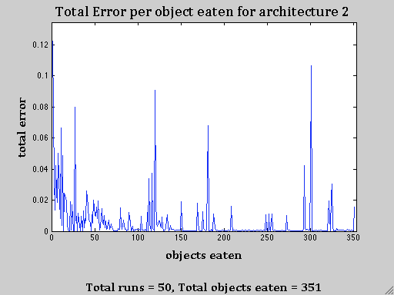Figure 6: Total error per life for architecture 2.

Architecture 3
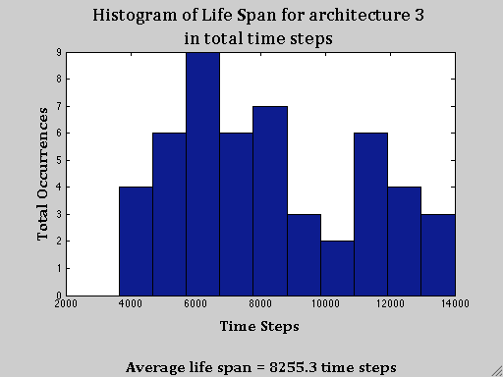

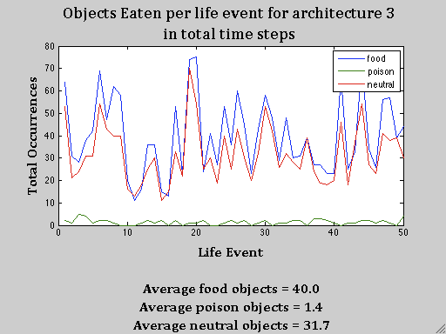

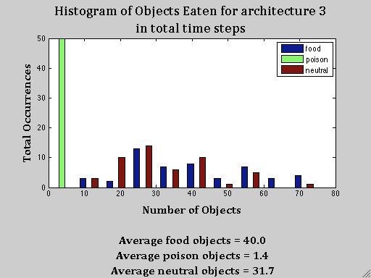

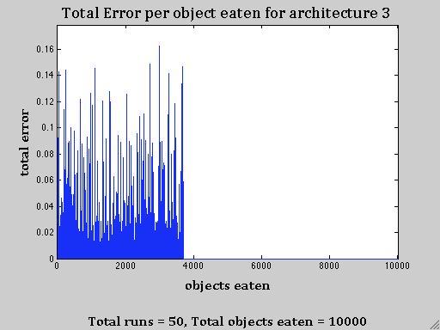

Architecture 4

