CS 547 Final Project Report
Matthew James Hall and Jeremy Sment
University of New Mexico
mjhall@unm.edu
jsment@unm.edu

Abstract
In fulfillment of the Final Project requirements for ECE 547 a series of neural network architectures were created for an agent in an artificial 2D world. Successive neural architectures were implemented to improve life span with ever more sophisticated abilities to identify and consume food objects in Flatworld using visual, aural, and somatic sensory inputs. The final architecture produced a brain for the agent that was able to live for a considerable amount of time and eat almost all of the available food.

Introduction

1.1 Overview of project and its goals
The goal of this project is to design, test, and evaluate an embodied, artificial neural network. A series of neural architectures will be implemented into a two dimensional agent “brain” measuring the quality of the neural network based on how long the agent survives in the 2d simulated environment provided by the professor called Flatworld. Flatworld consists of objects that are classified as food, poison, and neutral. Each of these Flatworld objects possesses certain self-identifying attributes which can be detected by the agent through simulated visual, auditory, and tactile sensory neurons. The agent needs to eat food objects for increased energy, and the agent should avoid poisonous objects to prolong its life. The agents goal is to learn to locate and classify these objects using only neural processes. The team will build a progressive series of more elaborate neural architectures retaining the brain from the previous architectures.

Approach
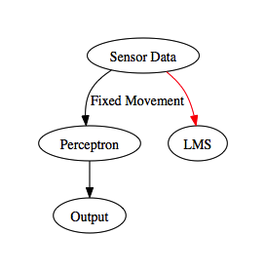Figure 1

Architecture 1
Movement: Straight line
Learning: Learn what food looked like feeding all of the eyelets into a single LMS neuron
Organization: Single component
The architecture proved useful because it helped solidify that the eyelets can classify food very reliably. The approach was revamped in architecture 2 because feeding all of the eyelets into a single neuron meant that using the eyes for navigation was difficult.

Architecture 2
Movement: Agent would turn towards food if it saw food. Agent would turn toward the brightest object if no food was in sight. If it saw nothing, the agent would turn right. The agent turned in fixed increments of 4 degrees. The agent would also slow down when it wasn't hungry.
Learning: Each RGB triple was feed into a single LMS neuron. The RGB values were not normalized which hindered the maximum range that food could be classified.
Organization: Vision, Acoustic, Soma, Decision, Motor (which is the organization for the rest of the architectures)

This architecture substantially improved the lifespan of the agent. The issues it had were that it had limited range in detecting food, the agent fidgets a lot because of the fixed turn angle, and it didn't account for the food in front of it when considering slowing down. It also would move right past a lot of food because it did not have the acoustic hearing or peripheral vision.
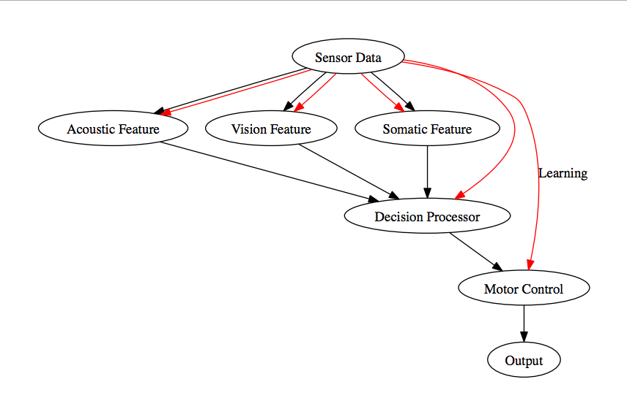Figure 2: Architecture 2 Flow Chart

Architecture 3
Movement: This is is architecture 2 except food identification was relied on more.
Learning: RGB values in vision were normalized which made it possible for the eyelets to identify food further away.

This architecture lived even longer except it still fidgets a lot which uses energy needlessly. It also still was able to move relatively near food without seeing it because it did not have peripheral vision or acoustic detection.

Architecture 4
Movement: Modified to turn toward the direction food was heard from.
Learning: The ears had a RBF network attached to classify food whenever something was consumed.

This suffered because one the noise in the ears is substantial because all of the objects noise is accumulated in each ear and two, the classification from the two ears was nearly always the same. Because of how sound is aggregated, the RBF network could not differentiate food between the left or right. Most of the time, the agent devolved into Architecture 3 behavior because the ears were of little use in classify food.

Architecture 5
Movement: Turning will now be direct to conserve energy
Learning: Eyes are fanned out a bit to give peripheral vision

Architecture 6
Movement: Go towards the loudest ear when food is not visible. This is because ears cannot classify. If nothing is visible, turn a fixed angle right.
Learning: Ears will have no learning

Architecture 7
TBD: Better energy conservation. Head turning?

Results
Text
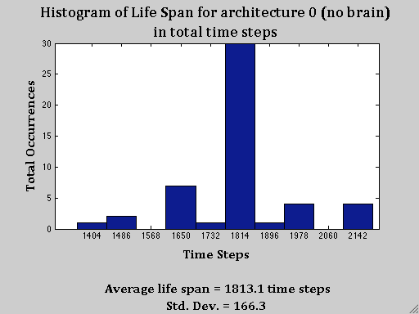Figure 3

Architecture 1
Text
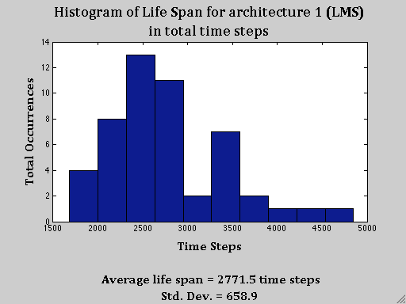Figure 4

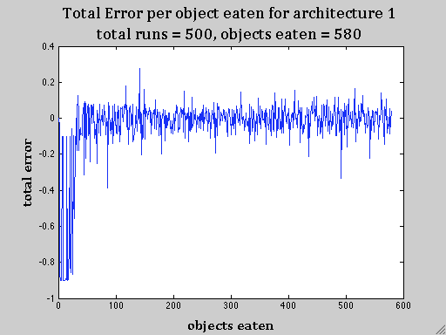
Text
Figure 5
Text
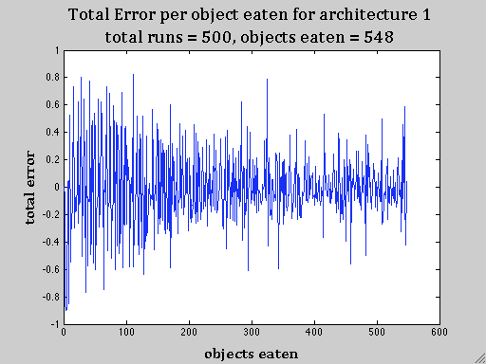Figure 6: Total Error with learning only applied to ears.

Architecture 2
Text
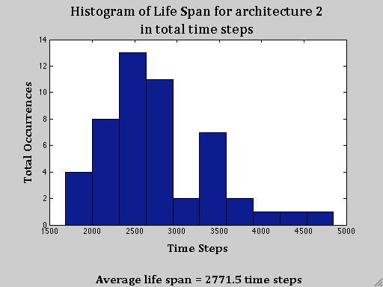Figure 7

Architecture 3
Text

Architecture 4
Text
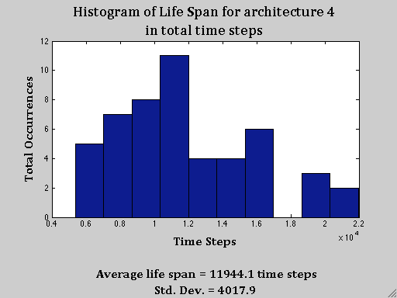Figure 8

Architecture 5
Text
Text
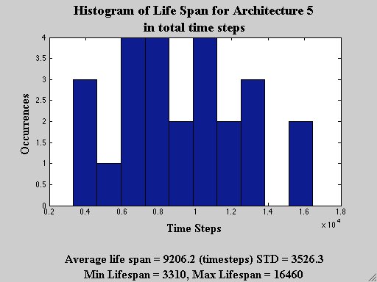Figure 9
Text
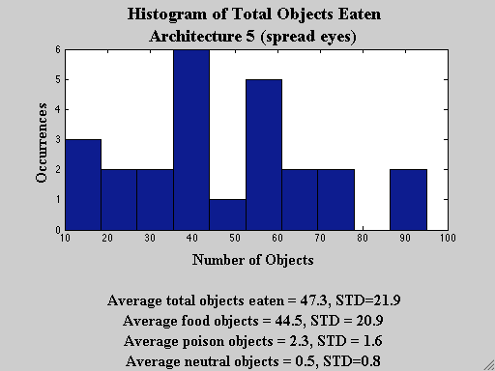Figure 10
Text
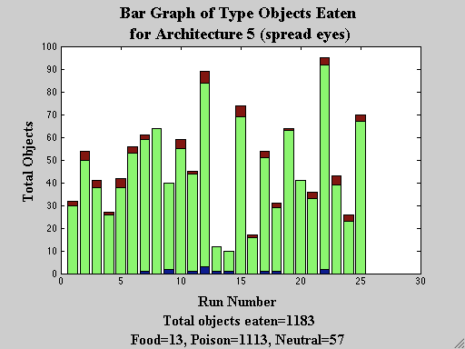Figure 11
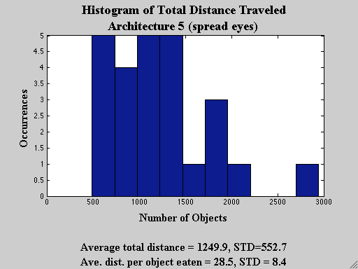Figure 12

Architecture 6
Text

Architecture 7
Text

Discussion
Text

Summary and Conclusions
Text

Acknowledgements
Text

References
Text
Appendices

