# Problem 1

## List the names of students along with each student’s department, department building, advisor, and advisor’s department. Note that you all students should be listed regardless of any missing information..

For this, I wrote the following query:-

1. List the instructors’ names and their advising load (number of students they advise) for those whose advising load is greater than 40 students.

I wrote the following query:-

## List the times (day/hour/min) that no “Comp. Sci.” class has been scheduled to start (among all valid sessions according to the section time slots)

I wrote the following query:-

select 'JV85', day, start_hr, start_min

from time_slot except (select 'JV85',day,start_hr,start_min from ((select * from course natural inner join section where dept_name='Comp. Sci.') as a1 left outer join time_slot on a1.time_slot_id=time_slot.time_slot_id))

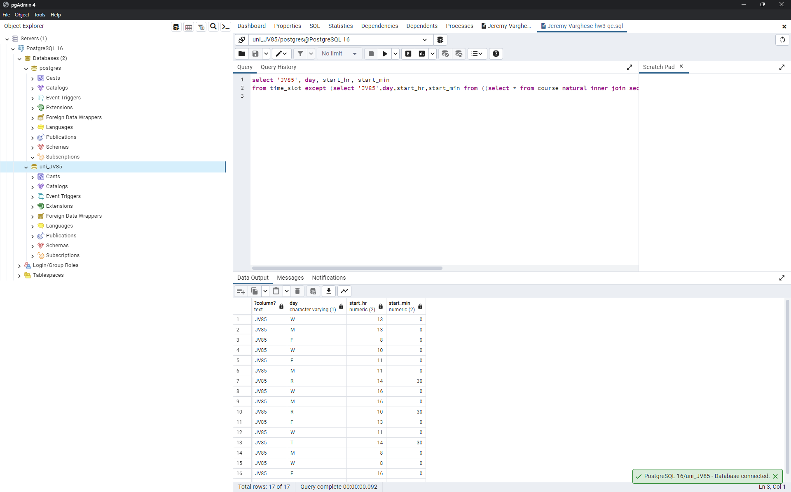

1. List the names of students who took classes in Spring 2010 along with the number of sessions that they needed to attend each week. Note that each time slot may include multiple sessions per week.

I wrote the following query:-

select 'JV85', name, count((time_slot_id,day,start_hr,start_min))

from ((select * from (student natural join takes) where takes.semester = 'Spring' and takes.year='2010') natural join(select * from section natural join time_slot))

group by name

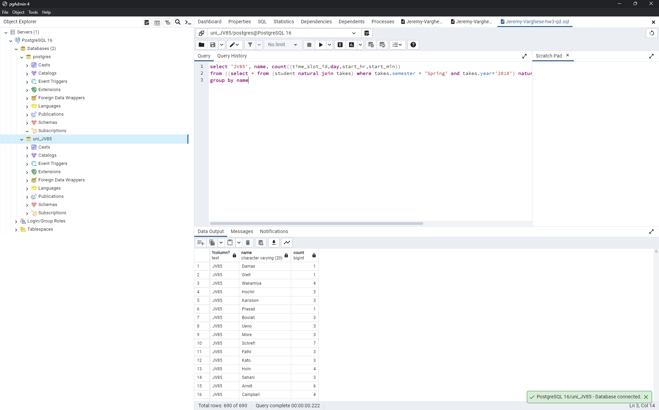

1. List the name of any instructor who has been assigned to teach in the same time slot in the same semester (i.e., a scheduling conflict). Include the semester/year of such conflict cases.

I wrote the following query:-

select name,semester,year

from ((instructor natural join teaches) natural join section)

group by name,semester,year

having count(time_slot_id)>1

