**Bugs**

1. Seem like when click the ‘Login’ Button from [Business Grants Portal (gds-gov.tech)](https://bgp-qa.gds-gov.tech/), it will always auto randomly populate an login user details (Login with your own user), and we just need to click the 2nd login button:

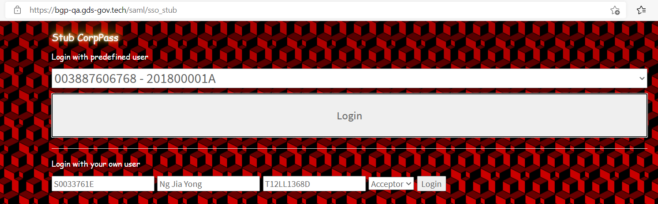

1. There are 5 questions, not 4 questions specify in the PDF in the Eligibility Section
2. Wrong error message displayed when select ‘No’ in the Eligibility Section

Expected: Visit Smart Advisor

on the SME Portal for more information on other government assistance.

Actual: The applicant may not meet the eligibility criteria for this grant. Visit [**FAQ**](https://www.ifaq.gov.sg/BGP/apps/fcd_faqmain.aspx#FAQ_1111145) page for more information on other government grants.

1. The URL from the error message when select ‘No’ also different from the pdf stated

Expected: <https://www.smeportal.sg/content/smeportal/en/moneymatters.html#saText>

Actual: [Business Grants Portal (ifaq.gov.sg)](https://www.ifaq.gov.sg/BGP/apps/fcd_faqmain.aspx#FAQ_1111145)

