None

Training model with LR=0.01 and num_epochs=10

Epoch 1/10

220/220 [==============================] - 1100s 5s/step - loss: 2.6982 - accuracy: 0.2382 - val_loss: 9.6740 - val_accuracy: 0.0271 - lr: 0.0010

Epoch 2/10

220/220 [==============================] - 1007s 5s/step - loss: 1.9690 - accuracy: 0.4128 - val_loss: 6.0967 - val_accuracy: 0.0857 - lr: 0.0010

Epoch 3/10

220/220 [==============================] - 1016s 5s/step - loss: 1.6849 - accuracy: 0.4907 - val_loss: 5.7017 - val_accuracy: 0.1541 - lr: 0.0010

Epoch 4/10

220/220 [==============================] - 1021s 5s/step - loss: 1.5174 - accuracy: 0.5349 - val_loss: 6.6564 - val_accuracy: 0.1527 - lr: 0.0010

Epoch 5/10

220/220 [==============================] - 1026s 5s/step - loss: 1.4020 - accuracy: 0.5658 - val_loss: 8.7028 - val_accuracy: 0.1329 - lr: 0.0010

Epoch 6/10

220/220 [==============================] - 1031s 5s/step - loss: 1.3105 - accuracy: 0.5928 - val_loss: 5.7152 - val_accuracy: 0.1845 - lr: 0.0010

Epoch 7/10

220/220 [==============================] - 1004s 5s/step - loss: 1.2413 - accuracy: 0.6118 - val_loss: 8.3520 - val_accuracy: 0.1806 - lr: 0.0010

Epoch 8/10

220/220 [==============================] - 1007s 5s/step - loss: 1.1737 - accuracy: 0.6314 - val_loss: 8.5295 - val_accuracy: 0.1504 - lr: 0.0010

Epoch 9/10

220/220 [==============================] - 1009s 5s/step - loss: 1.1140 - accuracy: 0.6475 - val_loss: 2.8937 - val_accuracy: 0.3152 - lr: 0.0010

Epoch 10/10

220/220 [==============================] - 984s 4s/step - loss: 1.0888 - accuracy: 0.6570 - val_loss: 7.8259 - val_accuracy: 0.1382 - lr: 0.0010

69/69 - 145s - loss: 5.2585 - accuracy: 0.2733 - 145s/epoch - 2s/step

Test accuracy for LR=0.01 and num_epochs=10: 0.2733325660228729

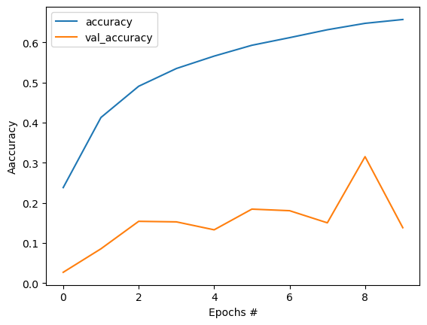

Training model with LR=0.01 and num_epochs=30

Epoch 1/30

220/220 [==============================] - 1018s 5s/step - loss: 1.0569 - accuracy: 0.6671 - val_loss: 4.6168 - val_accuracy: 0.2272 - lr: 0.0010

Epoch 2/30

220/220 [==============================] - 1023s 5s/step - loss: 1.0071 - accuracy: 0.6805 - val_loss: 3.9075 - val_accuracy: 0.3158 - lr: 0.0010

Epoch 3/30

220/220 [==============================] - 1019s 5s/step - loss: 0.9846 - accuracy: 0.6869 - val_loss: 3.5945 - val_accuracy: 0.3498 - lr: 0.0010

Epoch 4/30

220/220 [==============================] - 1015s 5s/step - loss: 0.9547 - accuracy: 0.6933 - val_loss: 5.1668 - val_accuracy: 0.2321 - lr: 0.0010

Epoch 5/30

220/220 [==============================] - 1012s 5s/step - loss: 0.9202 - accuracy: 0.7050 - val_loss: 5.8373 - val_accuracy: 0.2368 - lr: 0.0010

Epoch 6/30

220/220 [==============================] - 997s 5s/step - loss: 0.8925 - accuracy: 0.7164 - val_loss: 13.2633 - val_accuracy: 0.0989 - lr: 0.0010

Epoch 7/30

220/220 [==============================] - 993s 5s/step - loss: 0.8755 - accuracy: 0.7192 - val_loss: 4.1024 - val_accuracy: 0.2824 - lr: 0.0010

Epoch 8/30

220/220 [==============================] - 979s 4s/step - loss: 0.8596 - accuracy: 0.7249 - val_loss: 5.3559 - val_accuracy: 0.2469 - lr: 0.0010

Epoch 9/30

220/220 [==============================] - 977s 4s/step - loss: 0.8417 - accuracy: 0.7284 - val_loss: 5.1472 - val_accuracy: 0.3188 - lr: 0.0010

Epoch 10/30

220/220 [==============================] - 980s 4s/step - loss: 0.8256 - accuracy: 0.7325 - val_loss: 5.1697 - val_accuracy: 0.2647 - lr: 0.0010

Epoch 11/30

220/220 [==============================] - 979s 4s/step - loss: 0.8033 - accuracy: 0.7406 - val_loss: 4.1703 - val_accuracy: 0.3258 - lr: 9.0484e-04

Epoch 12/30

220/220 [==============================] - 973s 4s/step - loss: 0.7727 - accuracy: 0.7492 - val_loss: 2.8110 - val_accuracy: 0.4165 - lr: 8.1873e-04

Epoch 13/30

220/220 [==============================] - 978s 4s/step - loss: 0.7353 - accuracy: 0.7620 - val_loss: 2.9607 - val_accuracy: 0.4163 - lr: 7.4082e-04

Epoch 14/30

220/220 [==============================] - 974s 4s/step - loss: 0.7193 - accuracy: 0.7683 - val_loss: 2.8138 - val_accuracy: 0.4633 - lr: 6.7032e-04

Epoch 15/30

220/220 [==============================] - 974s 4s/step - loss: 0.6914 - accuracy: 0.7757 - val_loss: 1.3569 - val_accuracy: 0.6024 - lr: 6.0653e-04

Epoch 16/30

220/220 [==============================] - 983s 4s/step - loss: 0.6790 - accuracy: 0.7816 - val_loss: 2.0048 - val_accuracy: 0.4996 - lr: 5.4881e-04

Epoch 17/30

220/220 [==============================] - 981s 4s/step - loss: 0.6591 - accuracy: 0.7865 - val_loss: 1.9789 - val_accuracy: 0.5068 - lr: 4.9659e-04

Epoch 18/30

220/220 [==============================] - 975s 4s/step - loss: 0.6410 - accuracy: 0.7917 - val_loss: 1.1940 - val_accuracy: 0.6334 - lr: 4.4933e-04

Epoch 19/30

220/220 [==============================] - 970s 4s/step - loss: 0.6203 - accuracy: 0.7979 - val_loss: 1.4412 - val_accuracy: 0.6051 - lr: 4.0657e-04

Epoch 20/30

220/220 [==============================] - 970s 4s/step - loss: 0.6141 - accuracy: 0.7995 - val_loss: 2.5839 - val_accuracy: 0.4611 - lr: 3.6788e-04

Epoch 21/30

220/220 [==============================] - 979s 4s/step - loss: 0.6014 - accuracy: 0.8039 - val_loss: 2.4897 - val_accuracy: 0.4820 - lr: 3.3287e-04

Epoch 22/30

220/220 [==============================] - 981s 4s/step - loss: 0.5883 - accuracy: 0.8096 - val_loss: 1.3916 - val_accuracy: 0.6176 - lr: 3.0119e-04

Epoch 23/30

220/220 [==============================] - 967s 4s/step - loss: 0.5854 - accuracy: 0.8079 - val_loss: 0.8871 - val_accuracy: 0.7155 - lr: 2.7253e-04

Epoch 24/30

220/220 [==============================] - 971s 4s/step - loss: 0.5661 - accuracy: 0.8150 - val_loss: 0.9053 - val_accuracy: 0.7157 - lr: 2.4660e-04

Epoch 25/30

220/220 [==============================] - 964s 4s/step - loss: 0.5649 - accuracy: 0.8155 - val_loss: 3.0684 - val_accuracy: 0.4475 - lr: 2.2313e-04

Epoch 26/30

220/220 [==============================] - 969s 4s/step - loss: 0.5503 - accuracy: 0.8196 - val_loss: 1.0128 - val_accuracy: 0.6920 - lr: 2.0190e-04

Epoch 27/30

220/220 [==============================] - 968s 4s/step - loss: 0.5517 - accuracy: 0.8190 - val_loss: 0.8013 - val_accuracy: 0.7456 - lr: 1.8268e-04

Epoch 28/30

220/220 [==============================] - 946s 4s/step - loss: 0.5389 - accuracy: 0.8234 - val_loss: 0.8417 - val_accuracy: 0.7390 - lr: 1.6530e-04

Epoch 29/30

220/220 [==============================] - 937s 4s/step - loss: 0.5276 - accuracy: 0.8276 - val_loss: 0.6178 - val_accuracy: 0.7999 - lr: 1.4957e-04

Epoch 30/30

220/220 [==============================] - 952s 4s/step - loss: 0.5317 - accuracy: 0.8258 - val_loss: 0.6763 - val_accuracy: 0.7812 - lr: 1.3534e-04

69/69 - 77s - loss: 0.9116 - accuracy: 0.7345 - 77s/epoch - 1s/step

Test accuracy for LR=0.01 and num_epochs=30: 0.7344639301300049

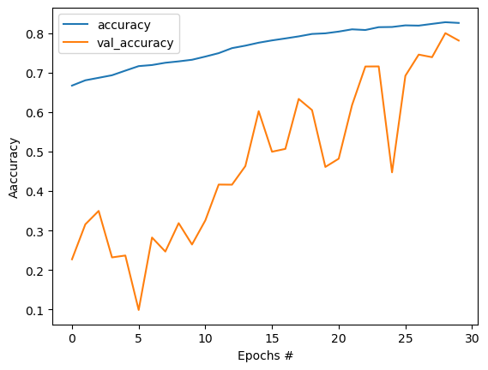

Training model with LR=0.01 and num_epochs=100

Epoch 1/100

220/220 [==============================] - 968s 4s/step - loss: 0.6918 - accuracy: 0.7739 - val_loss: 6.4284 - val_accuracy: 0.2464 - lr: 0.0010

Epoch 2/100

220/220 [==============================] - 943s 4s/step - loss: 0.6927 - accuracy: 0.7734 - val_loss: 2.9821 - val_accuracy: 0.4245 - lr: 0.0010

Epoch 3/100

164/220 [=====================>........] - ETA: 3:12 - loss: 0.6879 - accuracy: 0.7767