PROJECT REPORT
Customer Churn Prediction using AI/Machine Learning
A Data Analytics with AI approach to predicting and reducing telecom customer churn
Submitted by
Isha Sharma
IBM SkillsBuild — Data Analytics with AI
Academic Internship Program
Conducted by BharatCares, in association with AICTE
September 2026

Abstract
Customer churn — the loss of customers to competitors or discontinued service — is one of the most critical challenges for subscription-based businesses such as telecommunications providers, since retaining an existing customer is significantly cheaper than acquiring a new one. This project applies a complete data analytics and artificial intelligence workflow to the IBM Telco Customer Churn dataset (7,043 customers, 21 attributes) to understand the factors that drive churn and to build predictive models that identify customers at risk of leaving.
The workflow covers data cleaning, exploratory data analysis, feature engineering, class-imbalance handling (SMOTE), and the training and evaluation of four machine learning classifiers — Logistic Regression, Decision Tree, Random Forest, and Gradient Boosting. The best-performing model achieved an ROC-AUC of approximately 0.84 and an accuracy of about 78% on held-out test data. Key churn drivers identified include contract type, customer tenure, monthly charges, internet service type, and payment method. The report concludes with concrete, data-backed business recommendations that a telecom operator could use to reduce churn and protect revenue.

Table of Contents
1. Introduction
2. Problem Statement
3. Objectives
4. Dataset Description
5. Technologies & Tools Used
6. Methodology
7. Data Preprocessing
8. Exploratory Data Analysis
9. Model Building
10. Results & Model Evaluation
11. Feature Importance
12. Key Insights
13. Business Recommendations
14. Conclusion
15. References

1. Introduction
This project is submitted as part of the IBM SkillsBuild Data Analytics with AI Academic Internship Program, conducted by BharatCares in association with AICTE. It demonstrates an end-to-end data analytics and AI pipeline applied to a real-world business problem: predicting customer churn for a telecommunications company.
Subscription businesses depend heavily on customer retention for sustainable revenue. Every customer who churns represents lost recurring revenue and a sunk acquisition cost. By analyzing historical customer data and applying machine learning, a business can move from reacting to churn after it happens to proactively identifying and retaining at-risk customers before they leave.

2. Problem Statement
Given a dataset of telecom customer demographics, account details, and subscribed services, the goal is to: (a) identify the key factors associated with customer churn through exploratory data analysis, and (b) build a machine learning model that accurately predicts whether a given customer is likely to churn, so that targeted retention actions can be taken.

3. Objectives
- Perform thorough data cleaning and preprocessing on the Telco Customer Churn dataset.
- Conduct exploratory data analysis (EDA) to uncover patterns and relationships linked to churn.
- Engineer features suitable for machine learning and address class imbalance in the target variable.
- Train and compare multiple classification models to predict customer churn.
- Evaluate models using appropriate metrics (accuracy, precision, recall, F1-score, ROC-AUC).
- Translate analytical and model findings into actionable business recommendations.

4. Dataset Description
The project uses the Telco Customer Churn dataset, originally published by IBM as a sample dataset for customer retention analytics and widely used on Kaggle (blastchar/telco-customer-churn). It contains 7,043 customer records across 21 columns, covering demographics, account information, subscribed services, and the churn label.
Column | Description
customerID | Unique identifier for each customer (dropped before modeling)
gender, SeniorCitizen, Partner, Dependents | Customer demographic attributes
tenure | Number of months the customer has stayed with the company
PhoneService, MultipleLines | Phone service subscription details
InternetService, OnlineSecurity, OnlineBackup, DeviceProtection, TechSupport, StreamingTV, StreamingMovies | Internet service and add-on subscriptions
Contract, PaperlessBilling, PaymentMethod | Account / billing details
MonthlyCharges, TotalCharges | Billing amounts
Churn | Target variable — whether the customer left within the last month (Yes/No)

Dataset link (Kaggle): https://www.kaggle.com/datasets/blastchar/telco-customer-churn

5. Technologies & Tools Used
- Python 3 — core programming language
- pandas, NumPy — data loading, cleaning, and manipulation
- Matplotlib, Seaborn — data visualization
- scikit-learn — machine learning models, preprocessing, and evaluation metrics
- imbalanced-learn (SMOTE) — class-imbalance handling
- Jupyter Notebook — interactive development and documentation environment

6. Methodology
The project follows a standard data analytics and machine learning pipeline, illustrated below and implemented in full in the accompanying Jupyter notebook (IshaSharma_CustomerChurnPrediction.ipynb).
- Step 1 — Data Loading: Import the raw CSV dataset into a pandas DataFrame.
- Step 2 — Data Cleaning: Fix data types, handle missing/blank values, remove duplicates and irrelevant identifiers.
- Step 3 — Exploratory Data Analysis: Visualize distributions and relationships between features and churn.
- Step 4 — Feature Engineering: Encode categorical variables, scale numeric features.
- Step 5 — Train/Test Split & Class Balancing: Split the data and apply SMOTE oversampling to the training set.
- Step 6 — Model Training: Train Logistic Regression, Decision Tree, Random Forest, and Gradient Boosting classifiers.
- Step 7 — Evaluation: Compare models using accuracy, precision, recall, F1-score, and ROC-AUC; select the best model.
- Step 8 — Interpretation: Analyze feature importance and translate findings into business recommendations.

7. Data Preprocessing
The raw dataset required several cleaning steps before it was suitable for analysis and modeling:
- TotalCharges was stored as text and contained 11 blank values (for customers with zero tenure); it was converted to a numeric type and the blanks were filled with 0.
- The customerID column was dropped, as it is a unique identifier with no predictive value.
- Labels such as “No internet service” and “No phone service” were standardized to “No” so each service column is a clean binary feature.
- After removing customerID, 22 rows became exact duplicates on the remaining columns (different customers with identical profiles) and were removed to avoid redundant records.
- Binary categorical columns (Yes/No, gender) were label-encoded; multi-category columns (InternetService, Contract, PaymentMethod) were one-hot encoded.
- Numeric features were scaled using StandardScaler, and SMOTE was applied to the training set to correct the class imbalance (about 73% “No Churn” vs. 27% “Churn”).

8. Exploratory Data Analysis
Exploratory analysis was used to understand the distribution of the target variable and identify which customer attributes are most associated with churn.

8.1 Churn Distribution
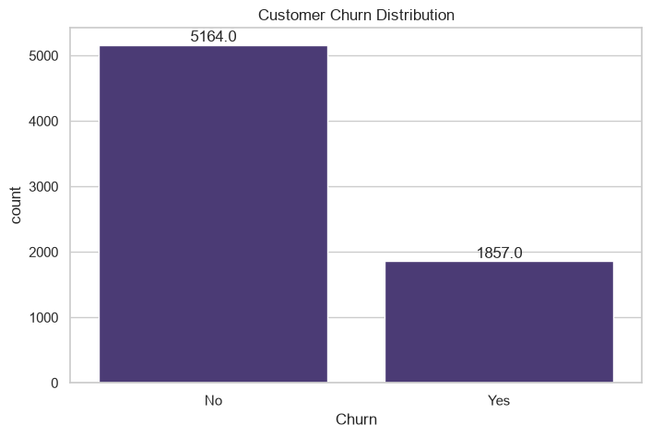
Figure 1. Overall churn distribution (26.5% of customers churned).
About one in four customers in the dataset (26.5%) churned, confirming a moderate class imbalance that was addressed during modeling with SMOTE.

8.2 Tenure, Monthly Charges & Total Charges
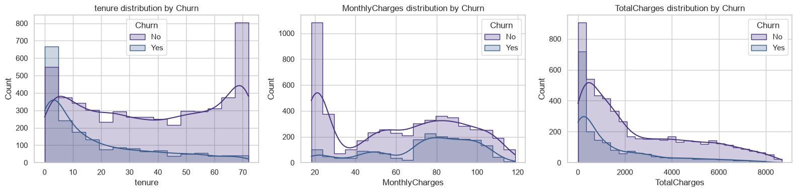
Figure 2. Distribution of tenure, monthly charges, and total charges, split by churn.
Customers who churn tend to have low tenure (they leave within their first few months) and higher monthly charges. Long-tenure, lower-monthly-charge customers form the most loyal segment.

8.3 Churn by Contract Type & Payment Method
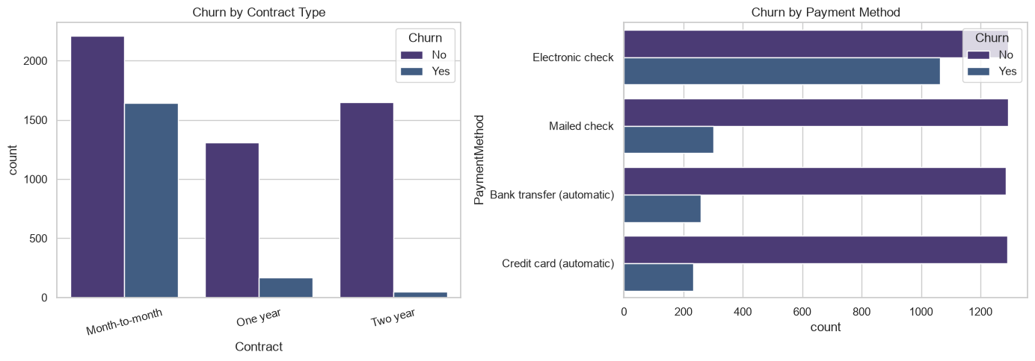
Figure 3. Churn by contract type and payment method.
Month-to-month customers churn far more than those on one- or two-year contracts. Customers who pay via electronic check also churn noticeably more than those using automatic payment methods, suggesting that both commitment level and payment friction influence churn.

8.4 Churn by Internet Service & Senior Citizen Status
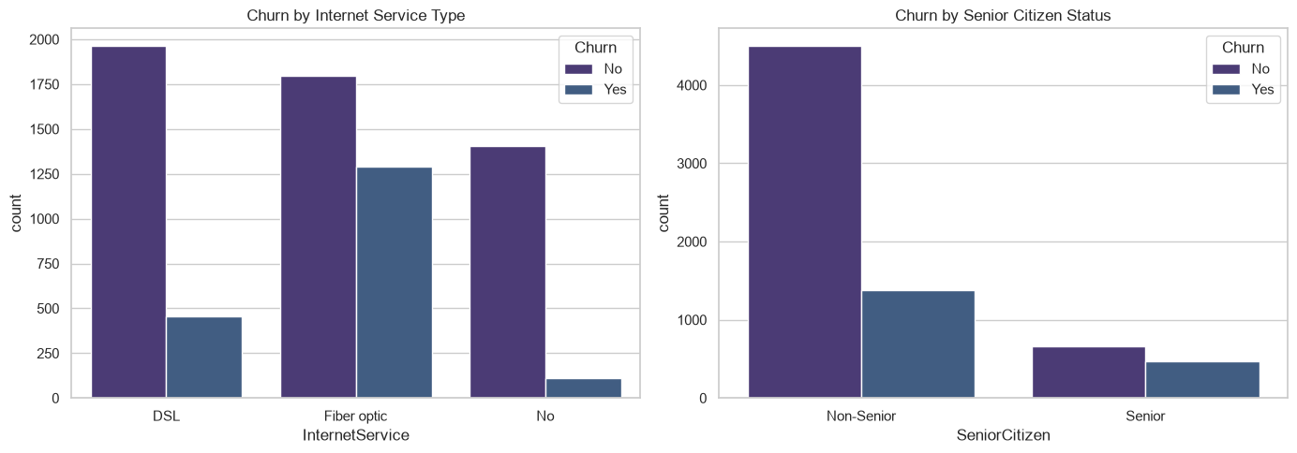
Figure 4. Churn by internet service type and senior citizen status.
Fiber optic customers churn more than DSL or no-internet customers, likely reflecting higher price points and competitive pressure in that segment. Senior citizens also show a higher relative churn rate than non-seniors.

8.5 Correlation Heatmap
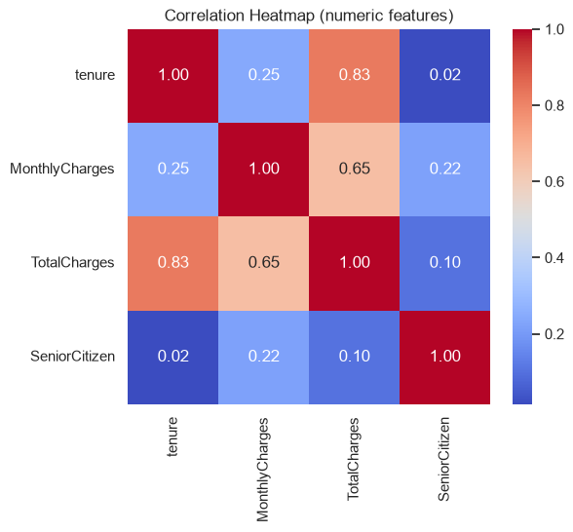
Figure 5. Correlation heatmap of numeric features.
Tenure and TotalCharges are strongly positively correlated (as expected, since charges accumulate over time), while both show weaker direct correlation with MonthlyCharges, indicating these features capture distinct signals useful to the model.

9. Model Building
Four classification algorithms were trained on the preprocessed, SMOTE-balanced training data and evaluated on a held-out test set (20% of the data, stratified by churn):
- Logistic Regression — a linear baseline model, fast and interpretable.
- Decision Tree — a single tree-based model capturing non-linear interactions.
- Random Forest — an ensemble of decision trees that reduces overfitting and improves generalization.
- Gradient Boosting — a sequential ensemble that iteratively corrects prior errors, often yielding strong predictive performance.
All models were trained with scikit-learn using consistent train/test splits and a fixed random seed for reproducibility.

10. Results & Model Evaluation
Model | Accuracy | Precision | Recall | F1-Score | ROC-AUC
Gradient Boosting | 0.781 | 0.574 | 0.675 | 0.621 | 0.842
Logistic Regression | 0.742 | 0.509 | 0.763 | 0.611 | 0.840
Random Forest | 0.778 | 0.566 | 0.691 | 0.622 | 0.840
Decision Tree | 0.743 | 0.510 | 0.785 | 0.618 | 0.819

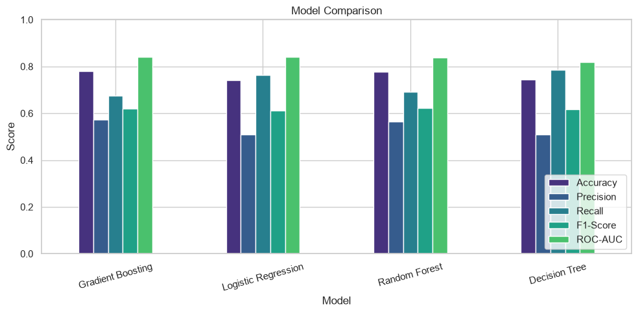
Figure 6. Model comparison across accuracy, precision, recall, F1-score, and ROC-AUC.
Gradient Boosting achieved the highest ROC-AUC (≈ 0.84) and the best overall balance of accuracy and precision, and was selected as the final model. Logistic Regression achieved the highest recall, meaning it catches the most true churners at the cost of more false positives — a useful alternative if the business prefers to err on the side of over-flagging at-risk customers.

10.1 Confusion Matrix (Best Model)
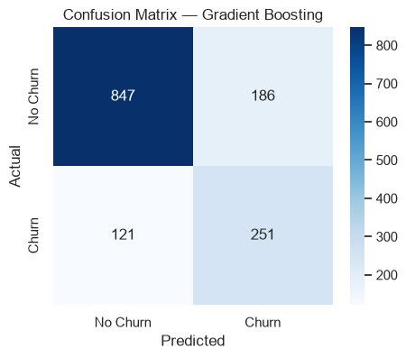
Figure 7. Confusion matrix for the Gradient Boosting model on the test set.
Of 372 customers who actually churned in the test set, the model correctly identified the majority of them, while keeping false alarms on loyal customers relatively low.

10.2 ROC Curve Comparison
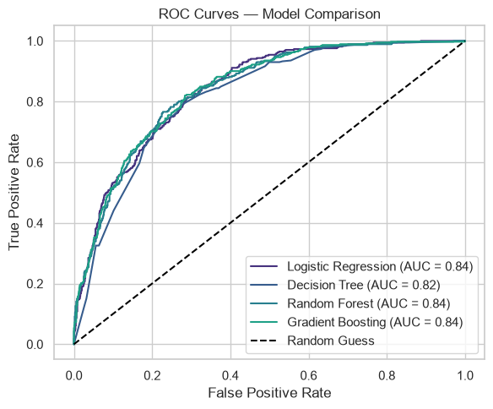
Figure 8. ROC curves for all four models.
All four models comfortably outperform random guessing (the diagonal reference line), with Gradient Boosting, Logistic Regression, and Random Forest achieving very similar, strong ROC-AUC scores around 0.84.

11. Feature Importance
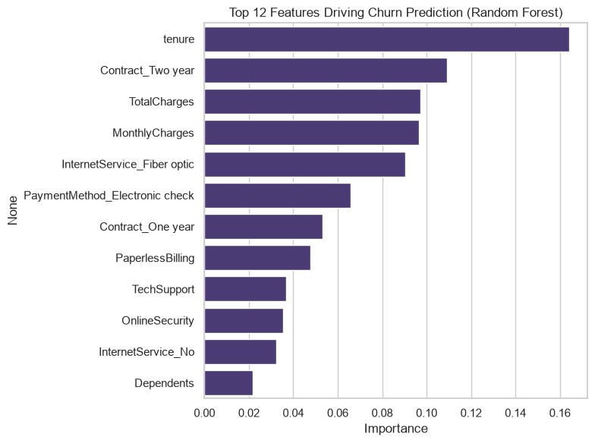
Figure 9. Top 12 features driving churn prediction (Random Forest).
Tenure, total charges, monthly charges, contract type, and internet service type consistently emerge as the strongest predictors of churn, reinforcing the patterns observed during exploratory data analysis and giving the business clear, interpretable levers to act on.

12. Key Insights
- Contract type is the single biggest churn driver — month-to-month customers churn far more than those on 1- or 2-year contracts.
- New customers are the most at risk — churn is heavily concentrated within the first ~12 months of tenure.
- Price sensitivity matters — higher monthly charges, especially with Fiber optic internet, correlate with higher churn.
- Payment friction correlates with churn — customers paying via electronic check churn more than those on automatic payment methods.
- Add-on services reduce churn — customers without OnlineSecurity or TechSupport churn more, suggesting these services increase perceived value and stickiness.

13. Business Recommendations
- Offer incentives (discounts, bundled services) to convert month-to-month customers onto longer-term contracts.
- Create a dedicated onboarding and retention journey for the first 3–12 months of a customer's lifecycle.
- Review Fiber optic pricing and competitiveness, and bundle add-on services (security, tech support) into higher-tier plans at low marginal cost.
- Encourage automatic payment methods (credit card / bank transfer) through small incentives to reduce payment-related churn.
- Deploy the trained model to score the active customer base monthly and proactively reach out to customers with a high predicted churn probability.

14. Conclusion
This project implemented a complete data analytics and AI pipeline — data cleaning, exploratory analysis, feature engineering, and the training and evaluation of four classification models — to predict telecom customer churn using the IBM Telco Customer Churn dataset. The best-performing model, Gradient Boosting, achieved an ROC-AUC of approximately 0.84, demonstrating that machine learning can meaningfully distinguish at-risk customers from loyal ones using account and service attributes alone.
Beyond the predictive model itself, the analysis surfaced clear, actionable business insights: contract type, tenure, pricing, and service bundling are the dominant levers influencing churn. A business applying these findings — through targeted retention offers, improved onboarding, and proactive model-driven outreach — can materially reduce churn and protect recurring revenue.

15. References
- Telco Customer Churn dataset, Kaggle: https://www.kaggle.com/datasets/blastchar/telco-customer-churn
- scikit-learn documentation: https://scikit-learn.org/stable/
- imbalanced-learn (SMOTE) documentation: https://imbalanced-learn.org/stable/
- pandas documentation: https://pandas.pydata.org/docs/
- IBM SkillsBuild — Data Analytics with AI Academic Internship Program, conducted by BharatCares in association with AICTE.

