Earl of Treats Site Plan

Cassidy Hale

WDD 130

Overview

Purpose
“We are here to bring the treats of Earl Taylor to the masses. Earl of Treats is One in a Papillion, from cake pops, to caramels, to cupcakes, we never fail to put a smile on your face”

Audience
Everyone and anyone interested in our treats! From ages 1 to 100, there’s no one we can’t please.

Branding

Website Logo
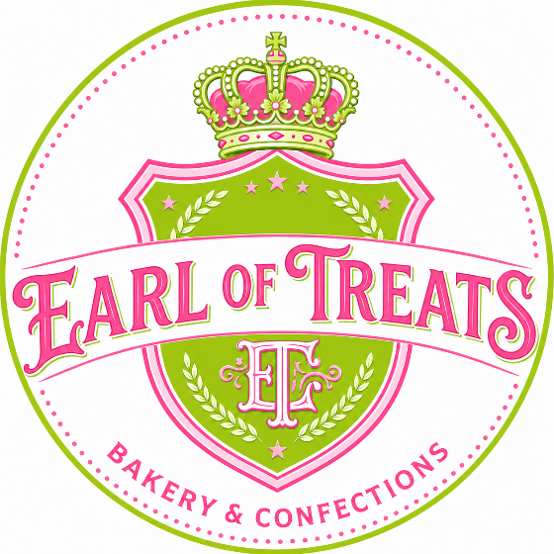

Style Guide

Color Palette
Primary | Secondary | Accent 1 | Accent 2
#FFFFFF | #FFB6C1 | #FF69B4 | #88E788

Typography

Heading Font: Century

Paragraph Font: Garamond

Navigation
Home About Us Order Contact Us

Content

Tagline: We’re One in a Papillion
Info: Based out of Papillion Nebraska, and the recipes of Earl Taylor, beloved grandfather, father, brother, and friend.

