

**QUALIFICATION NAME**: NATIONAL DIPLOMA INFORMATION TECHNOLOGY (COMMUNICATION NETWORKS)

**SUBJECT NAME**: COMMUNICATION NETWORKS IIB)

**SUBJECT CODE:** COB30BT

**DEPARTMENT NAME**: ICT

|  |  |  |  |  |  |  |
| --- | --- | --- | --- | --- | --- | --- |
| |  |  | | --- | --- | | **Student number** | **Student name and initials** | | 219618077 | Malatjie LC | | 219471122 | Makalapetlo MC | |

**Contents**

|  |  |  |  |
| --- | --- | --- | --- |
| **IP Plan**  **CHIEFS VLAN** |  |  |  |
| Subnet address | First usable address | Last usable address | Subnet mask |
| 172.30.0.0 | 172.30.0.1 | 172.30.0.254 | 255.255.255.0 |
| **PIRATES VLAN** |  |  |  |
| Subnet address | First usable address | Last usable address | Subnet mask |
| 172.30.1.0 | 172.30.1.1 | 172.30.1.126 | 255.255.255.128 |
| **SWALLOWS VLAN** |  |  |  |
| Subnet address | First usable address | Last usable address | Subnet mask |
| 172.30.1.192 | 172.30.1.193 | 172.30.1.254 | 255.255.255.192 |
| **SUNDOWNS VLAN** |  |  |  |
| Subnet address | First usable address | Last usable address | Subnet mask |
| 172.30.1.128 | 172.30.1.129 | 172.30.1.1.190 | 255.255.255.192 |
| **WAN1** |  |  |  |
| Subnet address | First usable address | Last usable address | Subnet mask |
| 172.30.2.0 | 172.30.2.1 | 172.30.2.2 | 255.255.255.252 |
| **WAN2** |  |  |  |
| Subnet address | First usable address | Last usable address | Subnet mask |
| 170.30.2.4 | 172.30.2.5 | 172.30.2.6 | 255.255.255.252 |
| **WAN3** |  |  |  |
| Subnet address | First usable address | Last usable address | Subnet mask |
| 172.30.2.8 | 172.30.2.9 | 172.30.2.10 | 255.255.255.252 |
| **WAN4** |  |  |  |
| Subnet address | First usable address | Last usable address | Subnet mask |
| 172.30.2.12 | 172.30.2.13 | 172.30.2.14 | 255.255.255.252 |

**The IP addresses for all devices.**

|  |  |  |  |  |
| --- | --- | --- | --- | --- |
| **DEVICE** | **INTERFACE** | **IP ADDRESS** | **SUBNET MASK** | **DEFAULT GATEWAY** |
| **Router1** | S0/0/0 | 172.30.2.1 | 255.255.255.252 | N/A |
| S0/2/0 | 172.30.2.2 | 255.255.255.252 | N/A |
| G0/0.10 | 172.30.0.1 | 255.255.255.0 | N/A |
| G0/0.20 | 172.30.2.1 | 255.255.255.128 | N/A |
| G0/0.30 | 172.30.1.1 | 255.255.255.192 | N/A |
| G0/0.40 | 172.30.1.129 | 255.255.255.192 | N/A |
| **Router 2** | G0/0 | 100.10.10.1 | 255.255.255.248 | N/A |
| S0/1/1 | 172.30.2.5 | 255.255.255.252 | N/A |
| S0/2/0 | 172.30.2.6 | 255.255.255.252 | N/A |
| **Router 3** | S0/0/0 | 172.30.2.9 | 255.255.255.252 | N/A |
| S0/0/1 | 172.30.2.10 | 255.255.255.255 | N/A |
|  |  |  | N/A |
| **Router 4** | G0/0 | 30.30.30.1 | 255.255.255.128 | N/A |
| S0/0/1 | 172.30.2.13 | 255.255.255.252 | N/A |
| S0/1/1 | 172.30.2.13 | 255.255.255.252 | N/A |
| **Wireless Router CHIEFS** | NIC | 172.30.0.1 | 255.255.255.0 | N/A |
| **Wireless Router**  **PIRATES** | NIC | 172.30.1.1 | 255.255.255.128 | N/A |
| **Wireless Router**  **SUNDOWNS** | NIC | 172.30.1.129 | 255.255.255.192 | N/A |
| **Wireless Router**  **SWALLOWS** | NIC | 172.30.1.192 | 255.255.255.192 | N/A |
| **PC0 (CHIEFS)** | NIC | 172.30.0.3 | 255.255.255.0 | 172.30.0.1 |
| **TABLET PC (CHIEFS)** | NIC | 172.30.0.2 | 255.255.255.0 | 172.30.0.1 |
| **TABLET PC**  **(PIRATES)** | NIC | 172.30.1.2 | 255.255.255.128 | 172.30.1.1 |
| **TABLET PC**  **(SUNDOWNS)** | NIC | 172.30.1.130 | 255.255.255.192 | 172.30.1.129 |
| **TABLET PC**  **(SWALLOWS)** | NIC | 172.30.1.193 | 255.255.255.192 | 172.30.1.192 |
| **Server1** | NIC | 100.10.10.2 | 255.255.255.248 | 100.10.10.1 |
| **Server2** | NIC | 30.30.30.2 | 255.255.255.128 | 30.30.30.1 |

**Logical Topology**

**TASK 3**

Pc2 Chiefs

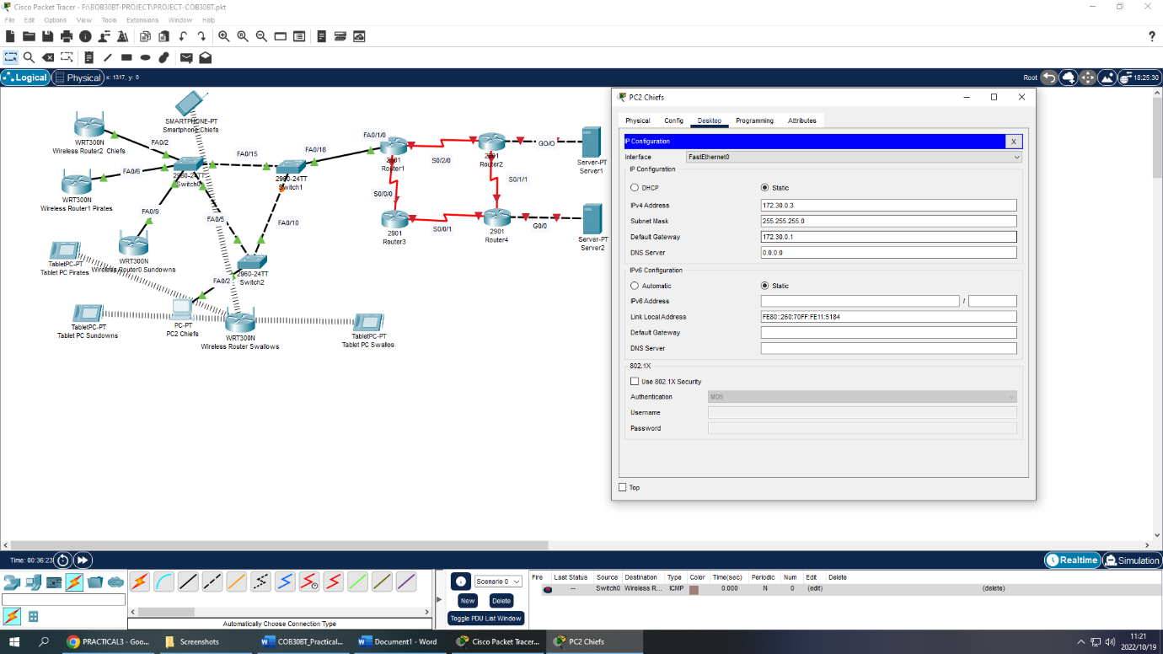

**Server1**

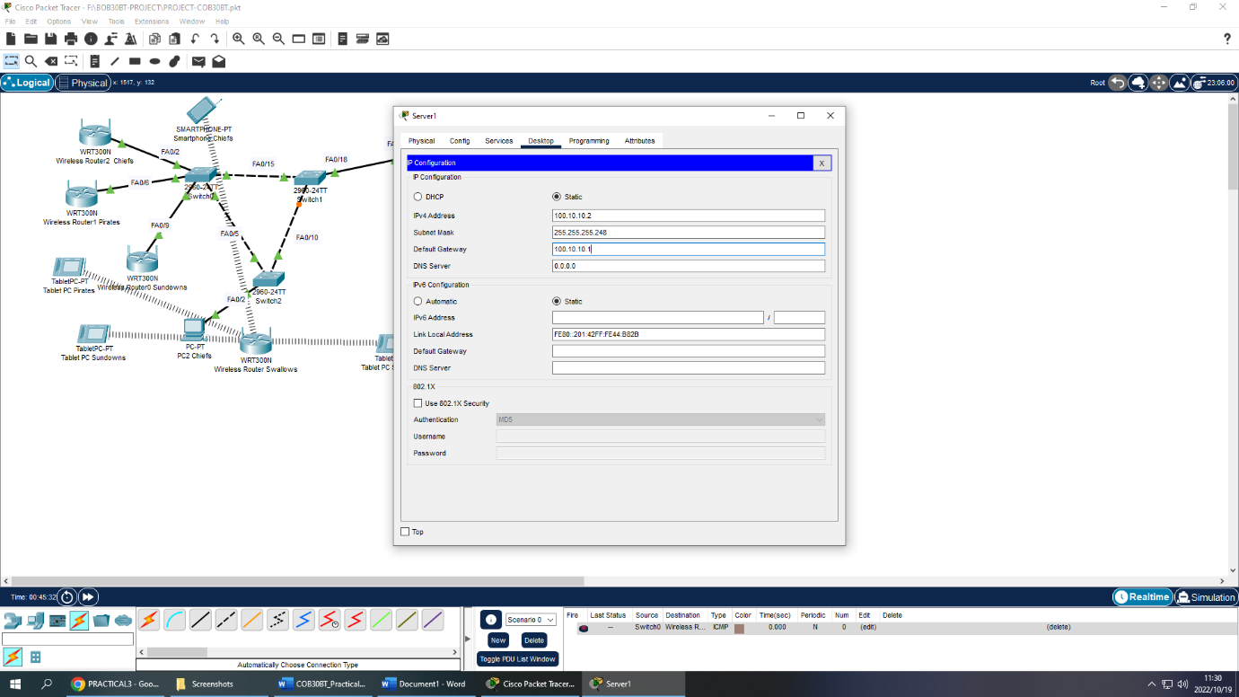

**Server2**

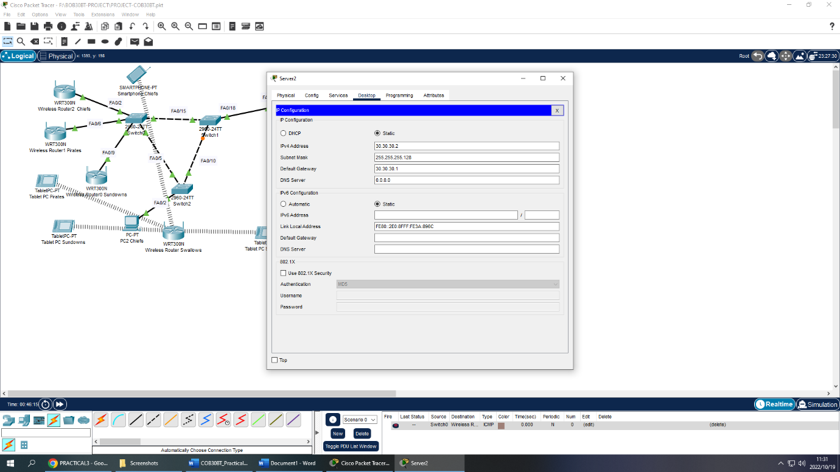

**Smartphone chiefs**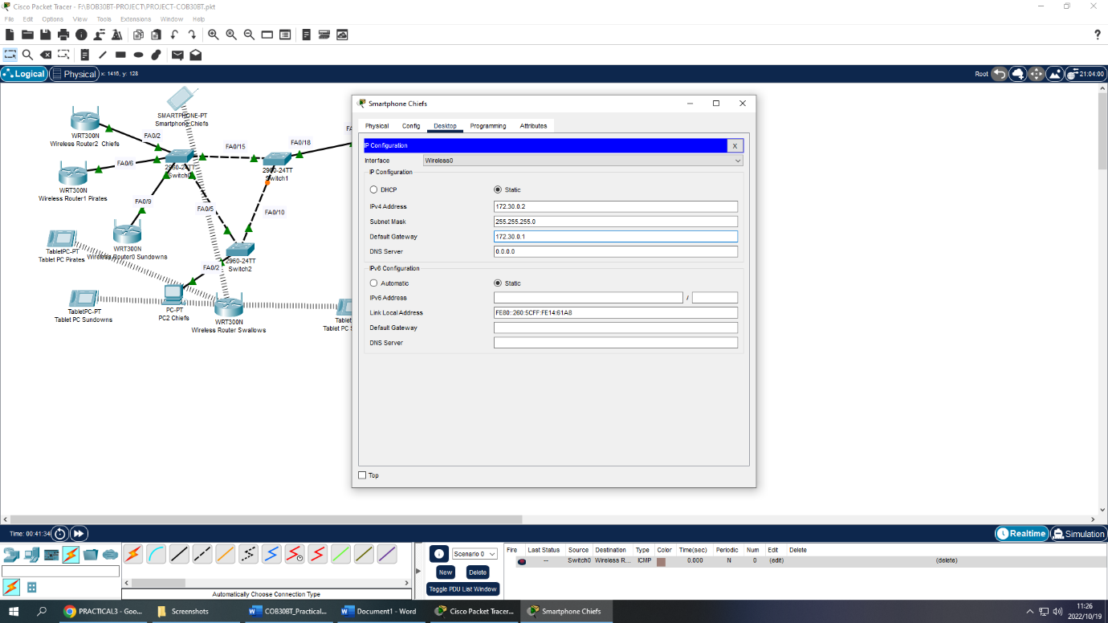

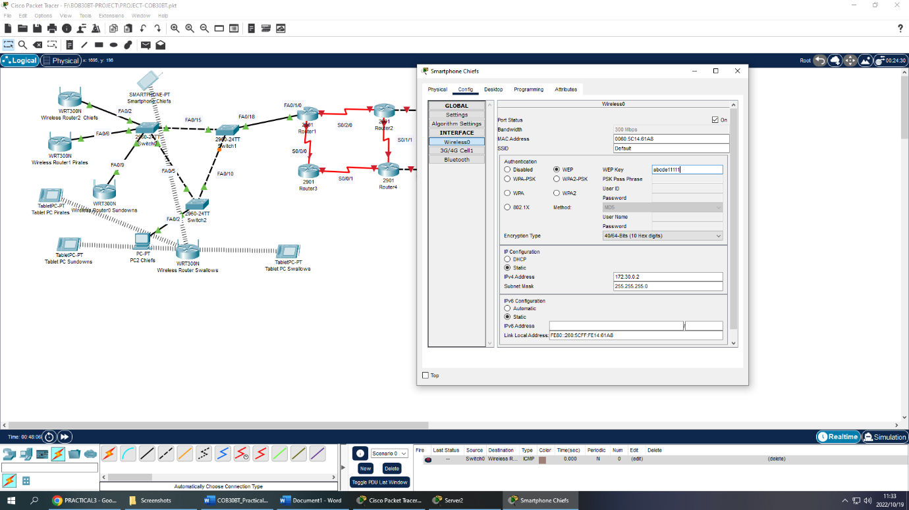

**Wireless router2 chiefs**

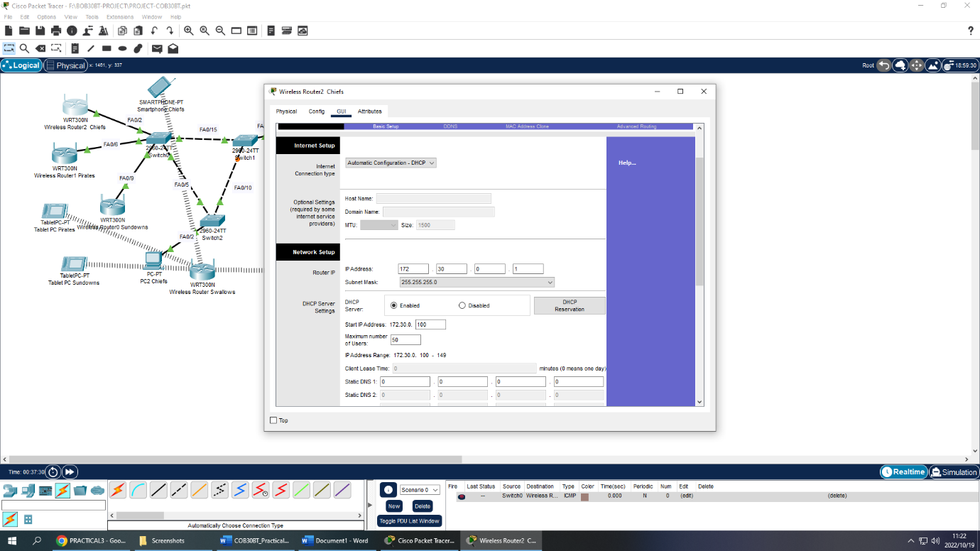

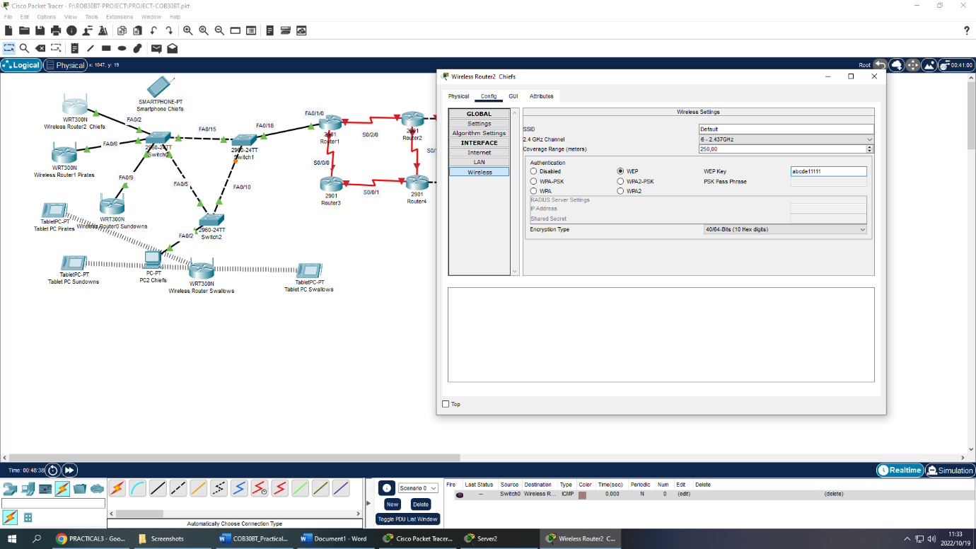

**Tablet pc pirates**

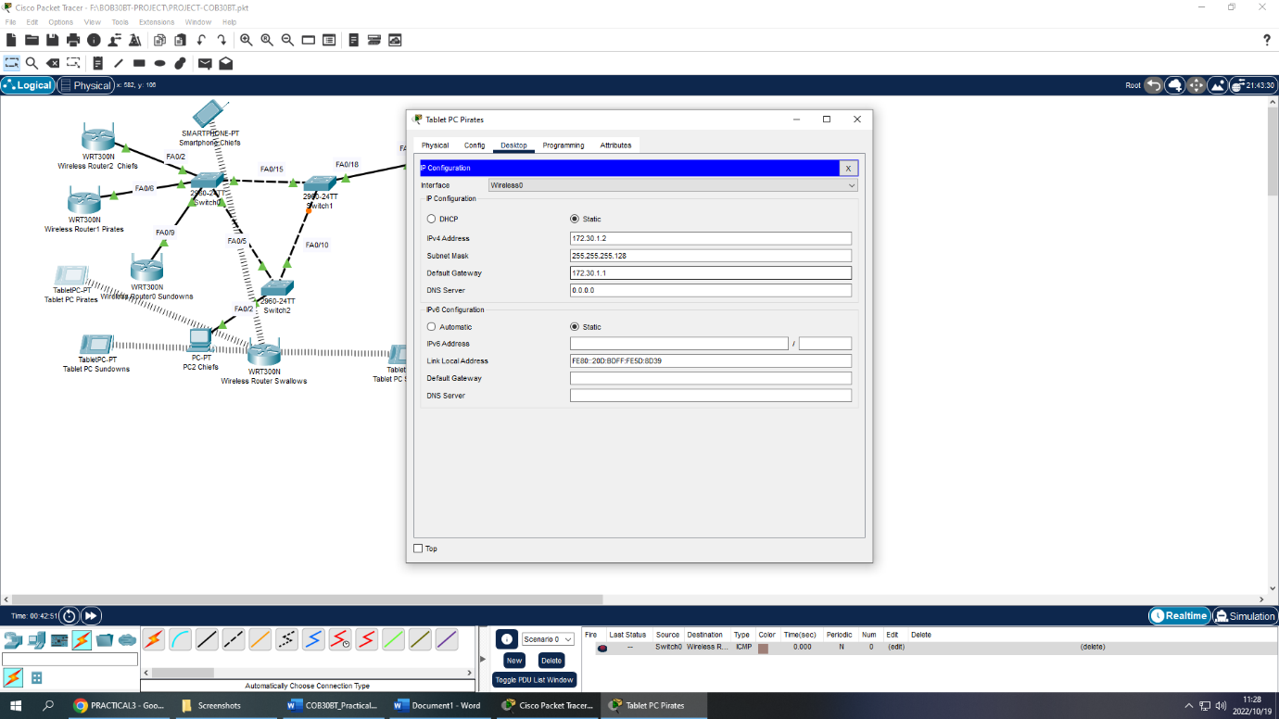

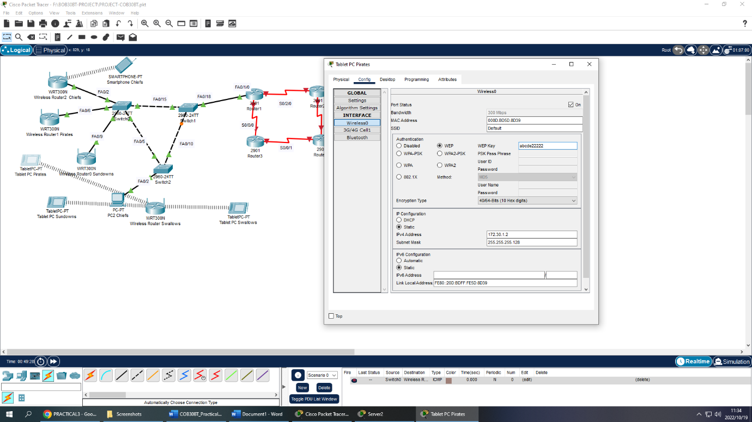

**Wireless router pirates**

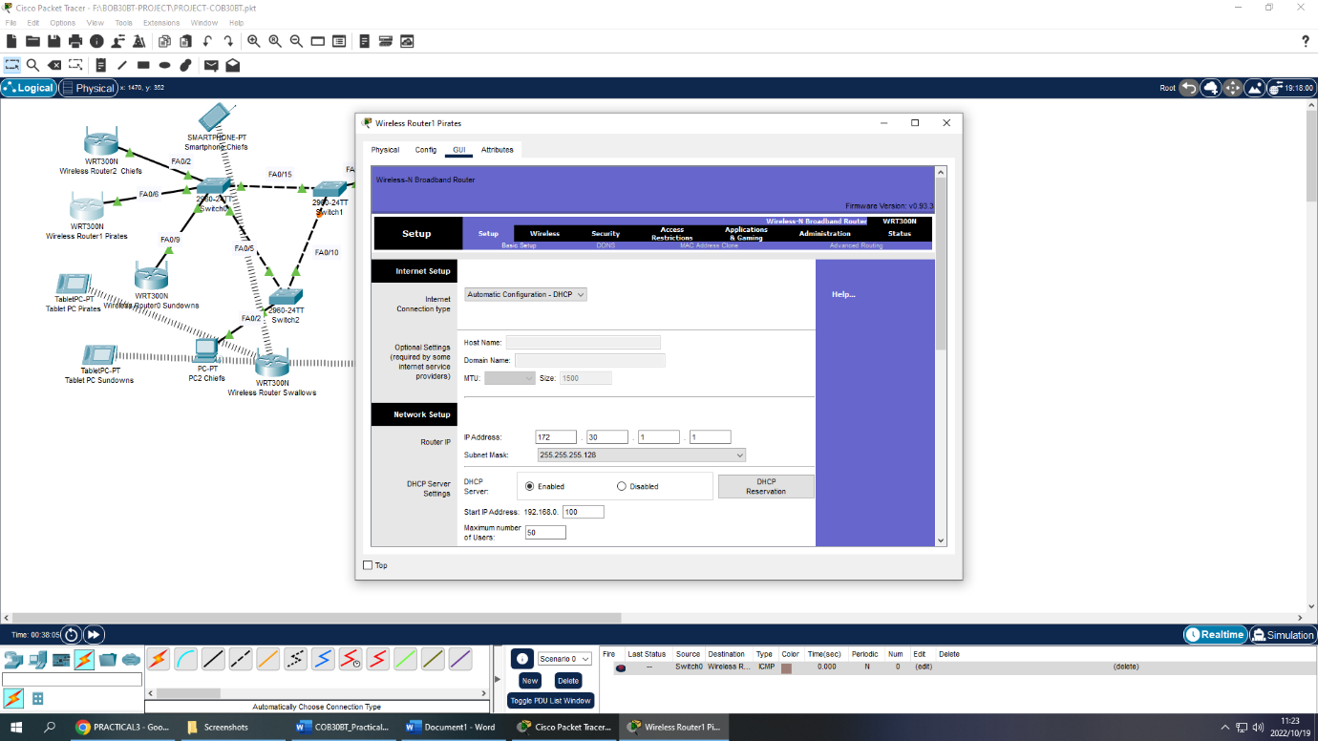

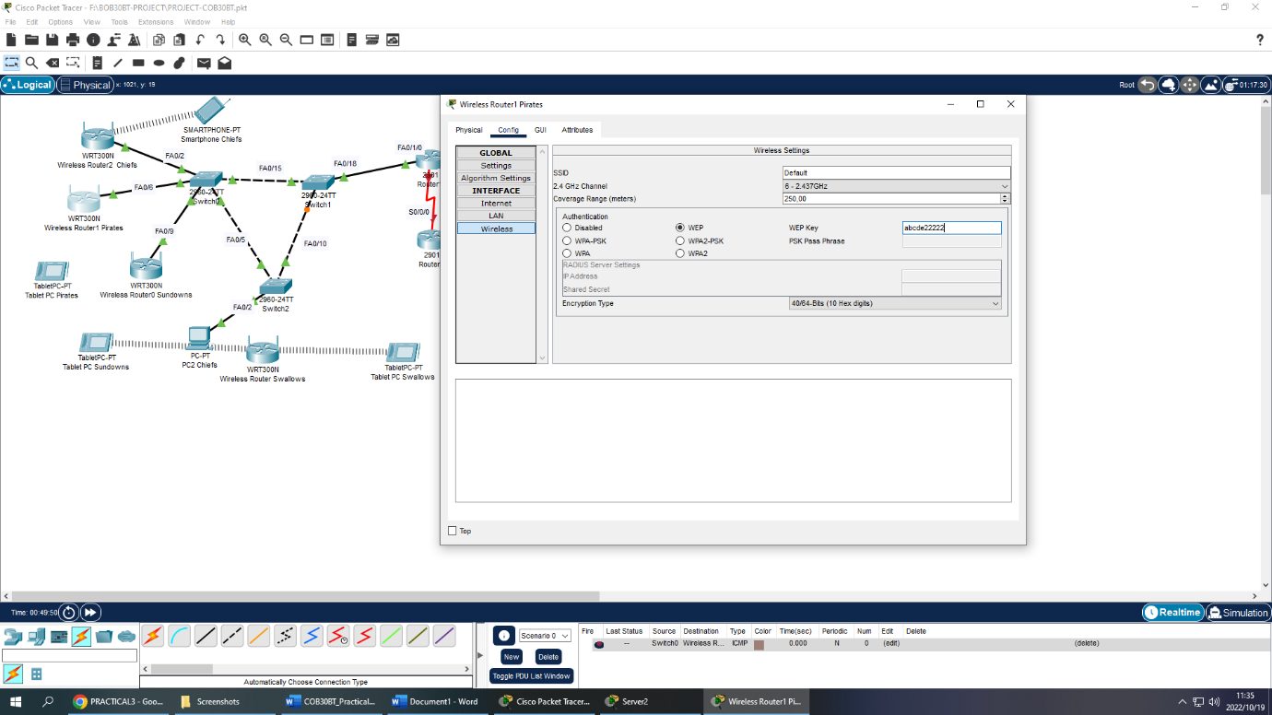

**Tablet pc sundowns**

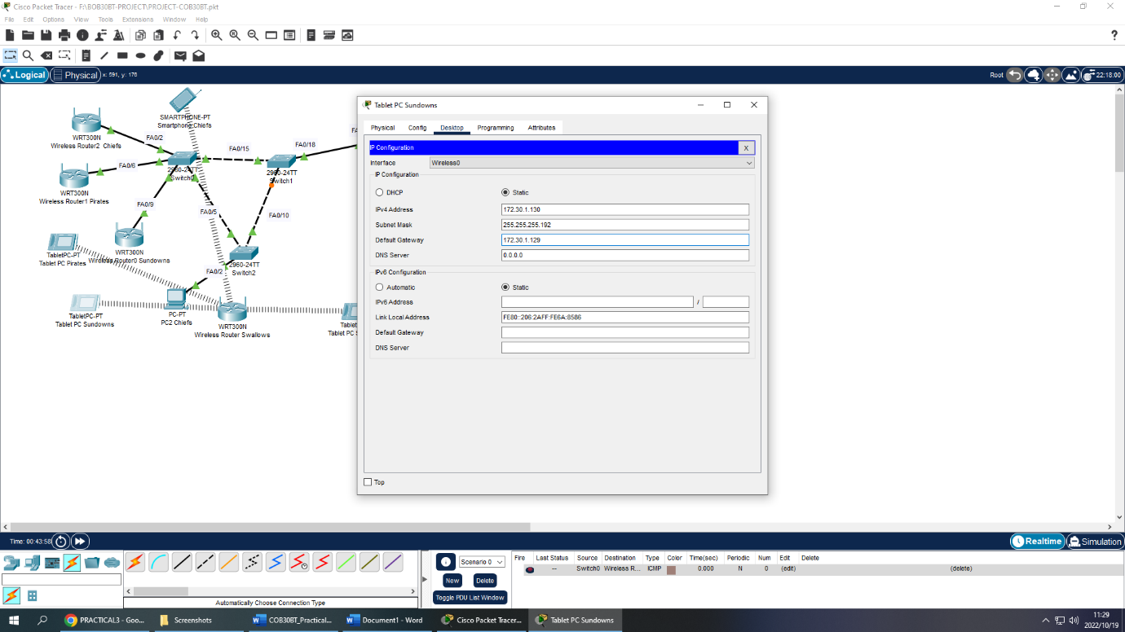

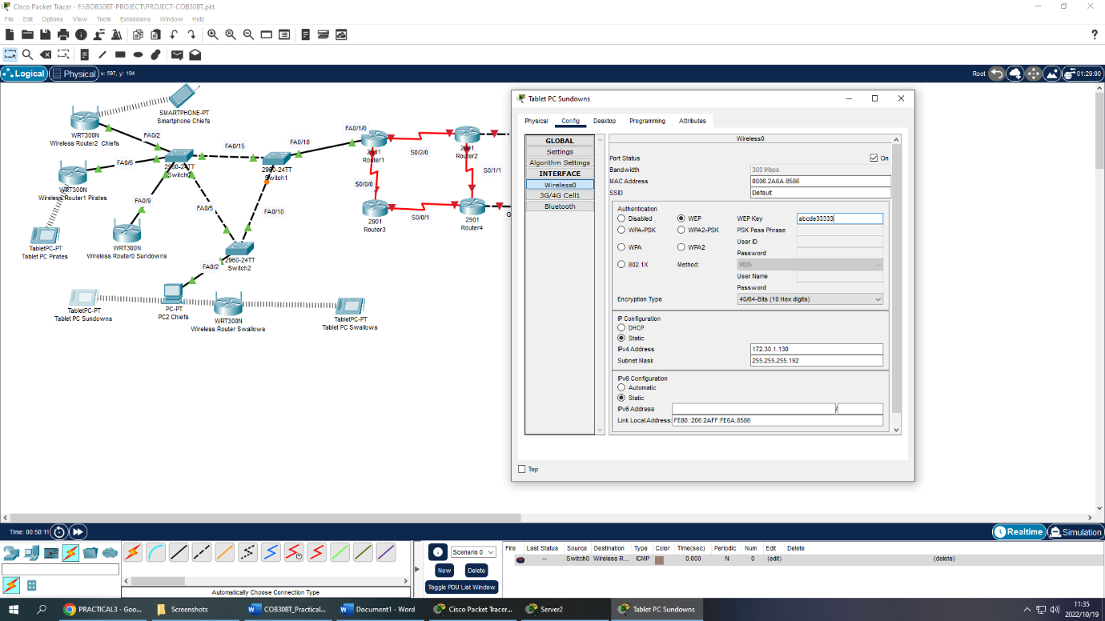

**Wireless router sundows**

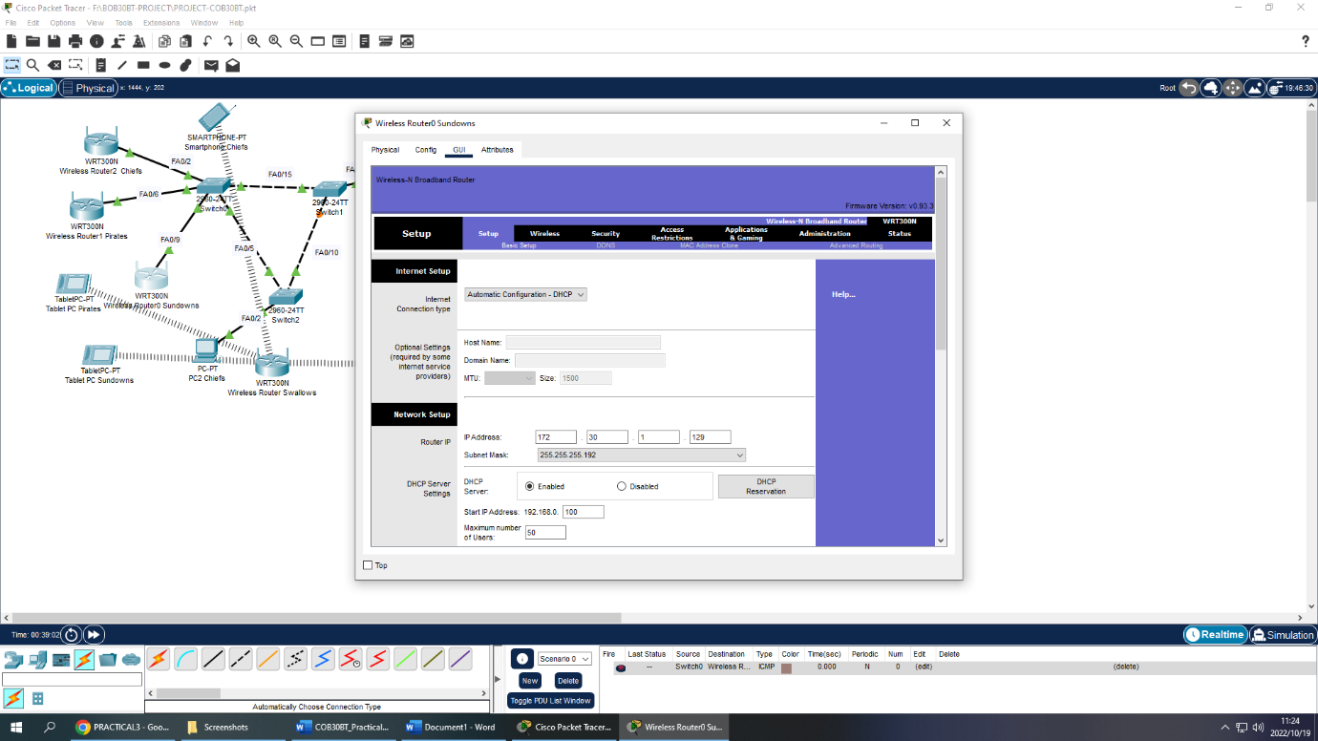

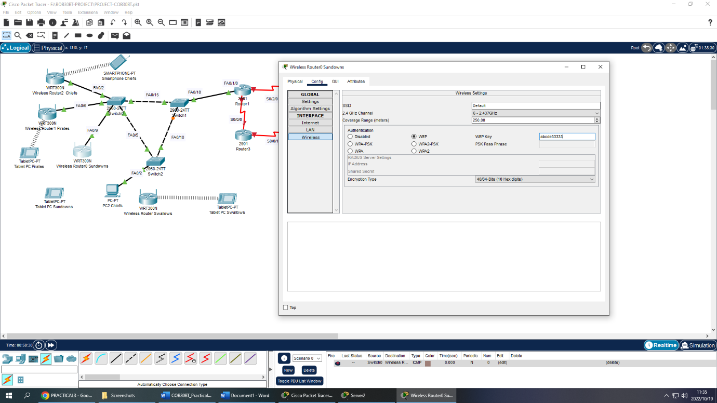

**Tablet pc swallows**

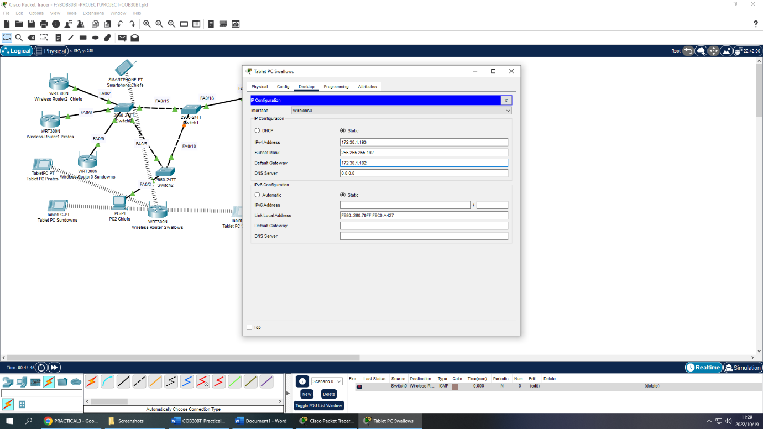

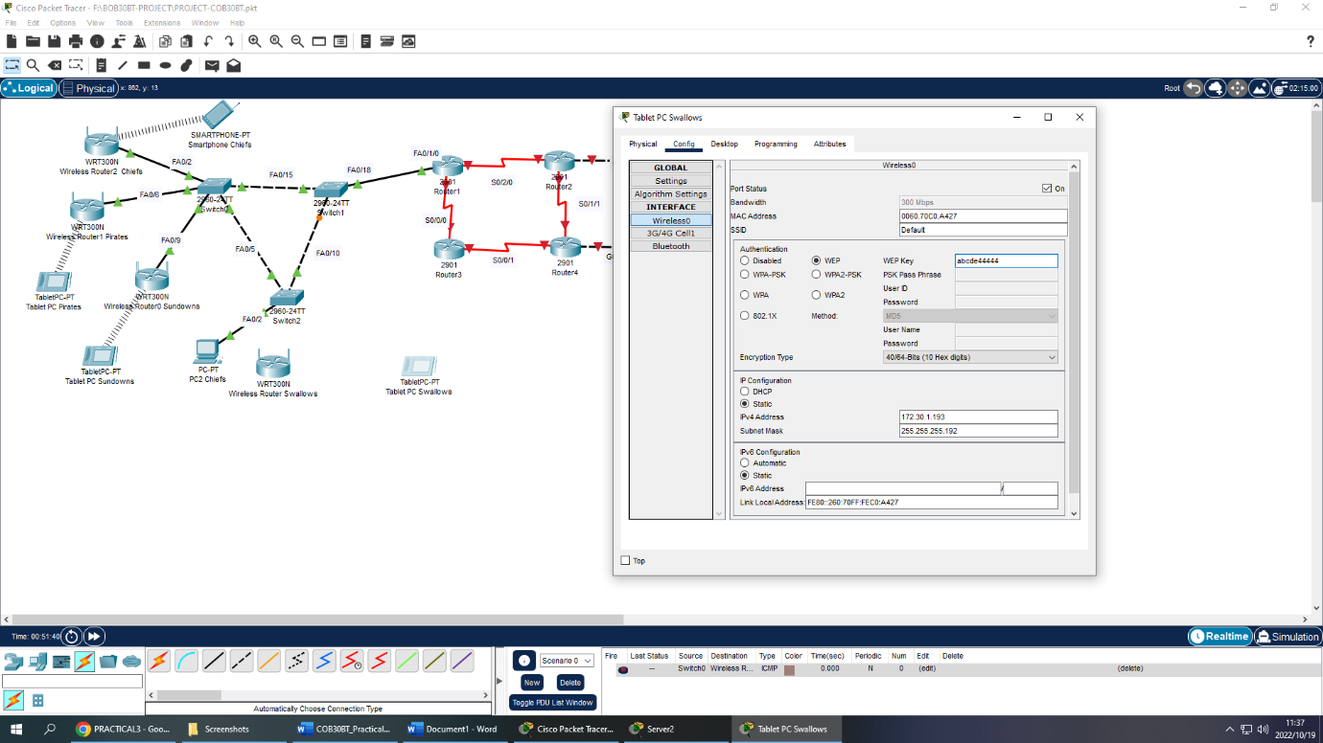

**Wireless router swallows**

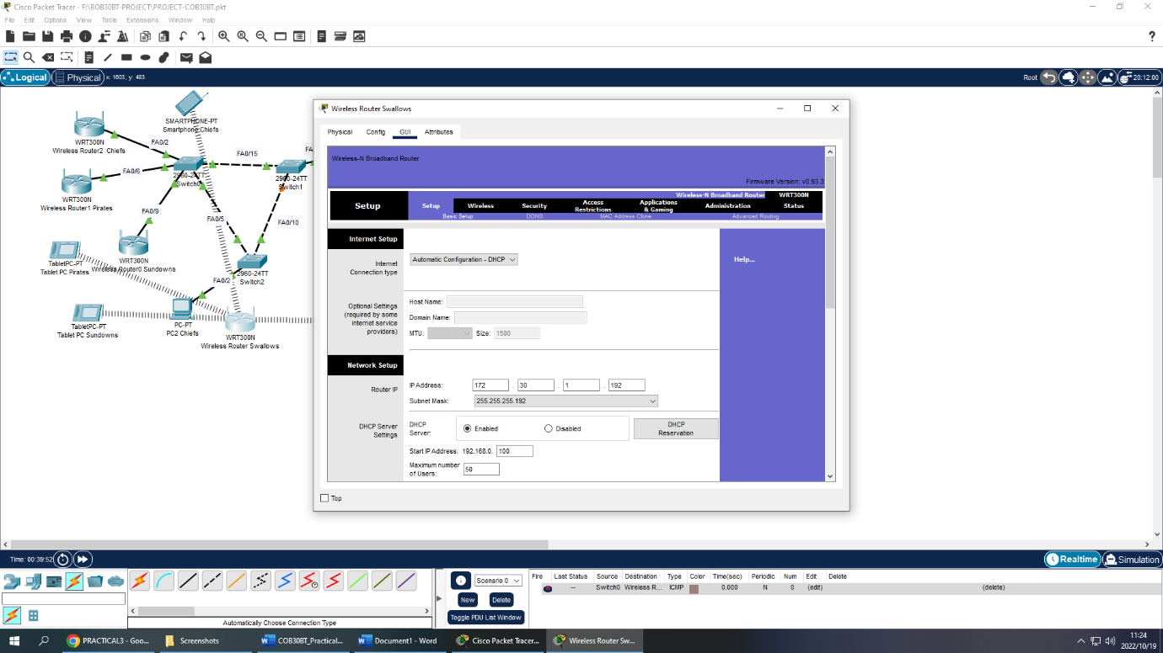

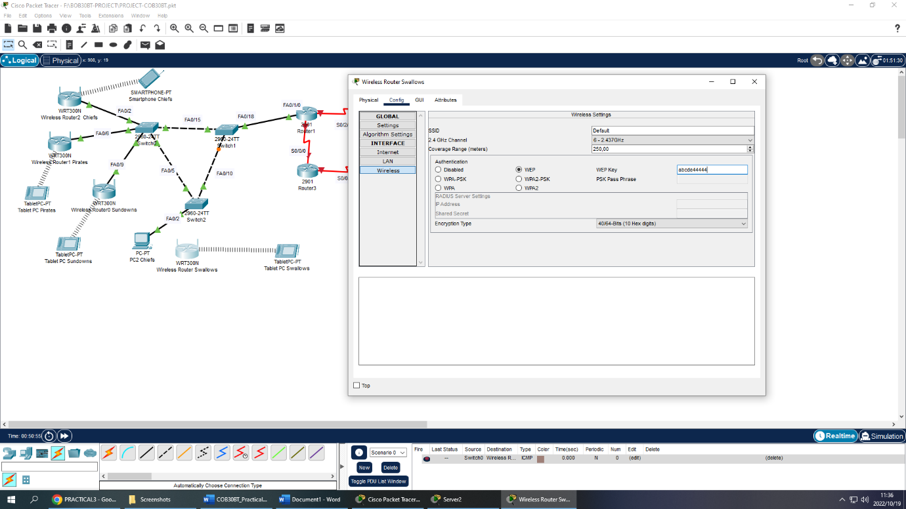

Router 1

Vlan configurations

Router 1

Router#show run

Building configuration...

Current configuration : 2023 bytes

!

version 15.1

no service timestamps log datetime msec

no service timestamps debug datetime msec

no service password-encryption

!

hostname Router

!

!

!

!

!

!

!

!

no ip cef

no ipv6 cef

!

!

!

!

license udi pid CISCO2901/K9 sn FTX1524QQL5-

!

!

!

!

!

!

!

!

!

!

!

spanning-tree mode pvst

!

!

!

!

!

!

interface GigabitEthernet0/0

no ip address

duplex auto

speed auto

!

interface GigabitEthernet0/0.10

encapsulation dot1Q 10

ip address 172.30.0.5 255.255.255.0

!

interface GigabitEthernet0/0.20

encapsulation dot1Q 20

ip address 172.30.1.5 255.255.255.128

!

interface GigabitEthernet0/0.30

encapsulation dot1Q 30

ip address 172.30.1.135 255.255.255.192

!

interface GigabitEthernet0/0.40

encapsulation dot1Q 40

ip address 172.30.1.195 255.255.255.192

!

interface GigabitEthernet0/1

no ip address

duplex auto

speed auto

shutdown

!

interface Serial0/0/0

ip address 172.30.2.1 255.255.255.252

!

interface Serial0/0/1

ip address 172.30.1.1 255.255.255.128

clock rate 2000000

shutdown

!

interface FastEthernet0/1/0

switchport mode access

switchport nonegotiate

!

interface FastEthernet0/1/1

switchport mode access

switchport nonegotiate

!

interface FastEthernet0/1/2

switchport mode access

switchport nonegotiate

!

interface FastEthernet0/1/3

switchport mode access

switchport nonegotiate

!

interface Serial0/2/0

ip address 172.30.2.5 255.255.255.252

clock rate 2000000

!

interface Serial0/2/1

no ip address

clock rate 2000000

shutdown

!

interface Serial0/3/0

no ip address

clock rate 2000000

shutdown

!

interface Serial0/3/1

no ip address

clock rate 2000000

shutdown

!

interface Vlan1

no ip address

shutdown

!

router ospf 1

log-adjacency-changes

network 172.30.0.0 0.0.0.255 area 3

network 172.30.1.0 0.0.0.127 area 3

network 172.30.1.192 0.0.0.63 area 3

network 172.30.1.128 0.0.0.63 area 3

network 172.30.2.0 0.0.0.3 area 3

network 172.30.2.4 0.0.0.3 area 3

!

ip classless

!

ip flow-export version 9

!

!

!

no cdp run

!

!

!

!

!

!

line con 0

!

line aux 0

!

line vty 0 4

login

!

!

!

End

**Router 2**