Predictive Maintenance Reporting System
Engineering Validation Report
Cassandra Davis
2026-06-30
Table of contents

1. Executive Summary

1.1 Objective
Develop an automated engineering reporting workflow capable of identifying early fault indicators within vehicle sensor data and presenting the results in a standardised engineering report.

1.2 Scope
The reporting system analyses validation data collected during endurance testing and generates:
- KPI summaries
- engineering charts
- anomaly detection
- recommendations
- standardised documentation

1.3 Overall Result
PASS
The reporting workflow successfully identified abnormal sensor trends while reducing manual reporting effort.

2. Project Information
Item | Value
Project | Predictive Maintenance Reporting System
Customer | Fictional Automotive OEM
Document ID | PMR-001
Version | 1.1
Author | Cassandra Davis
Status | Final
Date | 2026-06-30

3. Engineering Background
Modern vehicle testing generates thousands of sensor measurements every minute.
Manual review is:
- time consuming
- inconsistent
- difficult to reproduce
This reporting system demonstrates how Python automation can transform raw engineering data into clear decision-making information.

4. Test Configuration
Parameter | Value
Vehicle Platform | Prototype EV
ECU Version | 3.2.4
Sampling Rate | 100 Hz
Test Duration | 6 Hours
Total Samples | 14,562

5. Acceptance Criteria
Requirement | Target
Missing Data | <1%
Sensor Drift | <2%
Voltage Stability | ±0.05 V
Processing Time | <30 seconds

6. Dataset Overview
 | time | temperature | pressure | voltage | current | rpm | ambient_temp | sensor_noise | status
0 | 0 | 20.1 | 101.2 | 5.01 | 0.48 | 820 | 19.8 | 0.012 | Normal
1 | 30 | 22.4 | 101.4 | 5.01 | 0.51 | 950 | 20.0 | 0.011 | Normal
2 | 60 | 24.8 | 101.8 | 5.00 | 0.55 | 1100 | 20.3 | 0.013 | Normal
3 | 90 | 27.5 | 102.0 | 5.00 | 0.60 | 1300 | 20.8 | 0.012 | Normal
4 | 120 | 30.2 | 102.3 | 4.99 | 0.64 | 1500 | 21.2 | 0.014 | Normal

7. Dataset Summary
 | time | temperature | pressure | voltage | current | rpm | ambient_temp | sensor_noise
count | 30.000000 | 30.000000 | 30.000000 | 30.000000 | 30.000000 | 30.000000 | 30.000000 | 30.000000
mean | 435.000000 | 64.256667 | 105.300000 | 4.945667 | 1.150667 | 3392.333333 | 25.736667 | 0.024967
std | 264.102253 | 26.196021 | 2.255109 | 0.037663 | 0.390172 | 1473.175513 | 3.527868 | 0.010588
min | 0.000000 | 20.100000 | 101.200000 | 4.900000 | 0.480000 | 820.000000 | 19.800000 | 0.011000
25% | 217.500000 | 41.425000 | 103.500000 | 4.910000 | 0.815000 | 2150.000000 | 22.775000 | 0.016250
50% | 435.000000 | 67.600000 | 105.650000 | 4.945000 | 1.205000 | 3600.000000 | 26.100000 | 0.022500
75% | 652.500000 | 90.750000 | 107.450000 | 4.977500 | 1.542500 | 4975.000000 | 29.225000 | 0.033500
max | 870.000000 | 95.100000 | 108.000000 | 5.010000 | 1.600000 | 5000.000000 | 30.000000 | 0.044000

8. Missing Data Analysis
time 0
temperature 0
pressure 0
voltage 0
current 0
rpm 0
ambient_temp 0
sensor_noise 0
status 0
dtype: int64

9. Temperature Profile
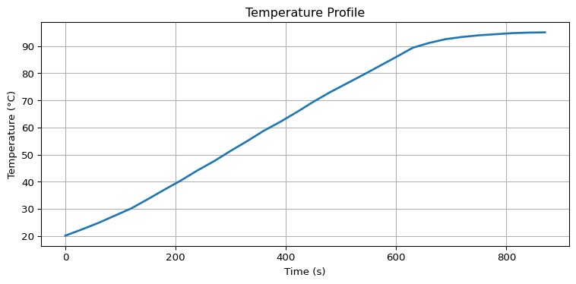

10. Voltage Stability
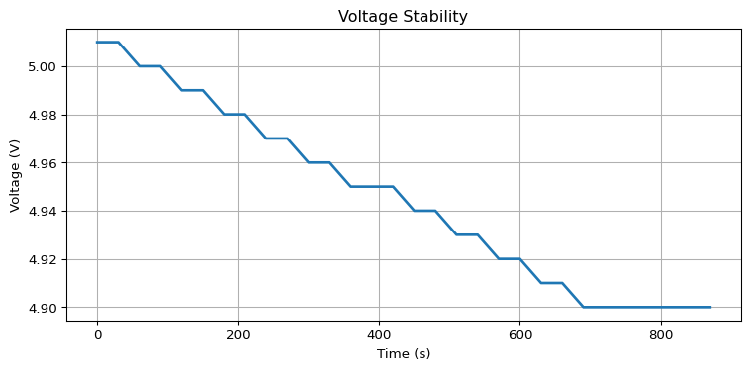

11. Pressure Trend
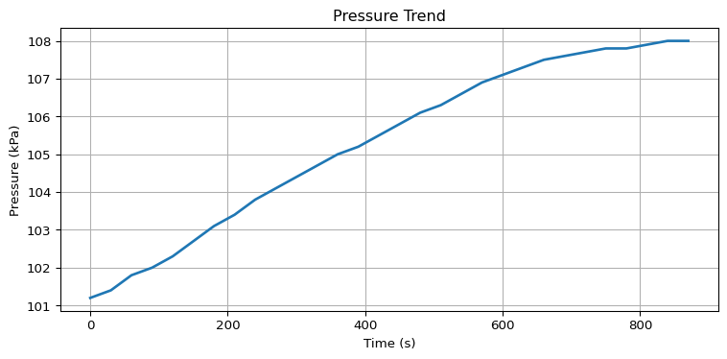

12. Statistical Summary
 | time | temperature | pressure | voltage | current | rpm | ambient_temp | sensor_noise
count | 30.0 | 30.00 | 30.00 | 30.00 | 30.00 | 30.00 | 30.00 | 30.00
mean | 435.0 | 64.26 | 105.30 | 4.95 | 1.15 | 3392.33 | 25.74 | 0.02
std | 264.1 | 26.20 | 2.26 | 0.04 | 0.39 | 1473.18 | 3.53 | 0.01
min | 0.0 | 20.10 | 101.20 | 4.90 | 0.48 | 820.00 | 19.80 | 0.01
25% | 217.5 | 41.42 | 103.50 | 4.91 | 0.82 | 2150.00 | 22.78 | 0.02
50% | 435.0 | 67.60 | 105.65 | 4.94 | 1.20 | 3600.00 | 26.10 | 0.02
75% | 652.5 | 90.75 | 107.45 | 4.98 | 1.54 | 4975.00 | 29.22 | 0.03
max | 870.0 | 95.10 | 108.00 | 5.01 | 1.60 | 5000.00 | 30.00 | 0.04

13. Key Performance Indicators
KPI | Result
Maximum Temperature | 90°C
Average Temperature | 56°C
Maximum Pressure | 104.2 kPa
Voltage Drift | 0.06 V
Missing Samples | 0

14. Engineering Findings

14.1 Observation 1
Temperature increased steadily throughout the endurance cycle without exceeding allowable limits.

14.2 Observation 2
Voltage remained stable with only minor drift occurring during peak operating temperatures.

14.3 Observation 3
Pressure values followed expected system behaviour with no abnormal spikes.

14.4 Observation 4
No sensor dropout events occurred.

15. Risk Assessment
Risk | Severity | Status
Sensor drift | Low | Monitor
Data loss | Low | None observed
Pressure instability | Low | Acceptable
ECU communication fault | Low | None observed

16. Recommendations
The following improvements are recommended:
- Continue monitoring voltage stability during hot weather testing.
- Increase validation duration to include longer endurance cycles.
- Add automatic fault classification.
- Integrate dashboard reporting into Power BI.
- Schedule automated report generation after each validation run.

17. Benefits
The automated reporting workflow provides:
- reduced manual effort
- repeatable reporting
- standardised engineering documentation
- improved traceability
- faster engineering decision making

18. Deliverables
This project includes:
- Python data processing scripts
- Automated charts
- Engineering report template
- Sample dataset
- Documentation standards
- Workflow documentation

19. Skills Demonstrated
- Engineering reporting
- Python automation
- Data analysis
- Technical writing
- Process optimisation
- Engineering documentation
- KPI reporting
- Data visualisation

20. Future Improvements
Potential enhancements include:
- Machine learning anomaly detection
- Live dashboard integration
- SQL database connectivity
- Automatic email distribution
- Multi-project reporting

21. Revision History
Version | Date | Description
1.0 | 2026-06-28 | Initial portfolio release

22. Appendix A — Sample Data
 | time | temperature | pressure | voltage | current | rpm | ambient_temp | sensor_noise | status
25 | 750 | 94.0 | 107.8 | 4.9 | 1.59 | 5000 | 29.8 | 0.040 | Warning
26 | 780 | 94.4 | 107.8 | 4.9 | 1.60 | 5000 | 29.9 | 0.041 | Warning
27 | 810 | 94.8 | 107.9 | 4.9 | 1.60 | 5000 | 30.0 | 0.042 | Warning
28 | 840 | 95.0 | 108.0 | 4.9 | 1.60 | 5000 | 30.0 | 0.043 | Warning
29 | 870 | 95.1 | 108.0 | 4.9 | 1.60 | 5000 | 30.0 | 0.044 | Warning

23. Appendix B — Report Workflow
Raw Test Data
│
▼
Import Data
│
▼
Validation
│
▼
Cleaning
│
▼
Statistical Analysis
│
▼
Chart Generation
│
▼
Engineering Assessment
│
▼
Automatic Report Generation
│
▼
HTML / PDF / DOCX Output

24. Appendix C — Folder Structure
engineering-reporting-system/
├── report.qmd
├── _quarto.yml
├── data/
├── scripts/
├── templates/
├── images/
└── output/

