This is my practice text for practicing using GitHub for version control.

In this version of my GitHub career, I post this document to my GitHub account and things go poorly. Oh no. I am upset and the GitKraken squid (octopus?) attacks me and I am dragged into the depths of the ocean, never to use GitHub again.

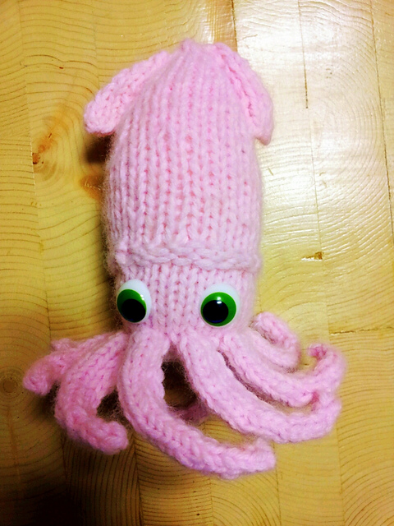

(Source: https://www.ravelry.com/patterns/library/cid-the-squid-knitted-squid-toy-pattern)