CollegeCarpool

My project hopefully falls into the ‘smart cities’ area of things. The aim is to create a web-based carpooling app that can be used across different colleges. This would decrease commuter traffic and environmental and noise pollution in the city. Parking spaces on college ground might also become less of a strain on college resources. Due to the average age of college students, not all are drivers. This can cause certain people problems getting into college. The carpool app may solve some of this issue.

The intended audience for this application is any commuters going to college in Ireland and potentially the world. It will be based off logging in with a valid college e-mail, eg. “@mail.dcu.ie”. I think only allowing college students to use this app increases a level of security I believe as a student is being picked up by any randomer. Also we have the e-mail of who picked them up so we’ll know who was driving if instances arise.

The basic layout of the app is:

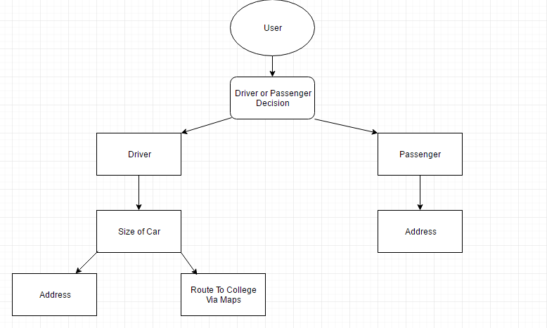

Users will be able to state their address. I will have a forum where people can go to discuss topics and routes/lifts with each other. This will be designed as an upvoted forum where more upvotes means the post will remain on the top of the forum for longer. Along with this I hope to implement both private and group messaging between users. This can allow users to organise lifts privately. The application will support user log in and registration. The application will contain a Google Maps Instance where users can mark locations and calculate routes, eg. A user can enter 4 addresses where they have to pick up students and the route they have to take is shown up.

I hope to implement a large portion of the project through the AngularJS framework. I have been experimenting with the framework and I believe the app can be made through it. I’m currently experimenting with combing the javascript with the Ruby on Rails framework. This has been successful so far and I have a prototype of my planned forum established. I am also following a course on using AngularJS with Firebase, a cloud hosting service maintained by Google which has a lot of support for AngularJS integration. HTML and CSS will also be included. If I have time I hope to possibly deploy an android version of this app or somehow enable the website to send push notifications to a smartphone. AngularJS can be used to design android apps so hopefully this will be possible.