Cassandra Ann Fernandes

H00200702

Web Programming

Coursework 2 – Cassandra Ann Fernandes And Amina Farook.

This coursework was done mostly by myself with added help from Amina. Special mention to my lecturers Ms. Smitha, Ms Hind and Mr. Hamdan for their added help and guidance through this coursework.

|  |  |
| --- | --- |
| Cassandra Ann Fernandes(CMS) | Amina Farook (EUI) |
| Tables and table design | RWD responsive |
| Ajax implementation (Hello Ajax) | Bootstrap website skeleton |
| API And web security principles | Mockup |
| Reformatting of web page |  |
| Report PDF |  |
| Browse, Edit, Insert, delete functions in the website |  |
|  |  |

**Best Practices of Web Programming:**

Good web design is one which contains the best practices within the programming realm. By using what we had been taught in the lectures, the theme of the website screams “fun”, and a more relatable design to the original twitter.com website. The template used in the website had been similar to one found on layitout.com. The website contents had been arranged in such a a way to facilitate easy navigation throughout the website.

The language used in the website is PHP. Through this language, it was possible to make the original layout of the website possible. The use of comments and identation made it easier to understand where to improve on certain areas of the website so it is easily maintainable and extendable.

**AJAX Implementation:**

To implement Ajax on the website, I referred to the notes given in the lectures, and W3C schools for understanding how the AJAX code is written. The notes given in the lectures paved a way for me to learn how to get the task done for the “Hello World” or in the website “Hello Ajax” to be created.   
When the user clicks the button, the loadAjaxText function gets the text from the HelloAjax.txt file and posts the contents “Hello Ajax” in the website without having to refresh the web page.

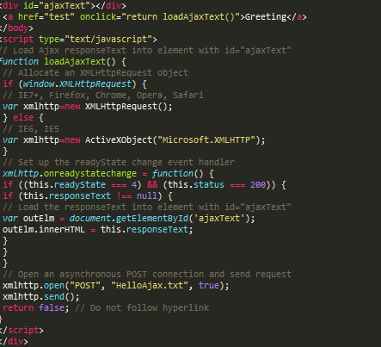

**Web Security:**

With Web security principles that we learnt of in the lectures, I implemented a way to prevent users submitting empty fields by using the ‘required’ code in the text fields where a user enters the details in the ‘insertform.php’ page.



**Web Service and API Aggregation** :

By successfully integrating a twitter API into the website, I was able to get live tweets from every user. The php page littleapp.php has the code that contains the keys for a successful and secure connection. The twitterAPIExchange creates an instance to retrieve the information required from the actual API.

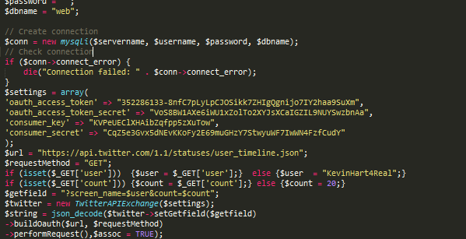

Excerpt from littleapp.php that retrieves tweets from the account Kevin Hart.