Stroop Effect

Claudia Cassidy

11/10/2017

## R Markdown

## Statistics: The Science of Decisions

## Project: The Stroop Effect

#### by Claudia Cassidy

#### Background Information

In a Stroop task, participants are presented with a list of words, with each word displayed in a color of ink. The participant’s task is to say out loud the color of the ink in which the word is printed. The task has two conditions: a congruent words condition, and an incongruent words condition. In the congruent words condition, the words being displayed are color words whose names match the colors in which they are printed: for example RED, BLUE. In the incongruent words condition, the words displayed are color words whose names do not match the colors in which they are printed: for example PURPLE, ORANGE. In each case, we measure the time it takes to name the ink colors in equally-sized lists. Each participant will go through and record a time from each condition.

#### Questions for Investigation

### 1. What is our independent variable? What is our dependent variable?

The independent variable is the ink color of each word and whether or not it is the same color as the word itself. The dependent variable is the time it takes for a person to say the color of all the words.

### 2. What is an appropriate set of hypotheses for this task? What kind of statistical test do you expect to perform? Justify your choices.

##### Null Hypothesis

An appropriate hypothesis for this task is that the ink color of the words will not affect the time it takes for a person to read through the list of words. This would be the null hypothesis.

$$H_{0}=μCongruent−μIncongruent=0$$

##### Alternate Hypothesis

An appropriate alternative hypothesis for this task is that the ink color of the words will significantly affect the time it takes for a person to read through the list of words.

$$H_{A}=μCongruent != μIncongruent$$

##### Statistical Tests

Given that the sample size of the dataset contains only 24 rows for each of the Congruent and Incongruent tests taken, it would be appropriate to do a two-tailed t-test. We do not have data about the population as a whole and our sample size is small. We will assume that for each of the 24 rows, each row represents one person who first read the Congruent words and then read the Incongruent words.

The dataset we are given contains two columns of data: Congruent and Incongruent, each containing time in seconds.

## [1] TRUE

### 3. Report some descriptive statistics regarding this dataset. Include at least one measure of central tendency and at least one measure of variability.

Here is an initial summary of the sample data:

## Congruent Incongruent   
## Min. : 8.63 Min. :15.69   
## 1st Qu.:11.90 1st Qu.:18.72   
## Median :14.36 Median :21.02   
## Mean :14.05 Mean :22.02   
## 3rd Qu.:16.20 3rd Qu.:24.05   
## Max. :22.33 Max. :35.26

The mean time it took to read the Congruent words was 14.05 seconds. The times ranged from 8.63 to 22.33 seconds. The mean time for the Incongruent words was 22.02 seconds with a range of 15.69 to 35.26 seconds.

Since we are measuring the difference in time, another column, Score, is added to show that difference. Here's a summary after adding a column for the difference (Congruent - Incongruent).

## Congruent Incongruent Score   
## Min. : 8.63 Min. :15.69 Min. :-21.919   
## 1st Qu.:11.90 1st Qu.:18.72 1st Qu.:-10.258   
## Median :14.36 Median :21.02 Median : -7.667   
## Mean :14.05 Mean :22.02 Mean : -7.965   
## 3rd Qu.:16.20 3rd Qu.:24.05 3rd Qu.: -3.646   
## Max. :22.33 Max. :35.26 Max. : -1.950

##### Range of the data (Highest - Lowest):

The difference in time it took each subject to read the Incongruent vs. the Congruent list ranged from 1.95 to 21.92 seconds. The mean of the time difference is 7.97 seconds and the median time is 7.67 seconds.

## Congruent_sd Incongruent_sd Score_sd Congruent_var Incongruent_var  
## 1 3.559358 4.797057 4.864827 12.66903 23.01176  
## Score_var  
## 1 23.66654

##### Standard Deviation:

The standard deviation of the Congruent results is: 3.5594, variance is 12.7 The standard deviation of the Incongruent results is: 4.7971, variance is 23 The standard deviation of the Difference is: 4.8648, variance is 23.7

### 4. Provide one or two visualizations that show the distribution of the sample data. Write one or two sentences noting what you observe about the plot or plots.

In order to get more meaningful plots, the next step was to combine the Congruent, Incongruent and Score columns into one by appending the Incongruent and Score data below the Congruent, for a total of 72 rows. Finally, a column was added to represent each person who took the test by using the row numbers into a subjectId column.

A summary of the data:

## # A tibble: 3 x 5  
## congruency time_mean time_median time_sd time_var  
## <chr> <dbl> <dbl> <dbl> <dbl>  
## 1 Congruent 14.051125 14.3565 3.559358 12.66903  
## 2 Incongruent 22.015917 21.0175 4.797057 23.01176  
## 3 Score -7.964792 -7.6665 4.864827 23.66654

Since we are measuring the difference, I separated the Score into one dataset and the Congruent/Incongruent data into another.

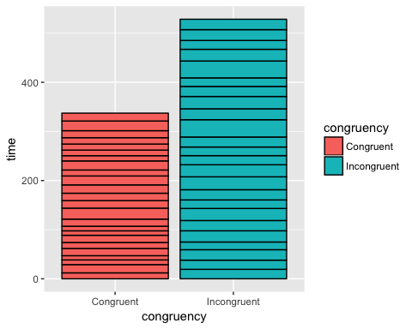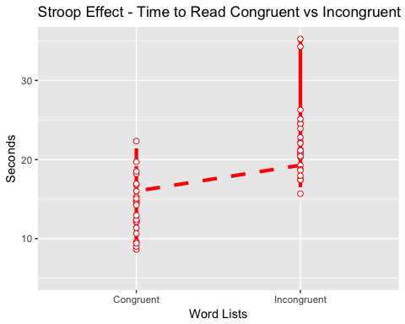

The chart above illustrates that reading the incongruent word list took longer than reading the congruent word list.

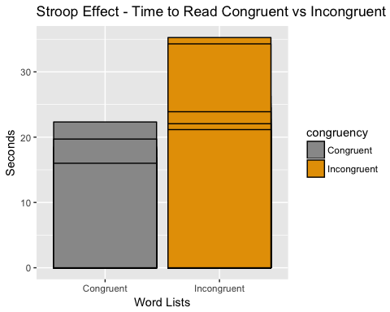

The bar chart above and the charts below also illustrate the difference between reading Congruent vs. Incongruent word lists. It took longer to read the Incongruent list.

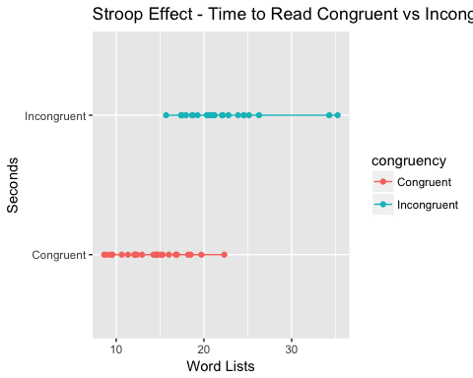

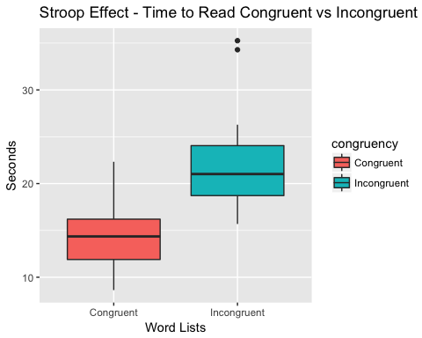

### 5. Statistical Test and Results

Now, perform the statistical test and report your results. What is your confidence level and your critical statistic value? Do you reject the null hypothesis or fail to reject it? Come to a conclusion in terms of the experiment task. Did the results match up with your expectations?

## [1] -8.020707

The T-statistic is -8.020707

## [1] 4.103001e-08

p-value

## [1] -10.019028 -5.910555

##   
## Paired t-test  
##   
## data: df$Congruent and df$Incongruent  
## t = -8.0207, df = 23, p-value = 4.103e-08  
## alternative hypothesis: true difference in means is not equal to 0  
## 95 percent confidence interval:  
## -10.019028 -5.910555  
## sample estimates:  
## mean of the differences   
## -7.964792

Since the p-value is less than 0.05, we reject the null hypothesis. The difference between the Congruent and Incongruent times is statistically significant. The Stroop Effect does impact the time it takes to read the word list.

The t-statistic of the difference data group is -8.0207, which is bigger than the t critical value -2.0687.

The Confidence Interval is between -10.091 and -5.911 seconds. With 95% confidence we can say that it would take between 5.911 and 10.091 more seconds on average to read the incongruent list than to read the congruent list.

### 6. Optional: What do you think is responsible for the effects observed?

Can you think of an alternative or similar task that would result in a similar effect? Some research about the problem will be helpful for thinking about these two questions!

According to Wikipedia: The Stroop Effect caused interference in the normal process of reading. "Such interference were explained by the automation of reading, where the mind automatically determines the semantic meaning of the word (it reads the word "red" and thinks of the color "red"), and then must intentionally check itself and identify instead the color of the word (the ink is a color other than red), a process that is not automated."

There are different parts of the brain which are involved in reading the words. This study can be applied to research in how the brain processes information such as colors vs. text, processing speed, and executive functions.

The Stroop test requires subjects to do something which is opposite from what we normally do in automatic visual processing.

Variations of the Stroop test are: 1 - Emotional: From Wikipedia: "In an emotional Stroop task, an individual is given negative emotional words like "grief," "violence," and "pain" mixed in with more neutral words like "clock," "door," and "shoe". Tthe words are colored and the individual is supposed to name the color. Research has revealed that individuals that are depressed are more likely to say the color of a negative word slower than the color of a neutral word. While both the emotional Stroop and the classic Stroop involve the need to suppress irrelevant or distracting information, there are differences between the two. The emotional Stroop effect emphasizes the conflict between the emotional relevance to the individual and the word; whereas, the classic Stroop effect examines the conflict between the incongruent color and word."

2 - Spatial: The spatial Stroop effect demonstrates interference between the stimulus location with the location information in the stimuli.[38] In one version of the spatial Stroop task, an up or down-pointing arrow appears randomly above or below a central point. Despite being asked to discriminate the direction of the arrow while ignoring its location, individuals typically make faster and more accurate responses to congruent stimuli (i.e., an down-pointing arrow located below the fixation sign) than to incongruent ones (i.e., a up-pointing arrow located below the fixation sign). A similar effect, the Simon effect, uses non-spatial stimuli.

### References

Wikipedia: Stroop effect <https://en.wikipedia.org/wiki/Stroop_effect>

PsyToolkit.org: Stroop effect <http://www.psytoolkit.org/lessons/stroop.html>