Course 1 end-of-course portfolio project overview: Automatidata
Learn about the Course 1 Automatidata workplace scenario!
The end-of-course project in Course 1 focuses on your ability to plan for data projects and create a project proposal. The end-of-course projects were designed with you in mind, offering an opportunity for you to practice and apply your data analytic skills. The materials provided here will guide you through discussions with co-workers, internal team members, and external stakeholders.
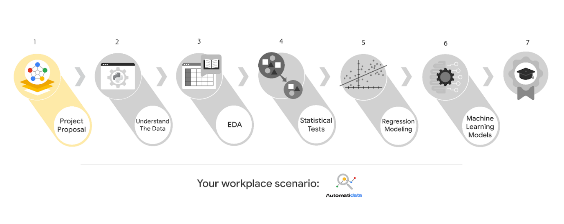
Learn more about the project, your role, and expectations in this reading.
Background on the Automatidata scenario
Congrats on your new job as a data analyst at a data consulting firm called Automatidata. Automatidata works with its clients to transform their unused and stored data into useful solutions, such as performance dashboards, customer-facing tools, strategic business insights, and more. They specialize in identifying a client’s business needs and utilizing their data to meet those business needs.
Automatidata is consulting for the New York City Taxi and Limousine Commission (TLC). New York City TLC is an agency responsible for licensing and regulating New York City's taxi cabs and for-hire vehicles. The agency has partnered with Automatidata to develop a regression model that helps estimate taxi fares before the ride, based on data that TLC has gathered.
The TLC data comes from over 200,000 taxi and limousine licensees, making approximately one million combined trips per day.
Note: This project's dataset was created for pedagogical purposes and may not be indicative of New York City taxi cab riders' behavior.
Project background
Automatidata is in the earliest stages of the TLC project. The following tasks are needed before the team can begin the data analysis process:
- A project proposal identifying the following:
  - Organize project tasks into milestones
  - Classify tasks using the PACE workflow
  - Identify relevant stakeholders
Your assignment
For your first assignment, Automatidata will need a project proposal that will create milestones for the tasks within the TLC project. Remember to take into account your audience, team, project goal, and PACE stages of each task in planning your project deliverable.
Team members at Automatidata and the New York City TLC
Automatidata Team Members
- Udo Bankole, Director of Data Analysis
- Deshawn Washington, Data Analysis Manager
- Luana Rodriquez, Senior Data Analyst
- Uli King, Senior Project Manager
Your teammates at Automatidata have technical experience with data analysis and data science. However, you should always be sure to keep summaries and messages to these team members concise and to the point.
New York City TLC Team Members
- Juliana Soto, Finance and Administration Department Head
- Titus Nelson, Operations Manager
Note: The story, all names, characters, and incidents portrayed in this project are fictitious. No identification with actual persons (living or deceased) is intended or should be inferred. The data shared in this project has been altered for pedagogical purposes.
The TLC team members are program managers who oversee operations at the organization. Their roles are not highly technical, so be sure to adjust your language and explanation accordingly.
Meeting notes
Now that you are working as Automatidata’s latest data analytics professional, you are given access to the company network and set up with a company email account (your first initial and last name, followed by @automatidata.org).
Opening your inbox, you notice an email from your supervisor, Deshawn.
From: Deshawn Washington
Subject: Review meeting notes
If you are able to read this, then your company accounts have been created! Now is the perfect time to get started. Last week, I attended an internal meeting with our leadership team about a new project we are about to begin. You’ll receive more information in the next few days, but I would like you to be aware of some needs that were identified by our leadership team. Here is an excerpt from the notes I took during the Automatidata leadership team meeting. I’ve organized the points by the person who made them.
Uli King (Senior Project Manager)
- The data team will need a global-level project document to outline the goals and milestones.
- I am working closely with Titus Nelson over at the New York City Taxi and Limo Commission. He has requested some visuals to share with TLC’s executives.
Luana Rodriquez (Senior Data Analyst)
- The dataset from TLC has to be inspected before any analysis can begin.
- Our team needs to determine what information the TLC data provides through exploratory data analysis (EDA).
- Eventually, our team will need to test to find if the model is delivering consistent results.
Udo Bankole (Director of Data Analysis)
- Before we present any insights to TLC, we'll need to determine whether or not the model we produce meets the project requirements.
- Once we have a final model, I'll need to know the main talking points going into our presentation with TLC.
My thoughts and concerns…
- I think it's best to use Python for the TLC project. I'll have someone on my team set that up as soon as we have the plan in place.
- It will be important to establish the relationship between any variables within the TLC data. I'd suggest the data team consider A/B testing, since that will analyze the relationship between the two most useful variables and subsequently provide data-driven support for future business decisions.
Review the meeting notes above to become familiar with the project’s context. I’ll ask you to identify project tasks and come up with a structure to guide the data team through this project. After our discussion about your experience in the certificate program offered by Google, I know that your efficient communication style and problem-solving will enhance the abilities of the data team.
There will be more details sent to you very soon.
Welcome to the team,
Deshawn Washington
Data Analysis Manager
Automatidata
(P.S. There will be muffins in the break room every Tuesday morning. Be early…unless you like bran muffins. LOL)
Specific project deliverables
With this end-of-course project, you will gain valuable practice and apply your new skills as you complete the following:
- Course 1 PACE Strategy Document to plan your project while considering your audience members, teammates, key milestones, and overall project goal.
- Create a project proposal for the data team.
Key takeaways
The Google Advanced Data Analytics Certificate end-of-course project is designed for you to practice and apply course skills in a fictional workplace scenario. By completing each course’s end-of-course project, you will have work examples that will enhance your portfolio and showcase your skills for future employers.

Activity Overview
In this activity, you will demonstrate your understanding of an effective data science workflow by completing a project proposal, intended to communicate information about project tasks and milestones with your team. You have previously learned about a tool that can help you complete project planning and development—the PACE strategy document. You will use the PACE strategy document to guide you through the process of creating a project proposal.
For additional information on how to complete this activity, review the previous readings: End-of-course portfolio project introduction and Course 1 end-of-course project overview: Automatidata.
Be sure to complete this activity before moving on. The next course item will provide you with completed exemplars to compare to your own work. You will not be able to access the exemplars until you have completed this activity.
Scenario
The data consulting firm Automatidata hired you as the newest member of their data analytics team. In a previous email, your new supervisor shared some bullet points from the last Automatidata leadership team meeting. You have just received an additional email from your manager asking you to complete a project proposal for the New York City Taxi and Limousine Commission project. Review the email, then follow the provided instructions to complete the PACE strategy document and the project proposal.
Note: Team member names used in this workplace scenario are fictional and are not representative of the New York City TLC.
______________________________________________
Email from Deshawn Washington, Data Analysis Manager
Subject: Welcome to Automatidata!
From: “Deshawn Washington,” Deshawn@automatidata.com
I hope you are adjusting well in your new position.
We are so happy to have you. We have been growing quickly, and we really could use your expertise.
For your first task on the team, you’ll be diving right into our current contract with the New York City Taxi and Limousine Commission (TLC). The TLC has been collecting New York City- based data on taxi and rideshare trips for several years now. They've contracted our team to build a regression model that predicts taxi cab fares before each ride based on distance, time of day, and any additional variables we find necessary.
For your first task, please draft a plan of action for the team. Include questions we need to answer before we get started on the project, important details to consider at the beginning of the project, and action items we'll need throughout the duration of the project.
I understand you’ve completed the Google Advanced Data Analytics Certificate and learned the skills for planning, analyzing, constructing, and executing strategies for data science. Jesse did one of the Google Career Certificates, too, and some of these skills have been really useful here at Automatidata. Maybe you could use some things you learned in that program to help you get started?
I really appreciate this, and again, welcome to the team!
Deshawn Washington
Data Analysis Manager
Automatidata
Step-By-Step Instructions

Follow the instructions to complete the activity. Then, go to the next course item to compare your work to a completed exemplar.
Step 1: Access the templates
To use the templates for this course item, click each of the following links and select Use Template.
Links to templates:
- Course 1 PACE strategy document
- Automatidata project proposal
OR
If you don’t have a Google account, you can download the templates directly from the following attachments.

Activity Template_ Course 1 PACE strategy document (1)
DOCX File

Activity Template_ Project Proposal
DOCX File

Step 2: Review the first page of the PACE strategy document
The Course 1 PACE strategy document will guide you in determining the tasks necessary to complete the project proposal. As you approach each section, keep the PACE framework in mind. Consider how and when a data professional would plan, analyze, construct, and execute each task. Begin by reading through the instructions and information on page 1 of the PACE strategy document.
Step 3: Complete the Data Project Questions & Considerations
In the Data Project Questions & Considerations section of the PACE strategy document, you are presented with questions designed to help you unlock a deeper understanding of data analytics. Complete the questions in this section.
Step 4: Complete the PACE workflow
In the PACE workflow section beginning on page 3 of the PACE strategy document, you are presented with a list of tasks identified by the team as necessary for the Automatidata project. Classify these tasks into the appropriate PACE stages and explain each classification.
Step 5: Complete the project proposal
As part of your work on the PACE strategy document, you identified PACE stages for tasks that need to be completed in the project. This information will help you assign tasks to milestones in the Automatidata project proposal. Complete the project proposal by:
- Entering a project title
- Adding an overview of the project
- Identifying the order of tasks
- Associating each task with the relevant milestone
- Determining the PACE stage(s) for each task*
- [Optional task] Assigning each task to the most relevant stakeholder

*Note that some tasks may be associated with more than one PACE stage. To connect more than one stage with a task, copy and paste the Select PACE stage dropdown menu and select an additional stage.
Pro Tip: Save the templates
Finally, be sure to save a blank copy of the templates you used to complete this activity. You can use them for further practice or in your professional projects. These templates will help you work through your thought processes and demonstrate your experience to potential employers.
What to Include in Your Response
Later, you will have the opportunity to assess your performance using the following criteria. Be sure to address the following elements in your completed activity.
Course 1 PACE strategy document:
- Answer the questions in the PACE strategy document
- Identify the proper stages of PACE for each task
Automatidata project proposal:
- Assign each task to the appropriate milestone
- [Optional task] Align the project tasks with the appropriate stakeholder(s)

