Course 1 end-of-course portfolio project overview: TikTok
Learn about the Course 1 TikTok workplace scenario!
This end-of-course project was designed with you in mind, creating an opportunity for you to practice and apply your data analytic skills. The materials provided here will guide you through discussions with co-workers, internal team members, and external stakeholders.
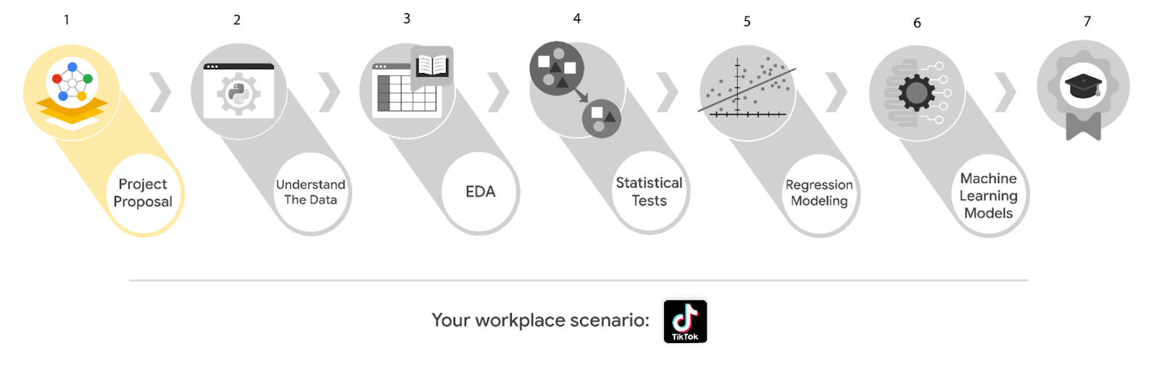
Learn more about the project, your role, and expectations in this reading.
Background on the TikTok scenario
Welcome to your new role at TikTok! We’re thrilled to have you on the data team!
At TikTok, our mission is to inspire creativity and bring joy. Our employees lead with curiosity and move at the speed of culture. Combined with our company's flat structure, you'll be given dynamic opportunities to make a real impact on a rapidly expanding company and grow your career.
TikTok users have the ability to report videos and comments that contain user claims. These reports identify content that needs to be reviewed by moderators. This process generates a large number of user reports that are difficult to address quickly.
TikTok is working on the development of a predictive model that can determine whether a video contains a claim or offers an opinion. With a successful prediction model, TikTok can reduce the backlog of user reports and prioritize them more efficiently.
Project background
TikTok’s data team is in the earliest stages of the claims classification project. The following tasks are needed before the team can begin the data analysis process:
- A project proposal identifying the following:
  - Organize project tasks into milestones
  - Classify tasks using the PACE workflow
  - Identify relevant stakeholders
Your assignment
For your first assignment, TikTok is asking for a project proposal that will create milestones for the tasks within the comment classification project. Remember to take into account your audience, team, project goal, and PACE stages of each task in planning your project deliverable.
Team members at TikTok
As a new data analyst, you’ll work closely with a talented team of experienced data professionals. You’ll also collaborate with TikTok co-workers outside the data team as your project requires.
Data team roles
- Willow Jaffey- Data Science Lead
- Rosie Mae Bradshaw- Data Science Manager
- Orion Rainier- Data Scientist
Cross-functional team members
- Mary Joanna Rodgers- Project Management Officer
- Margery Adebowale- Finance Lead, Americas
- Maika Abadi- Operations Lead
Note: The story, all names, characters, and incidents portrayed in this project are fictitious. No identification with actual persons (living or deceased) is intended or should be inferred. The data shared in this project has been altered for pedagogical purposes.
Your TikTok team includes several managers overseeing operations. It is important to adapt your communication to their roles since their responsibilities are less technical. The members of the data team at TikTok are well versed in data analysis and data science. Messages to these more technical co-workers should be concise and specific.
Meeting notes
Now that you are onboard, you have access to the company network and are set up with a company email account.
You notice an email from your supervisor at the top of your inbox.
From: Rosie Mae Bradshaw
Subject: Your first task: Review meeting notes
If you are able to read this, then your company accounts have been created! It’s the perfect time to get started with your first task. Last week, I attended an internal meeting with our leadership team about a new project we are about to begin. You’ll receive more information in the next few days, but I would like you to be aware of some needs that were identified by our leadership. Here is an excerpt from the notes I took during the leadership team meeting. I’ve organized the points by the individual who made the comment:
Mary Joanna Rodgers- Project Management Officer
- The project will need a global document identifying deliverables & milestones.
- We will need to generate some visuals to share with TikTok executives.
Orion Rainier-Data Scientist
- We will need to have an understanding of the data we will be working with on this project.
- It will require someone on the team to inspect the dataset for missing data.
- The data team needs to determine what information will be the most useful in TikTok’s data through exploratory data analysis (EDA).
- Eventually, our team will need to run some method of statistical testing.
Willow Jaffey- Data Science Lead
- The goal of the claim classification project is to build and deliver a reliable machine learning model.
- The team will need to determine the type of regression model for this project.
- Once we have a final model, I'll need to know the main talking points going into our presentation to the leadership team.
- The team will need to determine the best method of hypothesis testing for this dataset.
My thoughts and concerns…
- I think it's best to use Python for this project. I'll have someone on my team set that up as soon as we have the project proposal in place.
- I'd suggest the data team will need to check the assumptions made by any regression modeling developed for this project.
- The data team will identify and set up the project’s workflow.
There will be more details sent to you very soon.
Welcome to the team,
Rosie Mae Bradshaw
Data Science Manager
TikTok
(P.S. Don’t forget about the company-sponsored lunch on Friday. The food is always fantastic. It’s a great opportunity to meet more of our wonderful co-workers. Our team meets in the lobby around noon. Please join us!)
Specific project deliverables
With this end-of-course project, you will gain valuable practice and apply your new skills as you complete the following deliverables:
- Course 1 PACE Strategy Document to plan your project while considering your audience members, teammates, key milestones, and overall project goal.
- Create a project proposal for the data team.
Key takeaways
The Google Advanced Data Analytics Certificate end-of-course project is designed for you to practice and apply course skills in a fictional workplace scenario. By completing each project, you will have work examples that will enhance your portfolio and showcase your skills for future employers.


Activity Overview
In this activity, you will demonstrate your understanding of an effective data science workflow by completing a project proposal, intended to communicate information about project tasks and milestones with your team. You have previously learned about a tool that can help you complete project planning and development—the PACE strategy document. You will use the PACE strategy document to guide you through the process of creating a project proposal.
For additional information on how to complete this activity, review the previous readings: End-of-course project introduction and Course 1 end-of-course portfolio project overview: TikTok.
Be sure to complete this activity before moving on. The next course item will provide you with completed exemplars to compare to your own work. You will not be able to access the exemplars until you have completed this activity.
Scenario
TikTok, one of the world's leading destinations for short-form mobile videos, has just hired you as the newest member of their data analytics team. Your new supervisor has sent you the following email asking you to complete a project proposal for the team’s claims classification project. Review the email, then follow the provided instructions to complete the PACE strategy document and the claims classification project proposal.
Note: Team member names used in this workplace scenario project are fictional and are not representative of TikTok.
______________________________________________
Email from Rosie Mae Bradshaw, TikTok’s Data Analysis Manager
Subject: Welcome to the TikTok data team
From: Rosie Mae Bradshaw@TikTok
Welcome to the TikTok data team!
We are so glad to have you aboard.
I’d like to get you started on our latest project. I’ll provide a little background that will give some context.
With the number of submissions and interactions on TikTok each day, it’s challenging for our moderators to review each video, user comment, and content claim in a timely manner. You will assist us with the development of machine learning techniques that will assist in distinguishing between claims or opinions within content on the TikTok platform. The goal is to build a machine learning model with the capability to reliably classify user interaction data as a claim or opinion.
For your first task, please draft a plan of action for the team. Include questions we need to answer before we get started on the project, important details to consider at the beginning of the project, and the milestones we'll likely need throughout the duration of the project. To help get you started, I’ll pass along some bullet points I’ve collected from stakeholders in an email.
I recall from your interview that you’ve completed a Google Careers Certificate on Advanced Data Analytics. I’ve heard great things about the Google certificates. I'm sure that you’ll be able to use those skills to help get this latest project started.
If you need anything as you are settling in, feel free to reach out.
Rosie Mae Bradshaw
Data Analysis Manager
TikTok
Learn about TikTok’s Trust & Safety team
Step-By-Step Instructions
Follow the instructions to complete the activity. Then, go to the next course item to compare your work to a completed exemplar.
Step 1: Access the templates
To use the templates for this course item, click the following links and select Use Template.
Links to templates:
- Course 1 PACE strategy document
- TikTok project proposal
If you do not have a Google account, you can download the templates directly from the following attachments.

Activity Template_ Course 1 PACE strategy document
DOCX File

Activity Template_ Project Proposal
DOCX File

Step 2: Review the first page of the PACE strategy document
The Course 1 PACE strategy document will guide you in determining the tasks necessary to complete the project proposal. As you approach each section, keep the PACE framework in mind. Consider how and when a data professional would plan, analyze, construct, and execute each task. Begin by reading through the instructions and information on page 1 of the PACE strategy document.
Step 3: Complete the Data Project Questions & Considerations
In the Data Project Questions & Considerations section of the PACE strategy document, you are presented with questions designed to help you unlock a deeper understanding of data analytics. Complete the questions in this section.
Step 4: Complete the PACE workflow
In the PACE workflow section of the PACE strategy document, you are presented with a list of tasks identified by TikTok’s data team as necessary for the project. Classify these tasks into the appropriate PACE stages and explain each classification.
Step 5: Complete the project proposal
As part of your work on the PACE strategy document, you identified PACE stages for tasks that need to be completed in the TikTok project. This information will help you assign tasks to milestones in the TikTok project proposal. Complete the project proposal by:
- Entering a project title
- Adding an overview of the project
- Identifying the order of tasks
- Associating each task with the relevant milestone
- Determining the PACE stage(s) for each task*
- [Optional task] Assigning each task to the most relevant stakeholder
*Note that some tasks may be associated with more than one PACE stage. To connect more than one stage with a task, copy and paste the Select PACE stage dropdown menu and select an additional stage.
Pro Tip: Save the templates
Finally, be sure to save a blank copy of the templates you used to complete this activity. You can use them for further practice or in your professional projects. These templates will help you work through your thought processes and demonstrate your experience to potential employers.
What to Include in Your Response
Later, you will have the opportunity to assess your performance using the following criteria. Be sure to address these elements in your completed activity:
Course 1 PACE strategy document:
- Answer the questions in the PACE strategy document
- Identify the proper stages of PACE for each task
TikTok project proposal:
- Assign each task to the appropriate milestone
- [Optional task] Align the project tasks with the appropriate stakeholder(s)

