**Hidden singularities in the solid state**

Andrew Cassidy,a Frank P. Pijpers,b David Field,a

a) Department of Physics and Astronomy, Aarhus University, DK

b) Korteweg-de Vries Institute for Mathematics, University of Amsterdam, NL

Abstract:

A smooth function, governing how the experimental spontaneous polarization of solid films varies with deposition temperature, T, is shown to have the striking mathematical property that the differential can be singular. The differential is therefore not the slope of polarization vs T and minimum or maximum values of polarization are marked by singularities. These features, presently unique to any known physical system, are illustrated by films of *cis*-methyl formate, 1-butanol, 1-propanol and ammonia.

This letter concerns the properties of thin molecular films, formed by condensation from the gas phase. When composed of small dipolar species films exhibit spontaneous polarization, the so-called ‘spontelectric effect’.[1],[2],[3],[4],[5] Our focus here is on the functional relationship between the degree of polarization of these films and their temperature of deposition, T. The degree of polarization may be represented as proportional, through the Langevin function,[6] to Coth(E/T) - (E/T)-1, using atomic units. Here E is the energy of interaction of an average dipole with the mean effective field in the film, where this field is itself a function of the degree of polarization. This however fosters a conceptual nightmare: the differential of the continuous function, Coth(E/T) - (E/T)-1, is no longer its slope and minimum and maximum values are no longer marked by setting differentials to zero. Such pathological behaviour is well-documented in mathematics,[7] but not previously in physics. In addition, minimum and maximum values are not marked by setting differentials to zero, noting that such minima and maxima are observed experimentally.

We demonstrate here that minimum or maximum *numerical* *values* of the governing function, in contrast to familiar extremes,[8] are described through the change in sign of the total differential of polarization vs temperature, as it crosses a singularity. The presence, of maximum or minimum numerical values of polarization, becomes the signature of singular behaviour in the differential. Earlier work, involving films of *cis*-methyl formate (*cis*-MF) revealed the singular behaviour of the differential of the governing function,2,[9] but for some years remained the only such case. We have now three sets of experimental data, for *cis*-MF,2 1-butanol and 1-pentanol4 which display the phenomenon discussed here, and also results which point to the same phenomenon in thin films of ammonia.[10]

The origin of polarization in thin films, deposited from the gas phase, is through dipole orientation in the bulk of the film.2,3 The degree of orientation is dictated by competition between order and disorder. Order is created through intermolecular interactions and interactions of the molecular dipole with the self-generated spontelectric field. Disorder is represented through temperature. However the degree of dipole orientation does not monotonically decrease with increasing deposition temperature, as shown in Fig. 1, but rather shows a minimum value at 75 K to 77.5 K. 1-butanol and 1-pentanol also exhibit counter-intuitive properties, exhibiting a weak maximum in orientation in the 30-40K deposition temperature range.4

The degree of dipole orientation is defined as the average component of the dipole moment in the z-direction, normal to the plane of the film, divided by the total dipole moment of the species in the solid, <μz>/μ, where μ is the dipole moment of a molecule in the solid state (see S(i)). Components, in the x-y plane of the film, average to zero. The polarization electric field, Espont, the ‘spontelectric field’, equal to the macroscopic polarization divided by ε0, arises from the voltage on the surface of the film. This voltage is generated by dipoles protruding into free space at the film/vacuum interface. The voltage may be either positive, as in *cis*-MF or NH3, or negative, in 1-pentanol and 1-butanol, corresponding to positive or negative values of <μz>/μ. For example, with reference to *cis*-MF, the δ-positive methyl group of methyl formate, (HC=O)–O–CH3, has a greater probability to extend from the surface, into vacuum, compared with the δ-minus (HC=O)-O moiety. There is no free charge in the system and therefore Espontis constant. and given by the surface voltage divided by the thickness of the film.2

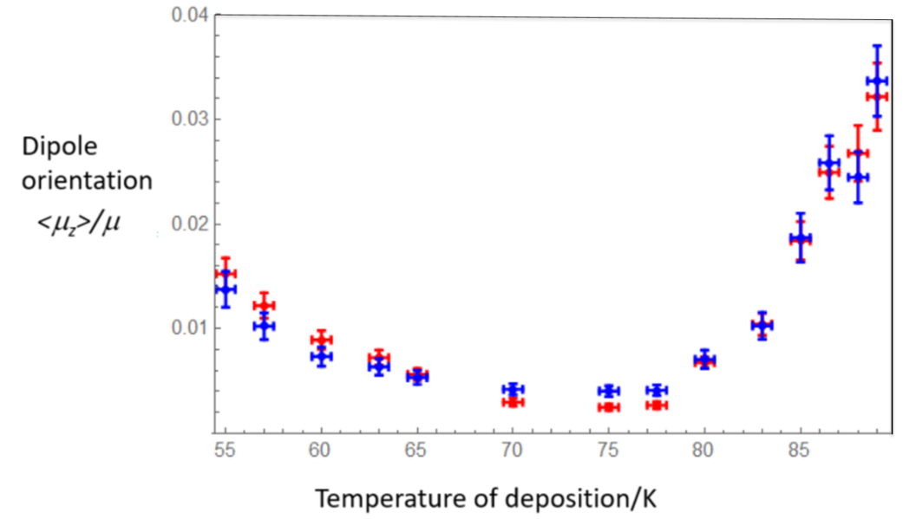

Fig. 1: The variation of the degree of dipole orientation, *<μz>/μ,* as a function of deposition temperature for *cis*-methyl formate. Experimental data are shown as red points, derived from direct measurement of film surface potentials. Fits to experiment, see S(iv), are shown in blue. Values of fitting parameters are given in Table 1. Note that values *<μz>/μ* are unstable for deposition temperatures ≥ 80K, decaying by ~50% on a timescale of an hour, after an initial period of stability of ~2000 seconds.2,[11]

The spontelectric model, outlined below, has proven successful in analysing data for the variation of spontelectric fields with deposition temperature,2 Stark shifts in reflection-absorption infrared spectroscopy (RAIRS),[12] vacuum ultraviolet spectroscopy of films of NH310 and secondary relaxation in glassy *cis*-MF.11 RAIRS experiments[13] have confirmed the increase in dipole orientation in *cis*-MF for deposition temperatures ≥ 80K, shown in Fig. 1.

In a spontelectric solid, molecules are subject to a mean field, Ez, whose value contains three terms: first a term defining the interactions which bind layers together, associated with polarization, dispersion and covalent interactions, second, a term explicitly involving the dipole-dipole interaction, proportional to (<μz>/μ)2, and third, a term representing the spontelectric field itself and proportional to <μz>/μ. Thus the mean field Hamiltonian for the system, E, is given by the energy of interaction of the dipole, μ, in this mean effective field and we write E as:

E = μEz = μ{ES[1 + ζ (<μz>/μ)2] - EA <μz>/μ} (1)

where ES, ζ and EA are three parameters to be determined by fitting to experimental data and additionally, for EA, appeal to theory. Since the surface bound charge gives rise to the surface potential and the spontelectric field is proportional to the degree of dipole orientation, this leads to Espont = EA<μz>/μ. The value of <μz>/μ is given by the Langevin function, writing E = μEz. The film settles down to a configuration corresponding to a balance between the short range and long range terms in the mean field Hamiltonian and thermal agitation. The governing equation therefore has the form f(T,<μz>/μ) = <μz>/μ, an implicit equation containing feedback, through which the behaviour of orientation with deposition temperature depends on the degree of orientation itself.

An explicit expression for f(T,<μz>/μ) is obtained directly by substitution of Ez, from Eqn.1, into the Langevin function: see S(ii). We seek the differential of f(T,<μz>/μ) with respect to T, and this yields

d(<μz>/μ))/dT = [-(μEz/T2) Cosech2 {μEz/T]} + (μEz)-1]/Φ (2)

where Ez is given by eq. 1 and

Φ = T[2ζ (<μz>/μ) ES - EA] (μEz2)-1 - (μ/T) (2ζ (<μz>/μ) ES - EA) Cosech2 [μEz/T]] -1 (3)

We show in S(iii) that the nominator in eqn. 2 cannot equal zero, for any combination of non-zero T and <μz>/μ or real values of parameters ES, EA or ζ. Thus, we are faced with the property that Fig.1 shows that <μz>/μ vs T displays a minimum value, or equally maximum values in data for 1-pentanol and 1-butanol, but that d(<μz>/μ)/dT cannot equal zero. The form of eq. 2 is such that the differential tends to infinity as Φ tends to zero. Referring for example to *cis*-MF, to the low temperature side of the condition that Φ tends to zero, d<μz>/μ)/dT is negative and to the high temperature side, d<μz>/μ)/dT is positive. This generates a minimum value in <μz>/μ vs. T. The signs of d<μz>/μ)/dT are reversed for 1-pentanol or 1-butanol which show a maximum (negative) value of <μz>/μ.

We obtain the values of parameters ES, EA and ζ, by fitting (S(iv)) to experimental data vs deposition temperature for *cis-*MF, 1-butanol and 1-pentanol2,4 and ammonia.10 For the glassy materials *cis*-MF, 1-butanol and 1-pentanol, we constrain ES and EA to be independent of deposition temperature. The parameter ζ may however be temperature dependent. For NH3, all three parameters are treated as temperature independent, for the higher temperature phase formed at T > 50K, the phase of interest here.10

|  |  |  |  |  |
| --- | --- | --- | --- | --- |
| Molecule | Dipole moment in solid, μ /D | ES/Vm-1 | EA/Vm-1 | ζ |
|  |  |  |  |  |
| *Cis*-methyl formate | 0.353 | 1.09±0.18 x 107 | 1.12±0.19x109 | See text |
|  |  |  |  |  |
| 1-butanol | 0.4326 | 2.583 x 107 | -2.834 x 109 | 425 at 36K: see text and S(v) |
| 1-pentanol | 0.4256 | 3.498 x 107 | -2.676 x 109 | 464 at 40K: see text and S(v) |
| Ammonia (NH3) | 0.577 | (i) 2.12± 0.04 x 107  (ii) 2.58± 0.03 x 107 | (i) 4.95±0.07 x 109  (ii) 5.49±0.06 x109 | (i) 23200±800  (ii) 17600±500 |
| Nitrous oxide | 0.0669 | 6.01±0.22 x 108 | 6.92±0.25 x 108 | 57.5±3.9 |

Table 1: Column 2: dipole moments, μ, of molecules in the solid. Columns 3, 4 and 5: values of parameters, in the Hamiltonian in Eqn. 1, defining the mean field in solid films of *cis*-methyl formate (MF),4,13, 1-butanol and 1-pentanol,4 and ammonia (NH3).10 Parameters for nitrous oxide for T ≥ 48K[14] are included for comparison. Errors in values of parameters leading to corresponding errors in values of the degree of dipole orientation, <μz>/μ, of ±10% to15% for *cis*-MF (see Fig. 1) and ±5% for NH3. The two different sets of ES, EA and ζ, (i) and (ii), for NH3 arise from values derived using the methods outlined in S(iv), using different weightings of the data in the least squares fitting procedure. Errors, both systematic and random, associated with 1-butanol and 1-pentanol values cannot be readily assessed, since these depend on the quantities, such as molecular spacing, which are not accurately known; see S (i).

We now seek to identify the temperature of deposition and associated degree of orientation which lead to singularities in d(<μz>/μ)/dT, subject to Φ = 0 and f(T,<μz>/μ) = <μz>/μ. Turning first to *cis*-MF, using a single set of values of parameters, ES, EA and ζ, we reproduce the general experimental form of <μz>/μ vs T (Fig. 1) for the full range of deposition temperature between 55K and 89K. In particular, if we restrict our determination of temperature independent values of ES, EA and ζ to those based upon values of orientation measured below 75K, that is, below the minimum value of <μz>/μ, then the rapid rise in orientation at T≥80K follows directly.2

To create a more quantitative fit to data for *cis*-MF, we refer to experimental data for the decay of dipole orientation with time in *cis*-MF.[15] These show that the extent to which molecules are restricted in their angular motion, represented by the term involving ζ (<μz>/μ)2 in Eq. (1), is deposition temperature dependent and that this dependence may be wholly attributed to the temperature dependence of ζ.11 This parameter rises from 1.31 x 104 at 55K to 4.77 x 104 at 80K. At T>80K, self-diffusion of molecules within the glassy material becomes measureable, with a diffusion coefficient > 10-20 cm2s-1, climbing rapidly as T increases.15 Diffusion implies freedom of motion and is accompanied by a decay of ζ, which reverts at 89K to 1.16 x 104, close to its low temperature value of 1.31 x 104 at 55K. Thus increased self-diffusion mirrors the growth in orientation in the temperature range >80K, see S(v). The minimum experimental value of <μz>/μ =0.0026±0.0001 (Fig. 1) is found to occur between 75K and 77.5K. The fitted value is 0.00405±0.00004, reproduced using T = 78.3K obtained with ζ = 4.40 x 104 on solution of Φ = 0.

We turn now to the glassy solids 1-butanol and 1-pentanol,4 between 32K and 48K in which maximum negative values of orientation were observed. Results, based on Kelvin probe measurements, may be expressed as electric fields. For example the value of the spontelectric field, Espont, is estimated 1.24 x 108 Vm-1 for 1-pentanol at 40K.[16] Here we use EA = 4πμ/Ω, in atomic units, as derived in [2], rather than fitting, where μ is the solid state dipole and Ω is the molecular volume, itself related to the polarizability, α,[17] see S(i) and S(v). We find that EA = -2.834 x 109 Vm-1 for 1-butanol and -2.676 x 109 Vm-1 for 1-pentanol. Since Espont = EA<μz>/μ, this allows the evaluation of <μz>/μ for 1-butanol and 1-pentanol shown in Table 2. These demonstrate maxima at 36K for 1-butanol and at 40K for 1-pentanol.

|  |  |  |
| --- | --- | --- |
| Deposition Temperature /K | <μz>/μ for 1-butanol | <μz>/μ for 1-pentanol |
|  |  |  |
| 32 | -0.0468 | -0.0386 |
| 36 | -0.0484 | -0.0451 |
| 40 | -0.0474 | -0.0463 |
| 44 | -0.0446 | -0.0453 |
| 48 | -0.0409 | -0.0449 |

Table 2: Degrees of dipole orientation, <μz>/μ, obtained from data in [4], vs deposition temperature for 1-butanol and 1-pentanol. Maximum absolute values are encountered at 36K for 1-butanol and 40K for 1-pentanol. Absolute values of <μz>/μ for 1-pentanol are about 50% higher than those reported in [[18]], due to a better assessment of molecular properties for this species.

The hypothesis is that the maximum negative value should occur at a point (T,<μz>/μ) such that f(T,<μz>/μ) = <μz>/μ and Φ = 0 are simultaneously satisfied. Holding ES and ζ constant with temperature, we find that the presence of a maximum negative value is a direct consequence of our theoretical model. However we estimate T = 29K for this to occur for 1-butanol, with an accompanying value of <μz>/μ = -0.050, and T = 36 K for 1-pentanol, with an accompanying value <μz>/μ = -0.047, whereas observed values are 36K and 40K, with <μz>/μ = -0.048 and -0.046 respectively (Table 2). This discrepancy may be rectified by appealing to the properties of glassy solids, as exemplified by *cis*-MF.11,15 We postulate that, in the region of Φ = 0, the temperature is such that molecular diffusion becomes significant and that diffusion will increase with increasing temperature. To mimic this increased mobility, we allow ζ to vary with temperature. We hold an optimized ES constant with temperature, and use EA = 4πμ/Ω, as before. We may then fit exactly to the observed values of <μz>/μ in Table 2, allowing only ζ as a fitting parameter. We find that this fit entails ζ (<μz>/μ)2 dropping by a factor of ~2 for each species over T = 32K to 48K, see S(v), in accord with the notion increasing temperature and diffusion is accompanied by relaxation of the grip which restricts molecular rotation.

For films of NH3, data have been measured only up to 80K. We are unable to perform experiments at higher deposition temperatures, since NH3 does not ‘stick’ at T > 80K under our experimental conditions of base pressure of <10-9 mbar. Data for NH3 are shown in Fig.2 in red and a fit to these values in blue, using parameters in Table 1, dataset (ii). A very similar fit is achieved with dataset (i), involving different weighting to individual data points: see S(iv). The results for NH3 are similar in character to those for *cis*-MF, in the range of temperature of deposition approaching that associated with the minimum value of <μz>/μ for *cis­*-MF, from the low T side. However, for NH3, access to values of high enough T, for which a minimum value of <μz>/μ might in principle be found, is not feasible. Thus experimentally T can never be such that Φ = 0 with f(T,<μz>/μ) = <μz>/μ. We suggest, from the appearance of the data in Fig.2, that 80K is nevertheless close to the temperature for which the switch from negative to positive slope occurs in d(<μz>/μ)/dT. The presence of a putative minimum value of <μz>/μ, at sufficiently high T, may be inferred from the property of NH3, shared with *cis*-MF, 1-butanol and 1-propanol, that ES<< EA and ζ is large. A comparison of parameters for N2O is shown in Table 1, for which ES, EA are comparable in magnitude and no such minimum value in <μz>/μ vs T can be identified.2

The relative importance of terms in the Hamiltonian in eq. 1 gives some insight into the analytic difference between *cis*-MF or 1-pentanol and spontelectric material such as nitrous oxide, which shows a monotonic decrease of <μz>/μ with deposition temperature.2 First, the removal of feedback via dipole-dipole interactions in the Hamiltonian, writing ζ = 0, entirely eliminates the phenomena described here. Second, the ratio, *r*, of the second and first terms μ(EA<μz>/μ) and μ{ES[1 + ζ (<μz>/μ)2], in the Hamiltonian, eq.1., is significantly greater in systems which display a minimum or maximum value in orientation vs deposition temperature. Thus, using values in Table 1 and S(iv), the value of *r* for *cis*-MF lies between 0.2 and 0.3 in the range T = 55K to 89K and between 1.5 and 2.1 for 1-pentanol in the range T = 32K to 48K. By comparison, for nitrous oxide, *r* ~ 0.06, in the range T = 52K to 60K. Thus, a stronger relative influence, of the term associated with spontelectric field, introduces singularities into the differential of the governing function f(T,<μz>/μ), with Φ, eqn. 3, passing through zero. For ammonia, in the range T = 55K to 80K, *r* ~ 0.7 to 0.8, lying between values for *cis*-MF and 1-pentanol.

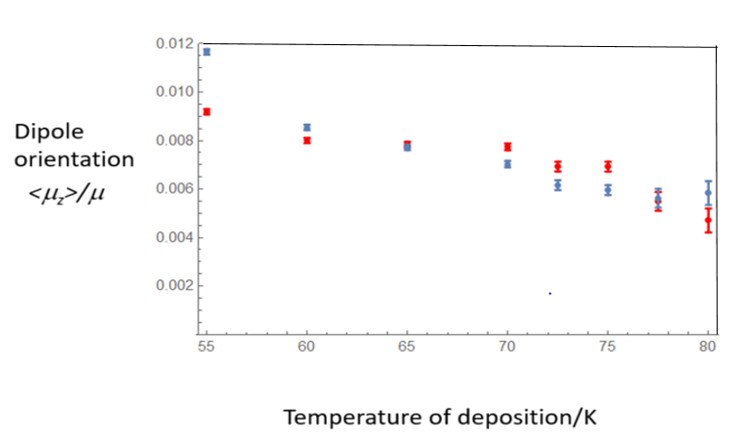

Fig. 2: Data for the degree of orientation, <μz>/μ, in solid ammonia films, taken from experimental data in [10] (red points). Blue points show the fit obtained using the technique in described in S(iv), yielding ES = 2.58 x 107 Vm-1 , EA = 5.49 x 109 Vm-1 , ζ = 1.76 x 104, using set (ii) in Table 1, weighting the value at 55K of orientation to 0.5 and all others to unity.

An important advance was made recently in understanding the mechanism for the spontaneous development of dipole order in films deposited from the gas phase.[19] Large scale simulations of *cis*-MF films showed that thermal fluctuations can lead the system down a weakly non-equilibrium branch into the spontelectric state. Strikingly, this *ab initio* work reproduced the minimum value in net orientation in *cis*-MF vs T, giving a value of deposition temperature of ~70K, close to that observed. This reinforced the earlier qualitative suggestion that librational fluctuations were an underlying feature in establishing the spontelectric state.[20] However, in developing the current model, or that in [19], there was no physics introduced that implied, or in any explicit manner imposed, a set of conditions that would lead to greater dipole ordering as T was raised and the presence of a minimum value at a specific temperature of deposition.

The physics of the model presented is rather straightforward. It involves no more than very familiar electrostatics and statistical arguments, to yield general agreement with experiment. Enhanced molecular mobility, that is, enhanced diffusion at higher T,15 can be added as described above, to achieve better agreement between model and experiment. However this is only a supplement and is inessential to the reversal of the slope of molecular orientation vs deposition temperature and the accompanying infinities in the differential of the governing function f(T,<μz>/μ). Further simulations, similar to those in [19], are in progress in order to shed some light on the physical mechanism which gives rise to the phenomena described here and to expose the distinctive process that acts around the singularity in the differential. For the present, we note only that nothing more is required than the mathematical structure of the model and its peculiar singular properties.

*Acknowledgments*

We should like to acknowledge the Centre for Storage Ring Facilities at Aarhus (ISA) for granting access to the VUV and UV beamlines on the ASTRID and ASTRID2 storage ring. We also acknowledge and the staff at ISA, for their technical assistance in performing our experiments, with special thanks to Nykola Jones and Søren Hoffmann. We are also grateful to A.A.Tsekouras, National and Kapodistrian University of Athens, for providing us with the means of conversion of Kelvin Probe data to electric fields within thin films. With regard to [15], we are grateful for the use of the Spallation Neutron Source, a DOE Office of Science User Facility operated by the Oak Ridge National Laboratory, Oak Ridge, TN 37831, USA and to the staff at the Neutron Scattering Division, especially to Dr. Valeria Lauter.

1. R. Balog, P. Cicman, N.C. Jones, D. Field, 2009, Spontaneous Dipole Alignment in Films of N2O, *Phys. Rev. Lett.*, **102**, 073003
2. D. Field, O. Plekan, A. Cassidy, R. Balog, N. C. Jones, and J. Dunger, 2013 2013, Spontaneous electric fields in solid films: spontelectrics. *Int. Rev. Phys. Chem*., **32**, 345–392
3. K. Kutzner, *Thin Solid Films* 1972, Spontaneous polarization of condensing carbon monoxide and other gases with an electrical dipole moment. **14**, 49
4. A.N.Pilidi, I.K.Gavra, A. Tsekouras, 2019 Spontaneous Polarization of Cryo-Deposited Films for Five Normal Saturated Monohydroxy Alcohols, CnH2n+1 OH, n = 1–5. *J.Phys.Chem.* B, **123**, 8505-8511.
5. R. Sagi, M. Akerman, S. Ramakrishnan, M. Asscher, 2020. Spontaneous polarization of thick solid ammonia films. *J.Chem.Phys.***153**, 124707-12
6. Kittel C *Introduction to Solid State Physics*, 3rd Edn. New York, London, Sydney: John Wiley&Sons.
7. E. Goursat, *A Course in Mathematical Analysis*, Vol. 1. University of Paris. Trans. E.R.Hedrick, University of Missouri. Ginn&Co., Boston, New York, Chicago, London 1904. <https://archive.org/details/courseinmathemat01gouruoft>, which states ‘.. there exist continuous functions which do not possess derivatives for particular values of the variable’, where ‘do not possess’ signifies that derivatives become singular.
8. R.Courant, *Differential and Integral Calculus*, Vol.II, Blackie and Son Ltd. London and Glasgow. 1962
9. O. Plekan, A. Cassidy, R. Balog, N.C.Jones, D. Field 2012, Spontaneous electric fields in films of *cis*-methyl formate. *Phys. Chem. Chem. Phys.*, **14**, 9972-9976
10. A.Cassidy, R.L. James, A.Dawes, D. Field. 2020 Crystallites and Electric Fields in Solid Ammonia *ChemistryOpen*, **9**, 983–990
11. Cassidy AM, Mads R. V. MRV,Glavic A,Lauter V, Plekan O, Field D. 2021. Low temperature aging in a molecular glass: the case of *cis*-methyl formate. *Phys. Chem. Chem. Phys.*, **23**, 15719-15726.
12. Lasne J, Rosu-Finsen A, Cassidy AM, McCoustra MRS, Field D. 2015 Spontaneously electrical solids in a new light. *Phys. Chem. Chem. Phys.*, **17**, 20971-20980.
13. Roman M, Taj S, Gutowski M, McCoustra MRS, Dunn AC, Keolopile ZG, Rosu-Finsen A, Cassidy AM, Field D. 2018. Non-linear and non-local behaviour in spontaneously electrical solids.2019.  *Phys. Chem. Chem. Phys.*, **21**, 1190-1197.
14. Cassidy AM, Jørgensen MRV, Rosu-Finsen A, Lasne J, Jørgensen JH, Glavic A, Lauter V, Iversen BB, McCoustra MRS, Field D. 2016 Dipole-Oriented Molecular Solids Can Undergo a Phase Change and Still Maintain Electrical Polarization. *J.Phys.Chem C.*, **120**, 24130-24136.
15. Cassidy AM, Mads R. V. MRV,Glavic A,Lauter V, Plekan O, Field D. 2021. A mechanism for ageing in a deply supercooled molecular glass. *Chem. Commun.*, **57**, 6368-6371.
16. A.A. Tsekouras *private communication*.
17. Blair SA, Thakkar AJ. 2014 Relating polarizability to volume, ionization energy, electronegativity, hardness, moments of momentum, and other molecular properties. J.Chem.Phys, 141 074306-074311
18. Field, D. Cassidy A., Comment on “Spontaneous Polarization of Cryo-Deposited Films for Five Normal Saturated Monohydroxy Alcohols, CnH2n+1OH, n = 1−5”, 2021, *J.Phys.B.* ***125****, 7568-7569*
19. Kexel C., Solov’yov A.V., Predicting dipole orientations in spontelectric methyl formate, 2021 *Eur.Phys.J.* D, 75-89
20. Cassidy A, Plekan O, Dunger J, Balog R, Jones NC, Lasne J, Rosu-Finsen, A, McCoustra MRS, Field D, 2014, Investigations into the nature of spontelectrics: nitrous oxide diluted in xenon. *Phys. Chem. Chem. Phys.*, **16**, 23843-23853.