Below we show that this is the correct equation!
Energy change associated with a particular deposition temperature is given by
2 E r (-1 + 1/(1- 2 E εr²)^{1/2}) (1)
where ‘energy change’ is the difference in energy between the energy level in the absence of a spontelectric field and in the presence of the spontelectric field (see below where eq. 1 comes from!).
Notation: use m == μ/μ₀, q==ξ so:
E = E_{A} m where m = $-\frac{T}{mu(-Am+Es(1+m^{2}q))}+Coth[\frac{mu(-Am+Es(1+m^{2}q))}{T}]$ (2)
Energy change must be expressed in au. Convert wavelength measured (and λ₀) to cm⁻¹, divide by 8065.5 gives the energy in eV, divide by 27.21 gives the energy in au.
So energy change = 2 E r (-1 + 1/(1- 2 E εr²)^{1/2}) = 2 E_{A} m r (-1 + 1/(1- 2 E_{A} m εr²)^{1/2})
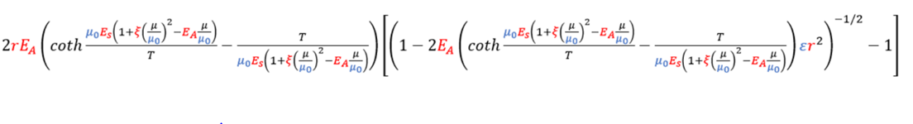
Conclusion: the equation that you are using is correct.
Derivation of equation 1 is given in the ammonia paper page 986, column 1. (eq. 1 et seq.)

