Monday 23rd May 2022

07:45 Pressure in the chamber: 8.4x10-9 mbar

Wednesday 25th May 2022 – Deposition at 20 K
08:00 Pressure in the chamber: 6.8x10-9 mbar
CRYO ON
Rachel James beam time for the next two weeks.

Bkg scans
File | λ range | λ step | #av/#sc | Temp/K | Keithley | Table/kstp | PMTVac | Sample
69526 | 110-220 | 1 | 15/2 | 19.4K | 5NPLC | -300 | ON | Clean MgF2
69527 | 110-165 | 0.5 |  |  |  | -450 |  | Clean MgF2
69528 | 160-220 |  |  |  |  | -100 |  | Clean MgF2
69529 | 210-330 | 1 |  |  |  | 400 | OFF | Clean MgF2

Test of TimeScan, settings #av of 5 i.e. 750 ms according to the time per point of 150 ms quoted in the time scan window. However, have now noticed that this value of time per point is a fixed value assuming the PLC is in use and not the block time from the cRio which is actually being used for the measurement.

So leave the block time for the cRio to be 100 ms (as changing this would mess things up for the scanning) and then will need to tell the OU lot that the time is not correct!

H2O dosing for 30s at 1e-7mbar
File: T69532
Temperature of substrate during deposition: 19.4K
Time start = 47s Time stop = 1m18 total dose = 31,86 dose 1-1,2x10-7 mbar for 30s

File | λ range | λ step | #av/#sc | Temp /K | Keithley | Table/kstp | PMTVac | Sample
69533 | 110-220 | 1 | 15/2 | 19.4K | 5NPLC | -300 | ON | H2O
69534 | 110-165 | 0.5 | 15/2 |  |  | -450 |  | H2O
69535 | 160-220 |  |  |  |  | -100 |  | H2O
69536 | 210-330 | 1 |  |  |  | +400 | OFF | H2O

Scan after lunch – everything the same
File | λ range | λ step | #av/#sc | Temp /K | Keithley | Table/kstp | PMTVac | Sample
69537* | 110-220 | 1 | 15/2 | 19.4K | 5NPLC | -300 | ON | H2O
69538
* Opened air valve by mistake
69539, 69540 - aborted

Anneal H2O: 20K --- 42K
File | λ range | λ step | #av/#sc | Temp /K | Keithley | Table/kstp | PMTVac | Sample
69541* | 110-165 | 0.5 | 15/2 | 19.4K | 5NPLC | -100 | ON | H2O
69544 | 110-165 | 0.5 | 15/2 |  |  | -450 |  | H2O
69545 | 160-220 |  |  |  |  | -100 |  | H2O
69546 | 110-220 | 1 |  |  |  | -300 |  | H2O
*wrong table position
69542, 69543 – aborted

Anneal H2O: 20K --- 50K
File | λ range | λ step | #av/#sc | Temp /K | Keithley | Table/kstp | PMTVac | Sample
69547 | 110-165 | 0.5 | 15/2 | 19.4K | 5NPLC | -450 | ON | H2O
69548 | 160-220 | 0.5 |  |  |  | -100 |  | H2O

Anneal H2O: 20K --- 60K
File | λ range | λ step | #av/#sc | Temp /K | Keithley | Table/kstp | PMTVac | Sample
69549 | 110-165 | 0.5 | 15/2 | 19.4K | 5NPLC | -450 | ON | H2O
69550 | 160-220 | 0.5 |  |  |  | -100 |  | H2O

Anneal H2O: 20K --- 70K
File | λ range | λ step | #av/#sc | Temp /K | Keithley | Table/kstp | PMTVac | Sample
69551 | 110-165 | 0.5 | 15/2 | 19.4K | 5NPLC | -450 | ON | H2O
69552 | 160-220 | 0.5 |  |  |  | -100 |  | H2O

Anneal H2O: 20K --- 80K
File | λ range | λ step | #av/#sc | Temp /K | Keithley | Table/kstp | PMTVac | Sample
69553 | 110-165 | 0.5 | 15/2 | 19.4K | 5NPLC | -450 | ON | H2O
69554 | 160-220 | 0.5 |  |  |  | -100 |  | H2O

Anneal H2O: 20K --- 90K
File | λ range | λ step | #av/#sc | Temp /K | Keithley | Table/kstp | PMTVac | Sample
69555 | 110-165 | 0.5 | 15/2 | 19.4K | 5NPLC | -450 | ON | H2O
69556 | 160-220 | 0.5 |  |  |  | -100 |  | H2O
69557 | 210-340 | 1 |  |  |  | +400 | OFF | H2O

Anneal H2O: 20K --- 100K
File | λ range | λ step | #av/#sc | Temp /K | Keithley | Table/kstp | PMTVac | Sample
69559 | 110-165 | 0.5 | 15/2 | 19.4K | 5NPLC | -450 | ON | H2O
69560 | 160-220 | 0.5 |  |  |  | -100 |  | H2O

69558– aborted

Anneal H2O: 20K --- 110K
File | λ range | λ step | #av/#sc | Temp /K | Keithley | Table/kstp | PMTVac | Sample
69561 | 110-165 | 0.5 | 15/2 | 19.4K | 5NPLC | -450 | ON | H2O
69562 | 160-220 | 0.5 |  |  |  | -100 |  | H2O

Anneal H2O: 20K --- 120K
File | λ range | λ step | #av/#sc | Temp /K | Keithley | Table/kstp | PMTVac | Sample
69563 | 110-165 | 0.5 | 15/2 | 19.4K | 5NPLC | -450 | ON | H2O
69564 | 160-220 | 0.5 |  |  |  | -100 |  | H2O

Anneal H2O: 20K --- 130K
File | λ range | λ step | #av/#sc | Temp /K | Keithley | Table/kstp | PMTVac | Sample
69565 | 110-165 | 0.5 | 15/2 | 19.4K | 5NPLC | -450 | ON | H2O
69566 | 160-220 | 0.5 |  |  |  | -100 |  | H2O

Anneal H2O: 20K --- 140K
File | λ range | λ step | #av/#sc | Temp /K | Keithley | Table/kstp | PMTVac | Sample
69567 | 110-165 | 0.5 | 15/2 | 19.4K | 5NPLC | -450 | ON | H2O
69568 | 160-220 | 0.5 |  |  |  | -100 |  | H2O
69569 | 110-220 | 1 |  |  |  | 400 |  | H2O
69570 |  |  |  |  |  |  |  | H2O
69571

Is 140K the onset of desorption?

Anneal H2O: 20K --- 150K
File | λ range | λ step | #av/#sc | Temp /K | Keithley | Table/kstp | PMTVac | Sample
69572 | 110-165 | 0.5 | 15/2 | 19.4K | 5NPLC | -450 | ON | H2O
69573 | 160-220 | 0.5 |  |  |  | -100 |  | H2O
69574 | 110-220 | 1 |  |  |  | -300

Anneal H2O: 20K --- 155K
File | λ range | λ step | #av/#sc | Temp /K | Keithley | Table/kstp | PMTVac | Sample
69575 | 110-220 | 0.5 | 15/2 | 19.4K | 5NPLC | -300 | ON | H2O

Anneal H2O: 20K --- 160K
File | λ range | λ step | #av/#sc | Temp /K | Keithley | Table/kstp | PMTVac | Sample
69576 | 110-220 | 0.5 | 15/2 | 19.4K | 5NPLC | -300 | ON | H2O

Anneal H2O: 20K --- 170K
File | λ range | λ step | #av/#sc | Temp /K | Keithley | Table/kstp | PMTVac | Sample
69578 | 110-220 | 0.5 | 15/2 | 19.4K | 5NPLC | -300 | ON | H2O

Onset of desorption at 140 K, fully desorbed by 170 K?

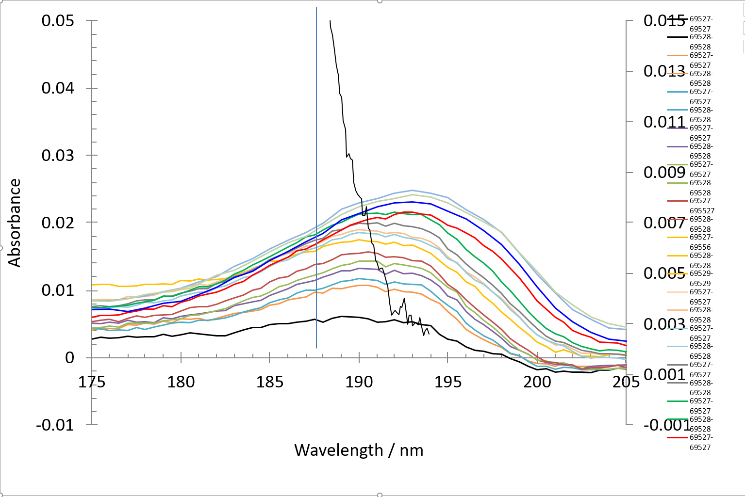

Is this band sensitive to phase change? Possible at 120K?

Thursday 26th May 2022 – Deposition at 50 K

07:05 p = 8.8e-8 mbar T = 273 K cryo ON

Plan
- Deposit at 50 K
- Analyse dep 20 K results

09:22 p = 2.4e-9 mbar T = 19. 3 K
09:40 p = 4e-9 mbar T = 50 K

Bkg scans at 50 K
File | λ range | λ step | #av/#sc | Temp/K | Keithley | Table/kstp | PMTVac | Sample
69578* | 110-220 | 0.5 | 15/2 | 19.4K | 5NPLC | -300 | ON | Clean MgF2
69579 |  |  |  | 50 K
69580 | 210-220 | 1 |  |  |  | +400 | OFF | Clean MgF2
*wrong temperature

H2O dosing for 30s at 1e-7mbar
File: T69583
P before deposition: 2e-8 mbar
Temperature of substrate during deposition: 50K
Time start =36 s
Time stop = 1m06
Total dose = 30s dose 1-1,2x10-7 mbar for 30s
T69581, T69592 * not ready
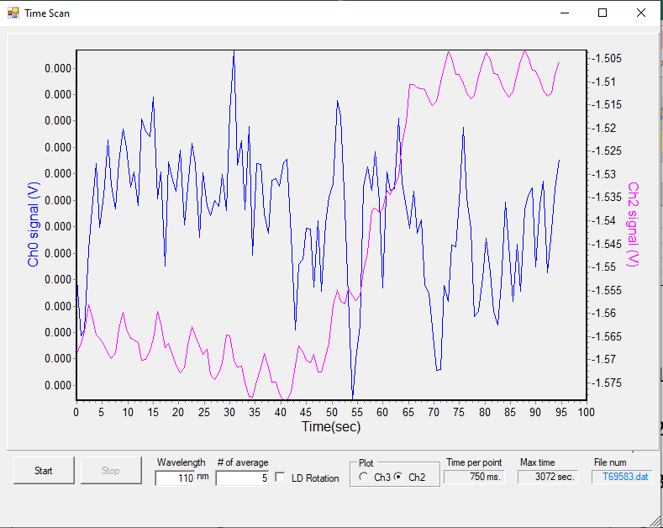

File | λ range | λ step | #av/#sc | Temp /K | Keithley | Table/kstp | PMTVac | Sample
69584 | 110-220 | 0.5 | 15/2 | 50K | 5NPLC | -300 | ON | H2O

Anneal to 60 K
File | λ range | λ step | #av/#sc | Temp/K | Keithley | Table/kstp | PMTVac | Sample
69585 | 110-220 | 0.5 | 15/2 | 50K | 5NPLC | -300 | ON | H2O at 60 K

Anneal to 70 K
File | λ range | λ step | #av/#sc | Temp/K | Keithley | Table/kstp | PMTVac | Sample
69586 | 110-220 | 0.5 | 15/2 | 50K | 5NPLC | -300 | ON | H2O at 60 K

Anneal to 80 K
File | λ range | λ step | #av/#sc | Temp/K | Keithley | Table/kstp | PMTVac | Sample
69587 | 110-220 | 0.5 | 15/2 | 50K | 5NPLC | -300 | ON | H2O at 60 K

Anneal to 90 K
File | λ range | λ step | #av/#sc | Temp/K | Keithley | Table/kstp | PMTVac | Sample
69588 | 110-220 | 0.5 | 15/2 | 50K | 5NPLC | -300 | ON | H2O at 60 K

Anneal to 100 K
File | λ range | λ step | #av/#sc | Temp/K | Keithley | Table/kstp | PMTVac | Sample
69589 | 110-220 | 0.5 | 15/2 | 50K | 5NPLC | -300 | ON | H2O at 60 K

Anneal to 110 K
File | λ range | λ step | #av/#sc | Temp/K | Keithley | Table/kstp | PMTVac | Sample
69590 | 110-220 | 0.5 | 15/2 | 50K | 5NPLC | -300 | ON | H2O at 60 K

Anneal to 120 K
File | λ range | λ step | #av/#sc | Temp/K | Keithley | Table/kstp | PMTVac | Sample
69591 | 110-220 | 0.5 | 15/2 | 50K | 5NPLC | -300 | ON | H2O at 60 K

Anneal to 130 K
File | λ range | λ step | #av/#sc | Temp/K | Keithley | Table/kstp | PMTVac | Sample
69592 | 110-220 | 0.5 | 15/2 | 50K | 5NPLC | -300 | ON | H2O at 60 K

Anneal to 140 K
File | λ range | λ step | #av/#sc | Temp/K | Keithley | Table/kstp | PMTVac | Sample
69593 | 110-220 | 0.5 | 15/2 | 50K | 5NPLC | -300 | ON | H2O at 60 K

Anneal to 150 K
File | λ range | λ step | #av/#sc | Temp/K | Keithley | Table/kstp | PMTVac | Sample
69594 | 110-220 | 0.5 | 15/2 | 50K | 5NPLC | -300 | ON | H2O at 60 K

Anneal to 160 K
File | λ range | λ step | #av/#sc | Temp/K | Keithley | Table/kstp | PMTVac | Sample
69595 | 110-220 | 0.5 | 15/2 | 50K | 5NPLC | -300 | ON | H2O at 60 K

Thursday 26th May 2022 – Deposition at 100 K 1
16:25 p=9e-9 T=100 K

Bkg scans at 100 K
File | λ range | λ step | #av/#sc | Temp/K | Keithley | Table/kstp | PMTVac | Sample
69597 | 110-220 | 0.5 | 15/2 | 100K | 5NPLC | -300 | ON | Clean MgF2
69599 | 138-150 | 0.2 |  |  |  | -450 | OFF | Clean MgF2

69596, 69598 – aborted

H2O dosing for 30s at 1e-7mbar
File: T69601
P before deposition: 2e-8 mbar
Temperature of substrate during deposition: 100K
Time start =1m06 s
Time stop = 1m36
Total dose = 30s dose 1-1,2x10-7 mbar for 30s
T69600 aborted

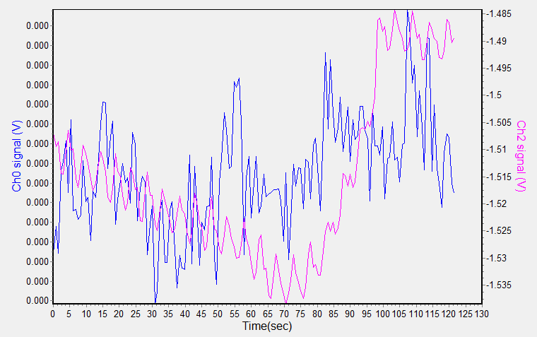
File | λ range | λ step | #av/#sc | Temp/K | Keithley | Table/kstp | PMTVac | Sample
69604 | 110-220 | 0.5 | 15/2 | 100K | 5NPLC | -300 | ON | H2O

69603, 69603.d02 aborted
Absorbance low – dose again.

H2O dosing for 30s at 1e-7mbar, total = 60s
File: T69605
P before deposition: 2e-8 mbar
Temperature of substrate during deposition: 100K
Time start =30 s
Time stop = 60s
Total dose = 30s dose 1-1,2x10-7 mbar for 30s

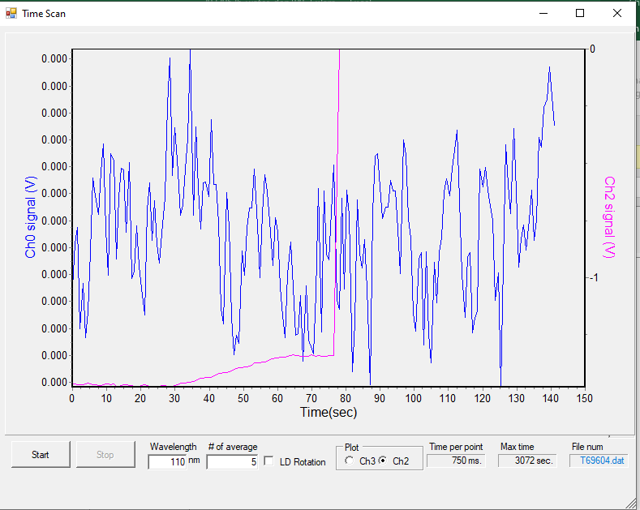

File | λ range | λ step | #av/#sc | Temp/K | Keithley | Table/kstp | PMTVac | Sample
69605 | 110-220 | 0.5 | 15/2 | 100K | 5NPLC | -300 | ON | H2O

No d02 - Not thick enough

H2O dosing for 60s at 1e-7mbar, total = 120s
File: T69607
P before deposition: 2e-8 mbar
Temperature of substrate during deposition: 50K
Time start =30 s
Time stop = 60s
Total dose = 30s dose 1-1,2x10-7 mbar for 30s

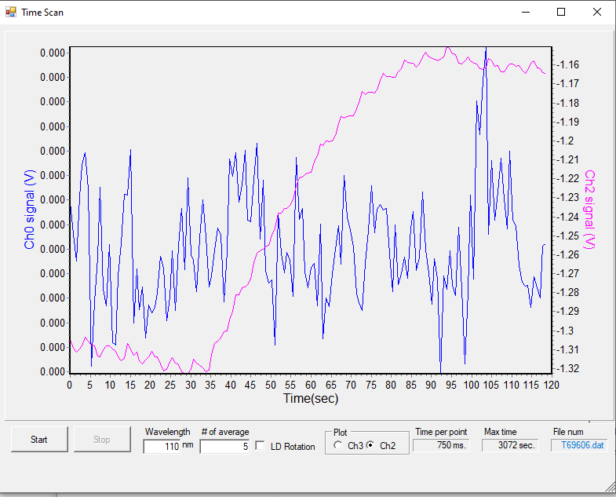

File | λ range | λ step | #av/#sc | Temp/K | Keithley | Table/kstp | PMTVac | Sample
69606 | 110-220 | 0.5 | 15/2 | 100K | 5NPLC | -300 | ON | H2O

Doh, wrong background files. Ice too thic – although features around 195 nm now enhanced… what are these? RESTART

Thursday 26th May 2022 – Deposition at 100 K 2

19:30 P = 1.4e-8 mbar T = 100 K

Bkg scans at 100 K
File | λ range | λ step | #av/#sc | Temp/K | Keithley | Table/kstp | PMTVac | Sample
69609 | 110-220 | 0.5 | 15/2 | 100K | 5NPLC | -300 | ON | Clean MgF2
69610 | 138-150 | 0.2 |  |  |  | -450 |  | Clean MgF2
69611 | 175-205 | 0.2 |  |  |  | -100

H2O dosing for 60s at 1e-7mbar
File: T69612
P before deposition: 2e-8 mbar
Temperature of substrate during deposition: 100K
Time start =36 s
Time stop = 1m36s
Total dose = 60s dose 1-1,2x10-7 mbar for 30s

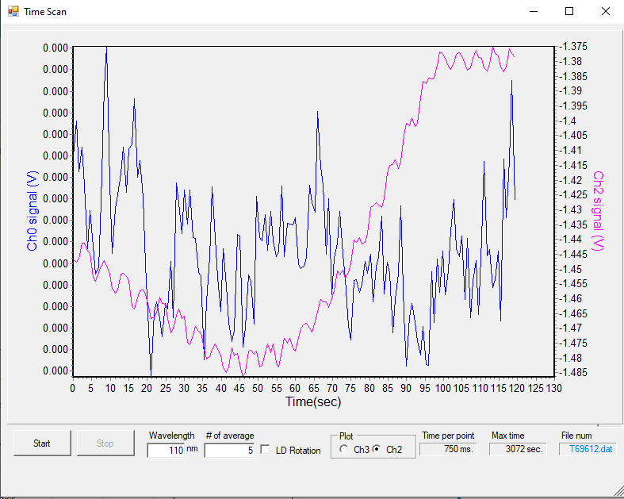

File | λ range | λ step | #av/#sc | Temp/K | Keithley | Table/kstp | PMTVac | Sample
69613 | 110-220 | 0.5 | 15/2 | 100K | 5NPLC | -300 | ON | H2O
69614 | 138-150 | 0.2 |  |  |  | -450 |  | H2O

Thick H2O dosing for 240s at 1e-7mbar
File: T69615
P before deposition: 2e-8 mbar
Temperature of substrate during deposition: 100K
Time start = ?
Time stop = ?
Total dose = 4m

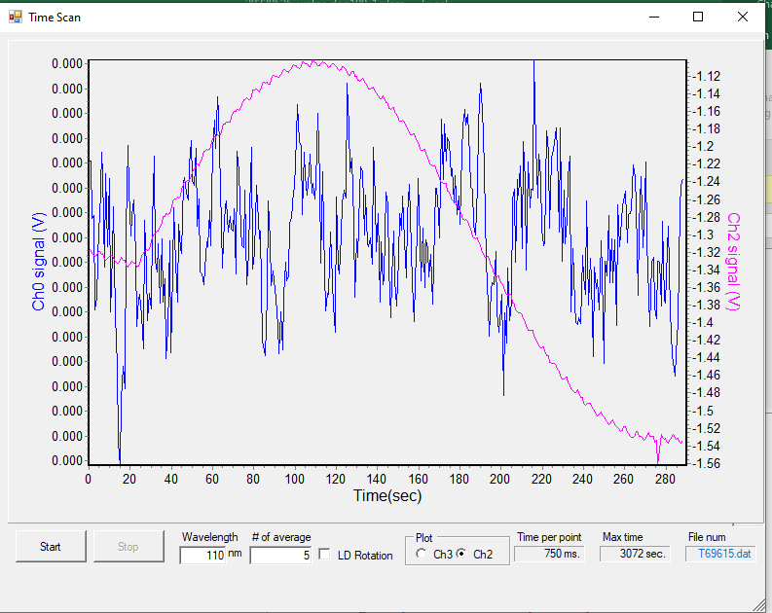

File | λ range | λ step | #av/#sc | Temp/K | Keithley | Table/kstp | PMTVac | Sample
69616 | 175-205 | 0.5 | 15/2 | 100K | 5NPLC | -100 | ON | H2O

H2O dosing for 120s at 1-1.2e-6mbar
File: T69617
P before deposition: 2e-8 mbar
Temperature of substrate during deposition: 100K
Time start =23 s
Time stop = 2m21s
Total dose = 120s

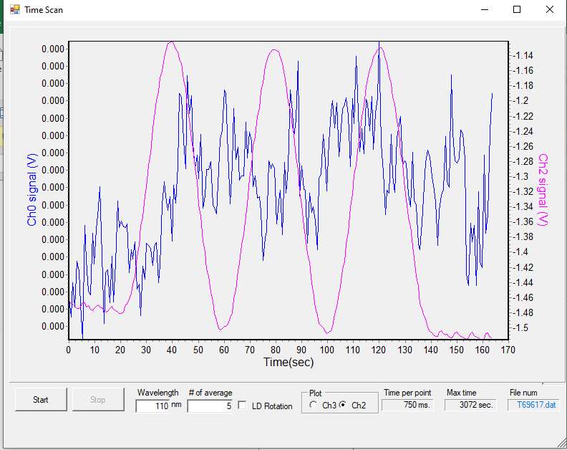

File | λ range | λ step | #av/#sc | Temp/K | Keithley | Table/kstp | PMTVac | Sample
69618 | 175-205 | 0.5 | 15/2 | 100K | 5NPLC | -100 | ON | H2O

Anneal to 136 K
File | λ range | λ step | #av/#sc | Temp/K | Keithley | Table/kstp | PMTVac | Sample
69619 | 175-205 | 0.5 | 15/2 | 136K | 5NPLC | -100 | ON | H2O

Anneal to 140 K
File | λ range | λ step | #av/#sc | Temp/K | Keithley | Table/kstp | PMTVac | Sample
69620 | 175-205 | 0.5 | 15/2 | 140K | 5NPLC | -100 | ON | H2O

Anneal to 150-160 K
File | λ range | λ step | #av/#sc | Temp/K | Keithley | Table/kstp | PMTVac | Sample
69621 | 175-205 | 0.5 | 15/2 | 150-160K | 5NPLC | -100 | ON | H2O

Anneal to 160 K
File | λ range | λ step | #av/#sc | Temp/K | Keithley | Table/kstp | PMTVac | Sample
69622 | 175-205 | 0.5 | 15/2 | 160K | 5NPLC | -100 | ON | H2O
Desorbing.

Friday 27th May 2022 – Deposition at 60 K

Morning Nyk,
Hope the gardening went well. Could you stick the cryo on?
Thanks, Rachel

07:45 p = 1.8e-8 mbar T = 271. K
cryo ON
09:10 P = 6.e-9 mbar T = 60 K

Bkg scans at 60 K
File | λ range | λ step | #av/#sc | Temp/K | Keithley | Table/kstp | PMTVac | Sample
69623 | 110-220 | 0.5 | 15/2 | 60K | 5NPLC | -300 | ON | Clean MgF2
69624 | 138-150 | 0.2 |  |  |  | -450 |  | Clean MgF2

H2O dosing for 30s at 1e-7mbar
File: T69625
P before deposition: 2e-8 mbar
Temperature of substrate during deposition: 60K
Time start = 23 s
Time stop =
Total dose = 30s dose

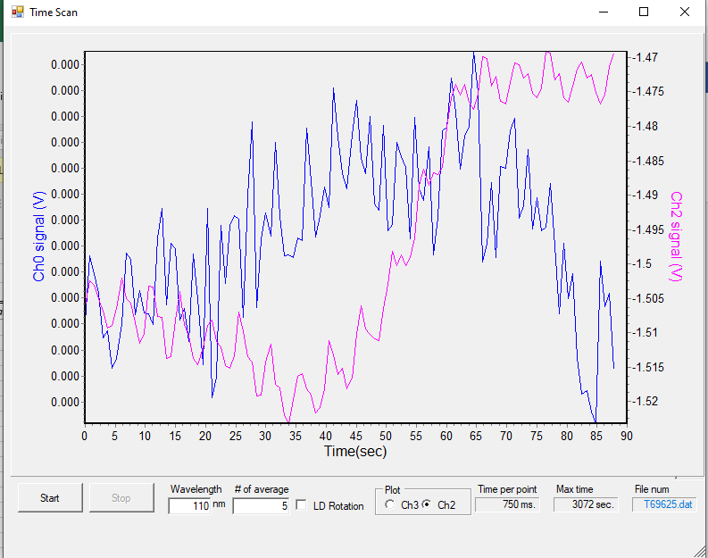

File | λ range | λ step | #av/#sc | Temp/K | Keithley | Table/kstp | PMTVac | Sample
69626 | 110-220 | 0.5 | 15/2 | 60K | 5NPLC | -300 | ON
69627 | 138-150 | 0.2 |  |  |  | -450
69628 | 138-150 | 0.2 |  |  |  | -450
*Wrong scan range

Are there any peak position shifts due to thickness?

H2O dosing for 15s at 1e-7mbar
File: T69629
P before deposition: 2e-8 mbar
Temperature of substrate during deposition: 60K
Time start = 1m16s
Time stop = 1m32s
Total dose = 45s dose
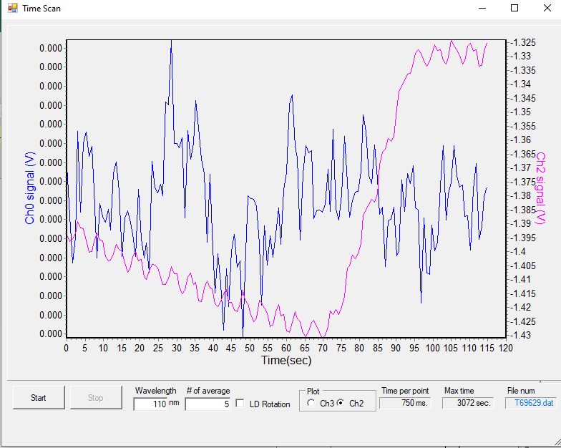

File | λ range | λ step | #av/#sc | Temp/K | Keithley | Table/kstp | PMTVac | Sample
69630*  69631 | 110-220 | 0.5 | 15/2 | 60K | 5NPLC | -300 | ON
69632  69633 | 138-150 | 0.2 |  |  |  | -450
*aborted

H2O dosing for 15s at 1e-7mbar
File: T69634
P before deposition: 2e-8 mbar
Temperature of substrate during deposition: 60K
Time start = 16s
Time stop = 26s
Total dose = 60s dose

File | λ range | λ step | #av/#sc | Temp/K | Keithley | Table/kstp | PMTVac | Sample
69635*  69636 | 110-220 | 0.5 | 15/2 | 60K | 5NPLC | -300 | ON
*aborted

Anneal to 100 K
File | λ range | λ step | #av/#sc | Temp/K | Keithley | Table/kstp | PMTVac | Sample
69637 | 110-220 | 0.5 | 15/2 | 100K | 5NPLC | -300 | ON

Anneal to 120 K
File | λ range | λ step | #av/#sc | Temp/K | Keithley | Table/kstp | PMTVac | Sample
69638 | 110-220 | 0.5 | 15/2 | 120K | 5NPLC | -300 | ON

Anneal to 130 K
File | λ range | λ step | #av/#sc | Temp/K | Keithley | Table/kstp | PMTVac | Sample
69639 | 110-220 | 0.5 | 15/2 | 130K | 5NPLC | -300 | ON

Anneal to 140 K
File | λ range | λ step | #av/#sc | Temp/K | Keithley | Table/kstp | PMTVac | Sample
69640 | 110-220 | 0.5 | 15/2 | 140K | 5NPLC | -300 | ON | H2O

PC d32519

Anneal to 230 K
File | λ range | λ step | #av/#sc | Temp/K | Keithley | Table/kstp | PMTVac | Sample
69641*  69642 | 110-220 | 0.5 | 15/2 | 230K | 5NPLC | -300 | ON | H2O
*aborted

Friday 27th May 2022 – Deposition at 40 K

BKG scans at 40 K
File | λ range | λ step | #av/#sc | Temp/K | Keithley | Table/kstp | PMTVac | Sample
69643 | 110-220 | 0.5 | 15/2 | 60K | 5NPLC | -300 | ON | Clean MgF2
69644 | 138-150 | 0.2 |  |  |  | -450 |  | Clean MgF2
69645 | 175-205 | 0.2 |  |  |  | -100 |  | Clean MgF2

Dep 1: H2O dosing for 15s at 1e-7mbar
File: T69646
P before deposition: 2e-8 mbar
Temperature of substrate during deposition: 40K
Time start = 37
Time stop = 52
Total dose = 15s dose

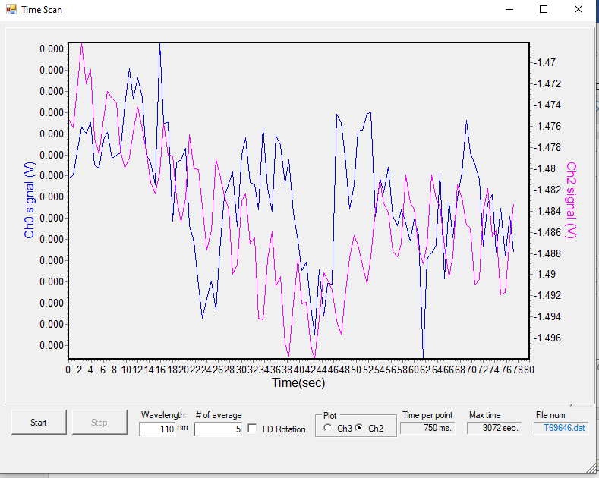

File | λ range | λ step | #av/#sc | Temp/K | Keithley | Table/kstp | PMTVac | Sample
69647 | 110-220 | 0.5 | 15/2 | 60K | 5NPLC | -300 | ON | H2O
69648 | 138-150 | 0.2 |  |  |  | -450 |  | H2O

Dep 2: H2O dosing for 15s at 1e-7mbar
File: T69649
P before deposition: 2e-8 mbar
Temperature of substrate during deposition: 40K
Time start = 37
Time stop = 52
Total dose = 15+15s dose

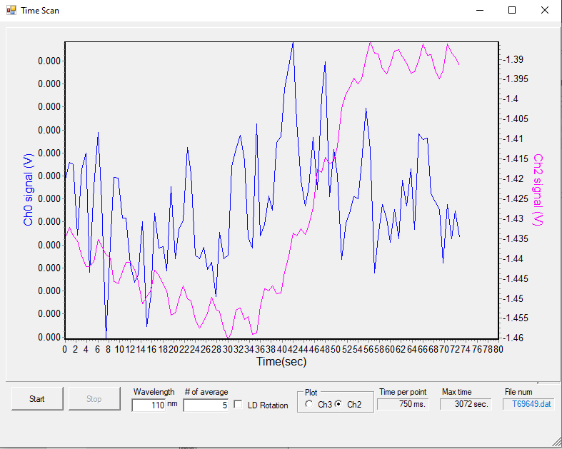

File | λ range | λ step | #av/#sc | Temp/K | Keithley | Table/kstp | PMTVac | Sample
69650 | 110-220 | 0.5 | 15/2 | 60K | 5NPLC | -300 | ON | H2O
69651*  69652 | 138-150 | 0.2 |  |  |  | -450 |  | H2O

Dep 3: H2O dosing for 14s at 1e-7mbar
File: T69653
P before deposition: 2e-8 mbar
Temperature of substrate during deposition: 40K
Time start = 29
Time stop = 43
Total dose = 44s dose

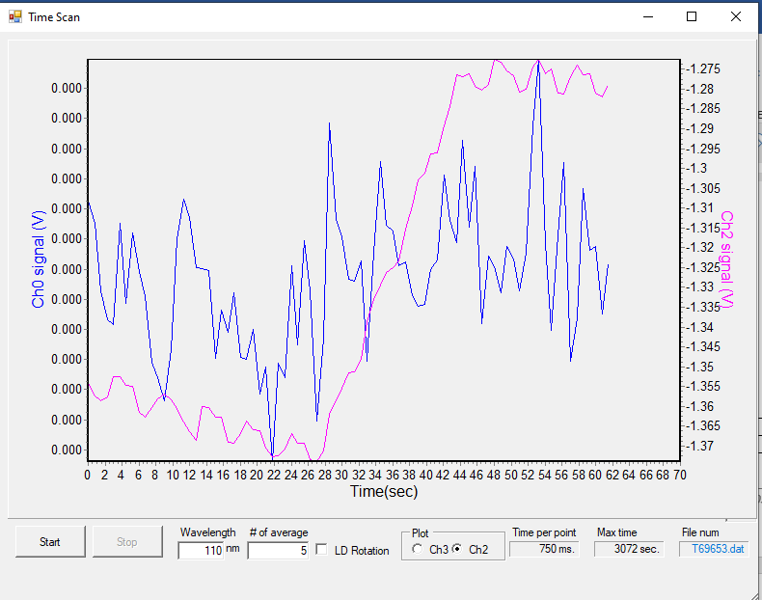

File | λ range | λ step | #av/#sc | Temp/K | Keithley | Table/kstp | PMTVac | Sample
69654 | 110-220 | 0.5 | 15/2 | 60K | 5NPLC | -300 | ON | H2O
69655*  69656 | 138-150 | 0.2 |  |  |  | -450 |  | H2O
* aborted

Thick H2O dosing for 1080s (18 m) at 1e-7mbar
File: T69657
P before deposition: 2e-8 mbar
Temperature of substrate during deposition: 40K
Time start = 28
Time stop = 17m32s
Total dose = 1080+15+15+15s dose

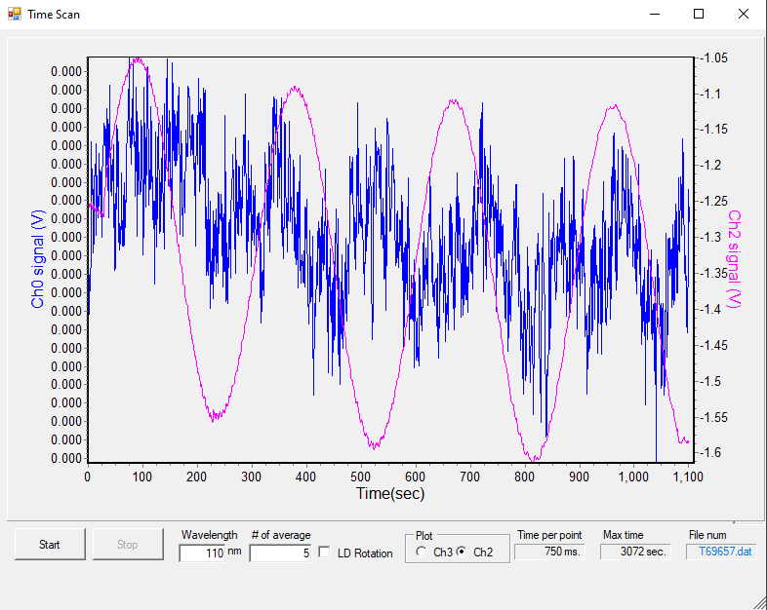

File | λ range | λ step | #av/#sc | Temp/K | Keithley | Table/kstp | PMTVac | Sample
69658 | 175-205 | 0.2 | 15/2 | 40K | 5NPLC | -100 | ON | H2O
69659 | 110-220 | 1 |  |  |  | -300 |  | H2O

Anneal to 50 K
File | λ range | λ step | #av/#sc | Temp/K | Keithley | Table/kstp | PMTVac | Sample
69660*  69661 | 138-150 | 0.2 | 15/2 | 50K | 5NPLC | -450 | ON | H2O
*aborted

Anneal to 60 K
File | λ range | λ step | #av/#sc | Temp/K | Keithley | Table/kstp | PMTVac | Sample
69662 | 138-150 | 0.2 | 15/2 | 60K | 5NPLC | -450 | ON | H2O
69663 | 200-220 | 0.5 |  |  |  | -300

Anneal to 70 K
File | λ range | λ step | #av/#sc | Temp/K | Keithley | Table/kstp | PMTVac | Sample
69664 | 138-150 | 0.2 | 15/2 | 70K | 5NPLC | -450 | ON | H2O

Anneal to 80 K
File | λ range | λ step | #av/#sc | Temp/K | Keithley | Table/kstp | PMTVac | Sample
69665 | 138-150 | 0.2 | 15/2 | 80K | 5NPLC | -450 | ON | H2O

Anneal to 90 K
File | λ range | λ step | #av/#sc | Temp/K | Keithley | Table/kstp | PMTVac | Sample
69666 | 138-150 | 0.2 | 15/2 | 90K | 5NPLC | -450 | ON | H2O

Anneal to 100 K
File | λ range | λ step | #av/#sc | Temp/K | Keithley | Table/kstp | PMTVac | Sample
69667 | 138-150 | 0.2 | 15/2 | 100K | 5NPLC | -450 | ON | H2O

Anneal to 120 K
File | λ range | λ step | #av/#sc | Temp/K | Keithley | Table/kstp | PMTVac | Sample
69668 | 138-150 | 0.2 | 15/2 | 120K | 5NPLC | -450 | ON | H2O

Anneal to 140 K
File | λ range | λ step | #av/#sc | Temp/K | Keithley | Table/kstp | PMTVac | Sample
69669 | 138-150 | 0.2 | 15/2 | 120K | 5NPLC | -450 | ON | H2O
Deosrbing?

Repeat at 140 K
File | λ range | λ step | #av/#sc | Temp/K | Keithley | Table/kstp | PMTVac | Sample
69669 | 138-150 | 0.2 | 15/2 | 120K | 5NPLC | -450 | ON | H2O

Yes desorbing at 140 K

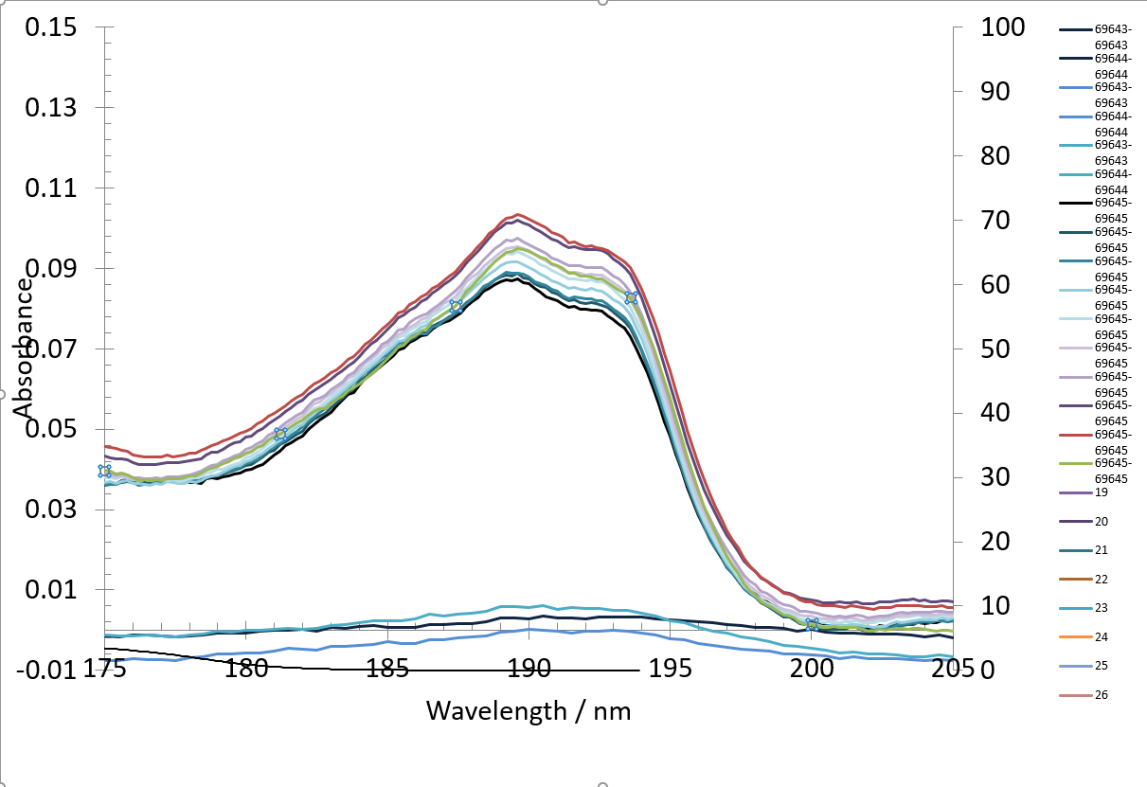

Saturday 28th May 2022 – Deposition at 70 K
08:17 6e-8 mbar T = 271.3 K cryo ON
09:30 only just realized there is no beam
10:30 beam back
11:00 8e-9mbar T = 70 K

BKG scans at 70 K
File | λ range | λ step | #av/#sc | Temp/K | Keithley | Table/kstp | PMTVac | Sample
69671*  69672 | 110-220 | 0.5 | 15/2 | 70K | 5NPLC | -300 | ON | Clean MgF2
69673*  69674 | 138-150 | 0.2 |  |  |  | -450 |  | Clean MgF2
69675 | 175-205 | 0.2 |  |  |  | -100 |  | Clean MgF2

*Aborted beam in decay 40 mA annnnd needed more coffee

Dep 1: H2O dosing for 15s at 1e-7mbar
File: T69676
P before deposition: 2e-8 mbar
Temperature of substrate during deposition: 70K
Time start = 29
Time stop = 44
Total dose =15 s dose
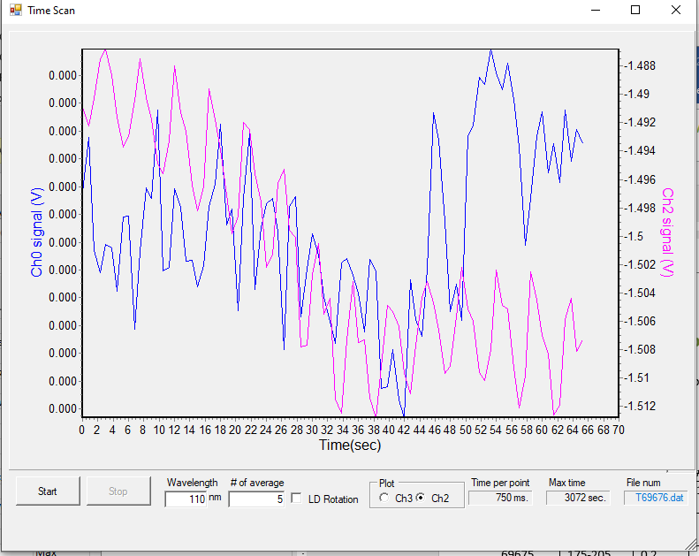

File | λ range | λ step | #av/#sc | Temp/K | Keithley | Table/kstp | PMTVac | Sample
69677 | 110-220 | 0.5 | 15/2 | 70K | 5NPLC | -300 | ON | H2O
69678 | 138-150 | 0.2 |  |  |  | -450 |  | H2O

Dep 2: H2O dosing for 15s at 1e-7mbar
File: T69679
P before deposition: 2e-8 mbar
Temperature of substrate during deposition: 70K
Time start = 31s
Time stop = 46s
Total dose =15 + 15 +15 s dose

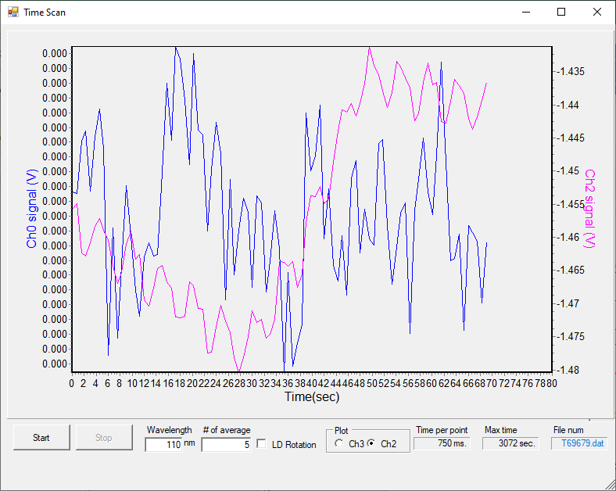

File | λ range | λ step | #av/#sc | Temp/K | Keithley | Table/kstp | PMTVac | Sample
69679*  69680 | 110-220 | 0.5 | 15/2 | 70K | 5NPLC | -300 | ON | H2O
69681 | 138-150 | 0.2 |  |  |  | -450 |  | H2O
*aborted

Dep 3: H2O dosing for 15s at 1e-7mbar
File: T69682
P before deposition: 2e-8 mbar
Temperature of substrate during deposition: 70K
Time start = 44s
Time stop = 59s
Total dose =15 + 15 + 15 s dose
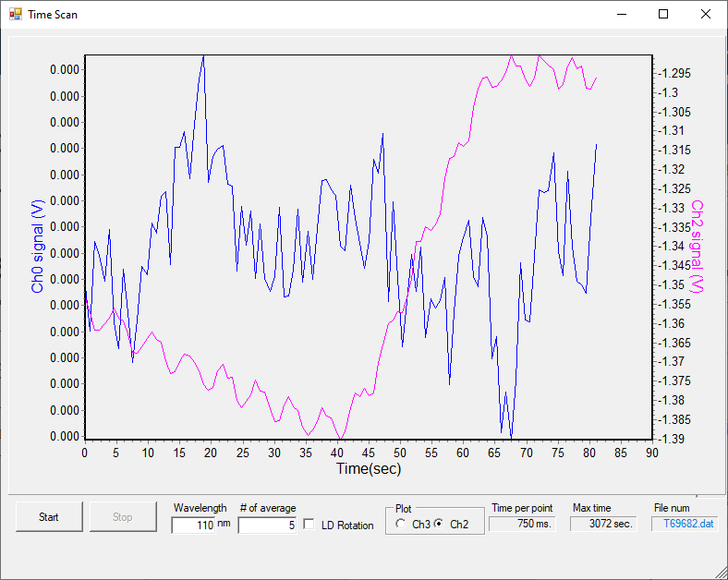

File | λ range | λ step | #av/#sc | Temp/K | Keithley | Table/kstp | PMTVac | Sample
69683 | 110-220 | 0.5 | 15/2 | 70K | 5NPLC | -300 | ON | H2O
69684 | 138-150 | 0.2 |  |  |  | -450 |  | H2O

H2O dep 4: dosing for 15s at 1e-7mbar
File: T69685
P before deposition: 2e-8 mbar
Temperature of substrate during deposition: 70K
Time start = 33s
Time stop = 48s
Total dose =15 + 15 + 15 + 15 s dose

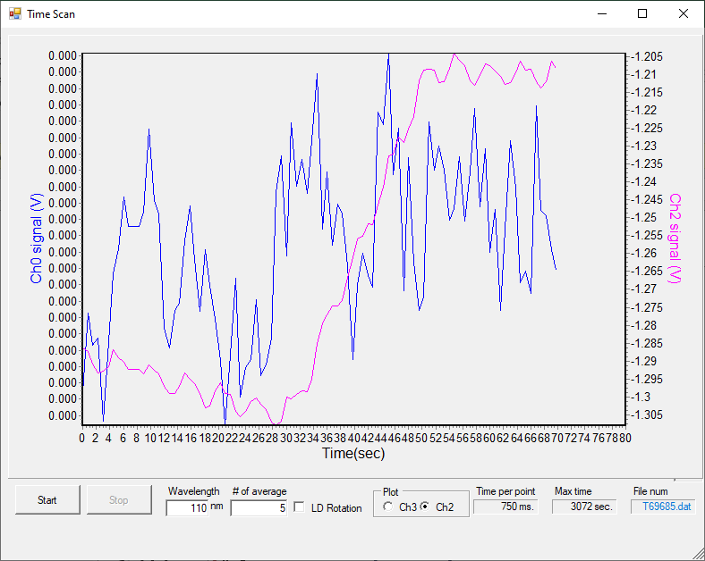

File | λ range | λ step | #av/#sc | Temp/K | Keithley | Table/kstp | PMTVac | Sample
69686 | 110-220 | 0.5 | 15/2 | 70K | 5NPLC | -300 | ON | H2O
69687*  68688 | 138-150 | 0.2 |  |  |  | -450 |  | H2O

Thick dep: H2O dosing for 30min at 1e-7mbar
File: T69689
P before deposition: 2e-8 mbar
Temperature of substrate during deposition: 70K
Time start = 27 s
Time stop = 30 m 27s
Total dose =15 + 15 + 15 + 15 s dose

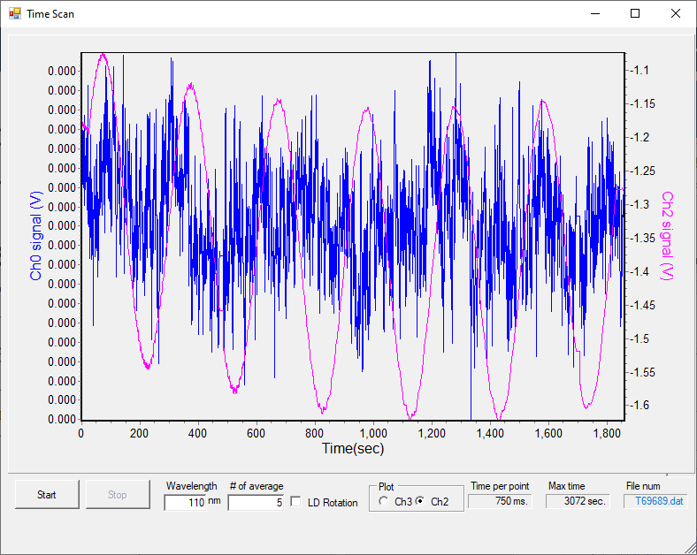

File | λ range | λ step | #av/#sc | Temp/K | Keithley | Table/kstp | PMTVac | Sample
69690  69691 | 175-205 | 0.2 | 15/2 | 70 K | 5NPLC | -100 | ON | H2O

Anneal to 80 K
File | λ range | λ step | #av/#sc | Temp/K | Keithley | Table/kstp | PMTVac | Sample
69692 | 175-205 | 0.2 | 15/2 | 70 K | 5NPLC | -100 | ON | H2O

Anneal to 90 K
File | λ range | λ step | #av/#sc | Temp/K | Keithley | Table/kstp | PMTVac | Sample
69693 | 175-205 | 0.2 | 15/2 | 70 K | 5NPLC | -100 | ON | H2O

Anneal to 100 K
File | λ range | λ step | #av/#sc | Temp/K | Keithley | Table/kstp | PMTVac | Sample
69694 | 175-205 | 0.2 | 15/2 | 70 K | 5NPLC | -100 | ON | H2O

Anneal to 120 K
File | λ range | λ step | #av/#sc | Temp/K | Keithley | Table/kstp | PMTVac | Sample
69695 | 175-205 | 0.2 | 15/2 | 70 K | 5NPLC | -100 | ON | H2O

Anneal to 140 K
File | λ range | λ step | #av/#sc | Temp/K | Keithley | Table/kstp | PMTVac | Sample
69696 | 175-205 | 0.2 | 15/2 | 70 K | 5NPLC | -100 | ON | H2O

Anneal to 160 K
File | λ range | λ step | #av/#sc | Temp/K | Keithley | Table/kstp | PMTVac | Sample
69697 | 175-205 | 0.2 | 15/2 | 70 K | 5NPLC | -100 | ON | H2O

Repeat at 160 K
File | λ range | λ step | #av/#sc | Temp/K | Keithley | Table/kstp | PMTVac | Sample
69698 | 175-205 | 0.2 | 15/2 | 70 K | 5NPLC | -100 | ON | H2O

Anneal to 180 K
File | λ range | λ step | #av/#sc | Temp/K | Keithley | Table/kstp | PMTVac | Sample
69699 | 175-205 | 0.2 | 15/2 | 70 K | 5NPLC | -100 | ON | H2O

Desorbed - 69700

Saturday 28th May 2022 – Deposition at 120 K

BKG scans at 120 K
File | λ range | λ step | #av/#sc | Temp/K | Keithley | Table/kstp | PMTVac | Sample
69701 | 110-220 | 0.5 | 15/2 | 120K | 5NPLC | -300 | ON | Clean MgF2
69702 | 138-150 | 0.2 |  |  |  | -450 |  | Clean MgF2
69703 | 175-205 | 0.2 |  |  |  | -100 |  | Clean MgF2

*Aborted beam in decay 40 mA annnnd needed more coffee

Dep 1: H2O dosing for 15s at 1e-7mbar
File: T69704
P before deposition: 2e-8 mbar
Temperature of substrate during deposition: 120K
Laser signal: 14uA
Time start = 30
Time stop = 45
Total dose = 15s dose
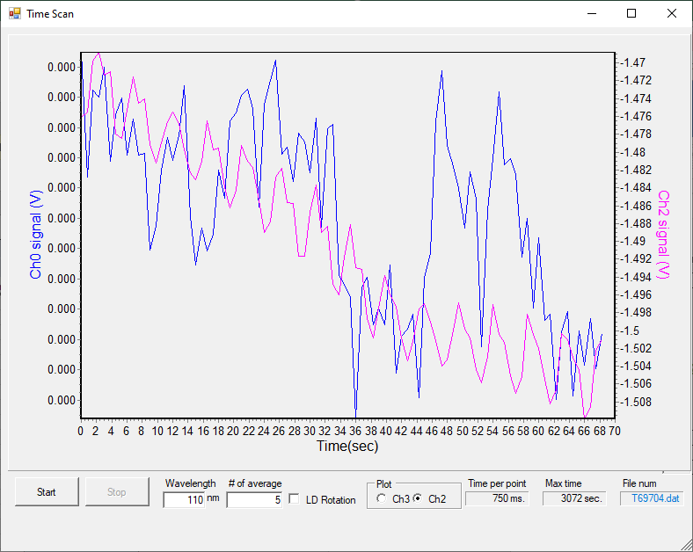

File | λ range | λ step | #av/#sc | Temp/K | Keithley | Table/kstp | PMTVac | Sample
69705 | 110-220 | 0.5 | 15/2 | 120K | 5NPLC | -300 | ON | H2O
69706 | 138-150 | 0.2 |  |  |  | -450 |  | H2O
69707 | 110-220 | 0.5 |  |  |  | -100 |  | H2O

Ice appears to be changing?
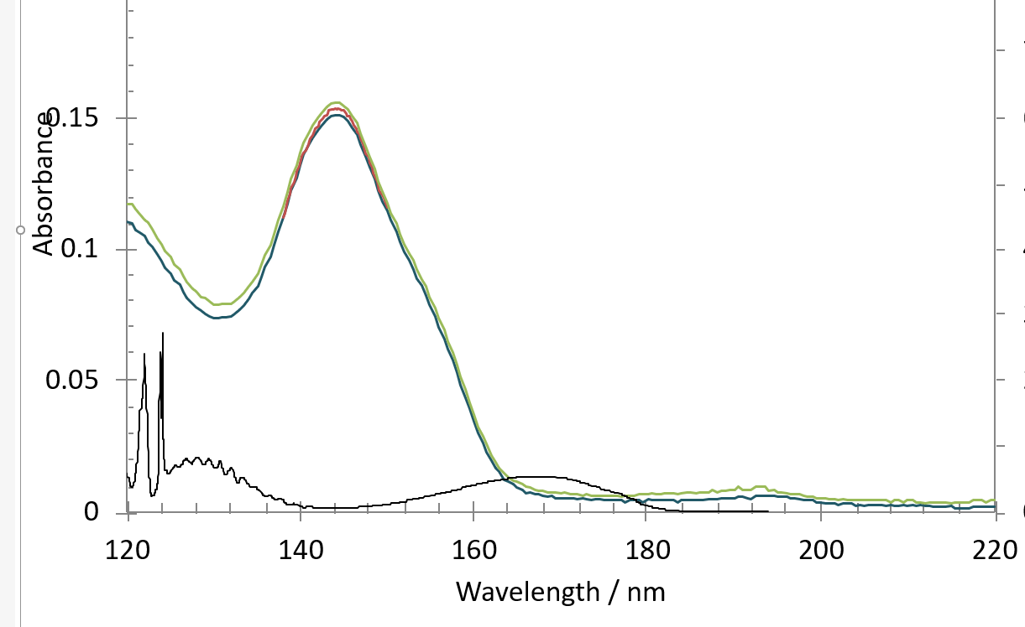

File | λ range | λ step | #av/#sc | Temp/K | Keithley | Table/kstp | PMTVac | Sample
69708 | 110-220 | 0.5 | 15/2 | 120K | 5NPLC | -300 | ON | Clean MgF2
Stopped growing… weird.

Dep 2: H2O dosing for 15s at 1e-7mbar
File: T69709
P before deposition: 2e-8 mbar
Temperature of substrate during deposition: 120K
Laser signal: 14uA
Time start = 30s
Time stop = 45s
Total dose = 15+15s dose
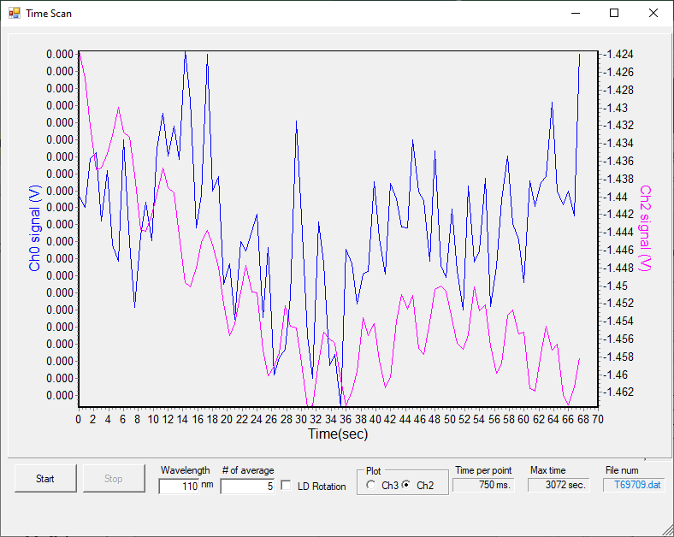

File | λ range | λ step | #av/#sc | Temp/K | Keithley | Table/kstp | PMTVac | Sample
69710 | 110-220 | 0.5 | 15/2 | 120K | 5NPLC | -300 | ON | H2O
69711 | 138-150 | 0.2 |  |  |  | -450 |  | H2O

Dep 3: H2O dosing for 15s at 1e-7mbar
File: T69712
P before deposition: 2e-8 mbar
Temperature of substrate during deposition: 120K
Laser signal: 13uA
Time start = 25 s
Time stop = 40 s
Total dose =15+15+ 15s dose

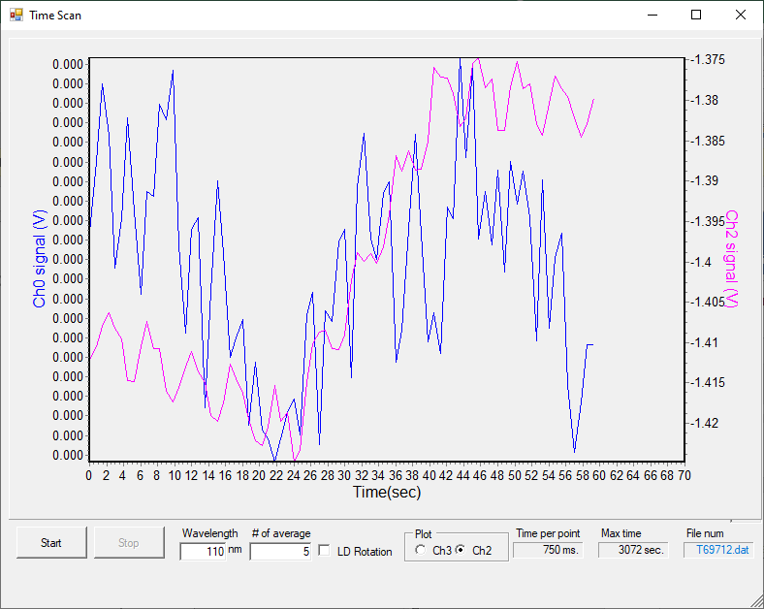

File | λ range | λ step | #av/#sc | Temp/K | Keithley | Table/kstp | PMTVac | Sample
69713 | 110-220 | 0.5 | 15/2 | 120K | 5NPLC | -300 | ON | H2O
69714 | 138-150 | 0.2 |  |  |  | -450 |  | H2O

Dep 4: H2O dosing for 15s at 1e-7mbar
File: T69715
P before deposition: 2e-8 mbar
Temperature of substrate during deposition: 120K
Laser signal: 13uA
Time start = 25 s
Time stop = 40 s
Total dose =15+15+ 15+15s dose

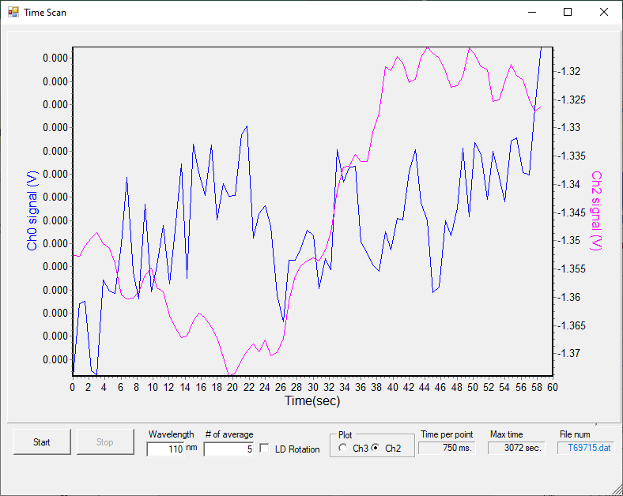

File | λ range | λ step | #av/#sc | Temp/K | Keithley | Table/kstp | PMTVac | Sample
69716*  69717 | 110-220 | 0.5 | 15/2 | 120K | 5NPLC | -300 | ON | H2O
69718 | 138-150 | 0.2 |  |  |  | -450 |  | H2O
*aborted

Thick H2O dosing for 30 min at 1e-7mbar
File: T69719
P before deposition: 2e-8 mbar
Temperature of substrate during deposition: 120K
Laser signal: 13uA
Time start = 31 s
Time stop = 30m 31 s
Total dose =15+15+ 15+15s dose

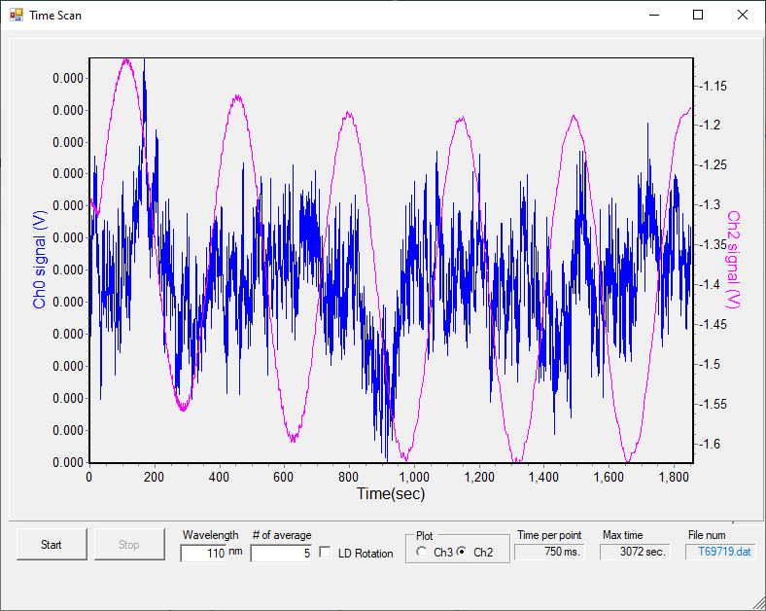
File | λ range | λ step | #av/#sc | Temp/K | Keithley | Table/kstp | PMTVac | Sample
69720*  69721 | 175-205 | 0.2 | 15/2 | 70 K | 5NPLC | -100 | ON | H2O
*aborted

Anneal to 120 K

File | λ range | λ step | #av/#sc | Temp/K | Keithley | Table/kstp | PMTVac | Sample
69722 | 175-205 | 0.2 | 15/2 | 70 K | 5NPLC | -100 | ON | H2O

Sunday 29th May – Deposition at 30 K

08:16 P = 2e-8 mbar T = 269.9 K cryo ON
09:53 P = 5e-9 T = 30 K

BKG scans at 30 K
File | λ range | λ step | #av/#sc | Temp/K | Keithley | Table/kstp | PMTVac | Sample
69723 | 110-220 | 0.5 | 15/2 | 30K | 5NPLC | -300 | ON | Clean MgF2
69724*  69725*  69726 | 138-150 | 0.2 |  |  |  | -450 |  | Clean MgF2
69727 | 175-205 | 0.2 |  |  |  | -100 |  | Clean MgF2
*aborted

Dep 1: H2O dosing for 11s at 1-4e-7mbar (a bit of wild dep)
File: T69728
P before deposition: 4e-8 mbar
Temperature of substrate during deposition: 30K
Laser signal: 15 uA
Time start = 38 s
Time stop = 49
Total dose =11 s dose

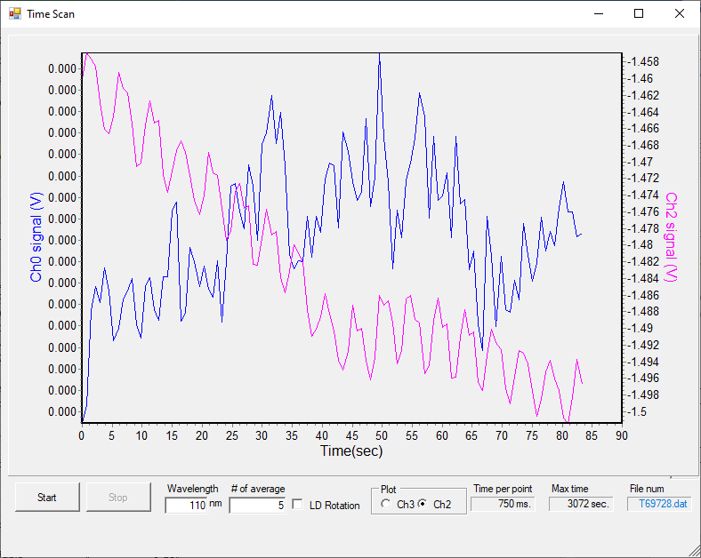

File | λ range | λ step | #av/#sc | Temp/K | Keithley | Table/kstp | PMTVac | Sample
69729 | 110-220 | 0.5 | 15/2 | 30K | 5NPLC | -300 | ON | H2O
69730 | 138-150 | 0.2 |  |  |  | -450 |  | H2O

Dep 1: H2O dosing for 15s at 1-4e-7mbar
File: T69731
P before deposition: 4e-8 mbar
Temperature of substrate during deposition: 30K
Laser signal: 14.4 uA
Time start = 34 s
Time stop = 49 s
Total dose =11 s dose

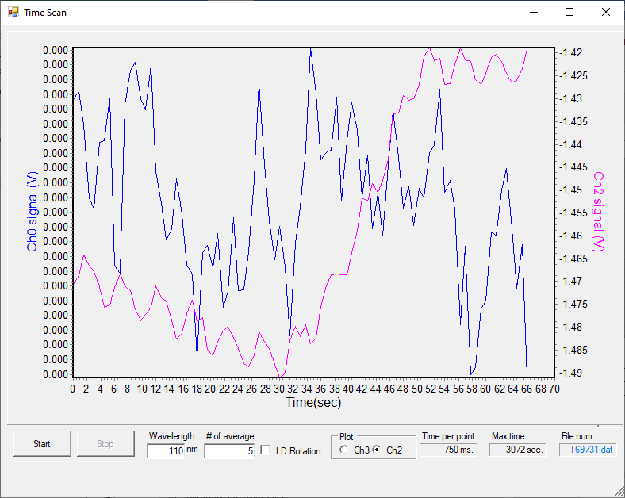

File | λ range | λ step | #av/#sc | Temp/K | Keithley | Table/kstp | PMTVac | Sample
69732 | 110-220 | 0.5 | 15/2 | 30K | 5NPLC | -300 | ON | H2O
69733 | 138-150 | 0.2 |  |  |  | -450 |  | H2O

Dep 3: H2O dosing for 15s at 1-4e-7mbar
File: T69735
P before deposition: 4e-8 mbar
Temperature of substrate during deposition: 30K
Laser signal: 13.4 uA
Time start = 28 s
Time stop = 43 s
Total dose =11+15+15 s dose

69734 aborted

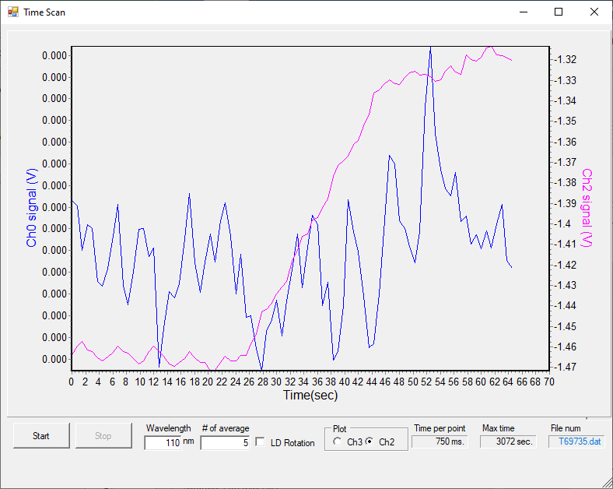

File | λ range | λ step | #av/#sc | Temp/K | Keithley | Table/kstp | PMTVac | Sample
69736 | 110-220 | 0.5 | 15/2 | 30K | 5NPLC | -300 | ON | H2O
69737 | 138-150 | 0.2 |  |  |  | -450 |  | H2O

Dep 4: H2O dosing for 15s at 1-4e-7mbar
File: T69738
P before deposition: 4e-8 mbar
Temperature of substrate during deposition: 30K
Laser signal: 12.3 uA
Time start = 28 s
Time stop = 43 s
Total dose =11+15+15+15s dose
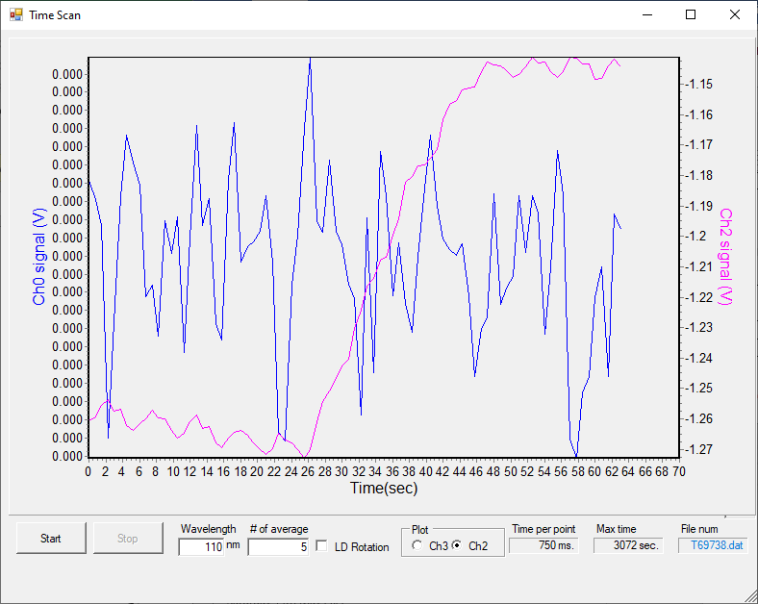

File | λ range | λ step | #av/#sc | Temp/K | Keithley | Table/kstp | PMTVac | Sample
69739 | 110-220 | 0.5 | 15/2 | 30K | 5NPLC | -300 | ON | H2O
69740 | 138-150 | 0.2 |  |  |  | -450 |  | H2O

Dep 5: H2O dosing for 15s at 1-4e-7mbar
File: T69741
P before deposition: 4e-8 mbar
Temperature of substrate during deposition: 30K
Laser signal: 12.3 uA
Time start = 28 s
Time stop = 43 s
Total dose =11+15+15+15+15s dose
File | λ range | λ step | #av/#sc | Temp/K | Keithley | Table/kstp | PMTVac | Sample
69742 | 110-220 | 0.5 | 15/2 | 30K | 5NPLC | -300 | ON | H2O
69743 | 138-150 | 0.2 |  |  |  | -450 |  | H2O

Thick H2O dep: dosing for 30 min at 1-4e-7mbar
File: T69744
P before deposition: 4e-8 mbar
Temperature of substrate during deposition: 30K
Laser signal: 12.3 uA
Time start = 30 s
Time stop = 30 m 30 s
Total dose =11+15+15+15+15s dose
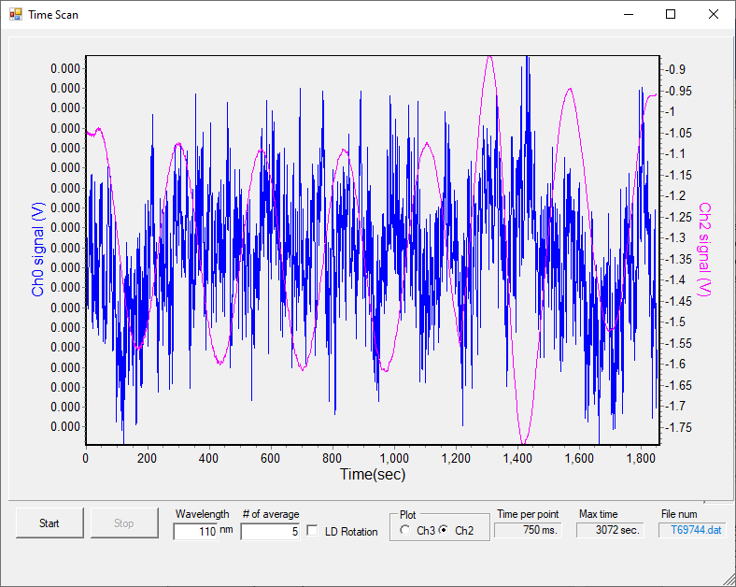

File | λ range | λ step | #av/#sc | Temp/K | Keithley | Table/kstp | PMTVac | Sample
69745 | 175-205 | 0.2 | 15/2 | 30K | 5NPLC | -100 | ON | H2O

Sunday 29th May – Deposition at 90 K

BKG scans at 90 K
File | λ range | λ step | #av/#sc | Temp/K | Keithley | Table/kstp | PMTVac | Sample
69746 | 110-220 | 0.5 | 15/2 | 30K | 5NPLC | -300 | ON | Clean MgF2
69747 | 138-150 | 0.2 |  |  |  | -450 |  | Clean MgF2
69748 | 175-205 | 0.2 |  |  |  | -100 |  | Clean MgF2

Dep 1: H2O dosing for 15s at 1.1e-7mbar
File: T69749
P before deposition: 9e-9 mbar
Temperature of substrate during deposition: 30K
Laser signal: 14 uA
Time start = 34 s
Time stop = 49 s
Total dose =15s dose
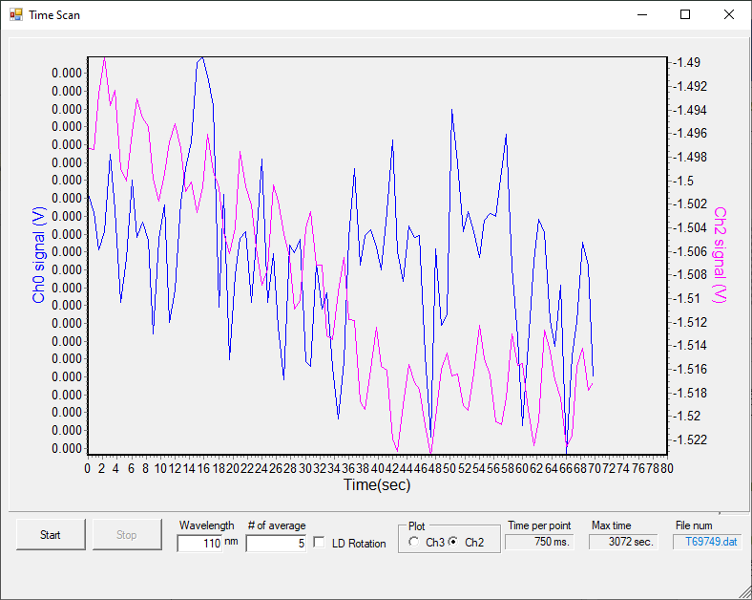

File | λ range | λ step | #av/#sc | Temp/K | Keithley | Table/kstp | PMTVac | Sample
69750*  69751*  69752 | 110-220 | 0.5 | 15/2 | 30K | 5NPLC | -300 | ON | H2O
69753 | 138-150 | 0.2 |  |  |  | -450 |  | H2O
*aborted

Dep 2: H2O dosing for 15s at 1.1e-7mbar
File: T69754
P before deposition: 9e-9 mbar
Temperature of substrate during deposition: 30K
Laser signal: 14.5 uA
Time start = 28 s
Time stop = 43 s
Total dose =15+15s dose
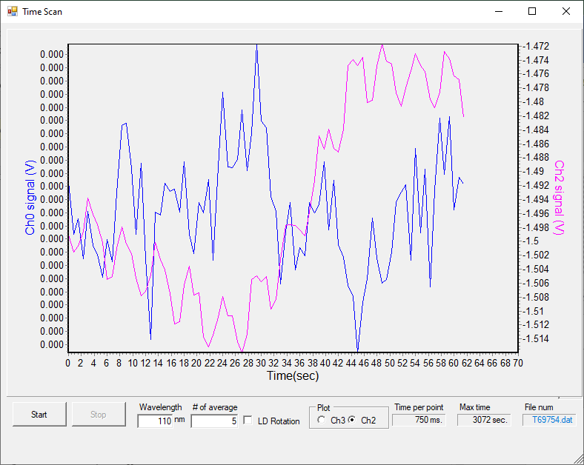

File | λ range | λ step | #av/#sc | Temp/K | Keithley | Table/kstp | PMTVac | Sample
69755 | 110-220 | 0.5 | 15/2 | 30K | 5NPLC | -300 | ON | H2O
69756 | 138-150 | 0.2 |  |  |  | -450 |  | H2O

Dep 3: H2O dosing for 15s at 1.1e-7mbar
File: T69757
P before deposition: 9e-9 mbar
Temperature of substrate during deposition: 30K
Laser signal: 14.3 uA
Time start = 29 s
Time stop = 44 s
Total dose =15+15+15s dose

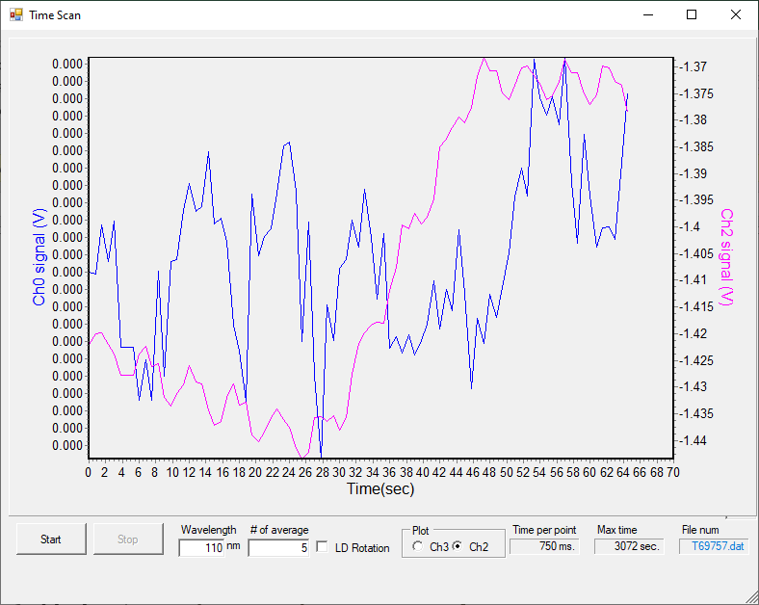

File | λ range | λ step | #av/#sc | Temp/K | Keithley | Table/kstp | PMTVac | Sample
69758 | 110-220 | 0.5 | 15/2 | 30K | 5NPLC | -300 | ON | H2O
69759 | 138-150 | 0.2 |  |  |  | -450 |  | H2O

Dep 4: H2O dosing for 15s at 1.1e-7mbar
File: T69760
P before deposition: 9e-9 mbar
Temperature of substrate during deposition: 30K
Laser signal: 14.3 uA
Time start = 29 s
Time stop = 44 s
Total dose =15+15+15s dose

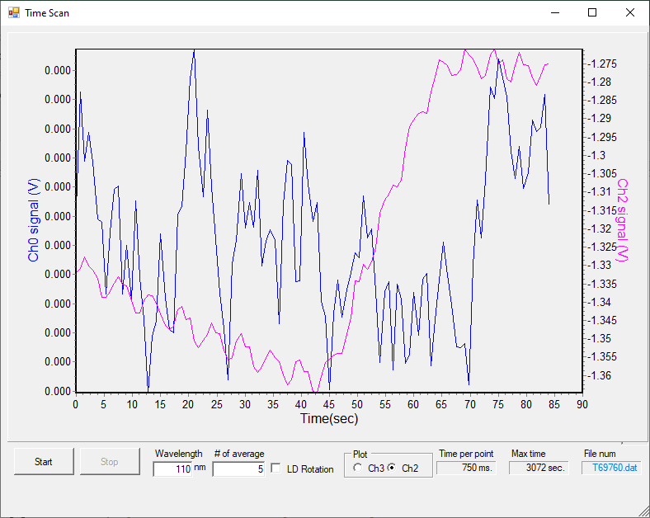

File | λ range | λ step | #av/#sc | Temp/K | Keithley | Table/kstp | PMTVac | Sample
69761 | 110-220 | 0.5 | 15/2 | 30K | 5NPLC | -300 | ON | H2O
69762 | 138-150 | 0.2 |  |  |  | -450 |  | H2O

Dep 5: H2O dosing for 15s at 1.1e-7mbar
File: T69763
P before deposition: 9e-9 mbar
Temperature of substrate during deposition: 30K
Laser signal: 12.5 uA
Time start = 30 s
Time stop = 43 s
Total dose =15+15+15s dose

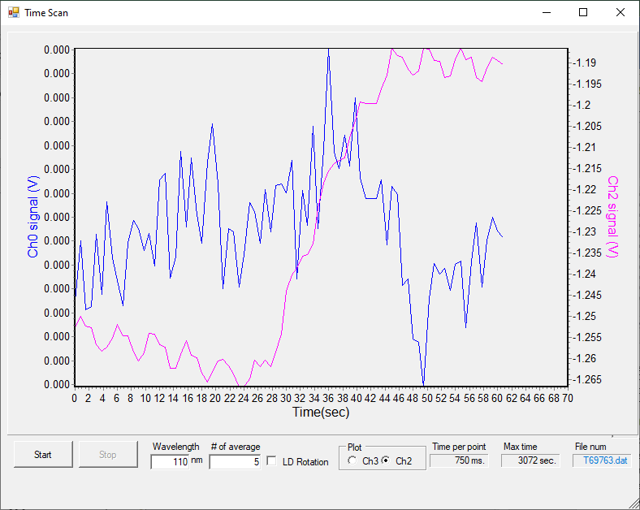

File | λ range | λ step | #av/#sc | Temp/K | Keithley | Table/kstp | PMTVac | Sample
69764 | 110-220 | 0.5 | 15/2 | 30K | 5NPLC | -300 | ON | H2O
69765 | 138-150 | 0.2 |  |  |  | -450 |  | H2O

Thick H2O dep: dosing for 30min at 1.1e-7mbar
File: T69766
P before deposition: 9e-9 mbar
Temperature of substrate during deposition: 30K
Laser signal: 12 uA
Time start = 30 s
Time stop = 30min 30 s
Total dose =15+15+15+15+15s + 30min dose
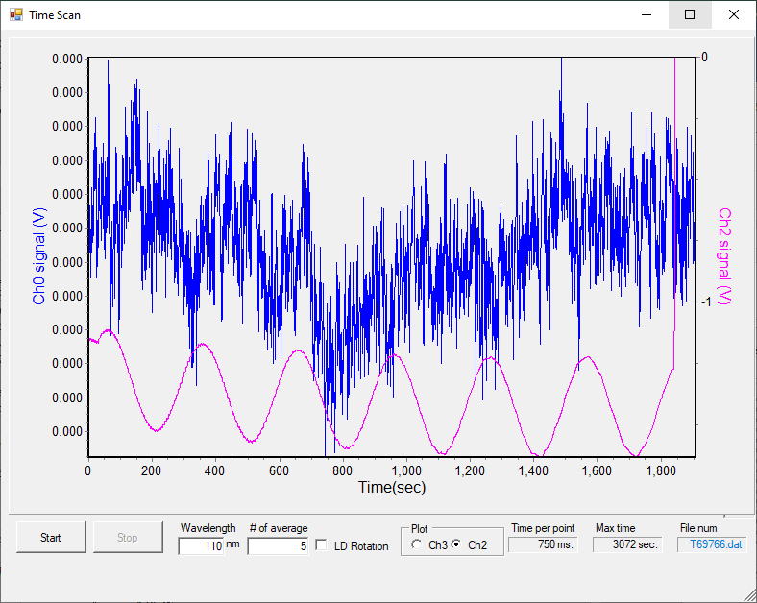

File | λ range | λ step | #av/#sc | Temp/K | Keithley | Table/kstp | PMTVac | Sample
69767 | 175-205 | 0.2 | 15/2 | 30K | 5NPLC | -100 | ON | H2O

20:57 cryo OFF

Monday 30th May 2022 – Deposition at 80 K

08:00 p = 1.4e-8 mbar T = 276.5 K

Turn off gauge and monitor diode signal while JSn is doing some tests in the ring. Problems on the AMO beamline with the new settings applied to the ring on Friday the 20th May which gives a higher lifetime.

REMEMBER TO RESET Keithley to correct settings for scanning. DONE!!

09:30 CRYO ON.

14:27 P=6e-8 mbar T=80K

BKG scans at 80 K
File | λ range | λ step | #av/#sc | Temp/K | Keithley | Table/kstp | PMTVac | Sample
69768 | 110-220 | 0.5 | 15/2 | 80K | 5NPLC | -300 | ON | Clean MgF2
69769 | 138-150 | 0.2 |  |  |  | -450 |  | Clean MgF2
69770 | 175-205 | 0.2 |  |  |  | -100 |  | Clean MgF2

Gas line dep fail
File: T69771.dat
69772 aborted
I just deposited ‘vacuum’ from the gas line… idiot. Maybe more caffeine is required.

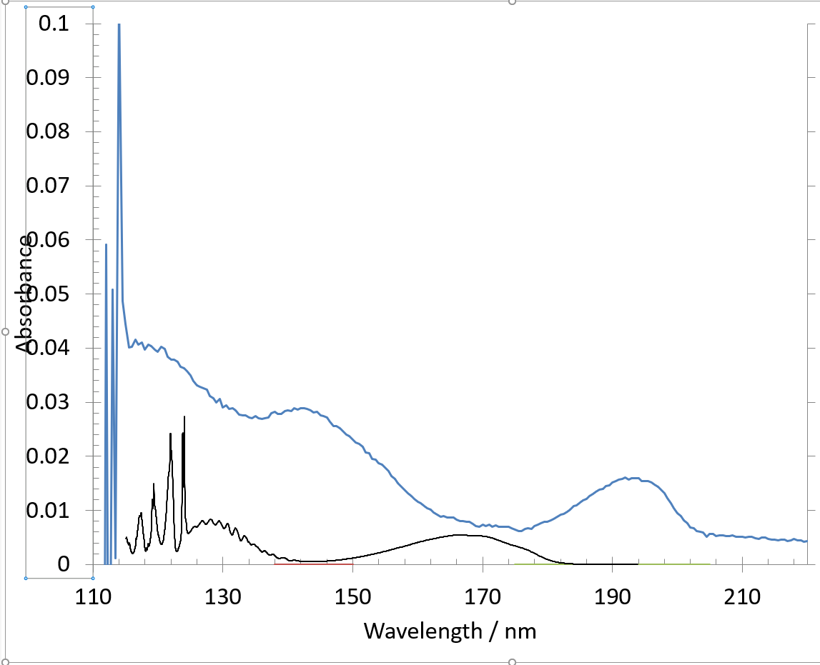
What is it? Pressure increase to 1e-6 mbar around 117-120 K – has it desorbed?

69771 and 69772 ABORTED.

File | λ range | λ step | #av/#sc | Temp/K | Keithley | Table/kstp | PMTVac | Sample
69773 | 110-220 | 0.5 | 15/1 | 80K | 5NPLC | -300 | ON | H2O
69774 |  |  | 15/2 | Heating |  |  |  | H2O
69775 |  |  |  | Heating |  |  |  | H2O
Something on the surface in 69773, fortunately only very low absorbance.
Started heating on the substrate and then measured both 69774 and 75 while the heater was on.
Apparently this does not work and gives a false signal on the diode, possibly giving off some light while on, such that there is current measured on the diode below the onset at 114 nm.

Stopped heating on the substrate and then measure again.

File | λ range | λ step | #av/#sc | Temp/K | Keithley | Table/kstp | PMTVac | Sample
69777 | 110-220 | 0.5 | 15/2 | 80 K | 5NPLC | -300 | ON | H2O
69778 | 138-150 | 0.2 |  |  |  | -450 |  | H2O
69779 | 175-205 | 0.2 |  |  |  | -100 |  | H2O

Turned combi gauge on after bkg scans and pressure at 1e-7 mbar but decreasing. Strange.

Dep 1: H2O dosing for 15s at 1.1e-7mbar
File: T69780
P before deposition: 3e-8 mbar
Temperature of substrate during deposition: 30K
Laser signal: 12.5 uA
Time start = 26 s
Time stop = 41 s
Total dose =15s dose

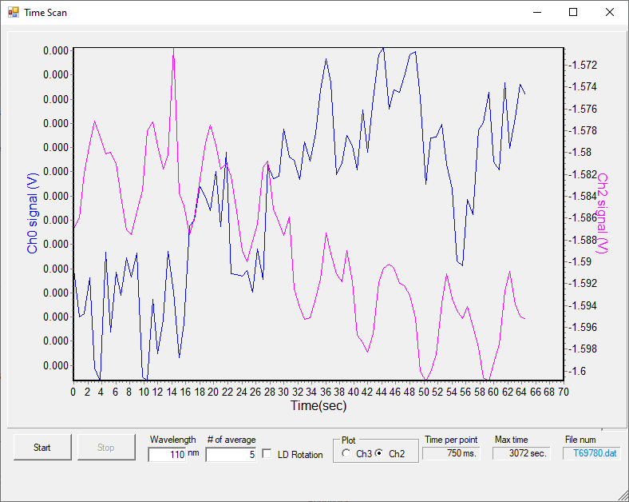

File | λ range | λ step | #av/#sc | Temp/K | Keithley | Table/kstp | PMTVac | Sample
69781 | 110-220 | 0.5 | 15/2 | 80 K | 5NPLC | -300 | ON | H2O
69782 | 138-150 | 0.2 |  |  |  | -450 |  | H2O

Dep 2: H2O dosing for 15s at 1.1e-7mbar
File: T69783
P before deposition: 3e-8 mbar
Temperature of substrate during deposition: 30K
Laser signal: 14.3 uA
Time start = 30 s
Time stop = 45 s
Total dose =15+15s dose
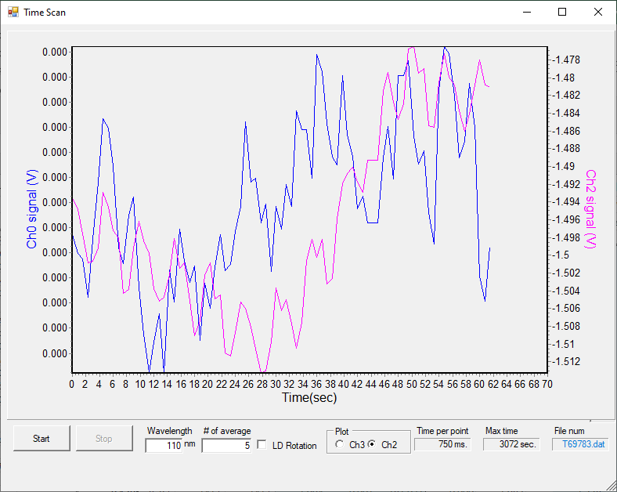

File | λ range | λ step | #av/#sc | Temp/K | Keithley | Table/kstp | PMTVac | Sample
69784 | 110-220 | 0.5 | 15/2 | 80 K | 5NPLC | -300 | ON | H2O
69785 | 138-150 | 0.2 |  |  |  | -450 |  | H2O

Dep 3: H2O dosing for 15s at 1.1e-7mbar
File: T69786
P before deposition: 3e-8 mbar
Temperature of substrate during deposition: 80K
Laser signal: 14.3 uA
Time start = 24 s
Time stop = 39 s
Total dose =15+15+15s dose

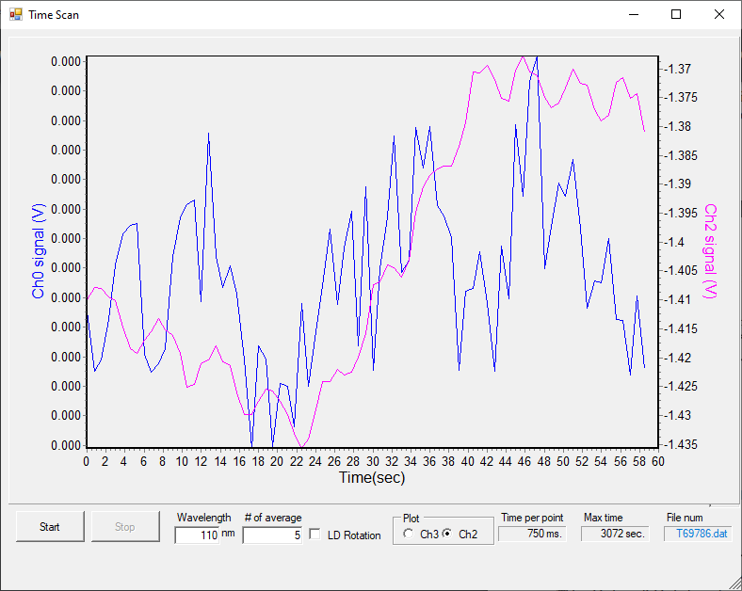

File | λ range | λ step | #av/#sc | Temp/K | Keithley | Table/kstp | PMTVac | Sample
69787 | 110-220 | 0.5 | 15/2 | 80 K | 5NPLC | -300 | ON | H2O
69788 | 138-150 | 0.2 |  |  |  | -450 |  | H2O

Dep 4: H2O dosing for 15s at 1.1e-7mbar
File: T69789
P before deposition: 3e-8 mbar
Temperature of substrate during deposition: 80K
Laser signal: 13.3 uA
Time start = 22 s
Time stop = 37 s
Total dose =15+15+15+15s dose
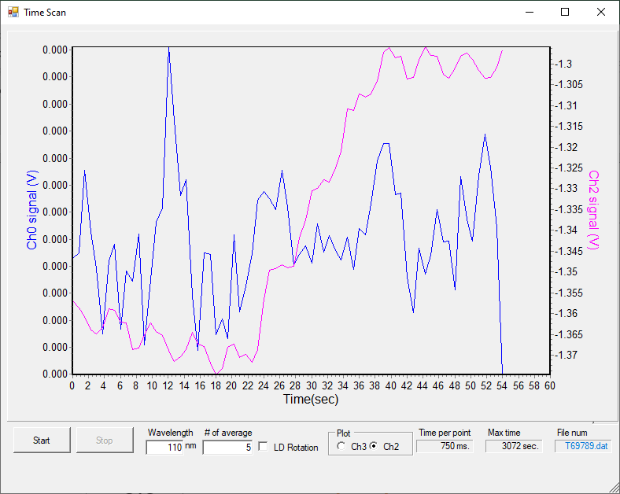

File | λ range | λ step | #av/#sc | Temp/K | Keithley | Table/kstp | PMTVac | Sample
69790 | 110-220 | 0.5 | 15/2 | 80 K | 5NPLC | -300 | ON | H2O
69791 | 138-150 | 0.2 |  |  |  | -450 |  | H2O

Dep 5: H2O dosing for 15s at 1.1e-7mbar
File: T69792
P before deposition: 3e-8 mbar
Temperature of substrate during deposition: 80K
Laser signal: 13.3 uA
Time start = 25 s
Time stop = 40 s
Total dose =15+15+15+15+15s dose
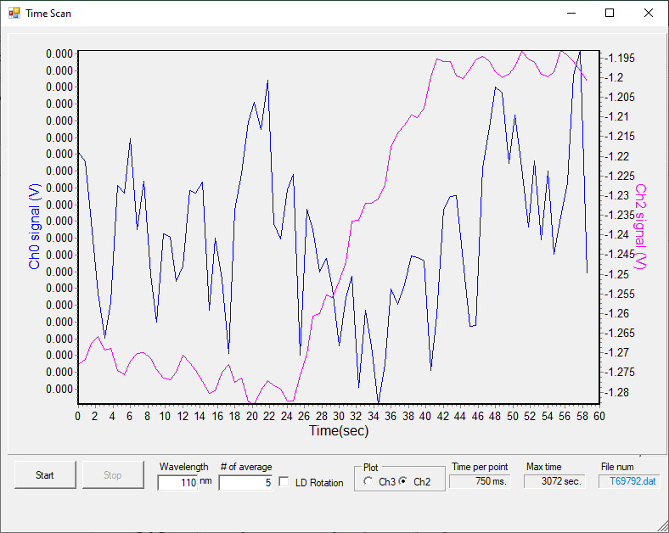

File | λ range | λ step | #av/#sc | Temp/K | Keithley | Table/kstp | PMTVac | Sample
69793 | 110-220 | 0.5 | 15/2 | 80 K | 5NPLC | -300 | ON | H2O
69794 | 138-150 | 0.2 |  |  |  | -450 |  | H2O

Thick H2O dep: dosing for 30 min at 1.1e-7mbar
File: T69795
P before deposition: 3e-8 mbar
Temperature of substrate during deposition: 80K
Laser signal: 11.3 uA
Time start = 29 s
Time stop = 30min24 s
Total dose =15+15+15+15+15s dose

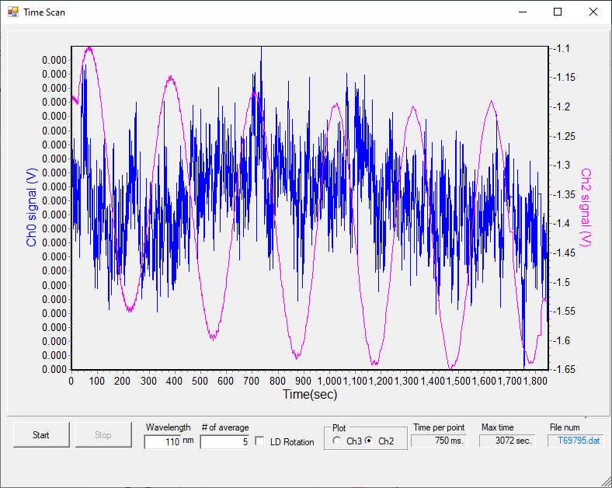
File | λ range | λ step | #av/#sc | Temp/K | Keithley | Table/kstp | PMTVac | Sample
69796 | 175-205 | 0.2 | 15/2 | 80 K | 5NPLC | -100 | ON | H2O

No ice?

Even thicker H2O dep: dosing for 3 min at 1.1e-6mbar
File: T69795
P before deposition: 3e-8 mbar
Temperature of substrate during deposition: 80K
Laser signal: 11.3 uA
Time start = 35 s
Time stop = 3 min58 s
Total dose =15+15+15+15+15 + 30min +3 min(1e-6mbar) s dose
File | λ range | λ step | #av/#sc | Temp/K | Keithley | Table/kstp | PMTVac | Sample
69800 | 110-175 | 0.5 | 15/2 | 80 K | 5NPLC | -300 | ON | H2O

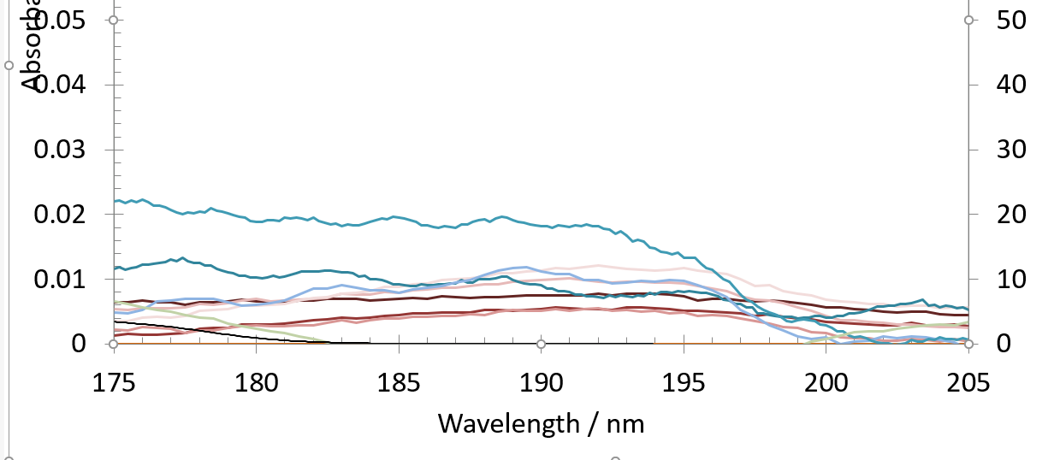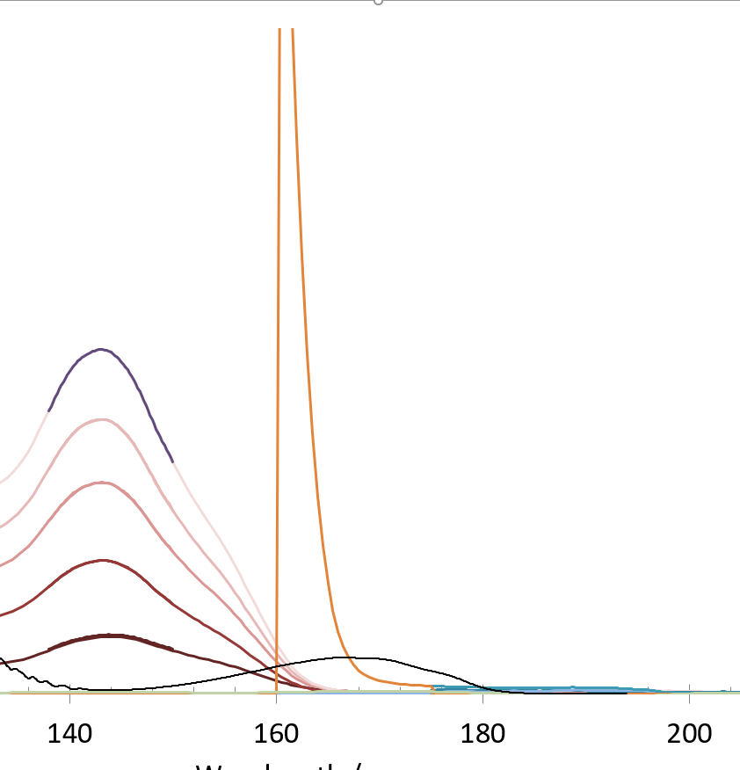

No peak for 190nm peak compared to other deps… puzzling.

Tuesday 31st May 2022 – Deposition at 20 K (repeat)

07:40 p = 1.4e-8 mbar T = 269.3 K
CRYO ON

09:23 p = 4 e-9 mbar T = 19.2 K

BKG scans at 19.1 K
File | λ range | λ step | #av/#sc | Temp/K | Keithley | Table/kstp | PMTVac | Sample
69801 | 110-220 | 0.5 | 15/2 | 20K | 5NPLC | -300 | ON | Clean MgF2
69802*  69803 | 138-150 | 0.2 |  |  |  | -450 |  | Clean MgF2
69804 | 175-205 | 0.2 |  |  |  | -100 |  | Clean MgF2
*aborted

Dep 1: H2O dosing for 15s at 1.1e-7mbar
File: T69805
P before deposition: 3e-8 mbar
Temperature of substrate during deposition: 19.1K
Laser signal: 14.4 uA
Time start = 33 s
Time stop = 48 s
Total dose =15s dose
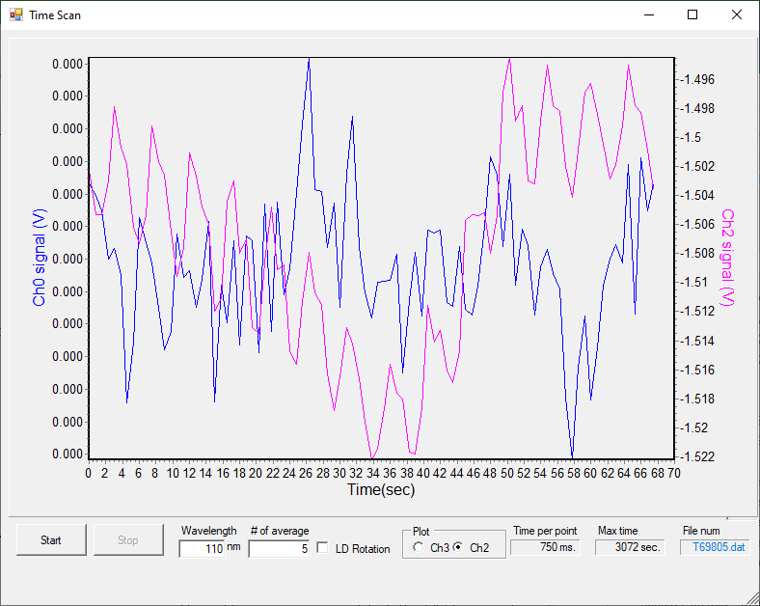

File | λ range | λ step | #av/#sc | Temp/K | Keithley | Table/kstp | PMTVac | Sample
69806 | 110-220 | 0.5 | 15/2 | 19.1 K | 5NPLC | -300 | ON | H2O
69807*  69808 | 138-150 | 0.2 |  |  |  | -450 |  | H2O

Dep 2: H2O dosing for 15s at 1.1e-7mbar
File: T69809
P before deposition: 3e-8 mbar
Temperature of substrate during deposition: 19.1K
Laser signal: 14. uA
Time start = 35 s
Time stop = 50 s
Total dose =15+15s dose

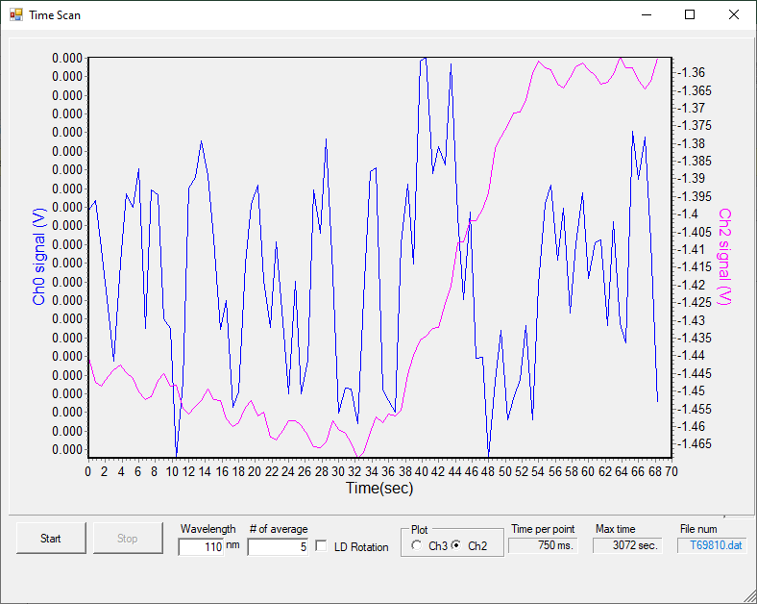

File | λ range | λ step | #av/#sc | Temp/K | Keithley | Table/kstp | PMTVac | Sample
69810*  69811 | 110-220 | 0.5 | 15/2 | 19.1 K | 5NPLC | -300 | ON | H2O
69812 | 138-150 | 0.2 |  |  |  | -450 |  | H2O
*aborted

Dep 3: H2O dosing for 15s at 1.1e-7mbar
File: T69813
P before deposition: 3e-8 mbar
Temperature of substrate during deposition: 19.1K
Laser signal: 14. uA
Time start = 36 s
Time stop = 51 s
Total dose =15+15+15s dose
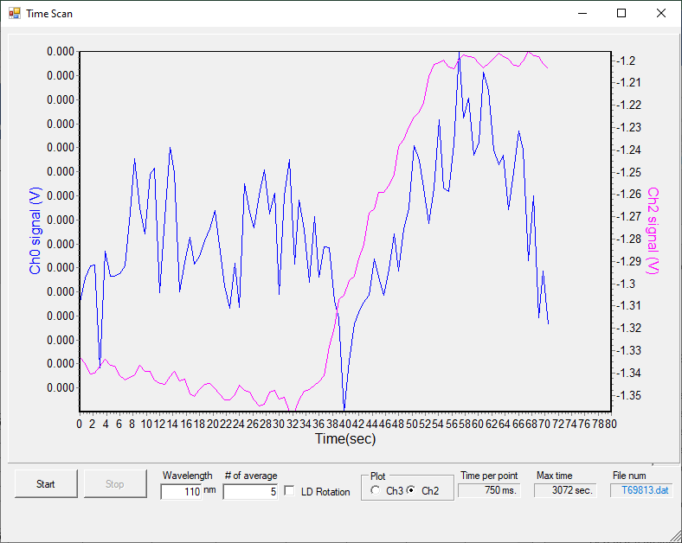

File | λ range | λ step | #av/#sc | Temp/K | Keithley | Table/kstp | PMTVac | Sample
69814 | 110-220 | 0.5 | 15/2 | 19.1 K | 5NPLC | -300 | ON | H2O
69815 | 138-150 | 0.2 |  |  |  | -450 |  | H2O

Dep 4: H2O dosing for 15s at 1.1e-7mbar
File: T69816
P before deposition: 3e-8 mbar
Temperature of substrate during deposition: 19.1K
Laser signal: 14. uA
Time start = 26 s
Time stop = 41 s
Total dose =15+15+15+15s dose
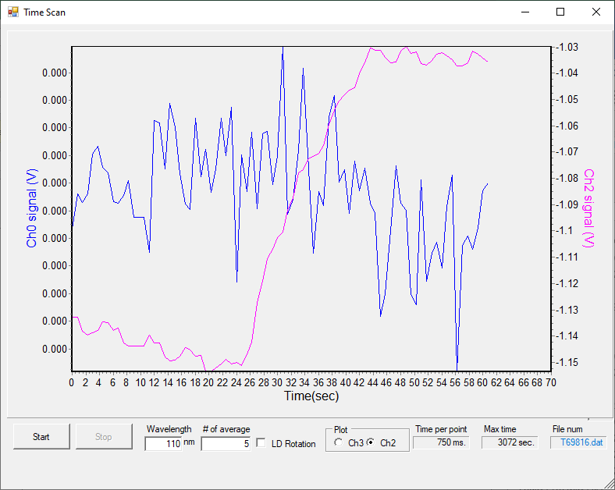

File | λ range | λ step | #av/#sc | Temp/K | Keithley | Table/kstp | PMTVac | Sample
69817 | 110-220 | 0.5 | 15/2 | 19.1 K | 5NPLC | -300 | ON | H2O
69818 | 138-150 | 0.2 |  |  |  | -450 |  | H2O

Dep 5: H2O dosing for 16s at 1.1e-7mbar
File: T69821
P before deposition: 3e-8 mbar
Temperature of substrate during deposition: 19.1K
Laser signal: 10.6 uA
Time start = 30 s
Time stop = 46 s
Total dose =15+15+15+15s dose

*69819, 69820 aborted

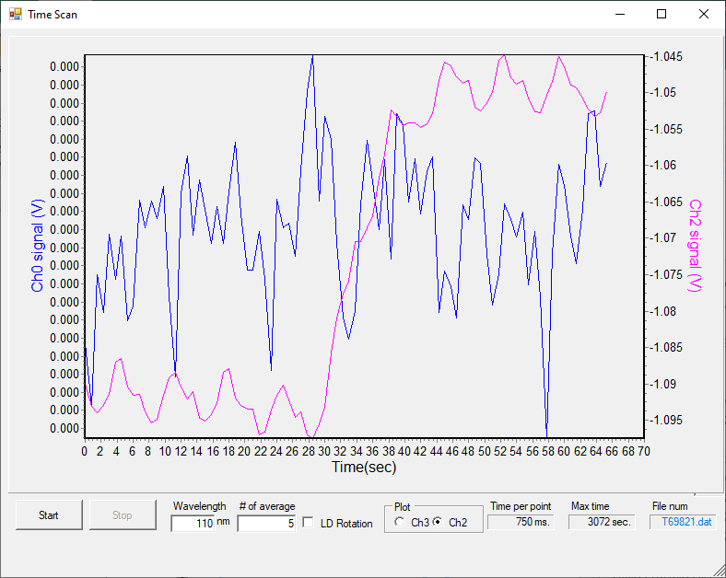

File | λ range | λ step | #av/#sc | Temp/K | Keithley | Table/kstp | PMTVac | Sample
69822 | 110-220 | 0.5 | 15/2 | 19.1 K | 5NPLC | -300 | ON | H2O
69823 | 138-150 | 0.2 |  |  |  | -450 |  | H2O

Thick H2O dep: dosing for 16s at 1.1e-7mbar
File: T69824
P before deposition: 3e-8 mbar
Temperature of substrate during deposition: 19.1K
Laser signal: 9.6 uA
Time start = 29 s
Time stop = 30m29s
Total dose =15+15+15+15+15s dose
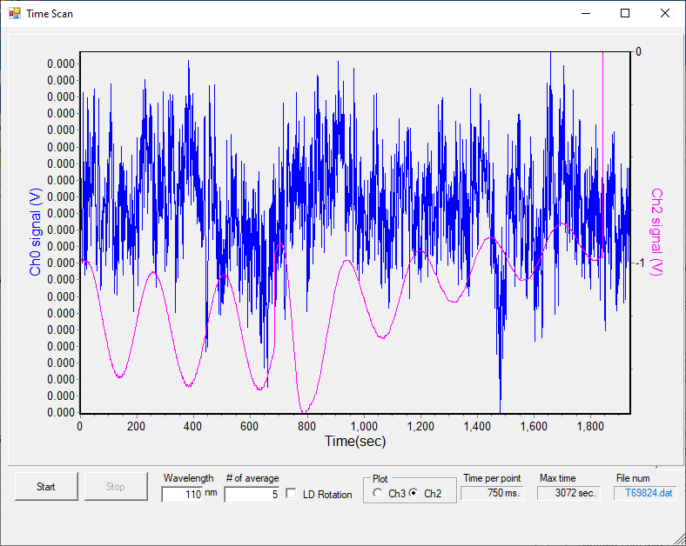

File | λ range | λ step | #av/#sc | Temp/K | Keithley | Table/kstp | PMTVac | Sample
69825*  69826 | 110-175 | 0.5 | 15/2 | 80 K | 5NPLC | -300 | ON | H2O
*aborted

Warming to 250 K
Left the combi gauge on for a bit.

File | λ range | λ step | #av/#sc | Temp/K | Keithley | Table/kstp | PMTVac | Sample
69827 | 110-175 | 0.5 | 15/2 | 80 K | 5NPLC | -300 | ON | H2O

Tuesday 31st May 2022 – Deposition at 50 K (repeat)

BKG scans at 50 K
File | λ range | λ step | #av/#sc | Temp/K | Keithley | Table/kstp | PMTVac | Sample
69828 | 110-220 | 0.5 | 15/2 | 30K | 5NPLC | -300 | ON | Clean MgF2
69829* | 138-150 | 0.2 |  |  |  | -450 |  | Clean MgF2
69830 | 175-205 | 0.2 |  |  |  | -100 |  | Clean MgF2
*something weird in d02 file.. do not use

Dep 1: H2O dosing for 15s at 1.1e-7mbar
File: T69831
P before deposition: 8e-9 mbar
Temperature of substrate during deposition: 50K
Laser signal: 10.6 uA
Time start = 30 s
Time stop = 45 s
Total dose =15 s dose

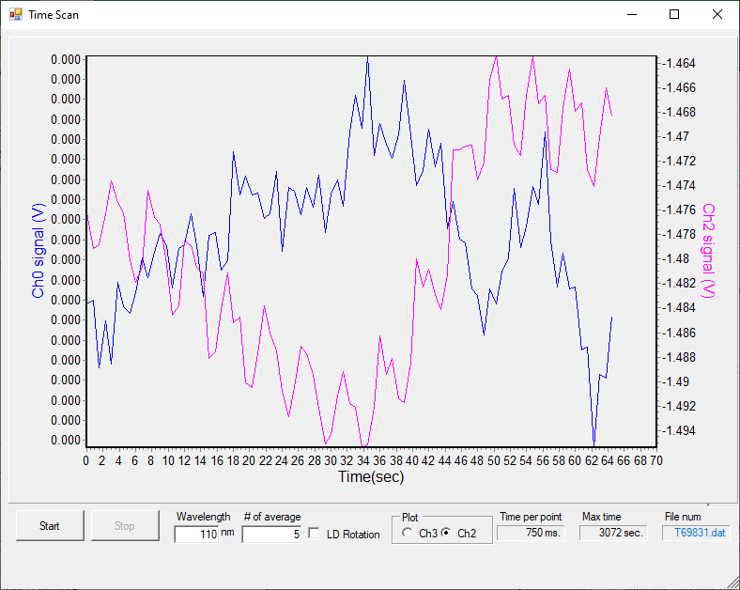

File | λ range | λ step | #av/#sc | Temp/K | Keithley | Table/kstp | PMTVac | Sample
69832 | 110-220 | 0.5 | 15/2 | 30K | 5NPLC | -300 | ON | H2O
69833 | 138-150 | 0.2 |  |  |  | -450 |  | H2O

Dep 2: H2O dosing for 15s at 1.8e-7mbar
File: T69834
P before deposition: 8e-9 mbar
Temperature of substrate during deposition: 50K
Laser signal: 10.6 uA
Time start = 31 s
Time stop = 46 s
Total dose =15+15 s dose

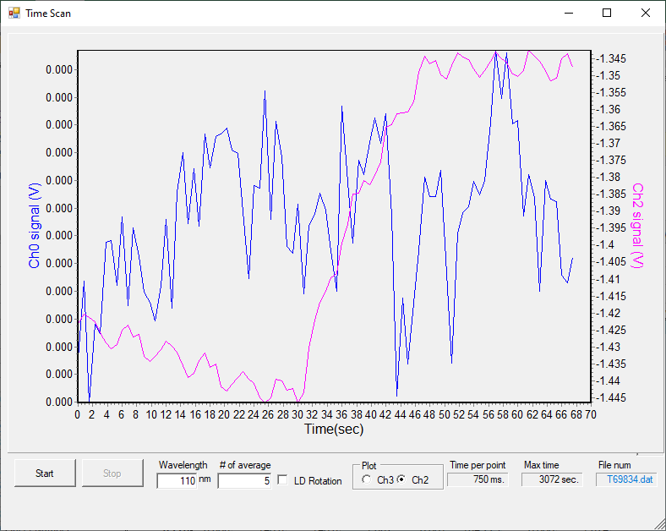

File | λ range | λ step | #av/#sc | Temp/K | Keithley | Table/kstp | PMTVac | Sample
69835 | 110-220 | 0.5 | 15/2 | 30K | 5NPLC | -300 | ON | H2O
69836 | 138-150 | 0.2 |  |  |  | -450 |  | H2O

Dep 3: H2O dosing for 15s at 1.8e-7mbar
File: T69837
P before deposition: 8e-9 mbar
Temperature of substrate during deposition: 50K
Laser signal: 12.6 uA
Time start = 28 s
Time stop = 43 s
Total dose =15+15+15s dose

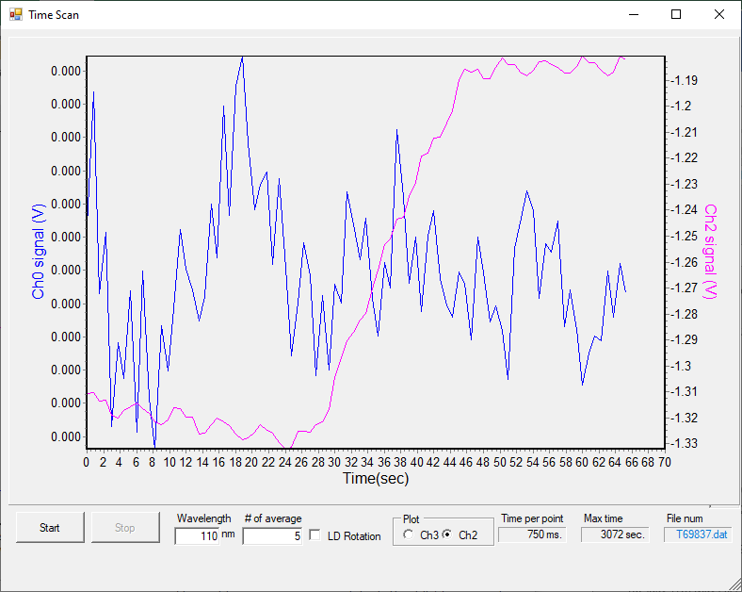

File | λ range | λ step | #av/#sc | Temp/K | Keithley | Table/kstp | PMTVac | Sample
69838 | 110-220 | 0.5 | 15/2 | 30K | 5NPLC | -300 | ON | H2O
69839 | 138-150 | 0.2 |  |  |  | -450 |  | H2O

Dep 4: H2O dosing for 15s at 1.8e-7mbar
File: T69840
P before deposition: 8e-9 mbar
Temperature of substrate during deposition: 50K
Laser signal: 11.6 uA
Time start = 31 s
Time stop = 46 s
Total dose =15+15+15s dose

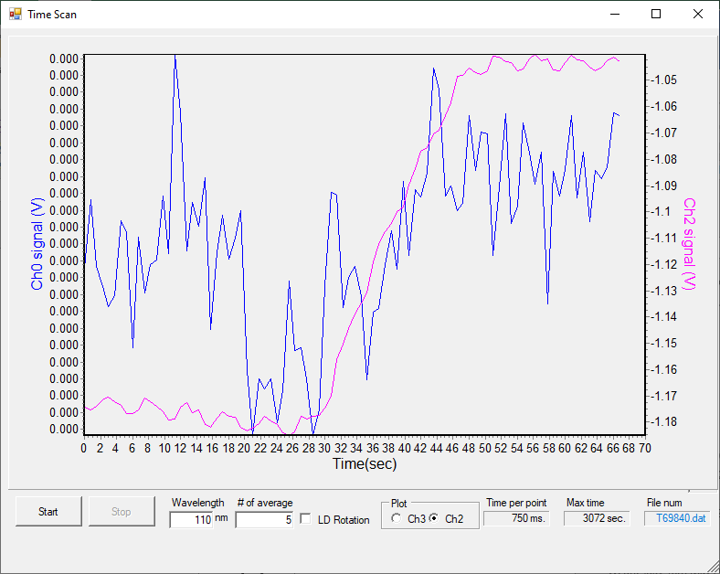

File | λ range | λ step | #av/#sc | Temp/K | Keithley | Table/kstp | PMTVac | Sample
69841 | 110-220 | 0.5 | 15/2 | 30K | 5NPLC | -300 | ON | H2O
69842 | 138-150 | 0.2 |  |  |  | -450 |  | H2O

Dep 5: H2O dosing for 15s at 1.8e-7mbar
File: T69843
P before deposition: 8e-9 mbar
Temperature of substrate during deposition: 50K
Laser signal: 9. uA
Time start = 27 s
Time stop = 43 s
Total dose =15+15+15+15+16s dose

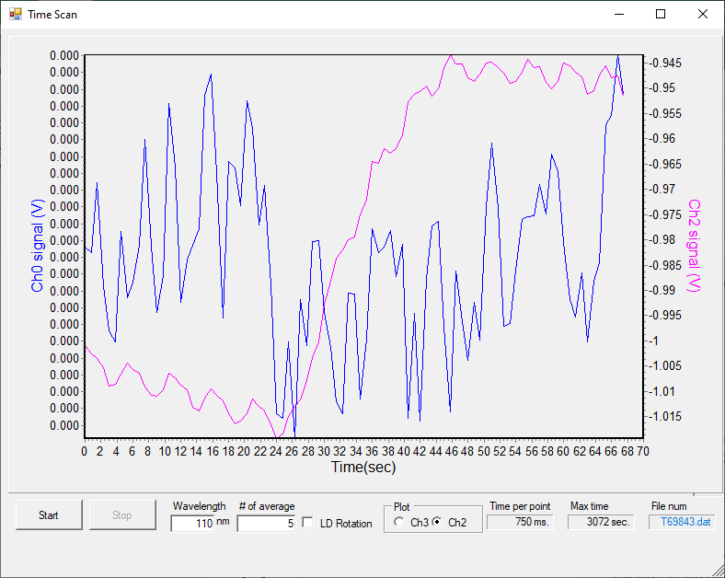

File | λ range | λ step | #av/#sc | Temp/K | Keithley | Table/kstp | PMTVac | Sample
69844 | 110-220 | 0.5 | 15/2 | 30K | 5NPLC | -300 | ON | H2O
69845 | 138-150 | 0.2 |  |  |  | -450 |  | H2O

Thick H2O dep: dosing for 30min at 1.8e-7mbar
File: T69846
P before deposition: 8e-9 mbar
Temperature of substrate during deposition: 50K
Laser signal: 9. uA
Time start = 27 s
Time stop = 43 s
Total dose =15+15+15+15+16s dose

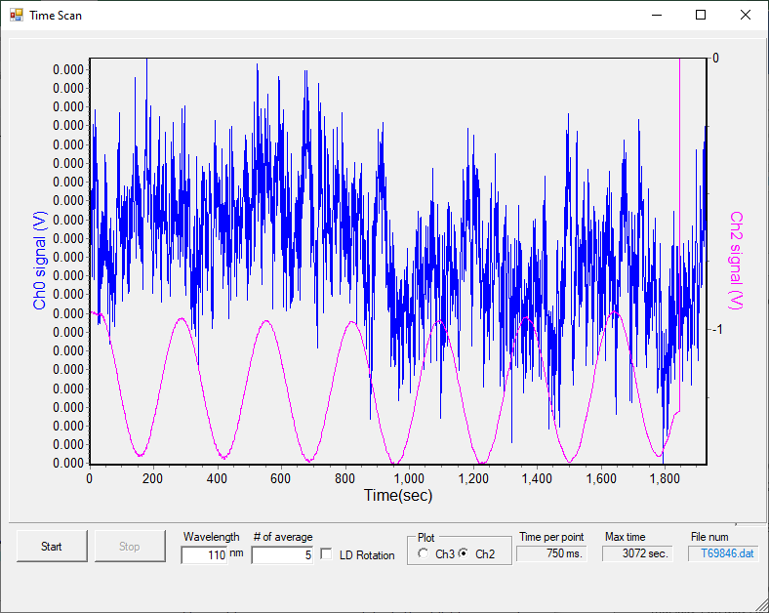

File | λ range | λ step | #av/#sc | Temp/K | Keithley | Table/kstp | PMTVac | Sample
69847 | 175-205 | 0.2 | 15/2 | 50K | 5NPLC | -100 | ON | H2O

Anneal to 70 K (pore collapse?)
File | λ range | λ step | #av/#sc | Temp/K | Keithley | Table/kstp | PMTVac | Sample
69848 | 175-205 | 0.2 | 15/2 | 50K | 5NPLC | -100 | ON | H2O

Anneal to 130 K
File | λ range | λ step | #av/#sc | Temp/K | Keithley | Table/kstp | PMTVac | Sample
69849 | 175-205 | 0.2 | 15/2 | 50K | 5NPLC | -100 | ON | H2O
69850

Anneal to 140 K
File | λ range | λ step | #av/#sc | Temp/K | Keithley | Table/kstp | PMTVac | Sample
69851 | 175-205 | 0.2 | 15/2 | 50K | 5NPLC | -100 | ON | H2O

21:38 cryo OFF

Wednesday 1st June 2022 – Deposition at 110 K

08:00 p = 1.3e-8 mbar T = 269.5 K
CRYO ON
09:20 P = 1e-8 mbar T = 110 K

BKG scans at 110 K
File | λ range | λ step | #av/#sc | Temp/K | Keithley | Table/kstp | PMTVac | Sample
69852 | 110-220 | 0.5 | 15/2 | 30K | 5NPLC | -300 | ON | Clean MgF2
69853 | 138-150 | 0.2 |  |  |  | -450 |  | Clean MgF2
69854 | 175-205 | 0.2 |  |  |  | -100 |  | Clean MgF2

Dep 1: Pump oil again… Why???
File: T69855
69856

File | λ range | λ step | #av/#sc | Temp/K | Keithley | Table/kstp | PMTVac | Sample
69857 | 110-220 | 0.5 | 15/2 | 30K | 5NPLC | -300 | ON | oil

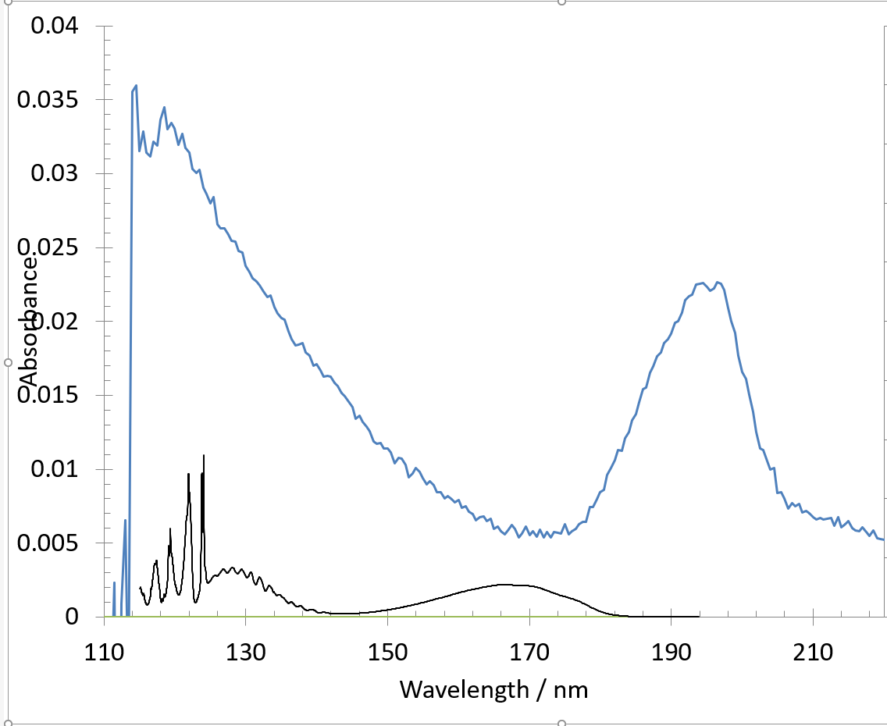

Destroying – scans taken while heating
File | λ range | λ step | #av/#sc | Temp/K | Keithley | Table/kstp | PMTVac | Sample
69858 | 110-220 | 0.5 | 15/2 | 190- | 5NPLC | -300 | ON | oil

Wednesday 1st June 2022 – Deposition at 135 K

11:51 restart
P = T = 135 K

BKG scans at 135 K
File | λ range | λ step | #av/#sc | Temp/K | Keithley | Table/kstp | PMTVac | Sample
69860 | 110-220 | 0.5 | 15/2 | 135K | 5NPLC | -300 | ON | Clean MgF2
69861*  ABORTED | 138-150 | 0.2 |  |  |  | -450 |  | Clean MgF2
69862 | 138-150 | 0.2 |  |  |  | -450 |  | Clean MgF2
69863 | 175-205 | 0.2 |  |  |  | -100

Dep 1: H2O dosing for 15s at 0.8-4e-7mbar (very dodgy)
File: T69864
P before deposition: 2e-8 mbar
Temperature of substrate during deposition: 135K
Laser signal: 15 uA
Time start = 24 s
Time stop = 39 s
Total dose =15s dose
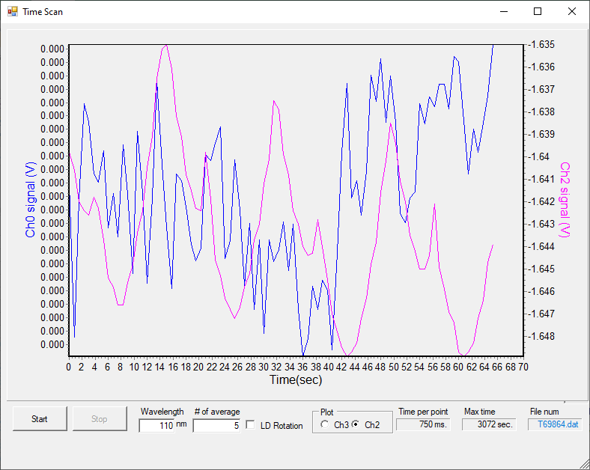

File | λ range | λ step | #av/#sc | Temp/K | Keithley | Table/kstp | PMTVac | Sample
69865 | 110-220 | 0.5 | 15/2 | 30K | 5NPLC | -300 | ON | H2O

Nothing.

Dep 2: H2O dosing for 30s at 1-2e-7mbar
File: T69866
P before deposition: 2e-8 mbar
Temperature of substrate during deposition: 135K
Laser signal: 15 uA
Time start = 25 s
Time stop = 55 s
Total dose =15+30s dose

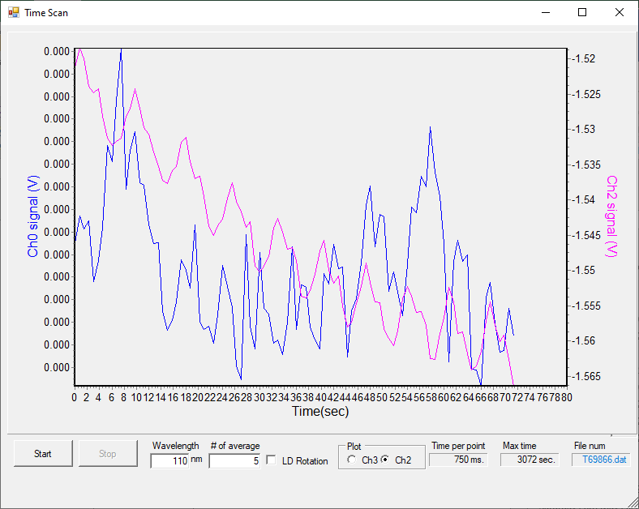
File | λ range | λ step | #av/#sc | Temp/K | Keithley | Table/kstp | PMTVac | Sample
69867 | 110-220 | 0.5 | 15/2 | 30K | 5NPLC | -300 | ON | H2O

Dep 3: H2O dosing for 120s at 1-2e-7mbar
File: T69868
P before deposition: 2e-8 mbar
Temperature of substrate during deposition: 135K
Laser signal: 15 uA
Time start = 31 s
Time stop = 2m31 s
Total dose =15+30+150s dose

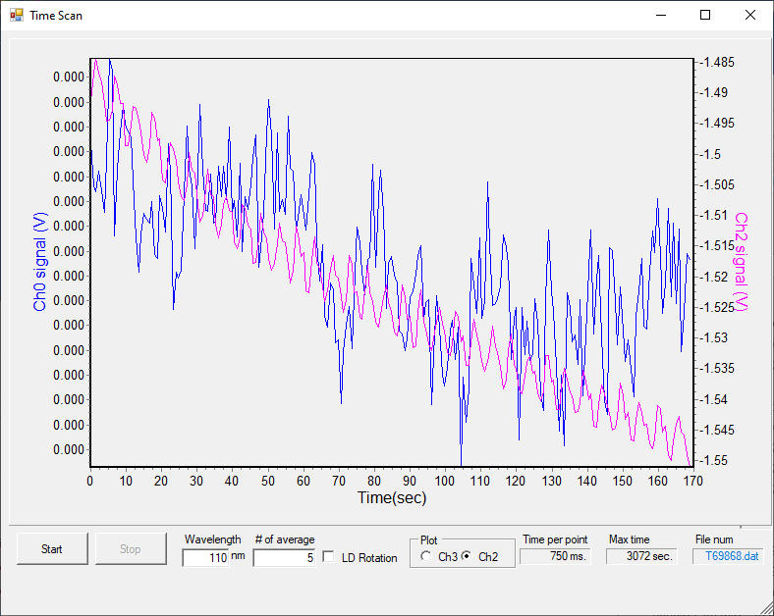
File | λ range | λ step | #av/#sc | Temp/K | Keithley | Table/kstp | PMTVac | Sample
69869 | 110-220 | 0.5 | 15/2 | 30K | 5NPLC | -300 | ON | H2O

Dep 4: H2O dosing for 10 mins at 1-2e-7mbar
File: T69870
P before deposition: 2e-8 mbar
Temperature of substrate during deposition: 135K
Laser signal: 15 uA
Time start = 46 s
Time stop = 10m46s
Total dose =15+30+150s +10 min dose

File | λ range | λ step | #av/#sc | Temp/K | Keithley | Table/kstp | PMTVac | Sample
69871 | 110-220 | 0.5 | 15/2 | 30K | 5NPLC | -300 | ON | H2O

Dep 5: H2O dosing for 5 mins at 1-2e-7mbar
File: T69872
P before deposition: 2e-8 mbar
Temperature of substrate during deposition: 135K
Laser signal: 15 uA
Time start = 27 s
Time stop = 5m27s
Total dose =15+30+150s +10 min + 5min dose

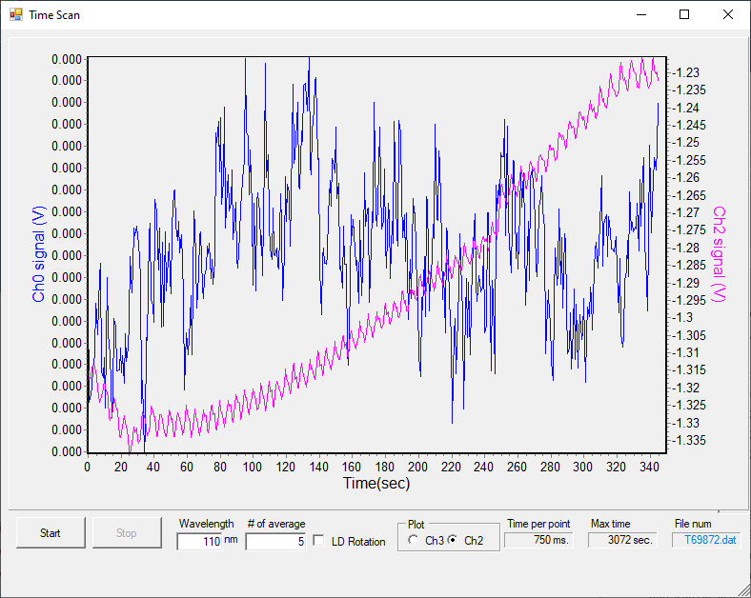

File | λ range | λ step | #av/#sc | Temp/K | Keithley | Table/kstp | PMTVac | Sample
69873  69874 | 110-220 | 0.5 | 15/2 | 30K | 5NPLC | -300 | ON | H2O

Thick H2O dep: dosing for mins at 1-2e-7mbar
29 s to 14:36 1e-7 mbar
14:36 onwards 1e-6

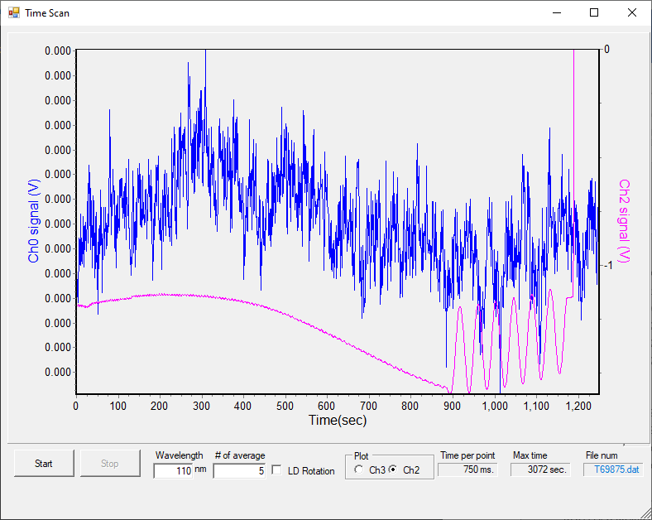
File: T69875
P before deposition: 2e-8 mbar
Temperature of substrate during deposition: 135K
Laser signal: 15 uA
Time start = 27 s
Time stop = 5m27s
Total dose =15+30+150s +10 min + 5min dose

File | λ range | λ step | #av/#sc | Temp/K | Keithley | Table/kstp | PMTVac | Sample
69877 | 175-205 | 0.2 | 15/2 | 135K | 5NPLC | -100 | ON | H2O
69876, 69878* aborted?
69878

Wednesday 1st June 2022 – Deposition at 140 K

11:51 restart
P = T = 135 K

BKG scans at 140 K
File | λ range | λ step | #av/#sc | Temp/K | Keithley | Table/kstp | PMTVac | Sample
69880 | 110-220 | 0.5 | 15/2 | 135K | 5NPLC | -300 | ON | Clean MgF2
69881 | 138-150 | 0.2 |  |  |  | -450 |  | Clean MgF2

Dep 1: H2O dosing for 120s at 1e-7mbar
File: T69883
69882* aborted
P before deposition: 2e-8 mbar
Temperature of substrate during deposition: 140K
Laser signal: 15 uA
Time start = 49 s
Time stop = 2m49 s
Total dose =120s dose

File | λ range | λ step | #av/#sc | Temp/K | Keithley | Table/kstp | PMTVac | Sample
69884 | 110-220 | 0.5 | 15/2 | 30K | 5NPLC | -300 | ON | H2O

Nothing there

Dep 2: H2O dosing for 240s at 1e-7mbar
File: T69885
P before deposition: 2e-8 mbar
Temperature of substrate during deposition: 140K
Laser signal: 15 uA
Time start = 35 s
Time stop = 3m35 s
Total dose =120 + 240s dose

File | λ range | λ step | #av/#sc | Temp/K | Keithley | Table/kstp | PMTVac | Sample
69886 | 110-220 | 0.5 | 15/2 | 30K | 5NPLC | -300 | ON | H2O

Not sicking

Dep 3: H2O dosing for 60s at 5e-7mbar
File: T69887
P before deposition: 2e-8 mbar
Temperature of substrate during deposition: 140K
Laser signal: 15 uA
Time start = 26 s
Time stop = 1m26 s
Total dose =120 + 240s +60s dose

File | λ range | λ step | #av/#sc | Temp/K | Keithley | Table/kstp | PMTVac | Sample
69888 | 110-220 | 0.5 | 15/2 | 30K | 5NPLC | -300 | ON | H2O

Dep 4: H2O dosing for 180s at 5e-7mbar
File: T69889
P before deposition: 2e-8 mbar
Temperature of substrate during deposition: 140K
Laser signal: 15 uA
Time start = 35 s
Time stop = 1m05 s
Total dose =120 + 240s +60+180 +30dose
File | λ range | λ step | #av/#sc | Temp/K | Keithley | Table/kstp | PMTVac | Sample
69890 | 110-220 | 0.5 | 15/2 | 30K | 5NPLC | -300 | ON | H2O

Dep 5: H2O dosing for 30s at 5e-7mbar
File: T69891
P before deposition: 2e-8 mbar
Temperature of substrate during deposition: 140K
Laser signal: 15 uA
Time start = 35 s
Time stop = 1m05 s
Total dose =120 + 240s +60+180 +30dose

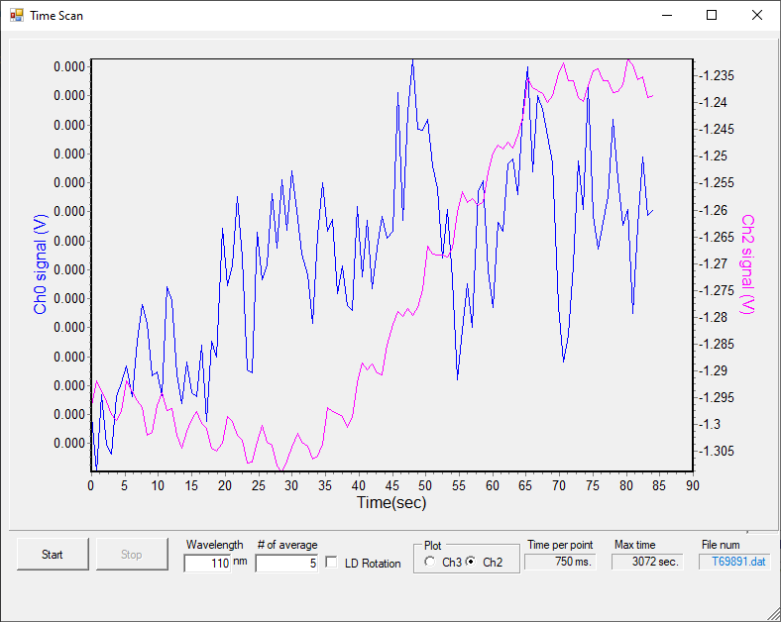

File | λ range | λ step | #av/#sc | Temp/K | Keithley | Table/kstp | PMTVac | Sample
69892 | 110-220 | 0.5 | 15/2 | 30K | 5NPLC | -300 | ON | H2O

Thick H2O dep: dosing for 20min at 5e-7mbar
File: T69893
P before deposition: 2e-8 mbar
Temperature of substrate during deposition: 140K
Laser signal: 15 uA
Time start = 35 s
Time stop = 1m05 s
Total dose =120 + 240s +60+180 +30+20

File | λ range | λ step | #av/#sc | Temp/K | Keithley | Table/kstp | PMTVac | Sample
69894 | 110-220 | 0.5 | 15/2 | 30K | 5NPLC | -300 | ON | H2O

22:56 cryo OFF

Thursday 2nd June 2022 – Deposition at 110 K

07:45 p = 1.4e-8 mbar T = 270.6 K
CRYO ON
09:32 p = 8e-9 mbar T = 110 K

BKG scans at 110 K
File | λ range | λ step | #av/#sc | Temp/K | Keithley | Table/kstp | PMTVac | Sample
69895 | 110-220 | 0.5 | 15/2 | 110K | 5NPLC | -300 | ON | Clean MgF2
69896 | 138-150 | 0.2 |  |  |  | -450 |  | Clean MgF2
69897 | 175-205 | 0.2 |  |  |  | -100 |  | Clean MgF2

Dep 1: H2O dosing for 15s at 1e-7mbar
File: T69898
P before deposition: 2e-8 mbar
Temperature of substrate during deposition: 110K
Laser signal: 37 uA
Time start = 53 s
Time stop = 15 s
Total dose =15 s dose

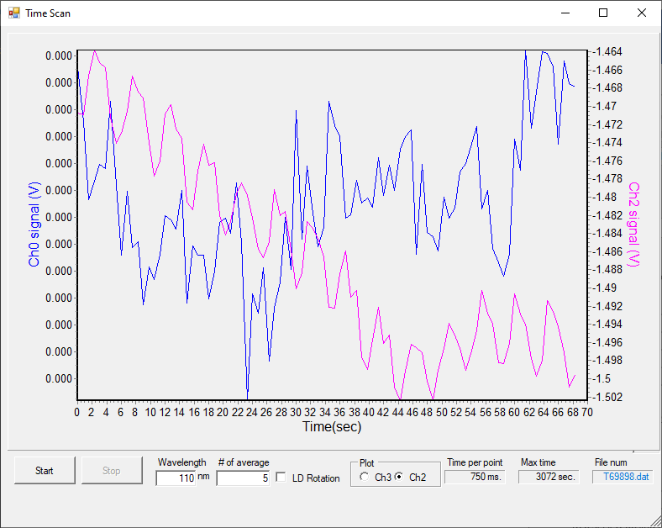

File | λ range | λ step | #av/#sc | Temp/K | Keithley | Table/kstp | PMTVac | Sample
69899 | 110-220 | 0.5 | 15/2 | 110K | 5NPLC | -300 | ON | H2O
69900 | 138-150 | 0.2 |  |  |  | -450 |  | H2O

Dep 2: H2O dosing for 15s at 1e-7mbar
File: T69901
P before deposition: 2e-8 mbar
Temperature of substrate during deposition: 110K
Laser signal: 14 uA
Time start = 45 s
Time stop = 60 s
Total dose =15 +15 s dose

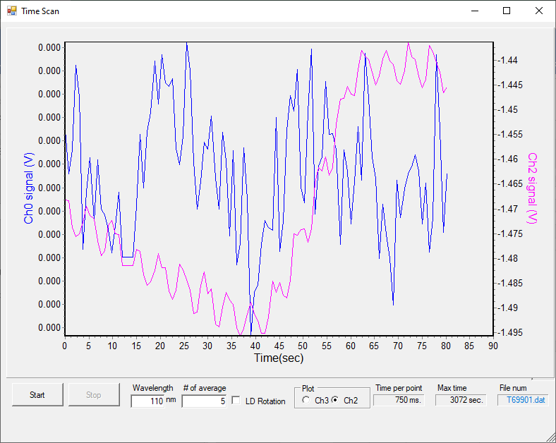

File | λ range | λ step | #av/#sc | Temp/K | Keithley | Table/kstp | PMTVac | Sample
69902 | 110-220 | 0.5 | 15/2 | 110K | 5NPLC | -300 | ON | H2O
69903 | 138-150 | 0.2 |  |  |  | -450 |  | H2O

Dep 3: H2O dosing for 15s at 1e-7mbar
5.15e-7 mbar from ~100 s

File: T69904
P before deposition: 6e-9 mbar
Temperature of substrate during deposition: 110K
Laser signal: 13.5 uA
Time start = 31s
Time stop = 51s
Total dose =15 +15 +15 s dose

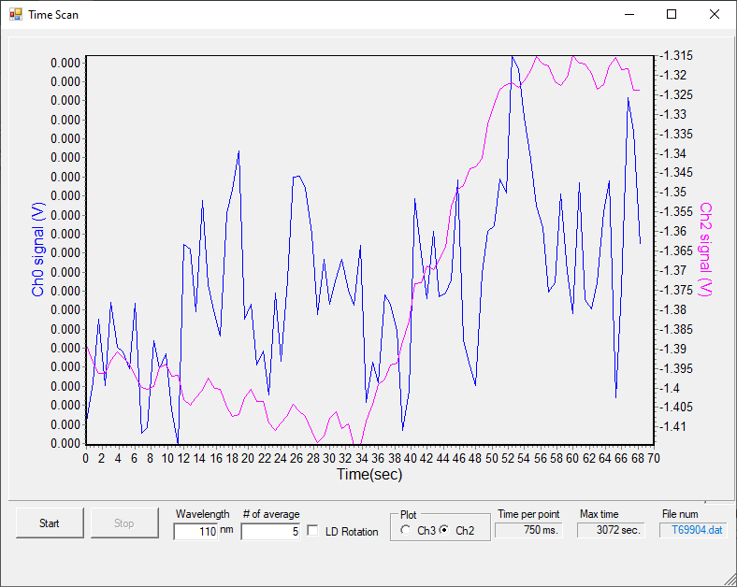

File | λ range | λ step | #av/#sc | Temp/K | Keithley | Table/kstp | PMTVac | Sample
69905 | 110-220 | 0.5 | 15/2 | 110K | 5NPLC | -300 | ON | H2O
69906 | 138-150 | 0.2 |  |  |  | -450 |  | H2O

Thick dep H2O: dosing for 9min at 5e-7mbar
5.15e-7 mbar from ~100 s

File: T69907
P before deposition: 6e-9 mbar
Temperature of substrate during deposition: 110K
Laser signal: 13.5 uA
Time start = 30s
Time stop = 9m30s
Total dose =15 +15 +15 s dose

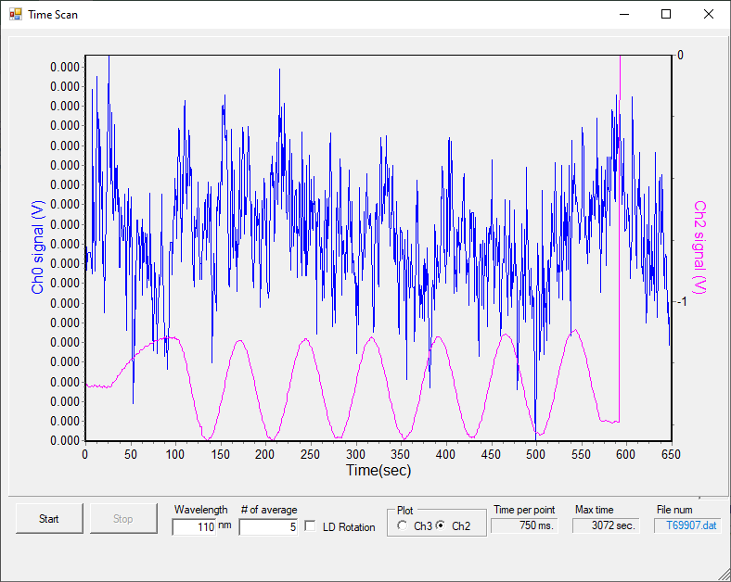

File | λ range | λ step | #av/#sc | Temp/K | Keithley | Table/kstp | PMTVac | Sample
69908 | 175-205 | 0.2 | 15/2 | 110K | 5NPLC | -100 | ON | H2O

Even thicker dep H2O: dosing for 9min at 5e-7mbar
1e-6-7 mbar from ~190 s

File: T69909
P before deposition: 6e-9 mbar
Temperature of substrate during deposition: 110K
Laser signal: 13.5 uA
Time start = 34s
Time stop = 6m34s
Total dose =15 +15 +15 s dose

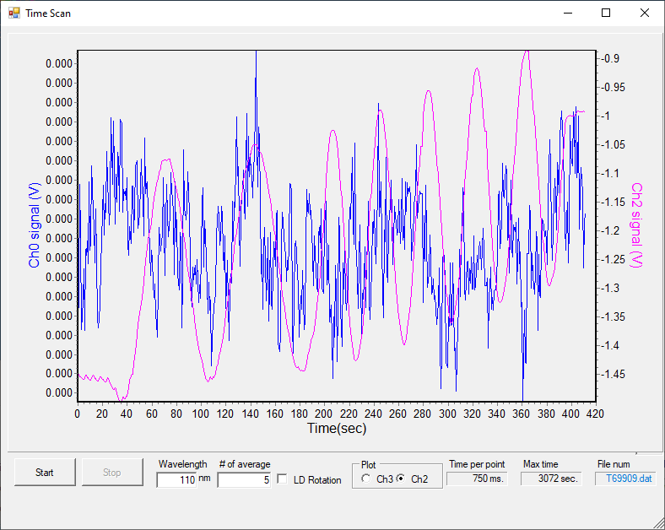

File | λ range | λ step | #av/#sc | Temp/K | Keithley | Table/kstp | PMTVac | Sample
69910 | 175-205 | 0.2 | 15/2 | 110K | 5NPLC | -100 | ON | H2O

Clean?
69911.d01 - yep

Thursday 2nd June 2022 – Deposition at 100 K

BKG scans at 100 K
File | λ range | λ step | #av/#sc | Temp/K | Keithley | Table/kstp | PMTVac | Sample
69912 | 110-220 | 0.5 | 15/2 | 110K | 5NPLC | -300 | ON | Clean MgF2
66913 | ABORTED
66914 | 138-150 | 0.2 |  |  |  | -450 |  | Clean MgF2
66915 | 175-205 | 0.2 |  |  |  | -100 |  | Clean MgF2

Dep 1: H2O dosing for 15s at 1e-7mbar
File: T69916
P before deposition: 2e-8 mbar
Temperature of substrate during deposition: 110K
Laser signal: 37 uA
Time start = 53 s
Time stop = 15 s
Total dose =15 s dose

File | λ range | λ step | #av/#sc | Temp/K | Keithley | Table/kstp | PMTVac | Sample
66917 | 110-220 | 0.5 | 15/2 | 110K | 5NPLC | -300 | ON | H2O
69918 | 138-150 | 0.2 |  |  |  | -450 |  | H2O

Dep 2: H2O dosing for 15s at 1e-7mbar
File: T69919
P before deposition: 2e-8 mbar
Temperature of substrate during deposition: 110K
Laser signal: 37 uA
Time start = 28 s
Time stop = 44 s
Total dose =15 s dose

File | λ range | λ step | #av/#sc | Temp/K | Keithley | Table/kstp | PMTVac | Sample
66920 | 110-220 | 0.5 | 15/2 | 110K | 5NPLC | -300 | ON | H2O
69921 | 138-150 | 0.2 |  |  |  | -450 |  | H2O

Dep 3: H2O dosing for 15s at 1e-7mbar
File: T69922
P before deposition: 2e-8 mbar
Temperature of substrate during deposition: 110K
Laser signal: 13.7 uA
Time start = 36 s
Time stop = 25 s
Total dose =15 s dose

File | λ range | λ step | #av/#sc | Temp/K | Keithley | Table/kstp | PMTVac | Sample
66923 | 110-220 | 0.5 | 15/2 | 110K | 5NPLC | -300 | ON | H2O
69924 | 138-150 | 0.2 |  |  |  | -450 |  | H2O

Thick H2O dep: dosing for 6min40s at 5e-7mbar
File: T69925
P before deposition: 2e-8 mbar
Temperature of substrate during deposition: 110K
Laser signal: 13.7 uA
Time start = 29 s
Time stop = 7min09 s
Total dose = s dose

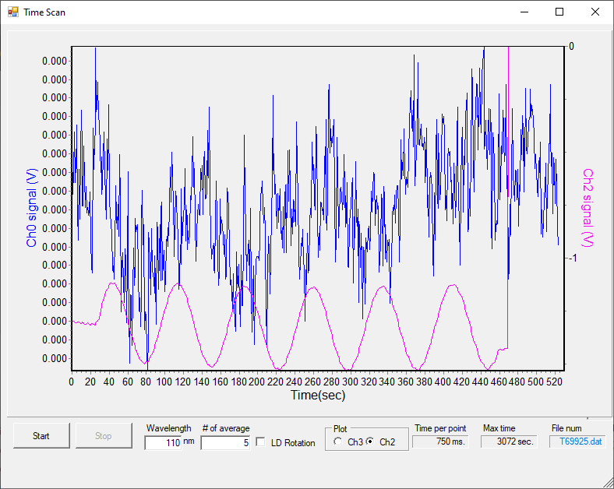

File | λ range | λ step | #av/#sc | Temp/K | Keithley | Table/kstp | PMTVac | Sample
69926 | 175-205 | 0.2 | 15/2 | 100K | 5NPLC | -100 | ON | H2O

Thursday 2nd June 2022 – Deposition at 90 K

BKG scans at 90 K
File | λ range | λ step | #av/#sc | Temp/K | Keithley | Table/kstp | PMTVac | Sample
69928 | 110-220 | 0.5 | 15/2 | 110K | 5NPLC | -300 | ON | Clean MgF2
66929 | 138-150 | 0.2 |  |  |  | -450 |  | Clean MgF2

Dep 1: H2O dosing for 10s at 5e-8mbar
File: T69930
Deposited nothing – air?
Idiot idiot idiot
69931* aborted
69932

BKG scans at 90 K
File | λ range | λ step | #av/#sc | Temp/K | Keithley | Table/kstp | PMTVac | Sample
69934 | 110-220 | 0.5 | 15/2 | 110K | 5NPLC | -300 | ON | Clean MgF2
69935 | 138-150 | 0.2 |  |  |  | -450 |  | Clean MgF2

Dep1: H2O dosing for 10s at 5e-8mbar
File: T69936
P before deposition: 2e-8 mbar
Temperature of substrate during deposition: 90K
Laser signal: 13.7 uA
Time start = 39 s
Time stop = 49 s
Total dose = s dose

File | λ range | λ step | #av/#sc | Temp/K | Keithley | Table/kstp | PMTVac | Sample
69937 | 110-220 | 0.5 | 15/2 | 110K | 5NPLC | -300 | ON | H2O

Dep2: H2O dosing for 10s at 5e-8mbar
File: T69938
P before deposition: 2e-8 mbar
Temperature of substrate during deposition: 90K
Laser signal: 13.7 uA
Time start = 33 s
Time stop = 43 s
Total dose = 10+10s dose

File | λ range | λ step | #av/#sc | Temp/K | Keithley | Table/kstp | PMTVac | Sample
69939 | 110-220 | 0.5 | 15/2 | 110K | 5NPLC | -300 | ON | H2O

Only scanning once

Dep3: H2O dosing for 10s at 5e-8mbar
File: T69940
P before deposition: 2e-8 mbar
Temperature of substrate during deposition: 90K
Laser signal: 13.7 uA
Time start = 12 s
Time stop = 49 s
Total dose = 10+10s dose

File | λ range | λ step | #av/#sc | Temp/K | Keithley | Table/kstp | PMTVac | Sample
69941 | 110-220 | 0.5 | 15/2 | 110K | 5NPLC | -300 | ON | CH2O

Dep 4: H2O dosing for 10s at 5e-8mbar
File: T69942
P before deposition: 2e-8 mbar
Temperature of substrate during deposition: 90K
Laser signal: 14.3 uA
Time start = 24 s
Time stop = 34 s
Total dose = 10+10+10+10s dose

File | λ range | λ step | #av/#sc | Temp/K | Keithley | Table/kstp | PMTVac | Sample
69943 | 110-220 | 0.5 | 15/2 | 110K | 5NPLC | -300 | ON | H2O

Dep 5: H2O dosing for 10s at 5e-8mbar
File: T69944
P before deposition: 2e-8 mbar
Temperature of substrate during deposition: 90K
Laser signal: 14.3 uA
Time start = 32 s
Time stop = 42 s
Total dose = 10+10+10+10+10s dose

File | λ range | λ step | #av/#sc | Temp/K | Keithley | Table/kstp | PMTVac | Sample
69945 | 110-220 | 0.5 | 15/2 | 110K | 5NPLC | -300 | ON | H2O

Dep 6: H2O dosing for 10s at 5e-8mbar
File: T69944
P before deposition: 2e-8 mbar
Temperature of substrate during deposition: 90K
Laser signal: 14.3 uA
Time start = 34 s
Time stop = 44 s
Total dose = 10+10+10s dose

File | λ range | λ step | #av/#sc | Temp/K | Keithley | Table/kstp | PMTVac | Sample
69947 | 110-220 | 0.5 | 15/2 | 110K | 5NPLC | -300 | ON | H2O

Dep 7: H2O dosing for 10s at 5e-8mbar
File: T69948
P before deposition: 2e-8 mbar
Temperature of substrate during deposition: 90K
Laser signal: 13.3 uA
Time start = 30 s
Time stop = 40 s
Total dose = 10+10+10s dose

File | λ range | λ step | #av/#sc | Temp/K | Keithley | Table/kstp | PMTVac | Sample
69949 | 110-220 | 0.5 | 15/2 | 110K | 5NPLC | -300 | ON | H2O

Dep 7: H2O dosing for 10s at 5e-8mbar
File: T69948
P before deposition: 2e-8 mbar
Temperature of substrate during deposition: 90K
Laser signal: 13.3 uA
Time start = 29 s
Time stop = 39 s
Total dose = 10+10+10s dose

File | λ range | λ step | #av/#sc | Temp/K | Keithley | Table/kstp | PMTVac | Sample
69950 | 110-220 | 0.5 | 15/2 | 110K | 5NPLC | -300 | ON | H2O

Dep 8: H2O dosing for 10s at 5e-8mbar
File: T69951
P before deposition: 2e-8 mbar
Temperature of substrate during deposition: 90K
Laser signal: 12.8 uA
Time start = 26 s
Time stop = 36 s
Total dose = 10+10+10s dose

File | λ range | λ step | #av/#sc | Temp/K | Keithley | Table/kstp | PMTVac | Sample
69952 | 110-220 | 0.5 | 15/2 | 110K | 5NPLC | -300 | ON | H2O

Dep 9: H2O dosing for 10s at 5e-8mbar
File: T69953
P before deposition: 2e-8 mbar
Temperature of substrate during deposition: 90K
Laser signal: 12.8 uA
Time start = 26 s
Time stop = 36 s
Total dose = 10+10+10s dose

File | λ range | λ step | #av/#sc | Temp/K | Keithley | Table/kstp | PMTVac | Sample
69952 | 110-220 | 0.5 | 15/2 | 110K | 5NPLC | -300 | ON | H2O

Dep 10: H2O dosing for 10s at 5e-8mbar
P before deposition: 2e-8 mbar
Temperature of substrate during deposition: 90K
Dose: 10s
File | λ range | λ step | #av/#sc | Temp/K | Keithley | Table/kstp | PMTVac | Sample
69953 | 110-220 | 0.5 | 15/2 | 110K | 5NPLC | -300 | ON | H2O

Dep 11: H2O dosing for 10s at 5e-8mbar
P before deposition: 2e-8 mbar
Temperature of substrate during deposition: 90K
Dose: 10s
File | λ range | λ step | #av/#sc | Temp/K | Keithley | Table/kstp | PMTVac | Sample
69954*  69955 | 110-220 | 0.5 | 15/2 | 110K | 5NPLC | -300 | ON | H2O
*aborted

01:44 cryo Off

Friday 3rd June 2022 – Deposition at 130 K

07:40 p = 2.5e-8 mbar T = 247.2 K
CRYO ON
09:12 T= 18.1 K P = 1.7e-8 mbar
09:36 P = 6e-9 mbar T = 80 K

BKG scans at 80 K
File | λ range | λ step | #av/#sc | Temp/K | Keithley | Table/kstp | PMTVac | Sample
69957 | 110-220 | 0.5 | 15/2 | 110K | 5NPLC | -300 | ON | Clean MgF2

Change of plan

BKG scans at 130 K
File | λ range | λ step | #av/#sc | Temp/K | Keithley | Table/kstp | PMTVac | Sample
69958 | 110-220 | 0.5 | 15/2 | 110K | 5NPLC | -300 | ON | Clean MgF2
66959*  66960 | 138-150 | 0.2 |  |  |  | -450 |  | Clean MgF2
*aborted

Dep 1: H2O dosing for 15s at 1e-7mbar
File: T69961
P before deposition: 2e-8 mbar
Temperature of substrate during deposition: 110K
Laser signal: 37 uA
Time start = 1min39 s
Time stop = 1min54 s
Total dose =15 s dose
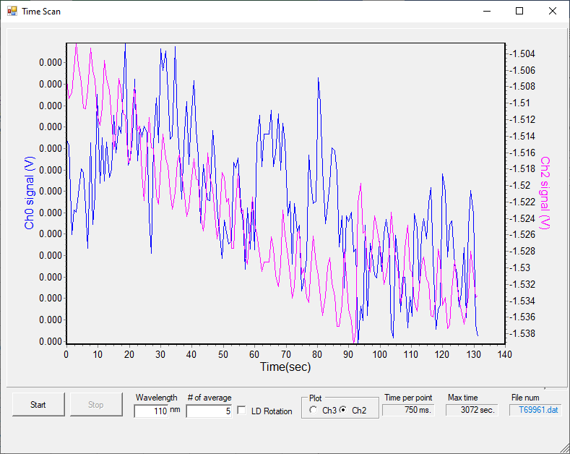

File | λ range | λ step | #av/#sc | Temp/K | Keithley | Table/kstp | PMTVac | Sample
69962 | 110-220 | 0.5 | 15/2 | 130K | 5NPLC | -300 | ON | H2O
 | 138-150 | 0.2 |  |  |  | -450 |  | H2O

Dep 2: H2O dosing for 29s at 1e-7mbar
File: T69963
P before deposition: 2e-8 mbar
Temperature of substrate during deposition: 110K
Laser signal: 37 uA
Time start = 28 s
Time stop = 57 s
Total dose =15+29 s dose
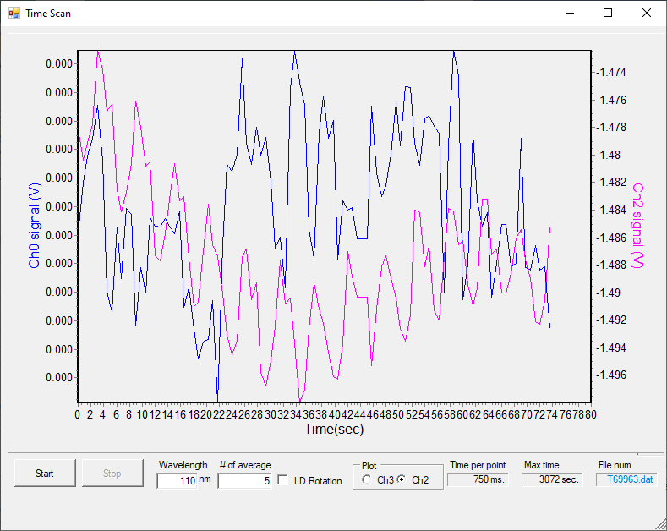

File | λ range | λ step | #av/#sc | Temp/K | Keithley | Table/kstp | PMTVac | Sample
69964 | 110-220 | 0.5 | 15/2 | 130K | 5NPLC | -300 | ON | H2O
69965 | 138-150 | 0.2 |  |  |  | -450 |  | H2O

Dep 3: H2O dosing for 29s at 1.1e-7mbar
File: T69966
P before deposition: 2e-8 mbar
Temperature of substrate during deposition: 110K
Laser signal: 37 uA
Time start = 30 s
Time stop = 58 s
Total dose =15+29 +29 s dose

File | λ range | λ step | #av/#sc | Temp/K | Keithley | Table/kstp | PMTVac | Sample
69967 | 110-220 | 0.5 | 15/2 | 130K | 5NPLC | -300 | ON | H2O
69968 | 138-150 | 0.2 |  |  |  | -450 |  | H2O

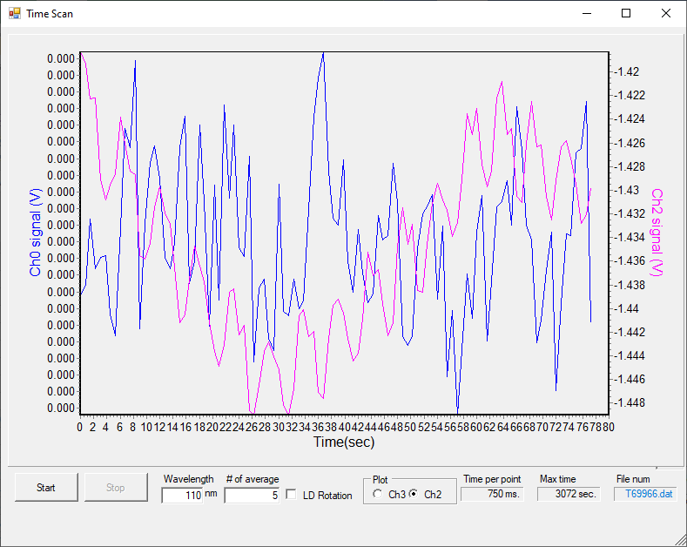

Dep 4: H2O dosing for 29s at 1.1e-7mbar
File: T69969
P before deposition: 2e-8 mbar
Temperature of substrate during deposition: 110K
Laser signal: 37 uA
Time start = 30 s
Time stop = 58 s
Total dose =15+29 +29 s dose

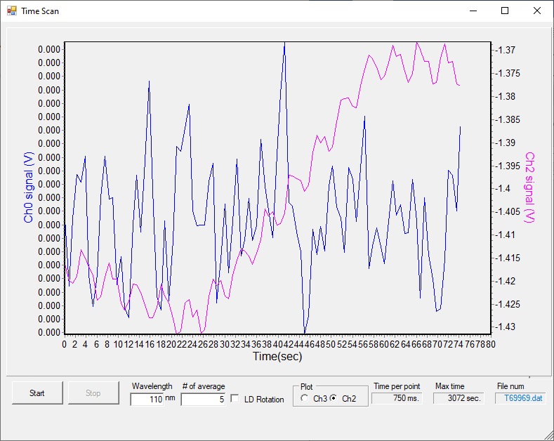

File | λ range | λ step | #av/#sc | Temp/K | Keithley | Table/kstp | PMTVac | Sample
69970 | 110-220 | 0.5 | 15/2 | 130K | 5NPLC | -300 | ON | H2O
69971 | 138-150 | 0.2 |  |  |  | -450 |  | H2O

Annealing to 132 K (1 scan)
File | λ range | λ step | #av/#sc | Temp/K | Keithley | Table/kstp | PMTVac | Sample
69972 | 110-220 | 0.5 | 15/2 | 130K | 5NPLC | -300 | ON | H2O

Annealing to 134 K (1 scan)
File | λ range | λ step | #av/#sc | Temp/K | Keithley | Table/kstp | PMTVac | Sample
69973 | 110-220 | 0.5 | 15/2 | 130K | 5NPLC | -300 | ON | H2O

Annealing to 138 K (1 scan)
File | λ range | λ step | #av/#sc | Temp/K | Keithley | Table/kstp | PMTVac | Sample
69974 | 110-220 | 0.5 | 15/2 | 130K | 5NPLC | -300 | ON | H2O

Annealing to 141 K (1 scan)
File | λ range | λ step | #av/#sc | Temp/K | Keithley | Table/kstp | PMTVac | Sample
69975 | 110-220 | 0.5 | 15/2 | 130K | 5NPLC | -300 | ON | H2O

Friday 3rd June 2022 – Deposition at 125 K

BKG scans at 125 K
File | λ range | λ step | #av/#sc | Temp/K | Keithley | Table/kstp | PMTVac | Sample
69976 | 110-220 | 0.5 | 15/2 | 125K | 5NPLC | -300 | ON | Clean MgF2
69977 | 138-150 | 0.2 |  |  |  | -450 |  | Clean MgF2
*aborted

Dep 1: H2O dosing for 15s at 1e-7mbar
File: T69978
P before deposition: 2e-8 mbar
Temperature of substrate during deposition: 110K
Laser signal: 37 uA
Time start = 1min 25 s
Time stop = 1min40s
Total dose =15 s dose
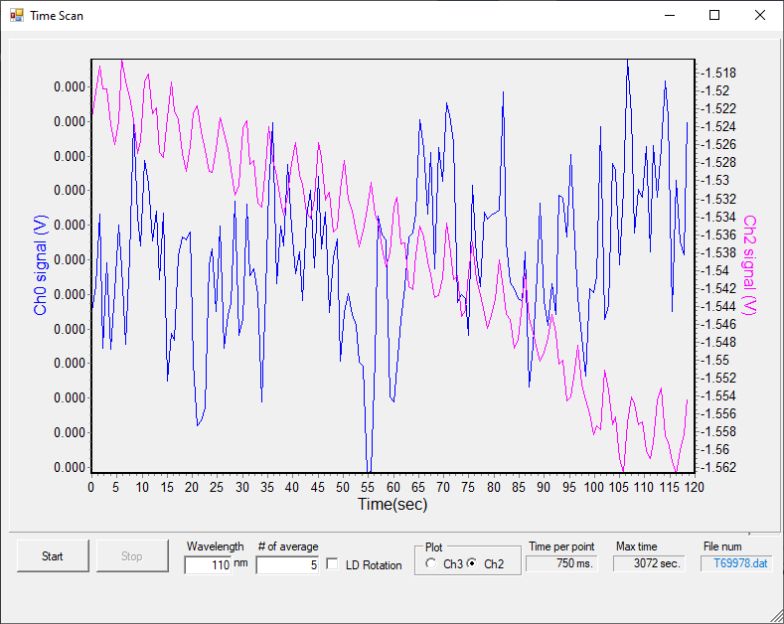

File | λ range | λ step | #av/#sc | Temp/K | Keithley | Table/kstp | PMTVac | Sample
69979 | 110-220 | 0.5 | 15/2 | 130K | 5NPLC | -300 | ON | H2O
699 | 138-150 | 0.2 |  |  |  | -450 |  | H2O
*Dohhh, left the gauge on in the BKG and didn’t check***

Laser dep experiment: H2O dosing for 30 min at 1e-7mbar
File: T6997
P before deposition: 2e-8 mbar
Temperature of substrate during deposition: 110K
Laser signal: 37 uA
Time start = 1min 25 s
Time stop = 1min40s
Total dose =15 s dose
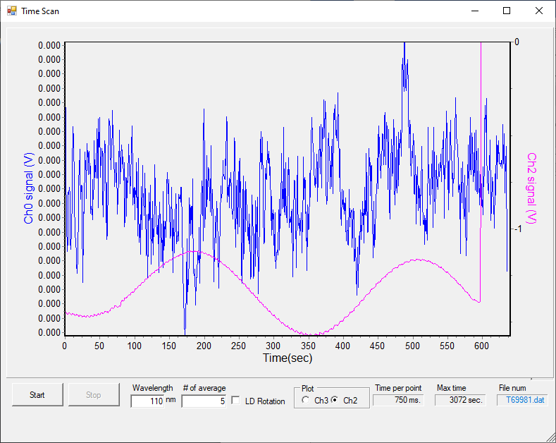

17:35 cryo OFF

Saturday 4th June – Deposition at 125 K
07:44 p = 2e-8 mbar T = 278.9 K cryo ON

BKG scans at 125 K
File | λ range | λ step | #av/#sc | Temp/K | Keithley | Table/kstp | PMTVac | Sample
69982*  69983 | 110-220 | 0.5 | 15/2 | 125K | 5NPLC | -300 | ON | Clean MgF2
69984 | 138-150 | 0.2 |  |  |  | -450 |  | Clean MgF2
*aborted

Dep 1: H2O dosing for 15s at 1e-7mbar
File: T69985
P before deposition: 2e-8 mbar
Temperature of substrate during deposition: 110K
Laser signal: 37 uA
Time start = 42 s
Time stop = 57 s
Total dose =15 s dose

File | λ range | λ step | #av/#sc | Temp/K | Keithley | Table/kstp | PMTVac | Sample
69986 | 110-220 | 0.5 | 15/2 | 130K | 5NPLC | -300 | ON | H2O
69987 | 138-150 | 0.2 |  |  |  | -450 |  | H2O

Dep 2: H2O dosing for 15s at 1e-7mbar
File: T69988
P before deposition: 2e-8 mbar
Temperature of substrate during deposition: 110K
Laser signal: 37 uA
Time start = 30 s
Time stop = 45 s
Total dose =15 s dose

File | λ range | λ step | #av/#sc | Temp/K | Keithley | Table/kstp | PMTVac | Sample
69989 | 110-220 | 0.5 | 15/2 | 130K | 5NPLC | -300 | ON | H2O
69990 | 138-150 | 0.2 |  |  |  | -450 |  | H2O

Dep 3: H2O dosing for 15s at 1e-7mbar
File: T69991
P before deposition: 2e-8 mbar
Temperature of substrate during deposition: 110K
Laser signal: 37 uA
Time start = 42 s
Time stop = 57 s
Total dose =15 s dose

File | λ range | λ step | #av/#sc | Temp/K | Keithley | Table/kstp | PMTVac | Sample
69992 | 110-220 | 0.5 | 15/2 | 130K | 5NPLC | -300 | ON | H2O

Intensity increasing – rescan a few times

File | λ range | λ step | #av/#sc | Temp/K | Keithley | Table/kstp | PMTVac | Sample
69993 | 110-220 | 0.5 | 15/2 | 130K | 5NPLC | -300 | ON | H2O
69994
69995
69996

Thick dep H2O: dosing for 15s at 1e-6mbar
File: T69997
P before deposition: 2e-8 mbar
Temperature of substrate during deposition: 110K
Laser signal: 37 uA
Time start = 42 s
Time stop = 57 s
Total dose =15 s dose

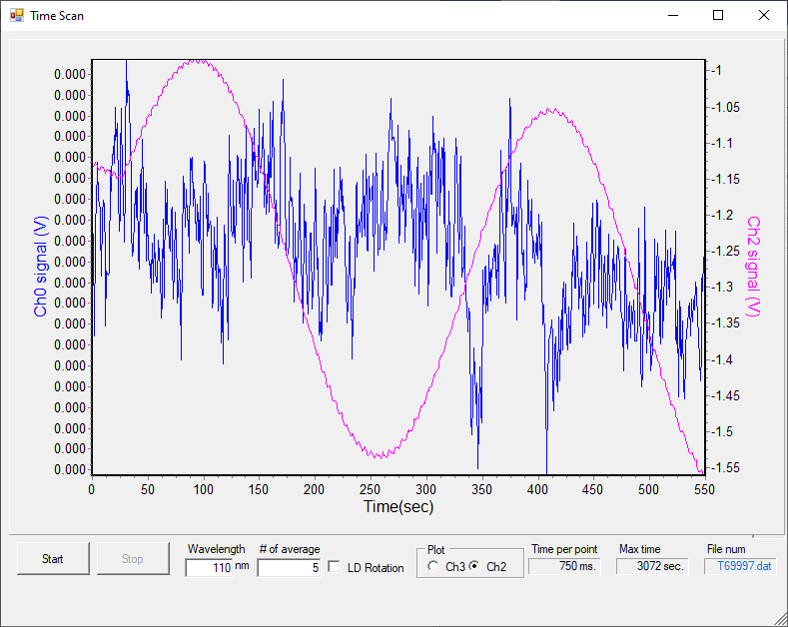

Clean substrate – 69998

Saturday 4th June – Deposition at 127.5 K

BKG scans at 127.5 K
File | λ range | λ step | #av/#sc | Temp/K | Keithley | Table/kstp | PMTVac | Sample
69999 | 110-220 | 0.5 | 15/2 | 125K | 5NPLC | -300 | ON | Clean MgF2
70000 | 138-150 | 0.2 |  |  |  | -450 |  | Clean MgF2

Dep 1: H2O dosing for 15s at 1e-7 ?? mbar
File: T70002
P before deposition: 2e-8 mbar
Temperature of substrate during deposition: 110K
Laser signal: 37 uA
Time start = 42 s
Time stop = 57 s
Total dose =15 s dose
File | λ range | λ step | #av/#sc | Temp/K | Keithley | Table/kstp | PMTVac | Sample
670003 | 110-220 | 0.5 | 15/2 | 130K | 5NPLC | -300 | ON | H2O

Need more.

Dep 2: H2O dosing for 15s at 1e-7 ?? mbar
File: T70004
P before deposition: 2e-8 mbar
Temperature of substrate during deposition: 127.5K
Laser signal: 14 uA
Time start = 49 s
Time stop = 1min04 s
Total dose =15 s dose
File | λ range | λ step | #av/#sc | Temp/K | Keithley | Table/kstp | PMTVac | Sample
670005 | 110-220 | 0.5 | 15/2 | 130K | 5NPLC | -300 | ON | H2O

Thick H2O dosing for 15s at 1e-7 mbar
File: T70006
P before deposition: 2e-8 mbar
Temperature of substrate during deposition: 127.5K
Laser signal: 14 uA
Time start = 49 s
Time stop = 1min04 s
Total dose =15 s dose

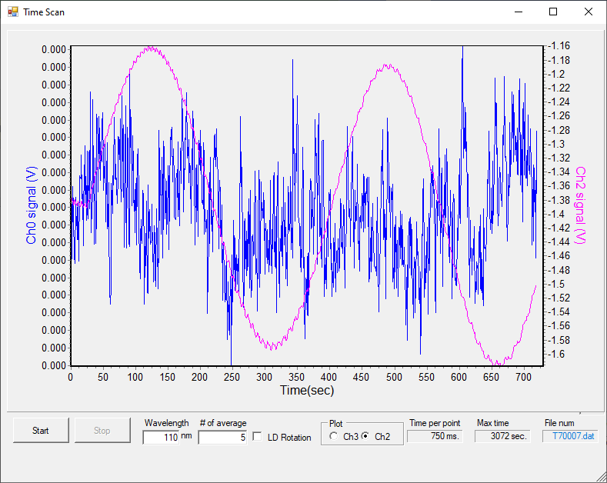

Saturday 4th June – Deposition at 137.5 K

BKG scans at 127.5 K
File | λ range | λ step | #av/#sc | Temp/K | Keithley | Table/kstp | PMTVac | Sample
70008 | 110-220 | 0.5 | 15/2 | 125K | 5NPLC | -300 | ON | Clean MgF2
70009 | 138-150 | 0.2 |  |  |  | -450 |  | Clean MgF2

Dep 1: H2O dosing for 30s at 1e-7 mbar
File: T70010
P before deposition: 2e-8 mbar
Temperature of substrate during deposition: 110K
Laser signal: 14 uA
Time start = 35 s
Time stop = 55 s
Total dose =15 s dose
File | λ range | λ step | #av/#sc | Temp/K | Keithley | Table/kstp | PMTVac | Sample
70011*  70012 | 110-220 | 0.5 | 15/2 | 130K | 5NPLC | -300 | ON | H2O

Dep 2: H2O dosing for 30s at 5e-7 mbar
File: T70013
P before deposition: 2e-8 mbar
Temperature of substrate during deposition: 110K
Laser signal: 14 uA
Time start = 27 s
Time stop = 57 s
Total dose =15 s dose

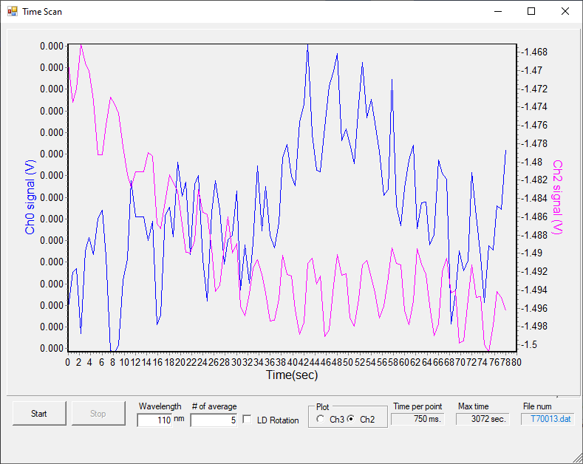
File | λ range | λ step | #av/#sc | Temp/K | Keithley | Table/kstp | PMTVac | Sample
70014 | 110-220 | 0.5 | 15/2 | 130K | 5NPLC | -300 | ON | H2O

Dep 3: H2O dosing for 30s at 5e-7 mbar
File: T70015
P before deposition: 2e-8 mbar
Temperature of substrate during deposition: 110K
Laser signal: 14 uA
Time start = 27 s
Time stop = 57 s
Total dose =15 s dose

File | λ range | λ step | #av/#sc | Temp/K | Keithley | Table/kstp | PMTVac | Sample
70016 | 110-220 | 0.5 | 15/2 | 130K | 5NPLC | -300 | ON | H2O

Dep 4: H2O dosing for 30s at 5e-7 mbar
File: T70017
P before deposition: 2e-8 mbar
Temperature of substrate during deposition: 110K
Laser signal: 14 uA
Time start = 27 s
Time stop = 57 s
Total dose =15 s dose

File | λ range | λ step | #av/#sc | Temp/K | Keithley | Table/kstp | PMTVac | Sample
70018  70019 | 110-220 | 0.5 | 15/2 | 130K | 5NPLC | -300 | ON | H2O
70020 | 138-150

Thick H2O dep: dosing for 5min at 5e-7 mbar
File: T70020
P before deposition: 2e-8 mbar
Temperature of substrate during deposition: 110K
Laser signal: 14 uA
Time start = 32s
Time stop = 5min32 s
Total dose =15 s dose

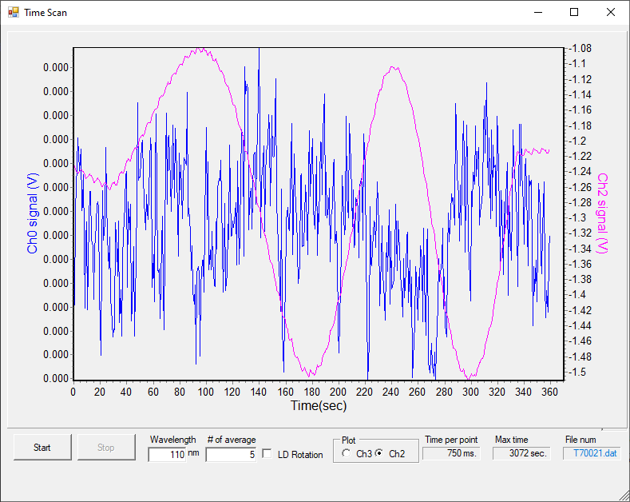

Sunday 5th June 2022 – Deposition at 80 K
07:45 P = 2e-8 mbar T = 275 K

BKG scans at 127.5 K
File | λ range | λ step | #av/#sc | Temp/K | Keithley | Table/kstp | PMTVac | Sample
70022 | 110-220 | 0.5 | 15/2 | 125K | 5NPLC | -300 | ON | Clean MgF2
70023 | 138-150 | 0.2 |  |  |  | -450 |  | Clean MgF2

Dep 1: H2O dosing for 45s at 1e-7 mbar
File: T70024
P before deposition: 2e-8 mbar
Temperature of substrate during deposition: 110K
Laser signal: 14 uA
Time start = 33 s
Time stop = 1min18 s
Total dose =45 s dose

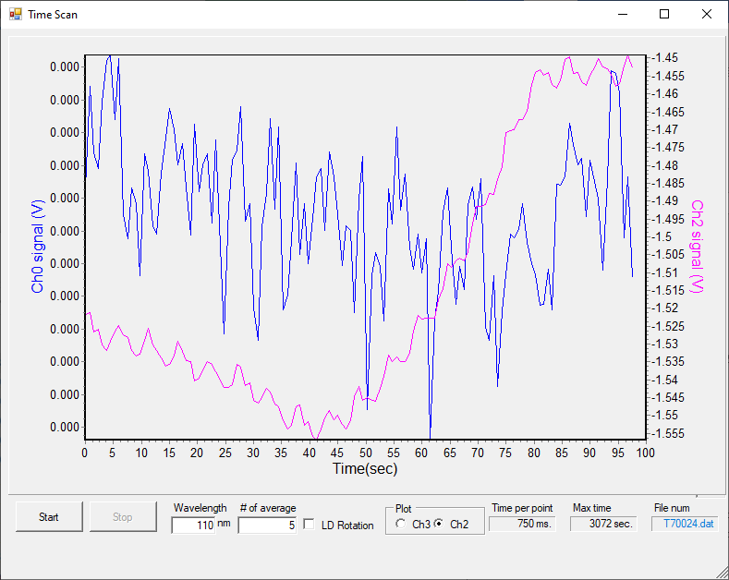
File | λ range | λ step | #av/#sc | Temp/K | Keithley | Table/kstp | PMTVac | Sample
70025 | 110-220 | 0.5 | 15/2 | 130K | 5NPLC | -300 | ON | H2O
70026 | 138-150 | 0.2 |  |  |  | -450 |  | H2O

Anneal to 90K
File | λ range | λ step | #av/#sc | Temp/K | Keithley | Table/kstp | PMTVac | Sample
70027 | 110-220 | 0.5 | 15/2 | 130K | 5NPLC | -300 | ON | H2O

Anneal to 100K
File | λ range | λ step | #av/#sc | Temp/K | Keithley | Table/kstp | PMTVac | Sample
70028 | 110-220 | 0.5 | 15/2 | 130K | 5NPLC | -300 | ON | H2O

Anneal to 110K
File | λ range | λ step | #av/#sc | Temp/K | Keithley | Table/kstp | PMTVac | Sample
70029 | 110-220 | 0.5 | 15/2 | 130K | 5NPLC | -300 | ON | H2O

Anneal to 120K
File | λ range | λ step | #av/#sc | Temp/K | Keithley | Table/kstp | PMTVac | Sample
70030 | 110-220 | 0.5 | 15/2 | 130K | 5NPLC | -300 | ON | H2O

Anneal to 125K
File | λ range | λ step | #av/#sc | Temp/K | Keithley | Table/kstp | PMTVac | Sample
70031 | 110-220 | 0.5 | 15/2 | 130K | 5NPLC | -300 | ON | H2O

Anneal to 130K
File | λ range | λ step | #av/#sc | Temp/K | Keithley | Table/kstp | PMTVac | Sample
70032 | 110-220 | 0.5 | 15/2 | 130K | 5NPLC | -300 | ON | H2O

Anneal to 140K
File | λ range | λ step | #av/#sc | Temp/K | Keithley | Table/kstp | PMTVac | Sample
70033 | 110-220 | 0.5 | 15/2 | 130K | 5NPLC | -300 | ON | H2O

Substrate clean – 70034

Thick dep H2O: dosing for at 1e-7 mbar
File: T70035
P before deposition: 2e-8 mbar
Temperature of substrate during deposition: 110K
Laser signal: 14 uA
Time start = 24 s
Time stop = 7min
Total dose =45 s dose

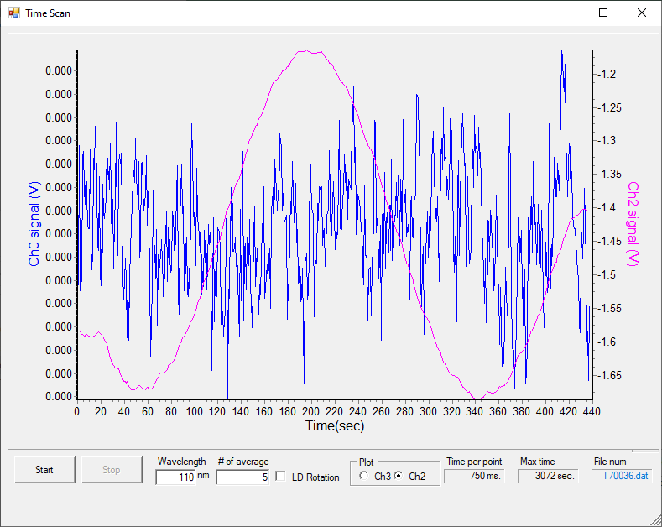

50 K Thick dep H2O: dosing for 460s at 1e-7 mbar
File: T7003
P before deposition: 2e-8 mbar
Temperature of substrate during deposition: 110K
Laser signal: 14 uA
Time start = 24 s
Time stop = 7min
Total dose =45 s dose

