Peer Evaluation for Mexican Train Dominos – Review of Chapter 14
Your name: (Your lab is the one being evaluated) | Cassidy Kane
Name(s) of peer evaluator(s) | self
Date: | 10/08/18

Instructions
You should have already completed as much of Mexican Train Dominos as you can given your time constraints. After you and a peer have evaluated your work, you will submit this evaluation along with screen shots and source code indicated in moodle. You may make corrections to your work as a result of the evaluation.
Programming style for all programs
Is proper indentation used? Is each method indented properly?
Are comments used appropriately?
Do variable names use camel case? (camelCase for example)
Do property/method names use Title Case (or Pascal Case?)

General comments and notes from the evaluator:

One thing that you learned from completing the evaluation:

Professional development tools and techniques
Class library includes an updated class diagram? Screen shot of class diagram is included?
Created a git branch for lab 1? | n (new repo)
Committed at least 3 times to the remote repository on git?
Issued a pull request upon completion of lab 1 and successfully merged the lab 1 branch with master?
Screen shot of git log is included?
Classes and methods are documented with (at a minimum) <summary> xml comments?
Screen shot of documentation file is included?

Screen shot of class diagram, git log, xml documentation
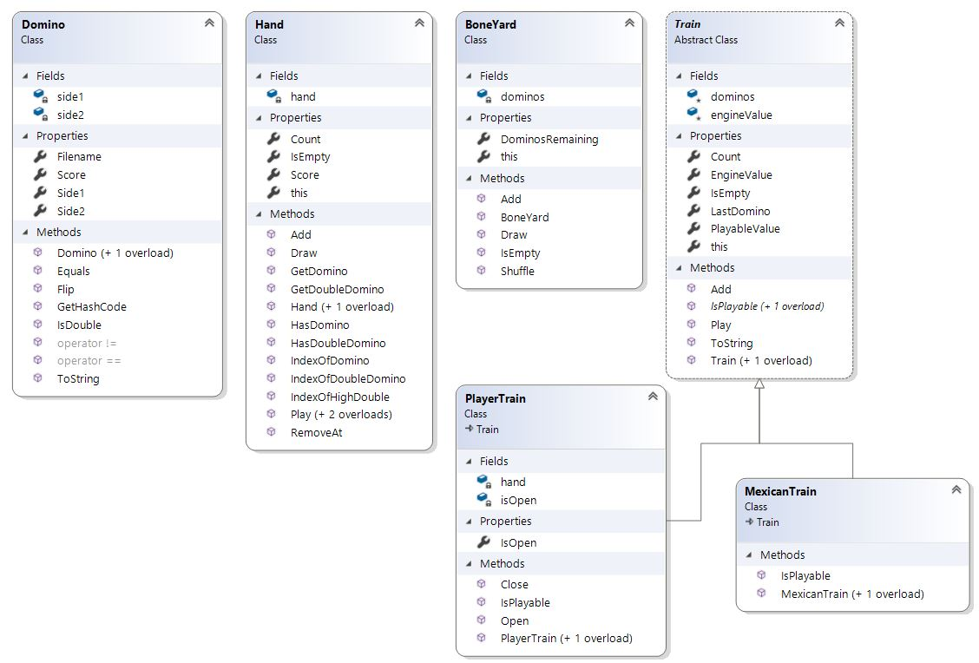

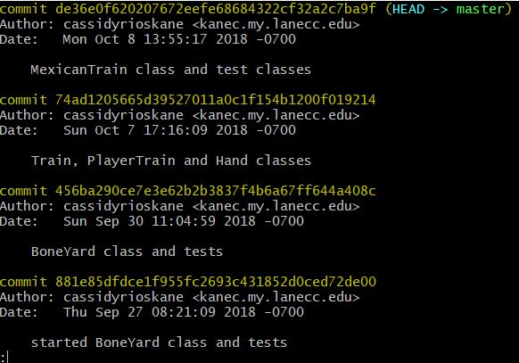

<?xml version="1.0"?>
<doc>
<assembly>
<name>MTDClasses</name>
</assembly>
<members>
<member name="P:MTDClasses.Domino.Score">
This is how I would have done this in 233N
</member>
<member name="T:MTDClasses.Hand">
<summary>
Represents a hand of dominos
</summary>
</member>
<member name="F:MTDClasses.Hand.hand">
<summary>
The list of dominos in the hand
</summary>
</member>
<member name="M:MTDClasses.Hand.#ctor">
<summary>
Creates an empty hand
</summary>
</member>
<member name="M:MTDClasses.Hand.#ctor(MTDClasses.BoneYard,System.Int32)">
<summary>
Creates a hand of dominos from the boneyard.
The number of dominos is based on the number of players
2â€“4 players: 10 dominoes each
5â€“6 players: 9 dominoes each
7â€“8 players: 7 dominoes each
</summary>
<param name="by"></param>
<param name="numPlayers"></param>
</member>
<member name="P:MTDClasses.Hand.Score">
<summary>
Sum of the score of each domino in the hand
</summary>
</member>
<member name="M:MTDClasses.Hand.HasDomino(System.Int32)">
<summary>
Does the hand contain a domino with value in side 1 or side 2?
</summary>
<param name="value">The number of dots on one side of the domino that you're looking for</param>
</member>
<member name="M:MTDClasses.Hand.HasDoubleDomino(System.Int32)">
<summary>
DOes the hand contain a double of a certain value?
</summary>
<param name="value">The number of (double) dots that you're looking for</param>
</member>
<member name="M:MTDClasses.Hand.IndexOfDomino(System.Int32)">
<summary>
The index of a domino with a value in the hand
</summary>
<param name="value">The number of dots on one side of the domino that you're looking for</param>
<returns>-1 if the domino doesn't exist in the hand</returns>
</member>
<member name="M:MTDClasses.Hand.IndexOfDoubleDomino(System.Int32)">
<summary>
The index of the double domino with the value you're looking for
</summary>
<param name="value">The number of (double) dots that you're looking for</param>
<returns>-1 if the domino doesn't exist in the hand</returns>
</member>
<member name="M:MTDClasses.Hand.IndexOfHighDouble">
<summary>
The index of the highest double domino in the hand
</summary>
<returns>-1 if there isn't a double in the hand</returns>
</member>
<member name="M:MTDClasses.Hand.GetDomino(System.Int32)">
<summary>
Finds a domino with a certain number of dots in the hand.
If it can find the domino, it removes it from the hand and returns it.
Otherwise it returns null
</summary>
<param name="value"></param>
<returns></returns>
</member>
<member name="M:MTDClasses.Hand.GetDoubleDomino(System.Int32)">
<summary>
Finds a domino with a certain number of double dots in the hand.
If it can find the domino, it removes it from the hand and returns it.
Otherwise it returns null
</summary>
<param name="value"></param>
<returns></returns>
</member>
<member name="M:MTDClasses.Hand.Draw(MTDClasses.BoneYard)">
<summary>
Draws a domino from the boneyard and adds it to the hand
</summary>
<param name="by"></param>
</member>
<member name="M:MTDClasses.Hand.Play(System.Int32,MTDClasses.Train)">
<summary>
Plays the domino at the index on the train.
Flips the domino if necessary before playing.
Removes the domino from the hand.
Throws an exception if the domino at the index
is not playable.
</summary>
<param name="index"></param>
<param name="t"></param>
</member>
<member name="M:MTDClasses.Hand.Play(MTDClasses.Domino,MTDClasses.Train)">
<summary>
Plays the domino from the hand on the train.
Flips the domino if necessary before playing.
Removes the domino from the hand.
Throws an exception if the domino is not in the hand
or is not playable.
</summary>
</member>
<member name="M:MTDClasses.Hand.Play(MTDClasses.Train)">
<summary>
Plays the first playable domino in the hand on the train
Removes the domino from the hand.
Returns the domino.
Throws an exception if no dominos in the hand are playable.
</summary>
<param name="t"></param>
<returns></returns>
</member>
<member name="M:MTDClasses.PlayerTrain.#ctor(MTDClasses.Hand,System.Int32)">
<summary>
This is the most appropriate constructor for the class.
</summary>
<param name="h">Represents the Hand object to which the train belongs</param>
<param name="engineValue">Represents the first playable value on the train</param>
</member>
<member name="P:MTDClasses.PlayerTrain.IsOpen">
<summary>
Returns whether or not the train is open. An open train
can be played upon by any player.
</summary>
</member>
<member name="M:MTDClasses.PlayerTrain.Open">
<summary>
Open the train
</summary>
</member>
<member name="M:MTDClasses.PlayerTrain.Close">
<summary>
Close the train
</summary>
</member>
<member name="M:MTDClasses.PlayerTrain.IsPlayable(MTDClasses.Hand,MTDClasses.Domino,System.Nullable{System.Boolean}@)">
<summary>
Can the domino d be played by the hand h on this train?
If it can be played, must it be flipped to do so?
</summary>
<param name="d"></param>
<param name="mustFlip"></param>
<param name="h"></param>
<returns></returns>
</member>
<member name="T:MTDClasses.Train">
<summary>
Represents a generic Train for MTD
</summary>
</member>
<member name="P:MTDClasses.Train.EngineValue">
<summary>
The first domino value that must be played on a train
</summary>
</member>
<member name="P:MTDClasses.Train.PlayableValue">
<summary>
Side2 of the last domino in the train. It's the value of the next domino that can be played.
</summary>
</member>
<member name="M:MTDClasses.Train.IsPlayable(MTDClasses.Hand,MTDClasses.Domino,System.Nullable{System.Boolean}@)">
<summary>
Determines whether a hand can play a specific domino on this train and if the domino must be flipped.
Because the rules for playing are different for Mexican and Player trains, this method is abstract.
</summary>
</member>
<member name="M:MTDClasses.Train.IsPlayable(MTDClasses.Domino,System.Nullable{System.Boolean}@)">
<summary>
A helper method that determines whether a specific domino can be played on this train.
It can be called in the Mexican and Player train class implementations of the abstract method
</summary>
</member>
</members>
</doc>

Unit Testing
Completed unit testing for all classes?
- Included a class for each test fixture? Class is annotated appropriately?
- Included one test for each constructor / property / method? Test is appropriately annotated? Test uses assertions appropriately? Test checks the functionality of JUST ONE THING?
- Tests pass? Screen shot is included?
- Source code is included for all test fixtures?

URL for github repo. Screen shot of tests passing.
https://github.com/cassidykane/MTD-Lab1.git
