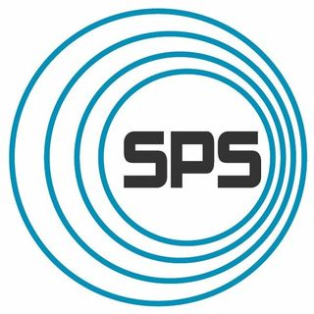Society of Physics Students

Zone 12 Meeting Report

*Washington University in St. Louis*

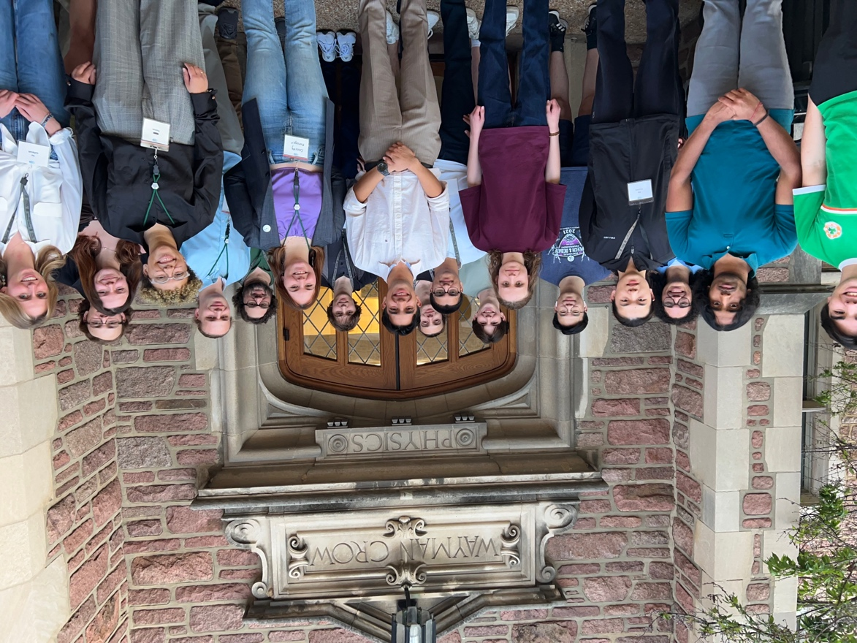

Figure 1: Attendees of the 2024 Zone 12 Meeting

# Overview of the event

# The SPS Zone 12 Meeting, hosted by Washington University in St. Louis (WashU), took place March 29th - March 30th. There were approximately 20 students in attendance, 5 speakers/panelists, and 8 organizers. In addition to WashU’s SPS chapter, the SPS chapters from Missouri S&T and the University of Missouri St. Louis were in attendance. Though we would have hoped for higher attendance, the event planners found the meeting to be highly successful. A large number of attendees reported positively on their time at WashU and found the meeting enjoyable and helpful.

* 1. Recommendations for future planning

In the future, the event planners would recommend advertising the event much earlier in order to give chapters from farther away universities time to request travel funds. Advertising the event earlier on would also give the event planners more of an ability to invite speakers from outside their home institution. Additionally, before hosting the meeting, we’d recommend gauging the participants’ interest in presenting their own research. We expected students to sign up to present their work, however, the vast majority of students were not interested in presenting posters or giving brief talks. We would recommend that other chapters consider using the first night of the meeting as a social time. We had tremendous success getting attendees to bond over dinner Friday night before engaging them in Jeopardy-style physics trivia. We placed them into teams, which, we believe, allowed many participants to make connections with the other attendees.

* 1. Chapters in attendance
* Washington University in St. Louis
* University of Missouri-St. Louis
* Missouri University of Science & Technology
  1. Expenses

The primary expense of hosting this Zone meeting was food. We provided Domino’s Pizza for dinner on Friday. The pizza was served alongside sides of fruit and a choice of either chocolate cake or carrot cake for dessert. On Saturday, breakfast-style snacks were served alongside coffee/tea. Jimmy John’s Sandwiches were served for lunch with cookies for dessert. For dinner, Vito’s Sicilian Pizzeria and Ristorante was catered. In total, this brought us just under $1,000 to $990.48.

|  |  |
| --- | --- |
| **Expense** | **Cost** |
| Friday dinner | $136.87 |
| Snacks/sides | $98.11 |
| Saturday lunch | $155.98 |
| Saturday dinner | $599.52 |
| **Sum** | **$990.48** |

*Expense receipts attached.*

* 1. Meeting Agenda

**Friday, March 29th**

5:30-6pm: Attendee Registration and Lanyard Handout

6-6:10pm: Welcome Remarks

6:10-7:10pm: Dinner

7:10-8:10pm: Physics Games and Trivia

8:30: Attendees Return to Hotels

**Saturday, March 30th**

9:9:30am: New Attendee Registration

9:45-10:15am: **Undergraduate Research Panel**

*Featuring panelists Garrett King, Nicole Osborn, and T. Thomas*

10:30-11am: Lecture by WashU’s Dr. Alex Chen: Pulsars

11:15-11:45am: Informal Research Poster Tours

11:45am-1:15pm: Lunch

1:15-2pm: **Graduate School Panel**

*Featuring Panelists Tansu Daylan, Garrett King, Nicole Osborn, and Bryce Wedig*

2:10-2:40pm: Lecture by WashU’s Dr. Tansu Daylan: Written in the Alignment of Planets and Stars

2:45-3:15pm: Graduate Student Lecture: Ultra-Heavy Galactic Cosmic Ray Elemental Abundances with SuperTIGER (Delivered by Nicole Osborn)

3:20-3:50pm: Graduate Student Lecture: Nuclear Structure, Reactions, and New Physics Searches (Delivered by Garrett King)

4-4:30pm: Undergraduate Student Lecture: An All-Sky Survey of TeV-emitting BL Lac Objects (Delivered by SPS President Cassidy Metzger)

4:35-4:55pm: Undergraduate Student Lecture: Exploring Modified Gravity Theories in Simulated Images of Supermassive Black Holes (Delivered by T. Thomas)

5:05-5:35pm: Undergraduate Student Lecture: The Legacy of TESS in the Making: The TESS Objects of Interests (Delivered by SPS Vice President Tomás Salazar)

5:40-6:10pm: Lecture by WashU’s Dr. Xi Wang: Interacting Opto-Moiré Quantum Matter

6:20-7:30pm: Dinner and Closing Remarks

# Narrative of the event

Figure 2: SPS Secretary, Macy Iyer, putting up signs on the day of the event

The 2024 Zone 12 Meeting, hosted by Washington University in St. Louis (WashU) began Friday, March 29th at 5:30. Both Missouri University of Science and Technology and University of Missouri–St. Louis joined WashU in Crow Hall to attend. Dinner was served to approximately 20 students starting around 6:00 pm. Pizza and lemonade were served for dinner with a choice of chocolate cake or carrot cake for dessert. During dinner, students gathered at the tables in the Gustavus Pierfer Physics Library. Conversations ranged from jokes about classes to more serious conversations about research involvement and post-graduate plans. As the movement to refill plates gradually began to slow, the meeting planners prompted the students to shift to Compton 241, in WashU’s Arthur Holly Compton Laboratory of Physics, to play a game of physics Jeopardy. There, students organized themselves into teams of approximately 4 members and competed in the areas of: knowledge of equations, historical knowledge of people and places, the ability to rapidly solve problems, and physics-based science fiction trivia. Students enthusiastically engaged with the game, shouting playfully over the music playing in the background and jokingly berating their competitors. After the final question had been completed, the event planners thanked everyone for their attendance and provided information about the following day’s events. As the event planners began to clean up, students were invited to linger to finish their conversations and take any leftover food. A number of students chose to stay and go for seconds on the dessert before heading out for the night.

The events of the next day began at 9:00 am. Students who had not registered for the conference the previous day were instructed to arrive between 9 and 9:30 am to have their attendance recorded and receive a lanyard with their name. A panel featuring three speakers: graduate students, Garrett King and Nicole Osborn and undergraduate student, T. Thomas, began at 9:45 am. The three panelists discussed their experiences doing research in the field of physics. They were asked about their current research and their past work. They shared how they had followed their interests toward their current field and how they knew what research was right for them. They were also asked what a good relationship with a principal investigator (PI) looks like. They concluded by discussing various ways to obtain a research position as an undergraduate student, highlighting various ways to connect with professors, REU programs, and SPS-based funding.

Figure 3: Panelists T. Thomas (left) and Garrett King (right)

Next, after a 15-minute break, a 30-minute talk on pulsars by WashU Assistant Professor, Alex Chen, began. Dr. Chen highlighted his work in the field of computational physics and how he uses computer models to understand the magnetic fields of pulsars. Much to the joy of his audience, he displayed several videos of his models.

Figure 4: WashU Assistant Professor, Dr. Alex Chen

After fielding questions, Dr. Chen concluded his talk. The meeting attendees were then given time to explore the research posters that lined the hallway outside the auditorium before lunch. Lunch was served in Compton 241 where attendees clustered at tables. We were delighted to note that the attendees from different schools sat together.

Figure 5: Students waiting for the panel to begin having finished lunch

Many discussed what life was like at their universities: their classes, their professors, and their research. Others enjoyed more lighthearted conversations about their interests.

After lunch, another panel commenced. This panel featured Professor Tansu Daylan and graduate students, Garrett King, Nicole Osborn, and Bryce Wedig. Each panelist shared their own experiences with graduate school; how they knew it was right for them, what led them towards it, and even the benefits and disadvantages of graduate school over industry work. The majority of the panel was directed by the attendee's questions.

Figure 5: Panelists (from left to right) Nicole Osborn, Garrett King, Tansu Daylan, and Bryce Wedig.

Following the panel, the meeting moved to a series of thirty-minute talks. The first one was from Dr. Tansu Daylan where he discussed his work on exoplanets and how they are discovered. He specifically focused on informing attendees about the transit method of exoplanet discovery. Then, after a quick break, we heard from graduate student Nicole Osborn about her work with the galactic cosmic rays. Osborn’s work focuses on studying elemental abundances in ultra-heavy galactic cosmic rays (UHGCRs) using a balloon-borne detector known as SuperTIGER. Aiming her discussion toward the undergraduate level, she defined cosmic rays and offered a simplified explanation of SuperTIGER’s purpose. Then, fellow graduate student Garrett King shifted the discussion away from astrophysics and toward particle physics. King’s work focuses on nuclear structure theory. He aims to use theoretical models to predict experimental data.

After thanking the graduate students and Dr. Tansu Daylan, a coffee break was had and the talk series shifted towards the undergraduate portion. Several undergraduates present their own research in thirty-minute talks. Cassidy Metzger kicked off the undergraduates by discussing her work studying the relativistic jets of active galactic nuclei. Metzger defined relevant concepts before posing the question: what causes the particle acceleration in relativistic jets? Her research aims to answer that question by utilizing multiwavelength data to create a comprehensive list of the most powerful relativistic jets in the Universe.

Figure 6: Undergraduate student, Cassidy Metzger, discussing her research on active galactic nuclei.

Then, in the same vein of astrophysics, undergraduate T. Thomas presented their work using supermassive black holes to test modified theories of general relativity. Thomas’s work utilizes data from the Event Horizon Telescope (EHT). Thomas explains that most of the models of the black holes imaged by EHT assume that the black hole is best described using the theory of general relativity. But Thomas’s research proposes alternative theories that may affect how the image is modeled.

Figure 7: Undergraduate student T.Thomas discussing their work on modified theories of general relativity.

Concluding the undergraduate talks, Tomás Salazar presented a hilarious talk on his work under Professor Tansu Daylan. Salazar followed up on Daylan’s talk by discussing his own experiences discovering exoplanets using the Transiting Exoplanet Survey Satellite (TESS). Salazar believes that exoplanets have the potential to reveal the formation and evolution pathways of planets in the Universe and contextualize the Solar System.

Figure 8: Undergraduate student Tomás Salazar discusses his work with exoplanets.

SPS advisor and assistant professor at WashU, Xi Wang, wrapped up the lecture series with her discussion of Interacting Opto-Moiré Quantum Matter. Wang presented her lab’s recent results working with interactions between excitons and charge carriers trapped in moiré potentials. Wang’s work provides a vital framework for understanding and engineering electronic and excitonic states in moiré quantum matters.

Figure 9: WashU Assistant Professor Xi Wang explains her work on Opto-Moiré Quantum Matter.

After a round of applause for Wang and the other speakers, attendees headed down the hall to where a caterer dinner had been laid out for them. Attendees were invited to serve themselves before gathering around tables where they were invited to spend the remainder of the meeting connecting with those around them. Numbers and emails were exchanged, and several attendees asked the event planners to loop them in for future events. Before attendees were dismissed, everyone was invited to participate in a picture outside of WashU’s physics department building to commemorate the occasion.

Back inside, everyone was thanked for coming and were invited to continue to stay as long as they pleased, although the event had formally concluded. Many attendees chose to linger to continue conversations. Over time, the room gradually emptied, and the event planners celebrated the success of the meeting and began to clean up from the event.

# Acknowledgements

# This event would not have been possible without a community behind it. We’d like to extend our gratitude to the 2024 SPS executive board: Cassidy Metzger, Tomás Salazar, Macy Iyer, Maseo Mercer, Joseph Sorel, and Brian Yu.

# And to the following WashU SPS members who stepped up to assist the board in organizing the event: Izzy Caffarelli, Grace Mead, and T. Thomas.

# We also received great assistance from the WashU Physics administrators Mary Sullivan and Sarah Akin. Mary especially organized all the meals that were provided to participants. She took time out of her Saturday to pick up Jimmy John’s and help the caterers set up dinner.

# The SPS advisor, Xi Wang, helped the executive board plan and organize the event alongside the Zone 12 Councilor, Jency Sundararajan. Jency even traveled from Virginia to stop by the meeting!

# We’d also like to thank the SPS National organization for providing us with the materials and funding necessary for this undertaking.

# Of course, the meeting would not have been possible without our speakers and panelists who diligently gave their time: Dr. Alex Chen, Dr. Tansu Daylan, Garrett King, Nicole Osborn, Dr. Xi Wang, and Bryce Wedig.

# And, finally, we’d like to extend our gratitude to everyone who attended the SPS Zone 12 Meeting. Hosting this meeting was a tremendous step for our chapter and we are so grateful to everyone who helped us along the way. Thank you!

*The photos in this report were taken by SPS Vice President Tomás Salazar. This report was written by SPS President Cassidy Metzger and SPS Secretary Macy Iyer.*