## Question 30

The Average RMSE for Original Test Set is 0.9341694523212585.

## Question 31

The Average RMSE for Popular Movie Trimmed Test Set is 0.931652900928051.

## Question 32

The Average RMSE for Unpopular Movie Trimmed Test Set is 0.9651697469437426.

## Question 33

The Average RMSE for High Variance Movie Trimmed Test Set is 1.4676561249836158.

## Question 34

We plotted ROC curves from kNN, NNMF and MF respectively to compare their performance as shown in Figure x.

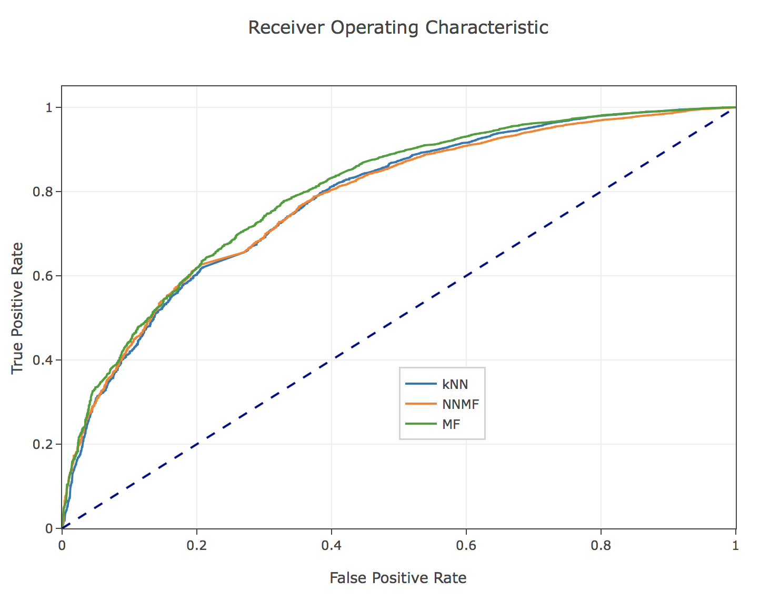

Figure x Performance Comparison of k-NN, NNMF, and MF

We can see that MF has the highest area under curve, indicating best performance among three.