1. The number of house records was 15932 in January that was the lowest at the past 8 years.

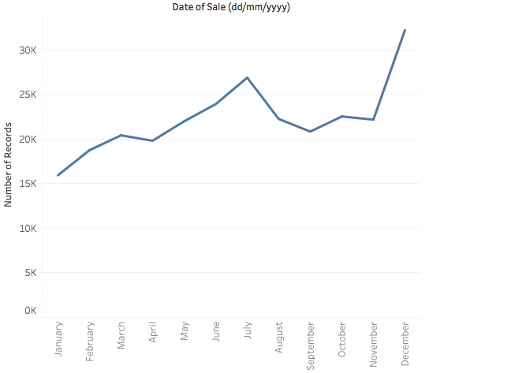

1. The lowest average house price was in December with €21754 in the past 8 years.
2. The highest average house price was in August with €240505 in the past 8 years.

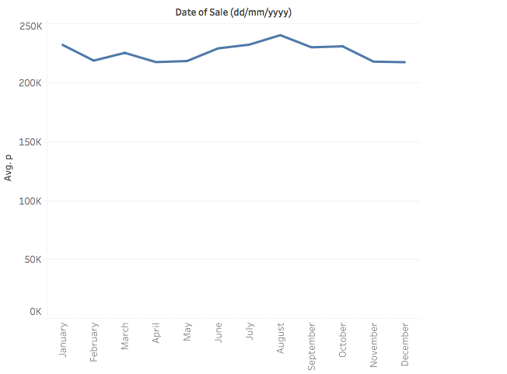

1. The price of house was increasing dramatically in Ireland over past 8 years.

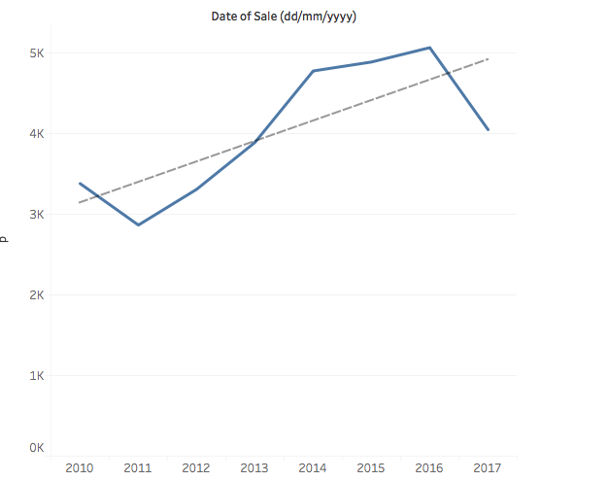

1. Yes, it is. Every quarter four had the highest volume of house sales, however first quarter had the lowest volumes of house sales.

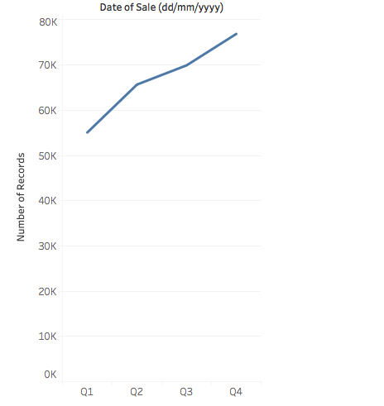

1. The highest volume of house sales was 7502 in December 2014.

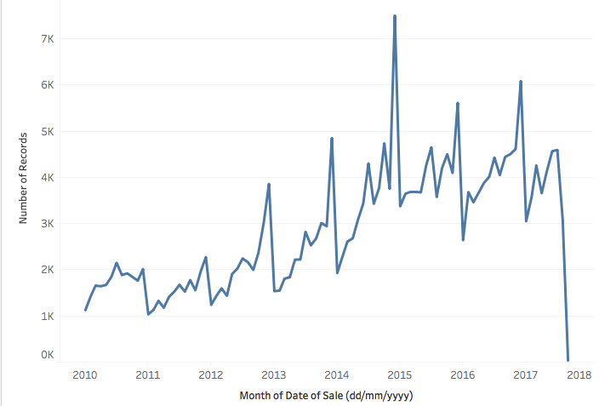

1. & 8. Dublin County had the highest volume of house sold and the highest total sales amount over the past 8 years.

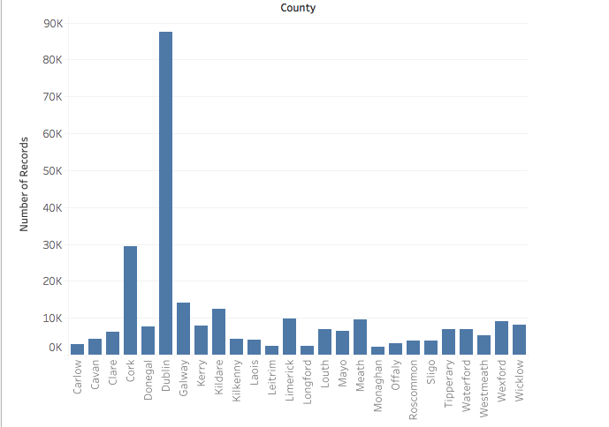

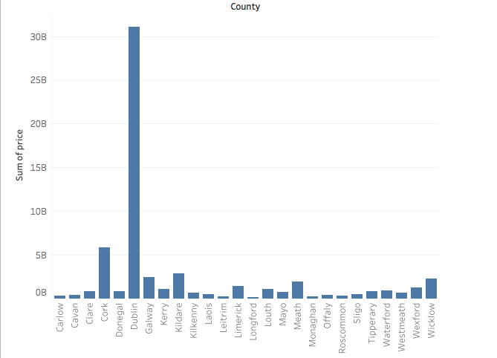

1. Longford County had the lowest average sales price over the 8 years.

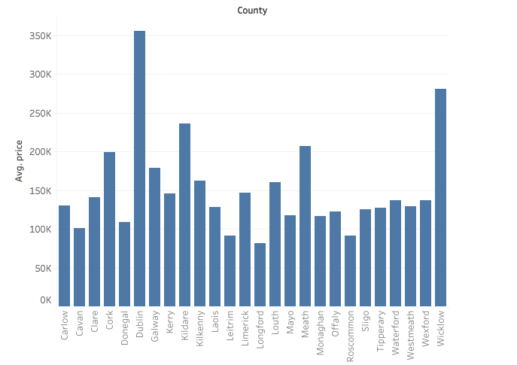

1. Dublin County had the largest rise in average house price over 8 years. However, Longford had the largest fall in average house price over 8 years.

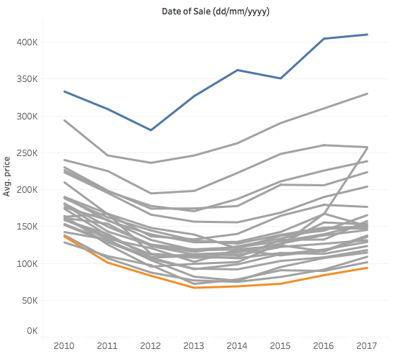

1. Yes, it has changed. It can be seen from the following graph that more and more second house were sold over past 8 years. But the new house sales had a slight change in the past 8 years.

