**Project: Facebook server Report**

**Background**

This project can allow to log in a user each time, then add friends, post messages to his friends and display all information included senders id and messages as well. Actually it seems similar to Facebook function. But there are some errors in my server. For example display information cannot display out; many terminals can execute client.sh simultaneously, which means that many users can concurrently log in.

**Processes**

1. Basic command of the server

The first step is to create users through writing a bash script called create.sh. According to request, I used If condition to implement.

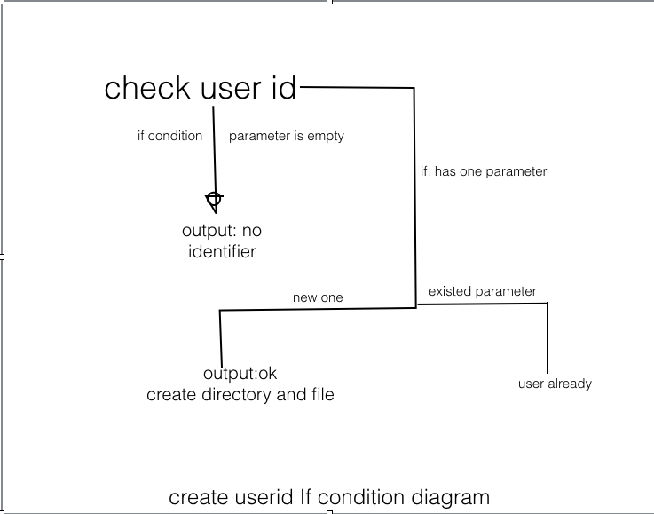

The second step is to write an add_friend.sh, which means that user can add friends. I also use IF condition to address the requirement.

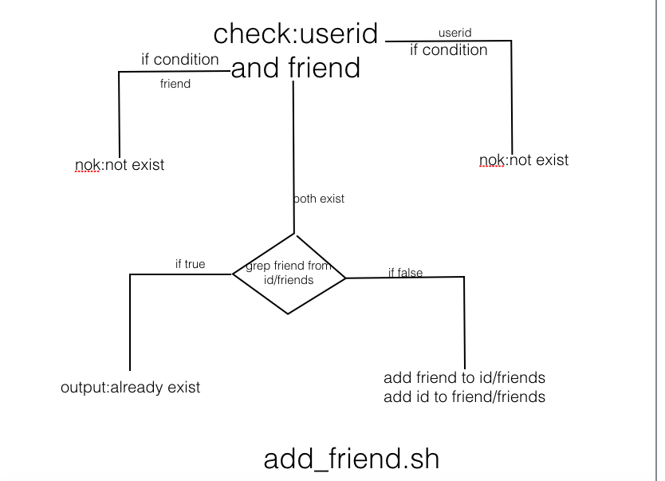

The third stage is to post messages to friends. This step is very similar to previous section. So, I just copied the above section, then replace $id to $sender, replace $friend to $receiver. Meanwhile I added one more parameter that is messages. Finally, echo $sender and messages to wall file.

The fourth step is to display user’s wall. By implementing it, I used IF condition.

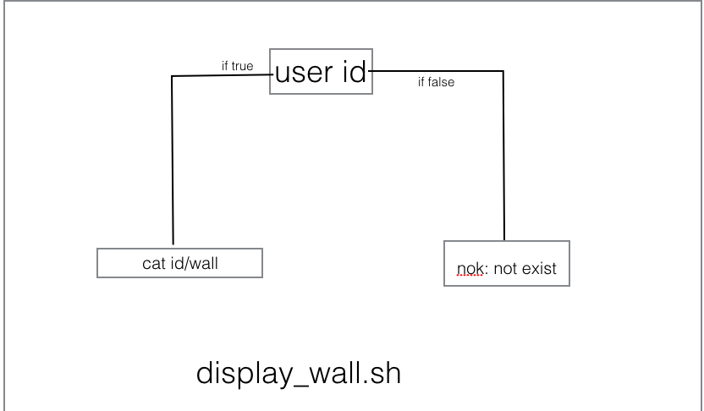

2. Server

This section is more difficult than the first section. This is a multithreads management. Before lecturer gave an extra class, I did not have any ideas to finish it. Meanwhile I asked help from TA. However, I still have one error in the following:

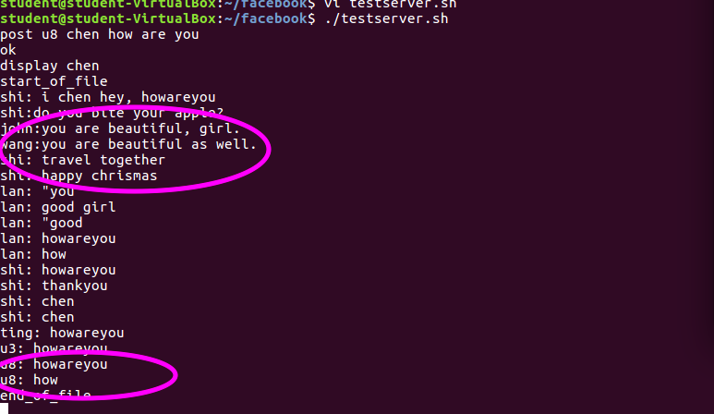

It is clearly noticed that the message displayed has only one word by server.sh. In the first section, messages are contained one word used double quotation. However, in server.sh, I do not know how to address the black space. I tried to use array to handle this issue, but it still does not work. Another issue is that I did not address synchronization. I tried to insert p.sh before critical section and v.sh after critical section in testserver.sh bash script. Unfortunately, I did not work well. Because the deadline is nearly closed, I gave up synchronization.

**3. Clients**

This section is much more complicated. I discussed with Wei Lan together.

At first, I got many errors, such as infinite loop, failed named pipe and so on. It is clearly noticed in the following:

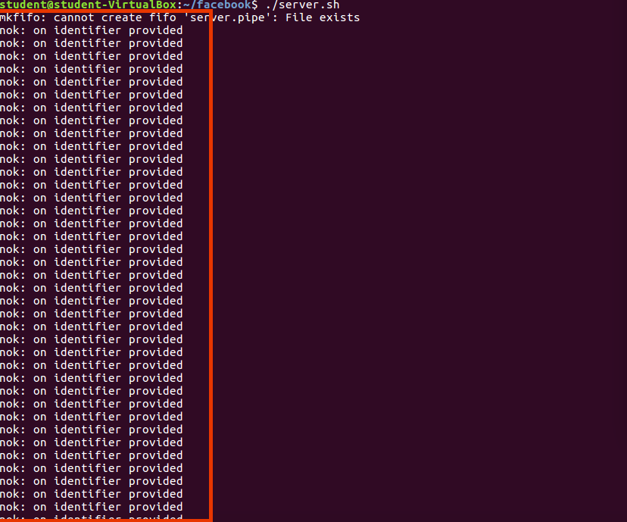

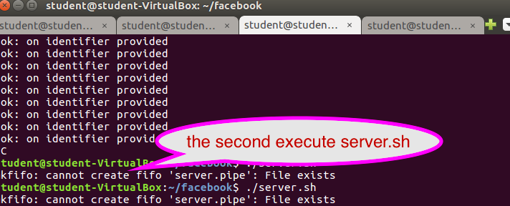

In order to handle those issues, I utilized Google resources, such as [www.stackoverflow.com](http://www.stackoverflow.com), which is much helpful and useful. Actually, about using while loop, I consulted to TA. During implementing this section, I have learnt how to built pipes and how to communicate with different processes. The following is my client.sh structure: 1. Using if condition to check parameter to make sure only one parameter; 2. Before building a new $id.pipe, the old $id.pipe should remove; 3. Using while loop with nested case condition input requests and transfer to server.pipe; 4. Utilizing while loop read the server.pipe replies, then if condition to choose the options.

However, I have not implemented how to use function to kill the client process. I tried to use the sample lecturer provided, but it did not work. Actually, function algorithm is my weakness.

**Conclusion**

When I finished this project, I got understand some difficult concepts that I did not understand well before. And I am familiar with using while loop and if condition. However, I still am confused with some concepts such as synchronization.