2002 Widener University School of Law Alumni News

Widener Hosts CLE Program and Alumni Reception in Washington, D.C.

October 2002
On October 24th, the Law School hosted a CLE Program and Alumni Reception at the Phoenix Park Hotel in Washington, D.C. to honor our newly formed D.C. Area Chapter of the Alumni Association. Professor John L. Gedid presented a one-credit CLE program entitled "Longarm Jurisdiction in Cyberspace: Can the Courts Make International Shoe Fit?" Following the CLE Program, the group gathered for a Reception.

The Office of Development and Alumni Relations would like to thank the following Executive Committee members for their efforts in making this event a success:
Aaron Marshall '98
Cynthia Ryan '79
Elaine Panzitta '90
John Flynn '98

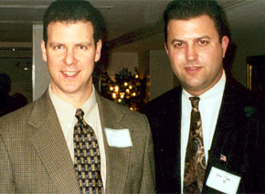
Chris Banker '92 and John Flynn '98
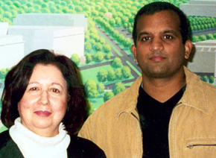
Elaine Panzitta '90 and Hemant Pathak '94

The energy and enthusiasm created by the birth of the Chapter has prompted plans for another event. If you would like to become an active member of the D.C. Chapter, please contact Jeremy Nelson, Coordinator of Alumni Relations, at 302-477-2191 or email him at: jeremy.r.nelson@law.widener.edu.

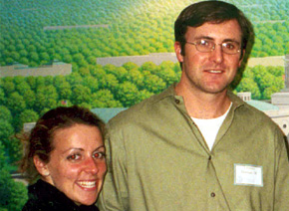
Maureen Danker '00 and Len Herman '00

Twenty-five Widener University School of Law Alumni Inducted into the Supreme Court Bar

June 2002
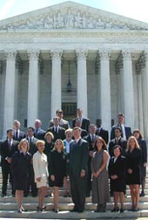
On June 17th, a group of twenty-five Widener University School of Law Alumni were inducted into the Supreme Court Bar. The ceremony was held at the Supreme Court where Chief Justice Rehnquist and Associate Justices Stevens, Ginsburg, Thomas, Scalia, Breyer, Kennedy, Souter were present.

Delaware Supreme Court Justice Randy Holland presented the names of the Widener contingency to Chief Justice Rehnquist who admitted them into the United States Supreme Court Bar. The pomp and circumstance of the event made it quite memorable.

The induction was followed by lunch at Washington's University Club where Professor Paul Regan, Widener Law's 2002 Outstanding Professor Award recipient, gave a short lecture entitled "Corporate Governance in a Post-Enron World."

The following attorneys were inducted:
Jennifer Archer '94
Thomas Archer '94
Marilyn Bromels '97
Romanna Butcher '98
Lorraine Capra '98
Scott Coppeto '95
Hilary Cornell '88
John Flynn, III '98
Ronnie Hess '95
Gentry Hogan '98
Vivian Houghton '79
Bernard Hvozdovic, Jr. '92
William Kelleher '95
Jennifer Letcavage Kelleher '96
Alvin Krantz '76
Carl Malatesta '97
Aaron Marshall '98
Michael Milstead '89
Anne Marie Mulligan '95
Kymberlee O'Neill '95
Raymond Rodriguez '98
Richard Sands '94
Christine Sudlow '97
Elizabeth Wilburn '96
Professor Paul Regan (J.D., Temple Univ. School of Law)

Annual Alumni Golf Outing 2002

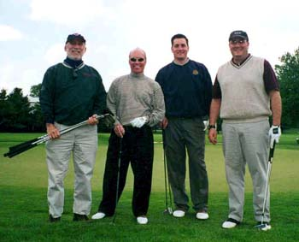
Widener Law's Annual Alumni Golf Outing was held on May 20th at the du Pont Country Club's Championship LPGA Course. Despite the record-breaking chilly temperatures, the Golf Outing was a big success with over seventy alumni, friends and staff participating.

The winning foursome, with a score of 291, included the following golfers:
Professor David Hodas,
Michael Doerr ('01),
Carl Price ('99)
Tom Lynam ('93).

Other winners were:

* 1st Place - Score of 75: David Glandsberg
* 2nd Place - Score of 76: John Conforti
* 3rd Place - Score of 79: Bill Satz
* First Par - Hole 2: Antonio Scotto
* Longest Putt - Hole 12: Tom Musi ('95)
* Longest Drive - Hole 11: Frank Carmody
* First Ball in the Water - Hole 3: Buddy New
* First Ball in the Water - Hole 18: Buzz Hannum
* Closest to the Pin - Hole 17: Tom Lynam ('99)
* Straightest Drive - Hole 10: David Rohde ('80)

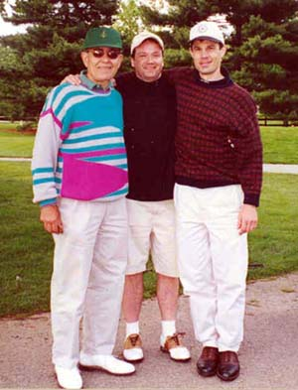
Sol Capodici, David Devine ('94), Dave Capodici

2001 - 2002 Widener University School of Law Awards

Delaware Scholarship Awards

E. Wallace Chadwick Memorial Scholarships
* Maria Carlucci
* Margaret England
* Riki Redente

Chadwick Constitutional Education Fellowship
* Walter Matthews
* Monika Pundalik

Harvey Alan Chernoff Memorial Scholarship
* James Merkins, Jr

Delaware Association of Lawyers' Wives Scholarship
* Elizabeth Winslow

Nancy and Howard Finkelman Scholarship
* Rashmi Rangan

Friends of Widener University School of Law Scholarship
* Benjamin Keenan

Honey F. Golby Memorial Scholarship
* James McMackin

Fairfax Leary, Jr., Memorial Scholarship
* Charles Williams III

Paul Isaac Leiter Memorial Scholarship
* Christopher Iacono

Charles P. Mirarchi, Sr., Memorial Scholarship
* Christopher Iacono

Bruce and Elizabeth Monroe Endowed Scholarship
* Corey Field
* Candyce Smith-Sklar

Pennsylvania Bar Foundation Scholarship
* Ronald Carter
* Jennifer Dezayas
* Courtney Gussman

Angelina & Victor Piccone Memorial Scholarship
* Margaret England

John C. Warrington Memorial Scholarship
* Khrishna Stone

Delaware Achievement Awards

Honorable Helen S. Balick Award
* Mark Olivere

Howard M. Berg Award
* Corey Field

William J. Conner Memorial Award for Administrative Law
* Komal Gupta

Dean’s Award
* Margaret England

Honorable Joseph W. deFuria Award
* Joy Abbot Inkpen

Judge J. Cullen Ganey Criminal Law Award
* GianClaudio Finizio
* Todd Baritz

Graham Foundation Award
* Matthew Fogg

Reed Hamilton Memorial Award
* Kathleen Martin
* Christopher Zalesky

Zelda K. Herrmann Memorial Cup Award
* Barbara Smith

International Academy of Trial Lawyers Advocacy Award
* Victor Zarrilli

Lindsay Law Library Award
* Todd Victor Clark
* J. Kurtis Kline

Most Promising Civil Litigator Award
* David Soldo

Outstanding Student Service Awards
* Kim Christy
* Melissa Dutton
* Donna Lumpkin
* Joseph Melican
* Ronald Piaseczny
* Riki Redente
* Scott Reid
* Brian Shea
* David Soldo
* Jennifer Warmann
* Kara White
* Charles Williams III
* Jennifer Zelvin

Philadelphia Trial Lawyers Association, James J. Manderino Award for Trial Advocacy
* Riki Redente

President’s Award
* Elizabeth Winslow

Alexander V. Sarcione, Jr., Memorial Award
* James Merkins, Jr.

Jerry Shields Environmental Award
* Thejender Prasad

Wapner, Newman & Wigrizer Award
* Andrew Rosenbloom

Dean Arthur A. Weeks Outstanding Service Award
* Andrew Walheim William J
* Ella C. Wolf

Award in Real Property Law
* Joy Abbot Inkpen

Harrisburg Scholarship Awards

Dean Anthony J. Santoro Scholarship
* Jennifer Zimmerman

Honorable Ned L. Hirsh Scholarship
* Thomas Brumbaugh

Bernard S. Wildstein Memorial Scholarship
* David Burkholder

Harrisburg Achievement Awards

George C. Blissman Memorial Award
* Jennifer Casini

James S. Bowman American Inn of Court Award
* Richard Martinelli

Judge James C. Crumlish, Jr.
* Jennifer Zimmerman

Pennsylvania Bar Foundation Awards
* Jennifer Casini
* Jason O’Malley
* Nguyen Trinh

William I. Schaffer Memorial Award
* Christie Billman

Legal Research and Writing Award
* Daniel Ferhat

Most Promising Civil Litigator Award
* David Burkholder

Outstanding Clinical Advocacy Award
* Tracie Clabaugh

American Academy of Matrimonial Lawyers Award
* Elizabeth Stineman

International Academy of Trial Lawyers Award
* Marianne Dreisbach

Dean Anthony J. Santoro Outstanding Service Award
* Maria Kraft

Moot Court Outstanding Executive Board Member
* Kathryn Peifer

Widener Journal of Public Law Best Student Article
* John Manning

Widener University School of Law Outstanding Service Awards
* Jonelle Anderson
* Brian Bornman
* Jennifer Casini
* Daniel Ferhat
* Ericka Hernandez
* Aaron Hollis
* JKimberly Musselman
* Elizabeth Stineman
* Nguyen Trinh
* Jennifer Zimmerman

The Distinguished Service Award
* Joseph Harmon

Outstanding Law and Government Student Award
* Joseph Harmon

John A. Fillion Memorial Award
* Rikardo Hull

Valedictorian Award
* Rikardo Hull

President’s Award
* Darryl Liguori

Dean’s Award
- Kenneth G. Pottor

Widener Law Class of 1976 Reunion
April 2002

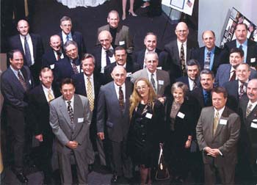
On April 13th, the presence of the Law School Class of '76 was felt in a very special way at the Law School when fifty members of Widener's second graduating class attended their 25th Reunion. Although they enrolled in the Delaware Law School in "the church" on Washington Street, it seemed fitting for the Class of '76 to hold its Reunion on our beautiful campus where cocktails were served in the Strine Atrium of the newly constructed Law Building and dinner followed in the renovated Barristers' Club.

The highlight of the evening was an open microphone session. Members of the Class of '76 came to the podium to share the most incredible stories about the Law School and its humble beginnings. They shared their unique experiences with Dean Avins and Professor Rubinstein, the bee-infested classroom, carting books from all over the region to build the library collection, the risk and promise involved with being the first to enroll in a non-accredited law school. These pioneering stories kept everyone chuckling and reminiscing. A member of the Graduating Class of '02 was so moved by the stories of courage and sacrifice, that he took the podium to thank the members of the Class of '76 for the persistence which would ultimately culminate in the Widener University School of Law that we know and are proud of today.
Special guest appearances by Pete Andrianopoulos, the owner of the local bar frequented by the law students in the city and Dr. Clarence Moll, President of Widener University from 1959-1981 spotlighted the event. Pete thanked the Class of '76 for "turning his business around" during a time when downtown Wilmington was commercially depressed. Dr. Moll described the emergency ABA accreditation appeal that forced him to leave his England vacation to face the accreditation board in Chicago. Led by Dr. Moll, the law school team stayed up all night gathering the information needed to convince the ABA that the Law School was worthy of accreditation - just in time for the Class of '75 to graduate and take the bar in August of that year.
The evening was a mixture of laughter and inspiration and a living example of the spirit that created the Widener University School of Law which has given nearly 10,000 graduates the opportunity to successfully live out their dreams of being lawyers.

Widener Alumni Judges Honored at 2002 Annual Fund Benefit

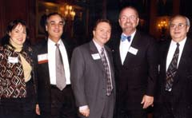
The Annual Philadelphia Reception was held on March 21st. Two hundred and eighty- nine alumni, friends, judges and staff members enjoyed this Annual Fund benefit held at the Union League in Philadelphia. A special honor was given to our Widener Alumni Judges. Sixty- seven graduates of the Law School are members of the judiciary in seven different states and the list is growing.

In April, the Scranton/Wilkes Barre Alumni Reception was held at the Lackawanna Radisson on the 4th and the Harrisburg Alumni gathered at the Whitaker Center in downtown Harrisburg on the 11th. Both events were well attended and all who participated enjoyed the networking opportunity that the affair provided.

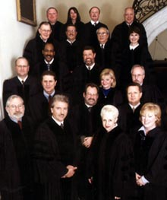
On April 9th, the Graduating Class Giving Campaign Kick Off Reception was held in the Barristers' Club. Mr. Cary Flitter, Esq. ('81) was the guest speaker. Cary spoke to the students about the importance of supporting the Law School as they join the ranks of "Widener Alumni." Graduating students are being asked to pledge a gift over a three-year period.

